Task Breakdown (100 Marks)
Task 1: Project Setup (15 Marks)
- Create a new Maven web application named feedback-portal.
- Maintain the correct Maven project structure.
- Configure the pom.xml file properly with packaging, dependencies, and plugins.
Evaluation Criteria (15 Marks)
Criteria | Marks
Proper Maven project structure | 7
Valid configuration in pom.xml | 8

code of POM.xml file

<project xmlns="http://maven.apache.org/POM/4.0.0" xmlns:xsi="http://www.w3.org/2001/XMLSchema-instance"
xsi:schemaLocation="http://maven.apache.org/POM/4.0.0 http://maven.apache.org/maven-v4_0_0.xsd">
<modelVersion>4.0.0</modelVersion>
<groupId>org.example</groupId>
<artifactId>feedback-portal</artifactId>
<version>1.0-SNAPSHOT</version>
<packaging>war</packaging>
<name>feedback-portal Maven Webapp</name>
<properties>
<maven.compiler.source>11</maven.compiler.source>
<maven.compiler.target>11</maven.compiler.target>
<project.build.sourceEncoding>UTF-8</project.build.sourceEncoding>
<junit.jupiter.version>5.9.3</junit.jupiter.version>
</properties>
<dependencies>
<dependency>
<groupId>org.junit.jupiter</groupId>
<artifactId>junit-jupiter</artifactId>
<version>${junit.jupiter.version}</version>
<scope>test</scope>
</dependency>
<dependency>
<groupId>org.apache.commons</groupId>
<artifactId>commons-text</artifactId>
<version>1.10.0</version>
</dependency>
</dependencies>
<build>
<finalName>feedback-portal</finalName>
<plugins>
<plugin>
<groupId>org.apache.maven.plugins</groupId>
<artifactId>maven-surefire-plugin</artifactId>
<version>3.1.2</version>
</plugin>
<plugin>
<artifactId>maven-war-plugin</artifactId>
<version>3.4.0</version>
<configuration>
<failOnMissingWebXml>false</failOnMissingWebXml>
</configuration>
</plugin>
</plugins>
</build>
<reporting>
<plugins>
<plugin>
<groupId>org.apache.maven.plugins</groupId>
<artifactId>maven-surefire-report-plugin</artifactId>
<version>3.1.2</version>
</plugin>
</plugins>
</reporting>
</project>

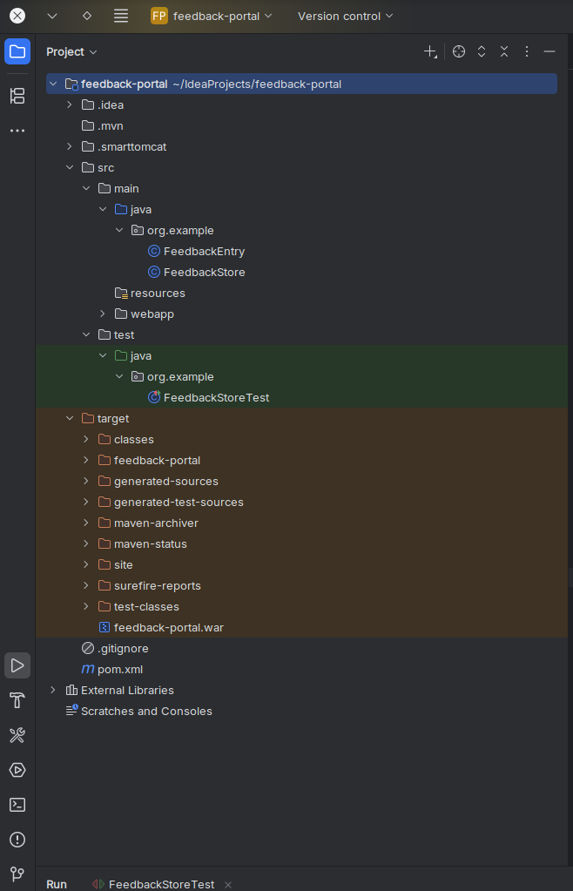

Task 2: Feedback Logic (20 Marks)
- Implement the backend logic to handle storing and retrieving feedback.
- Ensure empty feedback entries are not added.
- Data should be stored temporarily (no database).
Evaluation Criteria (20 Marks)
Criteria | Marks
Correct logic implementation | 10
Proper validation for empty input | 5
Feedback retrieval functionality | 5

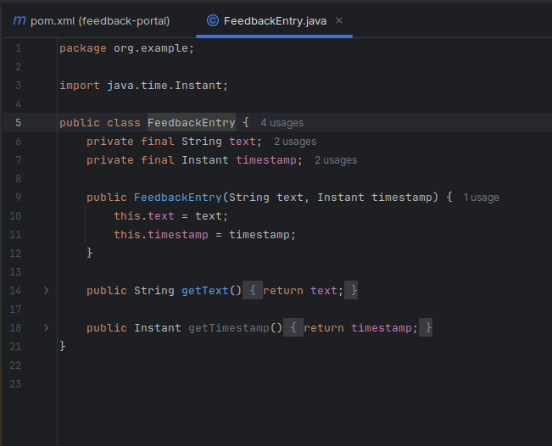

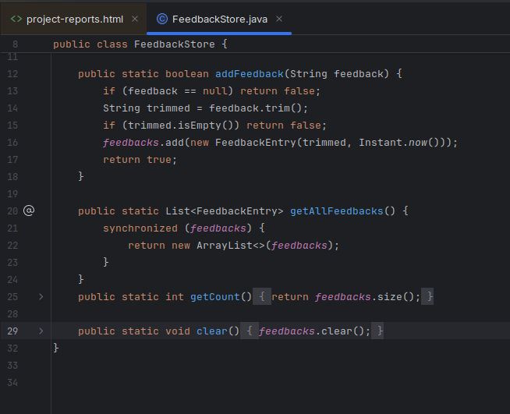

Task 3: JUnit Testing (15 Marks)
- Write unit tests to validate feedback addition and retrieval logic.
- Ensure the build process runs tests automatically.
- The application must only be packaged if all tests pass.
Evaluation Criteria (15 Marks)
Criteria | Marks
Adequate test coverage | 10
All tests pass successfully | 5

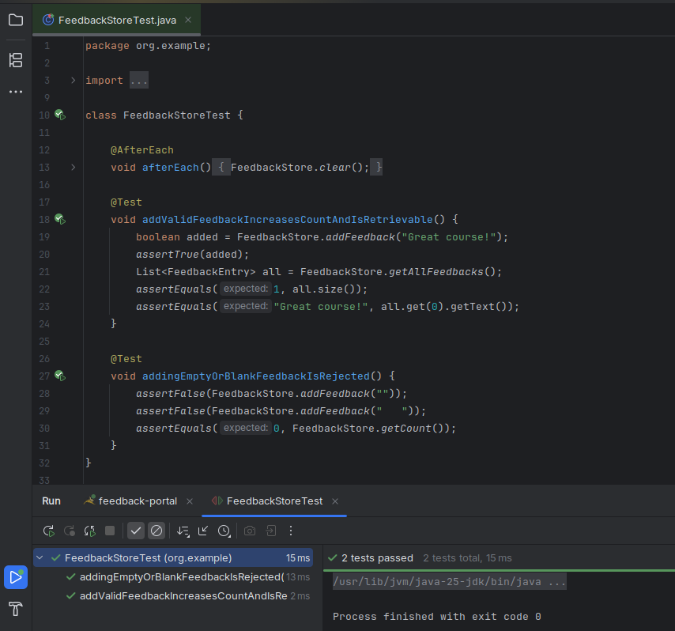

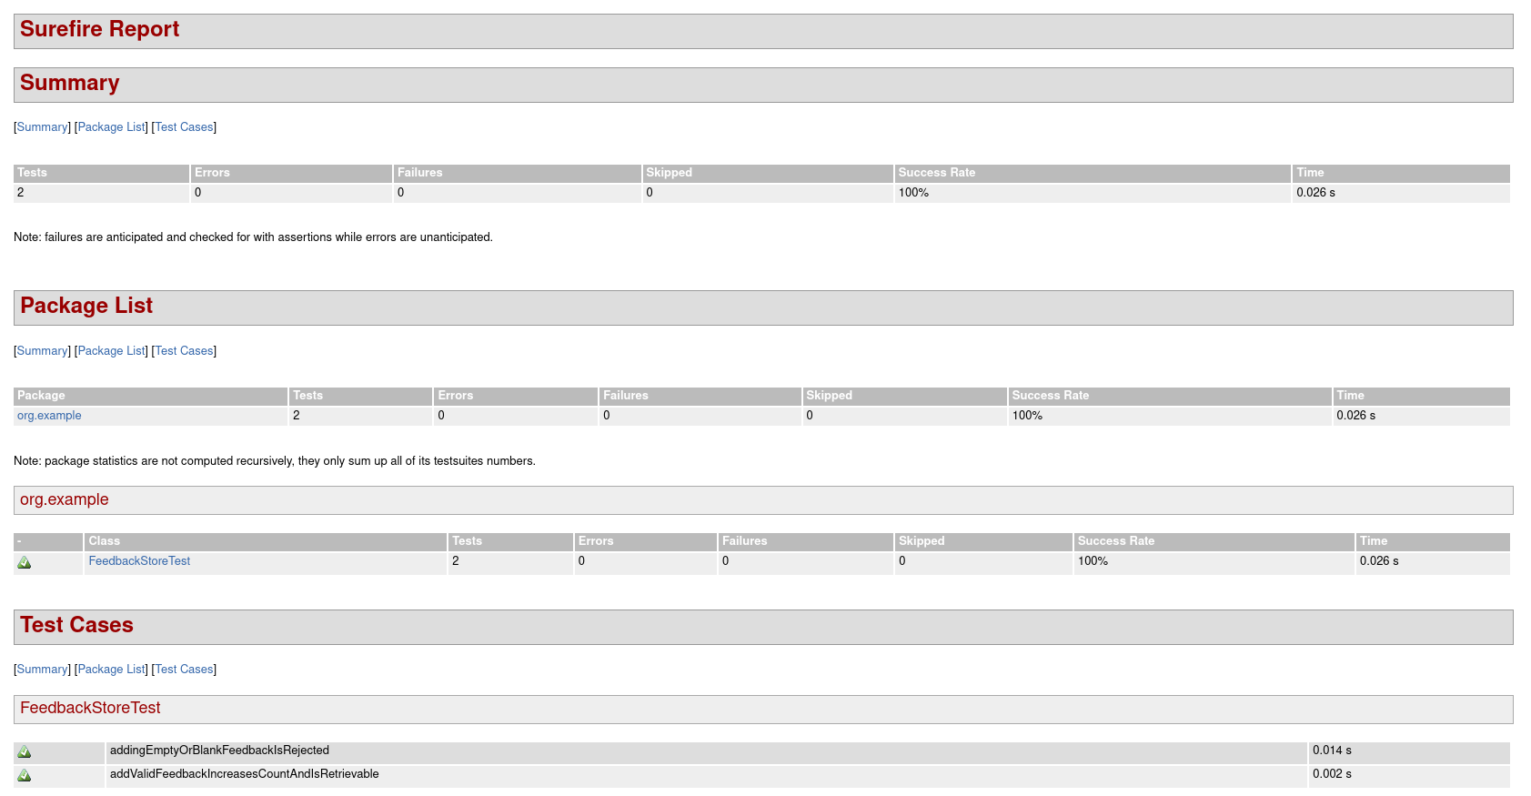

Task 4: JSP Pages (30 Marks)
- Design JSP pages for the web interface.
- One page should allow users to submit feedback.
- Another page should display all submitted feedback.
- No Servlets should be used; logic should be handled through JSP and Java class interaction.
Evaluation Criteria (30 Marks)
Criteria | Marks
JSP structure and navigation | 10
Data submission and display work correctly | 10
Proper use of backend logic within JSP | 10

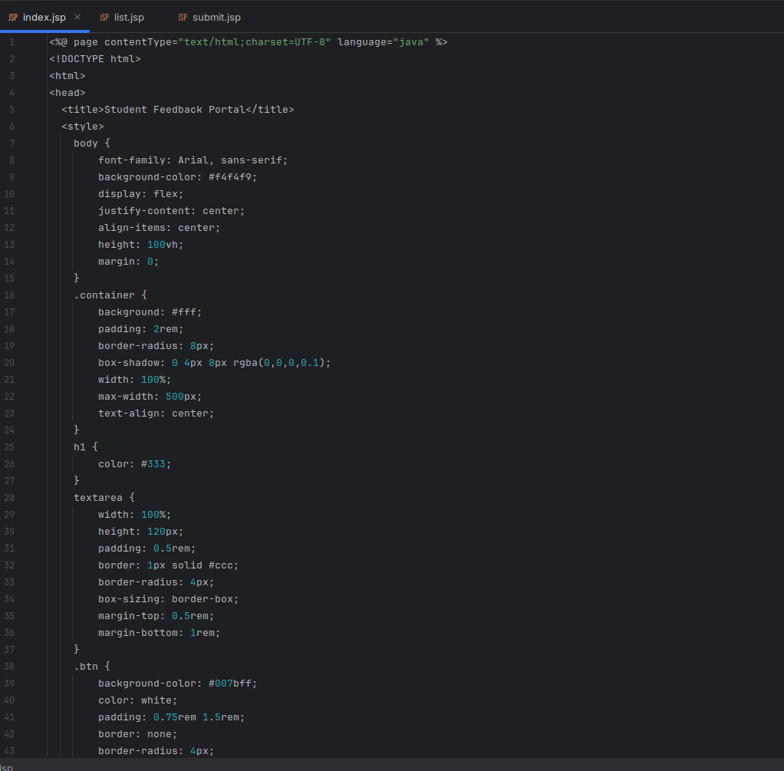
- Use simple CSS to improve the web page design.

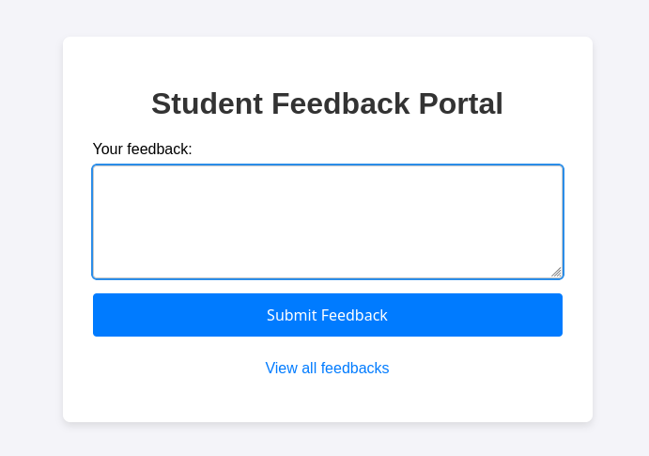

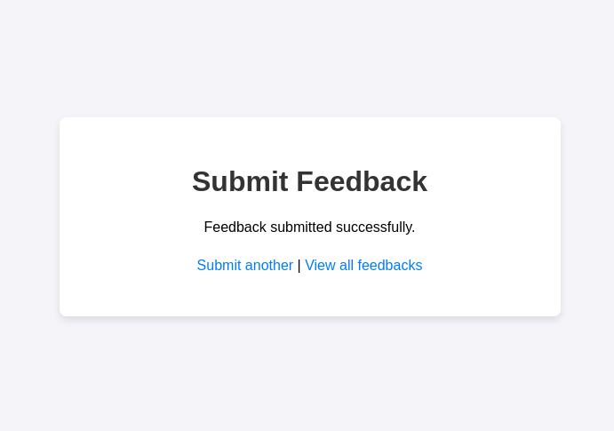

- Add a timestamp to each feedback entry.
- Display total feedback count dynamically.

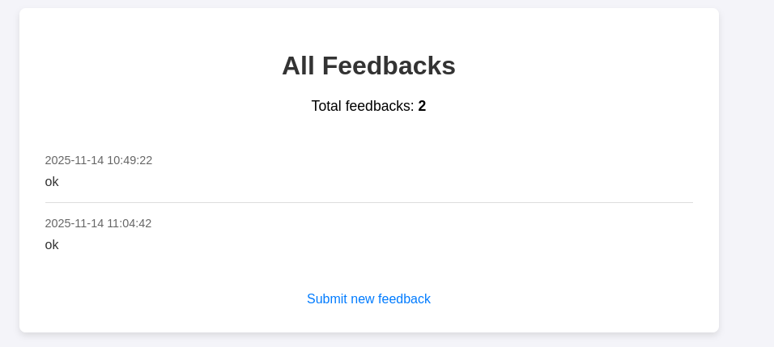

Task 5: Build and Deployment (15 Marks)
- Build the project from VS Code using Maven.
- Deploy the web application directly from VS Code to the Tomcat server.
- Verify that the deployed application works as expected on the browser.
Evaluation Criteria (15 Marks)
Criteria | Marks
Successful Maven build from VS Code | 7
Correct deployment to Tomcat | 8

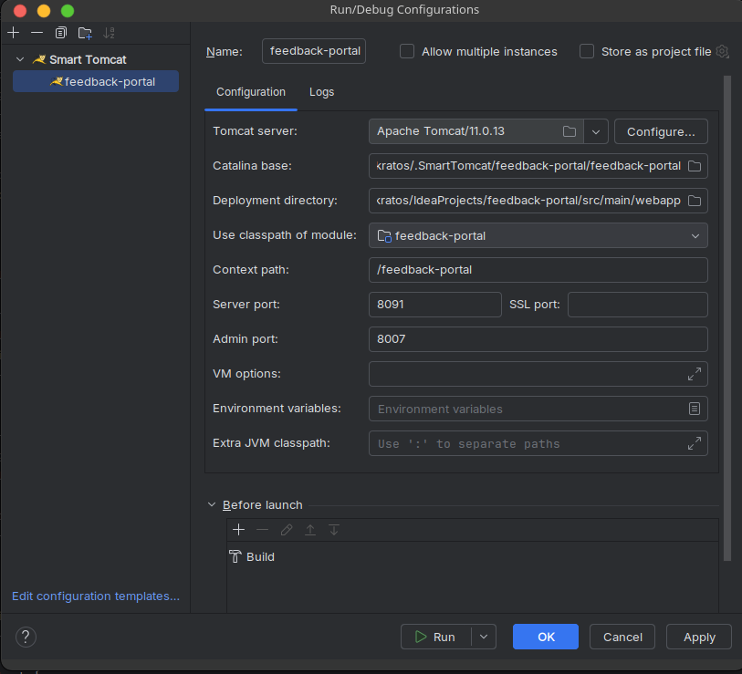

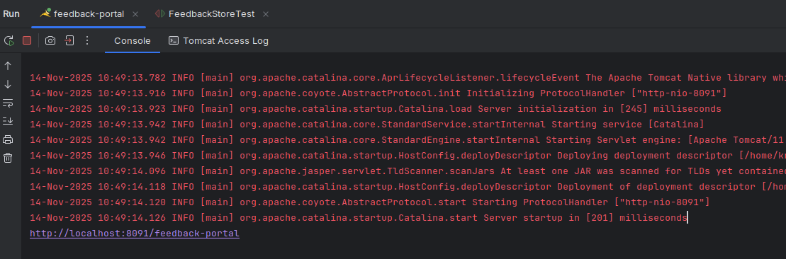

Task 6: Automation Validation (5 Marks)
- Ensure the build process stops if any unit test fails.
- Document evidence of the automated build process and successful deployment.
Evaluation Criteria (5 Marks)
Criteria | Marks
Proper build-test linkage | 3
Proof of deployment and results | 2

Evidence of the automated build process: The console output from the mvn package and mvn site commands that we ran earlier serves as this evidence. It shows the tests being executed automatically and passing, leading to a "BUILD SUCCESS" message.

