Description

Intended User

Features

User Interface Mocks

Screen 1

Screen 2

Key Considerations

How will your app handle data persistence?

Describe any corner cases in the UX.

Describe any libraries you’ll be using and share your reasoning for including them.

Describe how you will implement Google Play Services.

Next Steps: Required Tasks

Task 1: Project Setup

Task 2: Implement UI for Each Activity and Fragment

Task 3: Your Next Task

Task 4: Your Next Task

Task 5: Your Next Task

**GitHub Username**: Rahulxx01

NewsX

# Description

A News App which helps users especially living in India to get latest news about what is happening in India. A detailed information of each news article will be shown with the goal to keep the user up to date. The user will be provided with News Highlights and the news is sorted according to the categories like General, Entertainment, Sports, Health, Business, Science and Technology. The user will be able to save the news offline so that he/she can read the article anytime and also will be notified accordingly.

# Intended User

Intended for users who want to keep themselves up to date with current affairs happening in India.

# 

# Features

* Displays Top Headlines of the latest News happening in India
* Displays categories like General, Entertainment, Sports, Health, Business, Science and Technology and get top headlines related to each category
* Display detailed information about the selected news article.
* Save the News headline data for offline purpose
* Get randomly notified when new news arrives.
* Share news to anyone in social media.
* User Authentication is done via Firebase Authentication

# User Interface Mocks

## Screen 1

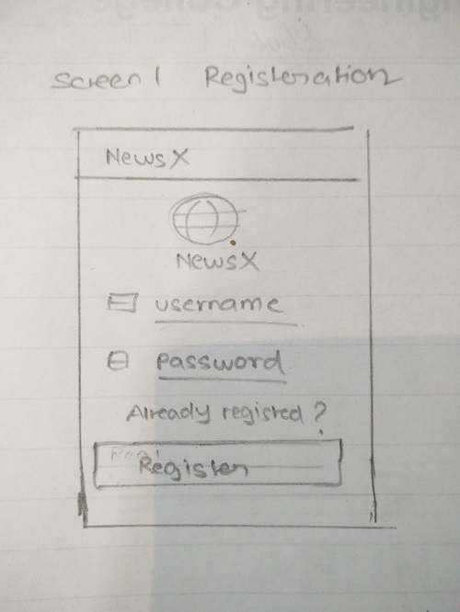

Initially when the user opens the application he/she needs to register to access the news.

## Screen 2

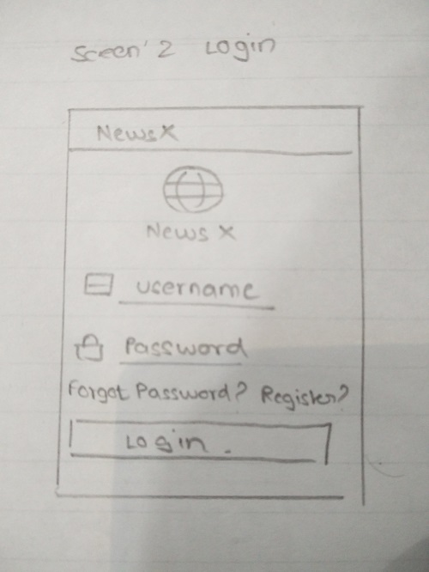

If the user has already registered then he/she needs to login to access the news.

## Screen 3

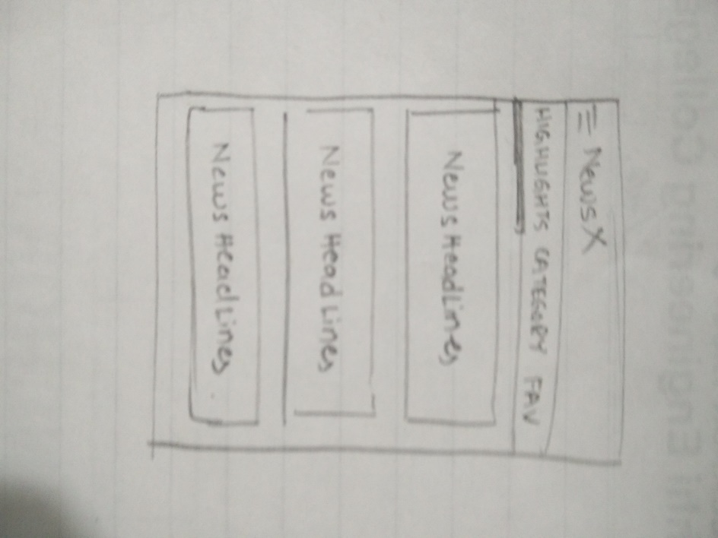

News Main Activity consists of 3 parts as given  
**Highlights** will give top headlines of the current day news.

**Category** will sort news among 7 parts General, Entertainment, Sports, Health, Business, Science and Technology.

**Fav** will give all the saved online news for offline purpose.

## Screen 4

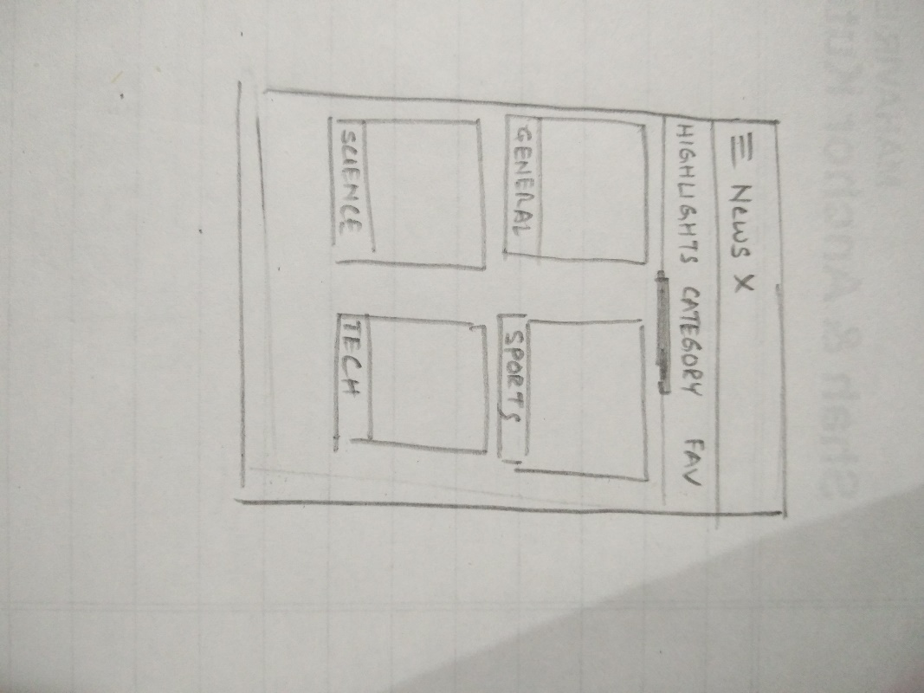

News Category will be displayed in a Grid format the blank space given is the Image representing the category.

## Screen 5

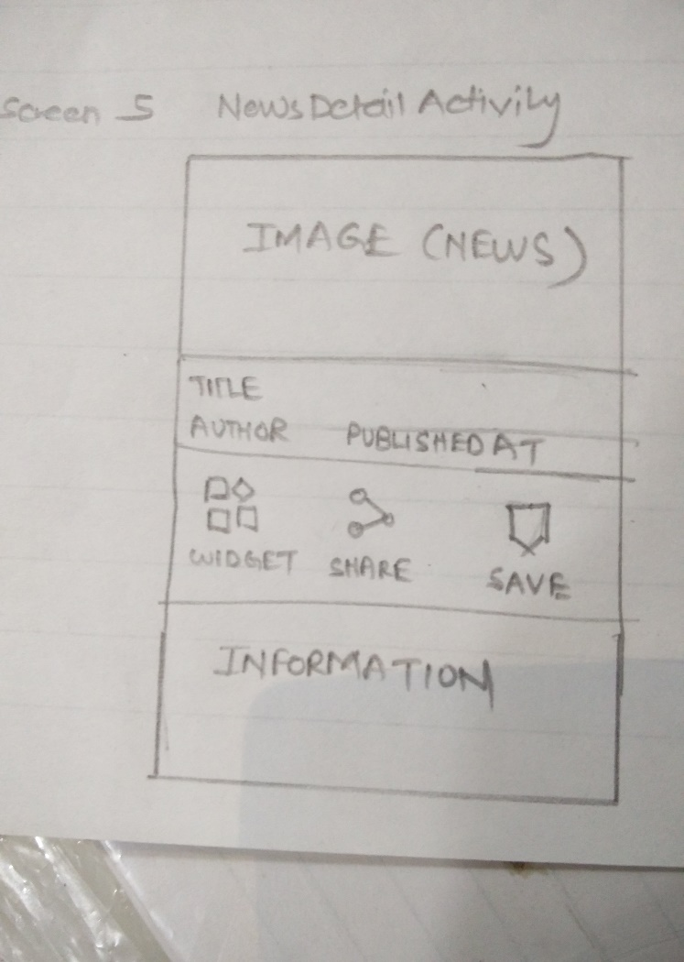

News Details when news articles item is clicked will give a detailed view of images.

## Screen 6

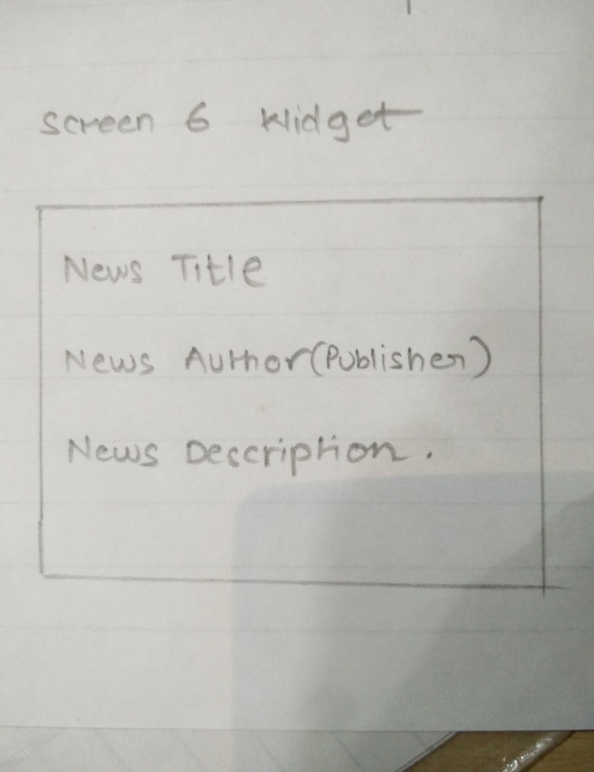

Widget to display some news information about the news article user has chosen to keep as widget.

# Key Considerations

### How will your app handle data persistence?

The App uses Retrofit to load data from the news API from https://newsapi.org/ and its uses combination of Live Data and View Model to handle data persistence.

The App also uses Room Database and combination of Live Data and View Model to handle data persistence.

### Describe any edge or corner cases in the UX.

When the app receives notification and when user clicks on the notification the same activity is loaded in which the user had previously left.

When there is no internet connection then user is given a message via toast saying “no internet connection” if the user is logged in then only Favorites news articles will we available for user to see and if there are no Favorite news articles then a message will be displayed saying no favorite news articles.

### Describe any libraries you’ll be using and share your reasoning for including them.

Picasso is used to handle the loading and caching of images.

Retrofit is used to get data from news API.

### Describe how you will implement Google Play Services or other external services.

AdMob: To monetize the App

Firebase Authentication.: Login and Registration.

Firebase Cloud Messaging: Push Notification.

# Next Steps: Required Tasks

## Task 1: Project Setup

1. Create an account on <https://newsapi.org/> and get the API KEY.
2. Configure the libraries required for the project

## Task 2: Implement UI for Each Activity and Fragment

1. Build UI for Login and Registration Activity.
2. Build UI for News Activity and News Fragment
3. Build UI for News Details Activity.
4. Build Fragments to populate the View Pager and Tab Layout.

## Task 3: Implement Networking (ONLINE)

1. Bind the activities with data received from the News API.
2. Fetch data using Retrofit and then use Live Data and View Model to populate the UI.

## Task 4: Implement Database (OFFLINE)

1. Implement Room Database to store news data offline and use Live Data and View model to populate the UI.

## Task 5: Implement Widget

1. Implement widget UI and display pinned news article selected by the user.

## Task 6: Implement Firebase and AdMob Services

1. Implement Firebase Authentication for registration and login
2. Implement Firebase Cloud Messaging for Push notification.
3. Implement AdMob services to display dummy ads