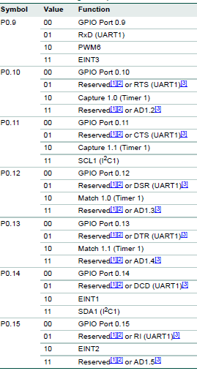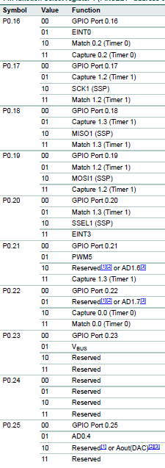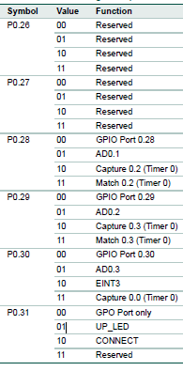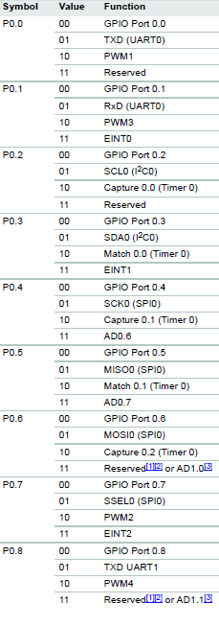

**P0.0 TO P0.15 CAN BE CONFIGURED THROUGH PINSEL0**

**P1.16 TO P1.31 ALL AS GPIO CONFIGURED THROUGH PINSEL2**

**P0.16 TO P0.31 CAN BE CONFIGURED THROUGH PINSEL1**