KENDRIYA VIDYALAYA , DURG

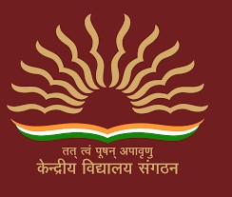

PHYSICAL EDUCATION PROJECT

# 2023_2024

TOPIC-SAI KHELO INDIA TEST,YOGA,SPORTS etc

GUIDED BY -MR.RESPECTED SURESH SIR

SUBMITTED BY-KARTIKEYAN RAI

CLASS-12thB ROLL.NO-12612700

## CERTIFICATE

TH at

This is to certify that of class

_1_2_‘B’ , KENDRIYA VIDYALAYA DURG has successfully completed the project on the topic

under the guidance of Mrs. Sheela Chacko in session : 2023-24

**INTERNALEXAMINER EXTERNAL EXAMINER**

**PRINCIPAL**

## ACKNOWLEDGEMENT

I would like to thank the CBSE, for providing me the opportunity to carry out this investigatory project. I also take this opportunity to express my sincere gratitude to my chemistry teacher Mrs. Sheela Chacko for guiding me and providing a sound base of knowledge pertaining to this project which ensures the successful completion of this project.

I wish to express my sincere thanks to my principal Sri. Uma Shanker Mishra who helped me to accomplish this project by providing me all necessary facilities and support.