Documentation For local Setup
Thursday, February 16, 2023
8:48 AM

- SPLUNK LOCAL SETUP:
Create "HTTP Event Collector":
SETTING -> DATA INPUTS -> HTTP Event Collector

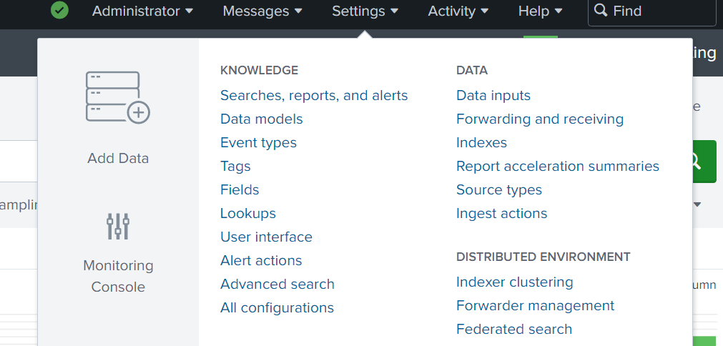

Set the HTTP Event Collector listen to PORT 8088
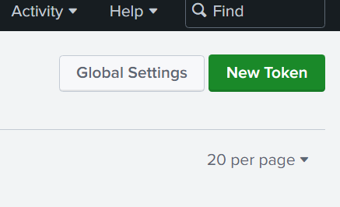

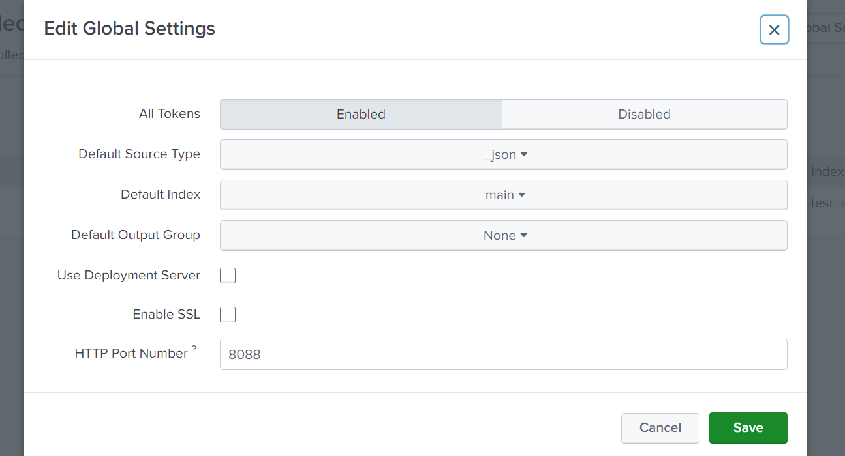

Important INFO for Integration:
Note down below attributes for log4j configuration.
URL: | Where your splunk server will redirect your logs
HOST: | What is the host where your splunk server is running
TOKEN: | What is the security token to connect with your splunk server
INDEX: | In which index you want to push your logs ?
SOURCE: | What is your source type, who will push the logs?

  - Splunk and log4j2 dependencies required for Spring boot application.

SPLUNK DEPENDENCIES
<repositories>
<repository>
<id>splunk-artifactory</id>
<name>SplunkReleases</name>
<url>https://splunk.jfrog.io/splunk/ext-releases-local</url>
</repository>
</repositories>

<dependency>
<groupId>com.splunk.logging</groupId>
<artifactId>splunk-library-javalogging</artifactId>
<version>1.6.2</version>
<scope>runtime</scope>
</dependency>

LOG4j2
<dependency>
<groupId>org.springframework.boot</groupId>
<artifactId>spring-boot-starter-log4j2</artifactId>
<version>3.0.2</version>
</dependency>

NOTE: Exclude Spring boot starter logging dependency
<exclusions>
<exclusion>
<artifactId>spring-boot-starter-logging</artifactId>
<groupId>org.springframework.boot</groupId>
</exclusion>
</exclusions>

  - Create .XML file for log4j2 configuration with Splunk
<?xmlversion="1.0"encoding="UTF-8"?>
<Configuration>
<Appenders>
<Consolename="console"target="SYSTEM_OUT">
<PatternLayout
pattern="%style{%d{ISO8601}}%highlight{%-5level}[%style{%t}{bright,blue}]%style{%C{10}}{bright,yellow}:%msg%n%throwable"/>
</Console>
<SplunkHttp
name="splunkhttp"
url="http://localhost:8088"
token="6778bfc5-f5df-412d-8519-15095c35d2ae"
host="localhost"
index="test_index"
type="raw"
source="http-event"
sourcetype="log4j"
messageFormat="text"
disableCertificateValidation="true">
<PatternLayoutpattern="%m"/>
</SplunkHttp>

</Appenders>

<Loggers>
<!--LOGeverythingatINFOlevel-->
<Rootlevel="info">
<AppenderRefref="console"/>
<AppenderRefref="splunkhttp"/>
</Root>
</Loggers>
</Configuration>

NOTE: change SplunkHttp attritubes with your HTTP Event Collector's attribute

ARCHITECTURE
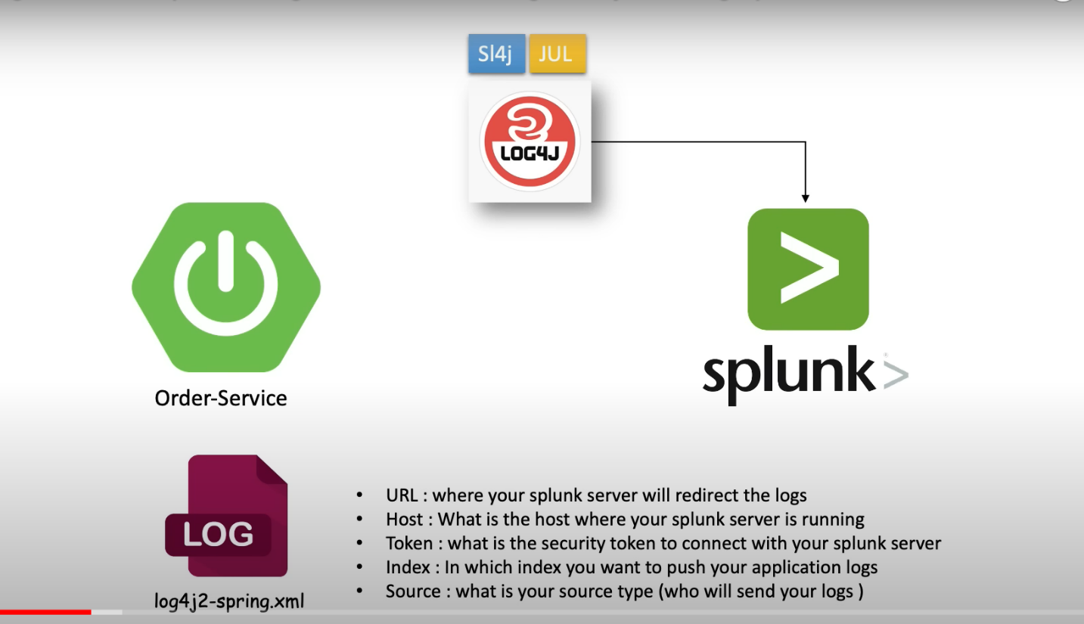

Splunk login
http://127.0.0.1:8000/

- JSON PAYLOAD

POST:
http://localhost:8080/employee/add

{
"name": "Mahi Singh",
"email": "Mahi@gmail.com",
"jobTitle": "Sales Manager",
"phone": "29333847",
"imageUrl": "https://images.app.goo.gl/7Pa73Gecfb8KHQUW7",
"employeeCode": "df808447-af37-2de-89f0-083912f1d1f5",
"xml": "<user><id>94</id><email>Mahi@exammple.com</email></user>",
"department":"Sales"
}

