**How to Access Live Tracking Data of Boat**

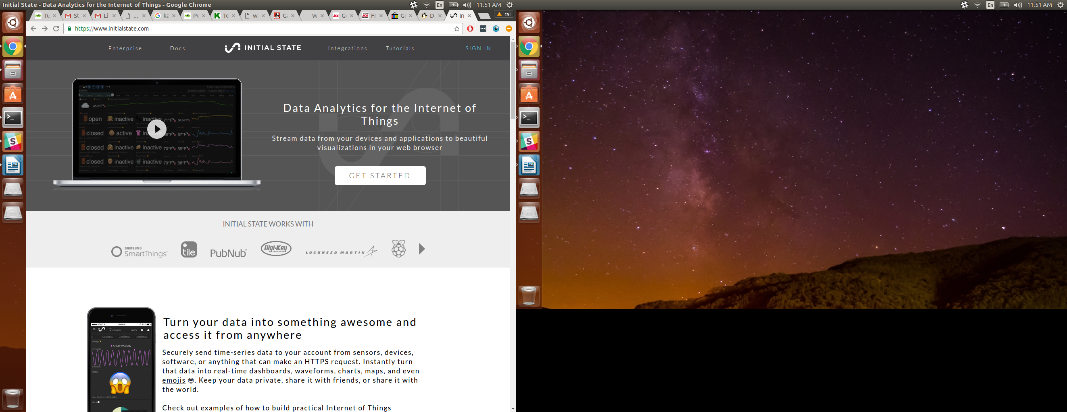**Who is this for :**  This guide shows how one can access data live from the tracking device on a boat during the launch. You can access this data on any device that has an internet connection and a web browser.

1. Open your favorite web browser and head over to <https://www.initialstate.com/>.

2. Click on the **sign in** button on the top right.

3. Enter the following credentials. Email : [shiptrackernichols@gmail.com](mailto:shiptrackernichols@gmail.com)

Pasword : nicholsboats123

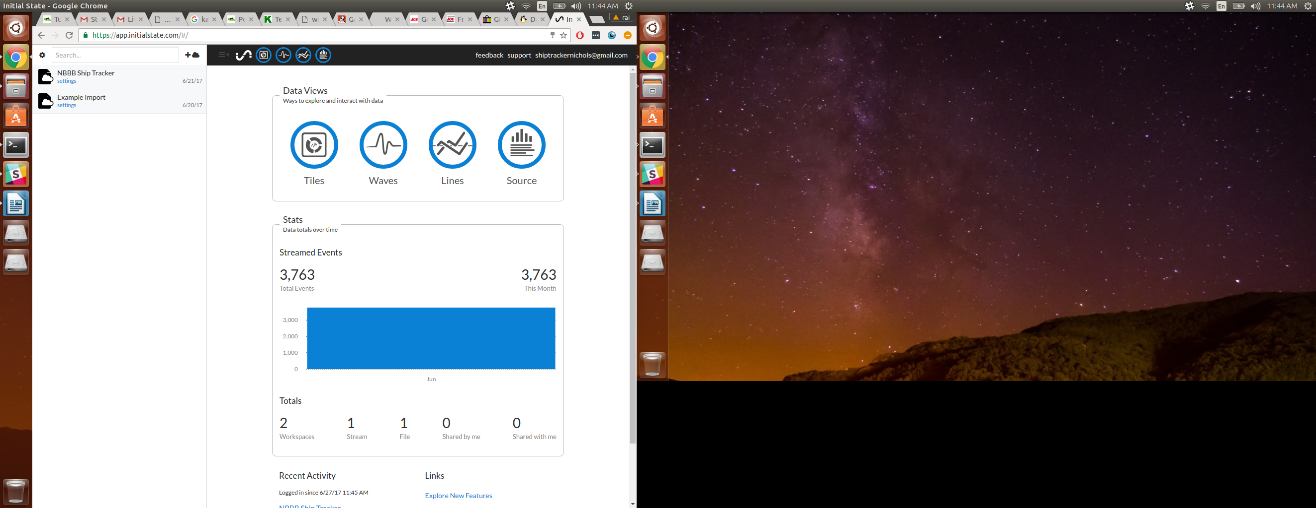4. Once loged in, you will see a section on the left showing all the streaming buckets. Click on **NBBB Ship Tracker.**



5. There are many ways to interpret the data. We recommend Tiles. Click on **Tiles** and it will open up all the data and its graphed logs.

6. The numbers beside the colored dots are the latest stream and the graphs are the historic values of each numeric parameter.

7. Once done with your session, simply close the website.