**Wired Access to Tracking Data**

**Who is this for** : This guide whould be used if the livestream fails or is faulty. The person conducting this guide can relay the data to appropriate people over a radio.

**Supported Devices** : Windows and Linux

1. Download this github repository and navigate to the **master/usb** folder . Open the appropriate OS

<https://github.com/RaiBearG/NBBB>

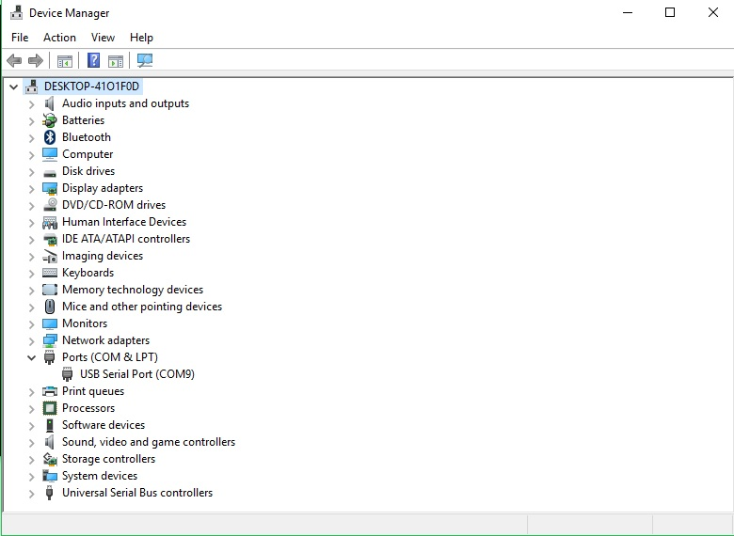2. Find the USB cable on the patio of the office beside the ramp and connect it to your computer’s usb port

3. Find the communication port

* On windows, open the **device manager** to find the com-port your usb is connected to
* On linux, open a terminal and go to the /dev/tty... directory to find the usb port

4. Start the application

* On windows, start the **local_serial.exe** application. A window will pop and ask for a com port. Type in your com port and press enter. You must add single quotes when typing your port for ex. ‘com9’ . Then it will ask for the height. Add the appropriate height of the 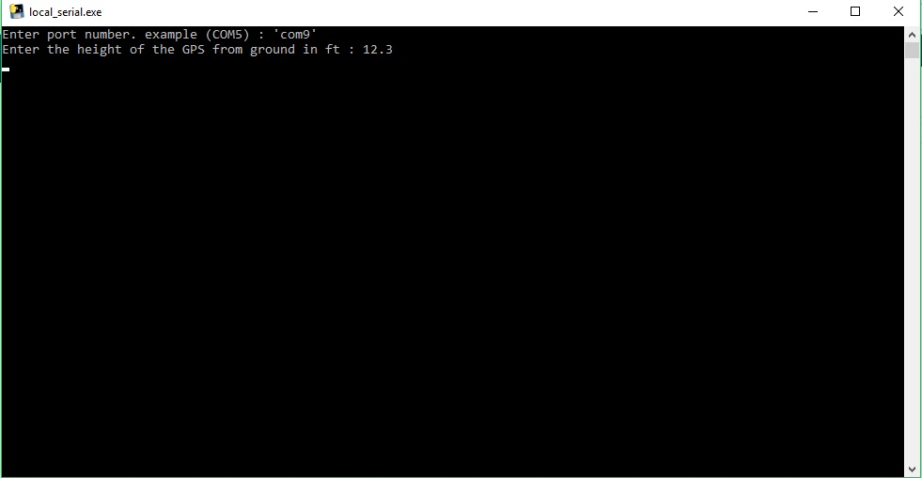rover in ft. Then press enter.
* On linux, open a terminal and start the python script using the python command. Type in your com port and press enter. Then it will ask for the height. Add the appropriate height of the rover in ft. Then press enter.

5. Then the data will start appearing on the screen at a rate of 0.5hz. Once finished, simply close the application or terminal and unplug the usb cable.