**Introduction to Truss Beam FEM**

*Oct. 2009*

The program is written in Matlab, initially for the course ENSC 281 at Simon Fraser University. A user can define a structure of trusses or beams and the program can calculate all forces, moments, and deformation at each joint (or node). Below list the steps that one need to follow to run the program.

**Step 1: Prepare the geometry and Finite Element model**

Use the example program “createmodel_truss.m” (other examples are given in the same directory, e.g., createmodel1.m, createmodel2.m, createmodel3.m, etc.). This function is to create a model file “*.mat” that will be used for computation. The model file includes the parameters of the nodes, elements, material and the section. The typical format of the program is listed as follows. You need to read all the comments to make sure you enter the correct data. Note this program does not specify the unit system. You need to make sure your units are consistent in one system (metric or imperial). After running of the program, a model file, e.g., “truss3.mat,” will be created in the same folder. You can change the model file name in the last sentence of the “createmodel_truss.m” file.

global node;

global element;

global material;

global section;

%%node information: Node No., Degree of Freedom (DOF), X coordinate, Y %coordinate, constraint along x, constraint along y, constraint on %rotation(1 means constrained; 0 is free), load on the node Fx, Fy, and %Moment

node=...

[ 1 2 0.0 1.0 0 0 0 0 0 0

2 3 1.0 2.0 0 0 0 -1000 -1000 100

3 3 1.0 0.0 1 1 1 0 0 0

4 3 2.0 1.0 0 0 0 0 0 0];

%element information: Element No., node1, node2, Element Type(1 is Truss,2 is %Beam), Material No., Cross-Section No.

element=...

[ 1 1 2 1 1 1

2 1 3 1 1 1

3 2 3 2 1 2

4 3 4 2 1 2

5 2 4 2 1 2];

%Material information: Material No, Modulus of elasticity

material=[ 1 2e11];

%Cross-Section No., Cross-sectional area, Moment of Inertia, the Maximum

% distance from Neutral axis

section=...

[ 1 0.01 0.01 0.01

2 0.02 2.0e-7 0.02];

save('model1.mat','node','element','material','section');

**Step 2 Run the FEA program**

Find the function “truss_beam_fem_GUI.m” in the folder named “truss_beam_fem.” Type “truss_beam_fem_GUI” in the command window. The main window of the program shows as the following.

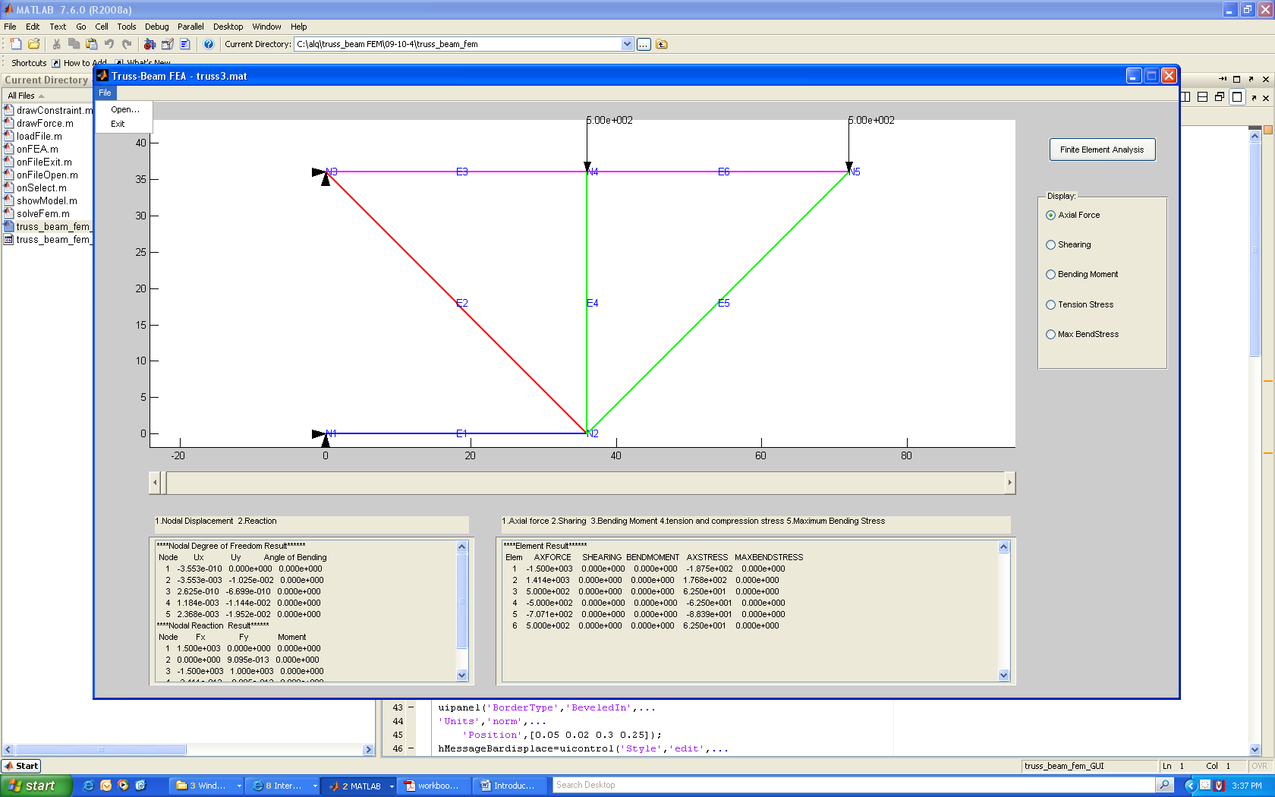

There is a menu named File at the top of the window. The button Open can open a model file. You can then choose to open the model generated in the first step, e.g., truss3.mat. The button named Finite element Analysis can run the FEA. The results of the node and the element list in the text box at the bottom of the window. The slide control can show the deflected structure of different scales.

**Final remarks:**

(1) The units of inputs should be consistent. For example if the inputs use (N-m-s), then the output deformation Ux and Uy will be in meter, the force in Newton, and moment in (N.m).

(2) The DOF of the node will be calculated in the program. If you do not know the right DOF of node, you can simply input 2 or 3.