FINANCIAL ASSESSEMENT FORM

NAME: _________________________________ DATE: _____________

GRADE: (G4-10) ____________ S.Y.: _____________

TOTAL COMPUTATION
TUITION_______________25,000.00__
REGISTRATION___________3,360.00__
TOTAL MISCELLANEOUS____6,100.00__
TOTAL INCIDENTALS________________

INCIDENTALS
PACEs_______________________
TLE_________________________
HELE________________________
MAPEH______________________
Parent Orientation____ ________
Handbook____________________
TOTAL ASSESSMENT: _________
Paid upon enrolment: _________
Balance : _________

Due every 5th of the month: ______
Payment received by: __________

Goal/Progress Chart Cover_______
Flags________________________
ID___________________________
Notebook____________________
Closing Fee___________________
Fetcher’s ID___________________
Founder’s Day ________________
Graduation Fee________________
Congress Fee _________________
Late Fee______________________
CEM_________________________

We the undersigned pledge to abide by the CHURCH-SCHOOL POLICY, DISCIPLINE, RULES AND REGULATIONS and the NO PAYMENT; NO STAMPING OF PACEs policy (1 month overdue) without reservations.

________________________________
Father’s Signature over Printed Name

________________________________
Mother’s Signature Over Printed Name
NAME: ________________________________ DATE: _____________
GRADE: (G4-10) ____________ S.Y.: _____________
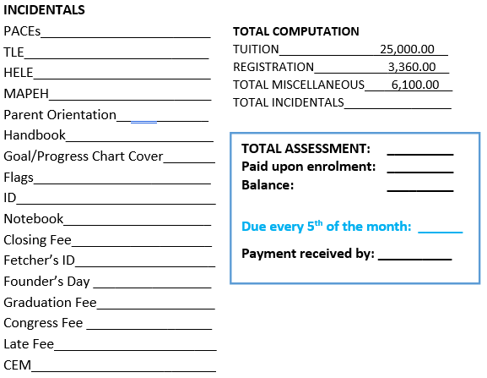
FINANCIAL ASSESSEMENT FORM

ACCOUNTING OFFICE COPY
NAME: ________________________________ DATE: _____________
GRADE: (G4-10) ____________ S.Y.: _____________

FINANCIAL ASSESSEMENT FORM

