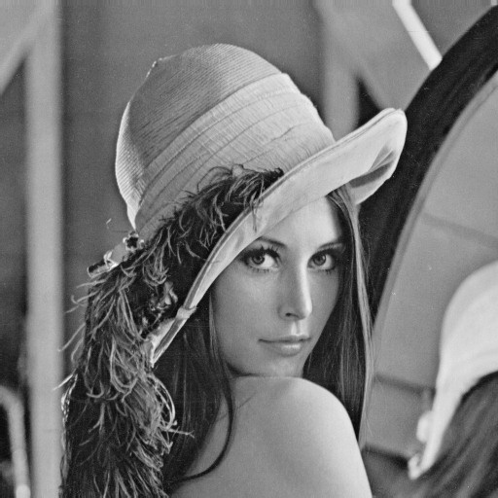

Fig 1.1: Input Image

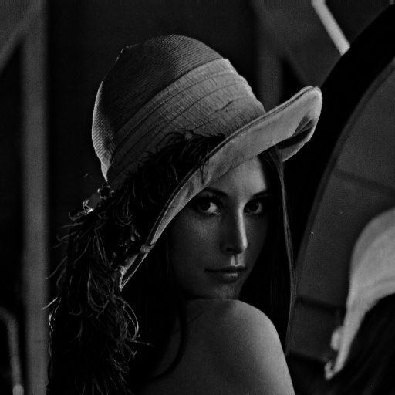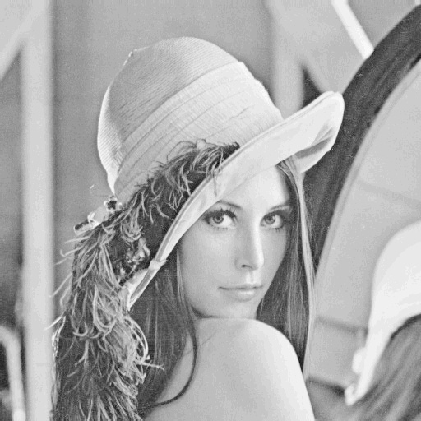

Fig 1.3: Output Image for Gamma = 0.2

Fig 1.2: Output Image for Gamma = 4

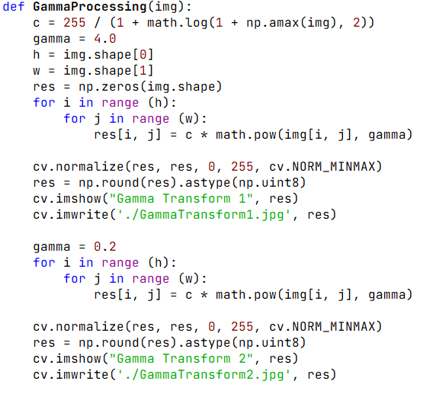

Fig 1.4: Corresponding Gamma Processing Code

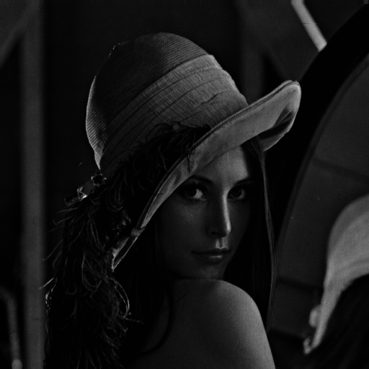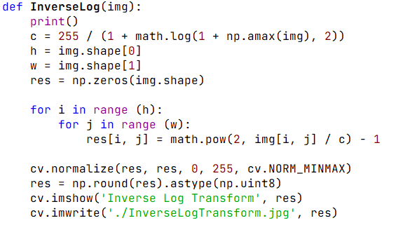

Fig 1.5: Output Image for Inverse Log Processing

Fig 1.6: Corresponding Inverse Log Processing Code

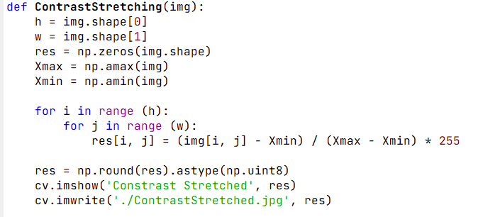

Fig 1.8: Corresponding Contrast Stretching Code

Fig 1.7: Output Image for Contrast Stretching

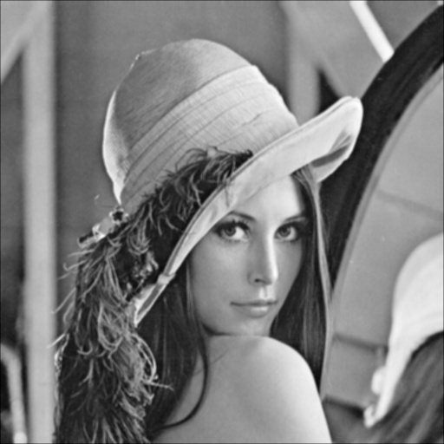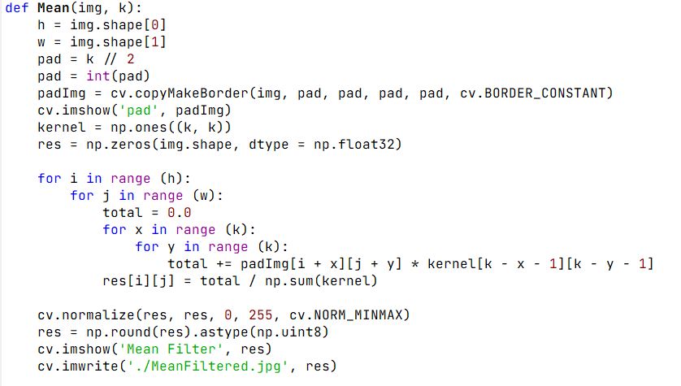

Fig 1.9: Output Image for Mean Filtering

Fig 1.10: Corresponding Mean Filtering Code

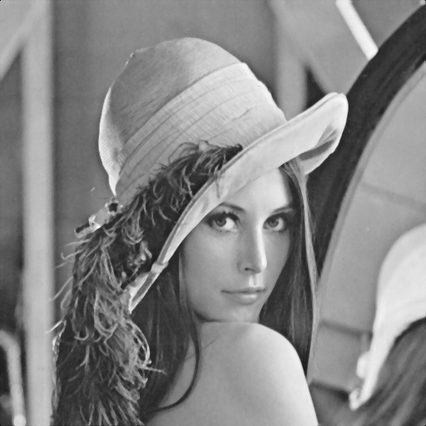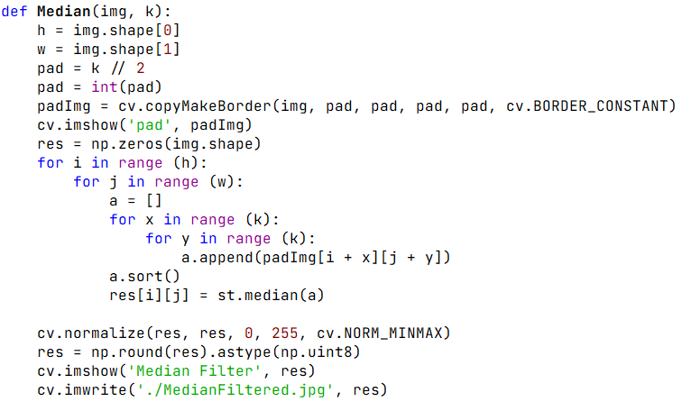

Fig 1.12: Corresponding Median Filtering Code

Fig 1.11: Output Image for Median Filtering

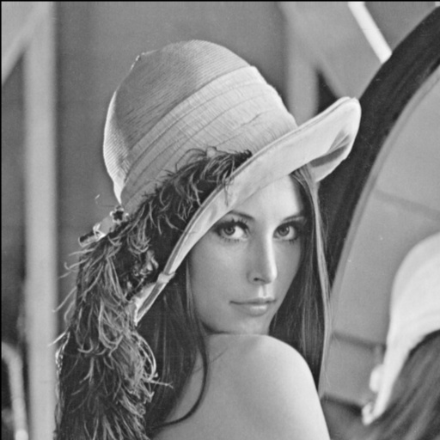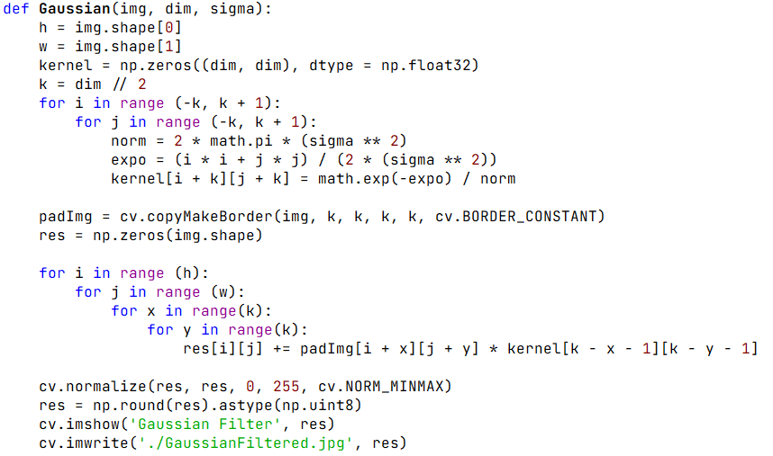

Fig 1.14: Corresponding Gaussian Filtering Code

Fig 1.13: Output Image for Gaussian Filtering

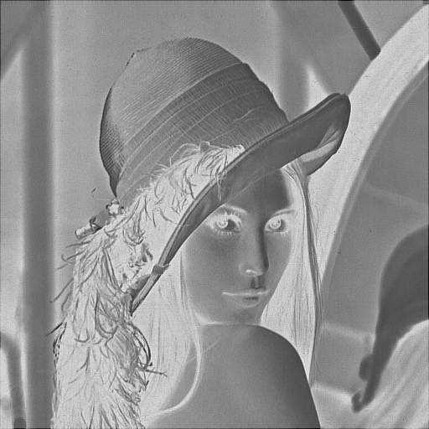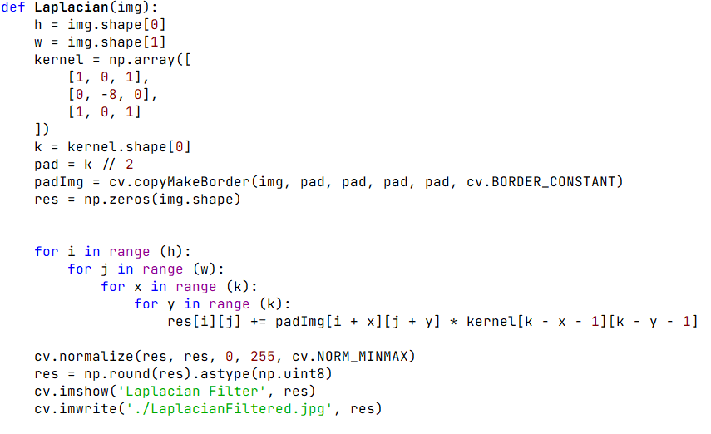

Fig 1.16: Corresponding Laplacian Filtering Code

Fig 1.15: Output Image for Laplacian Filtering

Fig 1.17: Output Images for Horizontal Sobel Filtering, Vertical Sobel Filtering and Sobel Filtering

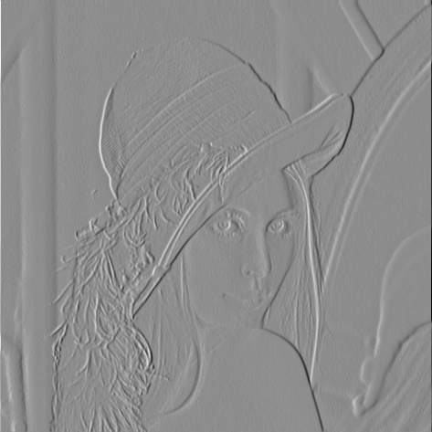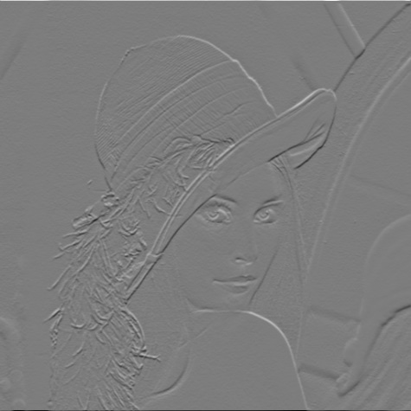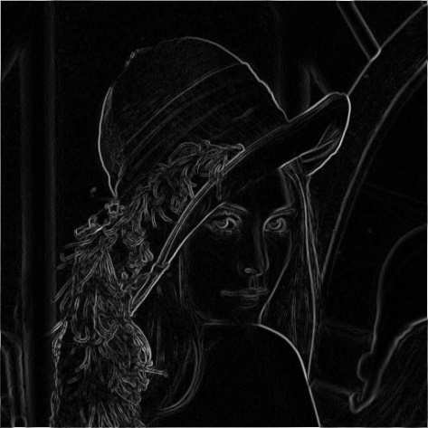

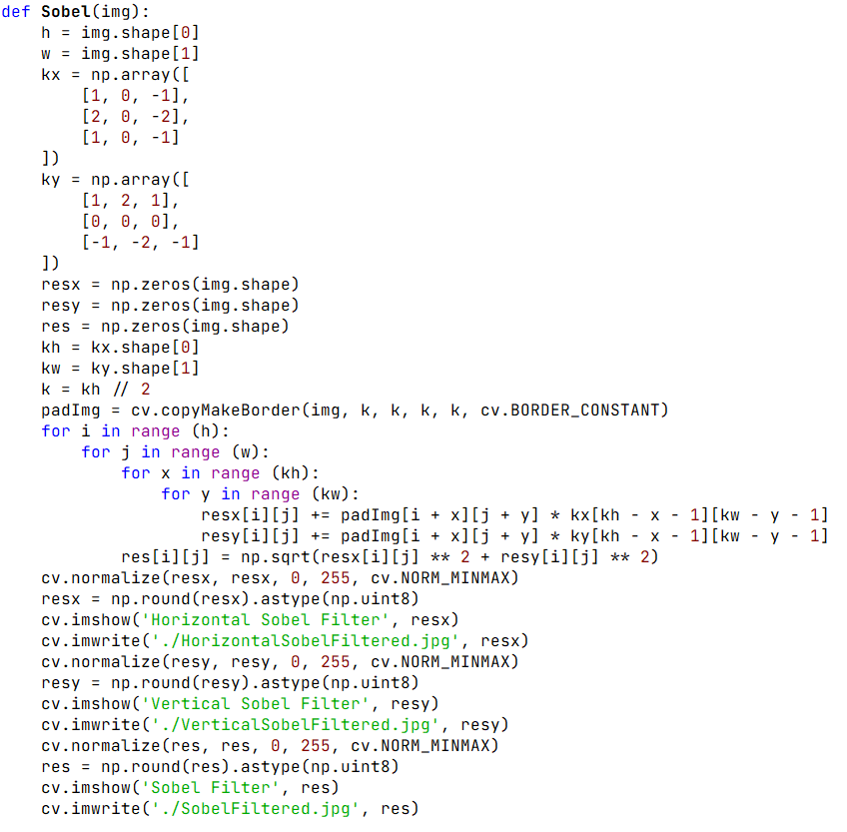

Fig 1.18: Corresponding Code Snippet for Horizontal Sobel Filtering, Vertical Sobel Filtering and Sobel Filtering