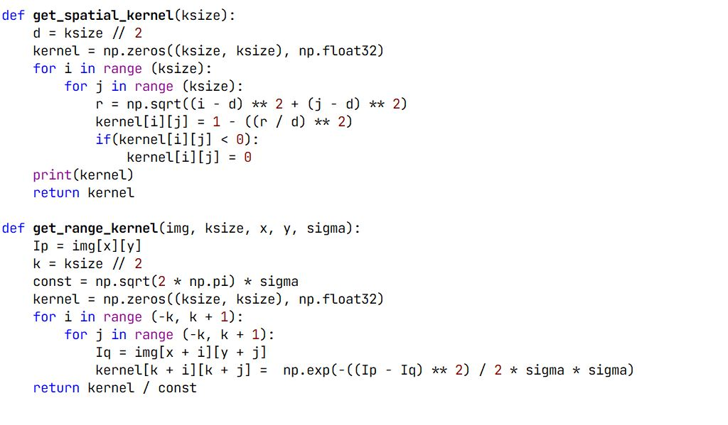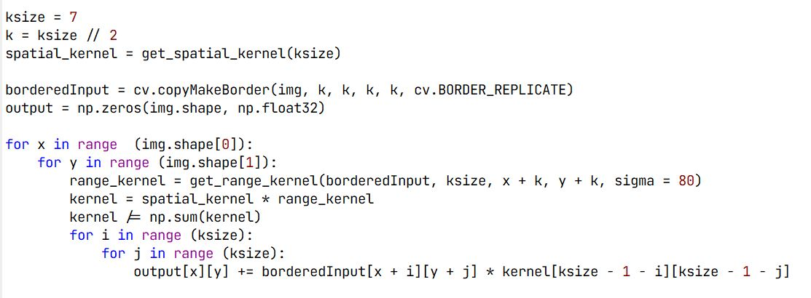

Code For Bilateral Filtering using Epanechnikov Distribution for Spatial Domain

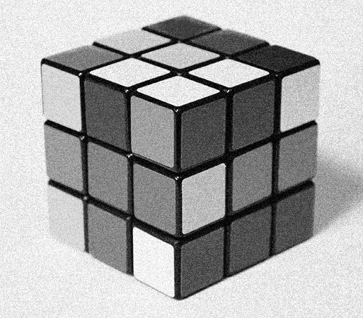

Output For Bilateral Filtering

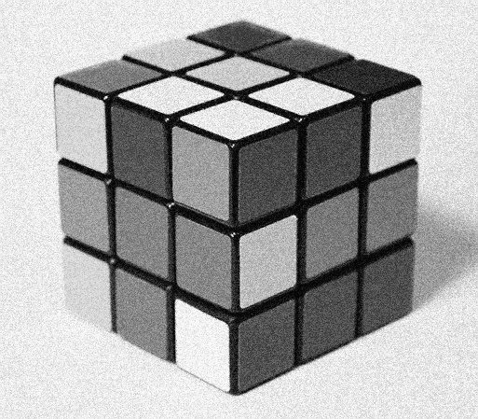

Fig 2.2: Bilateral Filtering Output

Fig 2.1: Input Image