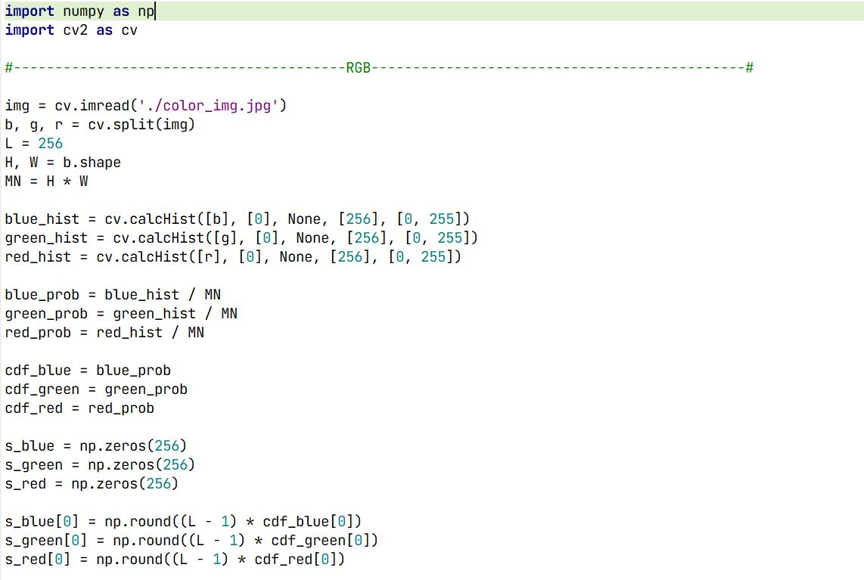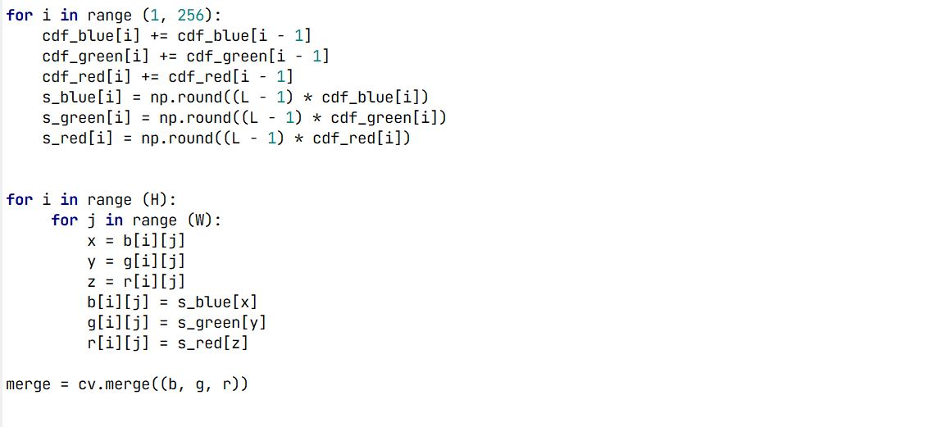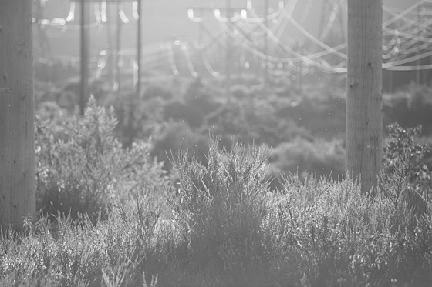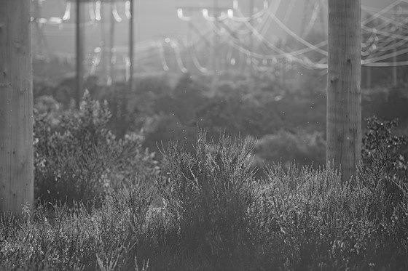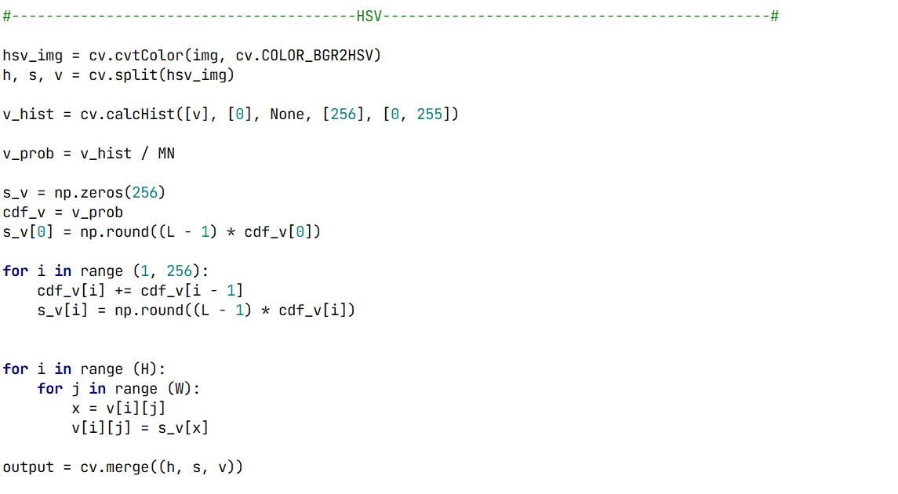

Code For Histogram Equalization

Fig 3.3: Before Equalizing Blue

Fig 3.4: Before Equalizing Green

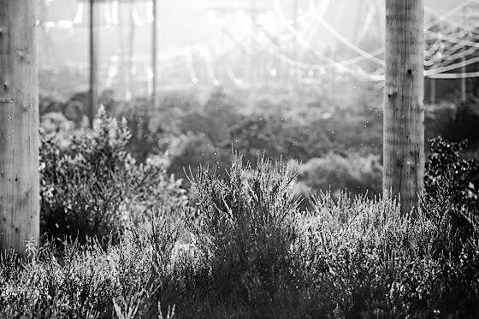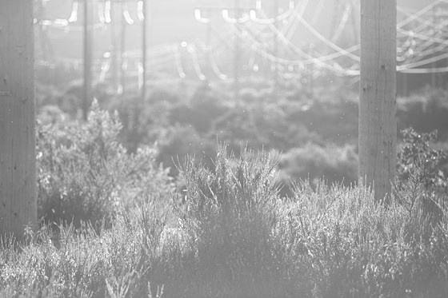

Fig 3.6: After Equalizing Blue

Fig 3.5: Before Equalizing Red

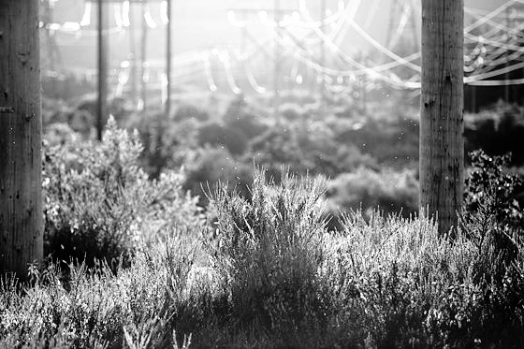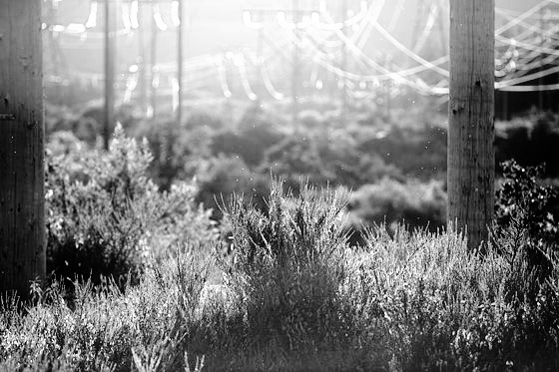

Fig 3.8: After Equalizing Red

Fig 3.7: After Equalizing Green

Fig 3.8: Input Image

Fig 3.7: Input Image

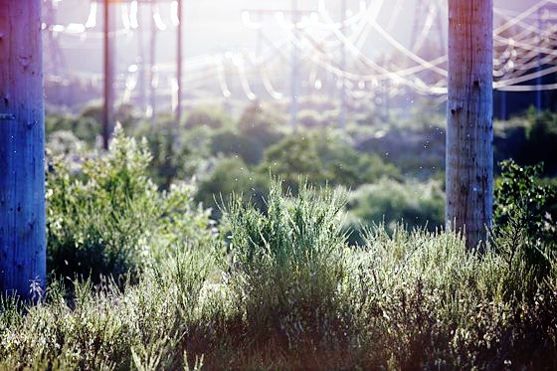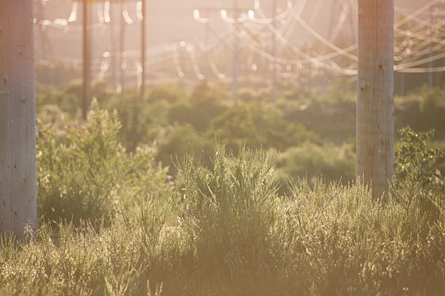

Fig 3.9: Input Image

Fig 3.10: Final Equalized Image



Fig 3.12: After Equalizing V Channel

Fig 3.11: Before Equalizing V Channel

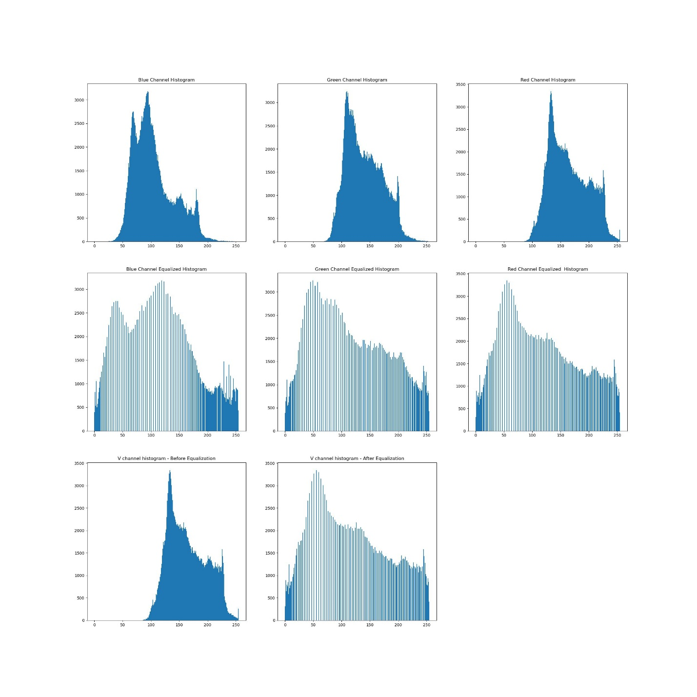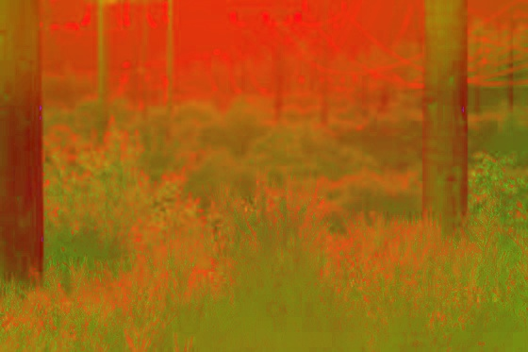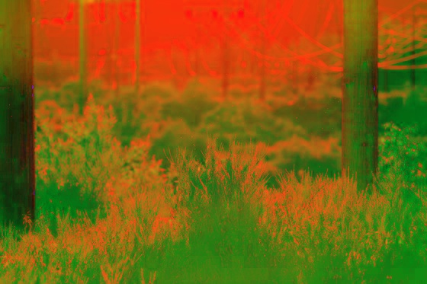

Fig 3.15: Corresponding Histograms

Fig 3.14: Final Equalized Image

Fig 3.13: Input Image in HSV Color Model

Fig 3.13: Input Image

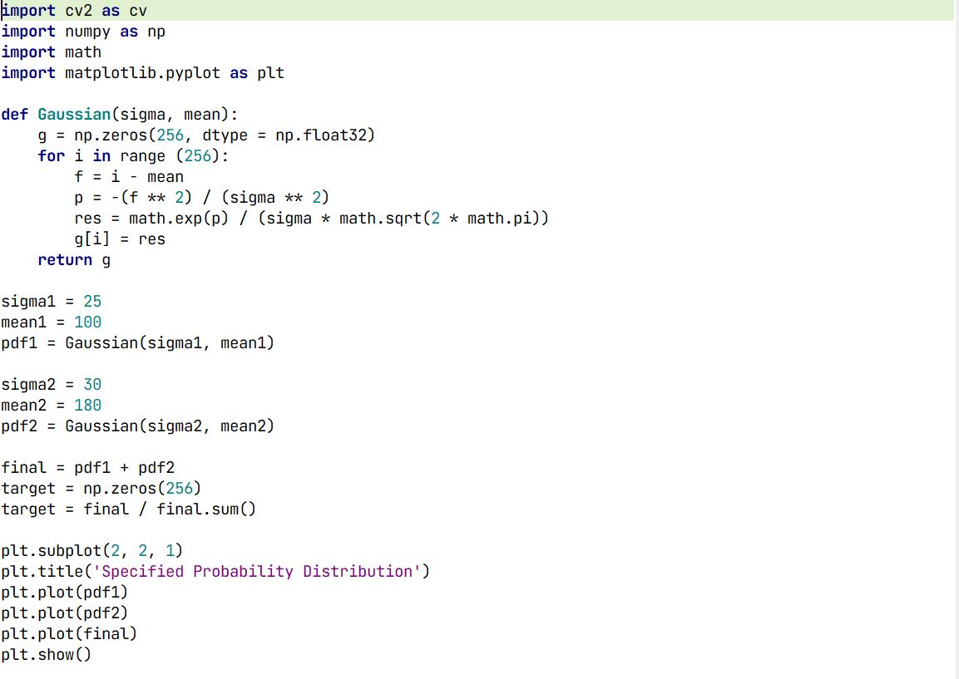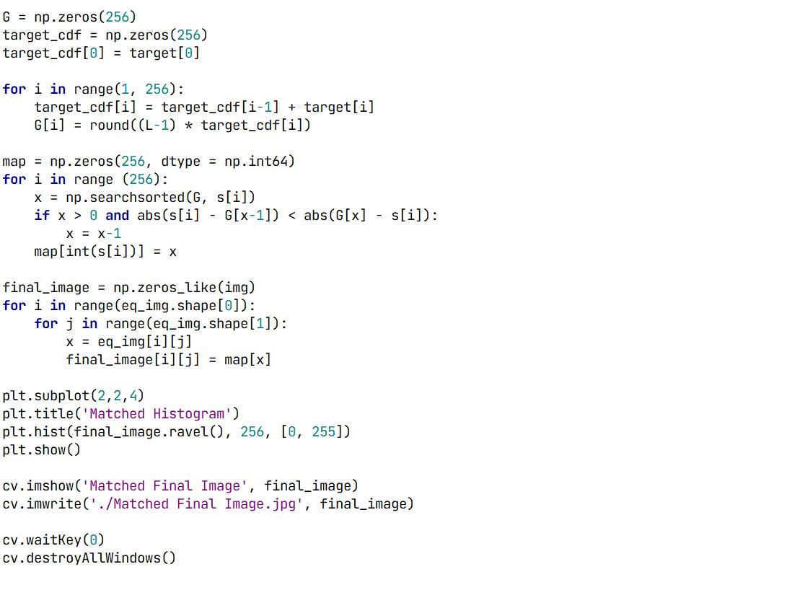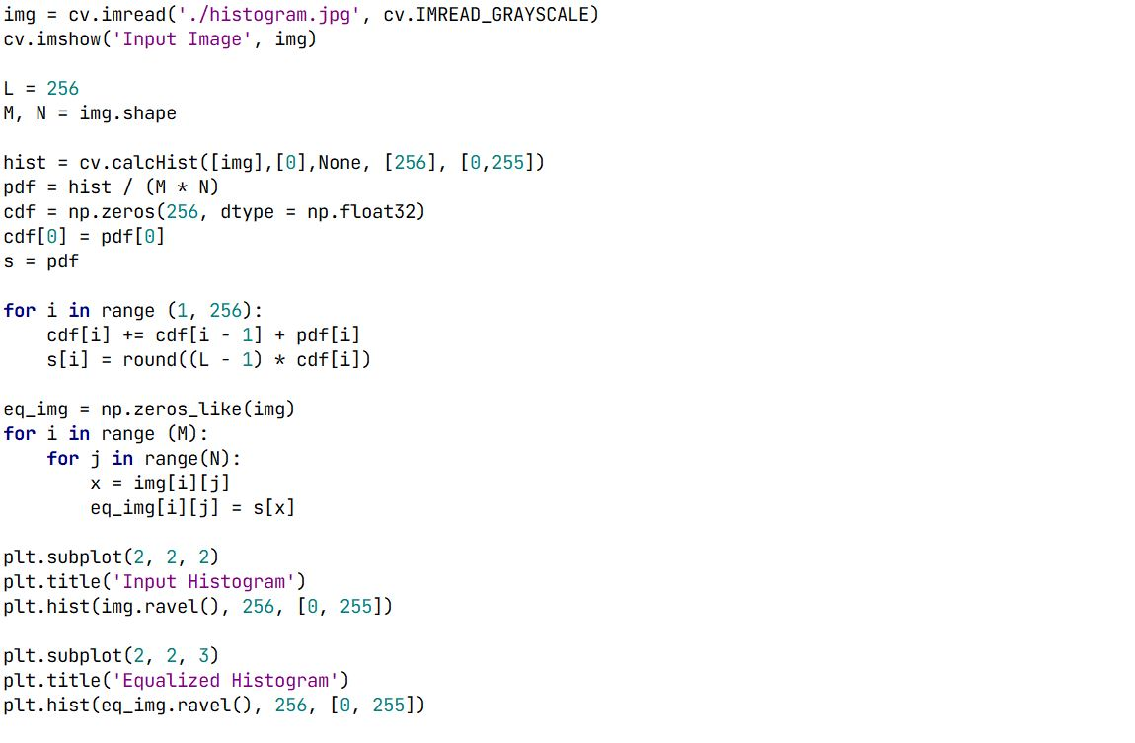

Code For Histogram Matching



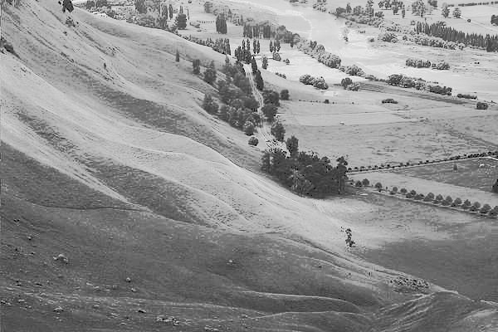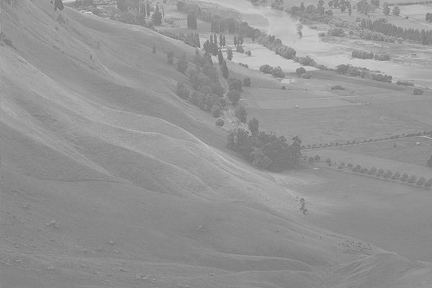

Fig 3.16: Input Image

Fig 3.17: Final Output Image After Histogram Matching

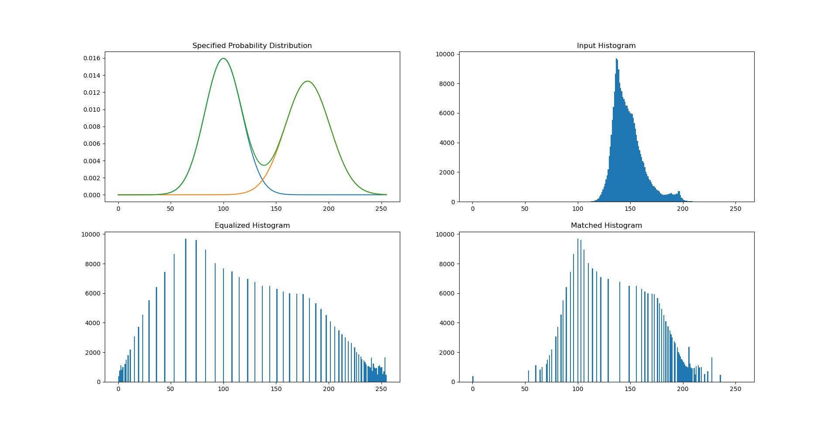

Fig 3.18: Specified Histogram and Final Image Histograms