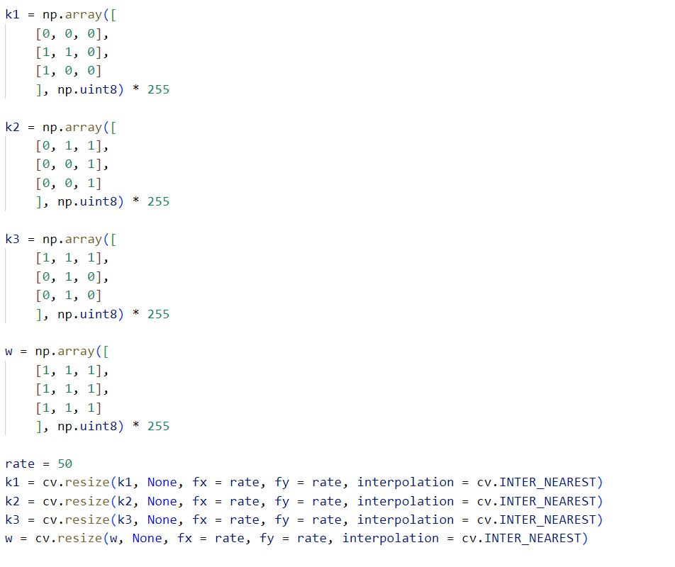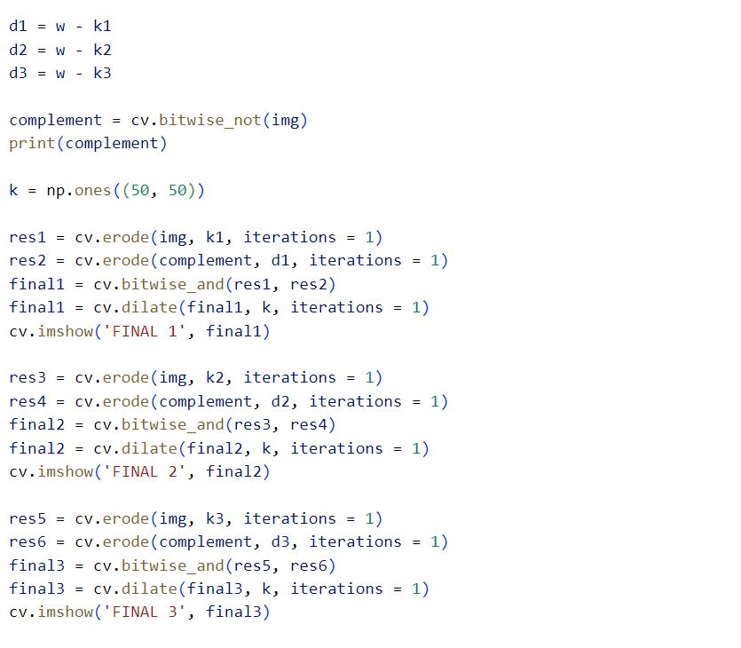

Code For Hit-or-Miss Transform

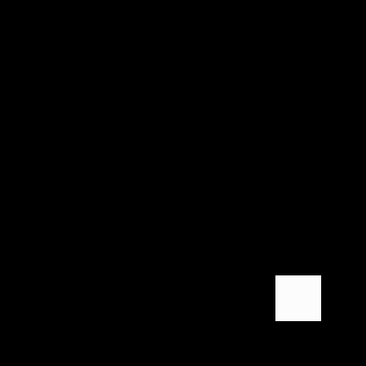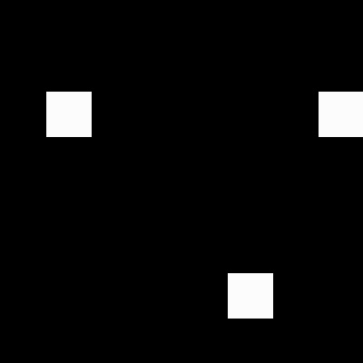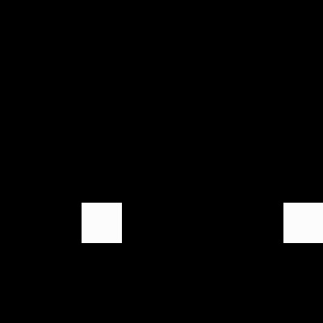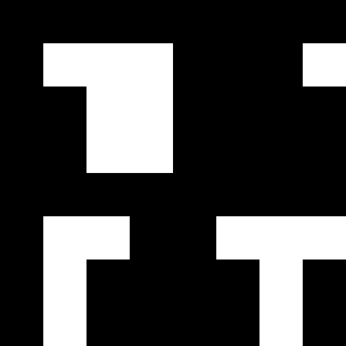

Output For Hit-or-Miss Transform

Fig 5.6: Ouput 1

Fig 5.7: Output 2

Fig 5.8: Output 3

Fig 5.4: Kernel 2

Fig 5.3: Kernel 1

Fig 5.5: Kernel 3

Fig 5.2: Input Image

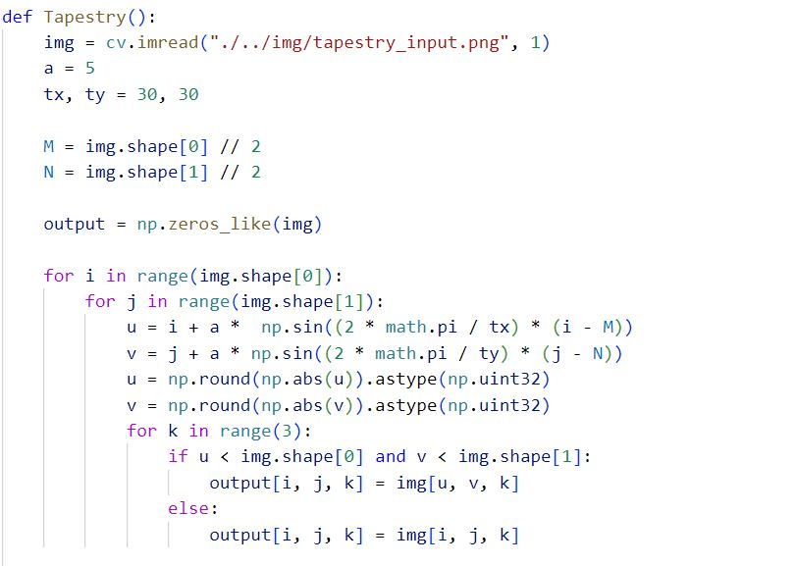

Code For Ripple and Tapestry Transform

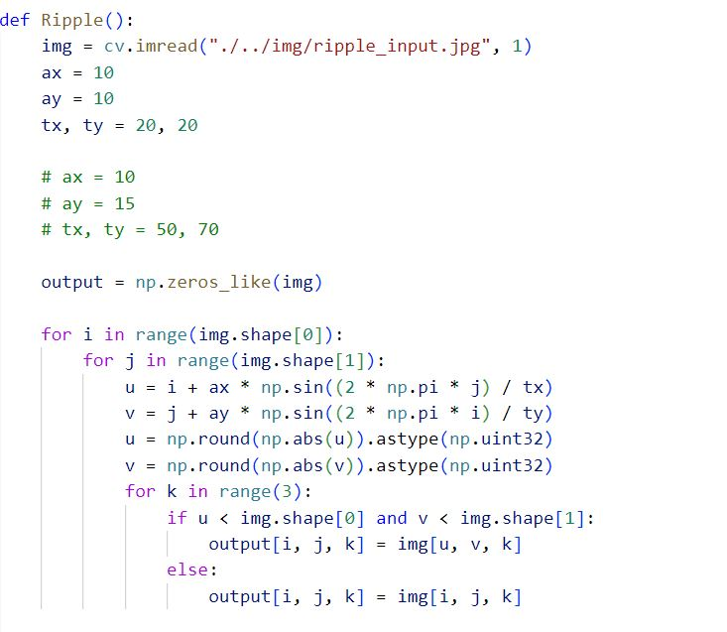

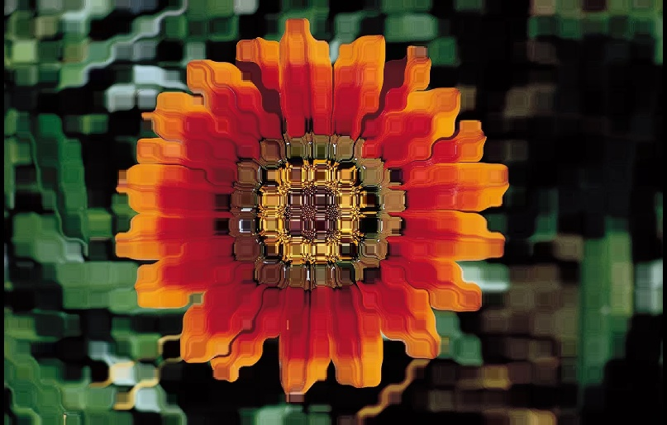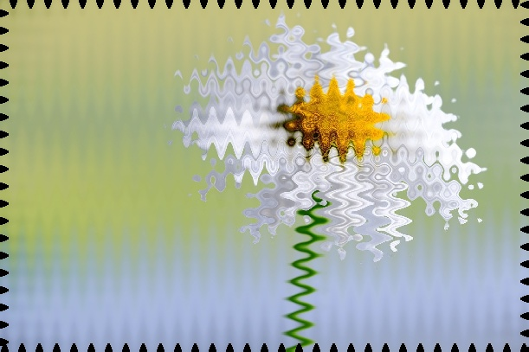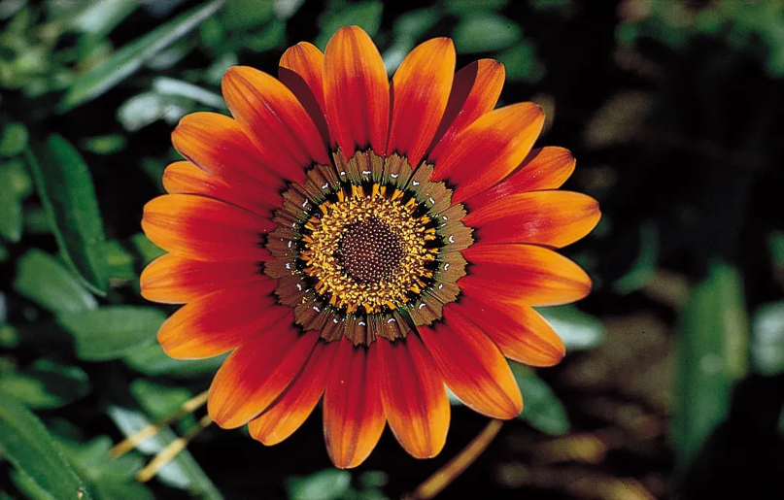

Fig 5.10: Output Image for Ripple Transform

Fig 5.12: Input Image for Tapestry Transform

Fig 5.11: Input Image for Tapestry Transform

Fig 5.9: Input Image for Ripple Transform

Output For Ripple and Tapestry Transform