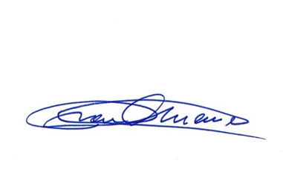**WASTE** means any waste material:

a. containing by-product material; and

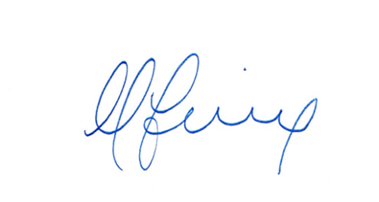b. resulting from the operation by any person or organization of any nuclear facility included within the definition of nuclear facility under paragraph a. or b.

______________________________ ________________________________

President Treasurer

Puerto Rico Medical Defense Insurance Company Puerto Rico Medical Defense Insurance Company

Countersigned by:

Name Signature Date