TERRORISM means activities against persons, organization*s*, property of any nature that involves the following or the preparation for the following:

* 1. Use or threat of force of violence;
  2. Commission or threat of a dangerous act;
  3. Commission or threat of an act that interferes with or disrupts an electronic, communication, information or mechanical system; and

When one or both of the following applies:

The effect is to intimidate or coerce a government or the civilian population or any segment thereof, or to disrupt any segment of the economy; or

It appears that the intent is to intimidate or coerce government, or to further political, ideological, religious, social or economic objectives or to express (or express opposition to) a philosophy or ideology.

**UNDERLYING INSURANCE** means all policies scheduled in Item 8 of the Declarations Page and any policies of the same insurer replacing or renewing them.

Close

**UNDERLYING LIMIT** means the per **Medical Incident** or aggregate limit of liability set forth in Item 8 of the Declarations Page for all **Underlying Insurance**.

**UNDERLYING POLICY** means the policy scheduled in Item 8 of the Declarations Page or any policy of the same insurer replacing or renewing such policy.

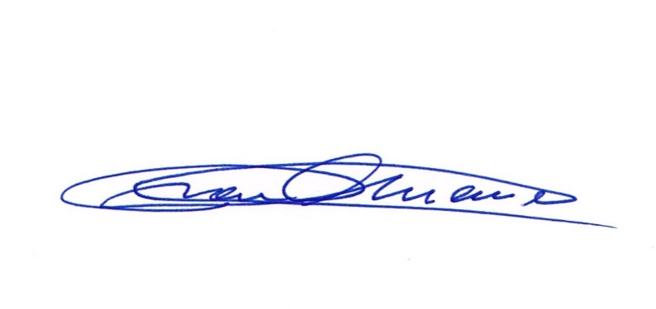

**WASTE** means any waste material:

1. 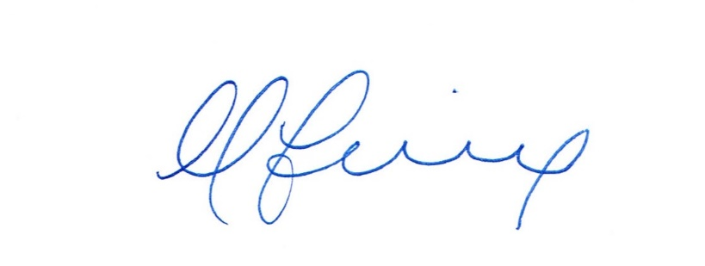containing by-product material; and
2. resulting from the operation by any person or organization of any nuclear facility included within the definition of nuclear facility under paragraph a. or b.

______________________________ ________________________________

President Treasurer

Puerto Rico Medical Defense Insurance Company Puerto Rico Medical Defense Insurance Company

Countersigned by:

Name Signature Date