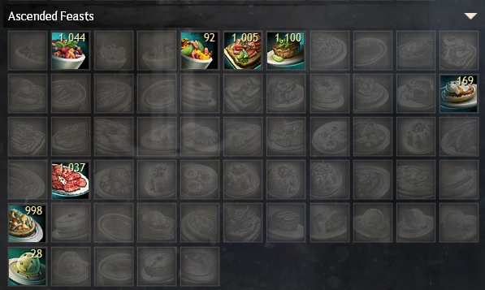

**Peppercorn-Spiced Beef Carpaccio (Power Boon)**

**Bowl of Fruit Salad with Mint Garnish (Healers)**

**Cilantro Lime Sous-Vide Steak (Power DPS)**

**Bowl of Spiced Fruit Salad (Handkiters)**

**Cilantro and Cured Meat Flatbread (Condi Damage Main)**

**Salsa-Topped Veggie Flatbread (Condi Duration Main)**

**Peppercorn-Spiced Eggs Benedict (Condi Boon)**

**Spherified Peppercorn-Spiced Oyster Soup (All Stats)**