Reltroner Studio Legal Declaration

# Project Information

Project Name: Reltroner Studio

Created & Owned by: Raidan Malik Sandra

First Publish Date: March 22, 2025

Deployment URL: https://reltroner-studio.vercel.app

GitHub Repository: https://github.com/RaidanRR/reltroner-studio

# Description

This document serves as an official declaration that all creative content, structure, assets, writings, and the name 'Reltroner Studio' (including its universe 'Asthortera', 'Reltronland', and related concepts) are original works created solely by Raidan.

All deployment, source code, and media are publicly published as digital proof of authorship.

# Ownership Clauses

* No other individual or organization has the right to claim or reproduce the name 'Reltroner Studio' without the owner's written permission.
* The first public version of this project was deployed at: reltroner-studio.vercel.app on March 22, 2025.

# Signed Declaration

Name: Raidan

Signature:

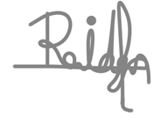

Date: March 22, 2025

Location: Depok, West Java, Indonesia