HTML – Hyper Text Markup Language
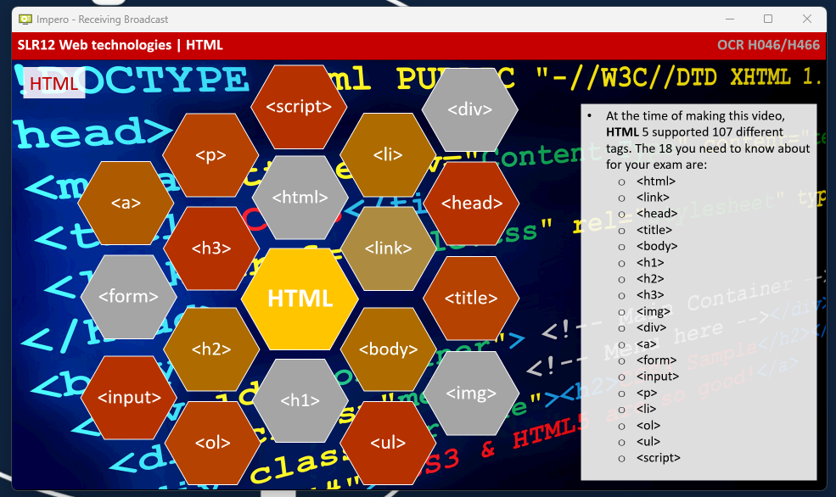
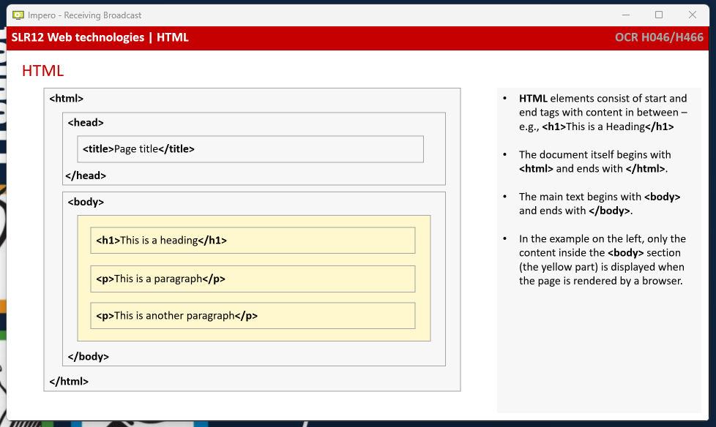

H1/H2/H3 are Headings
OL is ordered list
UL is unordered list

CSS – Cascading style sheets
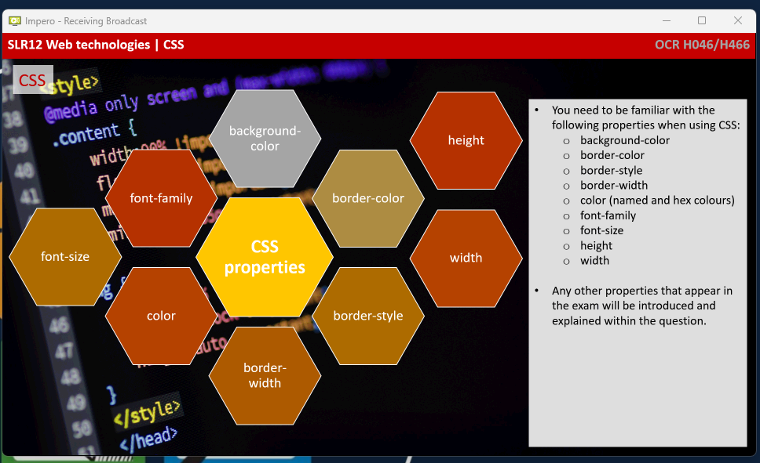

Javascript is the programming language that affects HTML and CSS.

