OCR GCE A
COMPUTER SCIENCE PROJECT
H446-03

Name: Oliver Blurton
Candidate Number: 4048
Centre Number: 28104
Title of Project: Free to Poker

Contents
Analysis 4
An outline of the problem 4
Stakeholders 4
How the program can be solved using computational thinking 6
Thinking Abstractly 6
Thinking ahead 7
Thinking procedurally 8
Thinking logically 10
Thinking concurrently 10
Conclusion 10
Research 11
Other games research 11
New features from research 13
Interview 14
Interview plan 14
Interview script 15
Interview review 16
Features of the proposed solution (Essential features) 17
Requirements 18
Hardware requirements 18
Software requirements 18
Limitations 19
Success criteria 20
Design 24
Systems Diagram 24
Explanation of each module 25
Structure diagram 27
Usability features 29
Algorithms 32
Acceptance testing 43
Test data 45
Key variables 47
Post development 53
Changelog 55
Cards Milestone 55
Card generation 55
Milestone Review / Testing 59
Ranking Milestone 61
Ranking System 61
Milestone Review / Testing 67
Comparison Milestone 70
Comparison System 70
Milestone Review / Testing 73
Betting Milestone 76
Betting System 76
Computer Decision 79
Computer Choice 83
Milestone Review / Testing 85
Graphic Milestone 89
Initial GUI 89
Player Cards Displayment 91
Bet Graphic 95
Milestone Review / Testing 96
Raising milestone 98
Computer Raising 98
Raising GUI 100
Milestone Review / Testing 103
Updated GUI Milestone 106
Chips Displayment 106
Computer Labels 107
Betting phase GUI 108
Backs GUI 111
Ranking Graphic 113
Computer Cards GUI 115
Milestone Review / Testing 116
Ending Milestone 117
Finish Function 117
Betting Backdoor 120
Milestone Review / Testing 121
Additional features milestone 123
Player Folding 123
Blinds 124
Intermediate Function 126
Computer All In 128
All In Backdoor 130
Player All In 131
RNG Adjustments 134
Milestone Review / Testing 136
Evaluation 138
Testing 138
Usability features 145
Success criteria evaluation 156
Unmet Success review 158
Future development 162
Usability features evaluation 164
Unmet usability features 166
Maintenance 166
Additional usability features 167
Limitations evaluation 171
Project appendixes 172

Analysis

An outline of the problem
For my project I am making a recreation of the game poker: Texas Holdem. This is a card game involving 2 pocket cards and 5 community cards where your goal as the player is to have a better set than your opponents, whilst strategizing how to feign your hand while deducing what sets your opponent has. You will be able to play against both real humans and bots

For this to work, the game will require card generation, a betting system involving checking, raising or calling, an evaluation system of all the potential sets that can be made, and a comparison system between one player’s set and other players set.

Stakeholders
As poker is usually a game involving betting and gambling, the target audience would be those who are legally able to do so. However, since this project is a way to play without real money, it instead will appeal to those who want to play/ practice Texas holdem and enjoy the psychological deduction without the risk of losing their own money.
I have selected a user to personify my target audience, Harry John Close, a 17-year-old student who holds an interest in card games like poker. I also have regular contact with Harry as he’s usually in the same computing class as me.
I will also be a stakeholder to determine what changes need to be made throughout the programs development. As the developer, my impact on the project will determine how long development takes, and depending on how the process goes certain features may have to be cut to get the project out in time. Also, as the stakeholder, it will be important to coordinate with the other stakeholders to ensure the project is suitable for the target audience as well as acceptable to be released with whatever server host I choose to publish with.
As this code will retain a resemblance to real gambling, it will not be suitable for all audiences. However, since this code is being made as an alternative to poker that does not ask the user to use real world money, the standard gambling laws will not apply and will not automatically be rated 18+. Because of these factors, I will make this project with a target audience of 12+. This will impact my code as I can build my code with the assumption that any user is vaguely familiar with technology, however, it is vitally important that the code be made to not encourage gambling for the 12-17. This general audience will be able to use this program as a way to play poker without having to bet real money, and can also for those who can legally gamble, it can be used as a way to practice in a risk free environment.
For a publishing site, because of the inherit nature of the program it won’t be the simplest task getting it published. Even though it is impossible to bet money, quite a few websites will reject this program based solely on the resemblance to actual gambling. Furthermore, if this project is unable to implement sufficient visuals and sound effects, it will not be of high enough quality to upload to a big publisher. As a result of this, I will choose to publish this game myself through the open source resource GitHub. This eliminates the complications caused with a gambling associated program, and the open source property does not concern me as I do not want money for this program.

How the program can be solved using computational thinking

Thinking Abstractly
I need to decide what to include/ remove from this game for it to function well. This is why abstraction is perfect for this

Abstraction for Poker:
- Remove all aspects of gambling as it would gatekeep the game as well as make it too similar to other poker simulators
- Include visuals for all 52 cards
- Add a computer thought system
- Add a menu to help users navigate the game

Thinking ahead
Thinking ahead involves planning out what you want and what will be needed, helping build structure to the code.
- I would write in python as it’s a good code to write software in and I’m familiar with it
- Inputs would involve clicking on buttons like “bet” and keyboard inputs for when a quantity of chips is needed
- Outputs will display the winner of each game, as well as what the winning hand was, the users hand, and the amount of chips won/lost

Thinking procedurally
Similar to thinking ahead, it breaks the problem into smaller problems that are easier to handle, creating better structure

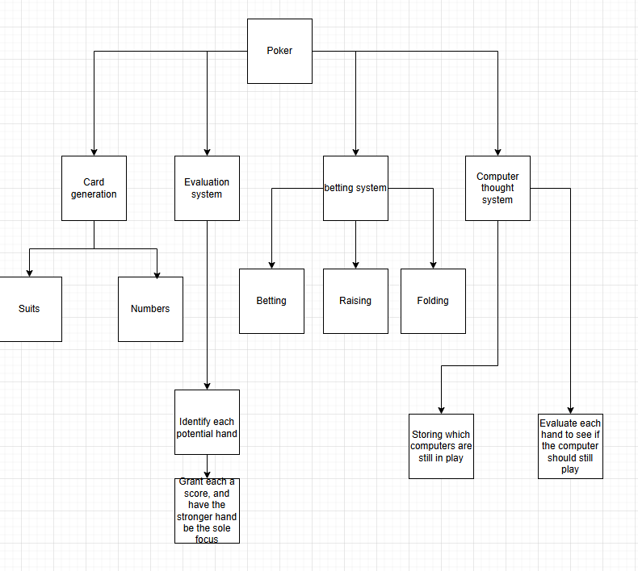

Card generation
Have the code generate as many cards as needed, determined by the number of players. Each card needs a number and a suit. There cant be 2 of the same card in one game. If the number is an 11, 12 or 13, its stored as a number but when displayed will show jacks, queens or kings respectively. If the number is a 1, then it will be displayed as an ace but hold the value of a 1 and 14 simultaneously

Evaluation system
By comparing the 2 pocket cards and the 5 community cards, the user can make a set. In order, the sets are high card (No set), a pair, 2 pairs, 3 of a kind, a straight (5 numbers all in sequence), a flush (5 of the same suit), full house (a three of a kind and a pair), 4 of a kind, Straight flush (5 concurrent numbers with the same suit)
The strongest hand able to be made will get the highest score
Theres also a minirank, where if the same set is made, then the higher minirank will decide, like 3,3 beating 2,2.

Comparison system
Once the evaluation function is finished, it stores the best hand in a record variable.
Then when the function is called again, this time with 2 different pocket cards, it determines which 2 players have a stronger hand, and stores the better set as the current winner and the record hand. This continues for all players.
This system will also exist for Mini rank, only when the scores of each set are the same
In the event of an actual tie, the game will print it’s a tie and split the pot between the tying winners

Computer thought system
The computers will need to evaluate there hand at each stage of the game and decide if their hand is worth keeping. This will be done by scoring there hand even when all 7 cards aren’t displayed, considering what they already have and what sets they could gain. There will also be aspects of rng to whether the computer will keep or fold their hand, as well as allow them to bluff even if they have a bad hand.

Thinking logically
Helps to solve the more logistical issues of the code

When the betting sequence finishes, the next cards are revealed, then the betting sequence restarts by recalling its function

Thinking concurrently
This is useful for thinking about how to make my solution more efficient when the solution is in use, such as creating all the cards at the start instead of recalling a function that makes a small amount of new cards each cycle.

Conclusion
The previous examples have demonstrated that the features of my problem can be solved using computational thinking, making it suited for a computer program. These methods are useful for giving the problem some structure, and hence making it easier for me to solve
If all problems are solved, then stakeholders will be able to play a full recreation of poker, with added computer opponents and removing the need to gamble.

Research

Other games research
Going into this project, there were a few main concerns with the programming that needed solving. The first of which was how the cards would be ranked, with the 5 central cards and all the different players 2 unique cards. For this, I looked at pokerstars handles it’s evaluation of cards, and what they do is wait until after all betting Is complete to evaluate the hands, only looking at each players 2 cards mixed with the 5 universal cards, making the best hand out of that, then moving onto the next players 2 unique cards. I also looked at how Balatro evaluates it’s hands, in that game you can select up to 5 out of 8 cards, and the ranking of the cards you select is updated dynamically.
For my code, I used the model provided by poker stars as their system of only evaluating at the end falls more in line with what I need out of my code, as the dynamic updating from Balatro is both unnecessary when you are always selecting 7 cards, and would be far beyond my programming abilities to implement. 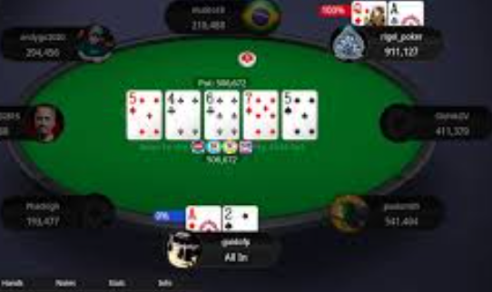
My next problem was determining how I would want to display my cards once I moved to a GUI. In Poker stars a very simplistic art style is used, and all the cards are positioned around a table, with the universal cards being in the middle of the table and each players 2 unique cards being at each “seat” on that table. In Balatro, the art style is very pixelated as that game leans into its indie attribute, and it displays its cards by keeping all of them in a row at the bottom, then bringing them up to the center when they have been selected. These cards are also a lot more animated than poker stars.
For my code, I wished to use a similar art style to Poker stars as its simplicity is more fitting for this project, and I wish to emulate the prominence of the universal cards that Poker stars uses. I also want to use attributes from Balatros visuals, having your own cards be prominently displayed. If possible, I would also like to include the light animations that make Balatro so visually appealing, although it may be outside my abilities as a programmer.
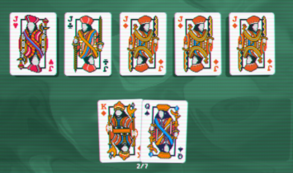
Next, I wanted to determine what would happen when a player had finished a round. Obviously, their chips would be affected by the pot, but I also needed a frame of reference of how to display that information, as well as congratulations for the player on their victory. Neither poker stars or Balatro were useful comparisons, as Poker stars makes its wins feel good with the real world money that is earned, and Balatro will simply move you on to the next round after winning a round in that game. What I chose to look at was older, simpler games where the gameplay consisted of rounds, and I ended up choosing “The worlds hardest game”, an old flash game. Here, the game will congratulate the player after passing a round, but will not tell the player anything if they lose, letting the player retry faster.
For my code, I chose to use this simple structure, telling the player they had won on their victory, and if they lost the focus would be on the other players victory rather than the players loss.
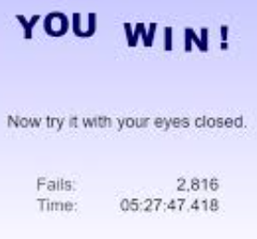(Worlds hardest game win screen)

New features from research
Feature | Justification | Implementation
Card ranking only happening at the end of a round. | Having the cards be ranked dynamically like Balatro is both unnecessary for the project and will be difficult to implement. | Only rank the cards once at the end, after all betting phases are complete.
Card displayment focussing on the players cards more than the computers. | Makes it easy for the user to understand which cards belong to them and which don`t, as well as making the UI have a predominant feature to work around | Keep the users cards predominantly displayed, the universal cards on display but less prominent, and the computers cards in an openable list on a side.
Victory screen in support of the player. | Focussing on the players victory rather than defeat creates a better feeling for the user than the alternative. | Focus on the winner rather than the players loss, and only display information necessary to the user.

Interview

Interview plan
This interview will be constructed to find the wants of the user and will give direction to how the code will be built. These questions are being tailored to Harry, a person already familiar with Card games like poker
The main three headings for this are, what makes normal poker good, what type of visuals should the game use, how important is multiplayer?

What makes poker good
-What introduced you into poker
-Why do you think it’s so popular
-What’s your personal favourite aspect
What visuals should the game use
- What do visuals on other poker games add to the experience
-Should a recreation of poker try to be as lifelike as possible, or aim to embrace that it’s on a device

How important is multiplayer
- What would local multiplayer add to the experience
- What would online multiplayer add to the experience
- How important is it that the game be able to be played offline with bots

Interview script
What makes poker good
-What introduced you into poker?
Seeing Poker matches played online
-Why do you think it’s so popular?
How easy it is to understand yet so difficult to master, as well as the potential to win money
-What’s your personal favourite aspect?
The feeling when you outplay someone by bluffing, especially when winning a large amount of chips

What visuals should the game use
- What do visuals on other poker games add to the experience?
In Balatro, it helps the indie and relaxed feel of the game. In PokerStars, it makes the user feel they are playing the exact game of poker as if they were sitting around a table
-Should a recreation of poker try to be as lifelike as possible, or aim to embrace that it’s on a device?
Since this isn’t trying to put a spin on the game like Balatro, it may be good to stick with realistic visuals. However, a different art style would help give the game distinction

How important is multiplayer
-What would local multiplayer add to the experience?
Allows friends to play with each other without physical cards and without gambling
-What would online multiplayer add to the experience?
Online multiplayer would allow users to play against other thinking humans easily, however, it would be much more difficult to difficult and maintain
-How important is it that the game be able to be played offline with bots
It allows players to get a feel for the game before heading online, and serves as a good way to practice even when internet isn’t available

Interview review
This interview was performed to see what the stakeholder believed would elevate this game to make it better

For visuals, we agree that a distinctive art style is good, so the style will be revolved around vintage cards to keep it classic but distinctive
For multiplayer, we decided to incorporate local multiplayer as well as Playing against CPUs, however since this is a small-scale project expecting an online player base to be maintained is too unrealistic, and so will be omitted.

Features of the proposed solution (Essential features)
Feature | Explanation
Betting | Putting chips into the pot to make the other players give you a bigger reward.
Pot | Acts an indicator for how many chips are able to be earned.
Folding | Putting yourself out of the game so you don’t have to waste chips.
Checking | Keeps the player in game without having them commit chips.
Buttons | Easy way to have the player navigate the program.
Independent thought process for computers | Having the computers make decisions based on what cards they have keeps the game from becoming stale, and forces the user to play better as the computers will be trying to win.
Simplistic art style | The program is trying to appeal to a broad audience so having a simple art style helps keep people in.
Alternate card colours | Helps with colour blindness and gives this version of poker it’s own distinction.
Looping | Have the game reset to the first betting phase to ensure the player feels rewarded for a win by having their chips carry over to the next round.
Main menu | Creates a link between loading the program, starting a game and gives the program a place to send the user if they lose.
Mouse controls | Intuitive to use for any user.

Requirements

Hardware requirements
Since the game will be using simplistic art, it will not be graphically challenging and therefore will be available on any modern device, excluding consoles as using a controller to play poker would be too slow to be fun.
Hardware | Justification
Monitor | To display the visuals of the game back to the user.
Mouse | To let the user interact with the game by allowing them to click what is on screen.
Touch screen | If this game becomes playable on mobile devices, a touch screen will be necessary for users to interact with the game.
Speakers | If I ever give this game sound design, the hardware will require speakers for the player to hear it.
20mb of secondary memory space. | This game is not very complex and does not need much to render, the only concern being storing 52 images of cards which should not be too demanding since each cards size will be small.
2GB of ram | Even the lowest end computers have at least 2GB of ram so any functional computer will be able to play.
33 MHz processor | This is the minimum processing power required to run this software,
Keyboard | Allow inputs from user where a single button isn`t sufficient i.e. a number for betting.

Software requirements
Software | Justification
Python language | Needed so the user can run the code
Operating systems: Windows, Macos, Vista, Linux | One is needed to download Python. All versions of these Operating systems are compatible with python.
Python Libraries | Allows for RNG as well as potential UI elements to be functional in my program, and will be necessary on the clients side to run properly.

Limitations
Requirement | Justification | Limitation
Local multiplayer | Would add more ways to play this game with friends. | It is impossible to show each different user’s cards on the same screen without seeing each others cards.
Online multiplayer | Would add more ways to play this game with other people. | I am not familiar with how hosting an only server would work and since I have other A levels to work on, I don’t have to time to learn.
Tutorial | Would give new plays an easier time learning how to play. | Writing up and then displaying the tutorial would be incredibly time consuming for an A level student.
Animation | Would make the game smoother to look at. | Learning and developing unique animations would be far too time consuming for me as an A level student.
Sound design | Would enhance the gameplay experience. | Creating and implementing these unique sounds would be far too time consuming for me as an A level student.

Success criteria
No. | Requirement | Justification | How to observe implementation (If implemented)
1 | Start up screen. | Gives the player a way to ease into the program. | Will be visible in game.
2 | Display player chips. | Lets the user always know how many chips they have left to play with. | Will be visible in game.
3 | Display computer chips. | Lets the user use the opponents remaining Balance to their advantage, without having to count the chips each individual computer had made. | Will be visible in game.
4 | Display Pot. | Lets the user know how many chips they can potentially win. | Will be visible in game.
5 | Helper sheet. | Lets the user see which hands are stronger than other hands, helpful for newer players who haven’t memorised which hands beat other hands yet. | The button to bring up this sheet will be visible in game.
6 | Player determines how many computers to play against. | Creates variety, as playing against different amounts of players changes how the player acts. | The option to choose players will be visible for the player.
7 | Betting rounds. | Allows all players to make bets, and to give each player a choice to call a bet, make it bigger, or fold. | Will be visible in game.
8 | Game looping. | Allows the game to be immediately replayed, with the amount of chips and amount of players being transferred to allow smooth gameplay. | The button for this feature will be visible at the end of a round.
9 | Game exiting. | Brings the program back to the start screen, resetting Balance and Computers to let the user replay if they lose without closing the tab. | The button for this feature will be visible at the end of a round.
10 | Checking. | Lets player skip their turn and not put any chips in. | The button for this feature will be visible during a round when allowed.
11 | Betting. | Putting a Bet into the pot and making all other players call it. | The button for this feature will be visible during a round when allowed.
12 | Calling. | Putting the same chips into the pot as a previous bet. | The button for this feature will be visible during a round when allowed.
13 | Raising. | Calling a bet, then making a bet of your own. | The button for this feature will be visible during a round when allowed.
14 | Folding. | Allows players to not need to put any more chips into the pot, in exchange no longer being able to win the chips in the pot. | The button for this feature will be visible during a round when allowed.
15 | All in. | Allows players to put in all their chips, and lets them skip making any further Betting choices. | The user will be told through labels if either they or another player have gone all in.
16 | Buttons. | Every choice not involving a number will use buttons, as they are intuitive to use and I can control where the player will go after pressing one. | Will be visible in game.
17 | Textboxes. | Inputs the computers and bets with textboxes, as there are too many options to be reduced to Buttons. | Will be visible in game.
18 | Displaying computers cards at end of round. | Lets the user see what cards the computers had, letting them understand why the computers took the actions they did. | Will be visible in game.
19 | Display what type of hand every player has. | Lets user easily see the strength of every computers hand without having to calculate it themselves every round. | Will be visible in game.
20 | Display who won predominantly. | Makes it clear at the end which player had won and will receive all the Pot’s chips. | Will be visible in game.
21 | Optional tutorial | Lets new players know how to play while not wasting the time of players who already know how to play | The button for this feature will be clearly visible in the main menu.
22 | Blinds. | Emulating poker, and encourages more aggressive play | Info about the blinds will be told through labels.
23 | Increasing blind size throughout a game. | Encourages more aggressive play the longer a game goes on, increasing excitement. | Info about the blinds will be told through labels.
24 | Bluffing on computers. | Stops the computers from being too predictable. | The player will be told with labels if a computer won through bluffing,
25 | Hide cards of players who folded. | Emulates real poker, gives a bigger incentive to fold. | The UI will only show the cards of those who won, and not show the cards of those who didn’t win.

Design

Systems Diagram
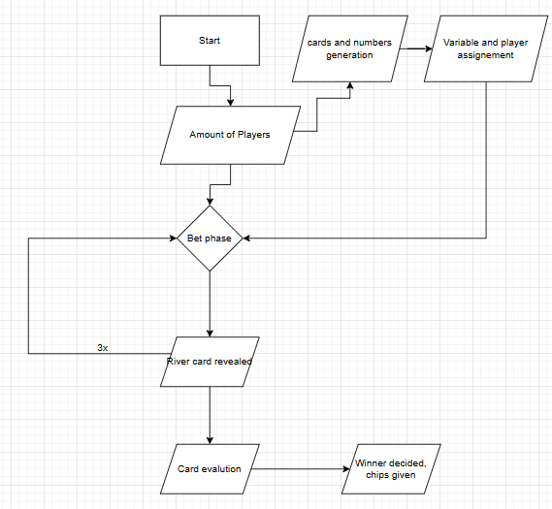
Using a simplistic Diagram structure ensures that the essentials of the program are prioritised while allowing solutions to each problem can be solved without worry of impacting other parts of the program.

Explanation of each module
Amount of players
The program immediately needs to know how many players is in a round, as this allows it to generate the correct amount of cards based on the total player count. There is a player minimum of 2 and maximum of 23

Cards generation
Generates a random suit and a random number between 1 and 13, then combines these numbers into a single variable that gets added to an array. If that exact card is already in the array, it regenerates the card until its unique. This is why the player count must max at 23, as with 24 players it’s impossible to have enough unique cards.

Variable and player assignment
After generating the array cards with numbers 11 12 and 13 get converted into their poker name equivalent, so jacks for 11 queens for 12 and Kings for 13. Then each player gets to see their 2 cards written as (Rank) of (Suit)

Bet phase
Players can choose to check or bet after seeing their cards. If a bet is made by anyone, every other player must choose to match that bet, raise that bet, or fold and give up. CPU players are capable of betting.

River card
After betting, the river cards are revealed. On the first cycle, 3 cards are revealed, then on the second and third cycle 1 extra card is revealed each. These cards can be used by any player, and are added to each player’s personal array.
Card evaluation
After everyone has finished betting, each players cards are sent to the evaluation function, where 5 river cards and their 2 pocket cards are put into an array, and are check to see if that array contains any poker hands, such as pair or flush.
Winner decided
After a player makes a hand, the value of their hand is stored in variables like Rank and Minirank, then their name is put as the variable “winner”. After the next players hand is scored, it compares the values of Variables like Rank and Minirank, and if they are determined to have a stronger hand, their player id replaces the old winners ID, and the Rank variables get updated with what the winner had.
After all players are compared, the winner gets chips that were accumulated through the game, and stores that value in a list that gets carried between games.

Structure diagram
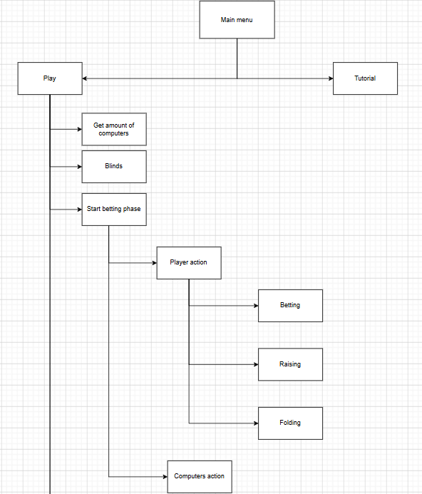
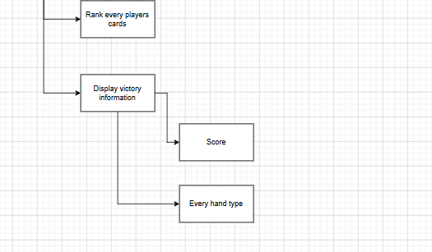

Main menu
Display basic introduction info and give the option of going into either a tutorial or the main game
Tutorial
Display the basic rules about poker and have the player always able to link back to the main menu
Get amount of computers
The program will ask the user for how many computers they want to play against, with validation.
Blinds
The program will deduct balance on 2 players who are part of the blinds, then will tell the user which player has first action.
Start betting phase
The player of first action has the choice of calling, raising or folding.
Player action
The user will have 3 buttons of calling, raising or folding. Calling passes action to the next player, raising asks for an input with validation, and folding will have the players action be skipped for future betting rounds.
Computers action
Computers will evaluate how strong their hand is based on how many cards they can see, then make the same actions as the player.
Rank every players cards
Every players cards will be given a score based on if they contain a poker hand i.e. pair or straight.
Display victory attributes
The winner, along with how many chips they won, will be displayed, as well as the cards and hand type of every player who hasn’t folded.

Usability features
Below are several images from other poker related games that will be used as a reference for my user interface

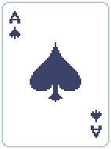 (The ace of spades from Balatro)
Each of the 52 cards will have a distinct visual about which suit and rank they are.
They will be pixelated like in Balatro but will not re use the same card models
As well as this, the suits of the colours will be different from the standard. Usually, spades/clubs are both black and hearts/diamonds are both red, making identifying them harder than it needs to be. To rectify this, clubs will be coloured a light green and diamonds will be coloured a light yellow.
Also, when card games use non standardised card colours, usually diamonds end up being a light blue. I have picked yellow as it relates to diamonds more than blue does, as well as I personally believe diamonds look better with yellow than blue

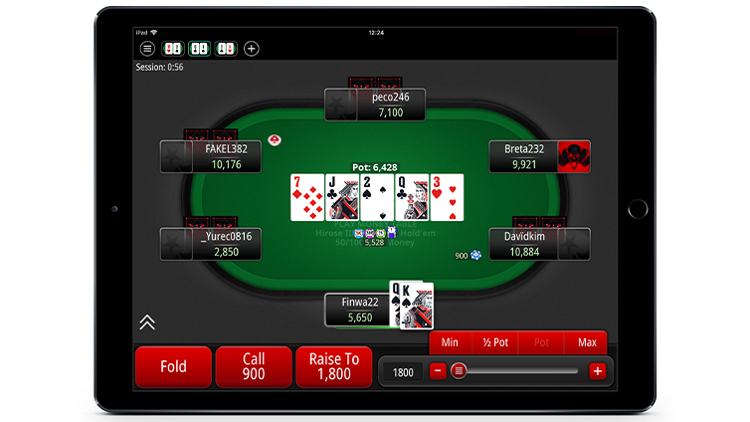
(From poker stars)

The in-game User interface will be similar to what poker stars uses, as it is a very concise way of displaying all the necessary information whilst ensuring everything looks nice.
There will be a call button and a bet button, however the option to bet to any value will be manual and will require users to type how much they want to bet.
The cards you can use will still be predominately displayed, but since this game will use more stylised pixel art, there might have to be slight alterations to the other aspects of the user interface to ensure everything feels natural and good to look at.
Lastly, since this project allows up to 22 players, and therefore will be very hard to recall what each player’s action was, each player’s action will be record next to their name, in an openable list.

Feature | Explanation | Justification
Distinct visuals on each card. | Every card will very clearly display both what suit and which rank it is. | Helps even those with weaker vision to identify the cards.
Pixelated card art. | Every card will have a distinctly pixelated “indie” look. | Easy for the user to interpret the cards.
Alternate card colours | The diamonds and clubs with be yellow and green respectively. | Helps with colourblind issues and makes spades/clubs and hearts/diamonds more distinct.
Poker stars User interface. | The Ui will be built in a way that resembles but not copies Poker stars. | Basing my UI on a priorly established successful site will ensure quality in mine.
Call/Bet buttons | Calling, betting and other similar actions will be attached to buttons. | Impossible not to understand how to call/bet.
Scrollable list | There will be a button to press that brings up each computers action or cards. | With large amount of computers, displaying the information otherwise would create too much clutter.
Action records | The most recent action of each computer will be displayed. | The player will know what each computer did without having to calculate it themself.

Algorithms
Overall structure
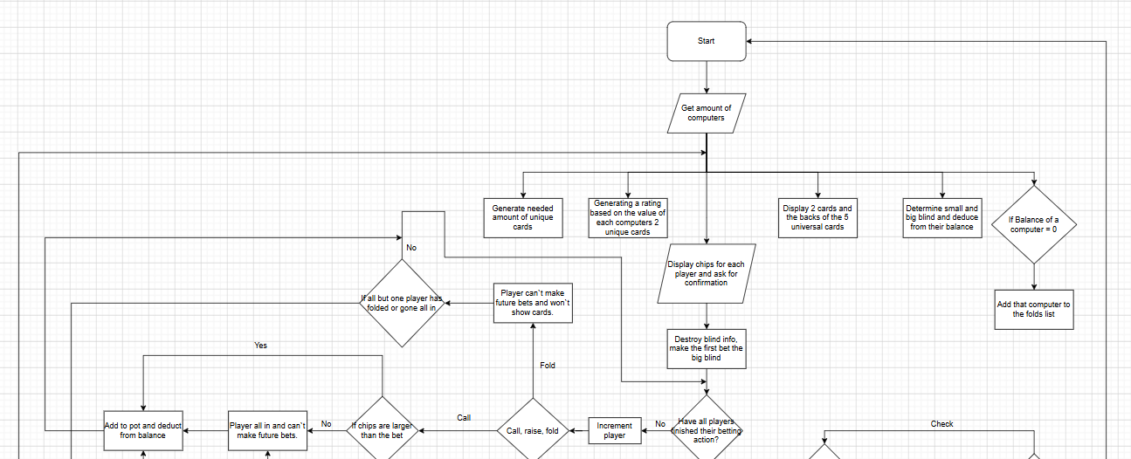
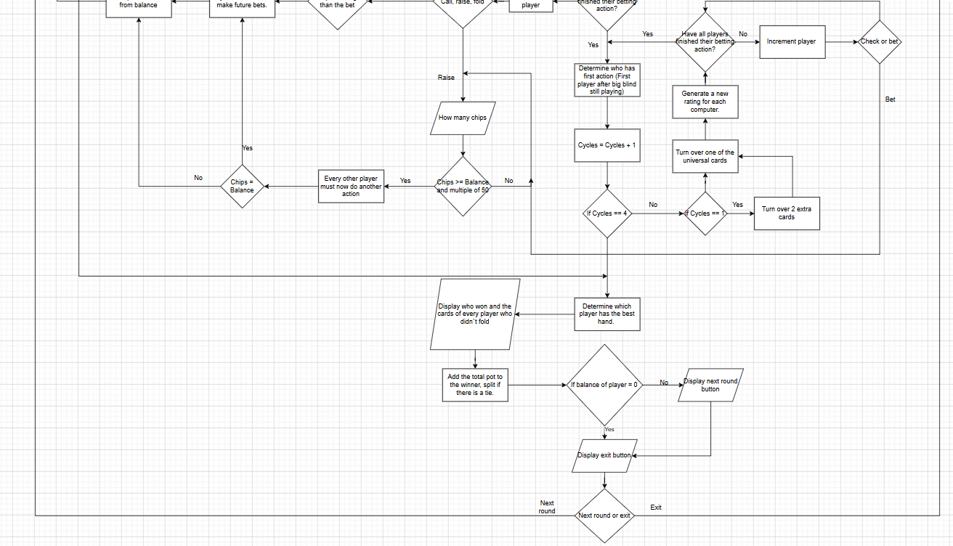
The program will follow this overall structure, going from the start and working through each potential betting phase. I have used this top down structure as it lets me sort through problems one and by one while allowing me to add new functions if I find it necessary during development.
Start()
Input the number of players that will be playing this round, with boundary checks.
Open a text file to determine if the player needs an injection of chips, so they won’t be stuck on 0 chips if they lost.
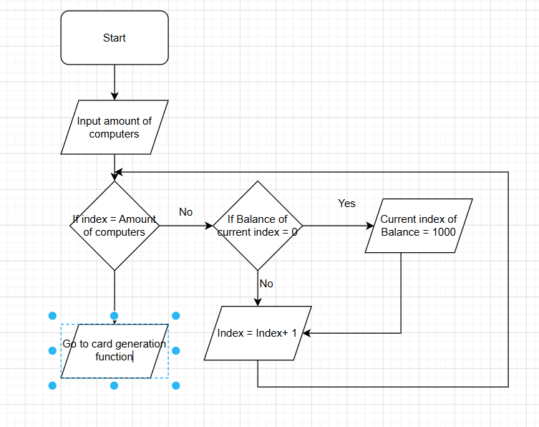

Cards_test()
Generate a random number and suit, then combine both into one variable.
Add that variable to the list “Cards”. If that exact card is already in the list, then re-run the function and don’t add it to the list
The number will have to be made into a string so it can be concatenated with the suit.
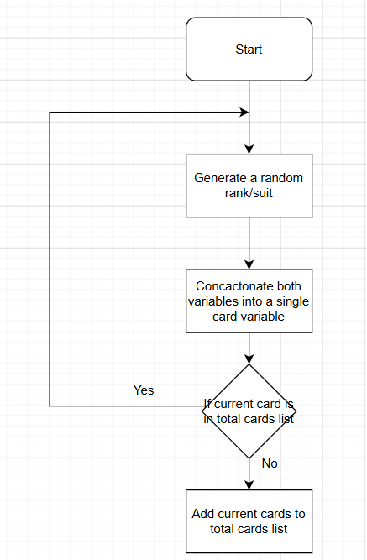

King_maker()
Before being added to the list, the number will be made into its poker equivalent.
Whatever number that needs to be checked will be written in the variable called “Placeholder”
The function will check whether the variable “Placeholder” is a 1, 11, 12 or 13. It will then overwrite the variable placeholder with either “Ace”, “Jack”, “Queen” or “King” respectively.
Lastly the variable that gave placeholder its value will be overwritten with the value of placeholder.
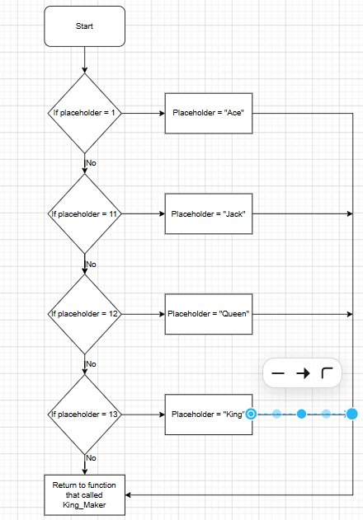

Bet_()
Two players will put in a big and small blind, as how poker works.
The First player of action will be given the choice to call the blind, fold or raise the blind.
After making any decision, the next player gets to make their decision.
If any player folds, their player id gets sent into a list. Later, that list will be used to determine who’s still in the game, and who’s results need to be processed.
If any player raises, then the cycle will repeat back until the player before that who made the bet, therefore every player will have to put the same amount of chips in, or folded before that.
Any bets made will be added to the variable “Pot”, affect by all players.

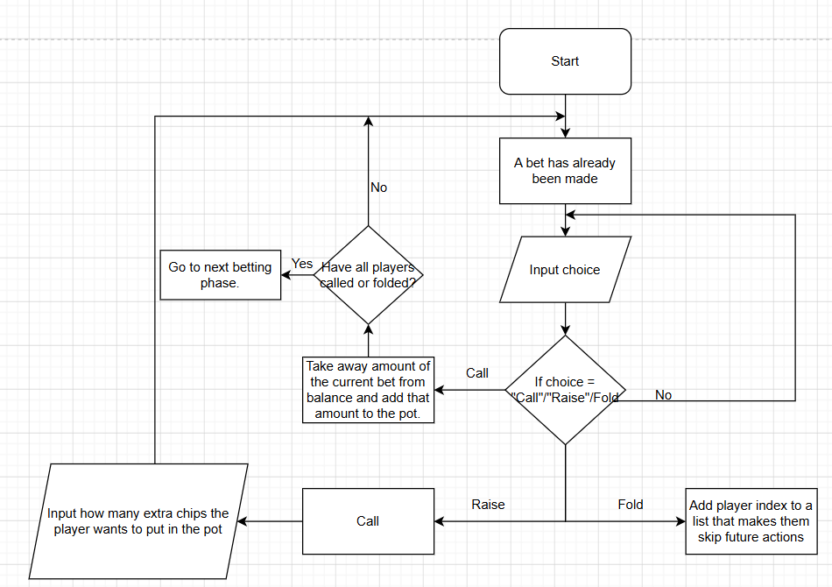

Computer_Thinking()
The computer players will be given the ability to decide whether they should keep playing with the cards they have or not.
This is done by evaluating the cards each computer has in a list.
By using the variable “Cycles” which determines how many river cards have been revealed, we can make lists using each player id’s cards and the river cards.
By conducting individual rating tests on each list (I.e. seeing if the first 2 cards are a pair or if they have 4/5 cards for a flush before the final card is revealed), the computer is given up to 100 points. Points will be given out in a randomized range depending on the strength of their hand.
There will be randomness to the behaviour of these bots, as to ensure a player can’t figure out easily the strength of a computer’s cards. They will be capable of bluffing as well, pretending they have a strong hand when they actually have bad cards. If a computer bluffs, it will have a high chance to continue to bluff, but the more chips it must put in, the higher chance it will fold instead. Bluffing will overwrite other systems of thought but will be rare for computers.
A computer will not be able to fold if it has one of the best hands possible.
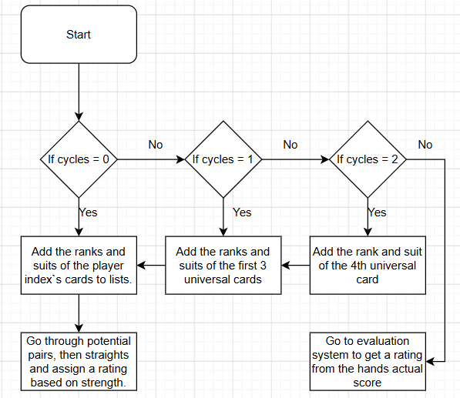
Evaluation_system()
Makes two lists of the players cards to be evaluated, one for the suits of the cards and one for the rank of the cards, by using a for loop to call this function. Since this function is being called inside of a for loop, we can use i to determine which values from the Suit_list and Num_list to pull from. Finally, both lists are sorted alphabetically/numerically.
Once the lists are made, the program checks for each of the poker hands (Pair, two pair, Three of a kind, Straight, Flush, Full house, Straight flush, Royal flush):

High card
No set can be made, the value of the hand is just whatever the highest ranked card is
Pair
Using a for loop, check if a number in the list is the same as the next number in the list

Two pair
Use a variable “Counter” that increases after a pair is found. If Counter is greater than 0, and the number isn’t the same number as the previous pair, then the hand is scored as a 2 pair instead.

Three of a kind
Using a for loop, check if a number in the list is the same as the number 2 ahead in the list.

Straight
Use a library to remove duplicates from the number list.
Then using a for loop, check if a number in the list + 4 = the value of the number 4th ahead in that list. So, if the list was [3,4,5,6,7] the program would do 3+4, then see if the 4th value after that was 7.
If the list is too small due to removing too many duplicates, then the for loop is not run
If there is a 1 in the list, then the temporary list is appended with a 14, as the value of the ace is simultaneously a 1 and a 14. This double value usually doesn’t come into effect until the ranking systems; however, it must be accounted for early here as otherwise hands that are straights wouldn’t be identified as such

Flush
Using a for loop, check if Suit_list[i] = Suit_list[i+4].
If they are the same, then there are 5 consecutive suits in the list, and therefore the player has a flush

Full house
Check if both a pair and a three of a kind was scored. Check they are different values by storing what rank the pair was, and if it’s the same rank as the three of a kind.
This must be done after two pair, as every full house will have a two pair in it, and the only way to distinct them is by scoring it as a two pair first, then overriding the variable score with the value given from a full house

Four of a kind
Using a for loop, check if a number in the list is the same as the number 3 ahead in the list. Some parts of the code are harder than others.

Straight flush
First, check if both a straight and flush has been made with that hand.
Remove duplicates from the number list again, except this time remove the value in the Suit list corresponding to the removed values, so if the second value in the number list was removed, then the second value in the suit list will be removed.
If Num_list[i] + 4 = Num_list[i+4], then check if Suit_list[i] = Suit_list[i+4]
If both conditions are true with the same value of I, then the hand is a straight flush
Royal flush
Same as a straight flush, but if the last value is 14, then it is given a higher score, used to given distinction to the strongest hand in poker.

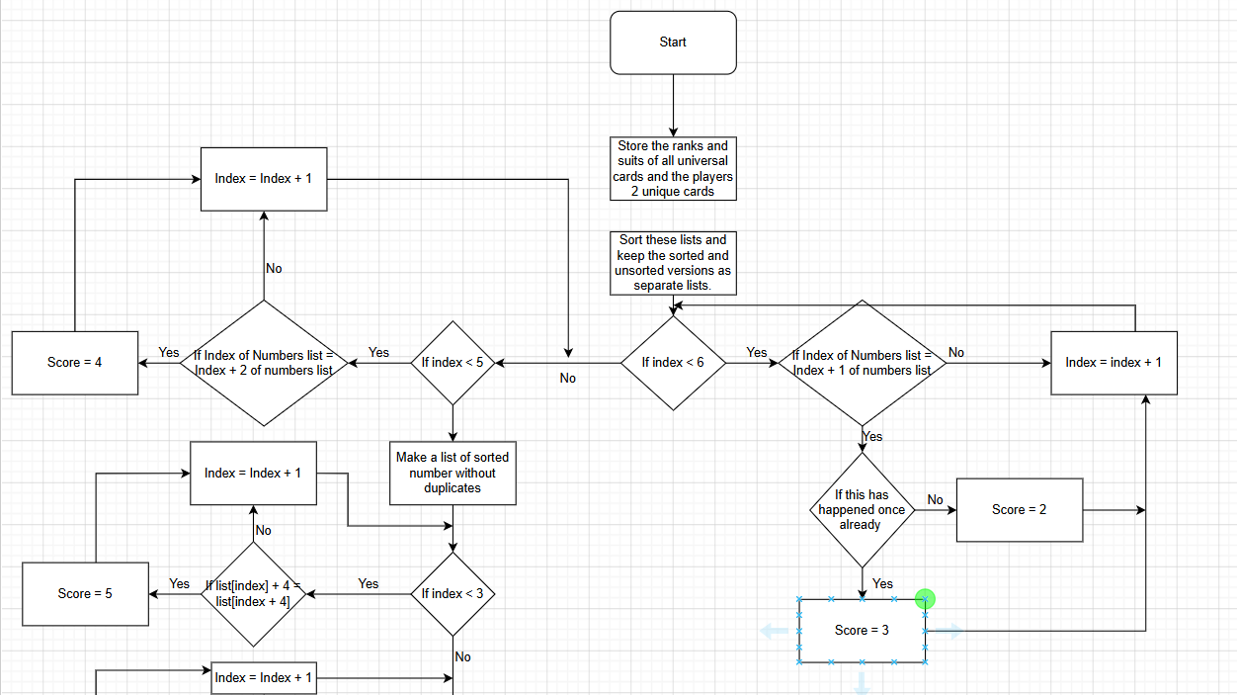
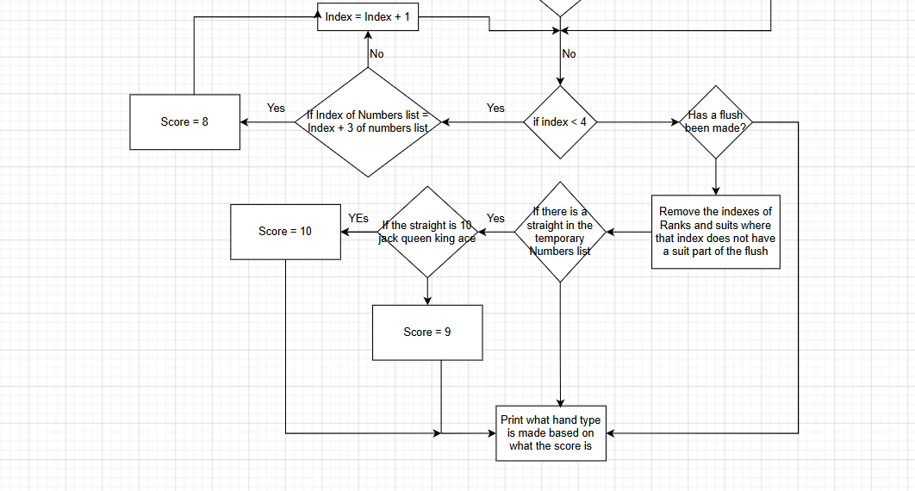

Ranking_system()
Each hand will give a score that corresponds to the hand (I.e pair will give 2 and two pair will give 3) which makes displaying a players score easy
Scoring will start at the weakest hand, so that if a player has both a pair and a full house, then the program can safely overwrite score with no issues.
As well as this, each hand will have a minirank, used to compare which hand is stronger if both players have the same type of poke hand (I.e, I pair of 10’s will be stronger than a pair of 2’s). For most hands, the minirank will be the set, so with a three of a kind, the minirank would be the card you have three of. For straights and flushes, the minirank will be the highest value in either set.
On top of this, for two pairs and full houses, a second minirank value will be needed as if the minirank is the same between two hands, then the value of the second pair will need to be the tie breaker.
Finally, hands that don’t use all 5 cards also have something called a “Kicker”. If 2 players have the same value hand (I.E both have a pair of 5’s), then the tiebreaker is who has the highest value card after that. If that card is the same, it repeats until a 5th card is used anywhere, as poker rules say that you must make the best possible 5 carded hand.
After a players hand has been evaluated, it is compared with the current winners hand, by comparing first if the Score is greater than the previous winners score. If it is greater, then all the current players values (Score, Minirank) get set as the record values that will now be competed against.
If the Score is the same, then the minirank is compared, and follows the same rules as when comparing the score. This continues for all the Comparing values.
Once a winner has been determined, then the value of the pot will be added to that players list, and then the game resets. If there is a tie, then the winning players id will be stored in a list and will split the prize pot between each other depending on how big the list is.
(No flowchart as this system is integrated inside of the evaluation system)

Acceptance testing
No. | Requirements | Input | Expectation
1 | The Player needs to input an amount of computers within the bounds 1-5 | Valid: 3  Invalid: E | Valid: The program will progress using the input as the amount of CPUS.  Invalid: The program will ask again for an input.
2 | The player needs to make a bet that is a positive integer. | Valid: 100  Invalid: -500 | Valid: The program will add the bet to the pot, deduct the bet from the players balance, then progress to the next round.  Invalid: The program will ask again for an input.
3 | The player earns all the chips in the pot if they win. | Valid: Winner = 0  Invalid: Winner = 1 | Valid: The player has the value of the pot added to their balance.  Invalid: The player designated as the winner will earn the value of the pot.
4 | If at least 2 players tie, the pot is split between the players who won. | Valid: Tie = “True”  Invalid: Tie = “” | Valid: The players will receive a portion of a pot equal to how many players tied.  Invalid: The pot will be given to the winner as normal.
5 | The player returns to the main menu when pressing the button for it at the end of a round. | Valid: The corresponding button is pressed. | Valid: The player will return to the main menu with all variables reset.
6 | Every player starts with 10000 chips. | Valid: Every players Balance will be 10000. | Valid: All players will have 10000 chips when a new game is started to bet with.
7 | The player makes a bet that does not exceed their balance. | Valid: Bet variable =< that players Balance variable.  Invalid: Bet variable > that players Balance variable. | Valid: The player puts their amount of chips into the pot and makes all other players bet that much.  Invalid: The program asks for the players bet again.
8 | All the cards art styles will be in a simplistic art style. | N/A | All the cards art styles will be in a simplistic art style.
9 | At the end of a round, the player will have the option to go to the next round or main menu. | Valid: There will be 2 distinctly labelled buttons at the end of round. | Valid: The player will be able  to either return to main menu, resetting chips, or continue to the next round with their current chips.
10 | If the player loses, they will be forced back to the main menu. | Valid: The only option at the end of the round will be a button to the main menu.  Invalid: There will be more than one option at the end. | Valid: The player will be naturally funnelled to the main menu, resetting their balance  Invalid: The player will be able to go into the next round with 0 chips, making that round essentially unplayable.
11 | After any player folds, they no longer make decisions until the end of round. | Valid: A players turn is skipped if they went all in.  Invalid: A player will still be able to make decisions after folding. | Valid: A player that has chosen to remove themselves to play will not be made to put more chips into the pot.  Invalid: A player will still be able to make bets despite choosing the option that takes them out of the game.
12 | If a player goes all in, they put all their chips into the pot then skip the rest of the betting rounds. | Valid: The player will have 0 chips and not bet any further.  Invalid: The player going all in will still be able to bet. | Valid: A player going all in will not make any more actions until round is over.  Invalid: A player going all in will be asked to make actions even though they can’t with 0 chips.
13 | If all players have either folded or gone all in, the game skips to the ending. | N/A | Valid: The game will evaluate all remaining players hands and determine a winner after skipping all betting rounds.  Invalid: The betting rounds will continue even though there should be no player able to bet.
14 | Central cards reveal themselves once a betting phase is complete. | Valid: Cards will be revealed over the course of the game to the user.  Invalid: All cards will be visible on round end. | Valid: Cards will be revealed as they do in normal poker.  Invalid: All 7 cards will immediately be known to the player, changing how they play.
15 | Computer cards will only be visible to the user at the end if that computer stayed in the game. | Valid: Only the cards of computers still in play will be revealed.  Invalid: All the computers cards will be visible. | Valid: The cards of those who folded will remain hidden, adhering to poker rules.  Invalid: All cards will be revealed no matter what actions the computer takes.

Test data
Inputting computers
Input | Type
2 | Valid
4 | Valid
50 | Invalid
-3 | Invalid
0 | Invalid
A | Invalid

Inputting a bet
Input | Type
50 | Valid
1000 | Valid
2 | Invalid
279 | Invalid
0 | Invalid
-50 | Invalid
F | Invalid

Folding
Test data | Type
Player who folded can’t act until the next round. | Valid
Player who folded can act normally | Invalid

Pot
Test data | Type
Pot is a multiple of 50 | Valid
Pot is not a multiple of 50 | Invalid

Reset upon new round
Test data | Type
All variables except player balance is reset. | Valid
Information from a previous round can be seen in this new round. | Invalid
Players balance is reset. | Invalid

Buttons pressed
Test data | Type
Button calls a function then deletes itself | Valid
Button does nothing when pressed | Invalid
Button does not destroy itself when pressed | Invalid

All in
Test data | Type
Balance set to 0 and can’t act until next round. | Valid
Balance not set to 0. | Invalid
Player can act after balance is 0. | Invalid

Unique cards
Test data | Type
Every card generated is guaranteed to have a unique value. | Valid
There can be multiple of the same type of card in a single round. | Invalid

Key variables
Variable name | Data type | Explanation | Justification
Suit_option | List | List of the 4 different suits. | Allows cards to easily pull from these options.
Suits | List | List of each suit that’s been generated. | Allows the program to search for a flush with the same suits.
Nums | List | List of each number that’s been generated. | Allows the program to evaluate hands depending on what numbers the player has.
Folds | List | List of players who are no longer in play. | Lets the program identify which players have taken themselves out of play and whose .turn should be skipped.
Cards | List | List of each card that’s been generated, a combination of suits and numbers. | Stops repeat cards from being generated.
Cycles | Integer | Number that determines how many times the betting phase has been called. | Determines how many cards to reveal and when to end the code.
Pot | Integer | Added to by all players, Variable that stores how many chips have been played. | Reward for winning.
Score | Integer | Determines how strong the players hand is based on what type of poker hand they have. | Helps deduce which player has won.
Minirank | Integer | Determines how strong the players hand is based on the value of the cards used in a set. | Helps deduce which player has won.
Kicker | Integer | Determines how strong the players hand is based on the value of the highest card not being used a set. | Helps deduce which player has won.
Highscore | Integer | Stores the results of the variable Score in the evaluation function, to be compared with new values of score. | Helps deduce which player has won.
Record_minirank | Integer | Stores the results of the variable Minirank in the evaluation function, to be compared with new values of Minirank. | Helps deduce which player has won.
Record_Kicker | Integer | Stores the results of the variable Kicker in the evaluation function, to be compared with new values of Kicker. | Helps deduce which player has won.
Winner | Integer | Tracks which player id has the strongest hand. | Necessary to know which player deserves the reward.
Number_option | Integer | Generated randomly between the values of 1 and 13. | Allows the cards generated to be random.
Num | String | The string version of number option. | Necessary distinction for printing purposes.
Suit | String | Picks a suit from the list “Suit_option” randomly, then stored as a variable. | Allows the cards generated to be random.
Rating | Integer | Number that determines how strong a computer thinks its hand is. | Allows the computer to determine what action it should take.
Choice | String | Determines what the player wants to do at the start of a betting round. | Has the computers respond differently depending on player action.
Tie | Boolean | Determines if 2 or more players have a winning hand of the same strength. | Lets the reward be split between players who have won.
Balance | Integer | Tracks the amount of chips a player has to bet with, not the amount in the pot they can win. | Gives players a maximum amount of bets they can bet, creating more risk.
Computers | Integer | Determines how many CPU players will be in the match. | Lets the user play with an amount of computers they choose.
Placeholder | String | Used to convert different variables like pair_num and number_option into their poker equivalent. | Necessary for printing purposes.
Card_check | Boolean | Checks if a card has already been generated. | Stops duplicated cards from being generated.
Straight_check | Boolean | Used to determine whether a straight has been made. | Checks if a straight has been made for the sake of straight flush.
Flush_check | Boolean | Used to determine whether a flush has been made. | Checks if a flush has been made for the sake of straight flush.
Computer_tracker | Integer | Determines whether it is a player or a computer’s turn. | Helps determine when going through the evaluation system what needs to be printed.
Pair_num | Integer | Determines which rank was used to make a pair. Will be updated to ensure the highest pair is counted. | Helps deduce which player has won.
Second_pair | Integer | Checks that this value is not Pair_num, and is lower than Pair_num. | Helps deduce which player has won.
Triple_num | Integer | Same as Pair_num but with Triples. Having the rank as a variable helps with displaying info to the players. | Helps deduce which player has won.
Quad_num | Integer | Same as before but with 4 of a kinds. Having these be their own variables also makes sending them to King_maker() easier. | Helps deduce which player has won.
Counter | Integer | Determines how many pairs have been made, helps to determine whether a hand has a pair, 2 pair or triples. | Helps deduce which player has won.
Num_list | List | List of all numbers that will be scored. First 2 cards Changed depending on which player id is going through the function. | Stores the numbers of the 7 cards used in the evaluation system.
Suit_list | List | List of all Suits that will be scored. Theres no need to evaluate a list of the cards, just two properties of each card. | Stores the suits of the 7 cards used in the evaluation system.
Unsorted_nums | List | An unsorted version of the numbers. | Necessary for straight flushes.
Unsorted_suits | List | An unsorted version of the suits. | Necessary for straight flushes.
Temp_list | List | An edited version of Num_list, used for deleting duplicates while not affecting Num_list. | Necessary for straights.
Blank | List | An empty list appended to while evaluating straight flush. | Necessary for straight flush.
Flush_suit | Integer | Determines which of the 4 suits is part of the flush, used for evaluation and printing. | Necessary for printing purposes.
Printer | String | Stores the rank of what cards won, with poker term names. | Necessary for printing purposes.
King_Maker() | Function | Converts 1’s, 11’s, 12’s, 13’s into their poker name equivalent, Aces, Jacks, Queens and Kings. | Necessary for printing purposes.
Cards_Test() | Function | Generates a unique card and adds it to the list of cards. | Poker does not work if cards of the same suit/rank are generated.
Bet() | Function | Lets the player Bet, which takes away chips, or check, which won’t take chips, then passes the turn to computers. | Necessary or else the users choices don’t matter.
Ranking_System() | Function | Gives a score per player based on how strong their hand is. | Necessary for real poker to be emulated.
Folding() | Function | Will ensure this player can’t make further actions. | Lets the player who folded skip their turn.

Post development
Since my code does not use any online servers, there will be no need to perform constant maintenance on the program as once the program is properly made, it will not break without further changes. There are no benefits to using online servers for this program, such as multiplayer or storing credentials, so it will not be implemented and therefore maintenance for online servers will not be necessary.

The only exception to post development is if bugs are found it the game after the game has been deemed finished, to which the program will be adjusted to fix that bug, while running more bug fix tests to ensure the last patch didn’t add a new problem. This is a standard way most modern programs are regulated, as it allows the program to be released in a fully complete model, while allowing users to test for problems that may not be able to be caught by a single person, then allows me to fix any potential problems.
This game will not require any credentials to store progress as it is intended that the player’s balance will always reset when loading up the main menu so they can always play. If info were stored between different times the program is ran, there could be issues where the player starts with 0 chips, making it impossible for them to play, so storing this information is both unnecessary and detrimental.
The rules of this game are very rigid, with the way each hand is evaluated and the way the betting phases works being directly tied to real life Texas Holdem, and therefore can’t change. There are other variations of poker, most famously 5 card draw, however the work required to allow even one alternate form of poker to be played would be far too much work, and would fall into it’s own program, maybe with some of the work from this program being imported.
For potential additional features post production, the UI may be updated if enough players have problems navigating it. The custom card colours may also be adjusted depending on stakeholders feedback. This is being done in post production to allow for more users feedback and their general opinions, as the opinions of just a few stakeholders is not enough, and the doing it after production lets me make smaller changes to suit peoples preferences, without having to build multiple entire models.

Changelog

Cards Milestone

Card generation
The first step of the code was to generate unique cards that could be evaluated to the official poker hands
The card generation began as a very inefficient process that involved storing the rank, suit and combination of each card in unique single variables.
This would be done by Generating a number between 1 and 13, generating a random suit from the list, manually changing the value of each number if it is expressed differently in poker terminology, then concatenating both values into a single card variable. Then for every other card, it would check if each card was identical to a previously made card, and if it was, it would reset the values for that card.
Number_option and Num were kept as 2 separate values so number_option could be used for evaluation and Num could be used for printing
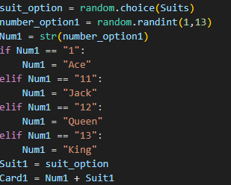
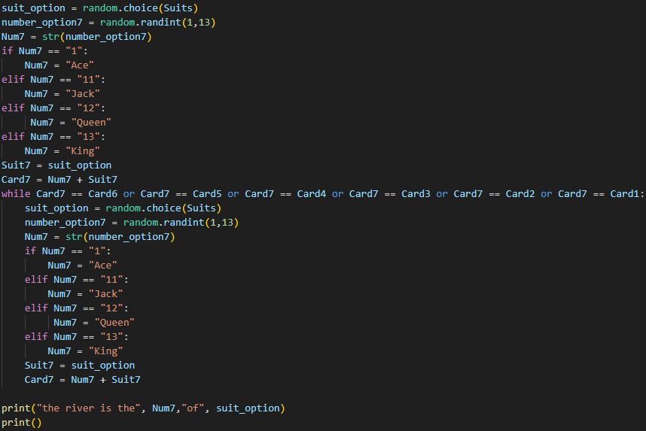
There were many issues with this method, part of which was how inefficient the entire process was, but also that the amount of cards generated would be invariant, which was a problem for a code that was always intended to support an invariant amount of computers.
The first prototype built was to create a new, equally inefficient function for just the computer cards: 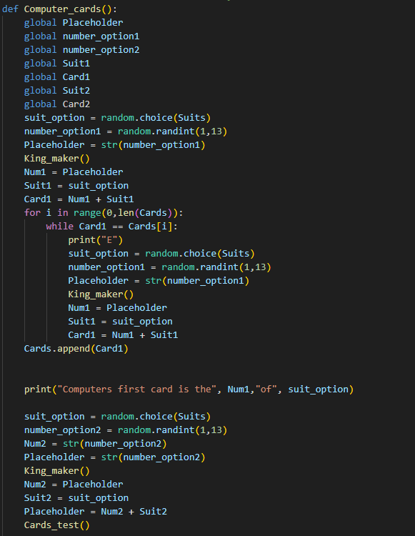
While this fixed the recursion issue, it was still dreadfully inneficient, as well as that there is simply no need to separate the computers cards with the players, and that long term it would have been impossible to display which cards had won, as Num1 and Num2 were being overwritten.
The first stage of simplification came with the function King_Maker.
This function takes the value of placeholder and changes it’s value if it is
one of the alternate names I.E. king is 13 and Jack is 11.
Having this as its own function reduces redundancy and makes it
More re-usable for later in the program, hence why placeholder is used and
not for example Number_option.
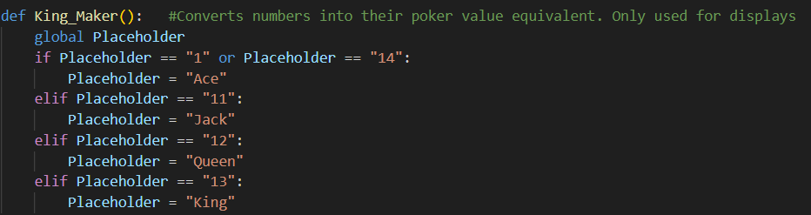
Afterwards, the next step was choosing to generate all the necessary cards at the start of the program and storing them in a list, rather than having 7 variables and overwriting them. The first stage of that was getting the number of computers immediately.
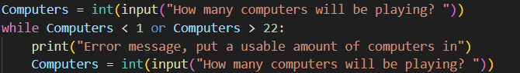
Then, the function Cards_Test runs recursively, generating 2 * the amount of computers, an extra 2 for the players and 5 for the universal cards
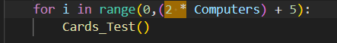
Cards_Test then runs the same process as the inneficient method, except now appending it’s values to lists instead of unique variables, making it much more efficient with recursion, and easier to find values by indexing the list.
(The function is called Cards_Test as it was initially a function ran each time a card was made, to verify the card is unique. This pretty quickly came where the cards were generated)
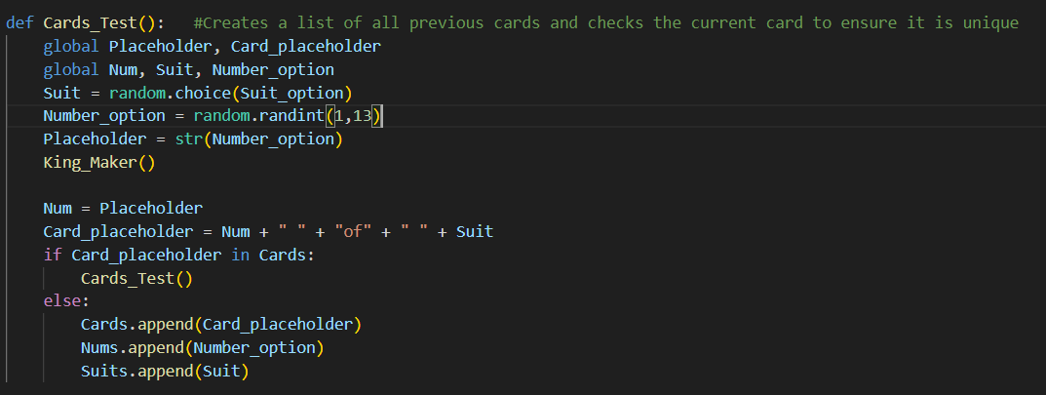

Milestone Review / Testing
Testing
The way to test if every card was unique was to print the total list of cards, and verify all options inside the list were unique. With 23 players, there will be 46 pocket cards + 5 universal cards, meaning 51/52 of the cards will be generated. So by printing this list, if all cards are unique there should only be one card missing from the list, in the below examples under valid testing being the 10 of hearts and the 6 of spades respectively.
The list is also sorted to make checking for duplicates easier.
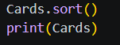

Unique cards
Test data | Expectation | Reality
Every card generated is guaranteed to have a unique value. | Valid | Valid
There can be multiple of the same type of card in a single round. | Invalid | Invalid

Proof for valid solution:
Example of failed solution
At one point in development, cards were not guaranteeably random despite my expectations. This was fixed by adding an extra check at the end of the function to ensure the card being created was not already in the list, as before this check was done only between ranks and suits, not combined.
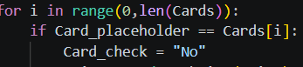
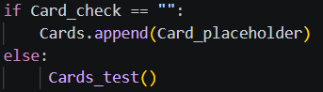
In this example you can see duplicates of certain cards like the 8 of Diamonds or the King of clubs, which showed me there was an error with how the cards were being identified as unique.

Review
This first section was simple enough to implement, even with how inefficient the prototypes were. The hardest part was including the indefinite amount of cards that could be in one match, rather than the generation of each individual card, so once the idea to put every card into a single list was made, the implementation was simple.

Ranking Milestone

Ranking System
After Card generation, the next objective was to take the 7 cards each player would have access to at the end and give them a score if they were a hand in poker, following the same system as how poker hands are normally evaluated. This is easily the biggest function in the program as each hand type must be written, as well as the computer side of things that integrated itself into the function, and the higher complexity requiring more notes inside this function. Even at the end when the displayment was moved to another function, it is still well over 100 lines longer than the next biggest function.

I first began by going hand by hand, assuming the player’s cards were the only group of cards that mattered. I made a list of all numbers and suits separately, as well as unsorted versions which was necessary for straight flushes.
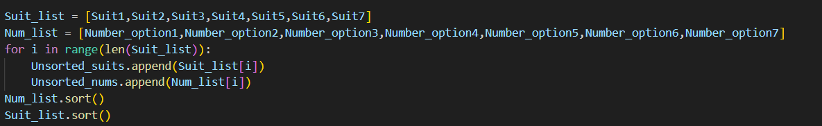
The code would run each transaction every loop, and would update the score with a higher value if the condition was met, so if a player had both a pair and a 4 of kind, I could guarantee only the highest hand would be considered their hand.

The scores read as followed:
High card - 0
Pair – 2
Two pair – 3
Three of a kind – 4
Straight – 5
Flush – 6
Full house – 7
Four of a kind – 8
Straight flush – 9
Royal flush – 10

For pairs, three of a kind and 4 of a kind, I went through the list of numbers, and check if the number ahead of them was the same. Since these numbers are ordered, if the number ahead of a number in the list was the same, It would mean there are 2 of that number in the list. This process is used for Pairs, 3OAK and 4OAK, with slightly different parameters and a different score
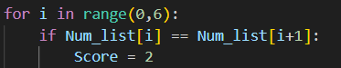
I then went straight to flushes, as they seemed easier to implement than two pair. For this transaction, I made a 5 long list, and checked if the start of the list was the same as the end of the list, as that would mean 5 values in a row would be the same suit, meaning there was a flush.
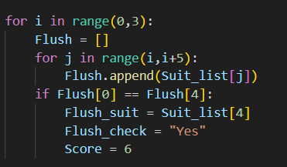
Moving onto straights, I made a temporary list that had the duplicate numbers removed from it, as the duplicate numbers made evaluating a straight properly near impossible. In this temporary list I made it so an ace acts like both a 1 and a 14, being true how to how it functions in poker while stopping the illegal straight loops [12, 13, 1, 2 ,3] from being counted as straights. Then I check if the value of a value is 4 less than a value 4 ahead in the list, as without duplicates that means all those 5 numbers are consecutive, giving an accurate straight
Also Num is brought into this transaction because for some reason python just breaks with Temp_list[i] + 4 = Temp_list[i+4], but does work when Temp_list[i] is it’s own variable.
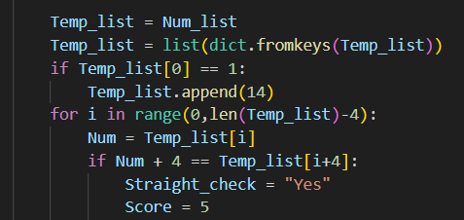
Next, I altered the pair transaction to also include second pairs, creating 2 possibilities if there is a pair found.
1 – There hasn’t been another pair found yet – the transactions runs as it did before
2 – Another unique pair was found – The bigger pair becomes Pair_num and the smaller pair becomes Second_pair
The “Counter” variable helps identify if another pair is present, and the != Pair_num stops 3OAK from being re-evaluated.
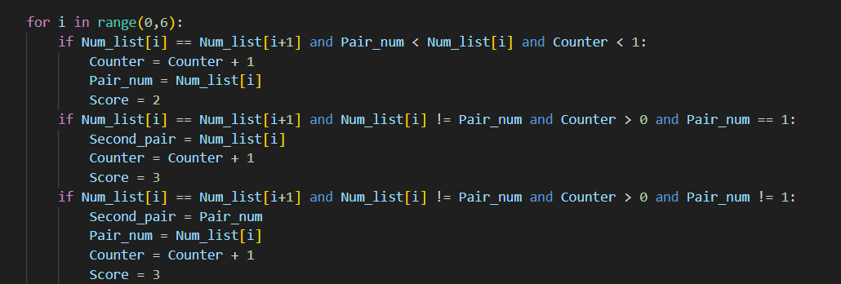

After, the hardest transaction of Full house was made, although the refinement took longer than for straight flush to be completed.
The hardest part is making sure it gets accurately counted while not impacting 3OAK or Two pair, but the final check was to ensure Triple_num and Second_pair were 2 distinct values that were both greater than 0, and there were also more than 1 pair found with counter, then it would properly evaluate a full house. Since the pair module must have also come before 3OAK, extra steps had to be put in place to ensure everything was accurate
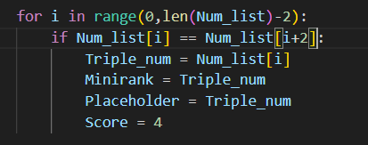
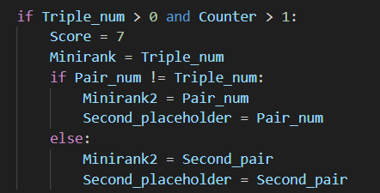

Finally, Straight flushes were evaluated. I left them last because I had falsely assumed I would just need to check if both a straight and a flush had occurred, but with 7 cards it’s possible for there to be a straight and a flush, without having 5 consecutive cards of the same flush. Exceedingly rare, but arguably more common than a natural straight flush.

The transaction beings by checking that there has been a straight and a flush, then adds the index of every number that is part of the flush, stored in blank.
After, it adds the corresponding values to Temp_list, then removes duplicates. The result being that we are now searching for a straight inside only the numbers part of the flush
Finally it runs the same process as the straight on the new list of numbers, the only extra checking being if the straight flush contains an ace, king and queen, meaning it’s a royal flush, the best hand in poker.
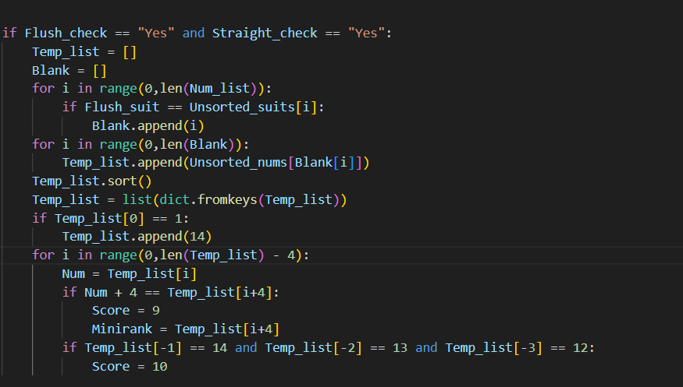

After each potential hand has been evaluated, the program printed the winner. The wording of the printing refined itself over time until eventually being remade with the Gui, but for most the codes life the printing segment looked like:
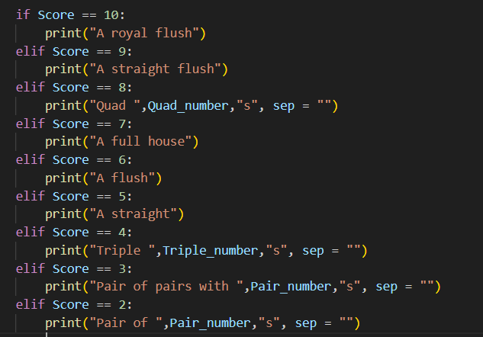
The sep = “” was used to remove the space between the number and the s, as otherwise it looked horrible.

Milestone Review / Testing
Testing
The ranking system had to be run a lot of times to check that each hand evaluated correctly under a lot of different scenarios, for example full house has the potential to claim it’s a full house when there is only a three of a kind or 2 pair, and for all hands it’s also possible it doesn’t correctly identify the hand.
However, if the program were just to be run repeatedly until every edge case had been covered, the program would never be finished. There is a less than 5% chance to hit a three of a kind or anything better, and less than a 1% to get either a 4 of a kind or a straight flush. Throughout my entire development of this code, I have hit a few natural full houses, found one 4 of a kind at the very end of this programs life, and have never found a natural straight flush, much less a royal flush.
To solve this program, the values in the Num_list were manipulated to what values I needed them to be. The program will act the same as if they had taken the numbers straight from the cards, with the only exception being if there is 5 or more of the same rank, as that would normally be impossible.
Not all numbers would be forcibly set, allowing for variance. For example if I gave myself three 5’s, I would be looking for full houses where the pair number is both higher and lower than 5, as well as checking other hands to check that a full house is only being counted when it should be.
The amount of computers would also be set to 22, to check as many potential hands as possible. For speeds sake I also added a backdoor straight to the ranking system if I set the computers to 22, allowing me to check my code faster than going through 4 betting phases.
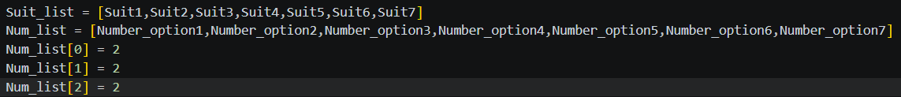
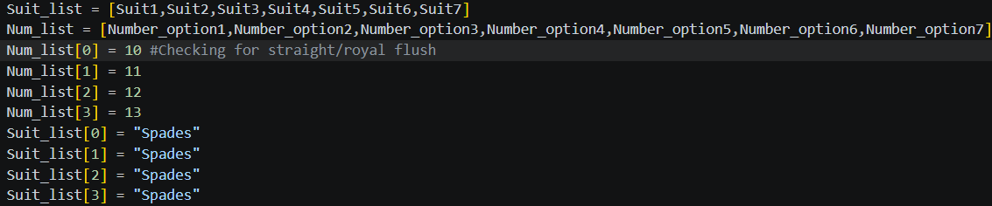
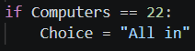
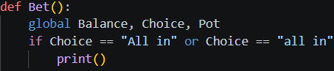
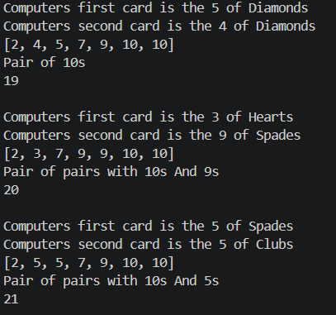
Example of failed solution
During development of full houses, it was hard to get exactly right as there were issues of whether the 3 of a kind was a higher or lower rank than the pair’s rank. Because of this, many solutions to full houses were not successful, either not evaluating full houses correctly or incorrectly evaluating triples and 2 pairs. The main issue stemmed from checking if there was a 3OAK and a pair with the same variable, score, and trying to make it work even though score would always be overwritten, so instead, these values were stored inside new variables, Triple_num and Counter (intended to be used later for printing purposes but were needed now for evaluation purposes), and then checking these variables to see if a valid full house had been made.
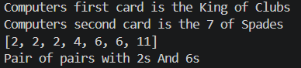 (Example of failed solution)
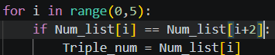
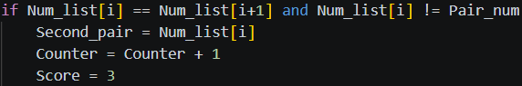
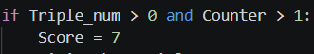
Review
This was one of the most fun milestones of the program to complete, having to go through each potential hand one by one and figure out how to solve each problem while ensuring every possible scenario was covered, invalid scenarios were correctly not evaluated as a certain hand, and that development of each hand type did not interfere with another i.e. full houses not messing up the logic for 2 pairs or 3 of a kinds.

Comparison Milestone

Comparison System
With the ranking system now complete, the next process was to generate an indefinite amount of computer cards, then run the ranking system and determine which player had the best hand.
There are 3 things to consider when comparing a hand against another hand
Score – A straight beats a pair, this has been solved with the previous milestone
Mini rank – Saying a pair of 5’s wins against a pair of 3’s, or A 10 high straight is better than an 8 high straight
Kicker – Normal poker dictates that a player makes their best “5 card hand”, meaning that a pair would use the next 3 highest cards as a point of comparison. So if both players had a pair of 5’s, but player One has a 10,5 and 4 and player Two has a King, 3,2, Then player 2 would win as a king is stronger than a 10.

Mini rank was simpler, going back to each transaction and making the largest value the Mini rank. For Full houses and Two pair, A second Mini rank was needed.
For “number” high hands, Mini rank added the necessity to add an extra transaction, checking if the score was 0, then making the largest number the Mini rank
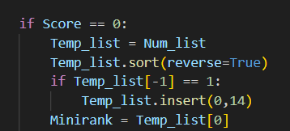

For kicker, a case-by-case basis was needed. For Straights, Flushes, Full houses and Straight flushes, a kicker is not needed as these hands already require 5 cards to form each hand.
For 4 of a kind and every hand weaker than a straight, A kicker is determined. This happens by reversing the order of Num_list, then finding the largest value that isn’t a part of a pair or 3OAK, and setting that number as the Kicker
For Pairs and 3OAK the process is repeated again except setting that value as Kicker2, then repeated for Pairs and being Appended to Kicker3.
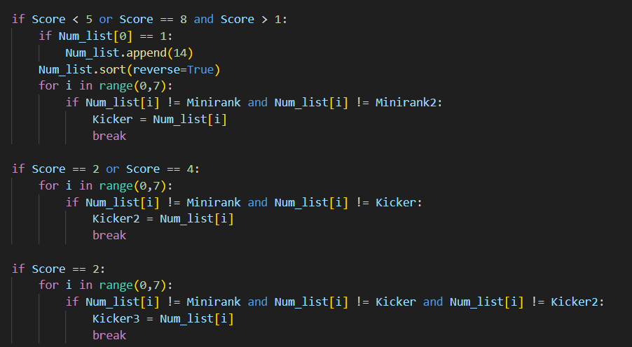
For specifically high card, for efficiencies sake all kickers are determined next to Minirank, as there are no pairs to dodge when evaluating the kickers, and that we need a Kicker4 just for high card. 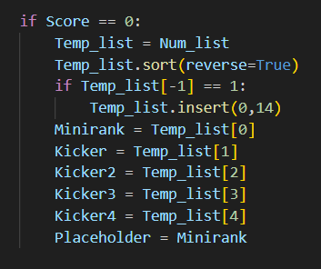

An updated version of printing happened around this time, using the printer variables to convert each number into its poker equivalent. Placeholder and Second_placeholder are determined at each transaction, but are usually just the Mini rank.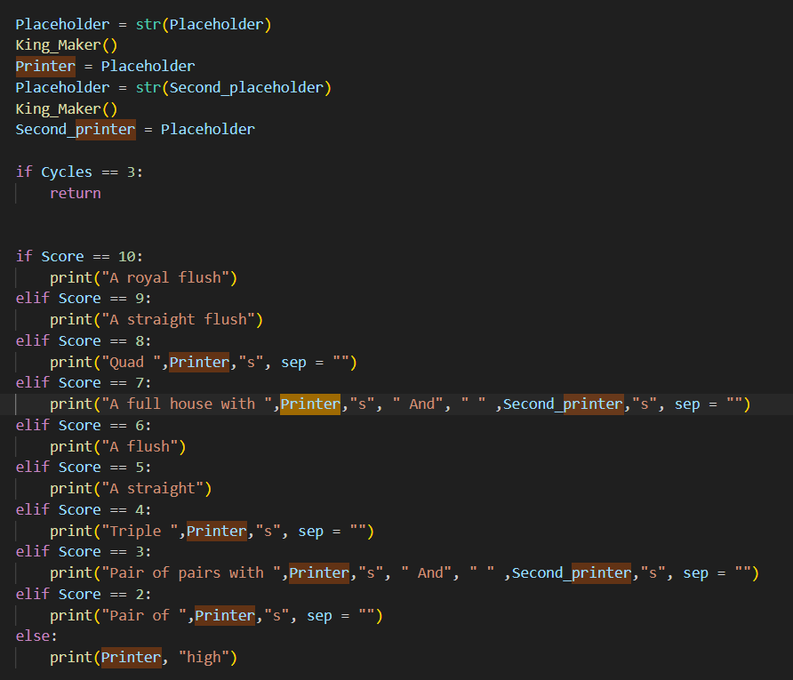
Finally a winner needs to be determined with these values, done by storing the values of Score, the Mini ranks and the kickers in Record Values, then comparing each new Score/Mini rank/Kicker with their record equivalent, updating the record Values only if the new hand is better than the original.
If each variable is the same as it’s record variant, then it is determined to be a tie, currently only stored a yes or no variable.
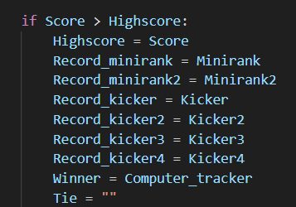

Milestone Review / Testing
Every time a player had become the new best player, a number was printed to signify which category they won in. For example, a better score printer A and a better Minirank printed B. This was extraordinarily helpful to determine why certain hands were or weren’t beating other hands, for example seeing a D told me the pairs and mini rank were being handled correctly, and that it was the kicker that needed attention.
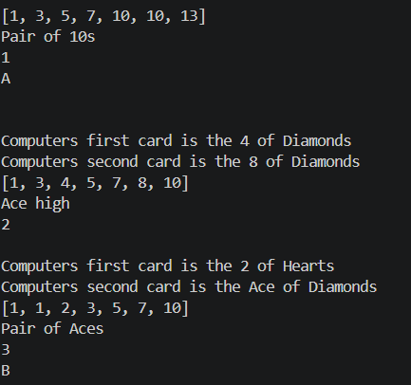
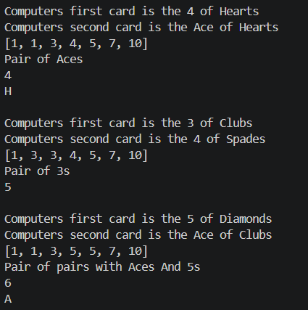
The record values for score, mini rank and kicker were also printed at the end, which helped understand which value was off from what It should have been when something went wrong.
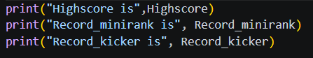
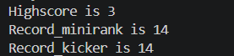
An absence of any letter was also useful, for example in the screen shot below where the fast hand was the strongest and every subsequent computer didn’t have a letter. This was also the second time I have ever seen a 4 of kind naturally.
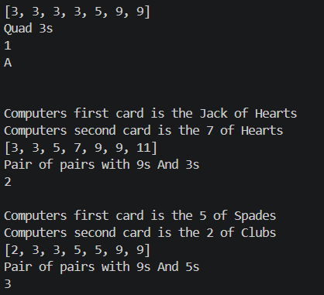

Review
This section was a little harder to go through, as instead of creating a new function to solve the problem, every major aspect of the ranking system had to be adjusted in order for the comparison between multiple players hands to be correctly evaluated. In terms of fixing non working solutions, there truthfully was not much work needed for testing, as for most of the sub problems the solution was to make the minirank or kicker a value which was already being identified, like the pair number being allocated as the minirank. The only exception to that being the kickers and having to adjust them for each different hand, which took a bit of testing and eventually went to each edge case being handled as it came, as is self evident in the below screenshot:
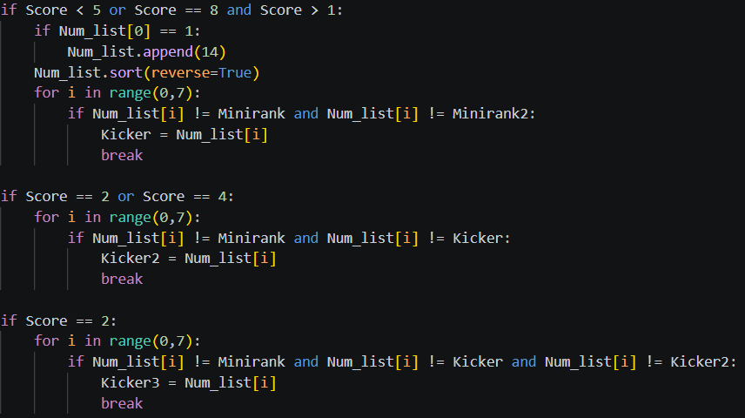

Betting Milestone

Betting System
Once the comparison system was complete, the next milestone was to form a proper betting system, but before that the players Balance needed to be established, the amount of chips the player has.
Balance started out as it’s own text file, done so the amount of chips could be transferred between each round. At the start of the program, the value in the text file was added to the variable Balance, then at the end the new value of Balance was added to the text file. For conveniences sake, extra chips were added if the player had 0 chips, making testing with going all in much easier
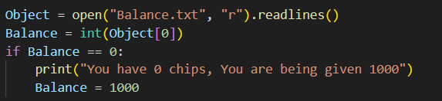
Eventually, much later than it should have been to be honest, Balance was changed to a list that stores the Balance of both the player and all the computers
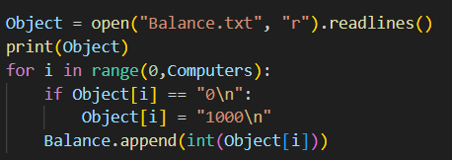
Eventually, at the very end of the programs development, after getting a clear vision on how the program would loop, I realized there was no need to keep balance as a text document, as I wanted the balance to be the same between each loop of the program, but reset when brought back to main menu. Therefore, Balance was initialized like a normal list
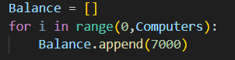
After balance was established, the Betting system could now be worked on. It started out very bare and incomplete as I waited until this skeleton was put into place to move on to letting computers make their own bets. For most the programs life, the bet function only asked the player “Check, Raise, or Fold”
If the player checked, it would display that every computer had checked, then skip to the next betting phase
If the player raised, It would use a while loop to ask for an amount of chips, and for now would assume every player called
If the player folded, the program would just end.
If the player inputted All in, then the program would skip straight to the end of the program, giving a shortcut to the ranking system, making testing that area much faster.

There are many levels of abstraction happening here
Check – The program is assuming that the player always moves first, which given how blinds work, is honestly quite rare. However for a function that’s only made to make the computer thought process to be easier to set up, Blinds and order can be abstracted for now and a while
Raise – In proper poker terminology this isn’t a raise, this is a bet. A raise is when another player bets and you bet higher than them, which isn’t possible here when the computers aren’t betting. As well as this, there is an assumption for both Checking and Raising happening where the Computers all Check/Call respectively
Folds – When a player folds, the game should continue for every other player, only properly ending when all but one player has folded. However while only the player can fold, it wasn’t that important to ensure folding was as true to life as possible as it’s its own procedure that can be ignored. More importantly, you can’t actually fold while you have the option to check, normal poker rules don’t allow it, so for now it was a simple way of ending the program.
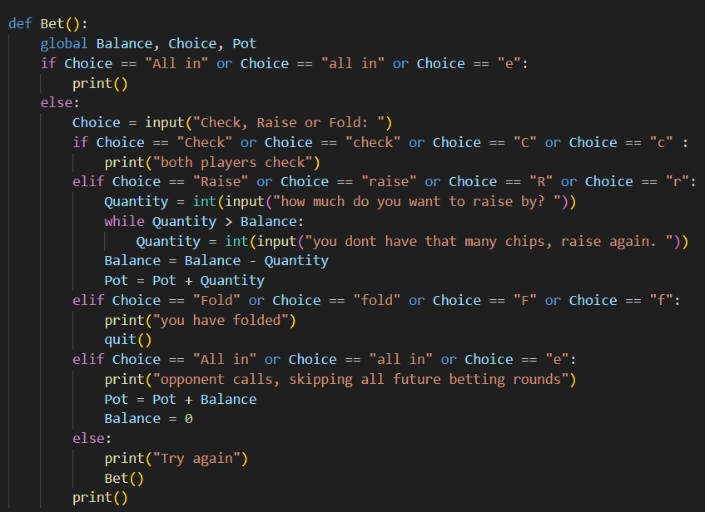

Computer Decision
After the simple betting stage came the much larger task of having the computers determine how good a hand they think they can make with the cards they can see in each betting phase.
So for example, at the start of the game the computers should only be able to see their two pocket cards, and will need to determine approximately how good those cards are. The program checks if there is a pair, then if the 2 cards are close to each other, then if they are of the same suit, then if the 2 numbers have a high value, and finally give a rating based on all these factors, the ranking of each card being heavily weighted.
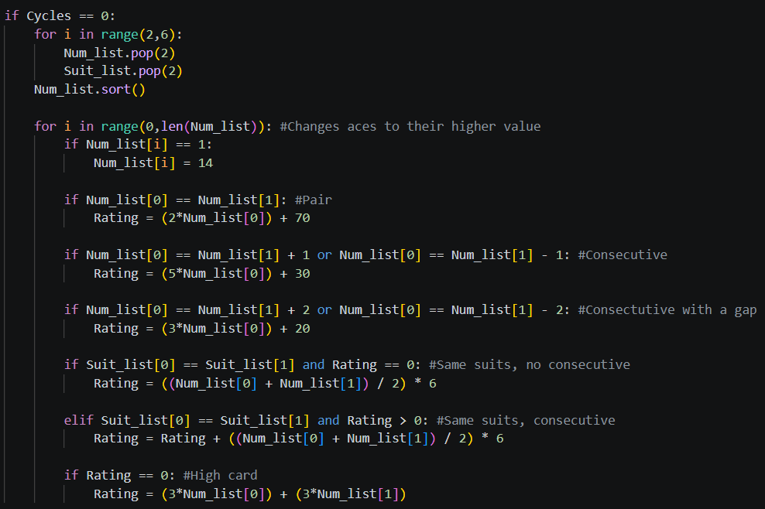

For 5 cards, the computer could look at if they have a pair/3Oak/Any other hand, how close they might be to a straight or how close they are to a flush, each scenario being given a unique rating. 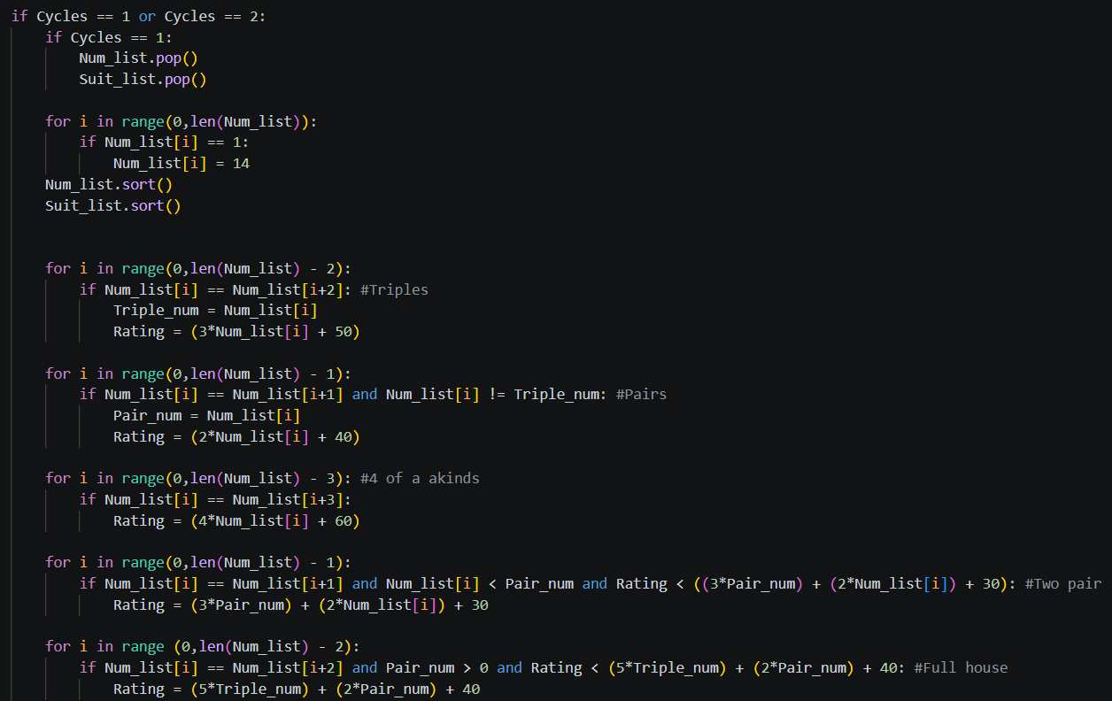
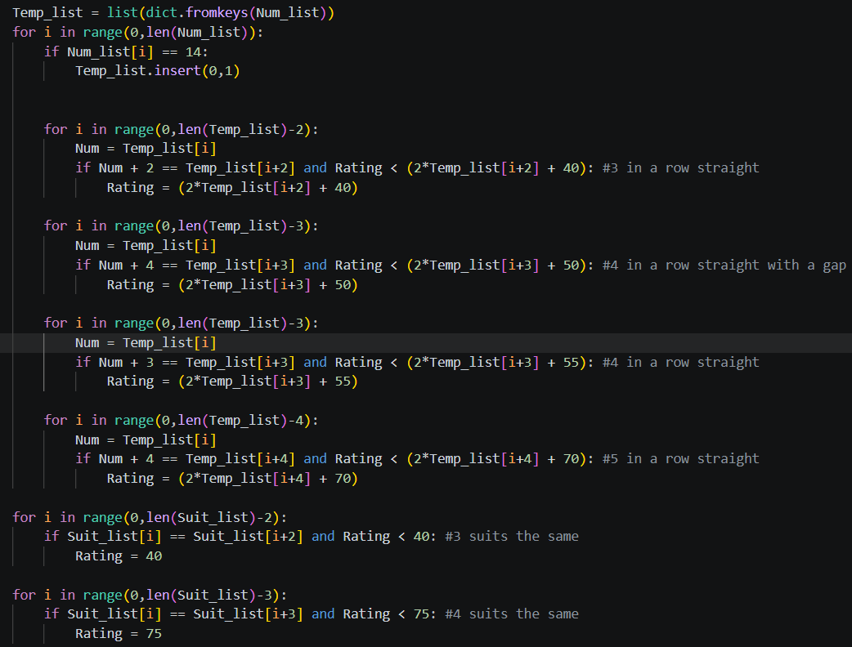

For 6 cards, while at first I started going through each scenario one by one, I realized eventually that every scenario was basically the same as for 5 cards. Initially I thought the rating needed to be adjusted, as having 4 cards of the same suit is much more valuable with 2 cards left to be revealed rather than 1

For evaluating the value of all 7 cards, I manipulated Ranking system to allow this new function Computer Decision to run through all of it, then find a rating based on the score, saving a lot of time by re using the function.
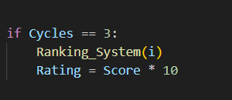
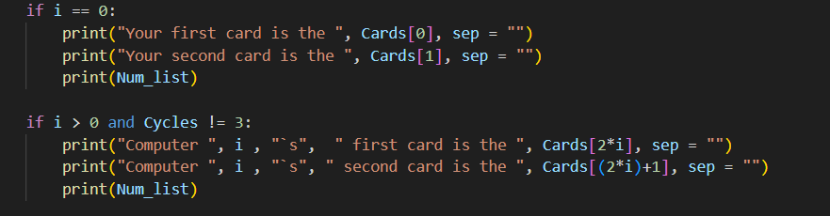
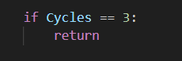
At earlier stages of development there was an idea to include a “Bluffing” feature, an idea that when a computer had a bad hand, they had a small chance of it still being rated incredibly high. The result would have been more thinking on the players end, as there was a concern that computer would always fold bad hands and only play good hands. However through testing, it was found that even without the bluff system being fully implemented, computers would commit to their hands even it was just card high, although generally committing more the better their hand was, which is exactly what I want these computers to do, so the bluff feature was unnecessary.
There was also temporarily a variable called “Value” which would categorize each Interval of rating into one of 5 values. It was completely redundant as not only are there only at most 3 outcomes for any situation (Call, Raise, Fold) (Check, Bet), But also that these conditions could be met with just the ratings variable. It reduced flexibility with the only benefit being redundancy.
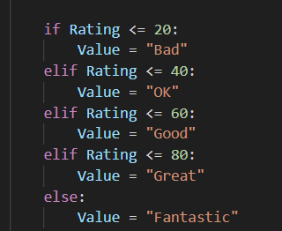

Computer Choice
After generating a rating for each computer, the next milestone was to give the computers choices after the players action, branching paths depending on whether the player had Checked or betted (For now, the player folding was an option being ignored)
If the player had checked, the computer for now was required to simply check, as the entire process of computers making their own bets was far too complicated to incorporate this early. For now this serves as a template for the future as well as an easy test to ensuring the folding side of things worked, which was being developed in parallel with the checking and betting functions
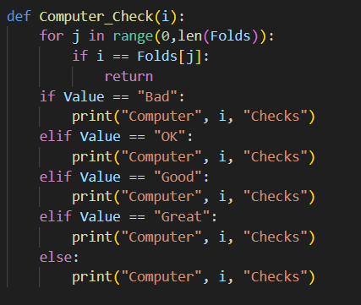
If the player had betted, the computers had the choice of calling the players bet, or folding. If the computer had a high enough value, they would call, and for now everything would act the same as checking since the balance on the computers had not been implemented yet.
If they chose to fold, then that computers number would be added to a list called “Folds”. After that, every time a function involving all the computers is ran (Computer_Decision, Computer_Bet), the start of that function runs a check to ensure that the computer being tested hasn’t already folded, and if they have, it skips and increments to the next computer
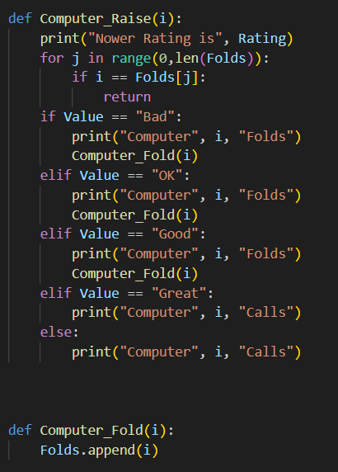

Milestone Review / Testing
Testing
What I needed from this milestone was to have the computers make different choices based on their hand strength if the player made the same choice. Currently that just means having variety between whether they call a bet made by the player or folding, as well as making sure both calling and folding work as intended.
To test this works, I would raise as my first option and watch every computers action, as well as what their rating was. Once I could see that there was variety that corresponded with how strong the computers hand was, I knew the milestone was complete.

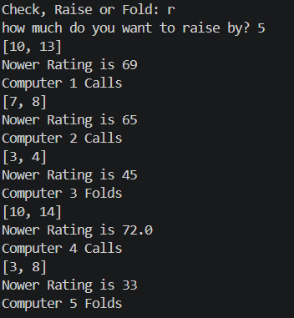

Player choice validation
Input | Expectation | Reality
Check | Valid | Valid
Raise | Valid | Valid
Fold | Invalid | Valid
C | Valid | Valid
r | Valid | Valid
t | Invalid | Invalid
7 | Invalid | Invalid
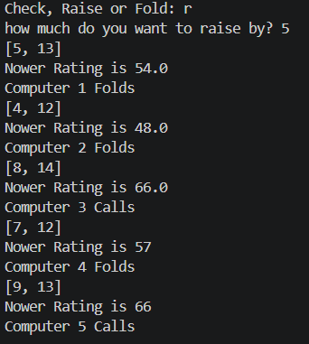 (Valid)
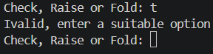(Invalid)

Betting validation
Input | Expectation | Reality
50 | Valid | Valid
1000 | Valid | Valid
27 | Invalid | Valid (Multiples of 50 was chosen to be implemented later)
-50 | Invalid | Invalid
a | Invalid | Invalid
Bet > Balance | Invalid | Invalid

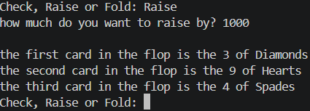
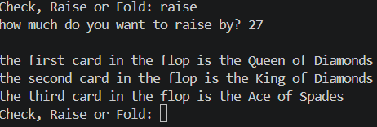
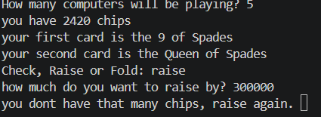

Milestone review
This milestone was mostly simple as I had expected, both the Bet function and the computer Check/Raise functions were simple to implement, especially as the computer functions were being kept simple for this milestone until the GUI was further along in development. The computer decisions was harder to implement, having to come up with each possible scenario for 2/5/6 cards, then having to implement them. Thankfully most of the logic could be re used from the ranking system, but some areas like a straight with a gap had to develop a new solution and were too essential to ignore.

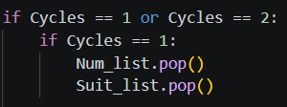(Current solution)
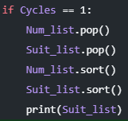
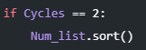 (Example of failed solution)

Graphic Milestone

Initial GUI
Once the simpler computer actions were put in place, instead of moving onto the Computer Raising side of things, I instead started work on giving the program a GUI. Before doing that, I first had to learn the very basics of python GUI, done with this helpful YouTube tutorial:
https://youtu.be/ibf5cx221hk?si=uY_7VCpf8QkoB-vj
After having a basic grasp on what to do, the first step involved understanding when exactly I needed certain info displayed, as well as connect one piece to the next with buttons. To begin, I needed the player to confirm they want to start, then for them to input the amount of computers they want to play with.
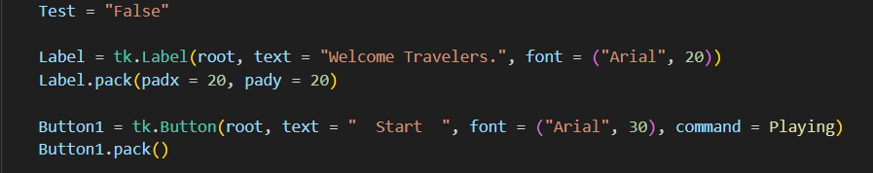
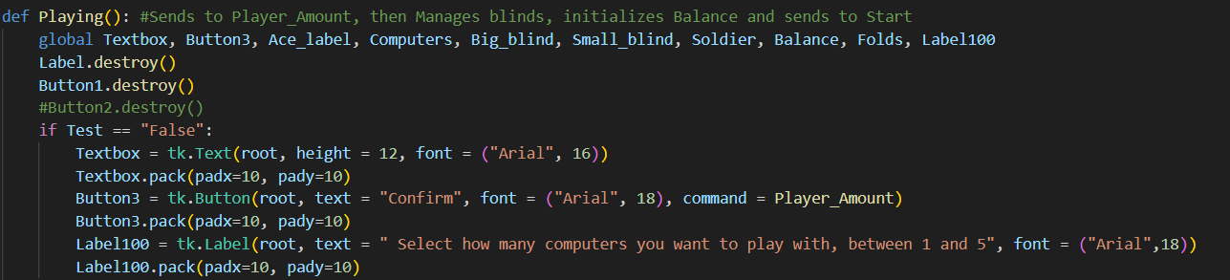
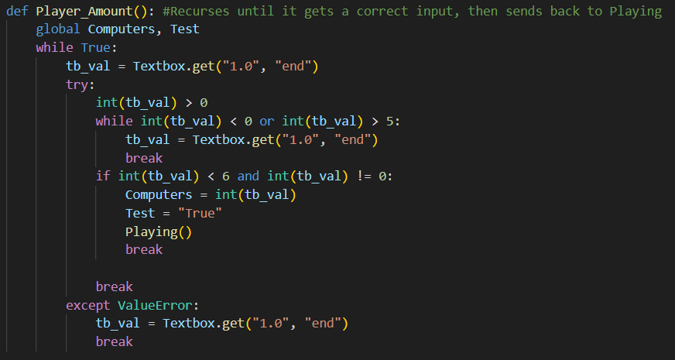
Player_Amount was tricky as in order to not break the program, the value inputted must be in range, but when dealing with a GUI you can’t simply run a while loop until the player gets it right, so an entire function that stops the player from inputting anything silly becomes a necessity.

Player Cards Displayment
After the start of the GUI was set up, the next step was to display what 2 cards the player had on the screen. To save time, I chose to download images of each card as creating 52 unique images when what I needed already existed seemed inefficient. I knew I wanted realistic and standard looking cards, nothing extremely stylized like Balatros 8-bit card designs, and I knew I needed them to be PNGs as Pythons TK-inter works better with PNGS than other file types, such as SVGs. After a bit of searching, I found an open-source file with all 52 cards, each consistent with each other.

As stated in the development segment, I knew from the beginning I wanted to have my club cards be green and my diamond cards be yellow. Obviously knowing no online resource would have cards like that which would be consistent with the other cards in the deck, I used Photopea to recolour each of the 26 cards to the colour I wanted. The process of recolouring took more time to figure out than I expected it to, but the it ended up being easy. To start, all the white needed to be made it’s own layer, then locking that layer so the icons stayed the same shape. After I would select all the parts of the cards except the edges, and replace the colour with the colour I wanted. For the face cards I also put more care into making a consistent colour scheme with their more complex designs.

For diamonds, I started with a very strong, bright yellow, but over time I preferred the look of a darker yellow, closer to orange. 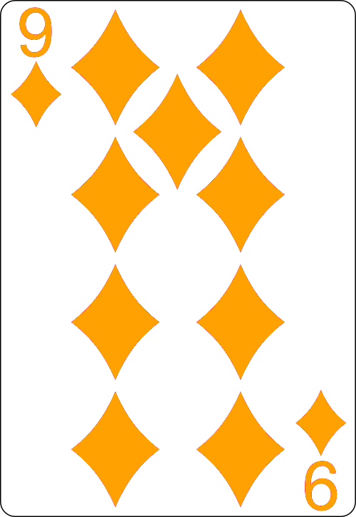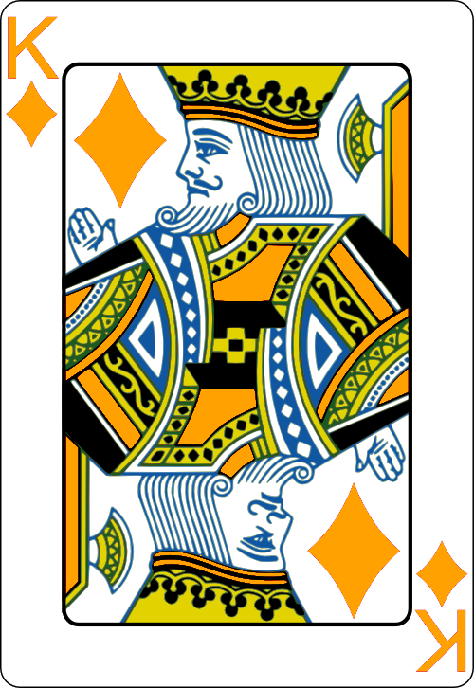

For clubs, I knew I always wanted them to be green, and ended up settling
on a light green for the sake of contrast. 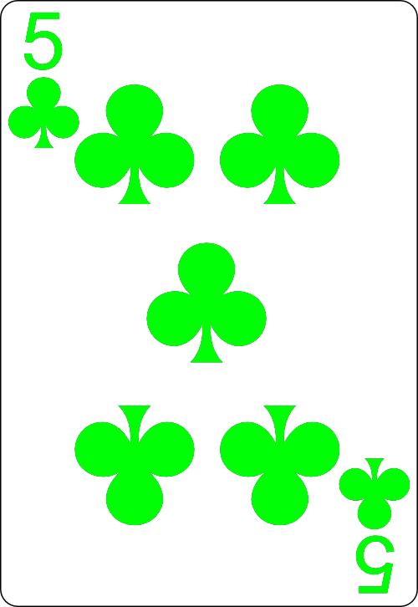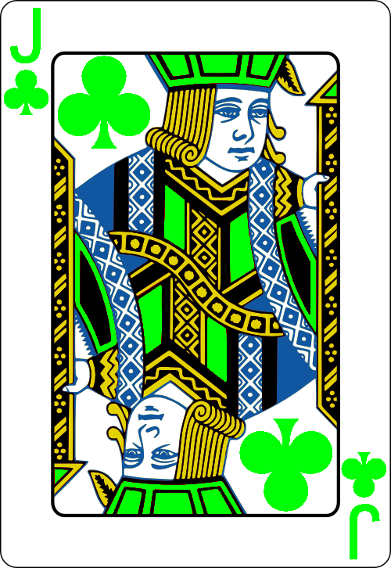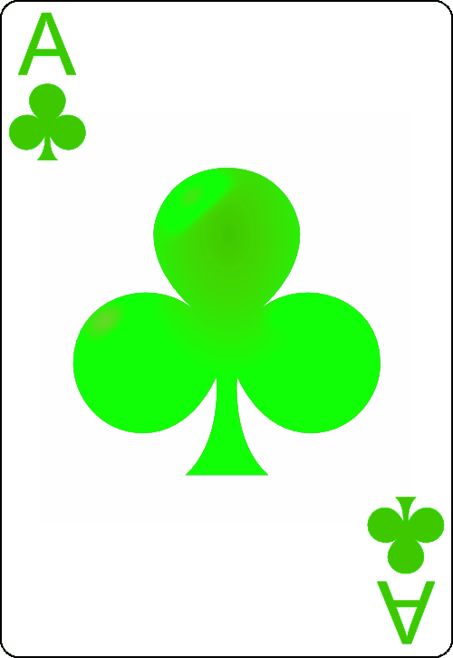

The exact position of the players cards move around throughout the code, but eventually ended up in the middle of the screen with some distance between them, predominantly displayed given how important they are.
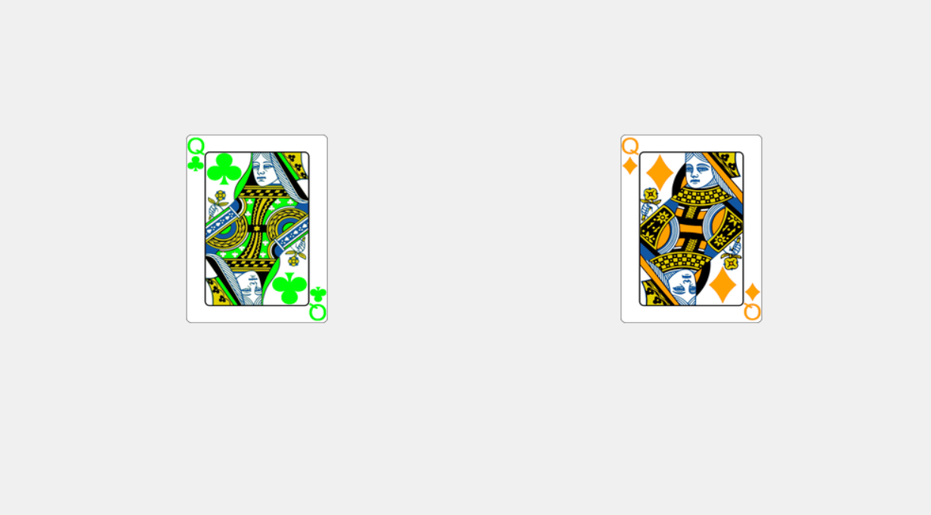

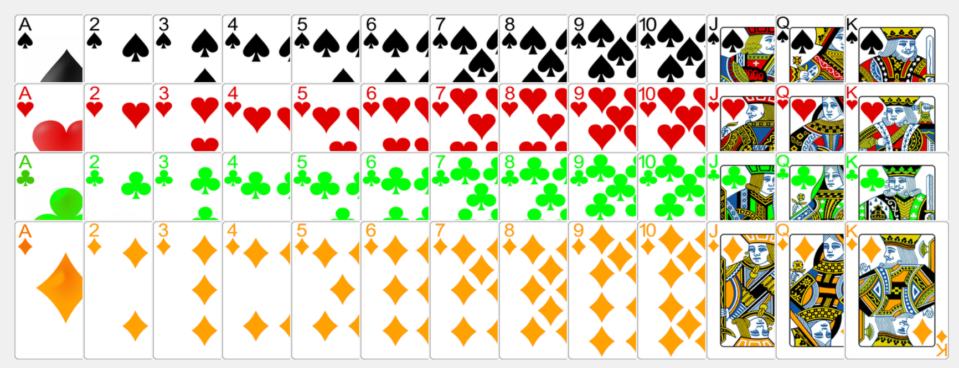

To find the cards, all cards were put inside folders that rested on the same layer as the main code. The code would open the folder corresponding to what suit is on the card, then would find the card via indexing the folder. The order of the cards had to be controlled, as Ace would be at the end, and 10/11/12/13 are organized to be between 1 and 2, so those cards needed a letter before them to order them as I wanted. 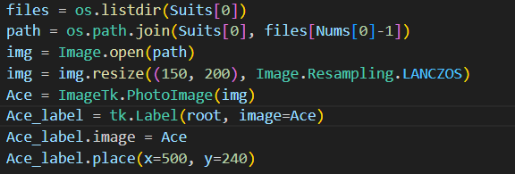

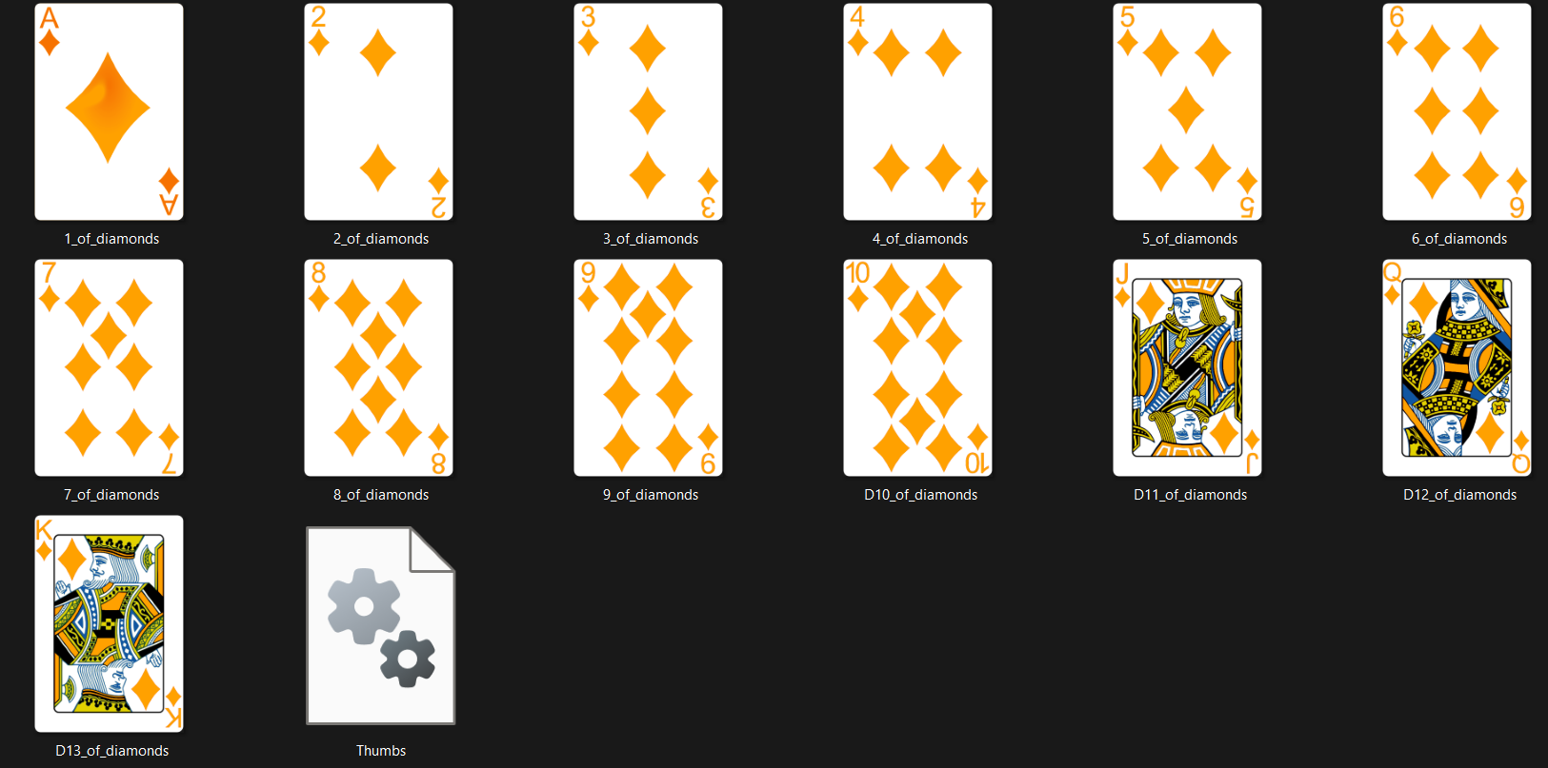

Bet Graphic
Once the players cards were displayed, the next stage was to transition into the bet function, by asking the player if they wanted to check or bet.
If the choice was to bet, the program also needed to ask for an input with a new textbox, and only continue once the bet was valid. After either choice, the program would go into the bet function, and continue as it did before.
Each separate path the player can follow is treated as a different function, before going back into Bet. For the bet side of things, Things are broken up for the sake of destroying specific buttons when they need to be broken.
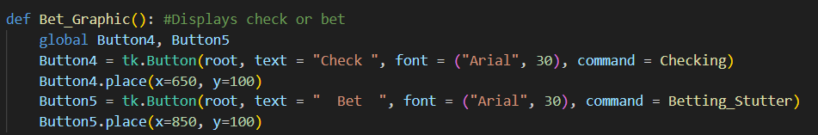
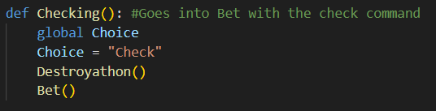
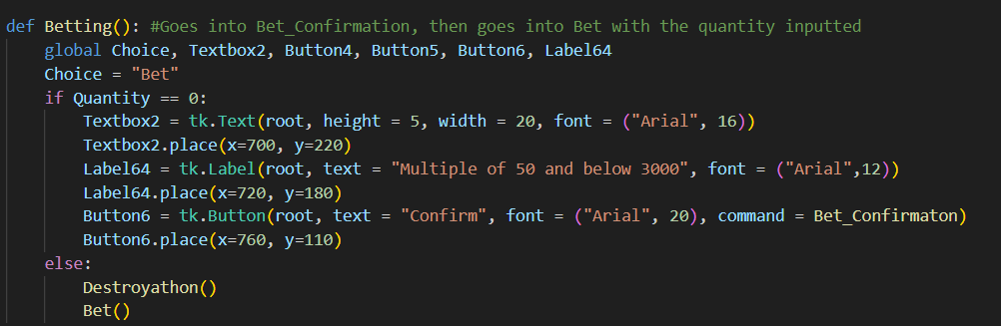
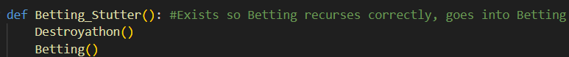
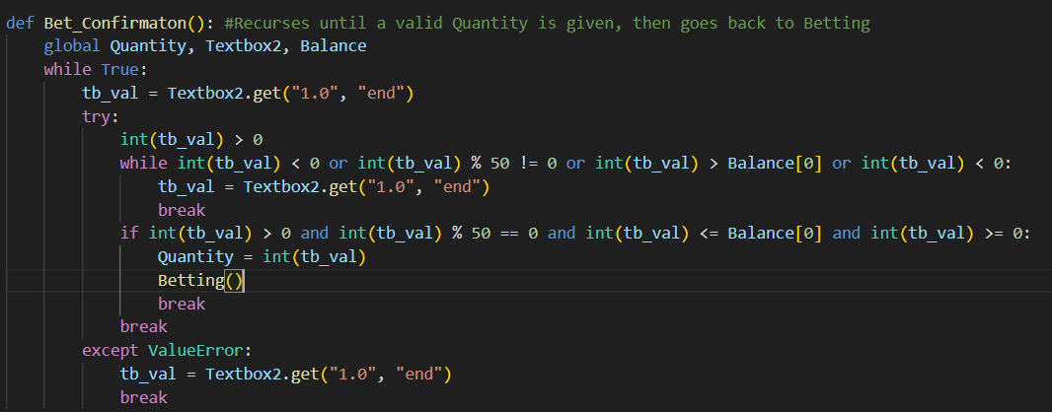

Milestone Review / Testing
Testing
Betting GUI validation
Input | Expectation | Reality
50 | Valid | Valid
44 | Invalid | Invalid
a | Invalid | Invalid
0 | Invalid | Valid (Fix for this described at the start of evaluation)


This invalid option would not progress the code and wait until a valid input was put in.
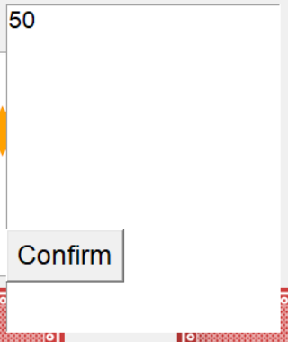
This valid option would delete all buttons and textboxes on screen, then would print out a verification it had reached the betting function.
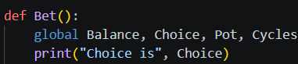

Review
This milestone did not need much testing, as it was very self evident when the graphics did or did not work. The only bit of testing needed was to ensure the betting graphic worked correctly, and ensuring it transitioned back to the main code correctly. It was difficult to learn how the basic components of a GUI actually worked, but once the fundamentals were learned development was simple and easy.

Raising milestone

Computer Raising
Once the GUI work was caught up to the bet function, the next stage was to develop the option for computers to bet and re raise. There were many issues to consider, the main one being that unlike betting, the raising algorithm could loop indefinitely for each computer, as well as that it could begin on any computer rather than guaranteeably beginning at the player.
The initial idea was to have a function where everyone from the computer making the bet to the end of the computer list would have an action, then the player would input their choice, then everyone from computer 1 to before the computer of action would make their action. If anyone made an action, the function would recurse with a new computer of action
Eventually this got simplified to one single for loop, that would go through every computer but would start at the computer of action, but before recalling the loop of computers the player would be given the ability to make an action. The second loop became redundant as the method of tracking became if all players had put in the same amount of chips for that betting round, meaning everyone had called a bet.
This also required that the computer that transitioned us to what I call the “Step loop” needed to be handled differently then every subsequent bet

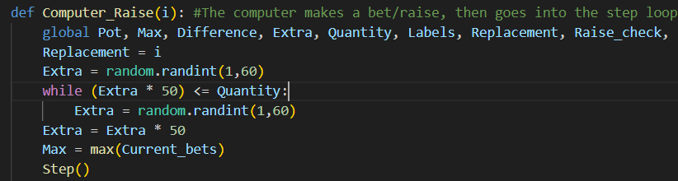

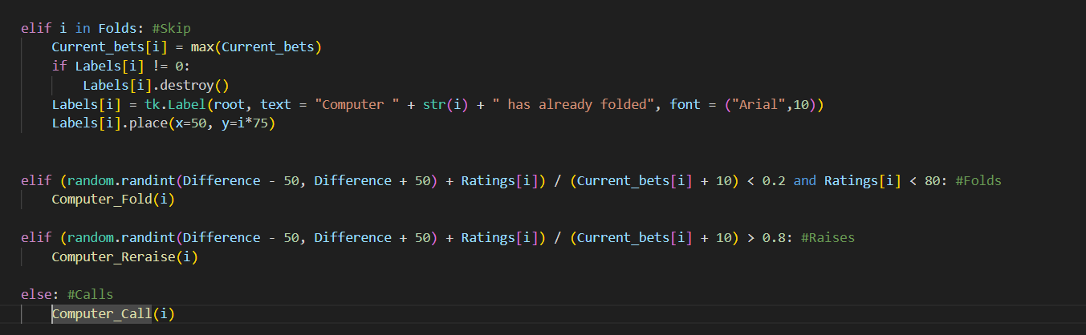

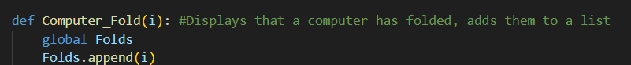

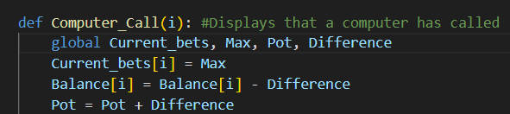
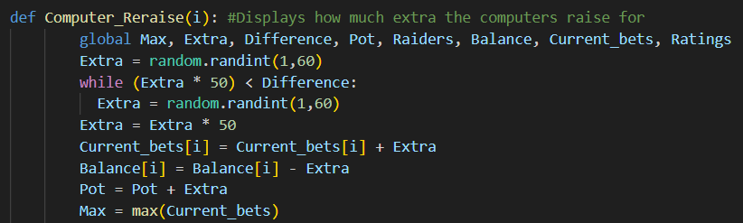

Raising GUI
After progressing the Computers Betting abilities, next came what ended up being the most difficult part of the entire program, implementing the GUI for the players raise. This part of the GUI was so much worse than the check/bet area since there was so much variance, and it was being run right next to a for loop. The original idea was to run a while loop that only exited it’s condition when the player made an input, but pythons TK-inter doesn’t allow while loops if they block access to root.mainloop, so the entire logic structure had to be reworked to accommodate. There was also a lot of variance, as unlike with Check/Bet where many variables are controlled, here any amount of computers could make whatever bet they wanted, and each could do that in indefinite amount of times.
Once that was sorted, we still needed the options of Calling/Raising/Folding. I chose to use a similar model to Bet, where I send each button to the same function, this time Player_Raise, but with a different command.
The work for folding has actually already been done as Check/Bet should never have had the option to fold, so I just needed to re use the button and make it send to a different location
Calling wasn’t terribly difficult, after making a unique label which displayed how much the player needed to call for, The necessary chips simply needed to be taken from balance, added to Pot, and update the current bets.
Raising was rather unorthodox, as the work put in to get the players input could be mostly re used from the Bet function done earlier, simply needing different values and sending to Player_Raise. The challenging part was updating the universal variables correctly, as verifying the right amount was added to the pot, or that Current_Bets was being changed by the perfect quantity, was hard to fine tune and even harder to detect if it was working properly.
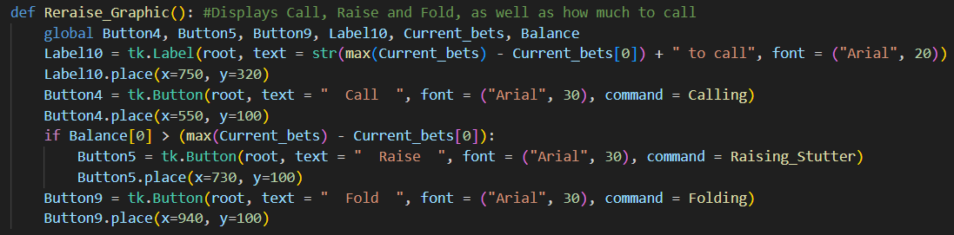
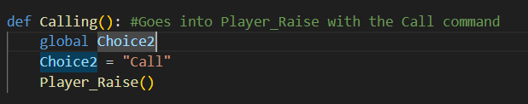
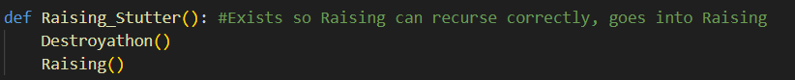
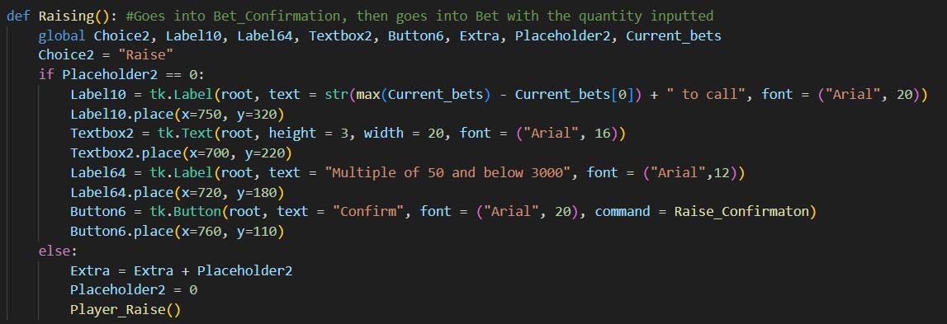
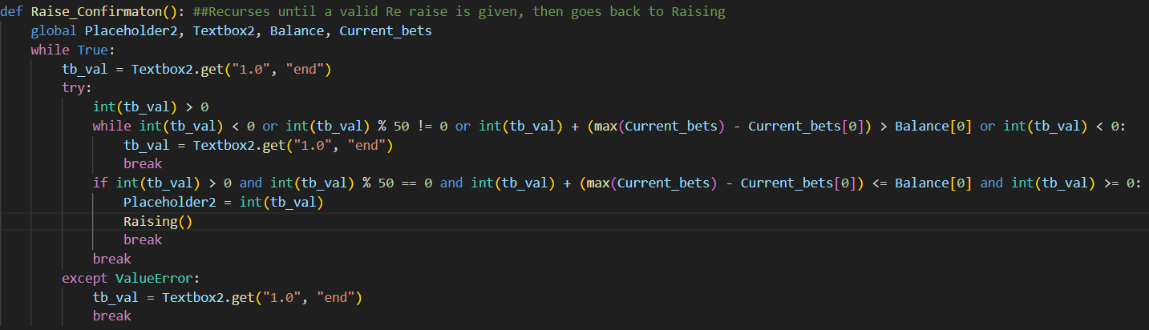
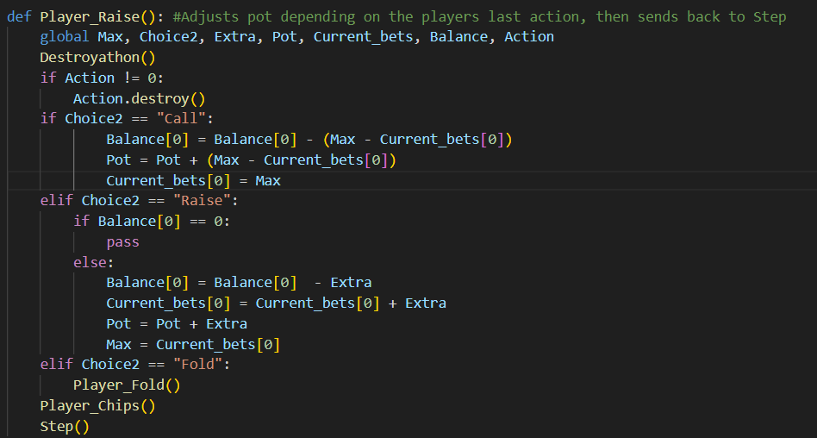
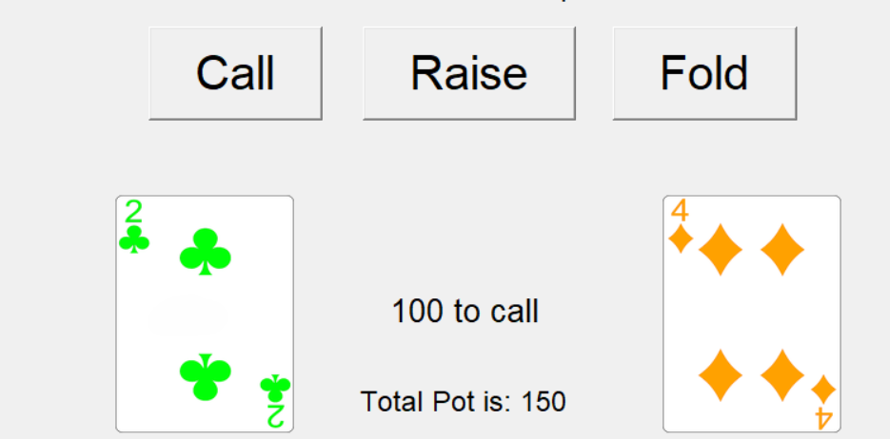

(if Raise had been pressed)
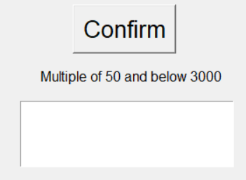

Milestone Review / Testing
Testing
For this milestone, the important part was to choose either call or raise, and go through these options while ensuring every action from the computers adds up, so for example ensuring that every time a computer calls, the correct amount of chips go into the pot. Because of the amount of variance in the computers choices, as well as having to account for the player either calling or raising, this function had to be tested for a long while before confidently being able to call it finished.
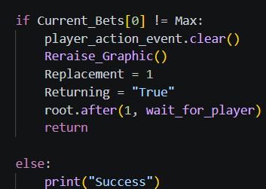
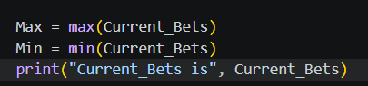
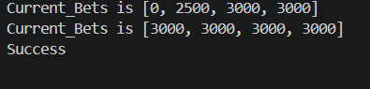
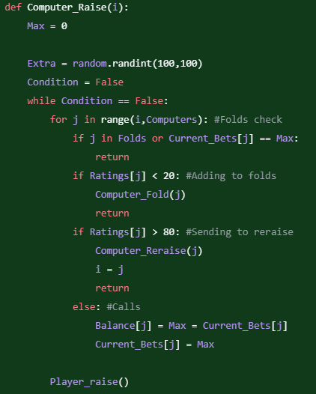
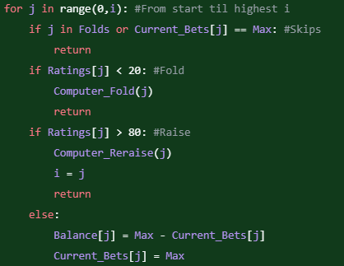
Above is an example of a failed solution, splitting the step loop into 3 distinct parts (Before player raise, player raise, after player raise). The program would loop to the start if any raise was made, but this never worked as the program would never know which computer to properly start on, so instead it was reworked to have an initial controlled segment, starting on the computer who raised, then go into the step loop which guaranteed the player starts. This also made the GUI possible as a while loop could not be done to stall the players action.
Review
This was, without a doubt, the worst milestone out of this program to implement. And I knew it would be bad going in, with the entirely new logic I had to pull from, the many different possibilities this function would have to account for like which computer started the raise or how to break the infinite loop of computers raising, and there was still concern of implement the computers rating from each hand and incorporating It in a way where the RNG would feel natural. Then the GUI needed developing, and while loops are non compatible with root.mainloop as python demands the code be able to return to root.mainloop constantly, and a while loop stops the program from doing that, so an entirely new solution with set_action_value had to be learned, integrated and developed. And then with how many different possibilities this milestone includes, testing took a lot longer as well given having to test every computers action several times against every players action, and the order of which computer started made everything horrible.

Updated GUI Milestone

Chips Displayment
While fine tuning all of the Betting functions, I also wanted to display how many chips each player had, as it would make testing faster since I wouldn’t need to constantly switch tab. It also made the pot update much more accurately than it would otherwise. It was decided that the players chips would be displayed predominantly at the top, while all the computers chips would be seen at the edge. Setting up the computers chips now would also make it easier to display their actions through the GUI later.
The displayment would be stored as variables in a list, each index corresponding to the computer. The player’s chips would be stored in the same list, but called by a different function due to the different positioning.
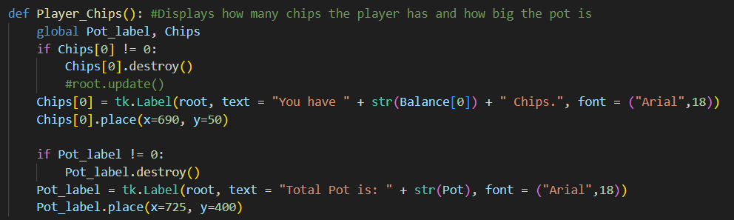
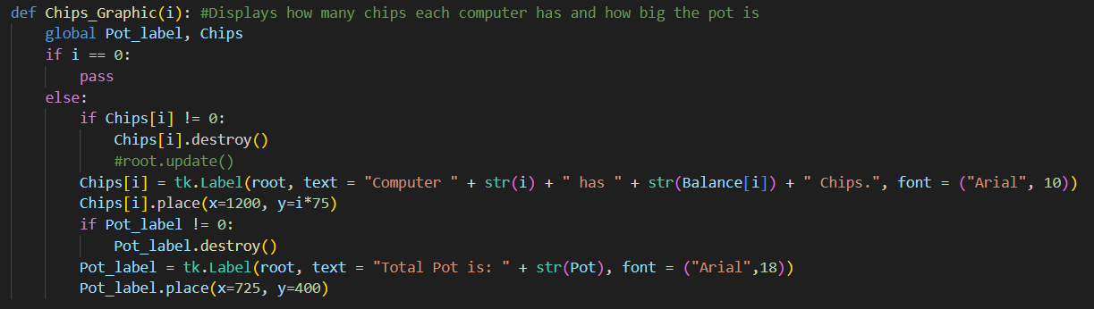

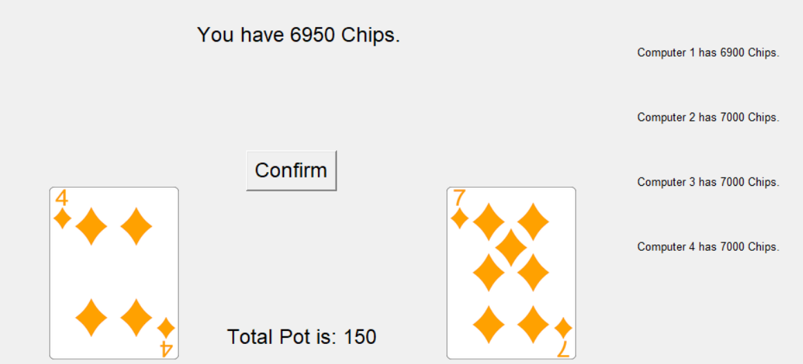

Computer Labels
Once Chips were correctly integrated to the GUI, Labels indicating the Computers last action also needed to be added, although these were slightly harder given the innate variation. The solution was still similar, updating each computers action using the index of “Labels”.
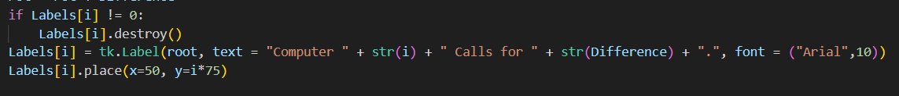
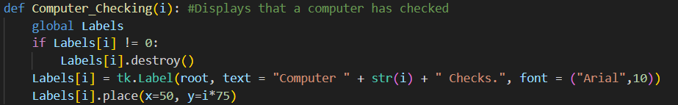
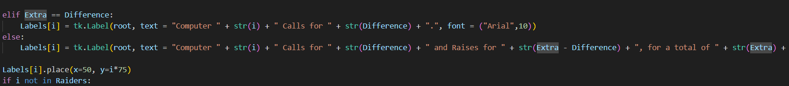
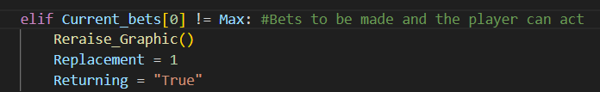
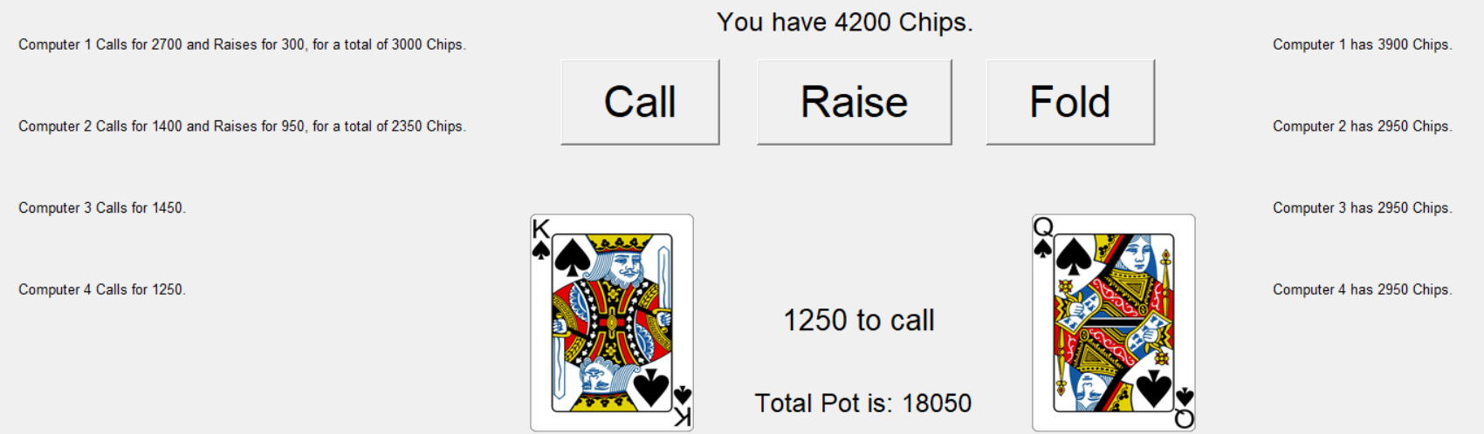

Betting phase GUI
This entire processing required a lot of testing, so while verifying every step worked correctly, I began developing the next stage, that being transitioning to the start of the next betting phase once everyone had called. This would require identifying when everyone was finished, resetting variables and GUI elements, and displaying the new turned over cards.

The first stage was verifying that everyone had successfully bet, which was a condition that was always being considered while building this area, so implementation was simple
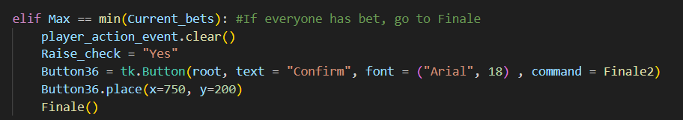
Instead of immediately resetting everything on screen, I added a confirmation button to allow the player to process what changes were being made, and only reset everything after the button was pressed.
Finale2 ends up being one of my favourite functions simply because it’s necessary to create an entirely new function that is 1 line long
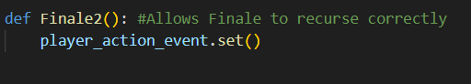
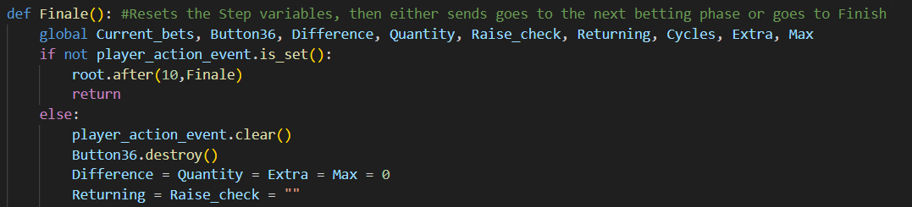
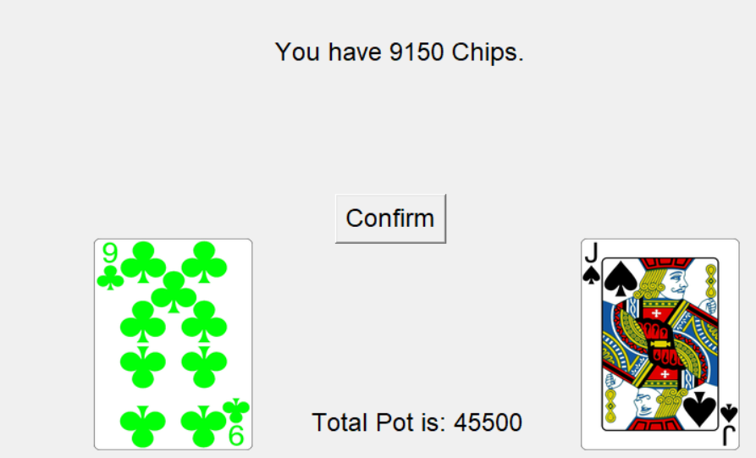
The number of cards to be displayed was dependant on how many cycles had passed, as the first time 3 cards needed to be displayed, the next 2 times only 1 card, and the last time would need to send to a finishing function
I knew I wanted to keep the displayment of all the players cards in one function, so I altered Drawing to allow for the other 5 cards, using different positioning depending on how many time the function had been called
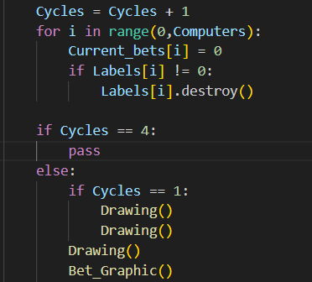
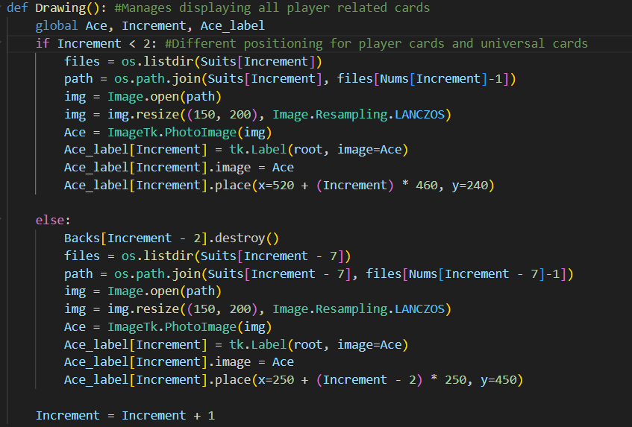

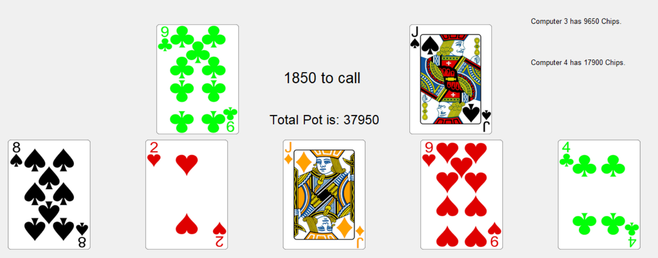

One of the most amazing feelings I got from this code was when doing just another test for the step loop, with the bare bones untested code from the Finale function in place, the program managed to correctly transition to the point where all 7 cards were being displayed, while still having the betting process happen. At that point, it had been ages since I had last been testing where all 7 cards were being printed/displayed to me, and seeing everything connect was a great feeling.

Backs GUI
While displaying the cards, I also realized I wanted to add the “Backs” of cards to the GUI. This was so it didn’t feel like cards were popping out of thin air in-between each betting phase.
I searched online again for a suitable png that fit the aesthetic of the main
cards, eventually finding:

This png had the same proportions as my other cards, and the curves at the corners were similar enough.
I had also found another card I liked with the correct proportions, but the design was too complex and the shadows clashed with the other cards aesthetic
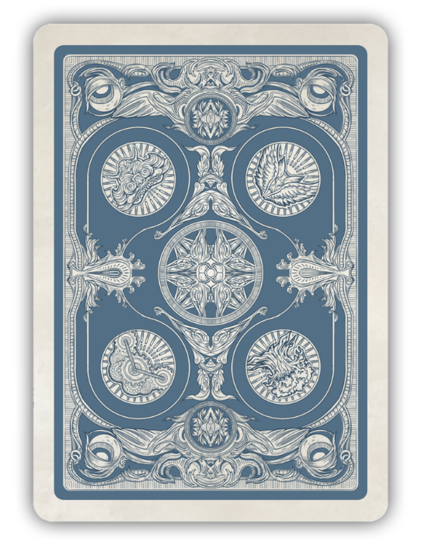
To incorporate the backs, Drawing() was modified to display 5 “Back” cards when first ran. Each back card was in the exact same position as where every Card would end up. Each time after the initial 2 times Drawing was ran, A back card would be destroyed to open up for the real cards, simulating the idea that the cards had been “Turned over”
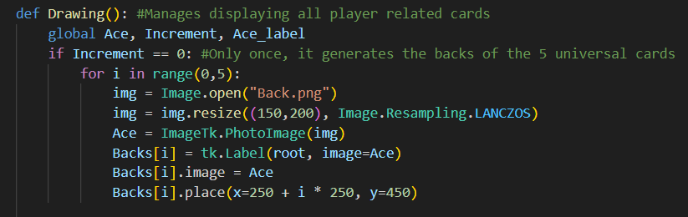
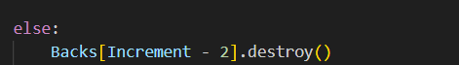

Ranking Graphic
Once the cards were on display, the next step was to move the ranking system up to the GUI, as once that happened an entire cycle of the program would be playable. A lot of the work had already been completed, namely the specific wording on each hand as well as incorporating the hands Minirank where appropriate.
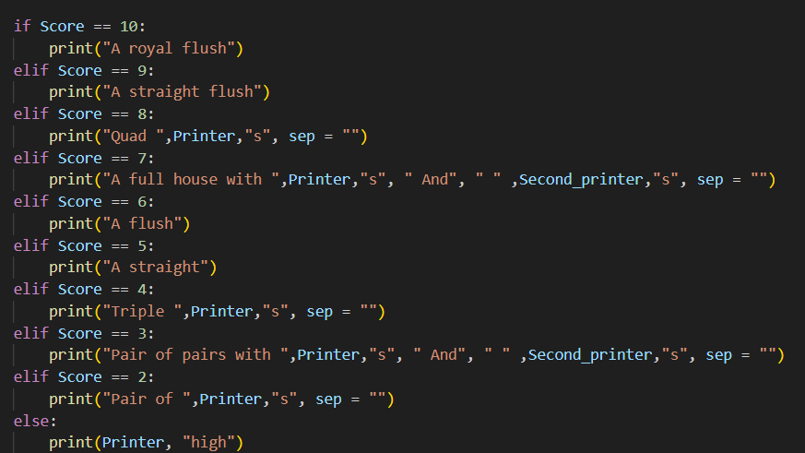
Many changes were still needed, obviously moving it all from prints to Labels, but also accounting for the different wording that comes from different scenarios, like if it’s the players or computers hand.
Printer and Second_Printer were always used for displayment, being the Minorant of each hand AFTER accounting for the different names for ranks poker uses. Third_printer was added for the different wording between “You have” and “Computer 1 has”, as well as the different wording for high card and triple. Third_printer is then concatenated with the other Printer Variables and other strings to form the message. The message is then place in the exact same positioning as the computers action messages.
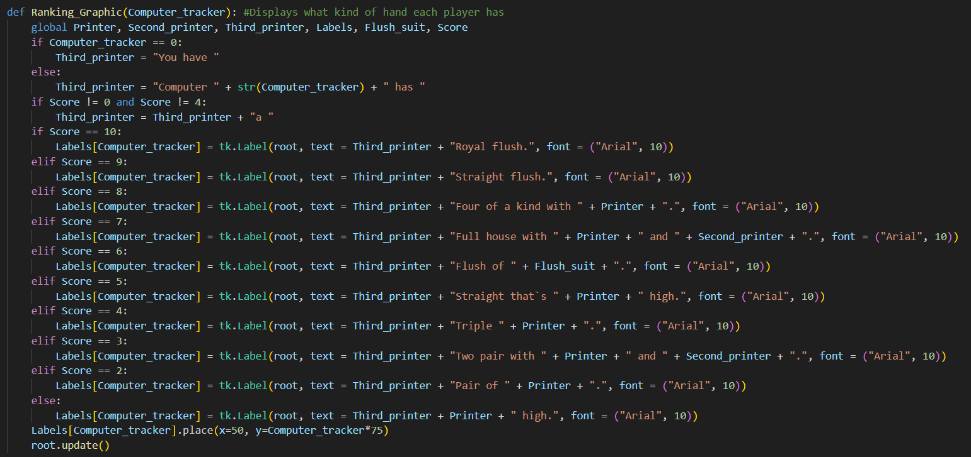

Computer Cards GUI
Now that the GUI was completely caught up with the main code, the program now needed ending functions that would transfer the value of the Pot to the correct players Balance, display the cards of the correct computers, display who won overall and finally resetting variables before calling one of the starting functions, establishing the loop.
Poker gives the privilege to players who have folded that they do not have to show their cards, and I wanted to reflect that in the program, so the program skips over players who are in the folds lists
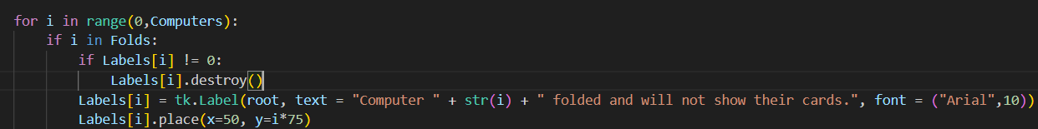
For the remaining computers, their 2 cards were decided to be displayed around their chips. From previous work with Cards_Test, I already knew exactly how to find each computers card by indexing a list.
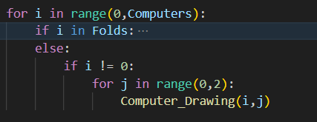
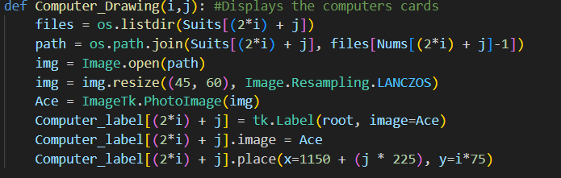

Milestone Review / Testing
Testing
Throughout testing, I found that on occasion labels would overlap with each other, making a horrible effect that stops the player from understanding what is and isn`t true. This could happen with computer actions but was far more common with the computers chips.
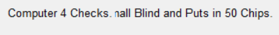
My first solution to this problem was to destroy the index for labels every time labels could be changed. This was implemented before, but with the current problem in sight I doubled down and added these destruction checks in more places than even I thought necessary.
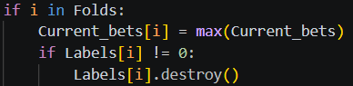
After more research, I came to understand the real issue was more of a software problem, the GUI could not update all the graphics fast enough consistently, and therefore would sometimes not properly delete what was on screen despite that when I printed the indexes for labels, they would be 0. To fix this, root.updates() were placed after any Label was placed on screen, and applied this to the chip and pot variables for good measure. After tests with the root.updates() in place, the labels stopped overlapping.
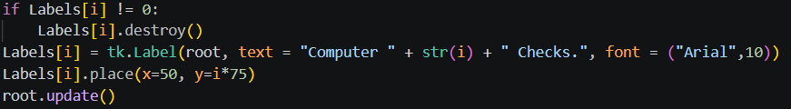
Review
This milestone did not need much testing, as not only is it very self evident when GUI elements are correctly made, but most of these changes are isolated additions, like the chips graphics or computer action labels, that don’t impact other segments of code.

Ending Milestone

Finish Function
After finish was done calling Computer Drawing, the function needed to display the rest of the important info given at the end of the game, including who had won and how many chips to give the winner.
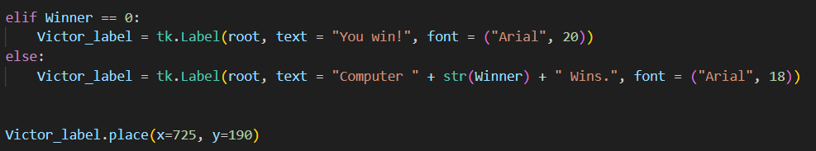
I needed a confirm button after all info had been displayed, and this button would lead back to the start of the program. The function that the button sends to also needed to destroy a lot of labels.
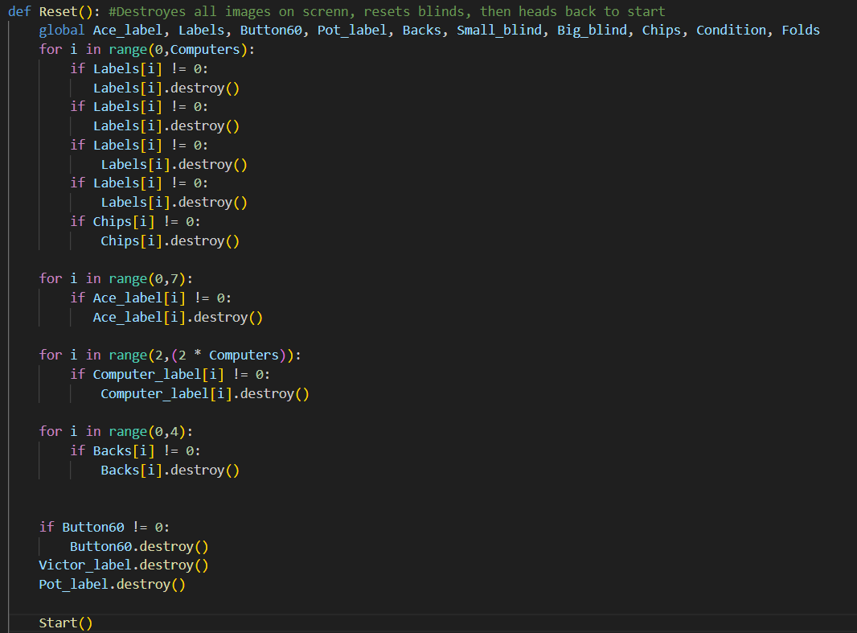
Now that the program was looping, I realized I wanted 2 options for the player at the end, to reset the loop and begin to betting loop again, or reset all the way back to the first page. The difference being that the Balance of every player would reset, and the amount of computers playing could be changed.
This required a change in logic, as before the start of the program was held outside any function, as it wasn’t intended to be re called until now. The idea was to make an “Initiate” function that could be called, and that initiate function would lead into the Playing function which gets computers, then that would lead to the Start function, which is where the program would loop back to if “Next round” was pressed.
This is also when Balance was changed to not be a txt file.
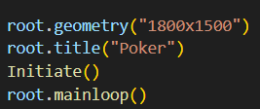 (Only lines that are outside any function now)
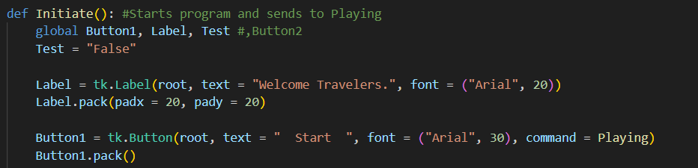
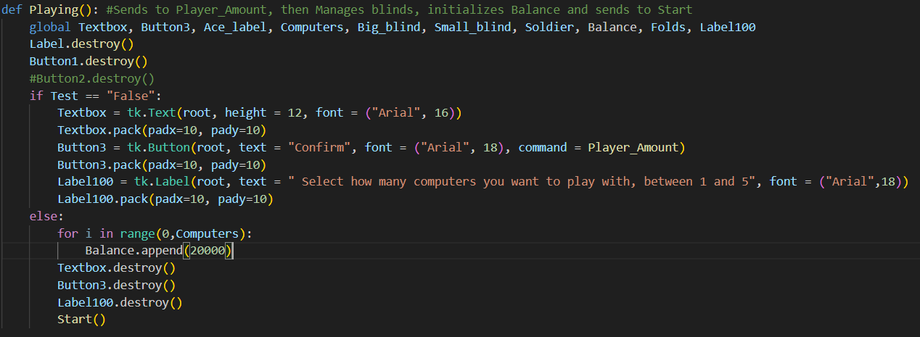

This process would also require 2 buttons for the player to press at the end, however there was a small issue, they would need to go to different places while both requiring the destruction of the Reset function. On top of this, I didn’t want the next round button to display if the Player didn’t have any chips left to bet, or if the player was the only one left to make any action. To fix this, this new button would go to “Reset Buffer” which would change the flag on “Condition”, before calling Reset. Reset would then be altered to go to either Initiate or Start depending on if the flag was triggered.
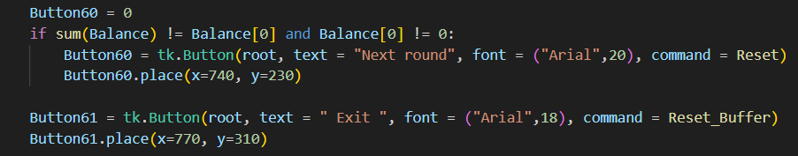
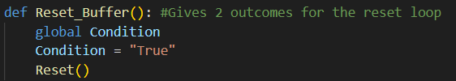
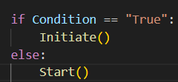

Betting Backdoor
With the Reset functions in place, the program now had its entire infrastructure in place, looping back on itself and branching where it needed to.

There was one edge case left to deal with before implementing other Poker features, and that was ensuring the program ran it’s course if every player had just checked, as otherwise the step loop would never happen and Finale would never get called. This wasn’t an issue during development as the values for the computer checking could be made too low to be achieved, making testing the step loop guaranteed. However, when adjusting for the values I want the code to have, this scenario must be accounted for.
To fix this, I added what I called a “Backdoor” to the Bet function. This Backdoor would connect straight to the Finale functions, and would only activate if the program never made it to the Step loop, a condition verified with the variable “Raise check”
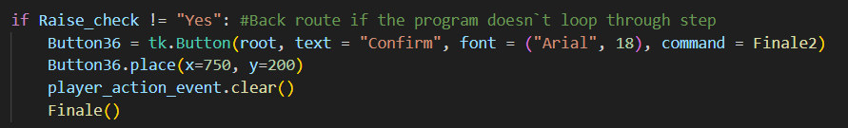

Milestone Review / Testing
Testing
Input | Expectation | Reality
All variables except player balance is reset. | Valid | Valid
Information from a previous round can be seen in this new round. | Invalid | Invalid
Players balance is reset. | Invalid | Invalid

Review
The important thing to test for within this milestone was ensuring all variables reset correctly on round restart, and that the program could not break from bringing a variable in that should not exist yet on a new round.
Balance also needed special adjustments during this testing period, as it is one of the few variables that doesn’t reset upon pressing “Next round”
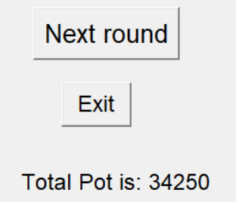
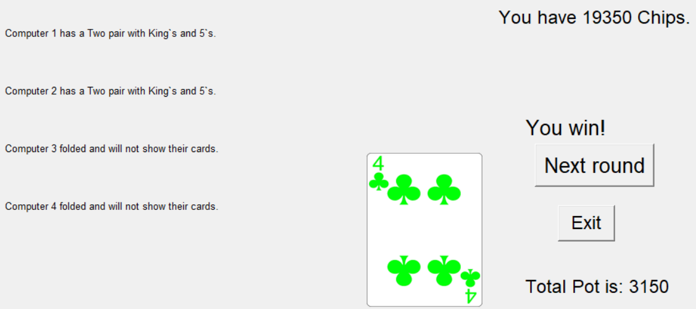

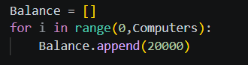

Additional features milestone

Player Folding
Now that the program would always run its course, there were certain necessary features I had abstracted on the way here though, and with the structure in place, adding these more complicated features would be easier.
The three big components left to deal with were the player folding, Blinds and the all in system. Of these, player folding seemed to be the easiest to implement.
The problem with Player folding was having the code naturally progress if the player had folded, as a lot of the progression is tied to calling a function after the player makes a bet or something similar. The solution here was to add a condition of if 0 was in Folds. If this condition wasn’t met, the program ran as it did before, but if it was, a confirm button was displayed instead that would send to the same place that Checking/Calling would.
Finish was made with the idea that the player could fold, even though it wasn’t yet implemented, so the main changes only needed to happen in the Step loop.
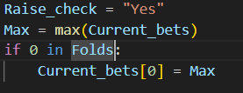
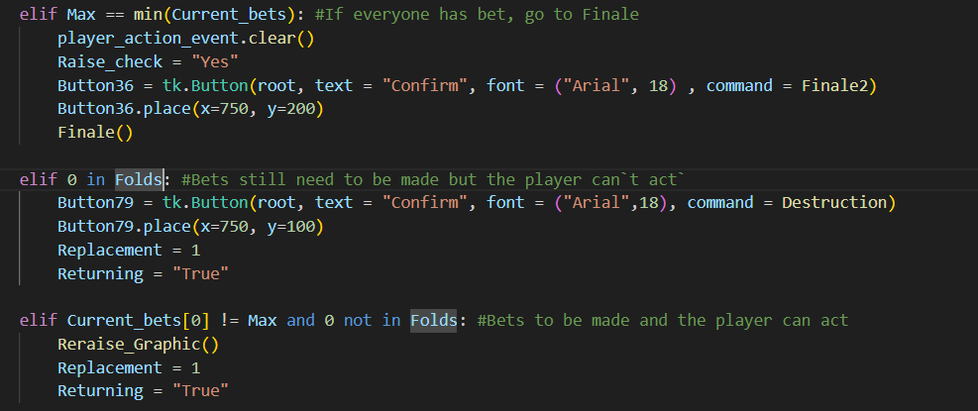

Blinds
What remained after implementing the Player Folding system were the 2 features I was dreading implementing the most, Blinds and All in.
Starting with Blinds, strictly speaking they aren’t the problem. Blinds are just taking away a little bit of Balance from certain players at the start of the game, meaning the first action is to call the Big blind, rather then Check or Bet. The real problem was that the first action begins on the player after the big blind, whereas up until this point, first action was always on the player.
This required major logic overhauls, as not only could Bet_Graphic not be consistently called anymore, but the options both before and after the players input grew substantially.

To begin with, the focus was replacing the initial Check/Raise part with an appropriate Call/Raise/Fold, as well as getting deducting the Blinds from balances along with corresponding new labels. After Computers gets inputted, a random player gets designated as the Big blind, and the computer before that gets designated as the small blind, with some insurance to check that player -1 doesn’t become a small blind
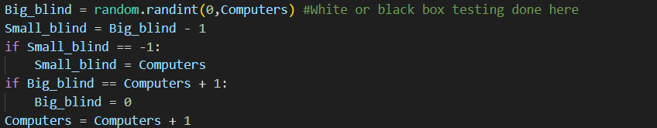

Start then got a major overhaul, instead of sending straight to Bet_Graphic, it runs through other functions before eventually arriving at the step loop.
While still in step, Current_Bets gets adjusted, treating it the same as if a player made a bet of 100

Then, Start calls a new function called “Blinds_Graphic”, displaying which players are the big/small blind, then throwing up a confirmation button
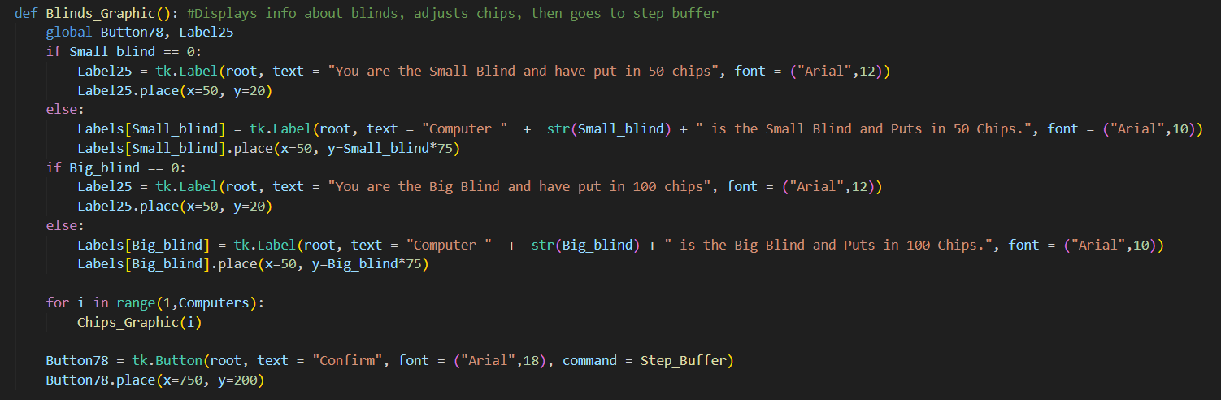
That confirm button connects to “Step_Buffer”, which deletes the Blinds Labels and then calls step
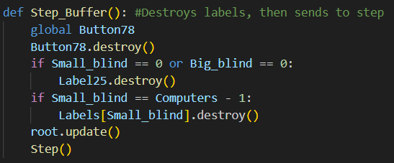
Finally, there was a small adjustment made in the step loop to have “Extra” work as intended.
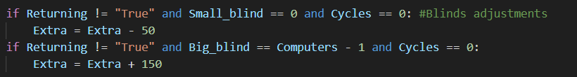

Intermediate Function
Once the changes to the first betting round were finished, the next step was to have every other betting round start on the player of first action, done by making the function “Intermediate”.
In poker, the player of first action is always being the next player still in play after the big blind. This player of first action was called the “Soldier”. The idea was to have all players from the Soldier to the end of the computer list act as if the Player had checked. If any of those players made a bet, then the step loop would take over, so the rest of intermediate wouldn’t need to run for the rest of that betting. If all computers checked, then the Player would be given the option of Check/Bet. If a bet was made, all computers would need to call/raise/fold, but if Check was pressed, only the computers from computer 1 to the computer before the soldier would need to make an action, and if all of their actions were checks then the next betting phase went on.
If first action was on the player, the code would run exactly as it did before
If the player had already folded, then everything would run the same except with a confirm button instead of giving the player a choice. This would require an extra buffer function because of the nature of Buttons.
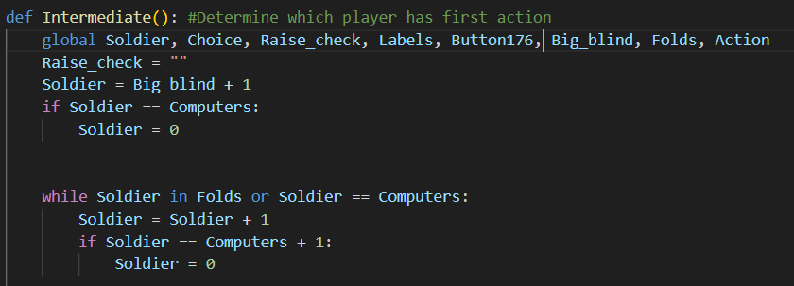
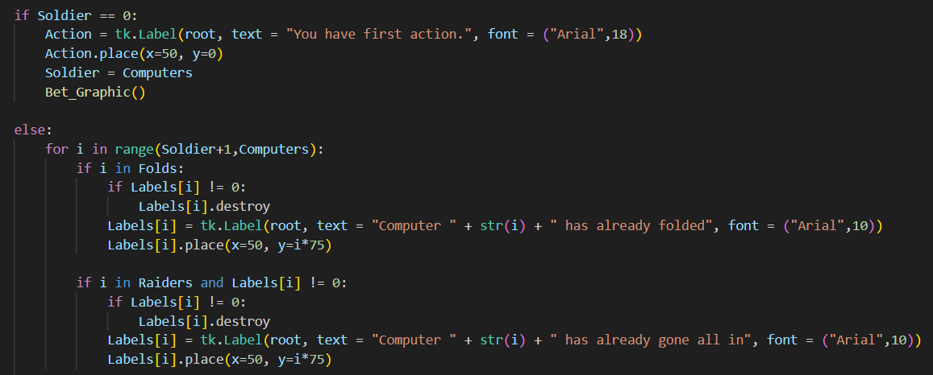
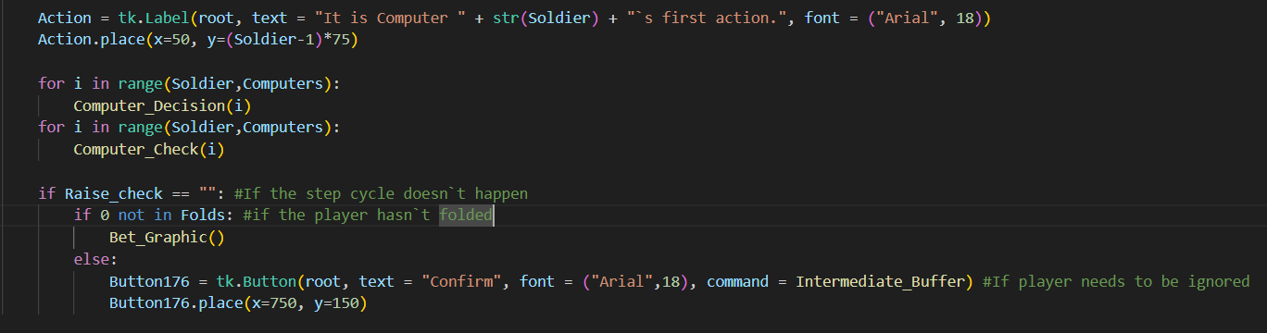
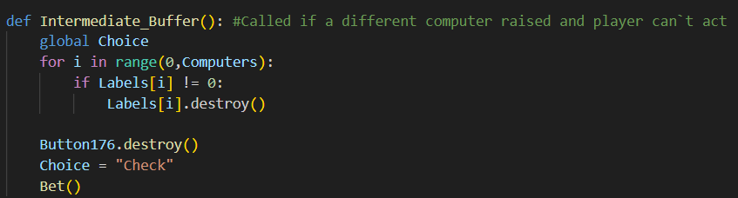

Computer All In
Once the intermediate system had finished refinement, the only feature left to implement (besides some rng adjustments) was the All in feature. This feature would stop players from having negative chips, as well as skip their turn of action if they had gone all in.
In real poker, if 3 players are in, and 1 player goes all in but has less chips then the other 2 players, the all in players turn of action gets skipped while the other 2 play as normal. If the all in player lost, the chips would be given to the winner as normal, but if they had won, they would only get as much as they put in multiplied by the amount of other players, then the remaining chips would be given to the second winner. In this program though that would be incredibly difficult to implement for such a rare scenario, so instead all the chips are given to the winner as normal.
This task was broken down into 2 parts, Computers going all in and the player going all in. Starting with computers, everytime they have the ability to put chips into the pot (Betting, Calling, Raising), a check is made to see if the amount they want to put in is greater or equal than the amount of chips that computer has. If not, the program runs as normal.
If they don’t have enough chips, the function “Overflow” is called, which adds that computer to a list called “Raiders”, indicating that computer had gone all in. All areas of the code that skipped a computers turn if they were in the Folds list were reworked to skip if they were in the All in list as well, including different visuals where necessary.
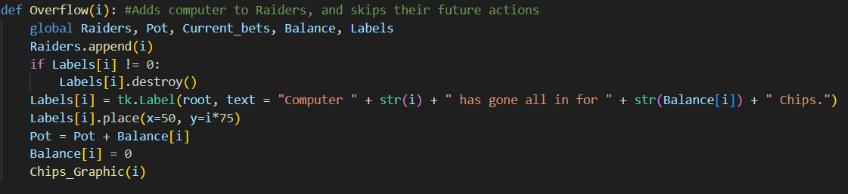
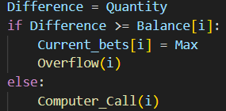
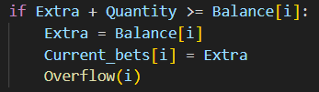
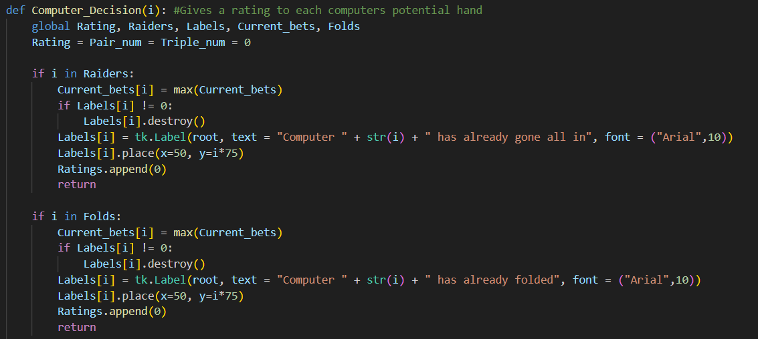
To avoid infinite loops, the Step loop was adjusted so that if the computer went all in by calling but didn’t have enough chips, “Current_bets” treated it like they always called without affecting the Pot.
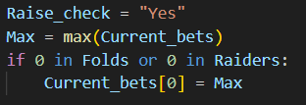

All In Backdoor
Before tackling the issues that come with the player going all in, I first had to deal with an edge case that only started appearing now that computers could go all in. In poker, if every player but one folds, the game immediately ends and the remaining player gets all the chips. If every player has either folded or gone all in, then every card would be revealed and the winner would be decided, skipping betting rounds.
Technically this feature did exist a while ago, before the GUI ever existed. I gave myself the option of going all in which would skip straight to the ranking system, although of course that was used more for testing and couldn’t be implemented that easily now with all the extra factors
To fix this, a new variable called “Tally” was created that would increment every time a player had folded. Using this, new Backdoors were created that linked straight the Finish function. 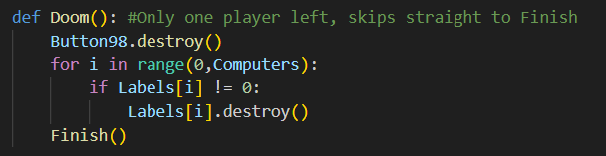
Tally + len(Raiders) would determine how many players were skipping rounds, and If that number was greater than Computers – 2, then that would mean only 1 player was left to make an action, which is entirely pointless.
This backdoor was placed in the step loop, but another was also needed in the Bet function, although this one didn’t need a confirmation button for the program to run smoothly.
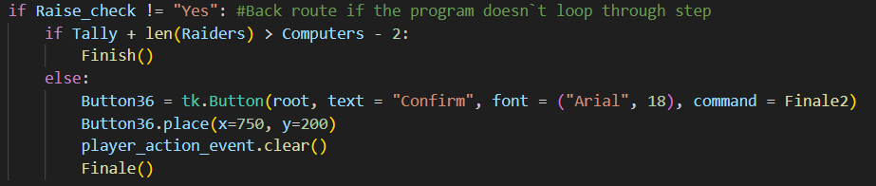

Player All In
With nothing else left in my way, it was time to tackle the final obstacle of this program, that being the player overflow system.
The first stage was correctly going into Overflow. There are 3 ways for the player to go all in, the same Betting/Raising/Calling that the computers can do. Calling was left last due to it’s higher complexity, so Betting/Raising were solved first, done by branching paths during the confirmation functions if the Bet/Raise made was the same as the players chips
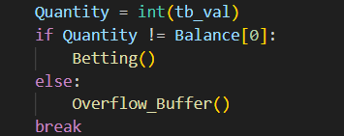
The branching path would lead to a confirmation button, necessary not for the program flow this time, but so the player was fully aware of what they’ve done, as going all in is rarely a choice made lightly.
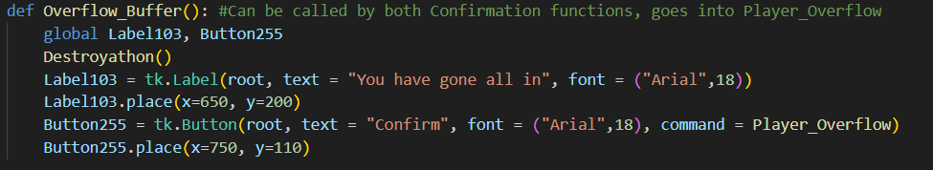
Once in Player_Overflow, the player would be added to Raiders and have their balance adjusted just like the computers Overflow.
Where to send the program after overflow wasn’t a problem for the computers overflow, as either a for loop would progress naturally, or the step loop would take over. For the player overflow however, since we branched paths and broke progression from multiple places, Overflow would need to call the function that the program would’ve called overwise.
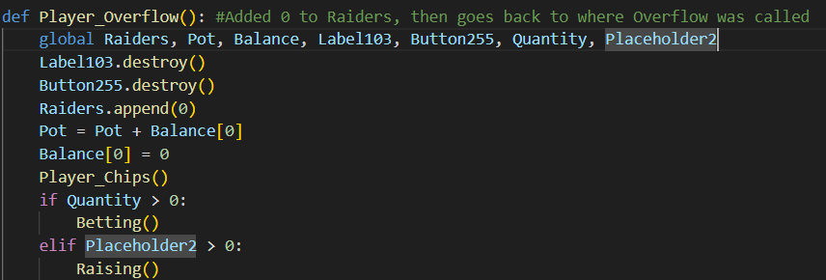
For when the player went all in by calling, the program would increase the pot by the amount of chips the player had rather than how much needed to call, then would handle Current_Bets the same as if a Computer had called with insufficient chips, then went in and out of Overflow.
Also, if the player could only either fold or go all in by folding, the Raise button would be taken away from them, not only helping the player understand their options, but helping to not cause an infinite loop where the player could never make a sufficient bet.

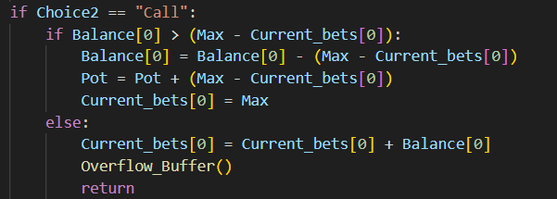
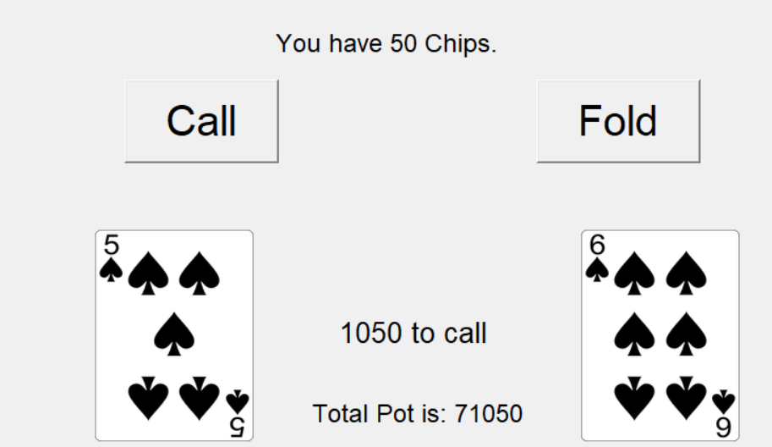

Once the player had gone all in, the same skips were made as if the player had folded, making this process dramatically easier than if I had implemented this feature before the Player folding feature. All the confirm buttons that were needed were already built when designing folding.
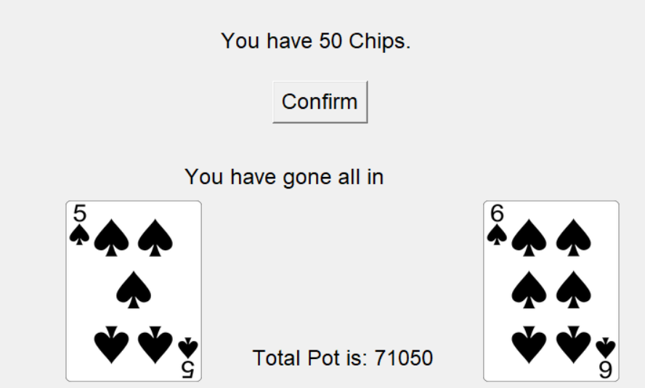

RNG Adjustments
At the very end of the program’s development, I knew I would want to go back and adjust the rng aspects of the code, trying to get every instance of rng to work exactly how I would want it each time I incorporated a new form of rng would be impossible. However, looking back, most elements of rng, namely the computers decision to keep/fold/raise any hand, ended up being about what I was hoping for. The computers would keep still play bad hands occasionally while mostly playing if they had good hands. They had patterns that could be observed and potentially outplayed, but never 100% consistent, keeping it from being stale. The most complicated it got was when determining for the computers to call, raise or fold, as in order for the code to not do an infinite loop in the step function, the rng needed to be dependent on how big of a bet the computer needed to call, as well as the computers rating.
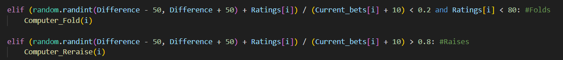
The exception to this was the rng attached to how much the computers could bet/raise, both instances just being a random.randint(1,60), then multiplying by 50. The giant problem with this was the computers could only ever put in up to 3000 chips at a time, which not only removed a lot of variance, it ran a high risk of crashing as if the player made a raise and a computer needed to call for over 3000 chips, the program would be caught in an infinite loop where it tries to make a better that’s always too small.
This is what the rng looked like for the majority of the codes life:
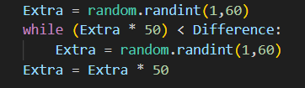

The next image below was my first attempt of fixing the rng, basing Extra on Balance, Difference, how much had been put in and which betting phase the game was on. This didn’t solve the primary issue however, as either the computers would go all in nearly every time, or when putting the bounds between a factor of Balance[i], it would quite consistently cause an infinite loop that could never reach Difference.

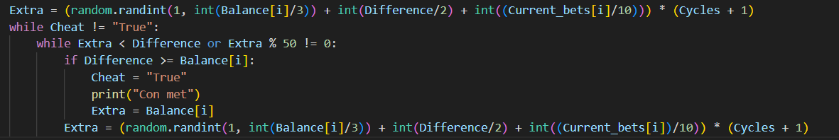
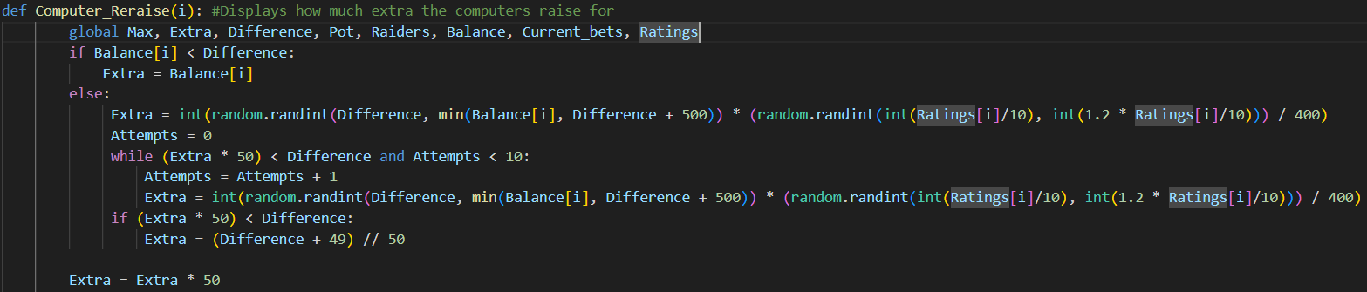
This was my final version of the rng, now using Difference and Balance as the bounds, and being dependant on Difference, Balance and Ratings. Furthermore, there is now insurance In place via the Attempts variable, which will forcibly made extra a little bet above Difference, only used if the program can’t get there naturally.
This insurance was also put in place for when the computer wanted to Bet, rather than raise. The biggest issue was always the risk of the program being stuck in an infinite loop, rather than the amount the computers were betting, so these changes were made to ensure all parties could bet as much as they wanted without the program collapsing.
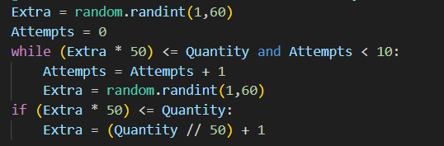

Milestone Review / Testing
Testing
Each of the 3 main components of this milestone needed a lot of attention.
Starting with player folding, since there are so many points where the player would otherwise need to take an action, there became many points that needed to be tested for. Each betting phase had me folding at various points in the step cycle to ensure every scenario was covered.
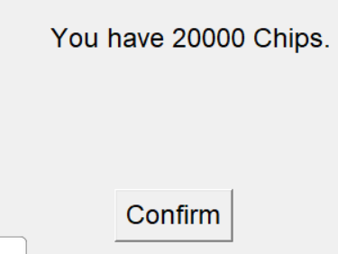
For blinds, once again there were a lot of scenarios to consider when betting phase 2 started (The first betting phase was surprisingly hassle free, relying on the structure already built by the step loop). Every potential first player of action was tested, done numerous times to ensure it worked with other computers folding, and is spread across too many parts of the program to get a screen shot for.
For going all in, there are only 2 spots where the computer could do it, and only 3 the player could so while covering each scenario was much easier, the challenge came in ensuring that the impact of going all in didn’t affect the other components of the code, especially given this was the last new component to the code. The main concern was ensuring the pot was correctly updated, and ensuring players couldn’t get negative chips.
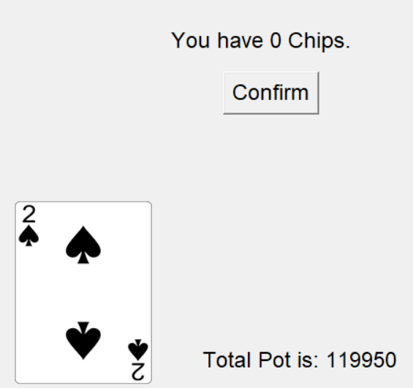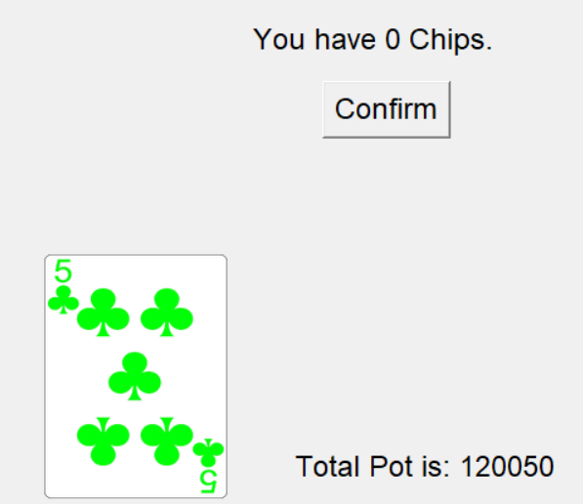

Review
This last milestone was one of the hardest to work through, due to the complexity of the problems (Mostly All in and Intermediate functions) as well as properly pacing myself since I could count how many more features I needed to implement before I was completely finished.
RNG adjustments came significantly later than every other feature, as while I knew the program was not complete without the proper RNG adjustments (the code could break with the wrong input with the bad rng), All in being completed meant no more new features had to be introduced, so I let my mind rest and put a temporary soft cap on how much a player could bet so the program didn`t break, and this stayed until I could mentally go back and fix the RNG.
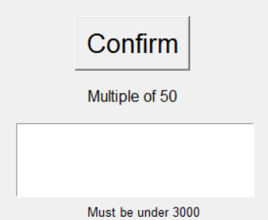

Evaluation

Testing
No. | What is being tested | Input | Expectation | Reality
1 | Validation for computers (Should be between 1 and 5 inclusive) | 1 | Valid | Valid
 |  | 4 | Valid | Valid
 |  | 5 | Valid | Valid
 |  | 6 | Invalid | Invalid
 |  | 10 | Invalid | Invalid
 |  | -1 | Invalid | Invalid
 | (Further details provided below table) | 0 | Invalid | Valid
2 | Validation for Raising (Should be a multiple of 50) | 1 | Invalid | Invalid
 |  | 50 | Valid | Valid
 |  | 100 | Valid | Valid
 |  | 2000 | Valid | Valid
 |  | 49 | Invalid | Invalid
 |  | 0 | Invalid | Invalid
 |  | -50 | Invalid | Invalid
 |  | -1 | Invalid | Invalid
3 | Folding stops the player who folded from making any further action | N/A | A player who folded can’t make any future bets. | As expected.
4 | Pot constantly updates in intervals of 50 | N/A | Pot constantly updates in interval of 50 | As expected.
5 | Reset validation | N/A | All variables will reset except each players balance, and all UI elements will be reset. | As expected, but sometimes a label from the previous round will carry over
6 | Buttons pressed | N/A | Whenever a button is pressed, it will remove itself and other similar buttons on screen. | As expected.
7 | All in | N/A | The player who went all in has their balance set to 0, and every future action of theirs is skipped. | As expected.
8 | Unique cards | N/A | Every possible card that can be generated is guaranteed to be unique from any other card generated in that round. | As expected.
9 | Next round | N/A | When button is pressed the next round starts, and there is another option to return to main menu. | As expected
10 | Computers have free choice over their actions | N/A | Computers may bet/raise/fold. | As expected
A few days after fully debugging my code and believing it was completely bug proof, I let my friend Benjamin Adam Jarvis try out my code, and encouraged him to try and break my code.
He immediately succeeded, by inputting that he wanted to play with 0 computers, an edge case I thought I had covered but clearly hadn’t.
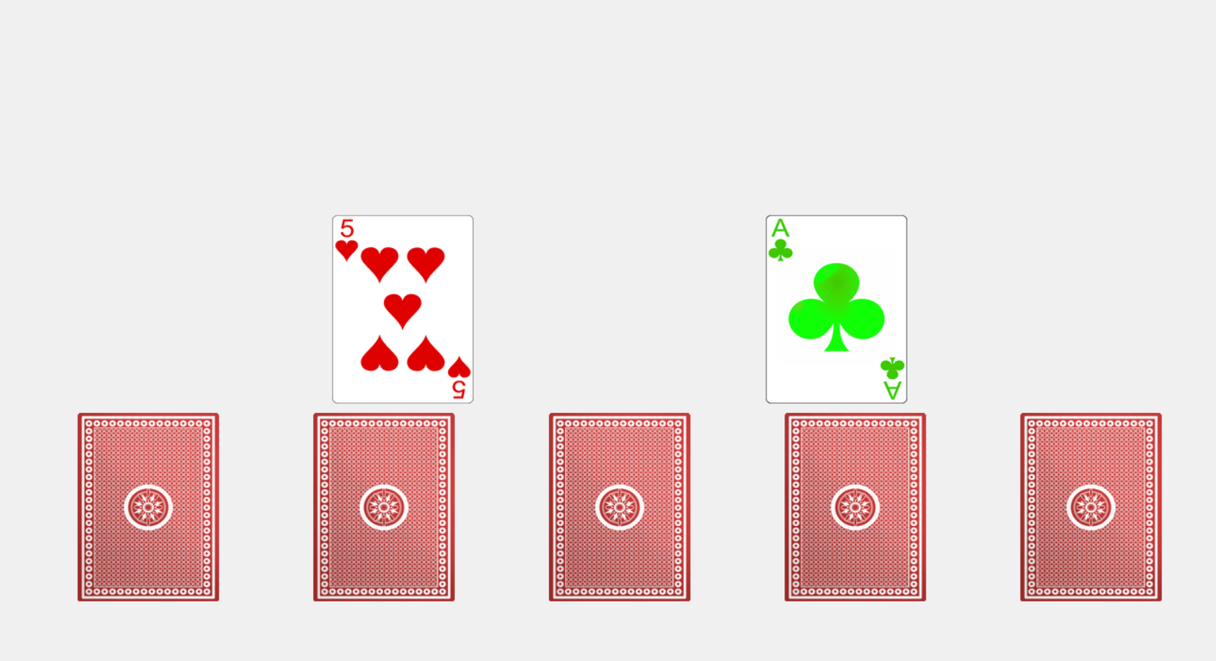
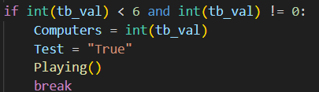(The change made to fix this)
He had also managed to make certain UI elements break in a way I had never seen before, labels staying on screen when they should have gotten destroyed ages ago. The solution to this was simply to use root.update() more, allowing TK inter to work no matter what type of person was pressing the buttons.

While watching him play, I noticed a small issue with my code that I wanted to fix, and that was with going all in with a raise. The problem was going all in required mental arithmetic, trying to get your input + the amount to call exactly equal to your current balance. This was far more complicated than it needed to be, and on top of this the player doesn’t that going all in was even an option.
To fix this, a simple label was added next to the textbox telling players how much they would need to go all in, making the feature much more accessible and intuitive.
The Betting and Calling sides of going all in would not need changing, as it was always obvious what needed to be done to go all in there.
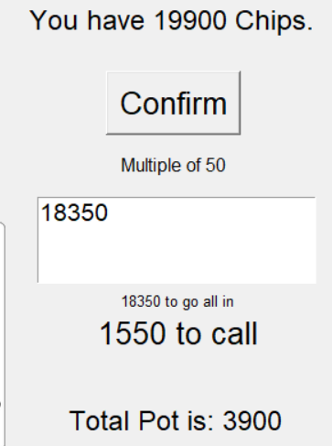

While adding this label helped improve clarity to the player, it also showed me 2 more new problems with the code. At this point in time the new RNG system was put into place and thoroughly tested, but every scenario had not been thoroughly tested yet, and that showed itself now.
The first issue was that when going all in, the total pot was not always being added to correctly, being 50 above or below what it should be, dependant on what player was allocated to be Big Blind.
The solution to this was going through each scenario for the Big_Blind, and adjusting the value of Extra depending on what was needed. Tests were run to make sure it worked correctly with going all in while not affecting the normal Step loop, which has had more thorough testing and worked properly.
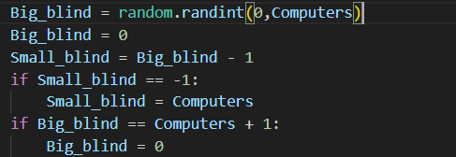(Control line)
There were already lines of code in the Step loop that was made to ensure the Step loop worked no matter who was Big or Small Blind, but through testing it was found these adjustments didn’t work with the all in system, and were hence updated to work with both systems.
Below is the before and after of these adjustments in the step loop.
Before:
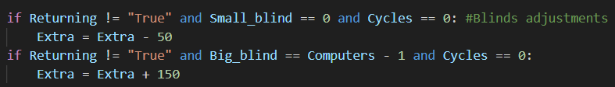
After:
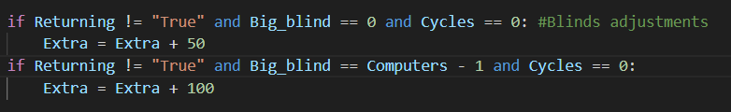
This is what would happen when the Big blind was set to be the player:

This is what would happen when Big blind was set to be the last computer:

The second issue discovered through testing was not related to the code giving an incorrect value, but rather attached to the rng. The new RNG system would allow all bets and calls and raises to be made no matter how big they were. Tests were run to ensure the computers were still calling/Raising/Folding as much as they usually would before the changes, but what was not looked at was what happened with much larger values of chips I.E. the player going all in at the start of the game. Here, the computers were calling the all in 100% of the time, ruining the program as these computers should only be going all in if their hand is strong enough to justify the amount of chips they’re putting in.
To fix this, the RNG around the step loop was adjusted to account for extremely large values of the “Difference” value, while placing more weight on Rating. All of this while trying to keep the rng mostly the same for lower values of Difference.
This is what one attempt of fixing this problem looked like:

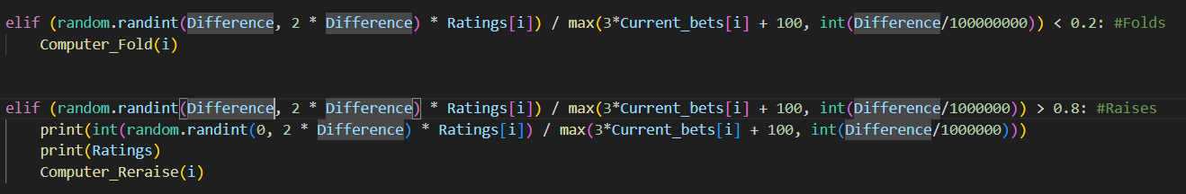
This solution never gave the values I needed it to.
What I realized was that the rest of the system was too delicate to simply overhaul and try to get similar results in one area. Therefore, the only logical solution was to add an extra scenario for what I wanted fixed here, namely the going all in system being responded to correctly, so the only change made ended up being a small adjustment for that:
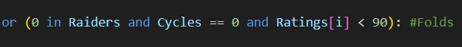

Usability features
Here I will annotate an image from my game highlighting all it`s usable features, followed by an explanation from me on how this features enhances usability for the user.
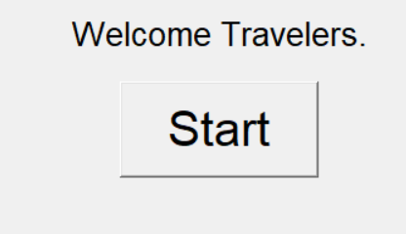
This is the only button the player can press when loading to the main menu, so every player knows exactly what they need to do here: press the button and start the game

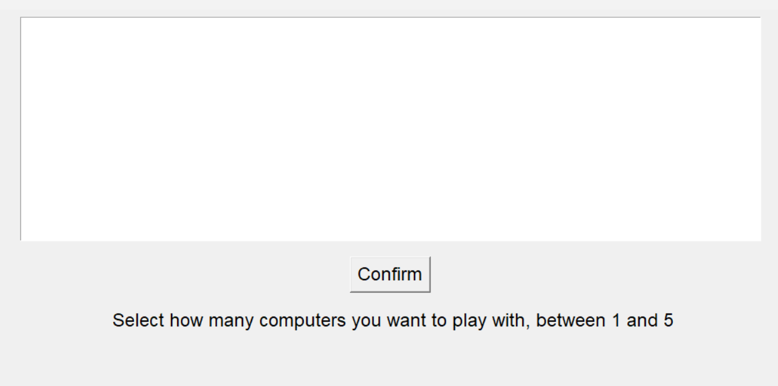

Clearly defined text box that also carries validation so the user can`t break the program by inputting an incorrect value.
Only one button so the player knows exactly what they need to do.
An extra label to inform the player what they are expected to input, which saves time from them having to try every potential option blindly until the program accepts their input.

This will be the screen the player loads into after pressing confirm:
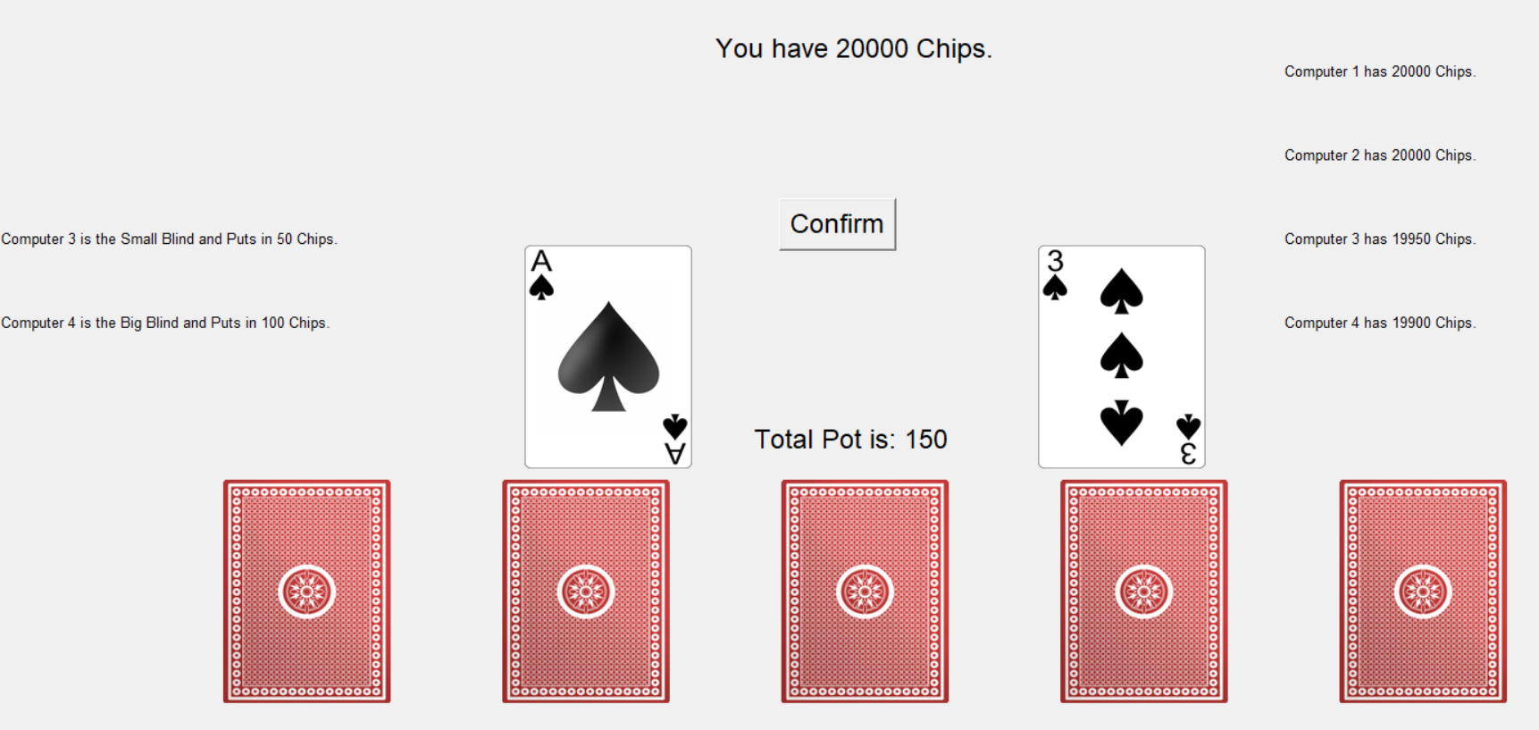

Upon loading in, the player is immediately told about the blinds information:
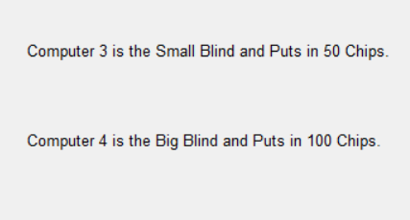
Upon loading in, the player immediately gets to see the amount of chips every computer has, which is a constant updating stream of information:
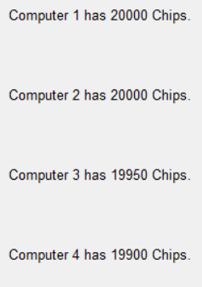

The player gets to see 5 unturned cards, immediately telling the player there are more cards that are not yet in play:

The player is told their own chips in a more prominent area than the rest of the computers, helping any player clearly understand which balance is theirs and therefore more important:

Finally, the player is shown their 2 cards predominantly in the center, making it clear to the player which 2 cards belong to them. There is also a counter for total pot placed inbetween these 2 cards, which updates throughout the game and makes a easy place to for the user to see how much could be won.
Finally, there is a single confirm button placed in the middle of the screen, which waits for the users command for as long as they are ready. Since this is the only choice, it is impossible for the player to make the wrong decision and because of the confirm label written on the button, the player knows what they need to do to progress.
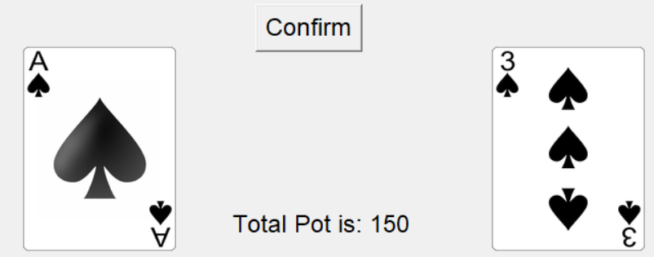

This will be the screen the player loads into after pressing confirm:
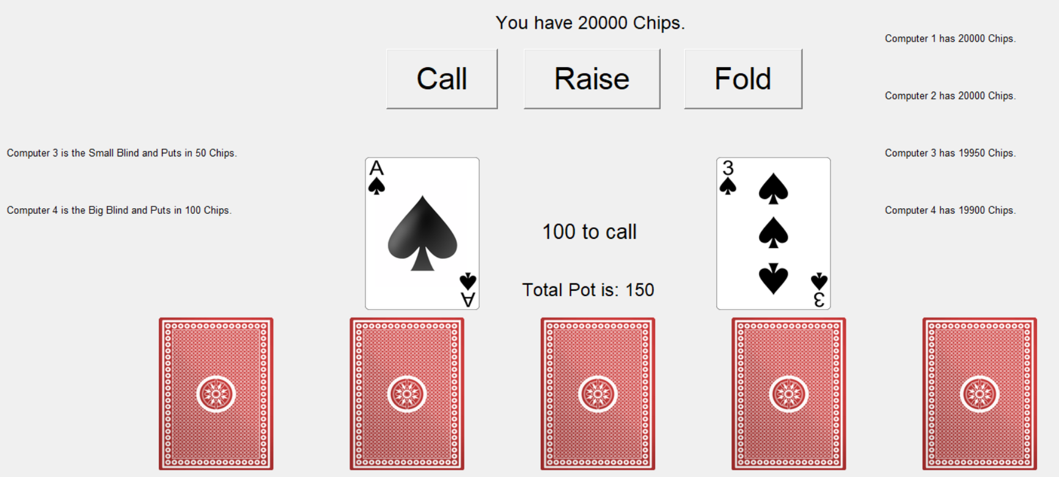

The player is given 3 distinct options, calling, raising or folding. Each of these options are clearly defined so as long as the player knows what these words mean, they will understand what they need to do.
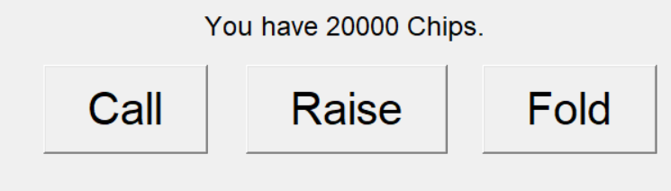
The user is also clearly told how much they need to call for, placed next to the amount in the pot. This is important for usability as it helps the player understand how much their call matters, instead of forcing the player to calculate it themselves every betting cycle:
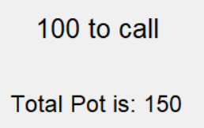
If a player chooses to raise, they will be met with this screen:
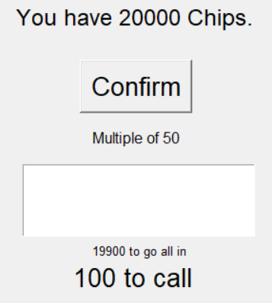
Text box that informs the user they need to make an input
Label that tells the user very simply their bet must be a multiple of 50, done so reading every players chips is easier to process.
Small label underneath the textbox to inform the user both that the all in feature exists, and to save them time having to calculate how much they would need to bet themselves.
All other buttons deleted, replaced by a single confirmation button so the user can’t break the code by pressing both raise and fold for example, and they only have one choice after raising.

Once any button is pressed (Call, fold, confirm), the left side will be updated with whatever actions the computers took, clearly defined for the user so they understand what each computer has done without needing to constantly look at the computers chips and calculate it themselves.
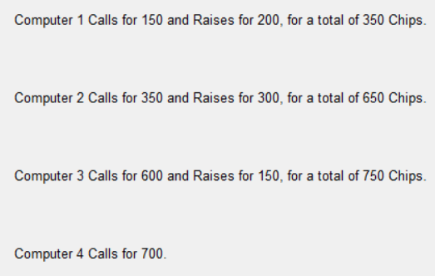
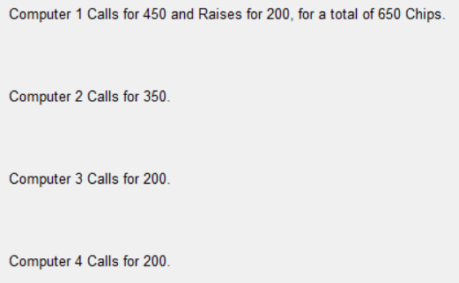
Once the betting round has concluded, the call/raise/fold buttons will be removed in exchange for a single confirm button, which tells the user that the betting round is now over, and once again funnels them to one choice.
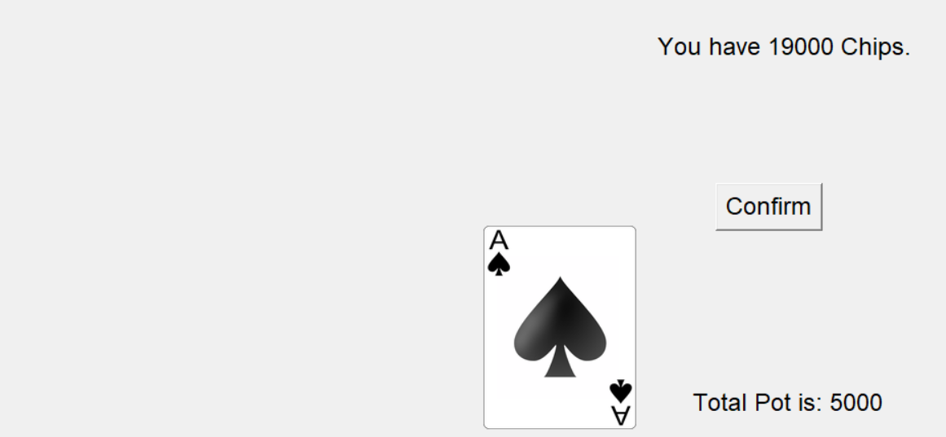
Once the confirm button is pressed, the screen will look something like:
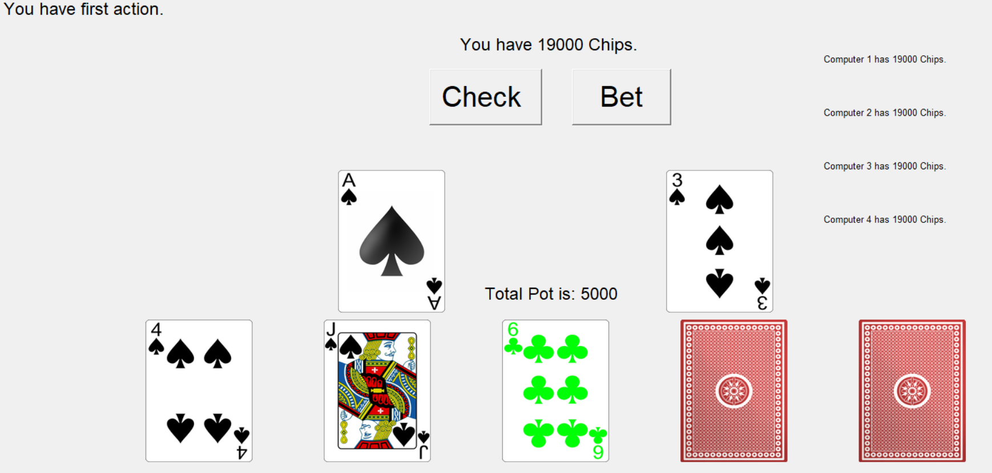
The program will clearly tell the user which player has first action, placed where the computers actions are normally kept for ease of sight.
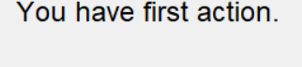
The program will reveal the first 3/5 cards to the user, allowing them to make new decisions based on how strong they believe their hand is. These cards are predominantly displayed to make it obvious to the user.

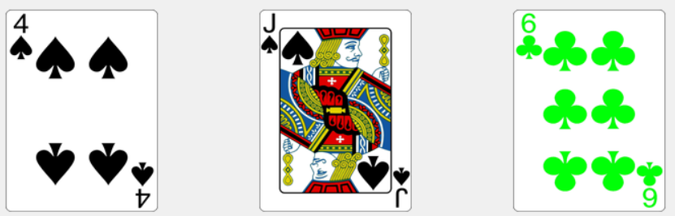

If it is the players first action, or no computers have made a bet to the pot yet, the player will be given the choice to either check or bet, with clearly defined buttons so the player understands their choices, as well as making it clear to the user their choices are different to the call/raise/fold. The option of folding has been taken away as it is never beneficial for the player to fold here, so this helps stop less experienced players from making a bad decision.
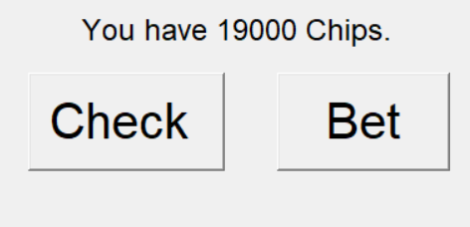
If bet is pressed the same validation as when raised in pressed takes place, now without telling the user how much they need to go all in, as that number is just the same as their current balance, so I chose not to repeat information to avoid clutter:
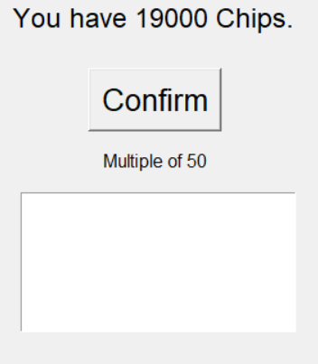

If the player folds, the betting rounds will continue as normal, however instead of calling/raising/folding being an option, the player will now only have the option to confirm. This confirm button just lets the first computer call/raise/fold, and allows the betting loop to run it`s natural course. A single button is used so the player can’t make an action after choosing the “I give up” button, and the placement of the button lets them press it repeatedly until the round or game is over:
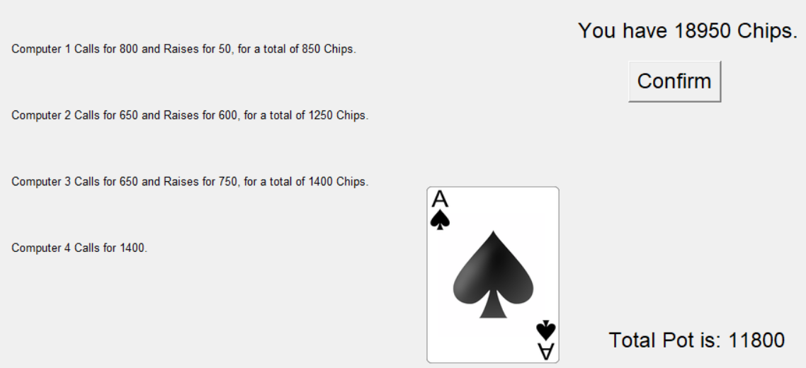
Similarly, if a computer has folded, rather than making an action like calling or raising, the GUI will display that a certain computer has already folded and won`t make an action. This is done as otherwise there are gaps in between each computer that both look off and create confusion to the user about what the computer has actually done:
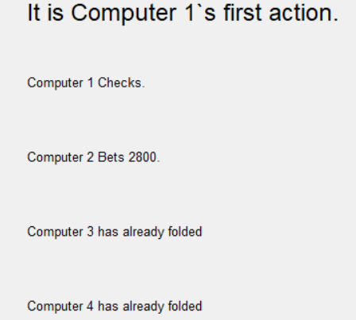
For each betting round completed, another card gets turned over, where in the final betting round every card has been turned over. This serves a double purpose of telling the player how far along they are in the game:
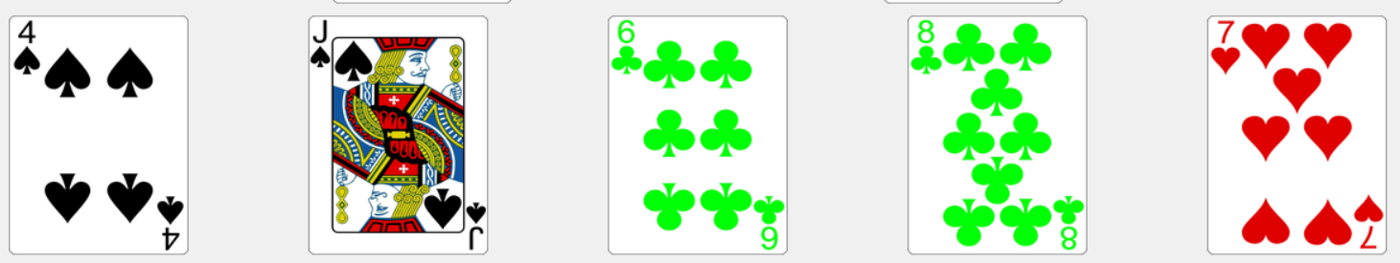

Finally, when all the betting rounds are complete, the game will show the final screen:
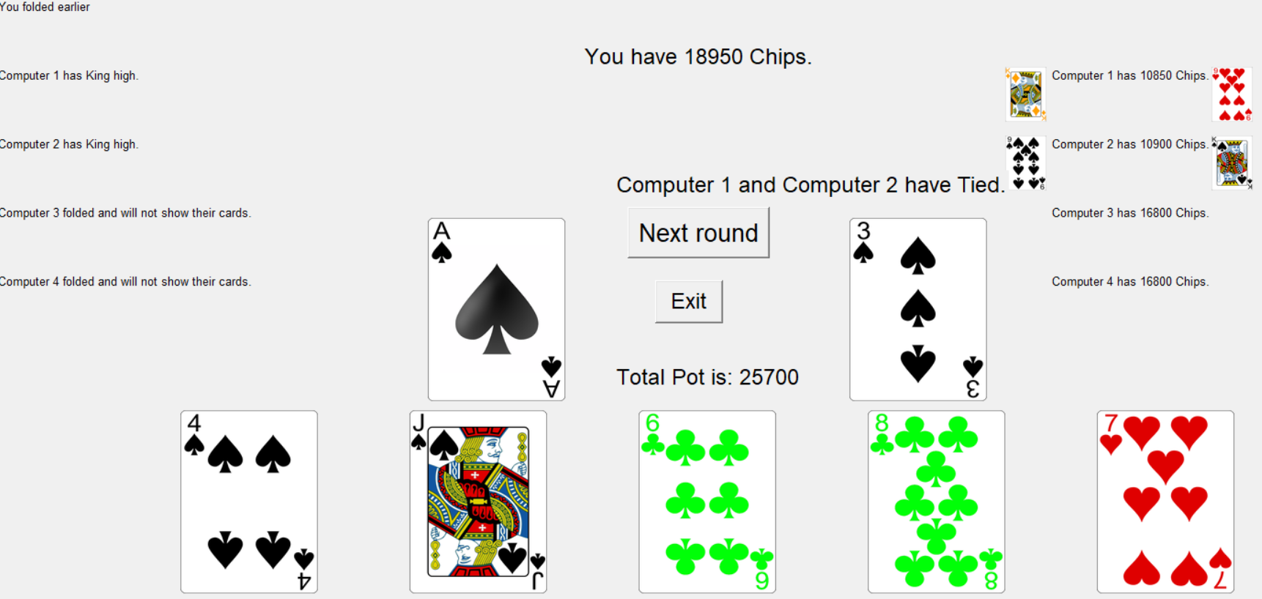
The program tells the user on the left side of the screen the type of hand every player who hasn`t folded has. So for example player 1 had their strongest hand as king high and so that information is clearly told to the user without them having to calculate it themselves.
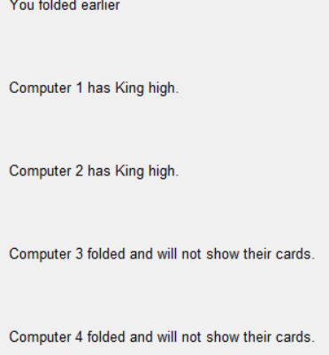
The program will show the actual cards of each computer around that computers chip total, done so the player can see what every computer had to work with and helps them understand why certain computers acted the way they did. The cards are very small by intention, not only to keep them neatly placed around the computers chips, but also to avoid visual clutter:
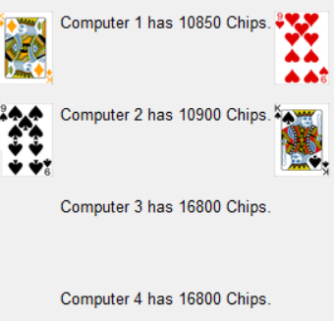

The program will predominantly display in the center which player(s) have won, done so the player does not have to calculate themselves which player has the strongest hand:

Finally, the player will be given the option to press 2 buttons, next round and exit, both clearly displayed in the centre. Both of these buttons are easy to interpret for the user, next round bringing them to the next round and exit bringing them to the main menu, so at the end the player will know exactly what to do after processing all the victory information.
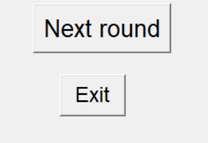

Success criteria evaluation
No. | Requirement. | Condition met? | Justification.
1 | Start up screen | Yes | Mandatory for proper game flow.
2 | Display player chips. | Yes | Necessary information for the user.
3 | Display computer chips | Yes | Necessary information for the user.
4 | Display pot | Yes | Necessary information for the user.
5 | Helper sheet | No | The GUI would have gotten too clunky if an extra button was added, along with the sheet itself not being able to be neatly placed. It was not worth the negatives for the positive of saving a player a google search.
6 | Player determines how many computers to play against. | Yes | The program was always built to accommodate a varying amount of computers.
7 | Betting rounds | Yes | Essential component of standard poker.
8 | Game looping | Yes | Mandatory for proper game flow.
9 | Game exiting | Yes | Mandatory for proper game flow.
10 | Checking | Yes | Essential component of standard poker.
11 | Betting | Yes | Essential component of standard poker.
12 | Calling | Yes | Essential component of standard poker.
13 | Raising | Yes | Essential component of standard poker.
14 | Folding | Yes | Essential component of standard poker.
15 | All in | Yes | Essential component of standard poker.
16 | Buttons | Yes | Made players easily understand what to do.
17 | Textboxes | Yes | Easiest way for players to input on a GUI.
18 | Displaying computer cards at end of round | Yes | Helpful UI element for the player.
19 | Display what type of hand every player has. | Yes | Helpful UI element for the player.
20 | Display who won predominantly | Yes | Helpful UI element for the player.
21 | Optional tutorial that can always be accessed. | No | The initial write up of a tutorial was written, with details on how the betting rounds worked and blinds and kickers and such, but transitioning that info onto the GUI was too large a task to handle.
22 | Blinds | Yes | Essential component of standard poker.
23 | Increasing blind size throughout a game. | No | Too little of a difference to justify how rarely it would’ve happened.
24 | Bluffing on computers. | No | Discovered to be unnecessary, as computers already had high variance in their bets.
25 | Hide cards of computers who folded. | Yes | Unimpactful change, but easy to implement and remains faithful.

Unmet Success review
Helper sheet
In a lot of casual poker games i’ve played, most of the time an image of the different poker hands is displayed that tells the players which hands are better than the others. This happens as newer players take a while to fully learn which hands beat others, for example a flush beating a straight isn’t entirely intuitive.
Since this program was made to be a casual way to play poker, I wanted it to be accessible to people who didn’t play poker that much. What would’ve happened was that a button would always be somewhere on the GUI that when clicked, would bring up an image of all the rankings, with the option to press x on the image to return to normal gameplay. The problem is the clunkiness, as the image overlaying the rest of the GUI elements would look terrible, the image would be too big to simply fit into a gap on the GUI, and that the player could always simply google the hands.
A potential solution would’ve been to delete all the GUI elements and then place the image alone on the screen however that comes with a greater issue of correctly replacing all GUI elements once the player goes back, and ultimately despite liking the idea, it could not have been implemented.

Optional Tutorial
This program has always been made as a casual, risk free way to play poker, and from that it generally targets those that would be newer to poker. This is why I had always felt that a tutorial would be a necessary addition.
The tutorial would have explained all the basics, from every option that could be taken at each betting round, to how the blinds work, to every edgecase when cards are being evaluated. It would have also included some specialist terminology that, while not necessary to play the program, are used generally in poker (for example, the “Nuts” describes the best possible hand that can be made in that rounds circumstances).
Since I believed the tutorial to be important, I started work on it early, after the evaluation system but before the computer thought process system. The work from that is attached right below:
The biggest problem was putting all that information neatly on a GUI, as there would have to be so many tabs, and with my current level of skill in python, i would not know how to transition to and from each slide or how to safely cancel and bring up the main menu again.
The work to start the function awas done at the very start of the GUIs life, before realizing how much of a problem displaying all the information would actually be. The function still exists in the code today and the code to call it is in place, but only in notes. Of the 51 functions in my code, this is the only one that can’t be called.
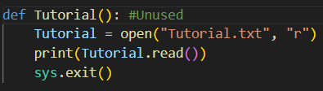

Increasing blind sizes
When playing normal games of poker, it is common for the blinds (amount put in at the start of a round) to increase as the game goes on. This is normally done to increase excitement as the game progresses, as the bigger the blinds, the more likely that an exciting play will have to be made.
In more competitive area of poker, the blinds are generally stagnant throughout the entire game of poker, however that is compensated by having different “Tables”, where each table as higher or lower blinds depending on what the player is comfortable with.
In this program, the blinds started at 50/100 as a nice baseline for the game, especially since I wanted all bets to be multiple of 50’s so it’s easier to read. However, I decided not to have them increase throughout a match as I could not decide a system for increasing them that would not seem arbitrary to the user. Having them increase after X many rounds would be redundant as the players are already betting aggressively regardless of the bets, so they would not become more aggressive with higher blinds. Having them increase after a player has lost all their chips would also not make sense as the number would jump around too much.
Not only would it be difficult to implement logically, but technically speaking having to display to the player when and by how much the blinds have increased would be clunky, and rewriting the step loop to account for the differing blinds value would also be difficult. All these difficulties are simply not worth the exceptionally minor change to gameplay that increased blinds would provide. Especially considering that varying blinds aren’t used in all versions of Texas holdem poker, as well as the prior problems of implementation, I was ok with sacrificing this feature of the code.

Bluffing on computers
Bluffing is about as basic a strategy as you can find in poker, the act of pretending you have a hand better then you actually have. While not part of any rules or set up, bluffing is arguably more fundamental to poker then the acts of drawing cards or betting chips, so getting it to work in the program was essential.
The important thing was to make sure the player couldn’t easily guess what the computers had, as otherwise I was scared players could just make a small bet, then just raise/fold immediately after seeing what the computers did if they were too predictable. My solution was to make a list called “Bluffs”. After each time the computer would evaluate their own hand, there would have been a small chance for them to be added to the bluffs list. This chance would have been larger the worst their hand was, and impossible to get if they had an even decent hand. Once added, they would have been stuck in that bluffs list, and would always bet high, only being scared to play at really large chip sizes.
The simple reason this was never added was that it was never necessary. The idea for this bluffs feature was there for a while but the implementation would always happen after the rest of the betting features were added. Since I got to test the betting system a lot, I found through development that the computers still played a variety of hands, while still folding weaker hands, exactly what I wanted out of their behaviour. From this, the bluffing feature never needed to be added as it’s purpose was already being fulfilled. Some difficult lines of logic would never have to be written as thankfully the RNG I put into the rest of the program solved the issue that this bluffing feature would’ve fixed.

Future development
If I were to continue making improvements to this program, what I would aim for is:
Optional tutorial
A lot of the work has already been done for it, and of all the features not to make it into the final program, it is by far the most important.
Helper sheet
Having a drag down sheet to assist players would feel nice to have, and nice to know potential inexperienced players won’t feel cheated by thinking a hand is better than another when it isn’t.
Blind adjustment
Instead of having the blinds be at the stagnant 50/100 they are at now, and instead of having them increase throughout the game as was the idea in my success criteria, I would instead now let the player decide how big they want the blinds to be. They would be given choices through buttons, giving them many but not infinite choices for the blinds. This would add variety to gameplay and emulate real poker more without any of the priorly established issues that came with increasing blinds before.
Alternate card colours
I am very fond of the custom yellow and green cards for diamonds and clubs respectively. However as good as I believe they look and however much I believe they should become a standard for the sake of the colour blind, there will be players who are confused by the differing colours and would like to play with the default colours. Hence I would add a checkbox at the start of the program that simply says “Alternate colours”, and would change the directory path of the “Drawing” function to get different cards. It would increase storage size quite a bit though, since an extra 52 pngs would need to be stored.

Updated UI
If this code were to ever be pushed to it’s limits, then I would have potentially liked to make it more visually distinct, rather than using the default Python TK inter visual interface for the buttons and backgrounds. It wouldn’t be anything fancy, just some custom visuals for the buttons, maybe a scrolling background and perhaps some more flair for when a winner is decided.
Sound design
I never strongly felt this program needed a strong focus on it’s sound, however if this program were to spread far beyond, it would feel weird to have everything be completely silent. Nothing drastic would be added, just a light noise every time a button is pressed, along with simple idly background music.

Usability features evaluation
Feature | Done? | Justification | Proof
Distinct visuals on each card | Yes | Each of the 52 unique cards are clearly distinct from each other while showing off their suit and rank. | 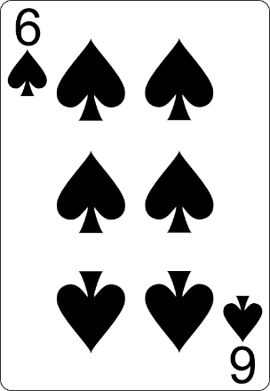
Pixelated card art. | No | I wanted to avoid copying Balatro too much and more standard cards looked better. | N/A
Alternate card colours | Yes | Makes the program more distinct, as well as helps certain visual challenged players discern cards. | 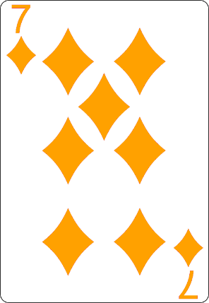
Poker stars User interface. | Partial | I wanted to avoid emulating an actual gambling site during development of the GUI, so instead the GUI was developed by simply displaying what information was important whilst using symmetry | N/A
Call/Bet buttons | Yes | Easy to understand what each button does, while being guided to press them. | 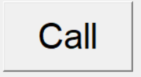  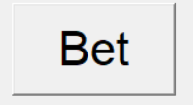
Scrollable list | No | Through development, the idea of having over 20 CPUs in one round was removed as it wasn’t practical and not that fun to play. Now with only a max of 5 CPU’s, their info could be easily displayed without having to bring up a drag down menu. | N/A
Action records | Yes | It’s important to see what each computer did, so what they did last cycle is displayed on the side, easy to read for the player without obscuring any detail. | 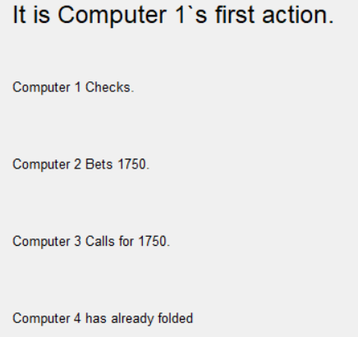

Unmet usability features
Most of the unmet usability features were not met because there were not necessary for the final solution. The lack of pixelation not being met meant I could use an art style later I preferred for the program. Poker stars UI was partially met as while I did take some basic ideas from that layout, I realized I didn’t want to copy a pre established website too closely. I would not try and go back to add these usability features as they no longer are necessary.
As for a scrollable list, when I decided to make the maximum computer count 5 to make programming easier, the need for a scrollable list no longer became necessary. However, re implementing the ability to play with up to 22 computers would give this program a unique factor to it, and if that were to happen the scrollable list would need to come back to avoid UI clutter.

Maintenance
I have not implemented any maintenance features into my program however I understand that if this game were to be professionally distributed these features would be required to fix bugs that are found or update the game by adding more features.
I would add an option on the main menu of this program that would bring up a patch note change log, a staple feature of most moderns games. Additionally, I would need the ability for used to report bugs they find, that option being found on the main menu, and have myself fix the program to eliminate the bugs.

Additional usability features
My main introduction to poker was through my grandfather, aged around 80. He’s not particularly good at the game, but he taught me the basics well enough to where I can beat him.
Part of the reason I made this coursework about poker was to have a project that would impress him, so when designing this program I always needed it to be easy enough to be used by an actual 80 year old.
As mentioned before, the entire path through the code is led by pressing buttons, and these buttons clearly display their purpose so even my grandfather could understand what to do.
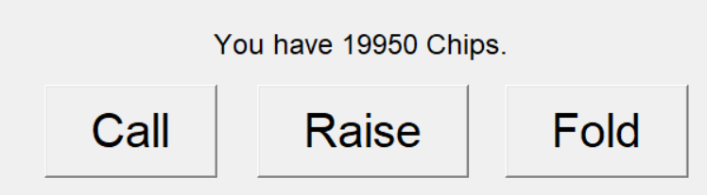
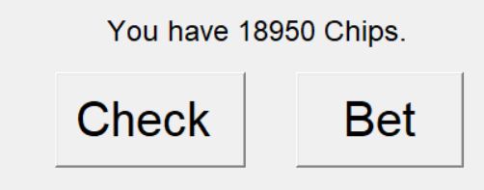

It was also important that he knew the rules of betting whether I was there or not, assisted by the labels under the betting textboxes.
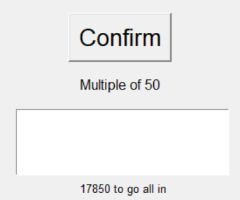
As for features i’ve already mentioned, I needed both my grandfather and all my players to easily understand what choices they can and can’t make. My grandfather has a habit of folding when his options are check/bet, so I removed the option to fold during that phase so he doesn’t waste a hand he shouldn’t have to. Similarly, it is impossible to raise if you have less chips then what is required to call, so to make it easy for the player to understand the option to raise was taken away.
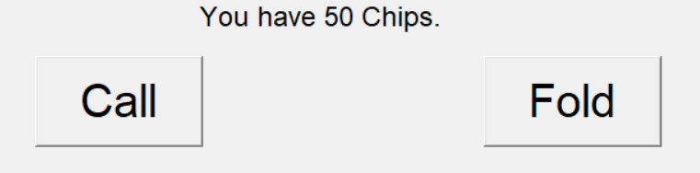
I also wanted all my players to easily understand what’s most important, so a constantly updating label about how much they need to call for is predominantly displayed in the center.
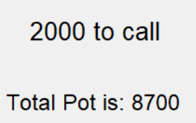

The player is constantly updated about the action of each computer, and can be overwhelming if each of the constant updates is fully processed, however it simply is not necessary for each bet to be completely processed, instead what actually matters in terms of the player is the amount they need to bet, which, as already described, is being clearly displayed in the middle. This information is important for the player to see, but due to it’s smaller importance the info is displayed at a smaller font and to the side. All this applies to the computers chips as well.
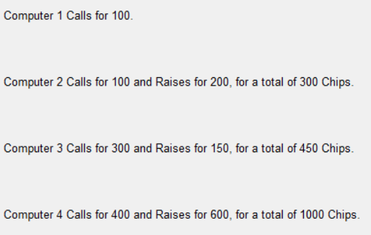
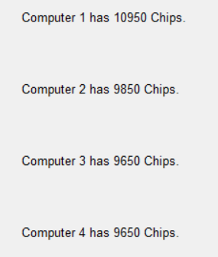

Finally, after the round is complete the player is given the option to either immediately begin the next round or return to the main menu, both options easily understood by the text on the buttons. Once either button is pressed, all other GUI elements are destroyed for the reset.
To give a sense of finality, if the player is either the only player remaining with chips (The winner), or has lost all their chips (Loser), then the program will tell remove their option to advance to the next round, forcing them back to the main menu and resetting all variables.
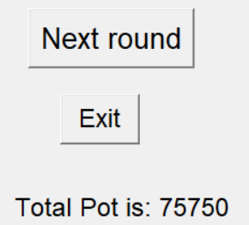
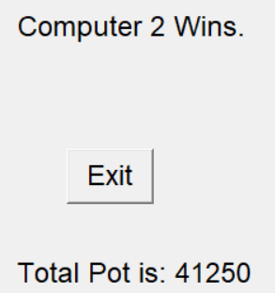
With all these features, the player is always given at most 3 options at any time which stops them from getting overwhelmed, and any potential choice a player can make is readily obvious on both how to perform it, and what the action is. This means that at all times, even for new players, as long as they understand the rules of poker, they will be easily able to use this code.

Limitations evaluation
Currently the program has a hardware limitation to only be played with a mouse and keyboard on a computer. In future development, I would first like to alter the current software to include keyboard shortcuts, eliminating the need for a mouse. This was not implemented in the base code as my programming skills as well as my limited time stopped me from implementing it, but if possible I would alter my code to remove the hardware requirement of a mouse.
Also, I would like to add a mobile port to this game, making the game more accessible to a larger audience. This was not done previously as it would require the entire UI to be rethought out and condensing all necessary info onto a smaller screen would be difficult, but in future If I’m able to add a mobile port I believe it would make the program much better with these easier hardware requirements.
Limit | Why was this a limit? | Potential improvement
Local multiplayer | Only one screen able to display info making it impossible to display 2 different users cards. | Have the cards of the users start out on their back, and have a button to reveal the cards temporarily.
Online multiplayer | Hosting online servers was beyond my abilities as a programmer, and this program would not be popular enough to get a consistent player base. | Spend time learning how to online servers work and alter the code to allow for multiple players input.
Tutorial | Writing up and then displaying the tutorial would be incredibly time consuming for an A level student. | Go through multiple drafts of the tutorial until easily understood by new players, then learn more about pythons GUI.
Animation | Not enough time to learn how to add animations to my program. | Learn more about animation software and develop some animations for cards.
Sound design | Not enough time to create and implement sounds to my program. | Learn more about sound files and how to implement them into a python program.

Project appendixes
