The following Bohem and Turner chart, resulted us needing to follow an agile development method. So we decided to create a unique combination of all 3 major agile development methods. One that would contain the following guidelines:

* 40 hour week
* Poker estimation
* Daily scrum meetings (managed by bot)
* Product owner
* Sprint based deployment
* Product backlog
* Sprint backlog
* Weekly Refinement meetings (organized and conducted by product owner)
* 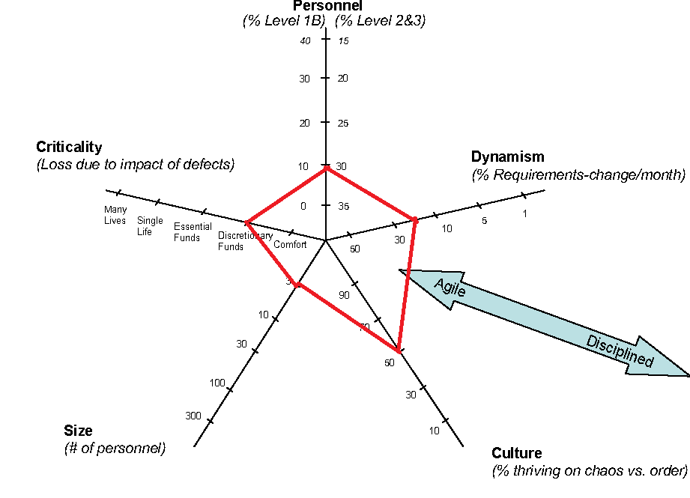Kanban board