Stakeholder analysis

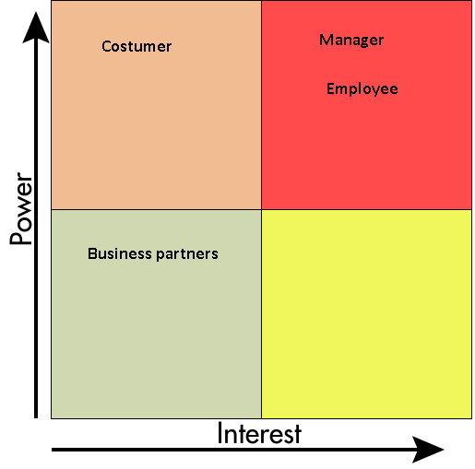

Stakeholders:

1. Manager- interested in more productive employees
2. Employee- wants to make existing processes more streamlined and less time consuming
3. Costumer- requires the same results as before, but isn’t interested in how its achieved
4. Business partners- Interested in company to succeed and continue cooperating