

University College of Northern Denmark

Technology and Business

Computer Science Academy Profession (AP) Degree

Class: BigData0916

Title: Problem Statement - 4th Semester 2018

Project participants (Group 2):

-Ralfs Zangis

-Andrei-Eugen Birta

# 1.Introduction

The purpose of this project is creating a machine learning algorithm that is capable of predicting to a higher degree of accuracy, next possible collisions between aircrafts and wildlife animals on a worldwide scheme, considering both civil and military aircrafts.

# 2.Case Description

Day to day activities thought us that, the collision between something massive and something small and frail, usually ends up pretty bad for the small object and affects little to not at all the massive object, when it comes to aircraft collisions with birds and other wildlife creatures, things tend to go bad for both parties. Usually killing the animal and ruining the aircraft, possible for the rest of its “life”.

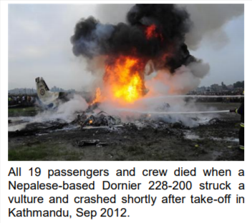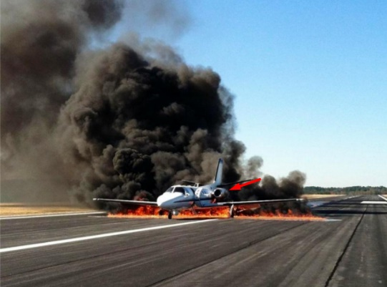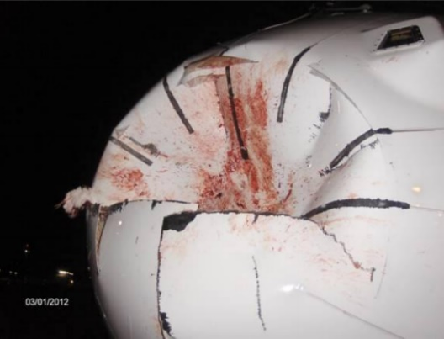The following are images of possible damage that such a collision can cause, to an aircraft.

And considering that wildlife population is fluctuating depending on different seasons of the year, but usually increasing in numbers, such collisions should be taken with all seriousness and evaded as much as possible.

# 3.Learning goals

Some of the learning goals for this project are:

* Gathering useful datasets related to the case
* Converting datasets to a common format, in order to facilitate data analysis, using tools offered by Python
* Filtering data (dealing with missing values, misspelled words or wrong datatypes), using tools offered by Python
* Predicting possible collision areas, at different times of the year and possibly wildlife species and types of damage, to facilitate warning emissions by concerned authorities