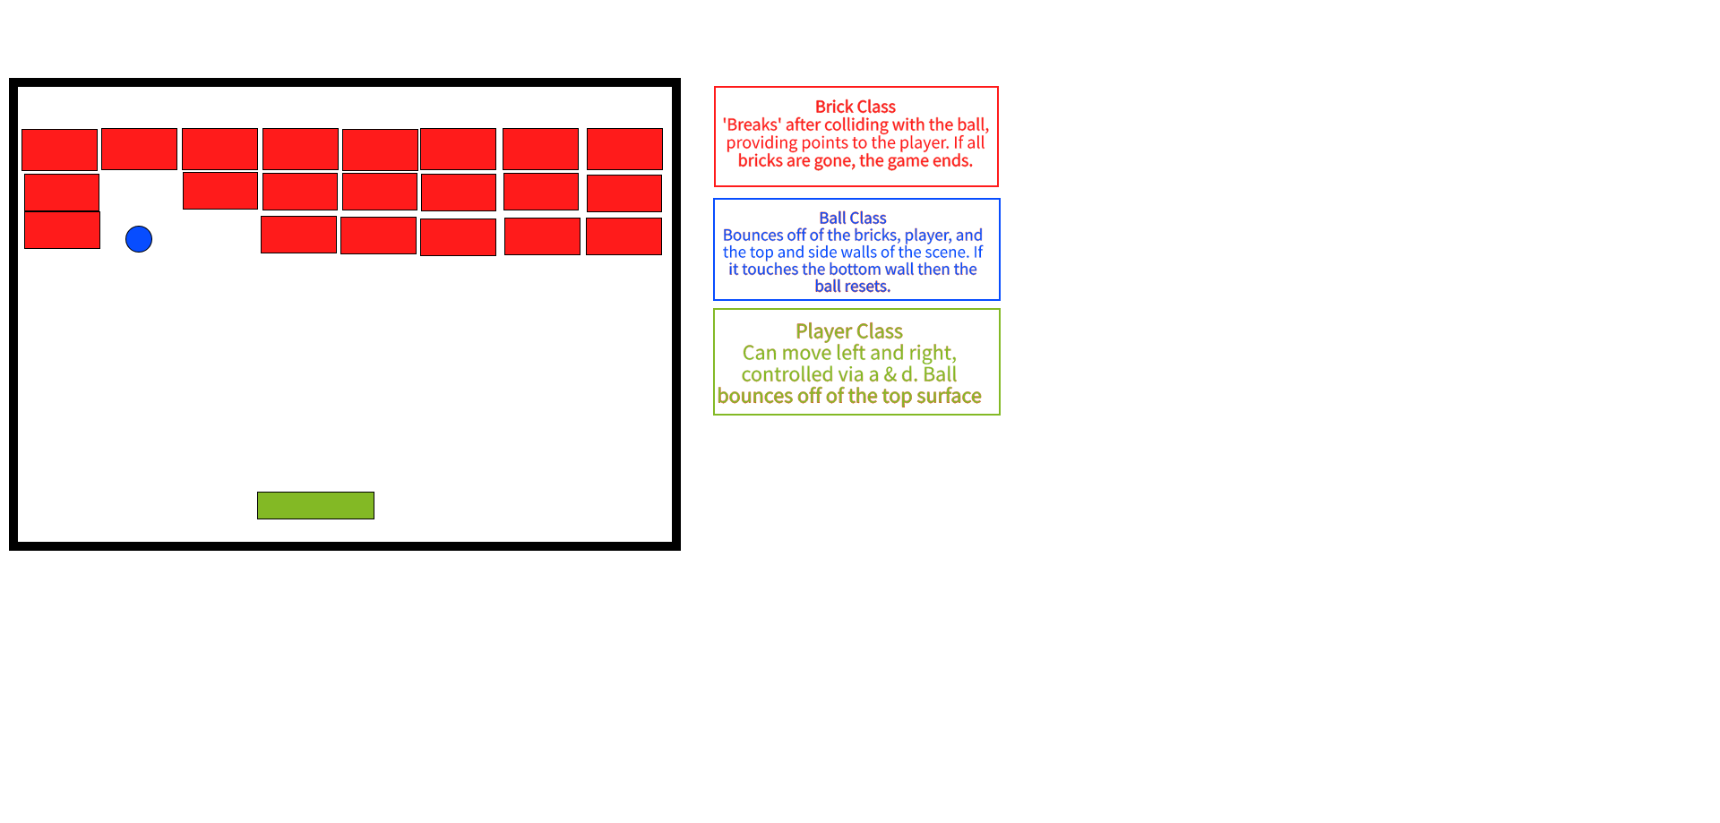

**How The Game Will Work**

The game will be a single-player experience, with the player controlling the ‘paddle’ at the bottom of the screen using the “A” and “D” keys. A score will be given at the end of the game showing how well a player did. If the player is able to ‘break’ all of the bricks then the player will win and be deemed victorious though, on the other hand, if the ball reaches the bottom of the screen the player will lose a life, after losing enough lives the game will end in defeat. Pressing the “ENTER” key will restart the game. The “ESC” key and “X” button will exit the game.

**GitHub Repository**

