DRIVERPASS SYSTEM

SYSTEM DESIGN DOCUMENT
Joseph Villicano
CS-255-11166-M01 System Analysis and Design
Instructor: Mohammad S. Habibi, Ph.D.
October 2026

TABLE OF CONTENTS
1. System Overview
2. UML Use Case Diagram
3. UML Activity Diagrams
4. UML Sequence Diagram
5. UML Class Diagram
6. Technical Requirements

1. SYSTEM OVERVIEW
DriverPass is a comprehensive online learning and testing platform designed to help students prepare for and pass their DMV driving tests. The system provides an integrated solution combining online lessons, practice tests, and appointment scheduling in a single, user-friendly platform.
Key Objectives:
Provide accessible, high-quality driver education resources
Enable efficient DMV test appointment scheduling
Track student progress through lessons and practice tests
Maintain enterprise-grade security and data protection

2. UML USE CASE DIAGRAM
The use case diagram illustrates all the primary functions and actors in the DriverPass system. It shows how different user types (Students/Users, Customers, Drivers, Secretaries, Owners, IT Officers) interact with the system and the DMV external system.
Key Use Cases:
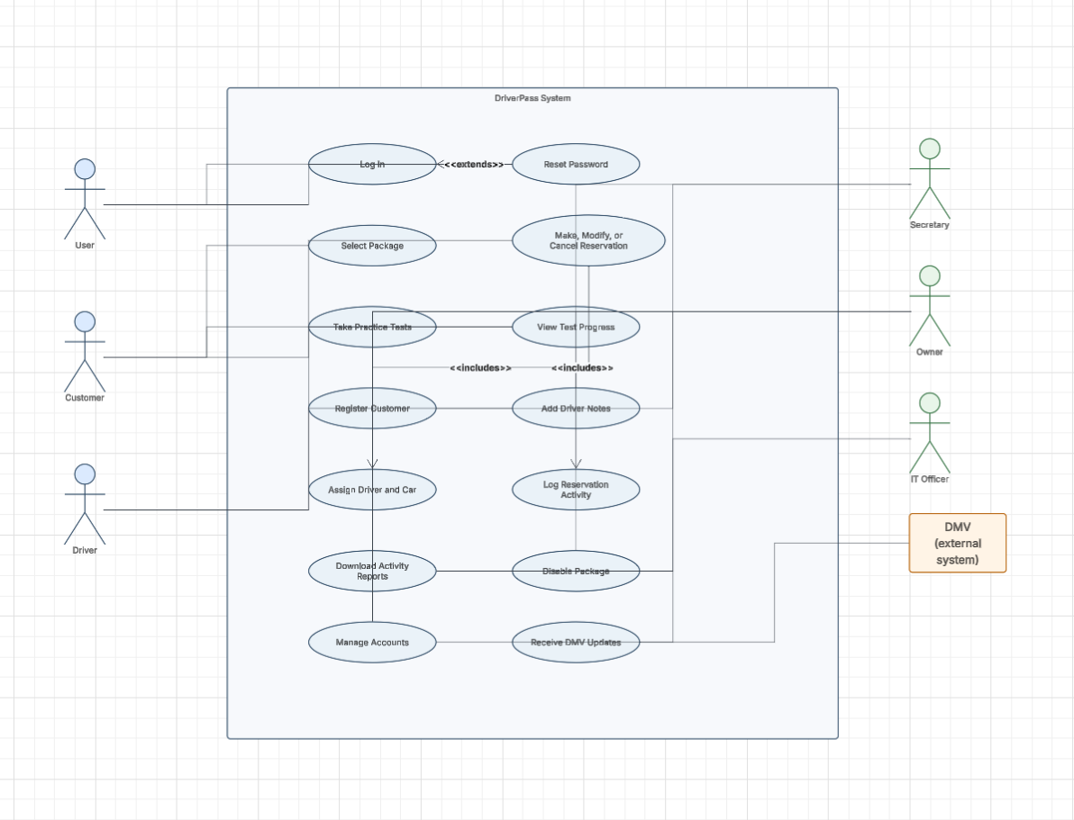
Log In / Reset Password - Authentication and account recovery
Select Package - Choose lesson bundles and test preparation packages
Make, Modify, or Cancel Reservation - Manage DMV test appointments
Take Practice Tests - Access practice exams with immediate feedback
View Test Progress - Track completion of lessons and practice tests
Register Customer / Add Driver Notes / Assign Driver and Car - Administrative functions

3. UML ACTIVITY DIAGRAMS
Activity diagrams model the flow of activities and decisions within key use cases. Two critical activity diagrams for DriverPass are described below:

3.1 Login Activity Diagram
The login activity diagram shows the complete authentication process. Users enter their credentials on the login page. The system validates credentials against the user database. If credentials are invalid, a failed login counter increments. After 3 failed attempts, the account is automatically locked to prevent brute-force attacks. If credentials are valid, the system checks the user's role (Customer, Secretary, Owner, IT Officer) and directs them to their appropriate dashboard. All activity is logged for security auditing.

3.2 Password Reset Activity Diagram
The password reset activity diagram illustrates the secure password recovery process. When a user clicks 'Forgot Password,' they enter their email address. The system searches for the account. If found, it generates a time-limited reset token valid for 30 minutes and sends a secure link via email. When the user clicks the link, they enter a new password. The system validates password strength (8+ characters, mixed case, numbers, special characters). If valid, the password is encrypted using bcrypt and updated in the database. This multi-step process ensures security even if the email is intercepted.

4. UML SEQUENCE DIAGRAM
The sequence diagram for the login process shows the exact message flow between system components:
1. User enters credentials and clicks login
2. Web application sends credentials to authentication service
3. Authentication service queries user database for user record
4. System compares entered password with stored hash using bcrypt
5. If match: Session manager creates session with user ID and role
6. Session token returned to web application
7. User redirected to appropriate dashboard
This sequence ensures passwords are transmitted securely and never stored in plain text. All communication between components is protected.

5. UML CLASS DIAGRAM
The class diagram defines the complete data structure of DriverPass. The diagram shows:
User Hierarchy: An abstract User class contains all common attributes (ID, email, hashed password, name, phone) and methods (login, logout, reset password). Four user types inherit from User:
Customer - Students preparing for DMV tests
Secretary - Administrative staff
IT Officer - System administrators
Owner - Business manager
Supporting Entities:
Package - Lesson bundles and test preparation materials
Reservation - DMV test appointments (one customer may have many reservations)
TestResult - Exam scores and performance data
Account - User account status and subscription tracking
ActivityLog - Security audit trail of all system actions

6. TECHNICAL REQUIREMENTS

6.1 Hardware Requirements
Web Servers: Minimum 2 servers for load balancing and high availability
Database Server: Dedicated database server with SSD storage for performance
Backup Storage: Redundant storage for automatic daily backups
Load Balancer: Hardware or software load balancer to distribute traffic

6.2 Software Requirements
Web Application Framework: Node.js with Express or equivalent
Database Management System: PostgreSQL or MySQL for data persistence
Authentication Service: OAuth 2.0 or JWT-based authentication
Email Service: SMTP server for password reset and appointment notifications
Session Management: Redis for caching and session state management

6.3 Infrastructure Requirements
SSL/TLS Certificates: For HTTPS encryption on all communication
Firewall: Configured to allow only necessary ports and protocols
VPN/Secure Network: Private network for internal server communication
Monitoring and Logging: Centralized logging and monitoring system (e.g., ELK Stack)

6.4 Nonfunctional Requirements
Availability: 99% uptime (approximately 7 hours downtime per year)
Performance: Response time under 2 seconds for all user interactions
Scalability: Support 10,000+ concurrent users during peak testing periods
Security: Encrypt all sensitive data at rest using bcrypt; encrypt data in transit using HTTPS/TLS
Compliance: Meet GDPR and CCPA data privacy requirements; maintain PCI compliance if handling payments
Backup and Recovery: Automatic daily backups with recovery time objective (RTO) of 4 hours

6.5 Security Implementation
Authentication: Bcrypt password hashing with account lockout after 3 failed login attempts
Authorization: Role-based access control (RBAC) to restrict user data visibility
Audit Logging: All system actions logged with timestamp and user ID for compliance
Password Reset: Time-limited tokens (30 minutes) with email verification
API Security: Rate limiting and input validation to prevent abuse

CONCLUSION
This system design document provides a comprehensive overview of the DriverPass platform architecture, including UML diagrams and technical requirements. The design ensures security, reliability, and scalability to meet the needs of students, administrators, and the business. The system is ready for development and implementation.

