Human
Post 1
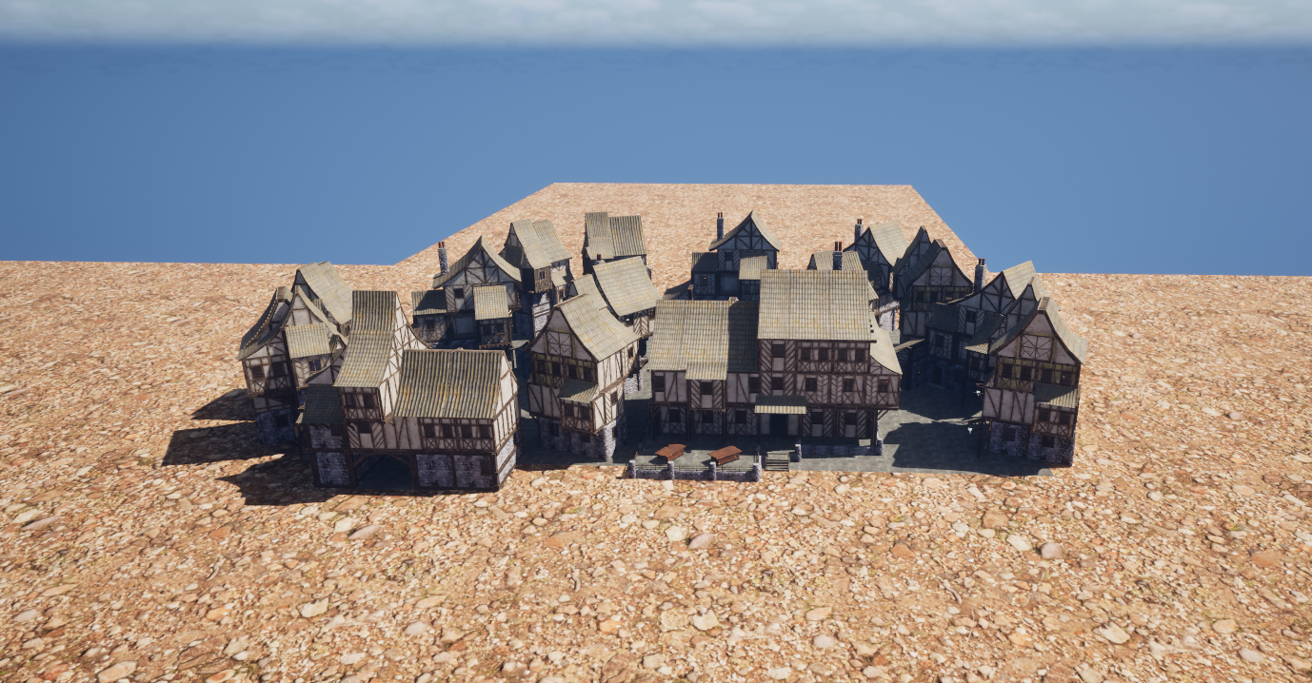
Post 2

Post 3
Dialogue setup
1:30
Post 4
Human dialogue for elder part 1
1:25
Post 5?
Human dialogue quest v1
1:30

GAI:
Quest prompts:
Can you write the dialogue for an npc interacting with the player in a game using these conditions - late medieval setting - The character is the village chief - the chiefs motivation being withholding information on whats going on in the village until the player obtains a stopwatch for him - the chief is quite condescending but not arrogant or mean
Output - Village Chief:
Ah. A traveler. You have the look of someone with questions—mud on your boots, and urgency in your eyes.
Player:
I was told you oversee this village. Something seems… off.
Village Chief:
Off? How observant. Yes, well, villages often appear that way to outsiders. Chickens scatter, folk whisper, doors close early. It is called life.

can you stick to writing the dialogue for the chief and respond to the dialogue I give you which will be sectioned inside "" also add to the setting the village is almost entirely abandoned but remains in almost pristine condition You start the dialogue off please
So… another set of footsteps, echoing where voices ought to be. Curious how the streets stay clean when no one walks them, hm?
(a measured glance)
Do not trouble yourself guessing where everyone has gone. Guessing is a waste of time—and time, as you may learn, is something this village treats… carefully.#
Can you give me one response to which would work with either of these options "Why are there so little people?" "I noticed that but didn’t want to pry."
A sensible instinct, that—whether born of courtesy or caution. Absence invites questions, but answers invite consequences.
For now, it is enough to know the village is managed, not abandoned. The rest is a matter of timing… and I find my means of measuring it regrettably lacking.
Brush the player off for the next response one response to work with both "So would money jog your memory then." "I could use my fist to remind you"
Oh, spare me the theatrics. Coins and knuckles are tools for simpler negotiations, and I assure you this is not one of them.
If you are determined to involve yourself, do it properly—or not at all. I have no patience for shortcuts, only for solutions that arrive on time.
Lead the next part while asking for the player to get an item
If you truly wish me to speak—clearly, and without wasting either of our dwindling moments—then bring me a device that does not lie.
A stopwatch. Precise, mechanical, indifferent to superstition. Such a thing will tell me whether events unfold as they should… or as they have begun to.
Return with it, and I will explain why a village can remain spotless while its people fade away.
One response for either "Why can’t you do it yourself?" "Get someone else to do it."
Because those who belong here are already accounted for, and those who understand the roads beyond our borders are… passing through.
You are unentangled, unrecorded, and—most importantly—expendable in ways the village cannot afford to be. Consider it a kindness that I ask at all.
For this one write 2 response 1 for each "So you don’t want others to get hurt." "So you want me to take the hits."
Village Chief (to “So you don’t want others to get hurt.”):
Let us say I prefer my responsibilities to remain intact. This village has lost enough without testing the limits of what remains. If risk must be taken, it should be by someone not yet woven into the fabric.
Village Chief (to “So you want me to take the hits.”):
If you insist on phrasing it so bluntly—yes, you are better suited to absorb inconvenience. You arrived whole, unattached, and curious. I would hate for curiosity alone to be the village’s undoing.
From now on if I put 1 before the dialogue that line is said in the context of So you don’t want others to get hurt. if i use 2 its in the context of So you want me to take the hits. 1 "Does that have something to do with the request?"
Everything I ask has something to do with preventing further loss. When time itself becomes unreliable, even good intentions arrive too late.
DELETED v
The device I seek is not a convenience—it is a safeguard. Without it, I would be guessing, and guessing is how people vanish while believing they are still safe.
DELETED ^
For the next dialogue act like you know the player will accept 1 "I still haven’t said I’m accepting it yet."
No, you have not. And yet you are still standing here, asking the right questions instead of walking away.
People who refuse do so quickly. Take your time if you must—but when you leave this square, it will be with purpose.
CHANGED SQUARE TO TAVERN
Tell the player to go to the edge of the farms and get the stopwatch from an old women that lives there 1 "So the job is to get a stopwatch for you"
In the plainest terms, yes.
At the far edge of the farms—where the fields are kept though no one tills them—you will find a lone cottage. An old woman lives there, or did the last time the hours behaved themselves.
She keeps what I need. Speak politely, listen carefully, and do not linger longer than you must. Bring the stopwatch to me, and then we will speak of what has truly been happening here.
REMOVED THE PART INBETWEEN THE –
For this part end the conversation write two responses one for each 1 "Seems simple enough" 1 "What's the catch"
Village Chief (to “Seems simple enough”):
Most things do, at the beginning. Go, then—before simple turns into late. We will continue this conversation when time is no longer working against us.
Village Chief (to “What’s the catch?”):
If you must name one, call it delay. Nothing here resists you outright—it merely waits until resistance costs more than expected.
Now go. The farms are closer than they feel, and farther than they should be.
Go back to the context 2 for these next few responses until i say otherwise 2 "You got a lot of scars on your back by chance?" this phrase means the player is asking if the elder is untrusting of people
Scars are what remain when lessons outlive the teachers.
I have trusted before—people, patterns, promises that things would resolve themselves in due course. They did not. So now I rely on those who can leave, take the damage if it comes, and return with results.
If that troubles you, best you discover it after the errand, not before.
DELETED THE MIDDLE SENTENCE
2 "I would to be one of your teachers"
Mm. Ambitious words for someone still untested by this place.
Very well—lessons are best delivered through action, not posture. Bring me the stopwatch, and we will see whether you teach me something new… or merely learn why I stopped expecting it.
2 "I can't wait to watch you croak old man" the player means he can't wait to watch the elder die in a more light hearted way
Careful. Jests age poorly in villages where time misbehaves.
Still… I have outlived sharper tongues than yours, and I expect I will endure your enthusiasm as well. Now go—if you linger any longer, you may miss me yet.

for this next section can you write dialogue responses as if you are the knight who is the son of the old lady that has the stopwatch he knows what is happening in the village but is reluctant to talk on that matter the old lady has died he is solemn but not depressed he has the stopwatch respond to what is wrote in between the "" "Do you know where the old lady has gone"
She has gone where the hours no longer trouble her. The cottage is empty because it has served its purpose.
If you came seeking her words, you are too late. If you came seeking what she kept… then speak plainly, and we will see how much time you truly have.
"I need something she owned"
Then you are in the right place, and the wrong moment.
She did not keep many things, but the few she did were guarded with intent. I carry one of them now—not as an heirloom, but as a responsibility.
If you mean the device that counts what the world pretends not to lose, say so. I will not have it taken under false names.
THE LAST SENTENCE WAS DELETED
For this next dialogue write one response for each "So how would I obtain this responsibility?" "Do I need to fight you too." for the second one brush the player off
Knight (to “So how would I obtain this responsibility?”):
By understanding why she kept it, and why I have not destroyed it. The stopwatch does not reveal truth on its own—it confirms it. If you intend to return it to the village, then you will carry it with care, not curiosity. Do that, and I will place it in your hands.
Knight (to “Do I need to fight you too.”):
No. This is not a trial of steel, and I have no interest in adding another grave to the roadside. If you are searching for an enemy, you are early—or late. Either way, not here.
Write the next response so that it works after either of the previous ones "Why is everyone in this village so reluctant to talk."
Because speaking gives shape to things better left without edges. Once named, they demand answers—and answers have a way of claiming people who were merely listening.
We choose silence not out of fear, but out of practice. It has kept what remains of the village intact… for now.
"So are you going to give me the watch or not?" send the player off with the watch a a closing statement
Yes.
Take it—while it still agrees to be taken. Keep it close, wind it often, and trust it more than your instincts once the seconds begin to slip.
Return it to the chief, and do not ask him what it proves unless you are prepared to learn what has already been lost.
DELETED THE MIDDLE
For the next part of dialogue responses go back to writing as the chief start the conversation by asking if the player has obtained the stopwatch
You have returned sooner than I expected… or later than I feared.
Tell me—do you have the stopwatch?
"It wasn’t as easy as asking an old lady for it." be curious as to who had it instead
So… she did not greet you herself.
Then tell me—who stood in her stead? The watch does not change hands without reason, and I would very much like to know whose time it is answering to now.
"A fancy looking knight had it."
Ah. Then her sense of caution endured longer than her breath.
A knight, you say… clad in polish rather than necessity? That narrows it more than you might think.
(a pause, thoughtful rather than alarmed)
Did he part with it willingly—or did time have to persuade him?
DELETED LAST 2 LINES
"So what happened to the old lady." Start to reveal what happened to the village over the next 3 responses The village was told to keep the place looking pristine so the lord could show it off when the village wasn't perfect the tax rate was increased considerably When the tax rate was too high to pay the villagers were given to the lord as cannon fodder for his army The chief spent these last years slowly moving everyone out of the village The chiefs last act is to burn the village to the ground with the lord in it (do not state this only hint at it towards the end)
She stayed longer than most. Someone had to keep the clocks honest while the rest of us learned how to leave without being noticed. When a village is ordered to look alive, it must first learn how to pretend.
We were instructed to keep the streets swept, the homes mended, the fields neat—so our lord might pass through and admire his stewardship. Perfection, he called it. When we failed to meet his standard, he corrected us in the only language he knew: heavier taxes, sharper deadlines, fewer excuses.
And when even obedience could no longer be afforded, our people were counted not as tenants, but as supplies. Sent away in armour that did not fit, to die where their absence would be called “service.”
So I began to measure time differently—how long it took to empty a house, how quietly a family could vanish, how much could be preserved while preparing for the moment when admiration finally arrives… and finds nothing left to praise.
SPLIT INTO THREE SPEPERATE DIALOGUE RESPONSES
"So what’s left."
What remains is what could not be taken by decree. Stone that still stands, streets that remember footsteps, and one last appointment that has been running late for years.
The people are gone, the village is accounted for, and the stopwatch tells me the moment approaches when cleanliness will no longer matter. When the lord comes to admire what he believes he owns, he will find that even the most carefully kept things are meant to end.
DID NOT USE v
"Who’s time does that watch count down." laugh the player off and end the conversation
Ha. Still thinking in straight lines, are you? Countdowns, names, tidy endings.
The watch does not belong to any one soul—it merely keeps pace with inevitability. When it stops, questions like that will feel… unnecessary.
Now go. You have done your part, and I have preparations that do not require an audience.
DID NOT USE ^
change that last response to hint at the time belonging to him and the lord
Heh. If only time were so courteous as to belong to one man alone.
Let us say the watch is most attentive when two schedules finally align—one that has been running far too long, and another that arrives precisely when invited.

That is all you need to know. Go now. Some moments are better met without witnesses.

