Software Requirements Specification

HAULUR

Version 1.1

Spring 2016



Josiah Moreno– Software Engineer

Ruben Castaneda  – Mobile Application Developer

Samantha Harry - UI/UX Designer

Table of Contents

1. Introduction

1.1 Purpose

1.2 Scope

1.3 Definitions, Acronyms, and Abbreviations

1.4 References

1.5 Overview

2. Overall Description

2.1 Production Perspectives

2.1.1 System Interfaces (Deployment Diagram)

2.1.2 User Interfaces

2.1.3 Software Interfaces

2.1.4 Communication Interfaces

2.1.5 Memory

2.1.6 Operation

2.2 Product Functions

2.3 Constraints

2.4 Assumptions and Dependencies

3. Specific Requirements

3.1 External Interface Requirements

3.1.1 User Interfaces

3.1.2 Hardware Interfaces

3.1.3 Software Interfaces

3.1.4 Communication Interfaces

3.2 Functional Requirements

3.3 Performance Requirements

3.4 Design Constraints

3.5 Software System Attributes

3.5.1 Reliability

3.5.2 Availability

3.5.3 Security

3.6 Other Requirements

3.6.1 Testing

3.7 Document Approval

# 1. Introduction

## 1.1 Purpose

The purpose of this document is to define the software requirements for the HAULUR mobile application. This application is being developed as part of an Independent Study (CSE 595) at CSUSB. It needs to be an accurate representation of the HAULUR service.

The team’s goal is to create an application that satisfies the technical and design requirements specified by Matt Acuna and Navy Miech, the owners of HAULUR. In addition, the team will give any technical support to Matt and Navy. Our goal is to create a prototype within 10 weeks that can accurately represent the capabilities of HAULUR and be complete enough to present to potential investors.

## 

## 1.2 Scope

The application will continue to be developed in Android, to focus on making more progress towards map features. Samantha Harry and Josiah Moreno will coordinate to provide animation needed for Matt and Navy’s business presentation. Addition information will be added to Haulur’s Support pages. The information will be detailed in a support document created by Matt and Navy. The mobile application will be able to connect to a server, and store and access data from it. User information and the location data will be available for the User Interface and the Map Interface.

Presentation - A graphical representation of the Haulur process, to be used in the presentation by the Clients, and as a mockup design for the application.

Animation and User Interface – The animation will be completed and delivered by Prototype 1, to the specifications of the clients. The UI/UX designer, Samantha, will then analyze the user interface and design any necessary changes. Also the UI/UX designer will create the components necessary for the User Interface, such as icons.

Prototype 1 – A Server will be set up for use with the Haulur. The server architecture be researched to match operational needs for Haulur now, and the future. The application will be able to store and access location information from the Map Interface. The information will be stored in the Server, and the prototype will be able to show the driver’s location and the User’s location on each device. There will also be additional User Interface design changes. This entails visual changes to certain pages of the application such as adding information to existing pages. For example adding or removing elements like buttons to modify to layout of the application.

Prototype 2 – The Map Interface will handle multiple driver and users, Estimated Time of Arrival, accepting and declining Hauls. User Interface Integration: Store and access basic profile Information inside the application. The Server will be scaled appropriately to match the features added. If necessary, the animation will be improved to greater reflect the client’s vision

## 1.3 Definitions, Acronyms, and Abbreviations

Here we will define technical terms, and also terms like avatar.

|  |  |
| --- | --- |
| Android | Google’s  mobile  operating  system |
| Android  Studio | Google’s  IDE  for  android  development |
| IDE | Integrated Development Environment |
| iOS | Apple’s  mobile  operating  system |
| Xcode | Apple’s  IDE  for  iOS  development |
| MySQL | Database  language  that  interacts  with  a  server  to  query  data |
| 3G | Third  generation  of  wireless  data  standard |
| 4G | Fourth  generation  of  wireless  standard,  typically  LTE  or  HSPA+ |
| WiFi | Wireless  internet  for  devices |
| HTTPS | Secure  transfer  protocol  for  server  communication |
| Java | The  language  used  for  Android  development |
| SRS | Software  requirement  specifications |
| API | Application programming interface |
| Avatar | Graphical representation of the user |
| Paypal | A service that enables you to pay, send money, and accept payments. |
| FAQS | Frequently Asked Questions |
| Start Up Animation | A page that is present to the user while the main screen is loading in the background. Also called a splash page. |
| Authentication | A process in which the credentials provided are compared to those on file in a database of authorized users' information on a local operating system or within an authentication server. |

## 1.4 References

Development resources references

Google Development

<http://developer.android.com/index.html>

Google Maps API

<https://developers.google.com/maps/?hl=en>

830-1998 - IEEE Recommended Practice for Software Requirements Specifications

<http://standards.ieee.org/findstds/standard/830-1998.html>

## 1.5 Overview

This document will cover any interfaces and specifications used by the mobile application. Also to specify the design requirements. The Overall Description will go into detail about the user interface and the implemented functions of the application.

# 2. Overall Description

## 2.1 Production Perspectives

The purpose of this application is to allow the user to request the transportation of desired materials to specified locations by local drivers. The user interface will be connected to other pages and will be connected to the Server to be filled in with the appropriate information. The map interface, the cornerstone of the application, will integrate with the server to display and store the driver’s and user’s location.

### *2.1.1 System Interfaces (Deployment Diagram)*

### The application will be written in Java and the server with My SQL. Currently we are only targeting Android, so the Android SDK will be utilized. The server will communicate with the application through HTTPS and the server will also contain the database.

### *2.1.2 User Interfaces*

* Start Up Screen: Page that shows the HAULUR Animation
* Login Screen: Has the login required input fields, a “Remember me” login option for returning users. A Sign Up button for Clients at the bottom (“Sign Up” and For Drivers at the top. Will interface with the user for authentication.
* Client Registration Screen: Allows for the input of data of client information. Will add new users to the database.
* Driver Registration Screen: Allows for the input of data of driver information. Currently the same informational requirements as client.
* Main Screen: Top has toolbar and button for navigation panel, Middle is the maps window where the user will book their HAULUR. Bottom portion will display the types of HAULUR vehicles.
  + Maps window will show the process of booking a HAULUR, using animations to simulate a request, waiting for pickup, and then rating.
  + Navigation Panel: Username at the top (with picture of avatar), contains links to Profile, History, Notification, Help, Settings.
* Profile Page: Information about the user, and customization for avatar.
* History: Show Previous hauls when connected to server.
* Notification: Shows promotional material from HAULUR.
* Help: Shows support information and link to Haulur website
* Settings: Change Password, Sign out/Reset button to reset user information, and an edit personal information option.
* Payment: Appropriate input fields for inputting credit cards, editing, and deleting. Mock information will be accepted.

### 

### *2.1.3 Software Interfaces*

* Google Maps API : Add maps based on Google Maps data to your application. The API automatically handles access to Google Maps servers, data downloading, map display, and response to map gestures.
* MySQL - This will used to query the database.
* Android SDK: Set of Code Libraries used to create an Android Application

### 

### *2.1.4 Communication Interfaces*

This  application  will  use  cellular  communication  such  as  3G  and  4G,  as  well  as  Wi-Fi  to communicate  with  the server. Also the map interface will use GPS to send the user’s location to the server.

### *2.1.5 Memory*

The memory will be reliant on the extent of the platform created. We are currently targeting the Android version of 4.2 as the minimum. Android 4.2 was added in 2012.

### 

### *2.1.6 Operation*

## This application is a prototype which has its information queried from the server database. This means for pages like Help, Profile, Notifications and other UI will need to access to server to display the user’s information. The Map interface which requires a GPS location and internet connection in addition. It sends and receives location data in order for the map interface to properly function. The downtime for the map interface will be dependent on the internet status and the server status. As of now there is no planned downtime as the application is still in development phases.

## 2.2 Product Functions( Use Case Diagram)

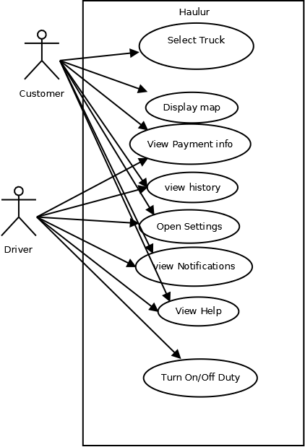

## 2.3 Constraints

* Operating System Constraints
  + The user must have Android 4.2 or higher.

## 2.4 Assumptions and Dependencies

* It is assumed that the user will have an internet capable phone or device.
* Hardware is assumed to be either a phone or tablet, with Wi-Fi and GPS.

# 3. Specific Requirements

## 

## 3.1 External Interface Requirements

### *3.1.1 User Interfaces*

This section will show how the user interacts with the mobile application**.** The UI/UX designer will analyze the current UI interface and design any improvements for later implantation.

*3.1.1.1 Start-Up Animation*

The current animation will be overhauled. Adding more detail to the walking animation. The quality will be improved and will have its performance and quality improved.

*3.1.1.2 Sign-In/Registration*

User will sign in and have the option to “Remember me” or sign up for new account. A driver icon will be included at the top left for driver registration. The Sign-in interface will have the credentials verified by the server though the HTTP interface.

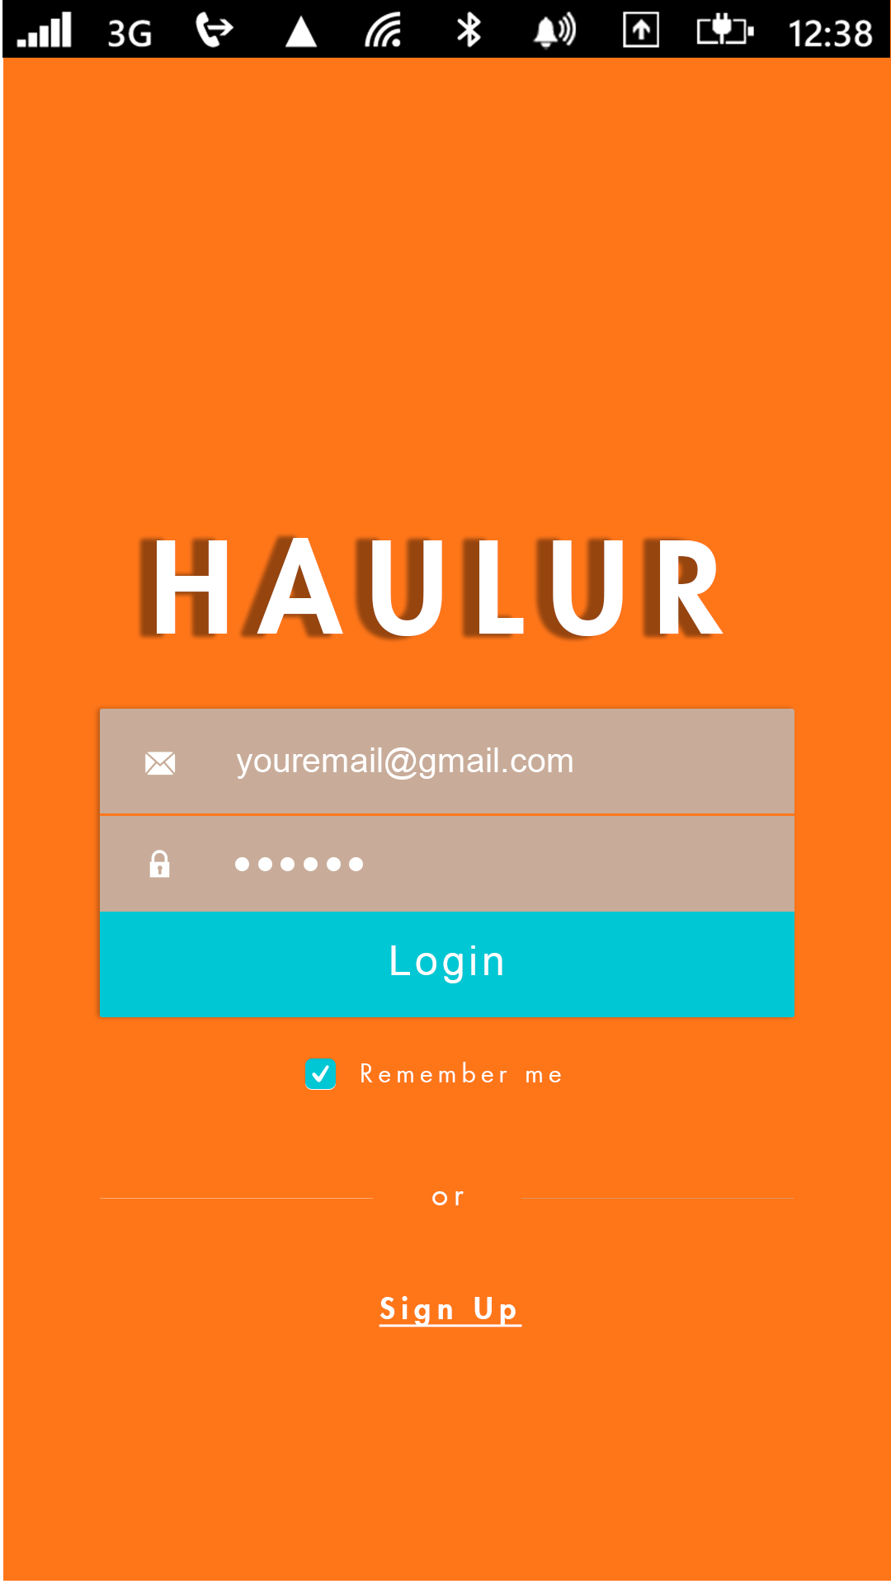

*3.1.1.2.1 New Username and Password*

User will create a username and password on this screen.

*3.1.1.2.2 New User information*

The next screen will have the user input personal information, such as first name, last name, street address, city, state, zip-code, phone number. The Register page will add the user to the server. Then the user be able to log in and have data accessed inside the application.

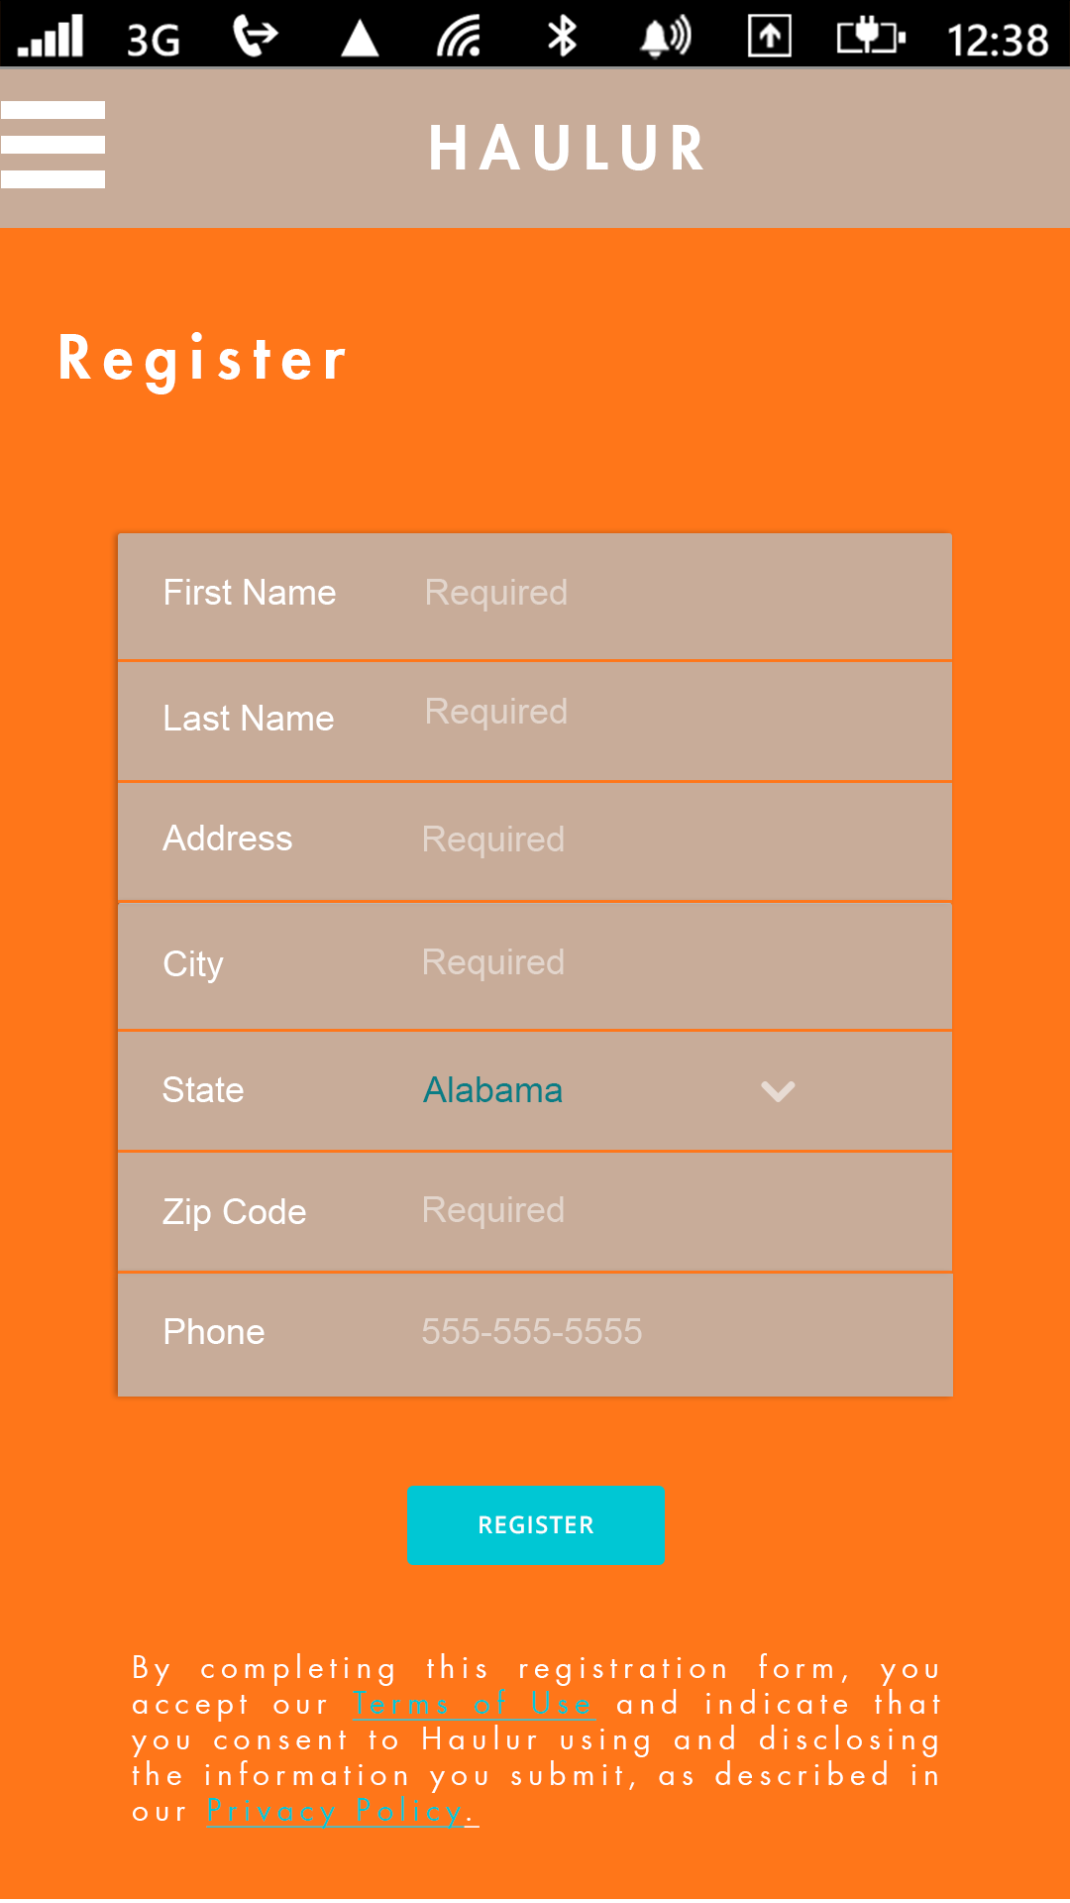

*3.1.1.3 Profile*

Show user information and the user’s avatar. The user’s information and avatar will be accessed from the server. Also the user can sign out at the bottom. The sign out will be verified with the server

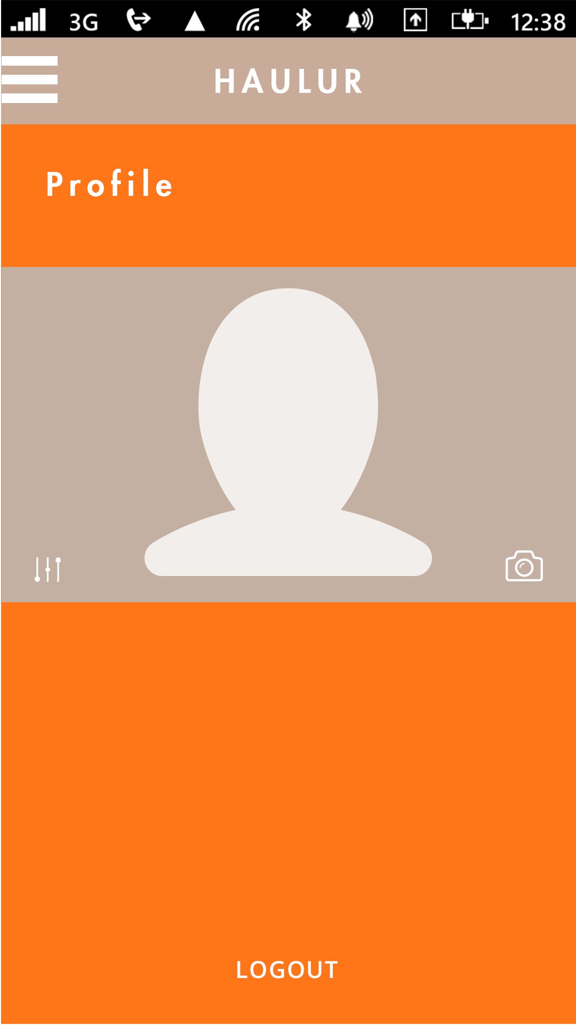

*3.1.1.4 History*

This page will display the recent hauls by the customer or the driver. The information will be accessed from the server. The user will be able to hide previous hauls as well.



*3.1.1.5 Notifications*

This page will display promotional data to the customer, or specific messages the customer/driver. The user will receive the data from the server and have it displayed here. The notifications will be able to be dispelled on the user’s swipe.



*3.1.1.6 Main Screen*

User will see HAULUR on the top of the page. User will see a map with his or her avatar on it showing the pin location with the stick avatar. User will see the truck icon on the bottom of the screen. There will be three options, a mid-size truck, full-size truck, and a hauler that they can tap. This will be selected by a slider. On the top left of the screen, next to the HAULUR name will be the menu button. The user and driver vehicle will be displayed on the map. In addition, there will be button for moving the interface to current location

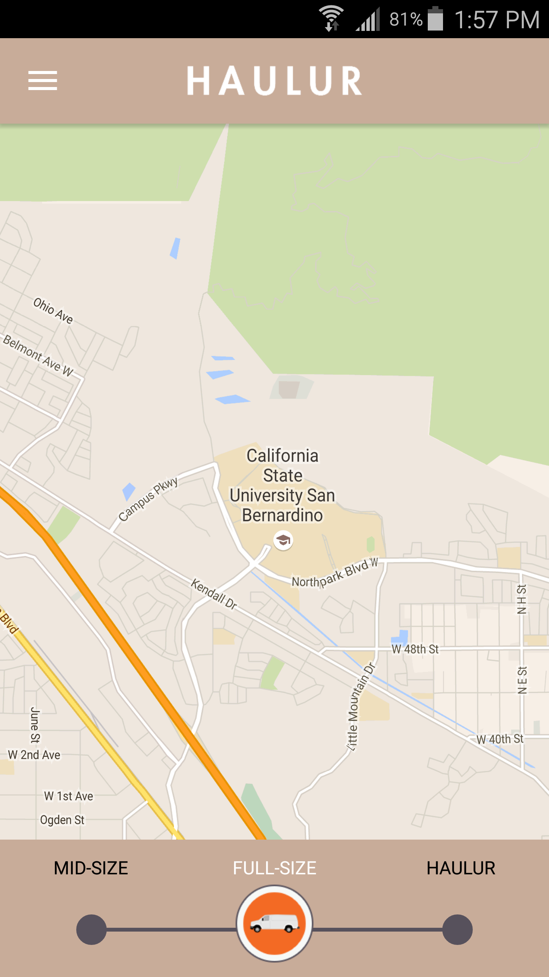

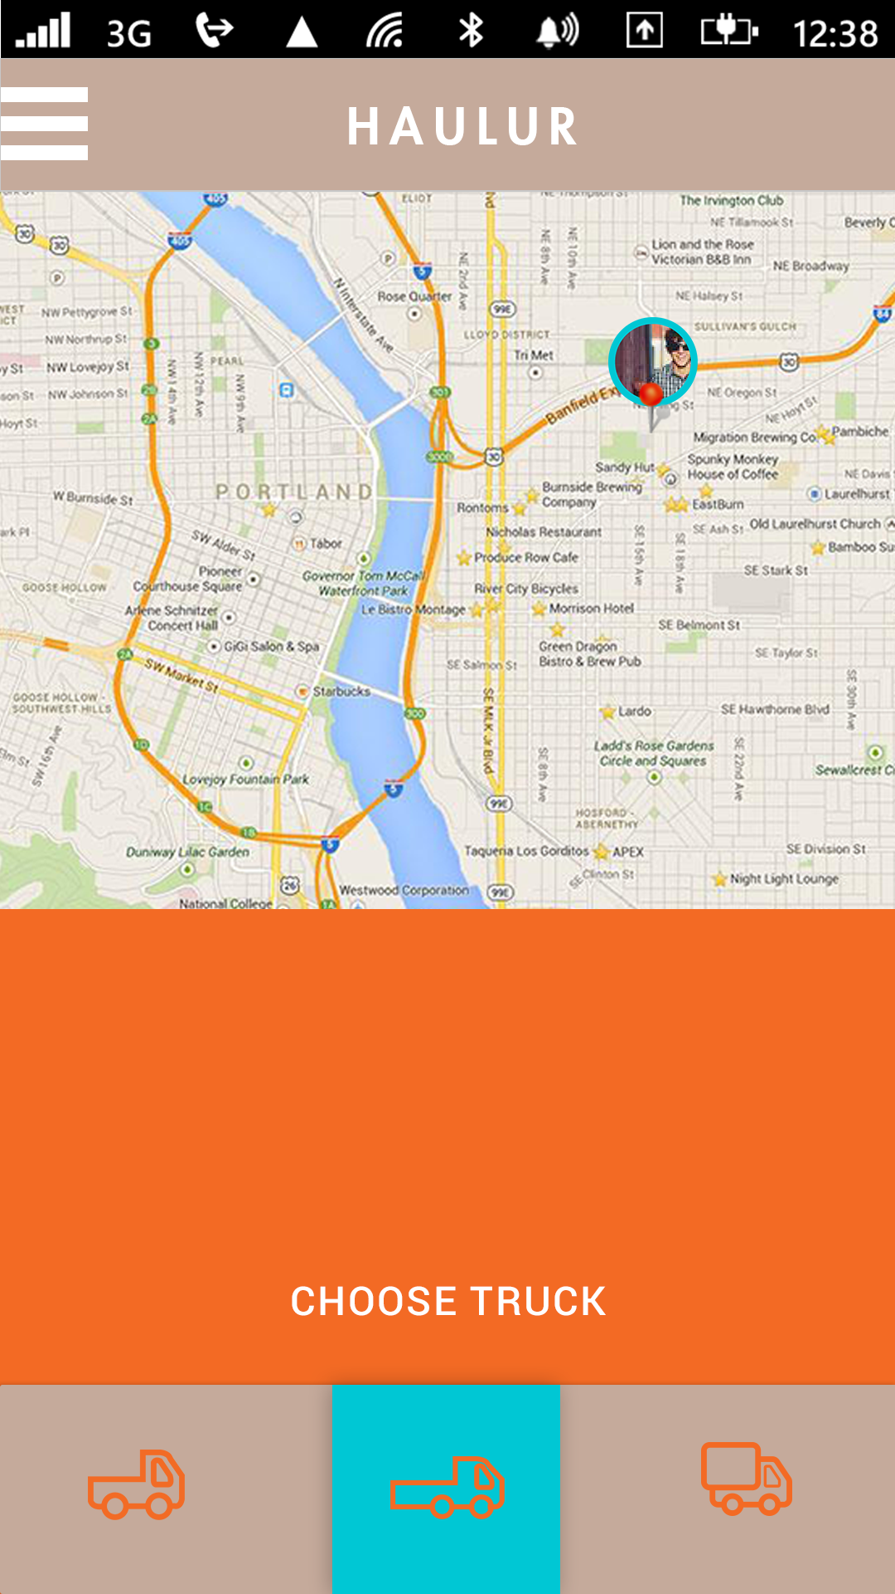

*3.1.1.7 Settings*

This page will have options for the customer or the driver to change their password, mute the sound, change the brightness, and edit personal information. These changes will be reflected on the server’s database.

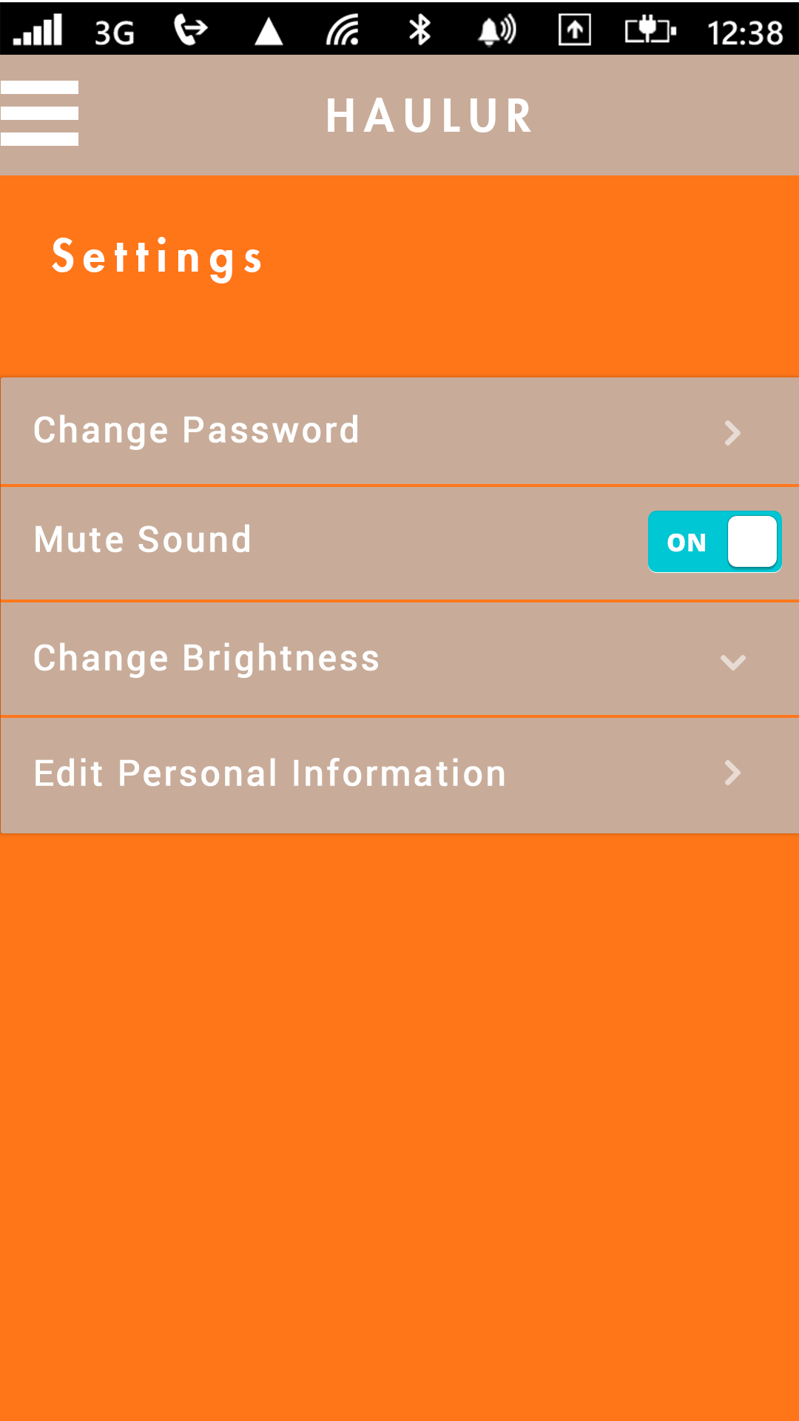

*3.1.1.8 Help*

This page will have a links to the many different options for support information. Additional information will be added and will be able to link the Haulur Website.

*3.1.1.9 Payment*

This page will contain a list of the user’s saved cards and have an add payment option page and an edit payment option page. The details of any payment information will need access to the server’s database. Any modifications will be saved on the server.

*3.1.2 Hardware Interfaces*

The application will be run native Android code, with the Android API level supported on 17 (=Android 4.2) and higher.

### *3.1.3 Software Interfaces*

Will utilize Google Map API and Android SDK. And an open source library for the slider. The application will communicate with the server’s MYSQL database.

### *3.1.4 Communication Interfaces*

The user’s device will communicate with Google servers to provide map functionality. The application will communicate with the Google servers via HTTPS through a mobile connection (3G or 4G) or Wifi. The application will also communicate with my MYSQL database though HTTPS.

## 

## 3.2 Functional Requirements

*3.2.1 Start-Up Animation*

This page will show the Hauler logo in an animated fashion and identify the app to the customer as the application loads.

*3.2.2 Sign-In/Registration*

This page will invite the customer to sign-in if setting up the app on the device for the first or if the user has previously signed out of the app. There will be an option to “remember me” for the customer to avoid re-entering the email and password again the next time the customer accesses the app. The sign-up option at the bottom of the screen allows the user to create a new account with an email and password, with following screens to enter in address information and payment information, if desired at the time. The top left will include a wheel for driver registration.

*3.2.3 Profile*

This page contains user information, accessed from the server interface. Currently a default image will be used. The sign out button is also located bottom.

*3.2.4 History*

This will be filled with data about previous hauls, and retrieved from the server, it will be able to be scrolled up and down through, and dismissible.

*3.2.5 Notifications*

This will eventually be filled with promotional and user messages. The data accessed from the server. If filled data, the notifications could be swiped away.

*3.2.6 Main Screen*

*3.2.6.1 Toolbar*

The HAULUR name centered inside. Also there will be a navigational panel button which will slide out the links to the other pages (Profile, Settings, etc…) when the panel clicked.

*3.2.6.2 Map*

Google Maps will be the source of the map, and be used as a navigational interface. If the map is integrated to the server, the location of the user marked by the user’s chosen avatar, as does the location of the driver. The avatar will use speech bubbles to display the states of the HAULUR service (Requesting, ETA ).

*3.2.6.3 Bottom Filter*

The bottom portion of the main screen shows the options of the HAULUR Vehicles. Currently cosmetic. This is because there are no official HAULUR vehicles and the implementation tests will only use 1 type of vehicle.

*3.2.7 Settings*

This page will have options for the customer or the driver to change their password, mute the sound (reset user information), and edit personal information. Any changes will modify the server information on the user.

*3.2.8 Help*

The links for support topics will have desired support information text placed. Links to the Haulur website will be placed

*3.2.9 Payment*

The options for payment. Would take fake information for testing.

3.3 Performance Requirements

The application will need to communicate with the server quickly. To have a short login duration, and also to display the diver and user’s location accurately.

3.4 Design Constraints

There are several design constraints that one must keep in mind with regards to mobile devices, and how much space Hauler app will actually require to run. These design constraints can be battery life, processor speed, memory size, and limited internet in certain areas.

3.5 Software System Attributes

*3.5.1 Reliability*

The Haulur application will be correctly formatted to be reliable in every test scenario. The Android and Server code will be kept up to date.

*3.5.2 Availability*

Since this is a test application any issues are able to be quickly resolved. Any information received from the database will be dependent on the Amazon web server’s availability.

*3.5.3 Security*

*3.5.3.1 System*

The application will require user verification to log in and for many change upload to the database.

*3.5.3.2 Data*

The server will require user verification for administrative functions, and will be fitted with up-to-date security measures.

## 3.6 Other Requirements

### 3.6.1 Testing

##### 3.6.1.1 Unit Testing

##### Each page of the application will be tested before being integrated with the other pages on the application.

##### 3.6.1.2 Integration Testing

Once each page is checked individually, the application will be combined to form a functional looking User Interface.

##### 3.6.1.3 Acceptance Testing

After unit testing and integration testing, the application will be tested on an actual device, to examine the real-world look and feel of the application, and to test for bugs.

3.6.2 Amazon Web Server Pricing

http://aws.amazon.com/ec2/pricing/

3.7 Document Approval

|  |  |
| --- | --- |
| Matthew Acuna (Client) |  |
| Navy Miech (Client) |  |