SIMATS ENGINEERING (SAVEETHA SCHOOL OF ENGINEERING)
Department of Artificial Intelligence and Data Science
ASSESSMENT TOOL 2 – SCENARIO BASED
Course Code: | DSA03 | Course Title: | Natural Language Processing
CO Assessed: | CO2 – Manipulation | Assessment: | Assessment Tool 2 – SCENARIO BASED
Weightage: | 35% of CIA
CO5 Statement: | Design inflectional, derivational, finite-state parsing, stemming algorithms and for analyse morphological methods. (BL-3)
Student Name: | Raihan Hussain | Reg. No.: | 192425342
Section / Batch: | AI ML | Date: | 24-10-2026

Code of Conduct
I Raihan Hussain / 192425342 (Name / Reg No) certify that this submission is my original work and that I have adhered to the guidelines specified for this assessment. I understand that any violation of academic integrity rules will result in disciplinary action.
Signature of the Student: Raihan Hussain

Instructions
- Read all questions carefully before attempting the answers.
- Answer all five questions. Each question carries equal marks.
- Show all intermediate steps, calculations, probability computations, tagging decisions, and justifications wherever applicable.
- Duration: 30 minutes.

Section / Topic | Focus | Q Nos
English Word Classes, Tagsets for English, Part of Speech Tagging | Morphological decomposition of analyzing, analysis, and analytical; identification of roots, affixes, inflectional and derivational forms, and normalization for indexing. | Q1
English Word Classes, Tagsets for English, Stochastic Part of Speech Tagging | Morphological parsing of disagree, agreement, and agreeable; identification of prefixes, suffixes, base forms, and semantic effects of derivation. | Q2
Counting Words, English Word Classes, Part of Speech Tagging | Morphology-based normalization of govern, government, and governance for topic modeling, clustering, and lexical standardization. | Q3
Rule-Based Part of Speech Tagging, Transformation-Based Tagging | Morphological analysis of activate, activation, and reactivation; identification of derivational layers, word-class changes, and semantic shifts. | Q4
Rule-Based Part of Speech Tagging, English Word Classes, Part of Speech Tagging | Inflectional normalization of create, creates, and creating; extraction of root forms and classification of tense/aspect transformations. | Q5
Annexure A – SCENARIO BASED
1. A large-scale search engine indexing system processes user queries containing word variants such as “analyzing, “analysis”, and “analytical”. The system must improve retrieval accuracy by grouping semantically related terms under a unified representation. Design a morphological processing approach to decompose each input word into root and affixes, distinguish between inflectional and derivational forms, and normalize them for indexing. Apply the process to the given inputs and determine the root form along with the morphological structure of each word.
- Develop a Python program to implement a rule-based morphological processing system for the input words "analyzing", "analysis", and "analytical". The program should identify the root word and separate the corresponding prefixes or suffixes using suitable morphological rules, classify each word as an inflectional or derivational form, normalize all related variants to a common representation for indexing, and generate a structured report showing the original word, extracted root, identified affix(es), transformation type, and normalized output to support efficient search engine retrieval.

Answer:
Approach:
- Normalize each query word (lower-case, trim spaces).
- Apply the ordered suffix rules (-ical, -ing, -is). A cut is accepted only when the remaining stem is a known root allomorph (analyz-, analys-, analyt-), which prevents wrong splits.
- Classify the affix: -ing is inflectional (only the grammatical form changes), whereas -is and -ic + -al are derivational (a new noun or adjective is formed from the verb).
- Map every allomorph to the common root "analyze" and store this single normalized term in the inverted index.
Program:
# Q1 - Rule-based morphological processing for search-engine indexing

# Allomorphs (spelling variants) of the same root and the lemma they normalize to
ROOTS = {"analyz": "analyze", "analys": "analyze", "analyt": "analyze"}

# (suffix, affixes, transformation type, grammatical effect)
RULES = [
("ical", ["-ic", "-al"], "Derivational", "forms an adjective (analyt + ic + al)"),
("ing", ["-ing"], "Inflectional", "present participle of the verb"),
("is", ["-is"], "Derivational", "forms a noun from the verb (analys + is)"),
]

def process(word):
word = word.lower().strip()
for suffix, affixes, kind, effect in RULES:
stem = word[:-len(suffix)]
if word.endswith(suffix) and stem in ROOTS: # validate the cut
return {"word": word, "stem": stem, "root": ROOTS[stem],
"affixes": affixes, "type": kind, "effect": effect,
"normalized": ROOTS[stem]}
return {"word": word, "stem": word, "root": word, "affixes": [],
"type": "Base form", "effect": "no affix", "normalized": word}

words = ["analyzing", "analysis", "analytical"]
results = [process(w) for w in words]

print("=" * 62)
print("MORPHOLOGICAL REPORT - SEARCH ENGINE INDEXING")
print("=" * 62)
for r in results:
print(f"Original word : {r['word']}")
print(f"Structure : {' + '.join([r['stem']] + r['affixes'])}")
print(f"Extracted root : {r['root']}")
print(f"Affix(es) : {', '.join(r['affixes']) or 'none'}")
print(f"Transformation : {r['type']} - {r['effect']}")
print(f"Normalized form : {r['normalized']}")
print("-" * 62)

# Inverted-index entry: every variant is stored under one normalized term
index = {}
for r in results:
index.setdefault(r["normalized"], []).append(r["word"])
print("INDEX ENTRY :", index)
Output:
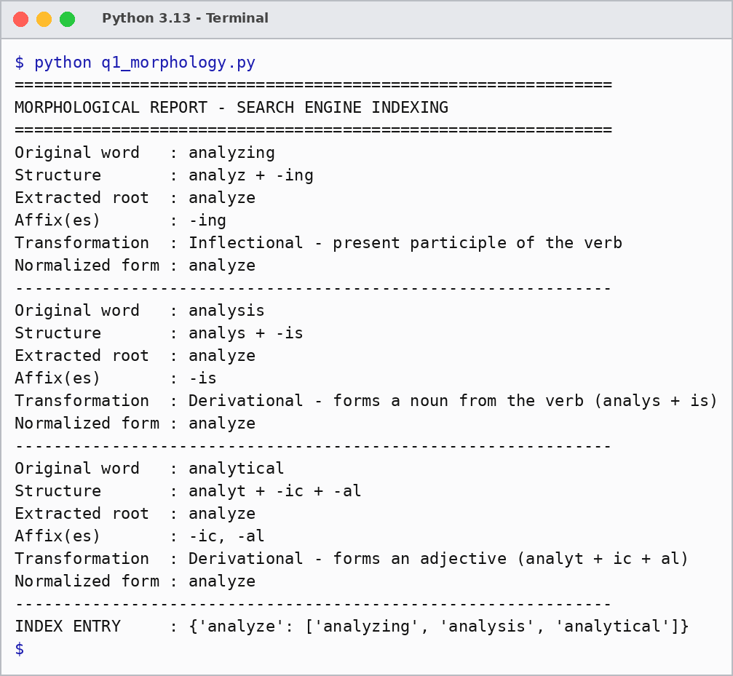
Result:
Original word | Structure | Root | Transformation type | Normalized
analyzing | analyz + -ing | analyze | Inflectional | analyze
analysis | analys + -is | analyze | Derivational | analyze
analytical | analyt + -ic + -al | analyze | Derivational | analyze

Result: analyzing is an inflectional form (present participle), while analysis and analytical are derivational forms. All three variants are stored under the single index term "analyze", so a query for any one of them retrieves documents containing the others. This improves recall without changing the meaning.

2. An AI-based sentiment analysis platform receives product reviews containing words like “disagree”, “agreement”, and “agreeable”. The system must interpret sentiment consistently despite variations in word formation. Develop a morphological parsing strategy to identify prefixes, suffixes, and base forms, while capturing how derivational changes influence meaning. Process the given inputs to extract roots and classify each transformation, ensuring accurate semantic interpretation across all word forms.
- Develop a Python program to create a morphological parser for the input words "disagree", "agreement", and "agreeable". The program should detect and separate prefixes, suffixes, and the base word using rule-based morphological analysis, examine how derivational modifications alter the meaning of the root word, classify each transformation according to its morphological type, and produce a comprehensive output containing the original word, identified prefix, root word, suffix, transformation category, semantic interpretation, and normalized base form for use in sentiment analysis applications.

Answer:
Approach:
- Strip a suffix (-ment, -able) only if the remaining stem is a known base word (agree).
- Strip a prefix (dis-) only if the remainder is a known base word.
- Classify each change as derivational and record its semantic effect: dis- negates the verb, -ment gives a noun (the act or state of agreeing) and -able gives an adjective (willing, pleasant).
- Normalize all forms to the base "agree" but keep a polarity flag, so that "disagree" is scored as negative and "agreement" / "agreeable" as positive.
Program:
# Q2 - Morphological parser for sentiment analysis (disagree, agreement, agreeable)

BASES = {"agree"}
PREFIXES = {"dis": "negation - reverses the meaning of the base word"}
SUFFIXES = {
"ment": "verb -> noun: the act or state of agreeing",
"able": "verb -> adjective: willing to agree / pleasant",
}
POLARITY = {
"disagree": "negative (polarity inverted)",
"agreement": "positive / neutral noun",
"agreeable": "positive",
}

def parse(word):
stem, prefix, suffix = word, "", ""
for s in SUFFIXES: # step 1: suffix
if stem.endswith(s) and stem[:-len(s)] in BASES:
suffix, stem = s, stem[:-len(s)]
break
for p in PREFIXES: # step 2: prefix
if stem.startswith(p) and stem[len(p):] in BASES:
prefix, stem = p, stem[len(p):]
break
if prefix:
category, meaning = "Derivational - prefixation", PREFIXES[prefix]
elif suffix:
category, meaning = "Derivational - suffixation", SUFFIXES[suffix]
else:
category, meaning = "Base form", "original verb"
return {"word": word, "prefix": prefix, "root": stem, "suffix": suffix,
"category": category, "meaning": meaning,
"sentiment": POLARITY.get(word, "neutral"), "normalized": stem}

words = ["disagree", "agreement", "agreeable"]
results = [parse(w) for w in words]

print("=" * 64)
print("MORPHOLOGICAL PARSING REPORT - SENTIMENT ANALYSIS")
print("=" * 64)
for r in results:
print(f"Original word : {r['word']}")
print(f"Prefix : {'dis-' if r['prefix'] else '-'}")
print(f"Root word : {r['root']}")
print(f"Suffix : {'-' + r['suffix'] if r['suffix'] else '-'}")
print(f"Category : {r['category']}")
print(f"Semantic meaning : {r['meaning']}")
print(f"Sentiment effect : {r['sentiment']}")
print(f"Normalized base : {r['normalized']}")
print("-" * 64)
Output:
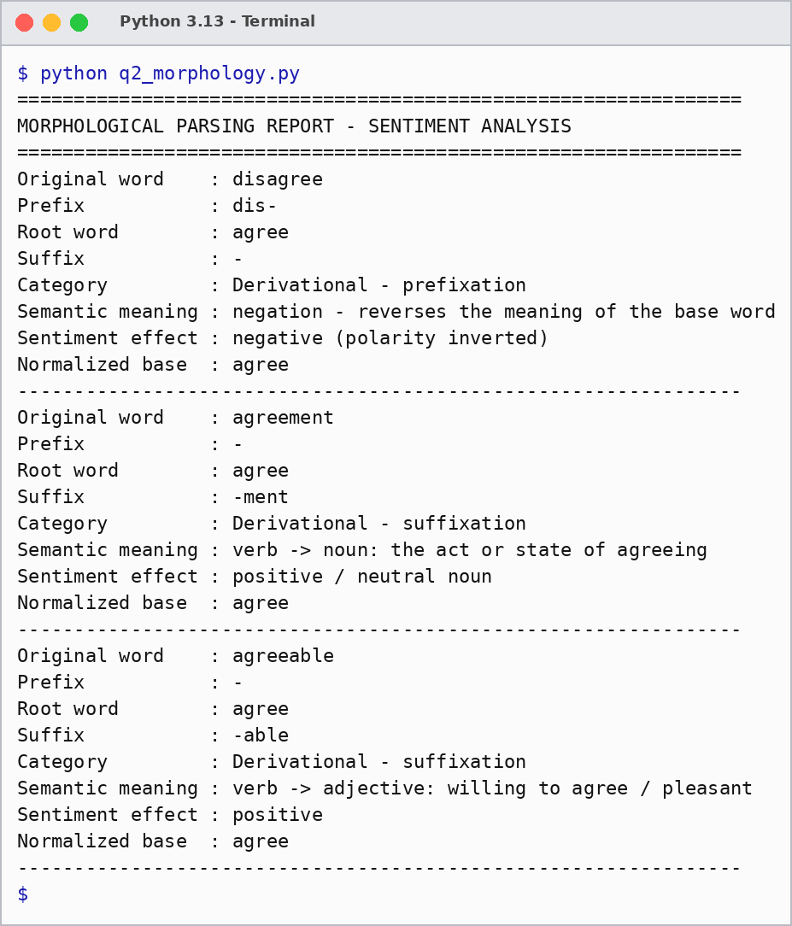
Result:
Original word | Prefix | Root | Suffix | Category | Normalized
disagree | dis- | agree | - | Derivational - prefixation | agree
agreement | - | agree | -ment | Derivational - suffixation | agree
agreeable | - | agree | -able | Derivational - suffixation | agree

Result: the prefix dis- reverses the meaning of the root, so it must be treated as a sentiment inverter, whereas the suffixes -ment and -able only change the word class (noun, adjective) and keep the polarity of the root. Normalizing to "agree" with a polarity flag keeps the sentiment interpretation consistent across all word forms.

3. A text analytics pipeline in a news aggregation system handles documents containing terms such as “govern”, “government”, and “governance”. The system must standardize these variations for topic modeling and clustering. Construct a morphology-based normalization mechanism that decomposes each word into its root and affixes, identifies derivational layers, and maps them to a common base form. Apply the approach to the input words and derive the normalized representation along with their morphological breakdown.
- Develop a Python program to implement a morphology-based normalization module for the input words "govern", "government", and "governance". The program should perform morphological decomposition to identify the root word and successive derivational suffixes, determine the derivational level associated with each word, normalize all variants to a common lexical representation, and generate a structured output displaying the original word, root form, detected affix(es), derivational hierarchy, normalized representation, and the final output used for topic modeling and document clustering.

Answer:
Approach:
- Peel suffixes one layer at a time while the remaining stem is a known root (govern).
- Count the peeled layers to get the derivational level (0 = root, 1 = first derivation).
- Record the derivational chain from the root to the word, for example govern -> government.
- Replace every variant by the root before topic modelling, so the term frequencies are merged into one token (govern x 3).
Program:
# Q3 - Morphology-based normalization for topic modeling and clustering
from collections import Counter

LEXICON = {"govern"}
SUFFIXES = [
("ment", "verb -> noun (act/result of governing)"),
("ance", "verb -> noun (act/state of governing)"),
]

def decompose(word):
current, affixes, layers = word, [], [word]
peeled = True
while peeled: # peel one derivational layer at a time
peeled = False
for suffix, meaning in SUFFIXES:
if current.endswith(suffix) and current[:-len(suffix)] in LEXICON:
affixes.append("-" + suffix)
current = current[:-len(suffix)]
layers.append(current)
peeled = True
break
return {"word": word, "root": current, "affixes": affixes,
"level": len(affixes), "hierarchy": " -> ".join(reversed(layers)),
"normalized": current}

words = ["govern", "government", "governance"]
results = [decompose(w) for w in words]

print("=" * 62)
print("MORPHOLOGICAL NORMALIZATION - TOPIC MODELING")
print("=" * 62)
for r in results:
print(f"Original word : {r['word']}")
print(f"Root form : {r['root']}")
print(f"Detected affix(es) : {', '.join(r['affixes']) or 'none'}")
print(f"Derivational level : {r['level']}")
print(f"Derivational chain : {r['hierarchy']}")
print(f"Normalized form : {r['normalized']}")
print("-" * 62)

# Final token stream used by topic modeling / document clustering
tokens = [r["normalized"] for r in results]
print("Final token stream :", tokens)
print("Cluster counts :", dict(Counter(tokens)))
Output:
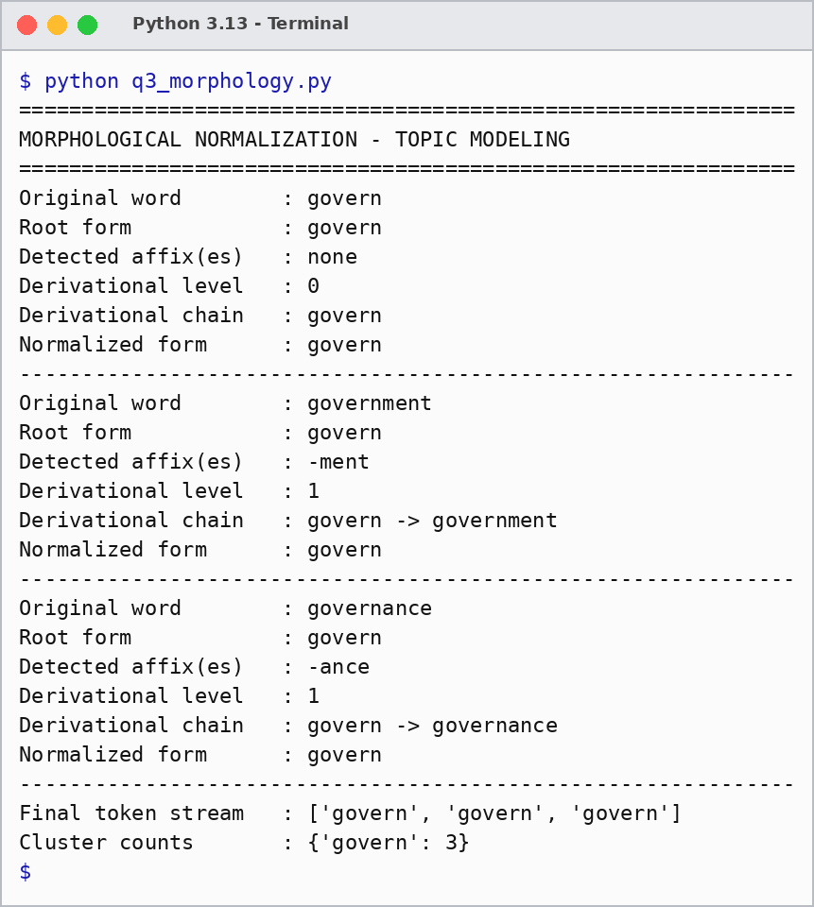
Result:
Original word | Root | Affix(es) | Level | Derivational chain | Normalized
govern | govern | none | 0 | govern | govern
government | govern | -ment | 1 | govern -> government | govern
governance | govern | -ance | 1 | govern -> governance | govern

Result: govern is the root (level 0), while government (-ment) and governance (-ance) are first-level derivational nouns. All three map to the common token "govern", so the topic model and the clustering algorithm treat them as one term instead of three sparse features.

4.A document classification system processes input words such as “activate”, “activation”, and “reactivation” to improve semantic grouping and indexing.
Construct a morphological parsing strategy to identify prefixes, suffixes, and root forms while distinguishing derivational layers.
Analyze how prefix addition and suffix transformation affect meaning and word class.
Apply the process to decompose each word and map them to a unified base representation.
Derive the morphological structure and normalized root for each input word.
- Develop a Python program to implement a morphological parsing and normalization system for the input words "activate", "activation", and "reactivation". The program should detect and separate prefixes, root words, and suffixes using rule-based morphological parsing, identify the sequence of derivational transformations that produce each word, analyze the effect of each morphological modification on the word class and semantic meaning, and generate a structured report showing the original word, prefix (if present), root word, suffix, derivational sequence, normalized base form, and final parsed representation for use in document classification and semantic indexing.

Answer:
Approach:
- Peel the outermost prefix first (re-), but only if the remainder is a valid word.
- Peel the suffixes layer by layer (-ion, -ate, -ive), restoring the dropped letter e (activat + e = activate) and validating every intermediate word against the lexicon.
- Record the word-class change at each layer: act (verb) -> active (adjective) -> activate (verb) -> activation (noun) -> reactivation (noun).
- Map all forms to the normalized root "act" for document classification and semantic indexing.
Program:
# Q4 - Morphological parsing and normalization (activate, activation, reactivation)

LEXICON = {"act", "active", "activate", "activation"}
WORD_CLASS = {
"act": "verb", "active": "adjective", "activate": "verb",
"activation": "noun", "reactivation": "noun",
}
PREFIXES = {"re": "again / repeat the action"}
# (suffix, letter restored to the stem, effect on word class and meaning)
SUFFIXES = [
("ion", "e", "verb -> noun (process or result)"),
("ate", "e", "adjective -> verb (to make active)"),
("ive", "", "verb -> adjective (tending to act)"),
]

def parse(word):
prefix, steps, current = "", [], word
for p in PREFIXES: # outermost layer: prefix
if current.startswith(p) and current[len(p):] in LEXICON:
prefix, current = p, current[len(p):]
steps.append(f"re- : {WORD_CLASS[current]} -> {WORD_CLASS[word]}, meaning '{PREFIXES[p]}'")
chain, suffixes = [word], []
if prefix:
chain.append(current)
done = False
while not done: # inner layers: suffixes
done = True
for suf, restore, effect in SUFFIXES:
base = current[:-len(suf)] + restore
if current.endswith(suf) and base in LEXICON:
suffixes.append("-" + suf)
steps.append(f"-{suf}: {WORD_CLASS[base]} -> {WORD_CLASS[current]}")
current = base
chain.append(current)
done = False
break
chain = chain[::-1]
suffixes.reverse()
parsed = " + ".join(([prefix + "-"] if prefix else []) + [current] + suffixes)
return {"word": word, "prefix": prefix, "root": current, "suffixes": suffixes,
"chain": chain, "steps": steps[::-1], "normalized": current, "parsed": parsed}

words = ["activate", "activation", "reactivation"]
results = [parse(w) for w in words]

print("=" * 66)
print("MORPHOLOGICAL PARSING REPORT - DOCUMENT CLASSIFICATION")
print("=" * 66)
for r in results:
print(f"Original word : {r['word']}")
print(f"Prefix : {r['prefix'] + '-' if r['prefix'] else 'none'}")
print(f"Root word : {r['root']}")
print(f"Suffix(es) : {', '.join(r['suffixes']) or 'none'}")
print(f"Derivational sequence : {' -> '.join(r['chain'])}")
for s in r["steps"]:
print(f" step : {s}")
print(f"Normalized base form : {r['normalized']}")
print(f"Final parsed form : {r['parsed']}")
print("-" * 66)
Output:
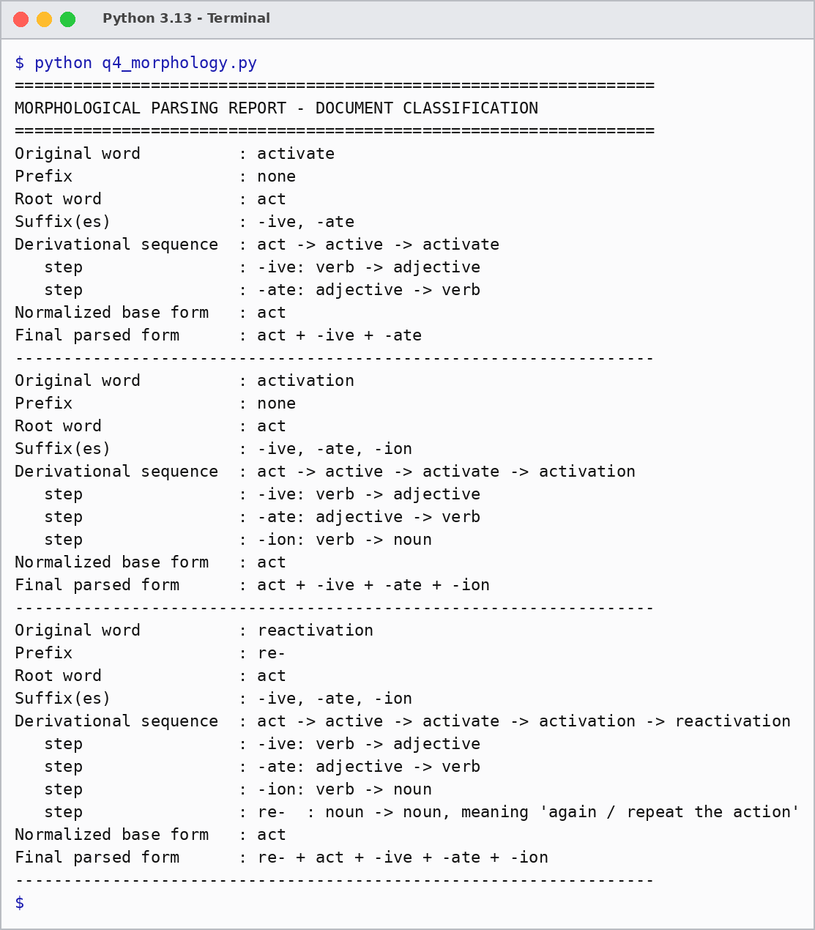
Result:
Original word | Prefix | Root | Suffix(es) | Derivational sequence | Normalized
activate | none | act | -ive, -ate | act -> active -> activate | act
activation | none | act | -ive, -ate, -ion | act -> active -> activate -> activation | act
reactivation | re- | act | -ive, -ate, -ion | act -> active -> activate -> activation -> reactivation | act

Result: the suffixes change the word class (-ive: verb -> adjective, -ate: adjective -> verb, -ion: verb -> noun), whereas the prefix re- keeps the class (noun -> noun) and only adds the meaning "again". Every form is therefore grouped under the root "act", which gives one semantic index entry for the whole word family.

5. A search optimization module processes input words such as “create”, “creates”, and “creating” to ensure consistent retrieval across grammatical variations. Design a morphology-based normalization approach focusing on inflectional transformations such as tense and aspect.
Identify suffix patterns and map all variations to a common base form without altering meaning.
Apply the process to extract root forms and classify each transformation.
Determine the morphological breakdown and normalized output for each word.
- Develop a Python program to implement an inflectional morphology-based normalization module for the input words "create", "creates", and "creating". The program should recognize grammatical suffixes corresponding to different inflectional forms, identify the underlying root word by applying appropriate normalization rules, classify each input according to its grammatical feature (e.g., base form, third-person singular, present participle), and produce a structured output containing the original word, identified suffix, grammatical category, extracted root, normalized base form, and the final normalized representation to support efficient search optimization and information retrieval.

Answer:
Approach:
- Check whether the word is already a base form in the lexicon (create).
- Otherwise match the inflectional suffixes (-ing, -s, -d); for -ing restore the dropped letter e (creat + e) and accept the cut only if the restored root is valid.
- Classify the grammatical feature and POS tag of the suffix: base form (VB), third-person singular (VBZ), present participle (VBG).
- Normalize all forms to the base form "create". Inflection changes only tense and aspect, so the meaning is not altered.
Program:
# Q5 - Inflectional morphology-based normalization (create, creates, creating)

LEXICON = {"create"}
# (suffix, letter restored to the stem, grammatical category, POS tag)
RULES = [
("ing", "e", "present participle (progressive aspect)", "VBG"),
("s", "", "third-person singular present", "VBZ"),
("d", "", "past tense / past participle", "VBD"),
]

def normalize(word):
if word in LEXICON: # already a base form
return {"word": word, "suffix": "-", "category": "base form (infinitive)",
"tag": "VB", "root": word, "normalized": word}
for suffix, restore, category, tag in RULES:
root = word[:-len(suffix)] + restore
if word.endswith(suffix) and root in LEXICON:
return {"word": word, "suffix": "-" + suffix, "category": category,
"tag": tag, "root": root, "normalized": root}
return {"word": word, "suffix": "?", "category": "unknown", "tag": "?",
"root": word, "normalized": word}

words = ["create", "creates", "creating"]
results = [normalize(w) for w in words]

print("=" * 62)
print("INFLECTIONAL NORMALIZATION REPORT - SEARCH OPTIMIZATION")
print("=" * 62)
for r in results:
print(f"Original word : {r['word']}")
print(f"Identified suffix : {r['suffix']}")
print(f"Grammatical category : {r['category']}")
print(f"Extracted root : {r['root']}")
print(f"Normalized base form : {r['normalized']}")
print(f"Final representation : {r['word']}/{r['tag']} -> {r['normalized']}/VB")
print("-" * 62)
Output:
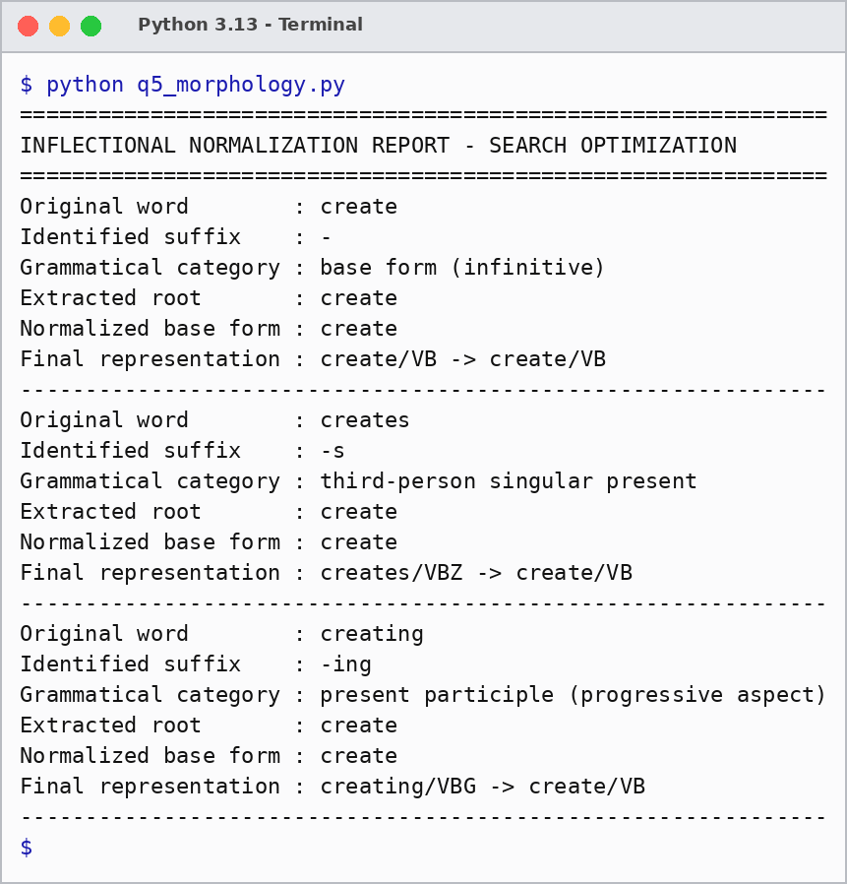
Result:
Original word | Suffix | Grammatical category | Root | Normalized
create | - | base form (infinitive) | create | create
creates | -s | third-person singular present | create | create
creating | -ing | present participle (progressive aspect) | create | create

Result: create is the base form, creates is the third-person singular present (-s) and creating is the present participle (-ing, with e-deletion). All are mapped to the base "create", so a search for any form retrieves documents with the others without changing the meaning.

Rubrics for Calculation
Criteria | Weightage (%) | Level 4 (Exemplary) | Level 3 (Proficient) | Level 2 (Developing) | Level 1 (Beginning)
Understanding of Scenario | 20% | Demonstrates clear and complete understanding of the scenario and context | Shows good understanding with minor gaps | Partial understanding; misses key aspects | Misinterprets or fails to understand the scenario
Identification of Key Issues | 20% | Accurately identifies all relevant issues and factors involved | Identifies most key issues with minor omissions | Identifies limited issues; some irrelevant points | Unable to identify key issues
Application of Concepts | 25% | Applies appropriate concepts effectively to address the scenario | Applies concepts with minor errors | Limited or partially correct application | Unable to apply relevant concepts
Decision Making | 20% | Makes well-reasoned, logical decisions with strong rationale | Makes reasonable decisions with some justification | Makes weak decisions with limited justification | No clear decisions made or rationale provided
Clarity of Response | 15% | Response is clear, structured, and logically presented | Generally clear with minor issues | Somewhat unclear or poorly structured | Disorganized and difficult to understand

Q. No. / Criteria Level | Understanding of Scenario | Identification of Key Issues | Application of Concepts | Decision Making | Clarity of Response | Sub. Total | Total %
1
2
3
4
5

Faculty In-charge | Course Coordinator | Program Director
Signature: _______________ | Signature: _______________ | Signature: _______________
Date: ___________________ | Date: ___________________ | Date: ___________________

