Seaborn Quick Reference
Class notes cheat sheet: line, scatter, facet, histogram, KDE, count, bar, regression, pair and joint plots
A short, beginner-friendly summary of the Seaborn class notebook. The code is cleaned up and every example is checked to run. Each section follows the same order: what the plot does, syntax, examples with expected output, then notes.
- Run the code blocks from top to bottom in a Jupyter Notebook. Each example makes one plot.
- The images under the examples are your own plots, saved in the class notebook.
- Note, Common mistake and Correction boxes point out the points most worth remembering.
- Written for Seaborn 0.12 or newer. The errorbar= argument does not exist in older versions.
Contents
1. Setup and Data  2. Axes-Level vs Figure-Level  3. Line Plot  4. Scatter Plot  5. Facet Plot  6. Histogram  7. KDE Plot | 8. Countplot  9. Bar Plot  10. Regplot and lmplot (Optional)  11. Pairplot  12. Joint Plot (Optional)  13. Parameter Summary

1. Setup and Data

1.1 Import the Libraries
Run these four lines once at the top of the notebook. The short names (aliases) are used in every example.
Library | Alias | Used for
numpy | np | Number functions, such as np.median and np.max (Section 9)
pandas | pd | Reading data and working with tables (DataFrames)
matplotlib.pyplot | plt | Seaborn draws on top of Matplotlib; plt.show() displays a plot
seaborn | sns | All the plots in this document

import numpy as np
import pandas as pd
import matplotlib.pyplot as plt
import seaborn as sns

Note: In Jupyter Notebook a plot appears automatically below the cell. In a normal .py script, add plt.show() after the plot.

1.2 Load a CSV File and Preview It
pd.read_csv() reads a CSV file into a DataFrame (a table). .head() shows the first 5 rows. Always check the column names before you plot.
Syntax and example (Dataset 1)
student = pd.read_csv('sns_data.csv')
student.head()

Expected output
student_id | class_level | subject | study_hours | test_score | week | attendance_rate | gender | hostel | Tshirt_size
1 | Freshman | Math | 5 | 78 | 1 | 90 | Male | True | 30
2 | Freshman | Science | 3 | 65 | 1 | 80 | Female | False | 20
3 | Freshman | History | 4 | 70 | 1 | 85 | Male | True | 20
4 | Freshman | Language | 2 | 60 | 1 | 75 | Female | True | 40
5 | Sophomore | Math | 6 | 82 | 1 | 92 | Male | True | 20

- Typing only the DataFrame name (for example student) shows the whole table. Long tables are shortened with ... and the size is printed at the bottom, such as [100 rows x 14 columns].
- Column names are case-sensitive: Marks and Tshirt_size must be typed exactly like this.
Common mistake: Writing y='marks' instead of y='Marks' gives ValueError: Could not interpret value marks for y. An entry with this name does not appear in data.

1.3 The Two Class Datasets
Your notebook uses two CSV files and stores both in the variable student. The second read_csv replaces the first, so reload the correct file whenever you switch. Each section below says which dataset it uses.
 | Dataset 1: sns_data.csv | Dataset 2: student_dataset_complete.csv
Used in | Sections 3 and 4 (line, scatter) | Sections 5 to 12 (facet to joint plot)
Size | 10 columns | 100 rows, 14 columns
gender | Male, Female | F, M
hostel | True, False | 0, 1
class_level | Text: Freshman, Sophomore, Junior, Senior | Number: 10, 11, 12 (text names are in class_name)
attendance_rate | Percentage, e.g. 90 | Fraction from 0.80 to 1.00
week | 1 to 6 | 1 to 5
subject | Math, Science, History, Language | Science, Math, English
study_hours, test_score | Whole numbers, e.g. 5 and 78 | Decimals, e.g. 4.508 and 19.202
Tshirt_size | 20, 30, 40 | 1 to 4

Note: In Dataset 2, study_hours has the same values as time_study, and test_score has the same values as Marks (in the rows shown in your notes). That is why Marks and test_score give similar plots.
Correction: Because student changes meaning halfway through the notebook, running an old cell after the reload can fail or give a different plot. Re-run the matching read_csv line first.

1.4 Built-in Datasets
Seaborn includes over 20 small practice datasets. sns.load_dataset() loads one by name. It needs an internet connection the first time.
Syntax and example
tips_data = sns.load_dataset("tips")
tips_data.head()

Expected output
total_bill | tip | sex | smoker | day | time | size
16.99 | 1.01 | Female | No | Sun | Dinner | 2
10.34 | 1.66 | Male | No | Sun | Dinner | 3
21.01 | 3.50 | Male | No | Sun | Dinner | 3
23.68 | 3.31 | Male | No | Sun | Dinner | 2
24.59 | 3.61 | Female | No | Sun | Dinner | 4

Tip: sns.get_dataset_names() returns the list of all available built-in datasets.
sns.get_dataset_names()

2. Axes-Level vs Figure-Level Functions
Every Seaborn plot function belongs to one of two groups. This idea is used in every section that follows.
- Figure: the entire canvas (window) where plots are displayed. It can hold one plot or many plots.
- Axes: one individual plotting area inside a Figure. It contains the actual graph, such as a scatter plot, histogram or line plot.
 | Axes-level function | Figure-level function
Draws | One plot on one Axes | On its own Figure (one or many plots)
Returns | An Axes object | A FacetGrid, PairGrid or JointGrid object
Facets (col=, row=) | Not available | Available
Plot type is chosen by | The function name | The kind= argument (relplot, displot)

Which function makes which plot
Plot | Axes-level | Figure-level | Best for
Line | lineplot | relplot(kind='line') | How a value changes over time or order
Scatter | scatterplot | relplot(kind='scatter') | Relationship between two numbers
Histogram | histplot | displot(kind='hist') | How one number is spread out (counts in bins)
KDE | kdeplot | displot(kind='kde') | Smooth curve of how one number is spread out
Count | countplot | not covered in class | Number of rows in each category
Bar | barplot | not covered in class | Average (or other summary) for each category
Regression | regplot | lmplot | Scatter plot with a trend line
Pair | none | pairplot | Every pair of numeric columns at once
Joint | none | jointplot | Scatter plot with both distributions on the edges

What Jupyter prints above the plot
sns.lineplot(...) -> <Axes: xlabel='week', ylabel='attendance_rate'>
sns.relplot(...) -> <seaborn.axisgrid.FacetGrid at 0x251978feba0>

- These text lines are the returned object, not errors. The number after 0x is different every run.
- Use an axes-level function for one simple plot. Use a figure-level function when you need col= or row= to split the data into several plots.
- relplot draws a scatter plot unless you give kind='line'. displot draws a histogram unless you give another kind.
Common mistake: Facet arguments only work with figure-level functions. sns.scatterplot(..., col='gender') fails with AttributeError: PathCollection.set() got an unexpected keyword argument col. Use sns.relplot(kind='scatter', ..., col='gender') instead.
Common mistake: Axes-level plots called one after another in the same cell are drawn on top of each other. Put plt.show() after each plot, as the multi-plot examples in this document do.

3. Line Plot
Dataset 1 (sns_data.csv) | Axes-level: sns.lineplot() | Figure-level: sns.relplot(kind='line')
A line plot shows how a number changes along an ordered x value, for example attendance_rate over each week.

Syntax
Template (replace df and the column names)
sns.lineplot(data=df, x='x_column', y='y_column',
hue='group_column', errorbar=None)

sns.relplot(kind='line', data=df, x='x_column', y='y_column',
hue='group_column', errorbar=None)

Examples
Example 1: Default line plot (axes-level)
The line is the mean attendance_rate of each week. The shaded band is the 95% confidence interval.
sns.lineplot(data=student, x='week', y='attendance_rate')

Example 2: Remove the shaded band
sns.lineplot(data=student, x='week', y='attendance_rate', errorbar=None)

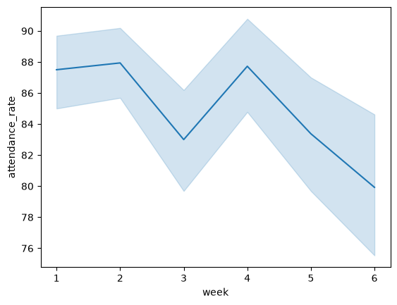  Example 1: shaded band | 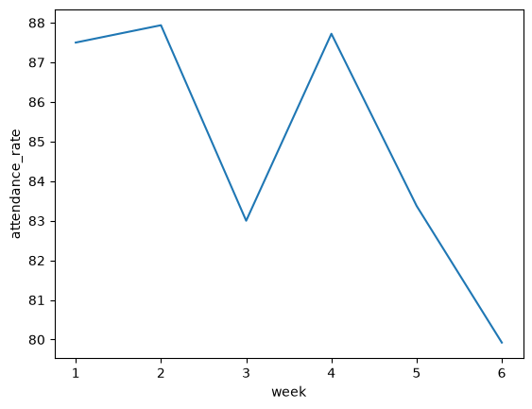  Example 2: errorbar=None

Example 3: One line for each group with hue
sns.lineplot(data=student, x='week', y='attendance_rate',
errorbar=None, hue='gender')

Example 4: The same plot, figure-level
sns.relplot(kind='line', data=student, x='week', y='attendance_rate',
errorbar=None, hue='gender')

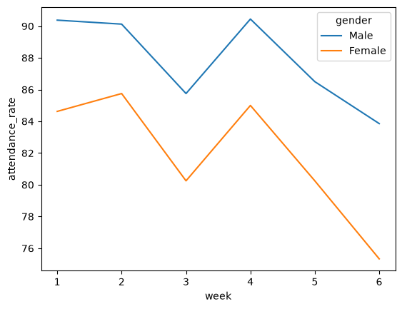  Example 3: lineplot | 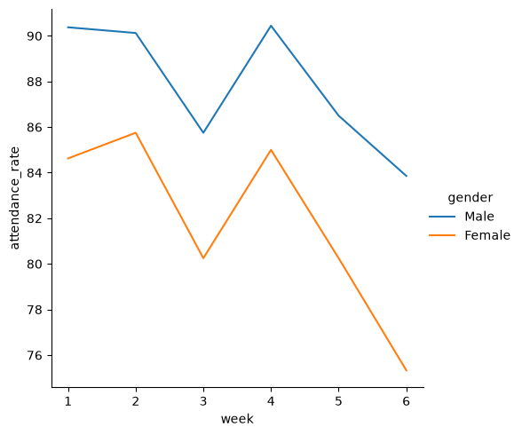  Example 4: relplot (legend outside)

Example 5: Other columns for y and hue
# test_score for each gender
sns.relplot(kind='line', data=student, x='week', y='test_score',
errorbar=None, hue='gender')
plt.show()

# test_score for each class_level
sns.relplot(kind='line', data=student, x='week', y='test_score',
errorbar=None, hue='class_level')
plt.show()

# attendance_rate for each class_level
sns.relplot(kind='line', data=student, x='week', y='attendance_rate',
errorbar=None, hue='class_level')
plt.show()

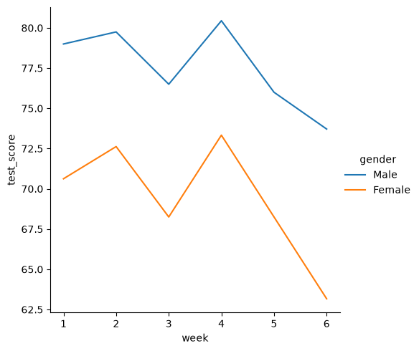  test_score, hue=’gender’ | 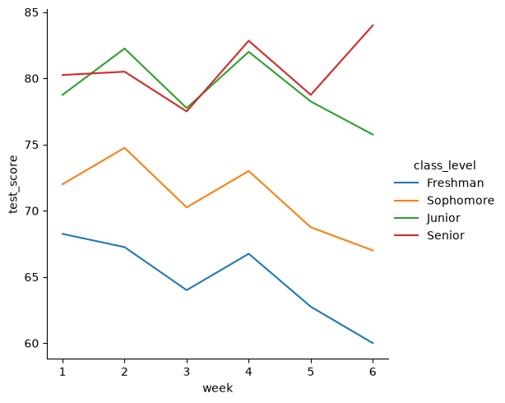  test_score, hue=’class_level’

Notes and common mistakes
- When one week has many rows, Seaborn plots the mean and shades the 95% confidence interval. errorbar=None removes this band.
- hue='gender' draws one line per group, each with its own color and a legend.
- x holds the ordered values (week). y holds the number you are tracking.
Common mistake: Writing sns.relplot(...) without kind='line' draws a scatter plot, not a line plot.
Note: Seaborn older than 0.12 uses ci=None instead of errorbar=None. In newer versions ci=None still runs but shows a FutureWarning.

4. Scatter Plot
Dataset 1 (sns_data.csv) and tips_data (Section 1.4) | Axes-level: sns.scatterplot() | Figure-level: sns.relplot(kind='scatter')
A scatter plot shows each row as one dot. It is used to see the relationship between two numeric columns, such as study_hours and test_score.

Syntax
Template (replace df and the column names)
sns.scatterplot(data=df, x='x_column', y='y_column',
hue='column', style='column', size='column')

sns.relplot(kind='scatter', data=df, x='x_column', y='y_column',
hue='column', style='column', size='column')

Parameter | Effect | Example from your notes
hue | Different colors for each group | hue='gender'
style | Different marker shapes for each group | style='subject'
size | Different marker sizes based on the column values | size='Tshirt_size'

Examples
Example 1: Basic scatter plot
sns.scatterplot(data=student, x='study_hours', y='test_score')

Example 2: Add hue, style and size
# hue='gender' -> a different color for each gender
# style='subject' -> a different marker shape for each subject
# size='Tshirt_size' -> a different marker size for each Tshirt_size value
sns.scatterplot(data=student, x='study_hours', y='test_score',
hue='gender', style='subject', size='Tshirt_size')

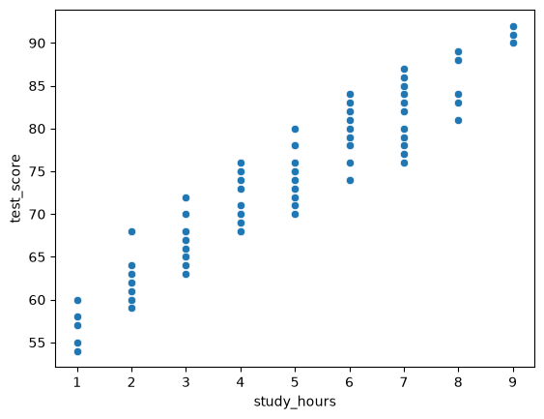  Example 1 | 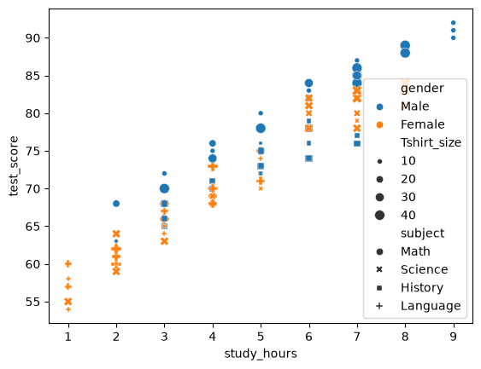  Example 2

Example 3: The same plot, figure-level
sns.relplot(kind='scatter', data=student, x='study_hours', y='test_score',
hue='gender', style='subject', size='Tshirt_size')

Example 4: Built-in tips dataset (relplot, then scatterplot)
# tips_data is loaded in Section 1.4
sns.relplot(kind='scatter', data=tips_data, x='total_bill', y='tip',
hue='sex', style='time', size='size')
plt.show()

sns.scatterplot(data=tips_data, x='total_bill', y='tip',
hue='sex', style='time', size='size')

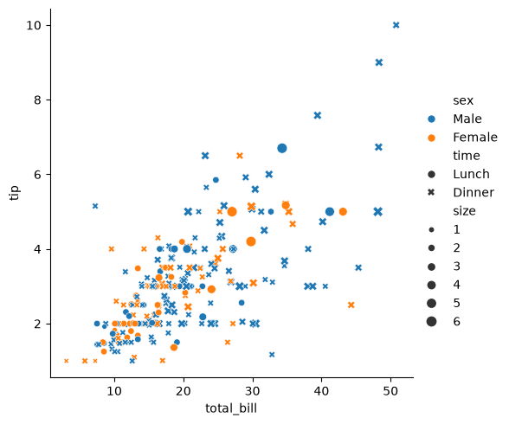  relplot: legend outside the plot | 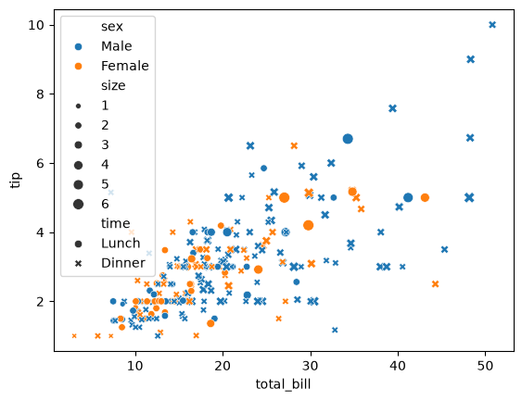  scatterplot: legend inside, covers dots

Notes and common mistakes
- Use hue, style and size only when they add useful information. Too many make the plot hard to read.
- In size='size' the first size is the Seaborn parameter and the second is the column name in tips_data.
- relplot is a scatter plot by default, so kind='scatter' is optional. It is written in class to make the plot type clear.
Correction: Your notebook ran Example 2 twice, with the comments split across two cells. It is shown once here with all three comments together.

5. Facet Plot
Dataset 2 (student_dataset_complete.csv) | Figure-level: sns.relplot() with col= and row=
A Facet Plot divides a dataset into several smaller plots (facets) based on one or more categorical columns. All small plots use the same axis ranges, so groups are easy to compare.

Syntax
Template (replace df and the column names)
sns.relplot(kind='scatter', data=df, x='x_column', y='y_column',
col='column', row='column', col_wrap=2)

Examples
Example 1: Switch to Dataset 2
student = pd.read_csv('student_dataset_complete.csv')
student.head()

Example 2: One plot for all groups (not yet a facet plot)
sns.scatterplot(data=student, x='study_hours', y='test_score', hue='gender')
plt.show()

sns.relplot(kind='scatter', data=student, x='study_hours', y='test_score',
hue='gender')

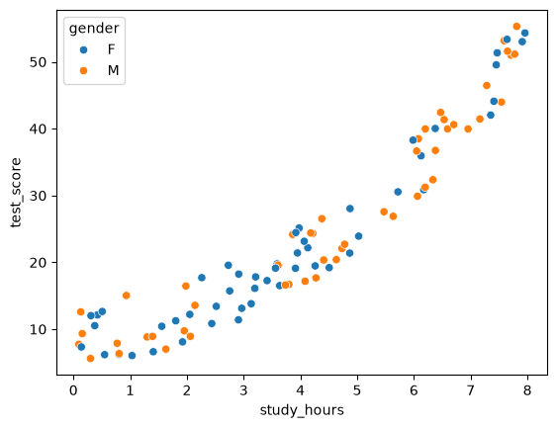  scatterplot with hue | 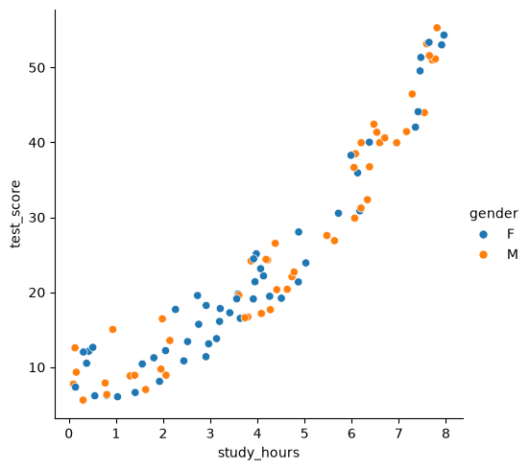  relplot with hue

Example 3: One plot per gender with col
col='gender' creates a separate plotting area for each gender. This is the facet plot.
sns.relplot(kind='scatter', data=student, x='study_hours', y='test_score',
col='gender')

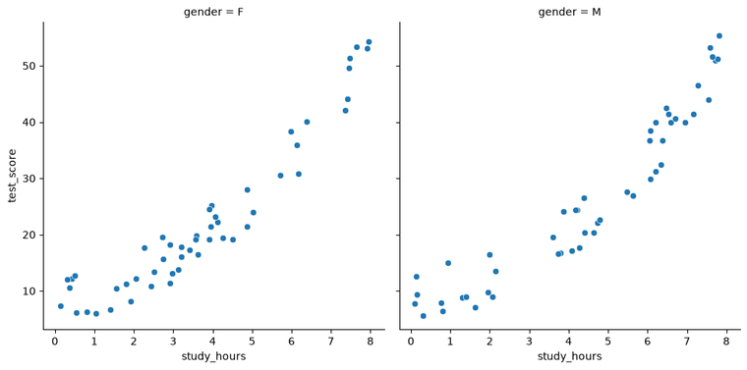
col=’gender’: one plot for F and one for M

Example 4: Rows and columns together
col='gender' makes one column for each gender. row='hostel' makes one row for each hostel value (0 and 1), giving a 2 × 2 grid.
sns.relplot(kind='scatter', data=student, x='study_hours', y='test_score',
col='gender', row='hostel')

Example 5: Limit the plots per row with col_wrap
col='week' makes 5 plots. col_wrap=2 allows at most 2 plots in a row, then continues on the next row.
sns.relplot(kind='scatter', data=student, x='study_hours', y='test_score',
col='week', col_wrap=2)

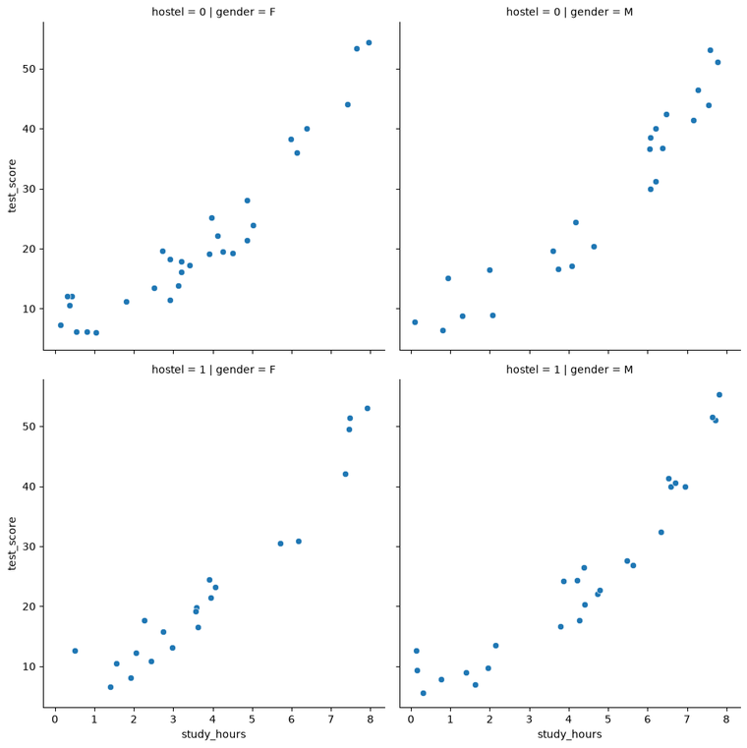  Example 4: col and row | 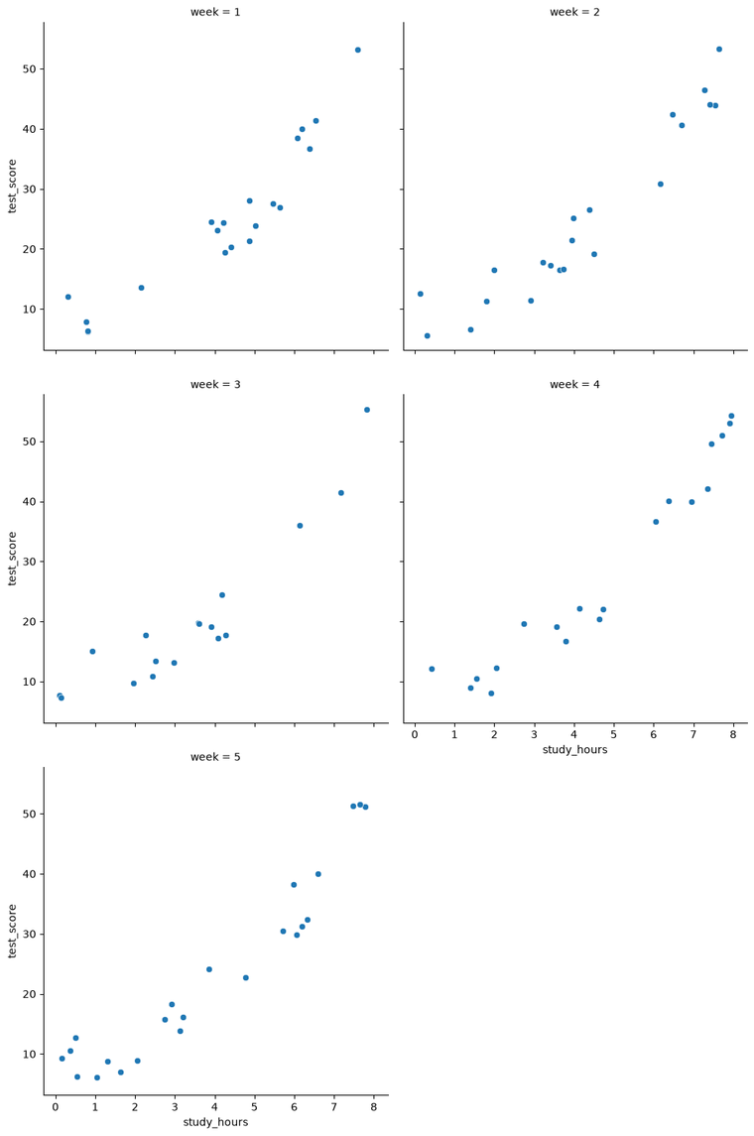  Example 5: col_wrap=2

Notes and common mistakes
- scatterplot() and relplot(hue=...) keep all groups in one plot. relplot(col=...) splits the groups into separate plots. That split is what makes it a facet plot.
- Each facet has a title above it, such as hostel = 0 | gender = F.
Common mistake: col_wrap cannot be used together with row. Seaborn stops with ValueError: Cannot use row and col_wrap together.

6. Histogram
Dataset 2 and tips_data | Axes-level: sns.histplot() | Figure-level: sns.displot(kind='hist')
A histogram shows how the values of one numeric column are spread out. The range is cut into bins and the bar height is the number of rows in each bin. Only x is needed; the y axis is automatically Count.

Syntax
Template (replace df and the column names)
sns.histplot(data=df, x='x_column', hue='group_column',
bins=10, element='step')

sns.displot(kind='hist', data=df, x='x_column', col='group_column', bins=10)

Examples
Example 1: Axes-level histogram with hue
sns.histplot(data=student, x='attendance_rate', hue='gender')

Example 2: Set the number of bins and the step style
sns.histplot(data=student, x='attendance_rate', hue='gender',
bins=10, element='step')

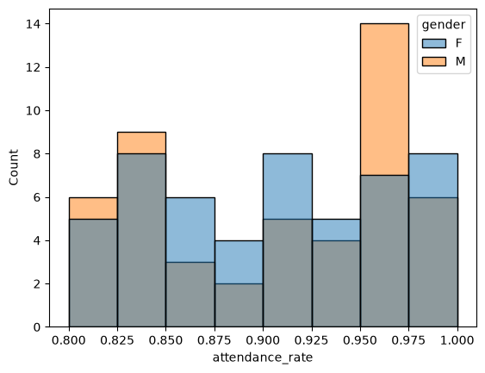  Example 1: default bars | 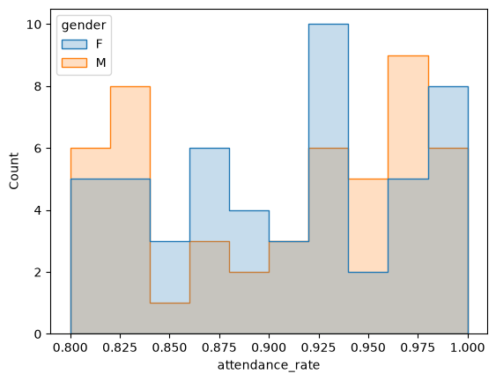  Example 2: bins=10, element=’step’

Example 3: Figure-level histogram
sns.displot(kind='hist', data=student, x='attendance_rate')

Example 4: One histogram for each gender
# attendance_rate
sns.displot(kind='hist', data=student, x='attendance_rate', col='gender')
plt.show()

# study_hours
sns.displot(kind='hist', data=student, x='study_hours', col='gender')

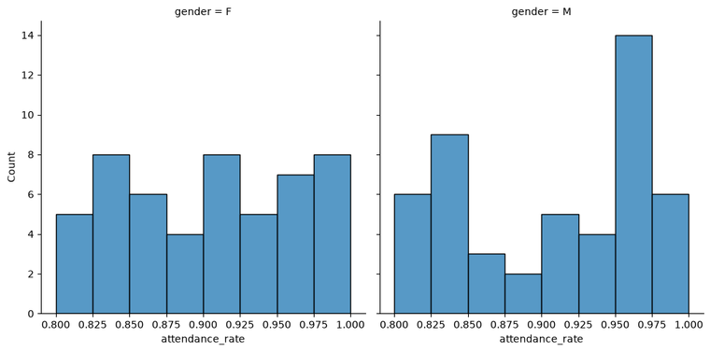
Example 4: attendance_rate, col=’gender’

Example 5: Histograms of the tips data
# tips_data is loaded in Section 1.4
sns.displot(kind='hist', data=tips_data, x='total_bill', bins=20)
plt.show()

sns.displot(kind='hist', data=tips_data, x='tip', bins=20)

Notes and common mistakes
- bins is the number of bars. More bins show more detail but can look noisy; fewer bins look smoother.
- element='step' draws a stepped outline instead of solid bars (the default is 'bars'). It makes overlapping groups easier to see.
- With hue, the groups are drawn on top of each other. Where they overlap, the colors mix.
- displot makes a histogram by default, so kind='hist' is optional. It is written in class to make the plot type clear.

7. KDE Plot
Dataset 2 and tips_data | Axes-level: sns.kdeplot() | Figure-level: sns.displot(kind='kde')
KDE (Kernel Density Estimate) draws a smooth curve that shows how the values of one numeric column are spread out. It is like a smoothed histogram. Higher parts of the curve mean values that occur more often. The y axis shows Density, not a count.

Syntax
Template (replace df and the column names)
sns.kdeplot(data=df, x='x_column', hue='group_column', fill=True)

sns.displot(kind='kde', data=df, x='x_column', col='group_column')

Examples
Example 1: Basic KDE plot (axes-level)
sns.kdeplot(data=student, x='attendance_rate')

Example 2: KDE with hue and shaded area
# tips_data is loaded in Section 1.4
sns.kdeplot(data=tips_data, x='tip', hue='sex', fill=True)

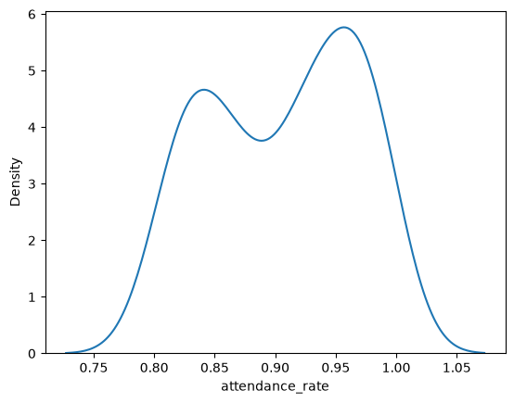  Example 1 | 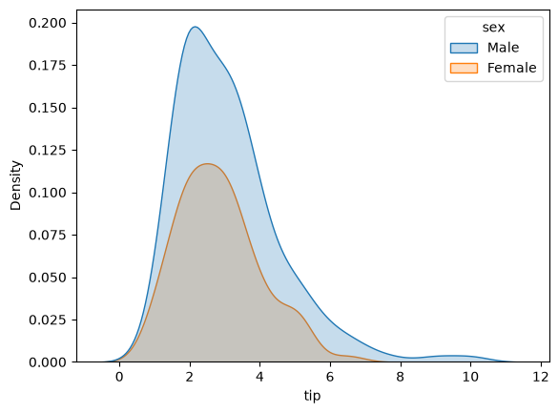  Example 2: fill=True

Example 3: One KDE plot for each gender (figure-level)
sns.displot(kind='kde', data=student, x='attendance_rate', col='gender')

Notes and common mistakes
- fill=True shades the area under each curve.
- The curve can reach slightly beyond the smallest and largest values (for example above 1.0 for attendance_rate). This is normal because a KDE smooths the data.
- Use a histogram when you want exact counts. Use a KDE when you want to compare the shapes of groups.

8. Countplot
Dataset 2 | Axes-level: sns.countplot()
A countplot counts how many rows fall in each category of a column. The bar height is the count. Seaborn does the counting, so you give only one column.

Syntax
Template (replace df and the column names)
sns.countplot(data=df, x='category_column', hue='group_column')

Examples
Example 1: Count of students by gender
sns.countplot(data=student, x='gender')

Example 2: Count by subject, split by gender
sns.countplot(data=student, x='subject', hue='gender')

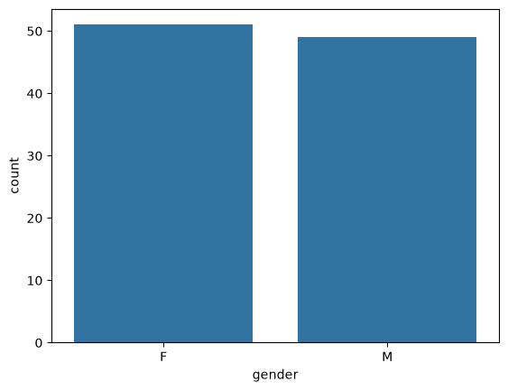  Example 1 | 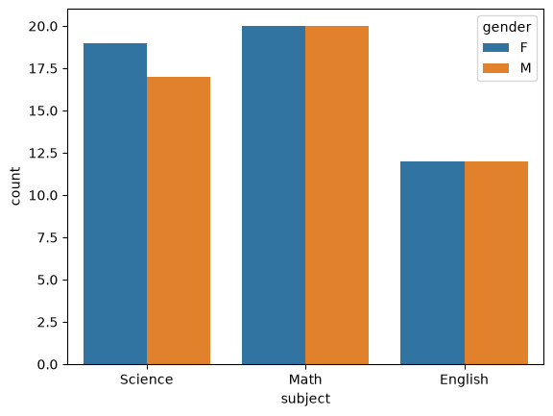  Example 2

Notes and common mistakes
- Use a countplot for categorical columns such as gender or subject. For a numeric column, use a histogram.
- A countplot counts rows. A bar plot (Section 9) summarizes a numeric column.
Common mistake: Do not give both x and y. sns.countplot(data=student, x='gender', y='Marks') fails with TypeError: Cannot pass values for both x and y.

9. Bar Plot
Dataset 2 | Axes-level: sns.barplot()
A bar plot draws one bar for each category. The bar height is a summary of a numeric column. By default this is the mean. The estimator argument changes the summary.

Syntax
Template (replace df and the column names)
sns.barplot(data=df, x='category_column', y='number_column',
errorbar=None, estimator=np.median)

Examples
Example 1: Mean (the default)
sns.barplot(data=student, x='gender', y='Marks', errorbar=None)

Example 2: Median
sns.barplot(data=student, x='gender', y='Marks', errorbar=None,
estimator=np.median)

Example 3: Maximum
sns.barplot(data=student, x='gender', y='Marks', errorbar=None,
estimator=np.max)

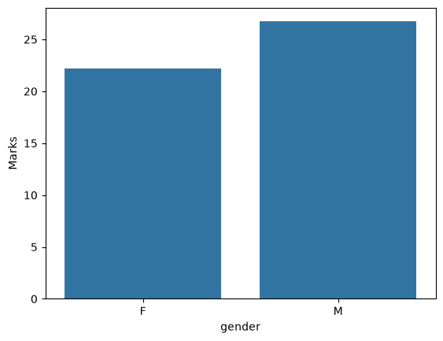  Example 1: mean | 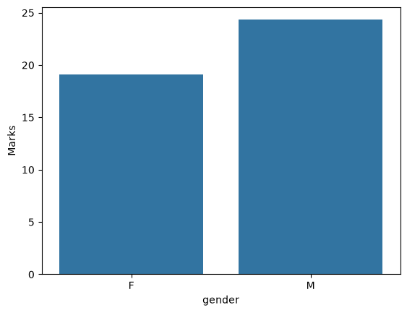  Example 2: median | 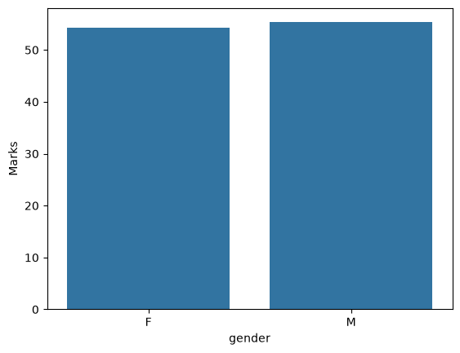  Example 3: maximum

Check what the bars show with pandas
groupby splits the table by gender. The result is one number per gender, the same as the bar heights.
student.groupby('gender')['Marks'].mean()

Notes and common mistakes
- errorbar=None removes the black error bars (the 95% confidence interval) that barplot draws by default.
- Seaborn also accepts the summary name as text, for example estimator='median'.
Correction: In your notebook the median plot had the comment # mean. The default is the mean, but estimator=np.median gives the median, so the comment was wrong. Your unused line student_ = student.groupby('gender') is replaced by the working check above.

10. Regplot and lmplot (Optional)
Dataset 2 | Axes-level: sns.regplot() | Figure-level: sns.lmplot()
These draw a scatter plot plus a regression line (the best-fit straight line) and a shaded band around it. They show the trend between two numeric columns.

Syntax
Template (replace df and the column names)
sns.regplot(data=df, x='x_column', y='y_column')

sns.lmplot(data=df, x='x_column', y='y_column', hue='group_column')

Examples
Example 1: One regression line (axes-level)
sns.regplot(data=student, x='study_hours', y='test_score')

Example 2: One regression line for each gender (figure-level)
sns.lmplot(data=student, x='study_hours', y='test_score', hue='gender')

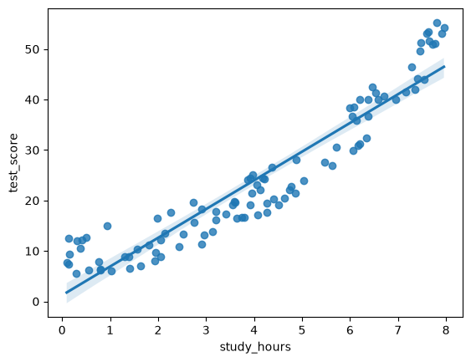  Example 1: regplot | 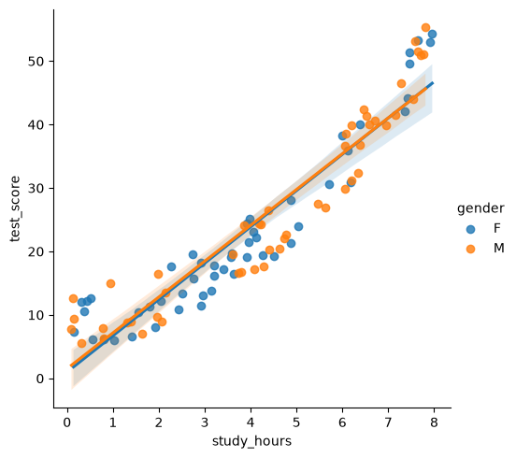  Example 2: lmplot with hue

Notes and common mistakes
- A line that goes up means that when study_hours increases, test_score also tends to increase.
- Both x and y must be numeric columns.
Common mistake: regplot has no hue argument. sns.regplot(..., hue='gender') fails with TypeError: regplot() got an unexpected keyword argument hue. Use lmplot for separate lines per group.

11. Pairplot
Dataset 2 | Figure-level: sns.pairplot()
A pairplot makes a grid of plots that compares every pair of numeric columns. The diagonal shows the distribution of each column on its own.

Syntax
Template (replace df and the column names)
sns.pairplot(data=df, hue='group_column', kind='hist')

Examples
Example 1: Choose the columns first
Double square brackets [[ ]] select several columns and create a smaller DataFrame. A pairplot of every column would make a huge grid, so pick only the columns you need.
student_marks = student[['Marks', 'study_hours', 'attendance_rate', 'gender']]
student_marks

Example 2: Pairplot with hue
sns.pairplot(data=student_marks, hue='gender')

Example 3: Pairplot with kind=’hist’
sns.pairplot(data=student_marks, kind='hist')

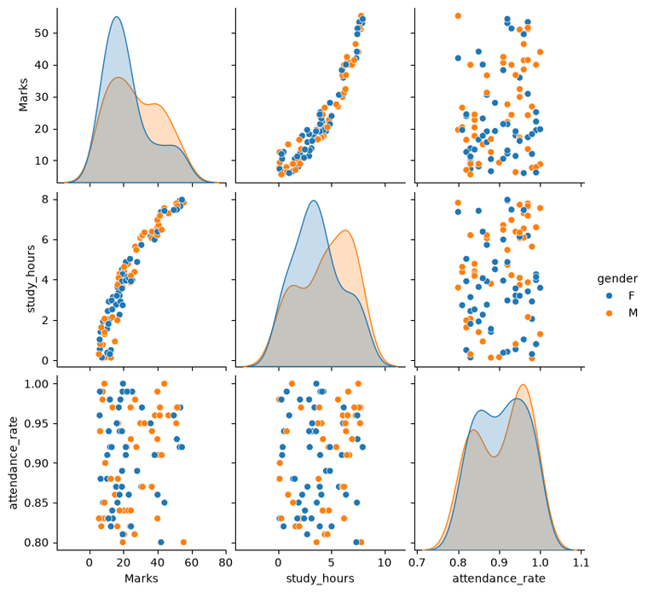  Example 2: hue=’gender’ | 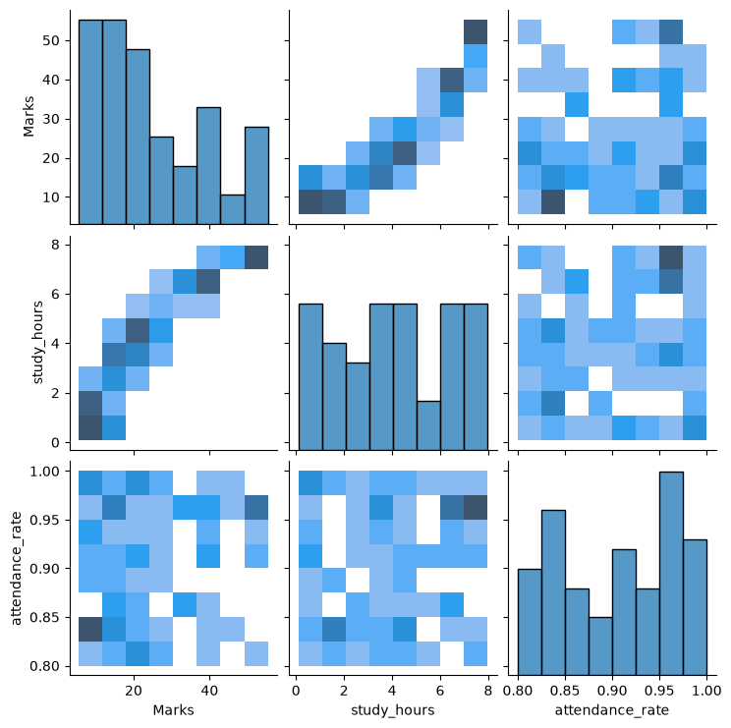  Example 3: kind=’hist’

Notes and common mistakes
- student_marks has 100 rows and 4 columns. Three of them are numeric, so the grid is 3 × 3.
- gender is text, so it gets no axis. It is used only for hue.
- The default plots are scatter plots. With hue the diagonal shows KDE curves; without hue it shows histograms.
- kind='hist' replaces the scatter plots with 2-D histograms. Darker squares mean more rows.

12. Joint Plot (Optional)
Dataset 2 (uses student_marks from Section 11) | Figure-level: sns.jointplot()
A joint plot shows a scatter plot of two numeric columns in the center, with the distribution of each column on the top and right edges.

Syntax
Template (replace df and the column names)
sns.jointplot(data=df, x='x_column', y='y_column',
hue='group_column', kind='kde')

Examples
Example 1: Scatter joint plot with hue
sns.jointplot(data=student_marks, x='study_hours', y='Marks', hue='gender')

Example 2: KDE joint plot
sns.jointplot(data=student_marks, x='study_hours', y='Marks', kind='kde')

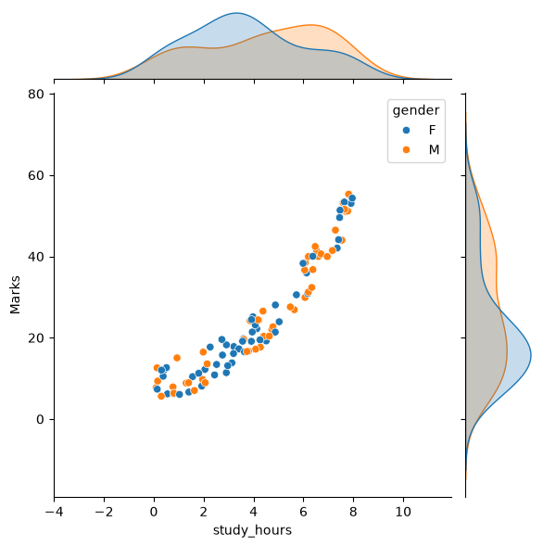  Example 1: scatter with hue | 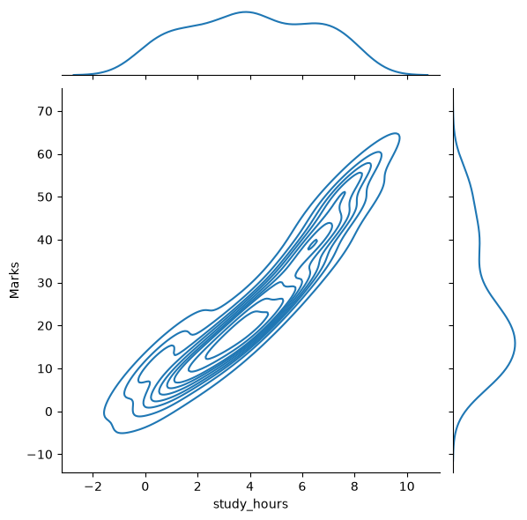  Example 2: kind=’kde’

Notes and common mistakes
- The default is kind='scatter'.
- kind='kde' draws density contour lines in the center. Lines packed closely together mean many rows in that area. The edges show KDE curves.

13. Parameter Summary
The arguments used in this document, in one place.
Parameter | What it does | Used in
data= | The DataFrame that holds the columns | All functions
x=, y= | Columns for the horizontal and vertical axes. histplot, kdeplot and countplot need only x | All functions
hue= | Colors the data by the groups in a column | Line, scatter, histogram, KDE, count, lmplot, pairplot, jointplot
style= | A different marker shape for each group | Scatter plot
size= | Marker size changes with the column values | Scatter plot
col=, row= | One small plot (facet) for each group, in columns or in rows | relplot, displot
col_wrap= | Maximum number of plots in one row. Use with col=, never with row= | relplot
kind= | Selects the plot type | relplot (line, scatter), displot (hist, kde), pairplot (hist), jointplot (kde)
errorbar=None | Removes the shaded band or error bars | lineplot, relplot(kind='line'), barplot
estimator= | Function that summarizes each bar (default mean) | barplot
bins= | Number of bars in the histogram | histplot, displot(kind='hist')
element='step' | Stepped outline instead of solid bars | histplot
fill=True | Shades the area under the curve | kdeplot

