Plotly Express Quick Reference
Scatter plots, line plots and histograms | Based on the class notebook Plotly.ipynb
Plotly Express (px) builds interactive charts from a pandas DataFrame in just one or two lines of code. This sheet follows the order of your class notes: setup, scatter plot, line plot, saving to HTML, and histogram.

1. Setup and Data

1.1 Imports, loading data and creating a subset
Run this cell first. All later examples use px, student and student_marks.
Example
import pandas as pd
import plotly.express as px

student = pd.read_csv('student_dataset_complete.csv')

# Subset of columns used later for the histograms
student_marks = student[['Marks', 'study_hours', 'attendance_rate', 'gender']]

What each line does
Line | Meaning
import pandas as pd | Loads pandas, which reads and works with tables of data. pd is its short name.
import plotly.express as px | Loads Plotly Express, which draws the charts. px is its short name.
pd.read_csv('...') | Reads a CSV file into a DataFrame (a table). Here it is stored in student.
student[['Marks', ...]] | Creates a smaller table that keeps only the listed columns. Here it is stored in student_marks.

Notes and common mistakes
- The CSV file must be in the same folder as your notebook, or you must give the full path. Otherwise Python shows FileNotFoundError.
- To select columns use double square brackets: the outer pair selects, the inner pair is a list of names. student['Marks', 'gender'] (one pair) gives a KeyError; student[['Marks', 'gender']] works.
- If import plotly.express as px gives ModuleNotFoundError, install it once with pip install plotly, then run the cell again.
- Style: write keyword arguments without spaces around =, for example x='time_study'. Spaces still work, but this is the standard Python style and is used in this sheet.

1.2 The student dataset
student has 100 rows and 14 columns: number_courses, time_study, Marks, student_id, class_level, subject, study_hours, test_score, week, attendance_rate, gender, hostel, Tshirt_size, class_name. These are the columns used in the notebook:
Column | Type | Example values | Used for
time_study | number | 4.508, 0.096 | Scatter plot (x)
Marks | number | 19.202, 7.734 | Scatter plot (y)
gender | text | F, M | Color (scatter plot and histogram)
Tshirt_size | whole number | 1, 2, 3, 4 | Point size (scatter plot)
hostel | 0 or 1 | 0, 1 | Extra hover information (scatter plot)
attendance_rate | number | 0.89, 0.98 | Histogram (x)
study_hours | number | 4.508, 0.096 | Kept in student_marks, not plotted

- In the rows shown in your notebook, time_study and study_hours hold the same values, and so do Marks and test_score.

1.3 Viewing a DataFrame
Type the DataFrame name on the last line of a cell to display it. Jupyter shows the first 5 and last 5 rows, with ... for the rows in between.
Example
student_marks

Output
Marks study_hours attendance_rate gender
0 19.202 4.508 0.89 F
1 7.734 0.096 0.98 M
2 13.811 3.133 0.83 F
3 53.018 7.909 0.92 F
4 55.299 7.811 0.80 M
.. ... ... ... ...
95 19.128 3.561 0.94 F
96 5.609 0.301 0.83 M
97 41.444 7.163 0.97 M
98 12.027 0.309 0.98 F
99 32.357 6.335 0.95 M

[100 rows x 4 columns]

- Typing student the same way shows all 14 columns. Only the last expression in a cell is displayed.

1.4 The basic workflow for every chart
- Create the figure with a px function and store it in a variable, usually fig.
- Display it with fig.show(). If you forget this line, no chart appears.
- Charts are interactive: hover over a chart to see the values. fig is only a variable name, and each new fig = px... line replaces the previous chart.

2. Scatter Plot: px.scatter()
A scatter plot shows one dot per row and is used to see the relationship between two numeric columns. Here we ask: do students who study longer get higher marks? (This topic was marked as optional in your notes.)
Syntax (replace the names with your own)
fig = px.scatter(df, x='col_x', y='col_y', color='col_c', size='col_s', hover_data=['col_h'])

Parameters
Parameter | What it does | In the example
x | Column for the horizontal axis | 'time_study'
y | Column for the vertical axis | 'Marks'
color | Gives each group its own color and adds a legend | 'gender'
size | Sets the dot size from a numeric column | 'Tshirt_size'
hover_data | Extra columns shown when you hover over a dot (a list) | ['hostel']

Example
fig = px.scatter(student, x='time_study', y='Marks',
color='gender',
size='Tshirt_size',
hover_data=['hostel'])

fig.show()

Output
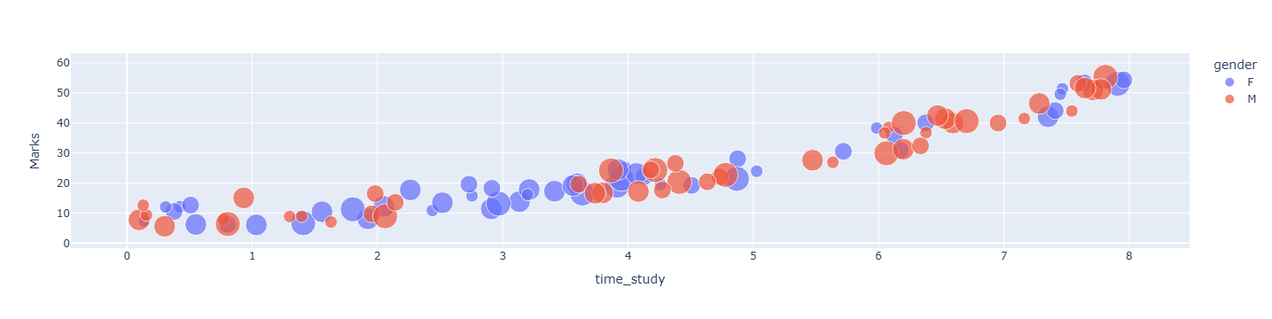
Figure 1. Scatter plot of Marks against time_study, colored by gender, sized by Tshirt_size.
How to read it: the dots rise from left to right, so students who study more tend to get higher marks. The two colors show gender, and bigger dots mean a larger Tshirt_size.
Notes and common mistakes
- Column names go in quotes and must match exactly, including capital letters. y='marks' gives a ValueError because the column is Marks. Without quotes you get a NameError.
- size needs a numeric column. A text column such as 'gender' gives a TypeError. Tshirt_size works because it is stored as numbers.
- hover_data takes a list, so use square brackets. Add more columns inside the list, for example ['hostel', 'week'].

3. Line Plot: px.line()
A line plot joins the points in order from left to right. It is used to show how a value changes over time. Here we look at course enrollment for each year.
Syntax (replace the names with your own)
fig = px.line(df, x='col_x', y='col_y', markers=True)

Parameters
Parameter | What it does | In the examples
x | Column for the horizontal axis (here, the year) | 'Year'
y | Column for the vertical axis (the value to track) | 'Programming' (3.1), 'Digital Marketing' (3.2)
markers | Optional. True adds a dot on every data point. Without it, only the line is drawn. | markers=True

3.1 Basic line plot
Example
enrollment = pd.read_csv('enrollment_data.csv')

fig = px.line(enrollment, x='Year', y='Programming')

fig.show()

Data behind the chart
Year | 2015 | 2016 | 2017 | 2018 | 2019 | 2020 | 2021 | 2022 | 2023 | 2024
Programming | 589 | 862 | 1085 | 1150 | 1439 | 1715 | 1785 | 1995 | 2236 | 2442
Digital Marketing | 734 | 963 | 1157 | 1404 | 1497 | 1579 | 1948 | 2073 | 2310 | 2338

Output
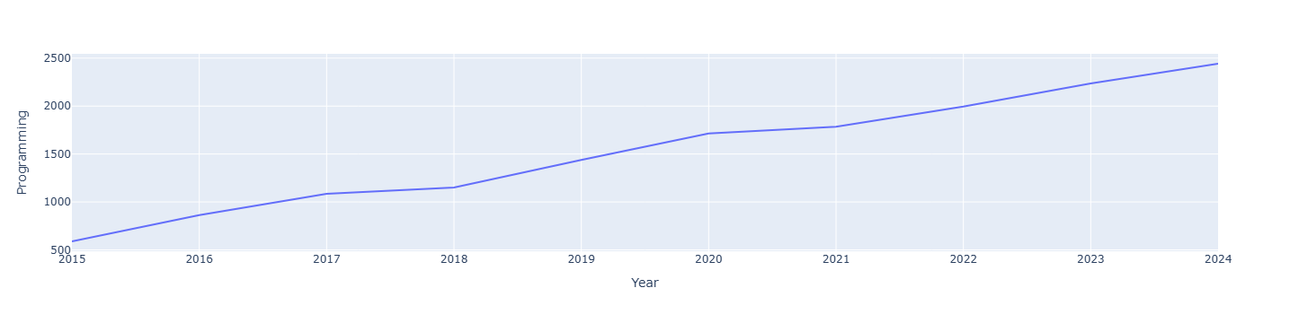
Figure 2. Line plot of Programming enrollment by Year.
How to read it: Programming enrollment rises every year, from 589 in 2015 to 2442 in 2024.

3.2 Line plot with markers
Example
fig = px.line(enrollment, x='Year', y='Digital Marketing', markers=True)

fig.show()

Output
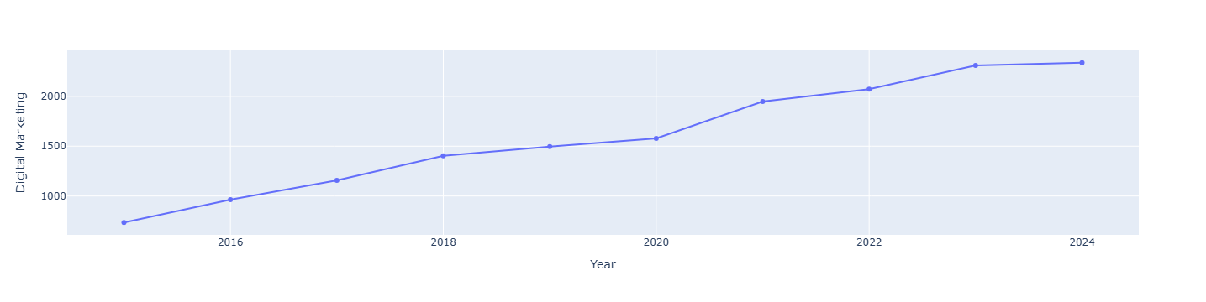
Figure 3. Line plot of Digital Marketing enrollment by Year, with markers.
Notes and common mistakes
- Write True with a capital T and no quotes. markers=true gives a NameError. With quotes, even markers='False' still turns markers on, because any non-empty text counts as true.
- A column name with a space, such as 'Digital Marketing', is fine inside quotes. The spelling and spacing must match the CSV exactly.
- The data comes from enrollment, a different DataFrame from student. Use the DataFrame that contains the columns you name.

4. Saving a Plot as an HTML File: fig.write_html()
write_html() saves a figure as a web page that you can open in any browser. The chart stays interactive, so you can share it with other people.
Syntax
fig.write_html('file_name.html')

Example
# Create an HTML file
fig.write_html('digital_marketing_data.html')

Nothing is printed in the notebook. The file digital_marketing_data.html appears in the same folder as your notebook. Double-click it to open it in your browser.
Notes and common mistakes
- It saves whichever chart fig holds at that moment. In class, fig was the Digital Marketing line plot with markers (section 3.2).
- The file name must end with .html. Saving again with the same name overwrites the old file.
- The file is several MB because it contains the Plotly library, so it opens offline.

5. Histogram: px.histogram()
A histogram splits the values of one numeric column into ranges called bins and counts how many rows fall in each bin. It shows how the values are spread out. Plotly counts the rows for you and labels the y-axis count.
Syntax (replace the names with your own)
fig = px.histogram(df, x='col_x', color='col_c', nbins=5)

Parameters
Parameter | What it does | In the examples
x | The numeric column to count | 'attendance_rate'
color | Optional. Draws separate bars for each group and adds a legend | 'gender'
nbins | Optional. The number of bins (bars) you would like | 5

5.1 Basic histogram
Example
fig = px.histogram(student_marks, x='attendance_rate')

fig.show()

Output
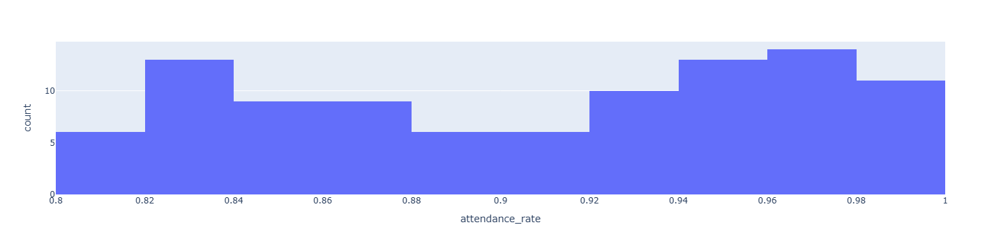
Figure 4. Histogram of attendance_rate for all 100 students.
How to read it: each bar is one attendance-rate range. A taller bar means more students in that range. The tallest bar here is near 0.96 to 0.98.

5.2 Histogram with color and nbins
Example
fig = px.histogram(student_marks, x='attendance_rate', color='gender', nbins=5)

fig.show()

Output
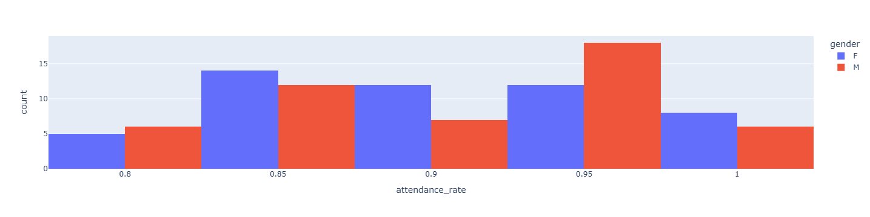
Figure 5. Histogram of attendance_rate split by gender, with about 5 bins.
Notes and common mistakes
- color='gender' draws separate bars for F and M. A legend explains the colors.
- nbins=5 asks for about 5 bars. Plotly treats it as the maximum number of bins wanted and picks neat bin edges, so the exact number can differ. Fewer bins give a simpler picture; more bins give more detail.
- In your class output the F and M bars sit side by side. In some Plotly versions they are stacked instead. Both are normal.
- You only need x. Plotly counts the rows for you, so no y column is needed.
- Use only columns that exist in the DataFrame you pass in. student_marks has just 4 columns, so x='hostel' gives a ValueError. Use student for that column.

6. Quick Revision Summary

6.1 Chart types
Chart | Function | Use it to show | Parameters used in class
Scatter | px.scatter() | The relationship between two numeric columns | x, y, color, size, hover_data
Line | px.line() | How a value changes over time | x, y, markers
Histogram | px.histogram() | How the values of one column are spread out | x, color, nbins

6.2 Other commands
Task | Command
Import pandas and Plotly Express | import pandas as pd and import plotly.express as px
Read a CSV file | df = pd.read_csv('file.csv')
Keep only some columns | df_small = df[['col1', 'col2']]
Show a chart | fig.show()
Save a chart as an HTML file | fig.write_html('file_name.html')

