Experiment-7: Verification of Thevenins,nortons ,maximum power theorem
Name: Farhana Tasnim ID: 2532289043 Group:03
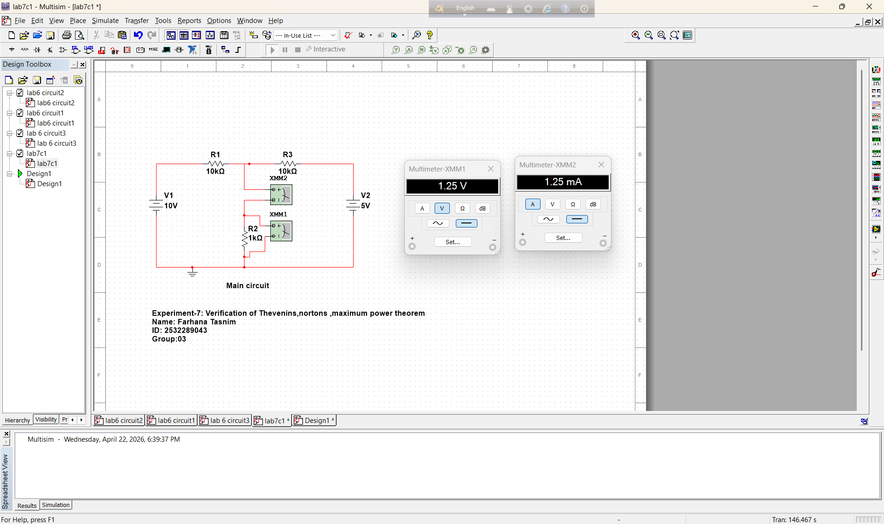
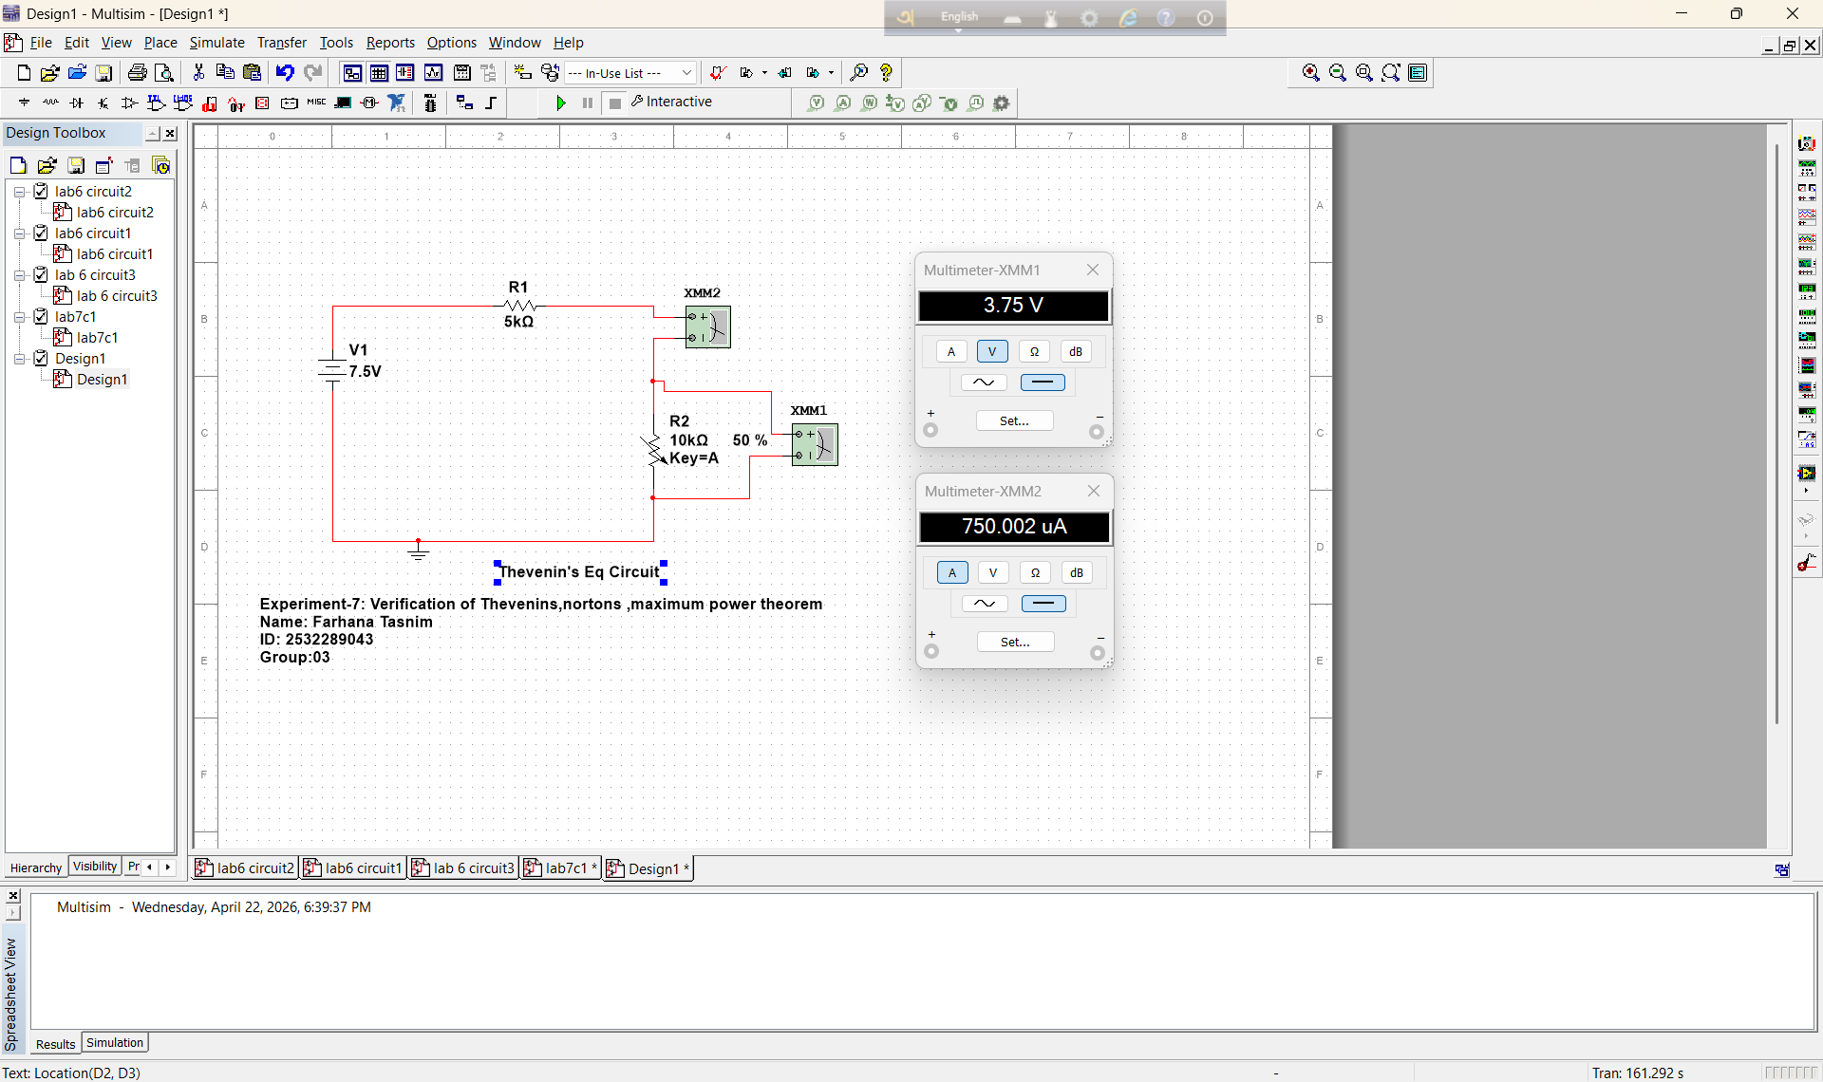

Table-1:
Measurement | Measured (DMM)
𝑉𝑇𝐻 | 7.5 V
𝑅𝑇𝐻 | 5 kΩ
IN | 1.5 mA
Table 2:
Value | Main Circuit | Thevenin’s Eq Circuit | Norton’s Eq Circuit
𝑉_{𝐿} | 1.25V | 1.25V | 1.25V
𝐼𝐿 | 1.25mA | 1.25mA | 1.25mA
Table 3:
R_{L} (kΩ) | V_{L} (V) | P_{L} (mW) VL² / RL
1.0 kΩ | 1.25 V | 1.56 mW
2.0 kΩ | 2.14 V | 2.30 mW
3.0 kΩ | 2.81 V | 2.64 mW
4.0 kΩ | 3.33 V | 2.78 mW
5.0 kΩ | 3.75 V | 2.81 mW
6.0 kΩ | 4.09 V | 2.79 mW
7.0 kΩ | 4.37 V | 2.73 mW
8.0 kΩ | 4.62 V | 2.66 mW
9.0 kΩ | 4.82 V | 2.58 mW
10 kΩ | 5.00 V | 2.50 mW

