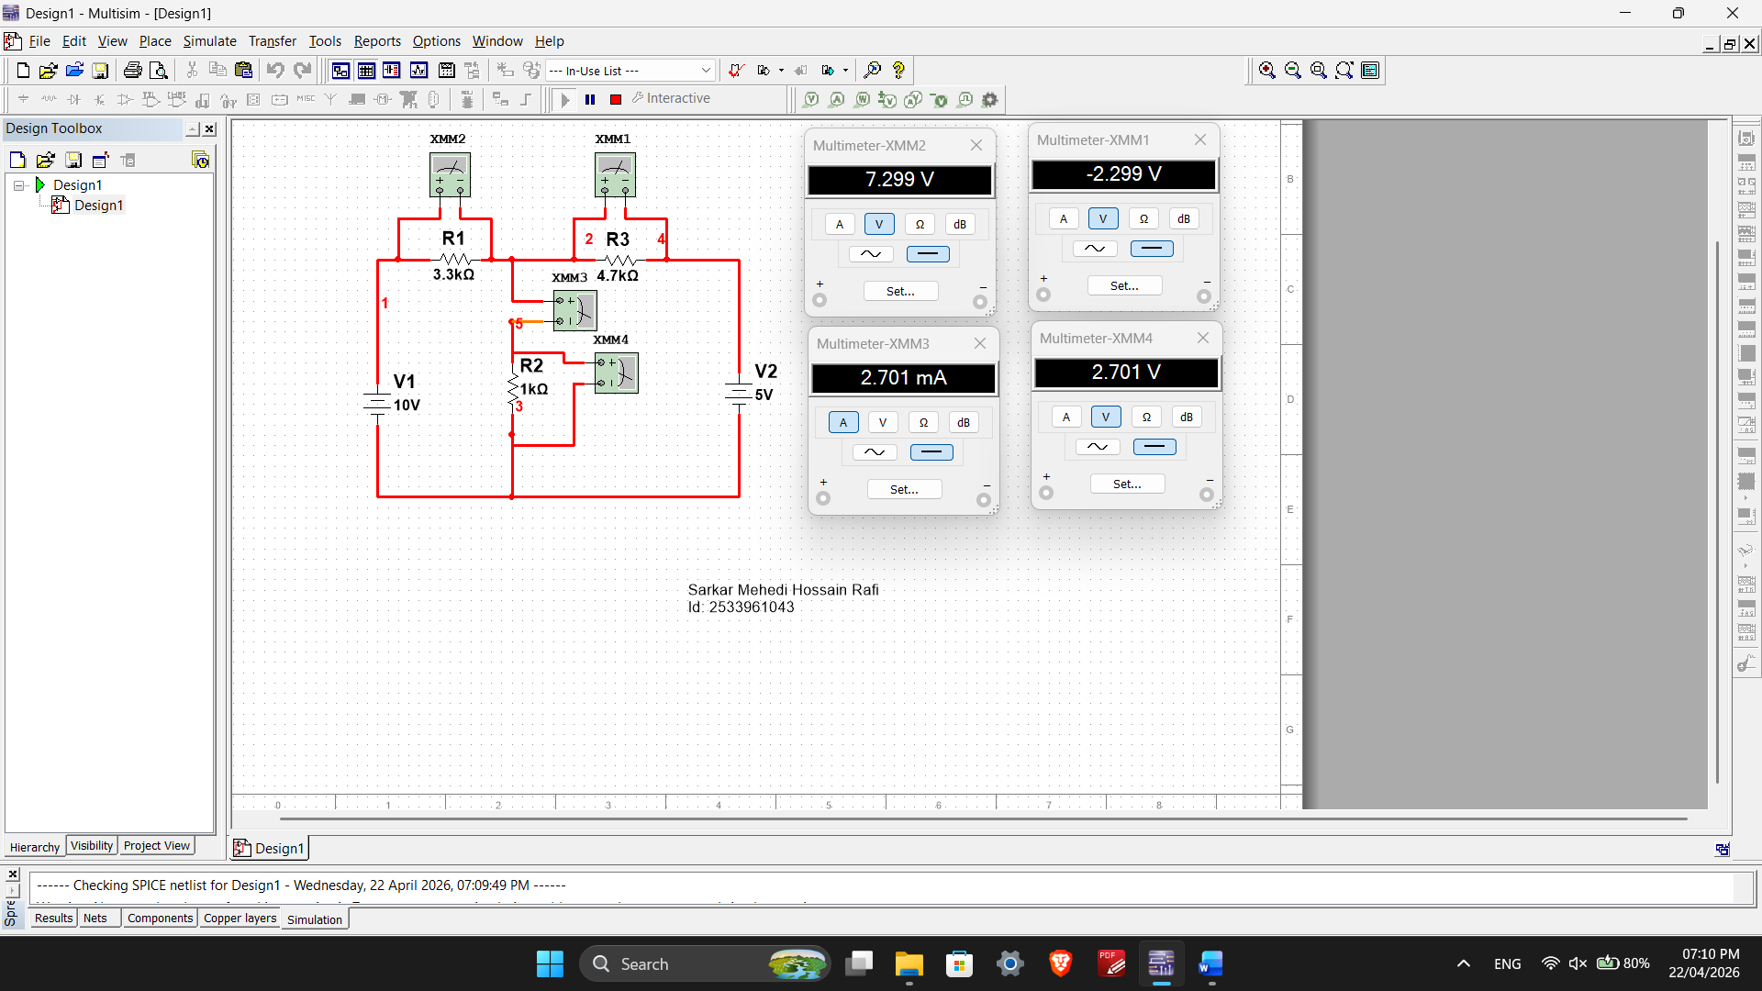

Sarkar Mehedi Hossain Rafi
Id: 2533961043

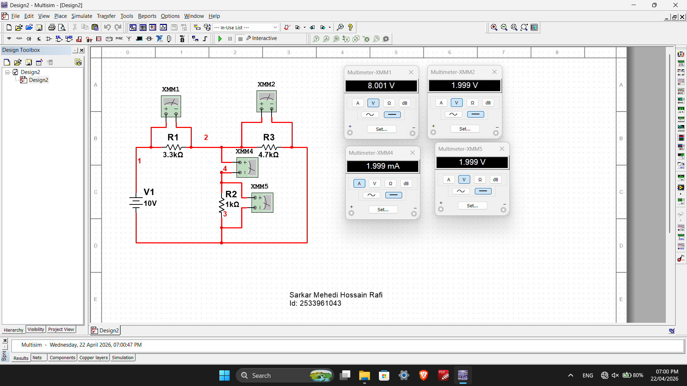
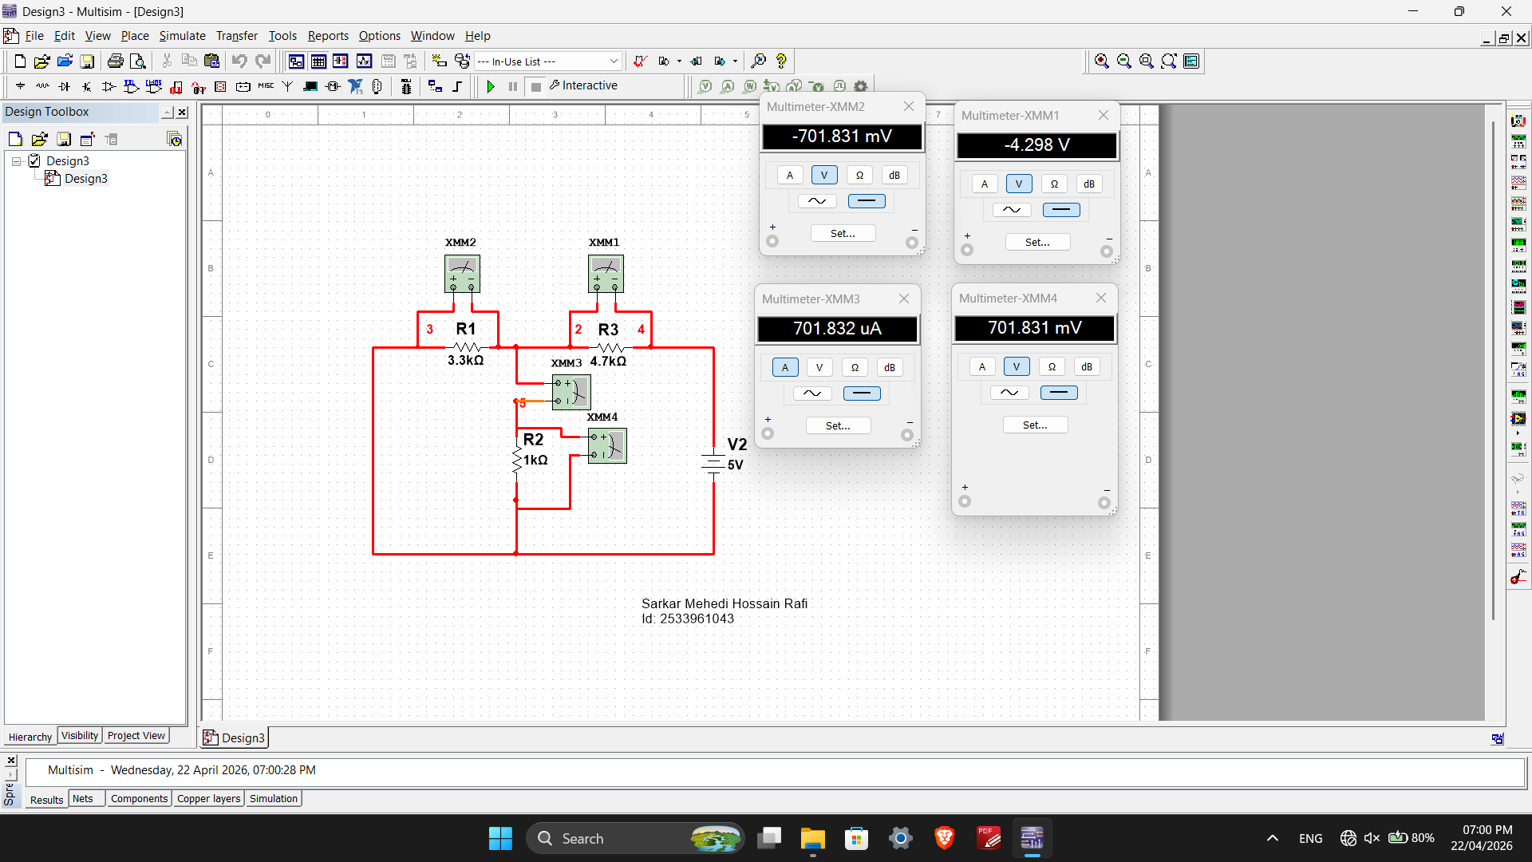
Table 1:
From Circuit 1 | From Circuit 2 | From Circuit 3
IR2 | I’R2 | I”R2 | I’R2 + I”R2
2.7A | 2A | 0.7A | 2.7A
Table 2:
From Circuit 1 | From Circuit 2 | From Circuit 3
VR1 | V’R1 | V”R1 | V’R1 + V”R2
7.3V | 8V | -0.7V | 7.3V
Table 3:
From Circuit 1 | From Circuit 2 | From Circuit 3
VR2 | V’R2 | V”R2 | V’R2 + V”R2
2.7V | 2V | 0.7V | 2.7V
Table 4:
From Circuit 1 | From Circuit 2 | From Circuit 3
VR3 | V’R3 | V”R3 | V’R3 + V”R3
-2.3V | 2V | -4.3V | -2.3V

