Experiment-08: Charging and Discharging of RC circuits
Name: Raihan Ahammed ID: 2532600043 Group: 03
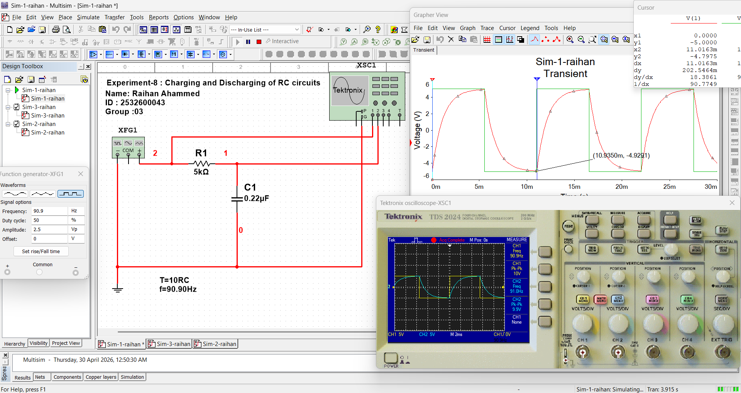

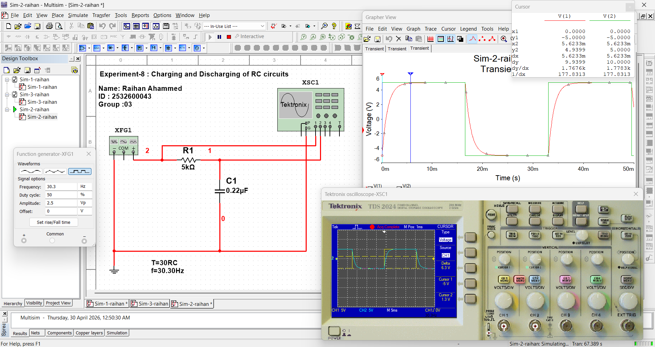
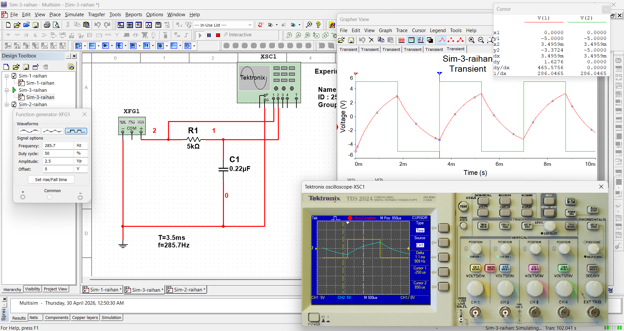

Table-1:
Measurement | T=10RC | T=30RC | T=3.5ms
Frequency of input signal | 90.90Hz | 30.30Hz | 285.7Hz
Time constant, 𝜏 | 1.16ms | 1.17ms | 1.13ms
Final Output Vc | 9.9V(p-p) | 10v(p-p) | 6.67V(p-p)
Measure the time the capacitor charges up to Vc | 5.54ms | 5.4ms | 1.76ms
Time the capacitor starts to discharge | 5.54ms | 16.3ms | 1.76ms
Time the capacitor stops discharging | 11ms | 32.7ms | 3.5ms

