**Submission Form**

**Fill up the following slots with appropriate content. You must submit the content of this document from this page only.**

1. Your Name: Md Raihanul Islam Bhuiyan
2. Your ID: 20101239
3. Your Section: 16
4. Experiment No: 3
5. Experiment Title: **To verify the value of vacuum permittivity by a parallel plate capacitor.**
6. **You must write your ID in each of the graphs you insert here.**
7. **Data Table 1**:

$$A =340. {mm}^{2}$$

| **Sl:** | **Separation between plates, d (mm)** | **Capacitance, C**  **(pF)** |
| --- | --- | --- |
| 1. | 2 | 1.51 |
| 2. | 3 | 1.00 |
| 3. | 4 | 0.75 |
| 4 | 5 | 0.60 |
| 5 | 6 | 0.50 |
| 6. | 7 | 0.43 |
| 7. | 8 | 0.38 |
| 8. | 9 | 0.33 |
| 9. | 10 | 0.30 |

**8. Data Table 2:**

$d = 6 mm$

| **Sl:** | ***Area, A***  ***( ${mm}^{2}$)*** | **Capacitance, C**  **(pF)** |
| --- | --- | --- |
| 1. | 100 | 0.15 |
| 2. | 150 | 0.22 |
| 3. | 200 | 0.30 |
| 4 | 250 | 0.37 |
| 5 | 300 | 0.44 |
| 6. | 350 | 0.52 |
| 7. | 400 | 0.59 |

9. Draw C vs 1/d graph for Data Table 1 and, that is, you plot 1/d along the x-axis

and C along the y-axis. You will get a straight line. You must label the axes and write your ID in the graph. Insert **graph-1** here:

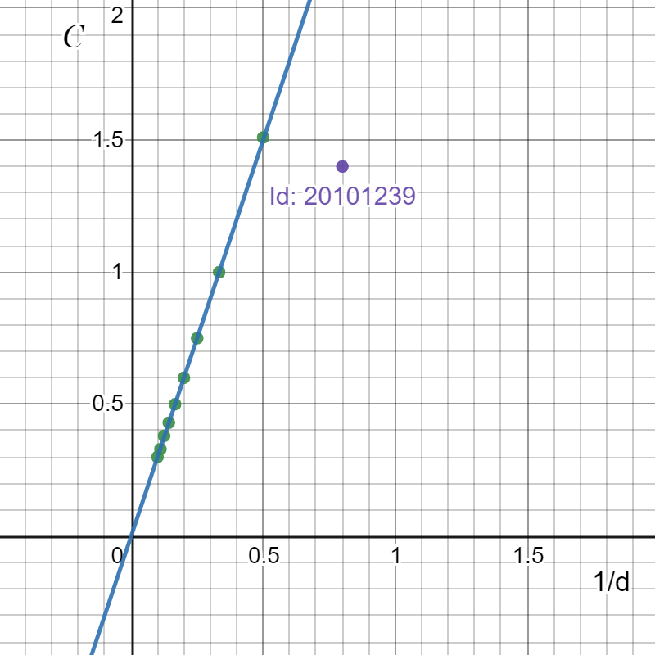

10. Draw C vs A graph for Data Table 2 and, that is you plot A along the x-axis and C along the y-axis. You will get a straight line. You must label the axes and write your ID in the graph. Insert **graph-2** here:

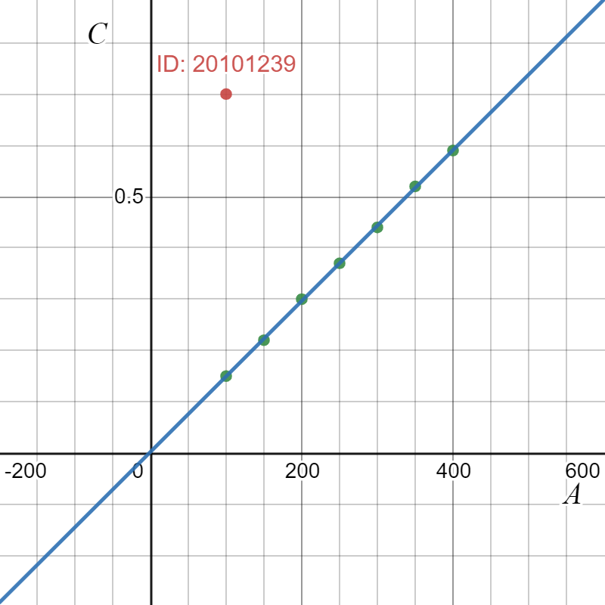

11. For Data Table 1,

Slope = 3.01945 $\frac{pF}{{mm}^{-1}}$ =3.01945*{10-12 /(10-3)-1}=3.01945*10-15

[ Use the formula for capacitance of a parallel plate capacitor to compute vacuum permittivity from slope.]

Calculated value of vacuum permittivity =(3.01945*10-15)/(340*10-6) =8.880*10-12

12. For Data Table 2,

Slope =0.00147143 $\frac{pF}{{mm}^{2}}$ = 0.00147143*{10-12/(10-3)2}=1.47143*10-9

Calculated value of vacuum permittivity =1.47143*10-9*6*10-3 =8.82858*10-12

13. From the calculated value of vacuum permittivity from 11 & 12, we calculate the mean.

Mean vacuum permittivity = 8.83929*10-12

**Comparing the calculated mean vacuum permittivity with the with the standard value of vacuum permittivity (ε_0 = $8.854 ×10{ C}^{2}N^{-1}m^{-2}$), we calculate the percentage of error.**

Percentage of error = [**|** Calculated mean vacuum permittivity - Standard vacuum permittivity**|** /Standard vacuum permittivity] * 100

= [|8.8392910-12- ***-12*** |/***-12***] %

=0.166%

You are ***strongly*** encouraged to use your **own words** to describe your thoughts for the following part. **However, any kind of plagiarism (such as copying and pasting from other students’ lab-reports) will not be tolerated and will be subject to disciplinary action according to BracU policy.**

Please briefly answer the following question(s):

13. If we place a dielectric material of dielectric constant, κ>1 in place of air in between the plates of a parallel plate capacitor then what should be the change in graph-1 (C vs 1/d graph for Data Table 1)? Explain.

hint: You may sketch a diagram in your answer to help you compare both the cases.

Ans: If we place a dielectric material of dielectric constant, κ>1 in place of air in between the plates of a parallel plate capacitor then the capacitors value will increase by a factor of k. Because,

C= k* (epsilon_0*A)/d

Let, k=3

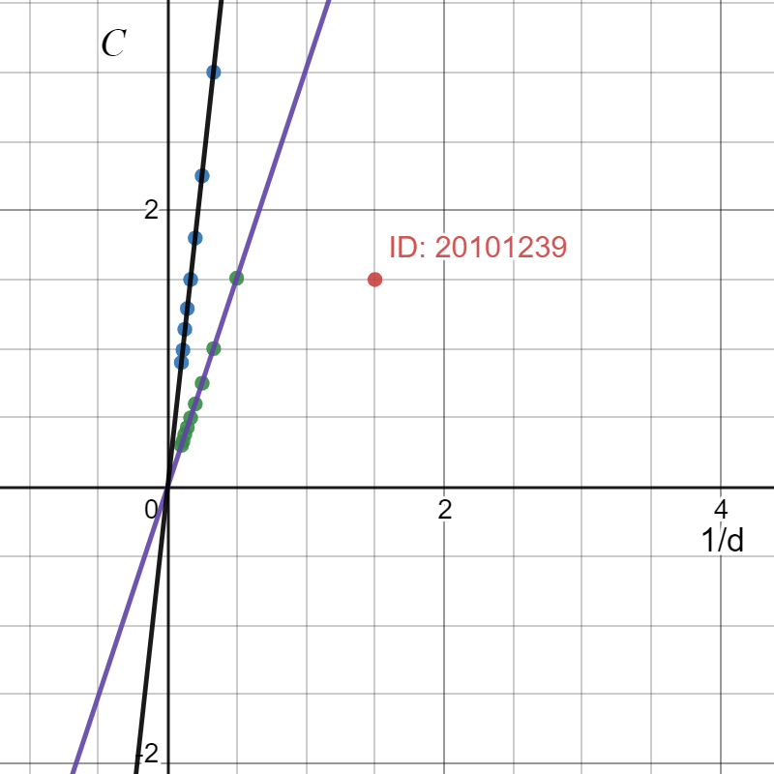

Here, when the value of k increases, the graph also changes. When we increase the value of k, the graph C vs 1/d goes closer to y axis. Also, the slope of the graph also increases.

14. If half of the space between the plates is filled with a dielectric material of dielectric constant κ_1 and rest of the half space is filled with a dielectric material of dielectric constant κ_2, then

* Find the equivalent dielectric constant.
* Find the capacitance of this configuration.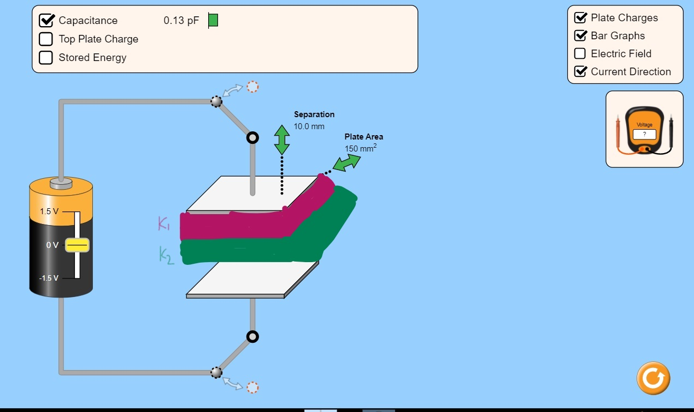

We know,

1/C(total) = 1/C1+1/C2

* 1/C(total) = 1/{(k1*epsilon*A)/(d/2)}+ 1/{(k2*epsilon*A)/(d/2)}
* 1/{(k*epsilon*A)/(d/2)}= 1/{(k1*epsilon*A)/(d/2)}+ 1/{(k2*epsilon*A)/(d/2)}
* (d/2)/{(k*epsilon*A)}= (d/2)/{(k1*epsilon*A)}+ (d/2)/{(k2*epsilon*A)}
* 1/{(k*epsilon*A) }= 1/{(k1*epsilon*A) }+ 1/{(k2*epsilon*A)
* 1/k=1/k1+1/k2
* 1/k = (k1+k2)/ (k1*k2)
* k = (k1*k2) / (k1+k2)

Again,

* 1/C(total) = 1/{(k1*epsilon*A)/(d/2)}+ 1/{(k2*epsilon*A)/(d/2)}
* 1/C(total) = {d/(2*epsilon*A)}* (1/k1+1/k2)
* 1/C(total) = {d/(2*epsilon*A)}* {(k1+k2)/ (k1*k2)}
* 1/C(total) = {d{(k1+k2)/(2*epsilon*A) (k1*k2)}
* C(total)= (2*epsilon*A) (k1*k2)/ d{(k1+k2)}

15. Compare the stored energy in the three cases- (a) when there’s no dielectric material between the plates, (b) when there’s only one dielectric material between the plates and (c) when there are two dielectric materials of same dielectric constant as the dielectric material in (b), placed between the placed as shown in Q.14 figure.

* + - * 1. when there’s no dielectric material between the plates, Stored energy, U= 0.5*(Q2/C)
        2. when there’s only one dielectric material between the plates, Stored energy, U=0.5*(Q2/C*k)
        3. If both material have same dielectric constant, then k will be sasme. So, Stored energy, U=0.5*(Q2/C*k)