**Bangladesh University of Business and Technology (BUBT)**

Department of Computer Science and Engineering



Project Report on

## Color Sorting Arduino

## Submitted To

Mr. Md. Abdullah Al Ahasan

Lecturer, Dept. of CSE,

BUBT

#### **Submitted By**

|  |  |
| --- | --- |
| **Name** | **ID** |
| Raihan Sikdar | 17181103133 |
| Kazi Sarwar | 17181103127 |
| Alimuzzaman Moon | 17181103123 |

**Abstract**

This paper represents the design and implementation of Color sorting Arduino which can pick the objects color exactly according to its predefined color. This color sorting robot can rotate according to its predefined angles. This color sorting robot can pick the color among red, blue and white. We made this color sorting robot’s physical structure by using plastic board. If the robot gets a red ball with the exact position, it places the ball in the red box. Respectively it picks the white and blue ball also. At a time, it picks only one color. In the industry there is highly increasing demands for automation. Sorting of an object is an essential mechanical process in which difficult work is quite required. Chronic manual arranging makes consistency troubles. Machines can perform dreary assignments superior to human beings. Laborer exhaustion on sequential manufacturing structures can result in decreased execution, and purpose troubles in retaining up object fine. Here we are designing and implementing an efficient color sorting robot using color sensor TCS3200 based on Arduino UNO. This project provides high accuracy and performance. Easy to operate and construct which reduces human errors.

Index

|  |  |
| --- | --- |
| Abstract | II |
| I.Introduction | 1 |
| II.Literature Survey | 2 |
| III.System Block Diagram | 3 |
| IV.Tools | 4-7 |
| V.Color Detection | 7-9 |
| VI.Sorting of Object | 9 |
| VII.Methodology | 10 |

|  |  |
| --- | --- |
| VIII.Algorithm | 14 |
| IX.Flowchart | 15 |

|  |  |
| --- | --- |
| X.Result | 20 |
| XI.Conclusion | 20 |

List of Figures

|  |  |
| --- | --- |
| Fig.1 | System Block Diagram |
| Fig.2 | Arduino Uno |
| Fig.3 | Servo Motor |
| Fig.4 | Color Sensor |
| Fig.5 | Tcs3200 Color Sensor Pinout |
| Fig.6 | Photodiode Table |
| Fig.7 | Visible Spectrum |
| Fig.8 | Functional Block Diagram of color sensor |
| Fig.9 | PWM |
| Fig.10 | Process Diagram |
| Fig.11 | Project Photo |
| Fig.12 | Project Photo |
| Fig.13 | Project Photo |
| Fig.14 | Flowchart |
| Fig.15 | Source Code |
| Fig.16 | Source Code |
| Fig.17 | Source Code |
| Fig.18 | Serial Monitor |

References 21

**INTRODUCTION**

In this fastest era, time is very precious. To save this valuable time, robotics plays an important role in human life. Robot is a manmade thing which reduces human effort and time. In recent years, robotic automation is a process that is extremely important for industrial environments, since it improves the quality while reduce the time spent to accomplish a given task, all with a minimal human intervention. Color sorting is simply to sort the things according to their color. It can be easily done by seeing it but when there are too many things to be sorted and it is a repetitive task then automatic color sorting machines are very useful. In the cutting-edge-day scenario of competitive manufacturing in commercial zone performance of manufacturing holds the important component for achievement. It's miles essential to beautify manufacturing pace, lower the labour charge and reduce the breakdown time of production gadget. Merchandise should be taken care of in numerous ranges of manufacturing and manual sorting is time consuming and labour extensive. This paper discusses about the automatic sorting tool which helps the sorting mechanism to kind based at the coloration. For sensing TCS3200 coloration sensor has been used. With the aid of reading the frequency of the output of the sensor, color primarily based absolutely sorting is completed. Layout of an innovative venture referred to as item sorting system by means of spotting the only of a kind shades of the item has been leader goal of the challenge. Accumulating the objects from the hopper and distributes those objects to their accurate area based on their coloration even they'll be unique in coloration. Many paintings environments aren't suitable for manual sorting and a few areas are risky for humans to paintings on. Consequently, to avoid the unstable work, time consumption and hard paintings catch 22 situations. This prototype is built as a simple digital gadget like microcontroller for processing, Servo motors for actions and coloration sensor for recognizing exclusive-colored devices.

**LITERATURE SURVEY**

The compilation of system and interfacing of different components, sensors, servo motors, Hardware and software interfacing of the system is prescribed by the

“Software Interfacing of TCS3200 color sensor with Arduino”

“LIM JIE SHEN [1] in this paper a color sorting robot is researched designed and created with Arduino UNO microcontroller, TCS3200 color sensor, SG90 tower pro servo motor and other electronics component. They found that color sensor gives different results when it tested outdoor and indoor.

Dhanoj M.[4] was researched on robotic arm based color sorting robot using this TCS3200 color sensor. They were also used LCD display to display the color detected. In image processing image is captured using real time system like webcam and then objects can be sorted as per our requirement like on the basis of shapes and colors [5].

Li Quaoyi [6] has used one method to test sensor’s output. They took a one empty tube and at the bottom of that tube they placed sensor and white light is placed at the top of the tube so that they went to know the filters are gated successively to measure the red, green and blue values and calculated other parameters. An article written by Bishop and Lee human eye can give response only to the lights which are in the range of visible light spectrum [8].

**SYSTEM BLOCK DIAGRAM**

As shown in fig1. system consists of color sensor module, servo motors, Arduino UNO and Box. TCS3200 is the color sensor which detects light reflected by an object and converts it into frequency. Servo motors are used to move a slider according to the color detected. Input and output operations are controlled by an Arduino UNO microcontroller. Detected output color and the count value of respective colored object is displayed on box.

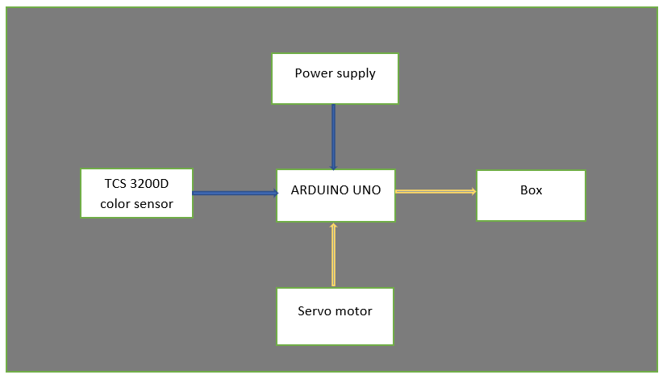

**Fig1. System Block Diagram**

**TOOLS**

**Arduino UNO**:

The **Arduino UNO** is the best board to get started with electronics and coding. If this is your first experience tinkering with the platform, the UNO is the most robust board you can start playing with. The UNO is the most used and documented board of the whole Arduino family.

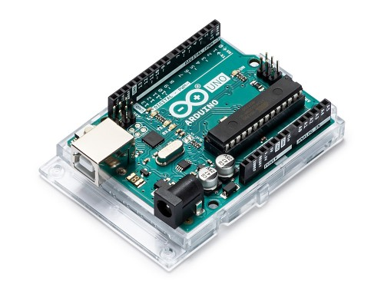

**Fig 2. Arduino Uno**

Arduino Uno is a microcontroller board based on the ATmega328P ([datasheet](http://ww1.microchip.com/downloads/en/DeviceDoc/Atmel-7810-Automotive-Microcontrollers-ATmega328P_Datasheet.pdf)). It has 14 digital input/output pins (of which 6 can be used as PWM outputs), 6 analog inputs, a 16 MHz ceramic resonator (CSTCE16M0V53-R0), a USB connection, a power jack, an ICSP header and a reset button. It contains everything needed to support the microcontroller; simply connect it to a computer with a USB cable or power it with an AC-to-DC adapter or battery to get started... You can tinker with your Uno without worrying too much about doing something wrong, worst case scenario you can replace the chip for a few dollars and start over again.

"Uno" means one in Italian and was chosen to mark the release of Arduino Software (IDE) 1.0. The Uno board and version 1.0 of Arduino Software (IDE) were the reference versions of Arduino, now evolved to newer releases. The Uno board is the first in a series of USB Arduino boards, and the reference model for the Arduino platform; for an extensive list of current, past or outdated boards see the Arduino index of boards.

**Servo Motor:**

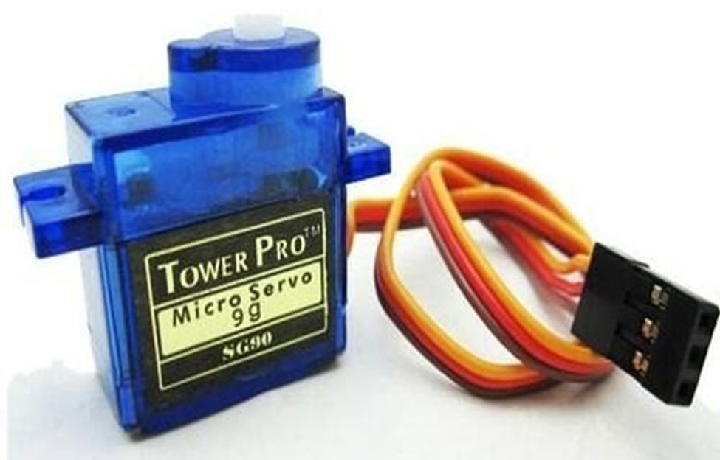

**Fig 3. Servo Motor**

A servo motor is a type of motor that can rotate with great precision. Normally this type of motor consists of a control circuit that provides feedback on the current position of the motor shaft, this feedback allows the servo motors to rotate with great precision. If you want to rotate an object at some specific angles or distance, then you use a servo motor. It is just made up of a simple motor which runs through a servo mechanism. If motor is powered by a DC power supply then it is called DC servo motor, and if it is AC-powered motor then it is called AC servo motor. For this tutorial, we will be discussing only about the DC servo motor working. Apart from these major classifications, there are many other types of servo motors based on the type of gear arrangement and operating characteristics. A servo motor usually comes with a gear arrangement that allows us to get a very high torque servo motor in small and lightweight packages. Due to these features, they are being used in many applications like toy car, RC helicopters and planes, Robotics, etc.

**Color Sensor:**

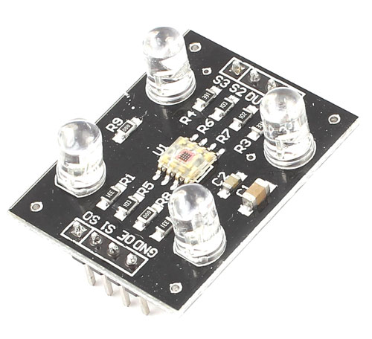

**Fig 4. Color Sensor**

Color sensors provide more reliable solutions to complex automation challenges. They are used in various industries including the food and beverage, automotive and manufacturing industries for purposes such as detecting material, detecting color marks on parts, verifying steps in the manufacturing process and so on.

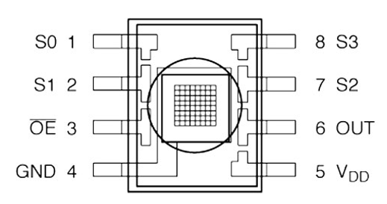

**Fig 5. TCS3200 Color Sensor pinout**

**COLOR DETECTION**

TCS3200 is the color sensor which converts light intensity into frequency. It has an array of 64 photodiodes divided into 4 types namely red, green, blue and no color each of using (4*4) 16 photodiodes. Each type can be activated using the S2, S3 selection inputs. Since each photodiode are coated with different filters each of them can detect the corresponding colors.

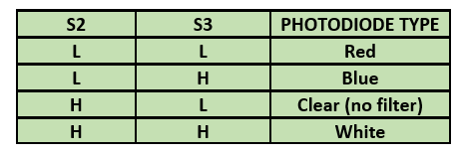

**Fig 6**. **Photodiode Table**

TCS3200 color sensor detects reflected light from an object which are in the range of visible light spectrum (fig7) and convert it into frequency with the help of inbuilt current to frequency converter (fig8) and gives us output in the form of frequencies of RGB components.

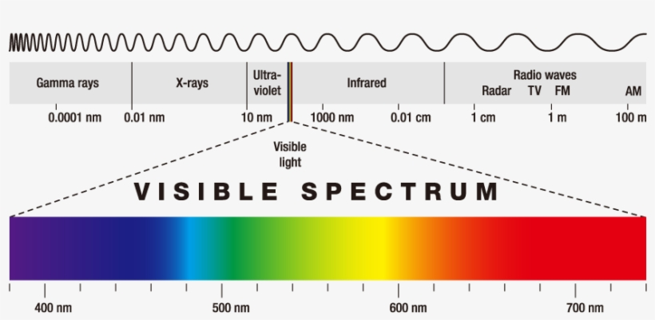

**Fig 7. Visible Spectrum**

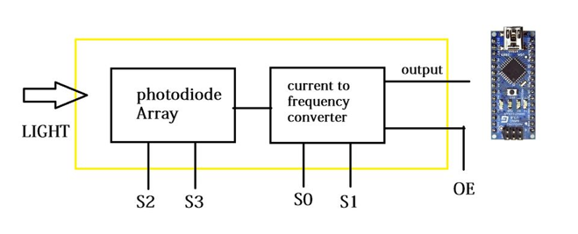

**Fig 8. Functional Block Diagram of Color Sensor**

**SORTING OF OBJECT**

Servo motors have high torque as 1.8 Kg\cm and wide speed range. Here we are using two Sg9 micro servo motors to sort objects according to the color detected by sensor. It rotates approximately 180-degree 90 degree in each direction. Fig9 shows the pwm cycle to set the rotation. Position "0" (1.5 ms pulse) is middle, "90" (~2ms pulse) is middle, is all the way to the right, "-90"

(~1ms pulse) is all the way to the left

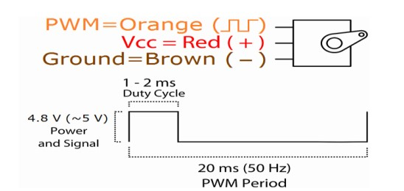

**Fig- 9**.PWM

**Methodology**

Fig10. shows the actual process of our project that how it is going to work. 1st servo motor is used to collect the balls and place it on the platform for color detection procedure. Sensors collect frequency to detects the color of ball and gives frequency output to the Arduino. If frequency stay in red ball frequency range then 1st servo motor rotates 90 degree and 2nd servo motor open the gate so that red ball put the “R” box. Moreover, frequency stay in blue ball frequency range then 1st servo motor rotates 130 degree and 2nd servo motor open the gate so that blue ball put the “B” box. On the other hand, frequency stay in white ball frequency range then 1st servo motor rotates 150 degree and 2nd servo motor open the gate so that white ball put the “W” box.

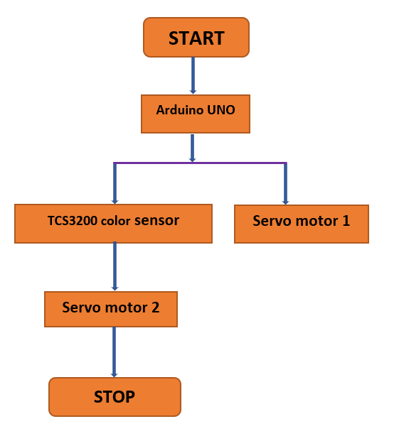

**Fig 10**. **Process Diagram**

**Project Picture**

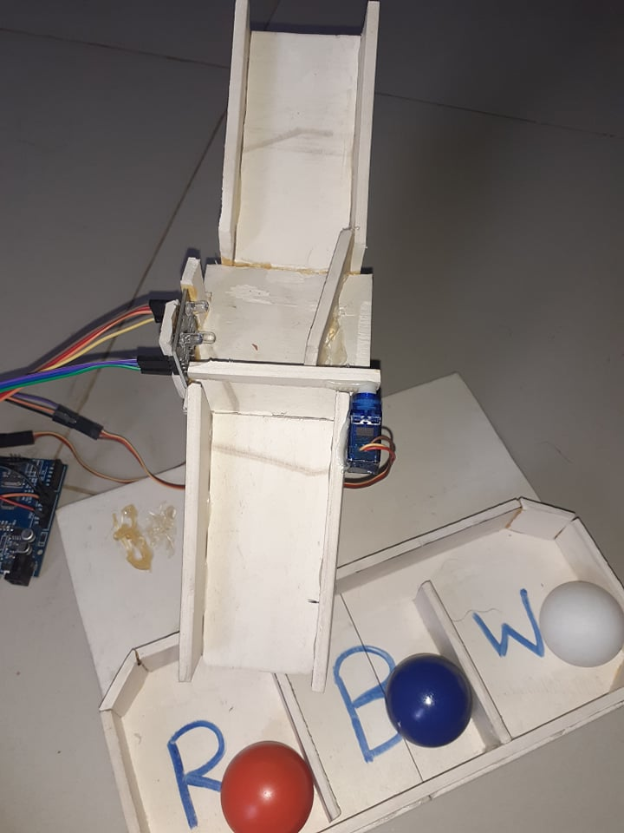

**Fig.11(Project Photo)**

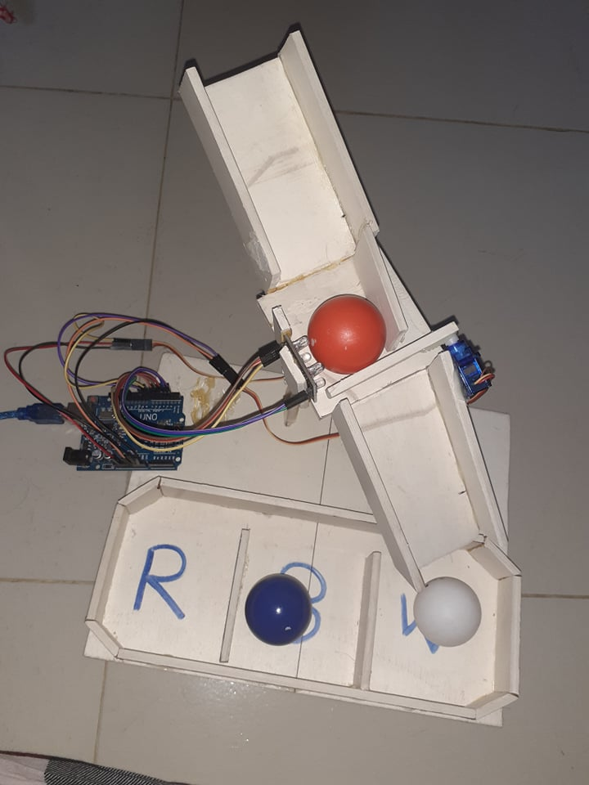

**Fig.12(Project Photo)**

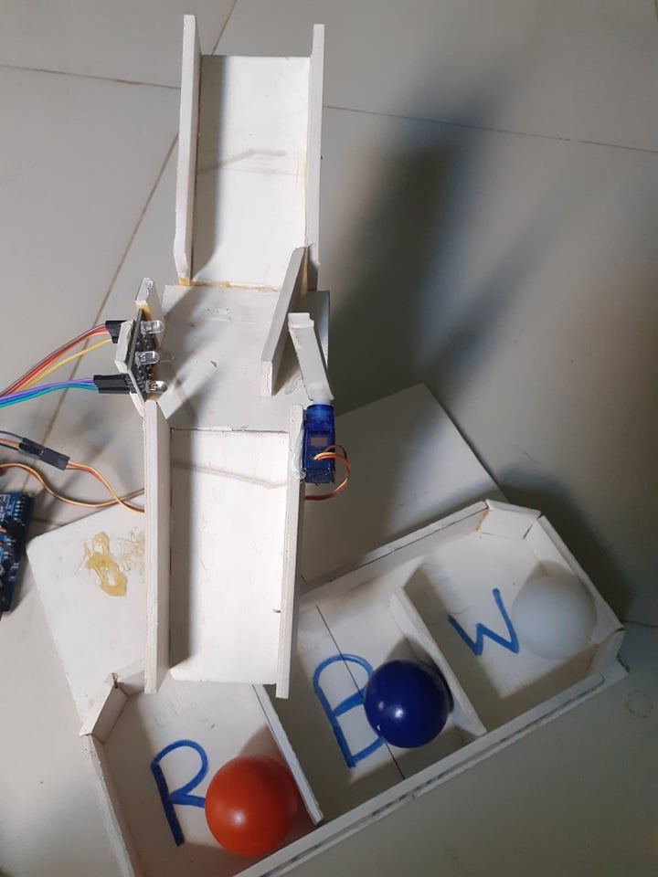

**Fig.13(Project Photo)**

**Project Algorithm**

**Step 1: Start**

**Step 2: Read (frequency of different color of ball)**

**Step 3: If frequency stay in given range**

**go to step 4**

**else**

**go to step 5**

**Step 4: Detect the color of the ball**

(i)1st servo motor rotates in specific degree

(ii)2nd servo motor opens the gate

and go to step-6

**Step 5: Fail to detect the color**

**and go to step 7**

**Step 6: Place the ball in the desire box**

**Step 7: Stop**

**Flowchart**

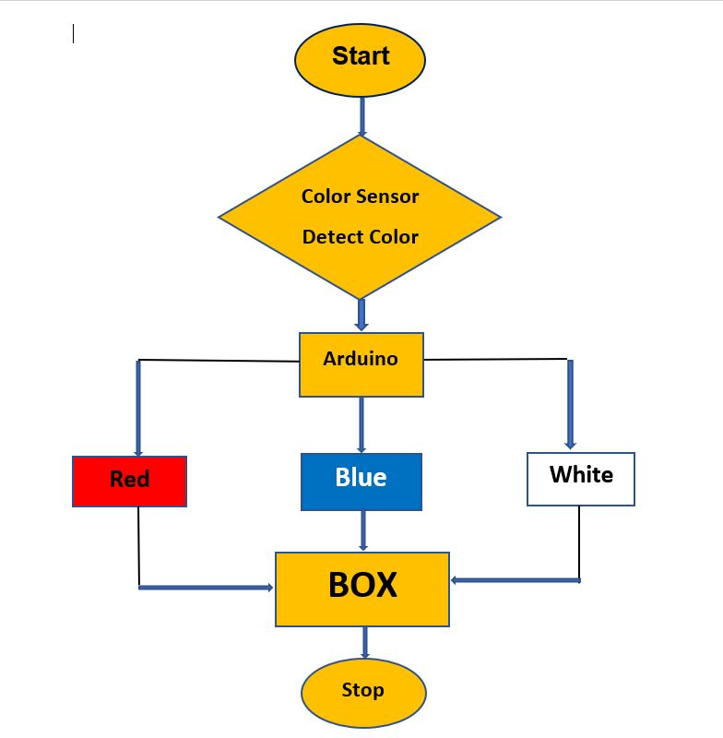

**Fig.14(flowchart)**

**Project Code**

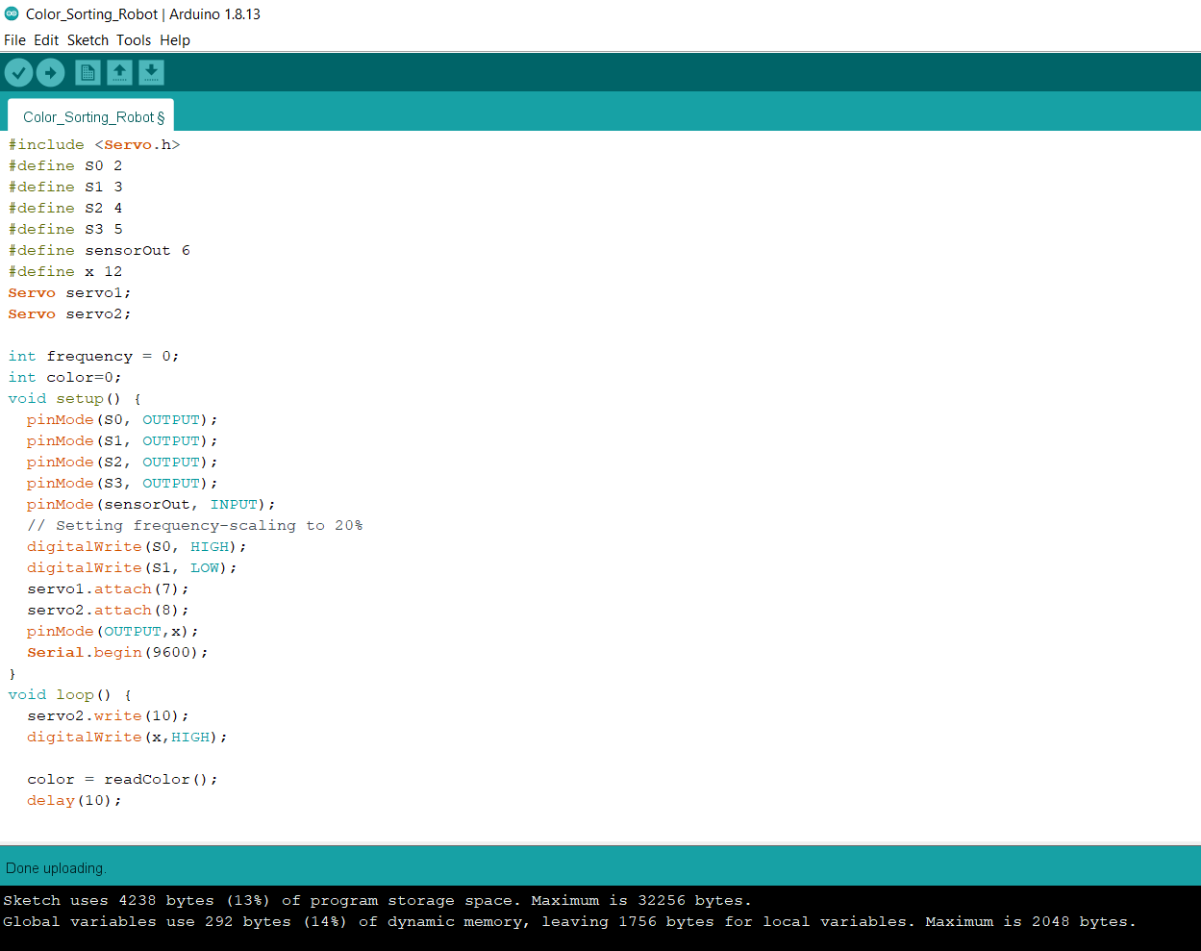

**Fig.15(Project Code)**

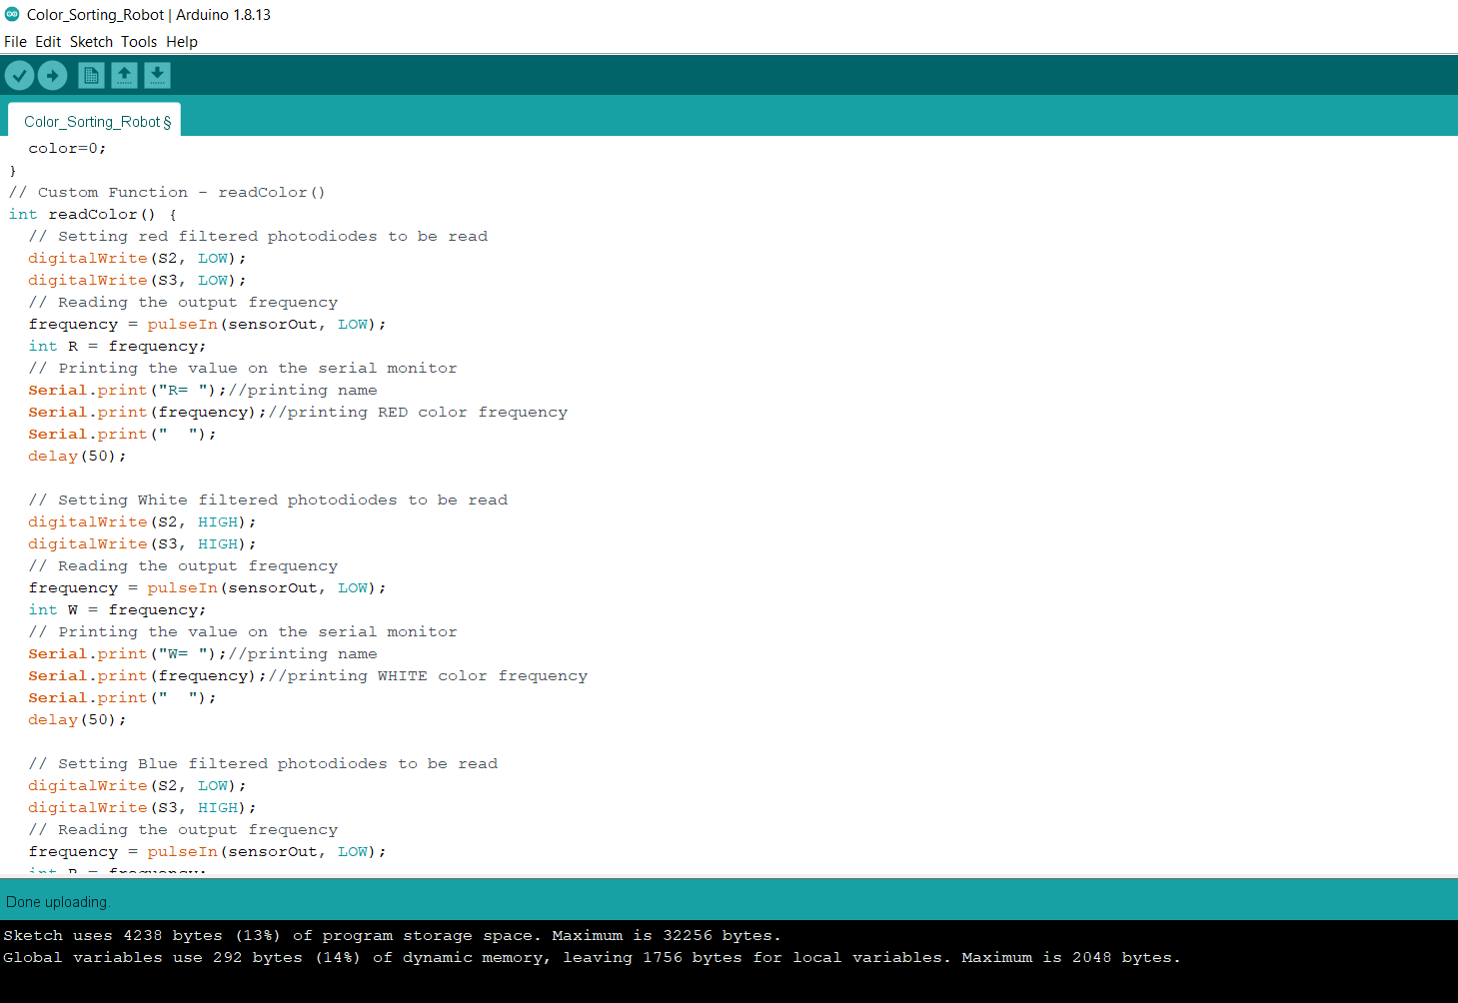

**Fig.16(Project Code)**

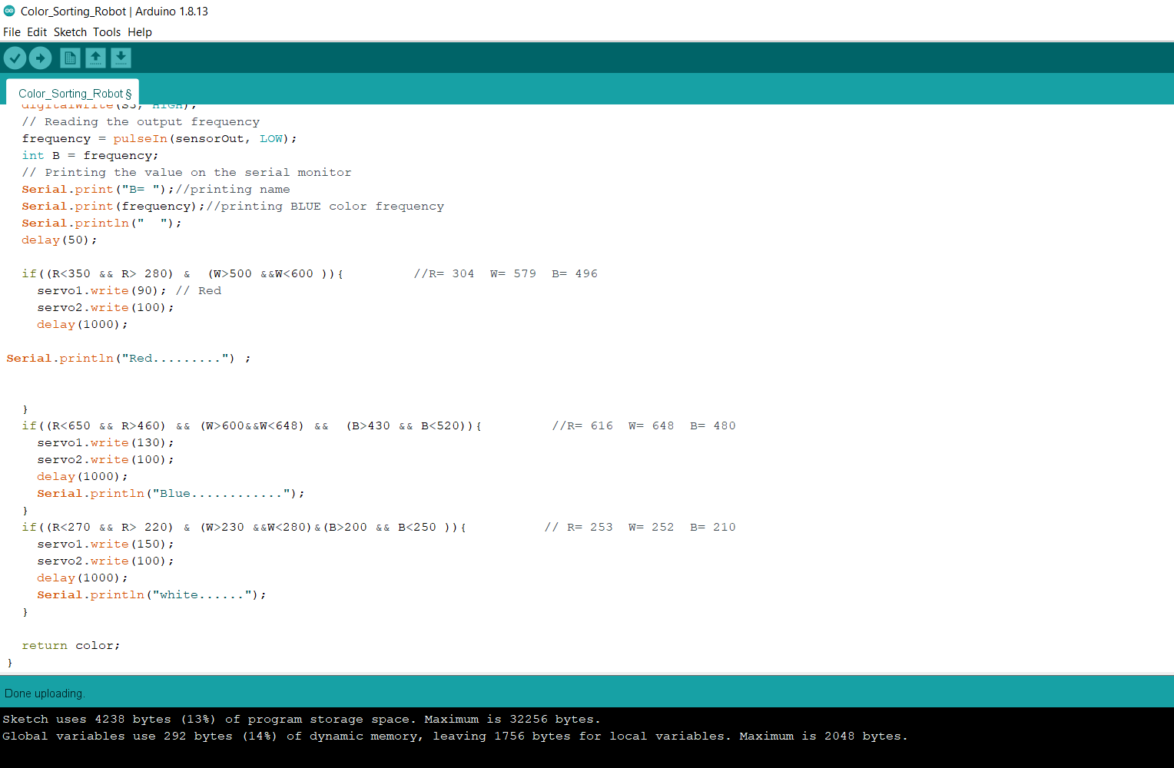

**Fig.17(Project Code)**

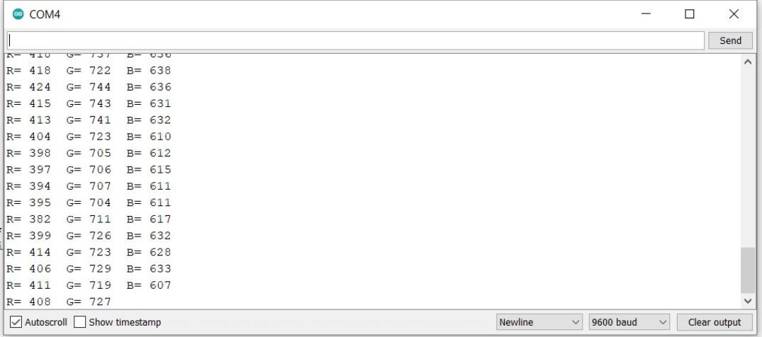

**Fig.18(Serial Monitor)**

**RESULT**

This chapter presents the results gathered from testing the robot. Fig.10 shows the completed results how the robot is working.1st servo motor checks the frequency range of the color and detects the color of the ball. After detecting the color ,2nd servo motor open the gate with specific rotation and the balls put in their respective boxes.

**CONCLUSION**

In this project the developing of a color sorting robot has been achieved. Color sensor TCS3200 gives precise output. It can be improved by using different advanced color sensors and microcontrollers. As per our requirement we can put limitation on objects to be sort and replace fully containers with the empty one using robot.

**REFERENCES**

1.LIM JIE SHEN*, IRDA HASSAN ”Design and Development of Color Sorting Robot” EURECA 2014 Special Issue January (2015).

2.http://www.mouser.com/catalog/specsheets/TCS3200-E11.pdf

3.Aji Joy “Object Sorting Robotic Arm Based on Color Sensing” International Journal of Advanced Research in Electrical, Electronics and Instrumentation Engineering Vol. 3, Issue 3, March 2014.

4.Dhanoj M, Reshma K V, Sheeba V, Marymol P “Color Sensor Based Object Sorting Robot Using Embedded System” International Journal of Advanced Research in Computer and Communication Engineering vol. 4, Issue 4, April 2015.

5.Abhishek Kondhare, Garima Singh, Neha Hiralkar , M.S.Vanjale “Colour And Shape Based Object Sorting” International Journal Of Scientific Research And Education ||Volume||2||Issue|| 3 ||Pages|553-562||2014|| ISSN (e): 2321-7545.

6.Li qiaoyi “Study on Color Analyzer Based on the Multiplexing of

TCS3200 Color Sensor and Microcontroller” ijhit Vol 7, no 5 (2014).

7.Uzma Amin, Ghulam Ahmad, Nudrat Liaqat, Manzar Ahmed,

Sumbal Zahoor “Detection & Distinction of Colors using Color Sorting Robotic Arm in a Pick & Place Mechanism”International Journal of Science and Research (IJSR) ISSN (Online): 2319-7064.

8.Akriti Kaushik, Aastha Sharama “Rgb Color Sensing Technique” IJARSE, Vol. No.2, Issue No.9, September 2013.

9.Kunhimohammed C. K, Muhammed Saifudeen K. K, Sahna S, Gokul M. S and Shaeez Usman Abdulla “Automatic Color Sorting Machine Using TCS230 Color Sensor And PIC Microcontroller” International Journal of Research and Innovations in Science and Technology .Volume 2 : Issue 2 : 2015.