Pilot FTV-Based Prediction of Pathologic Complete Response in I-SPY2 Breast MRI
Tumor-source validation with a future temporal graph learning framework

Abstract
This pilot study built a reproducible Cradle-to-GitHub pipeline for I-SPY2 breast MRI. The project tested raw DICOM SEG masks, found that they were not reliable tumor-only masks for the main analysis, moved to official MRI/FTV support-data features, mapped pCR labels, and trained pilot pCR prediction models. The strongest current result is an SVM_RBF model using FTV support features with AUROC 0.6667, AUPRC 0.7528, and Brier score 0.2405.

1. Research Question
Can official MRI/FTV support-data features provide a stronger and more reliable pilot pCR prediction signal than features derived from weak DICOM SEG or proxy biomarker paths?

2. Dataset and Computing Environment
Dataset size on Cradle: 1.6T.
Patients in inventory: 719.
Series counted: 32411.
DICOM files counted: 5586493.

3. Tumor-Source Validation
The DICOM SEG path was tested first. It became a diagnostic part of the study rather than the final modeling path. Many SEG files behaved like full-slice analysis masks. Fractional mask recovery was possible for a limited subset, but it did not provide enough labeled patients for reliable supervised modeling.

4. Main Modeling Path
The official MRI/FTV support-data path was selected as the main current result because it gave the strongest pilot pCR prediction signal.
Table 1. Baseline vs FTV model comparison
analysis | best_model | n_patients | positive_pCR | negative_non_pCR | n_features | AUROC | AUPRC
Phase 5A baseline biomarker model | LogisticRegression | 33 | 20 | 13 |  | 0.5461538461538461 | 0.7506391256164644
Phase 8C FTV support-data model | SVM_RBF | 13 | 7 | 6 | 28 | 0.6666666666666667 | 0.7527734170591311

5. Main Result
Best FTV model: SVM_RBF.
AUROC: 0.6667.
AUPRC: 0.7528.
Brier score: 0.2405.
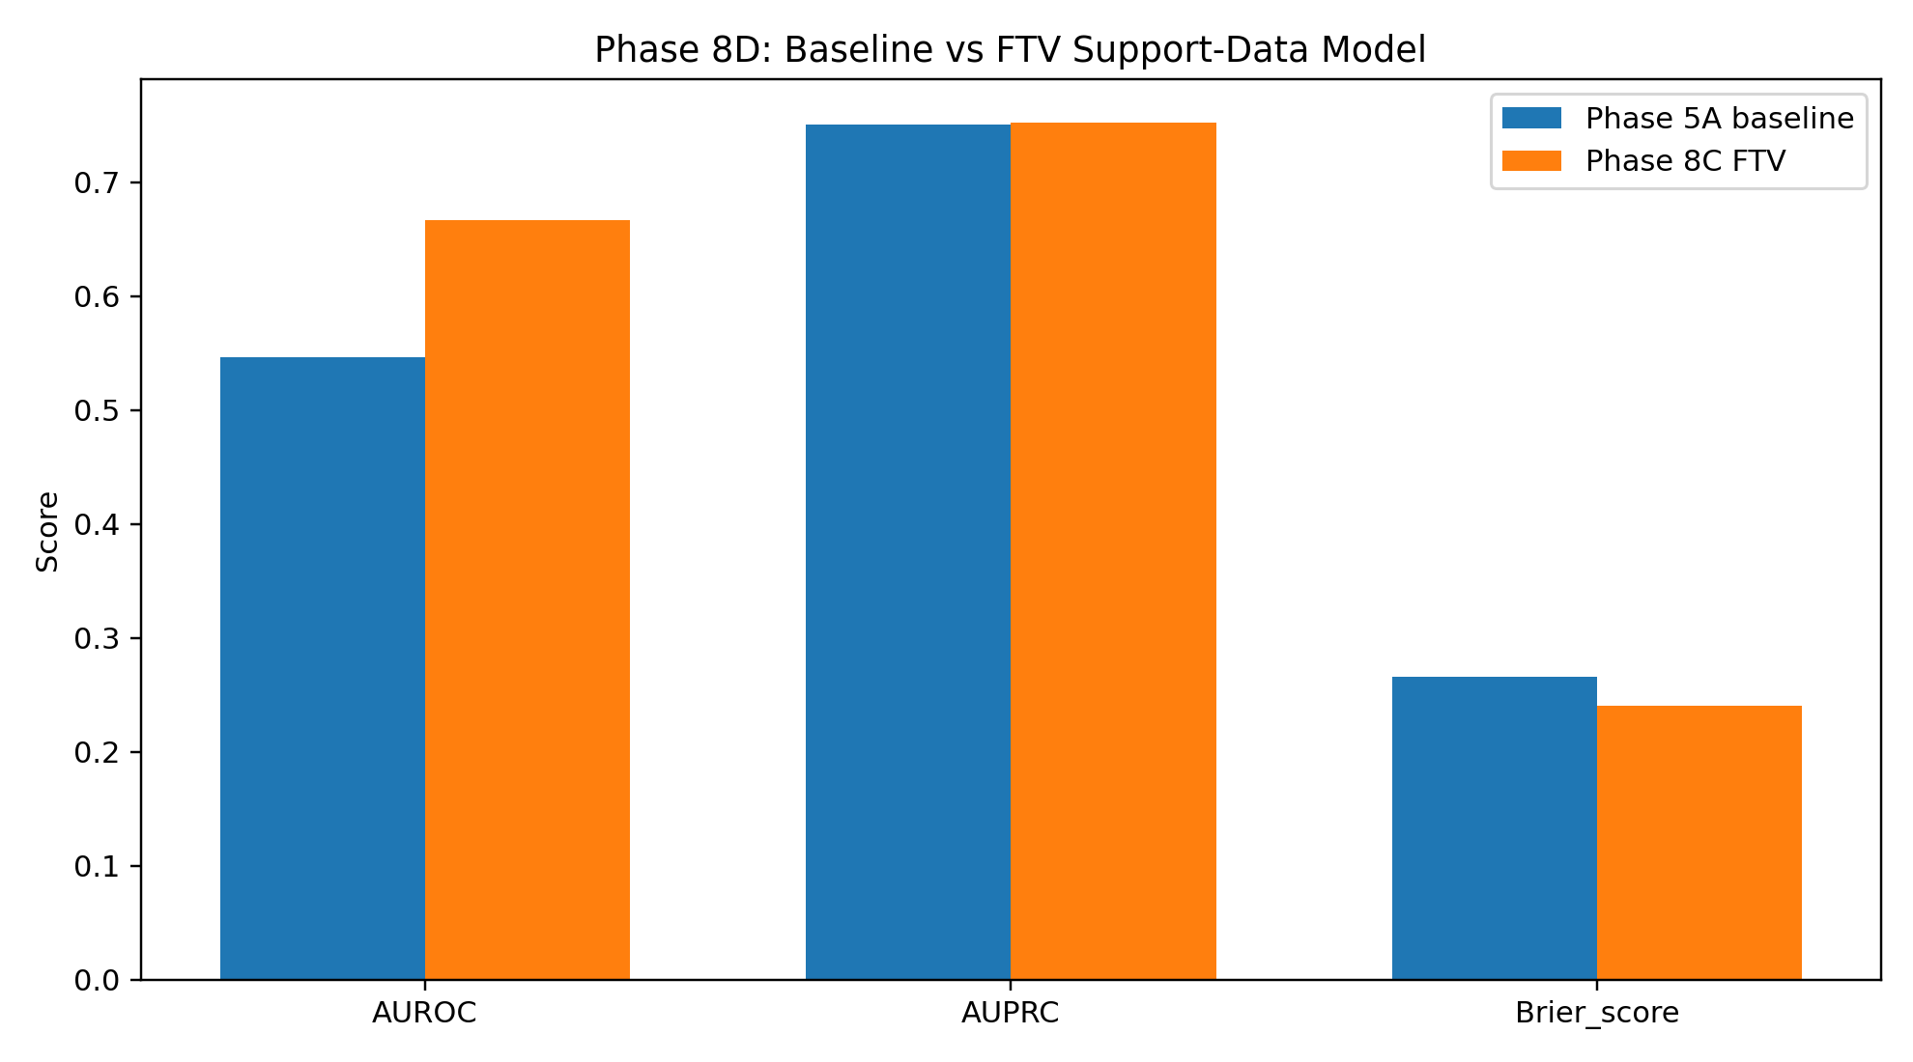
Figure 1. Baseline vs FTV support-data model metrics.

6. Visual Methods Output
Stage 10D packaged the visual preprocessing, recovered tumor mask overlay, breast-pair formation, and contrast-transport proxy into thesis-ready figures.
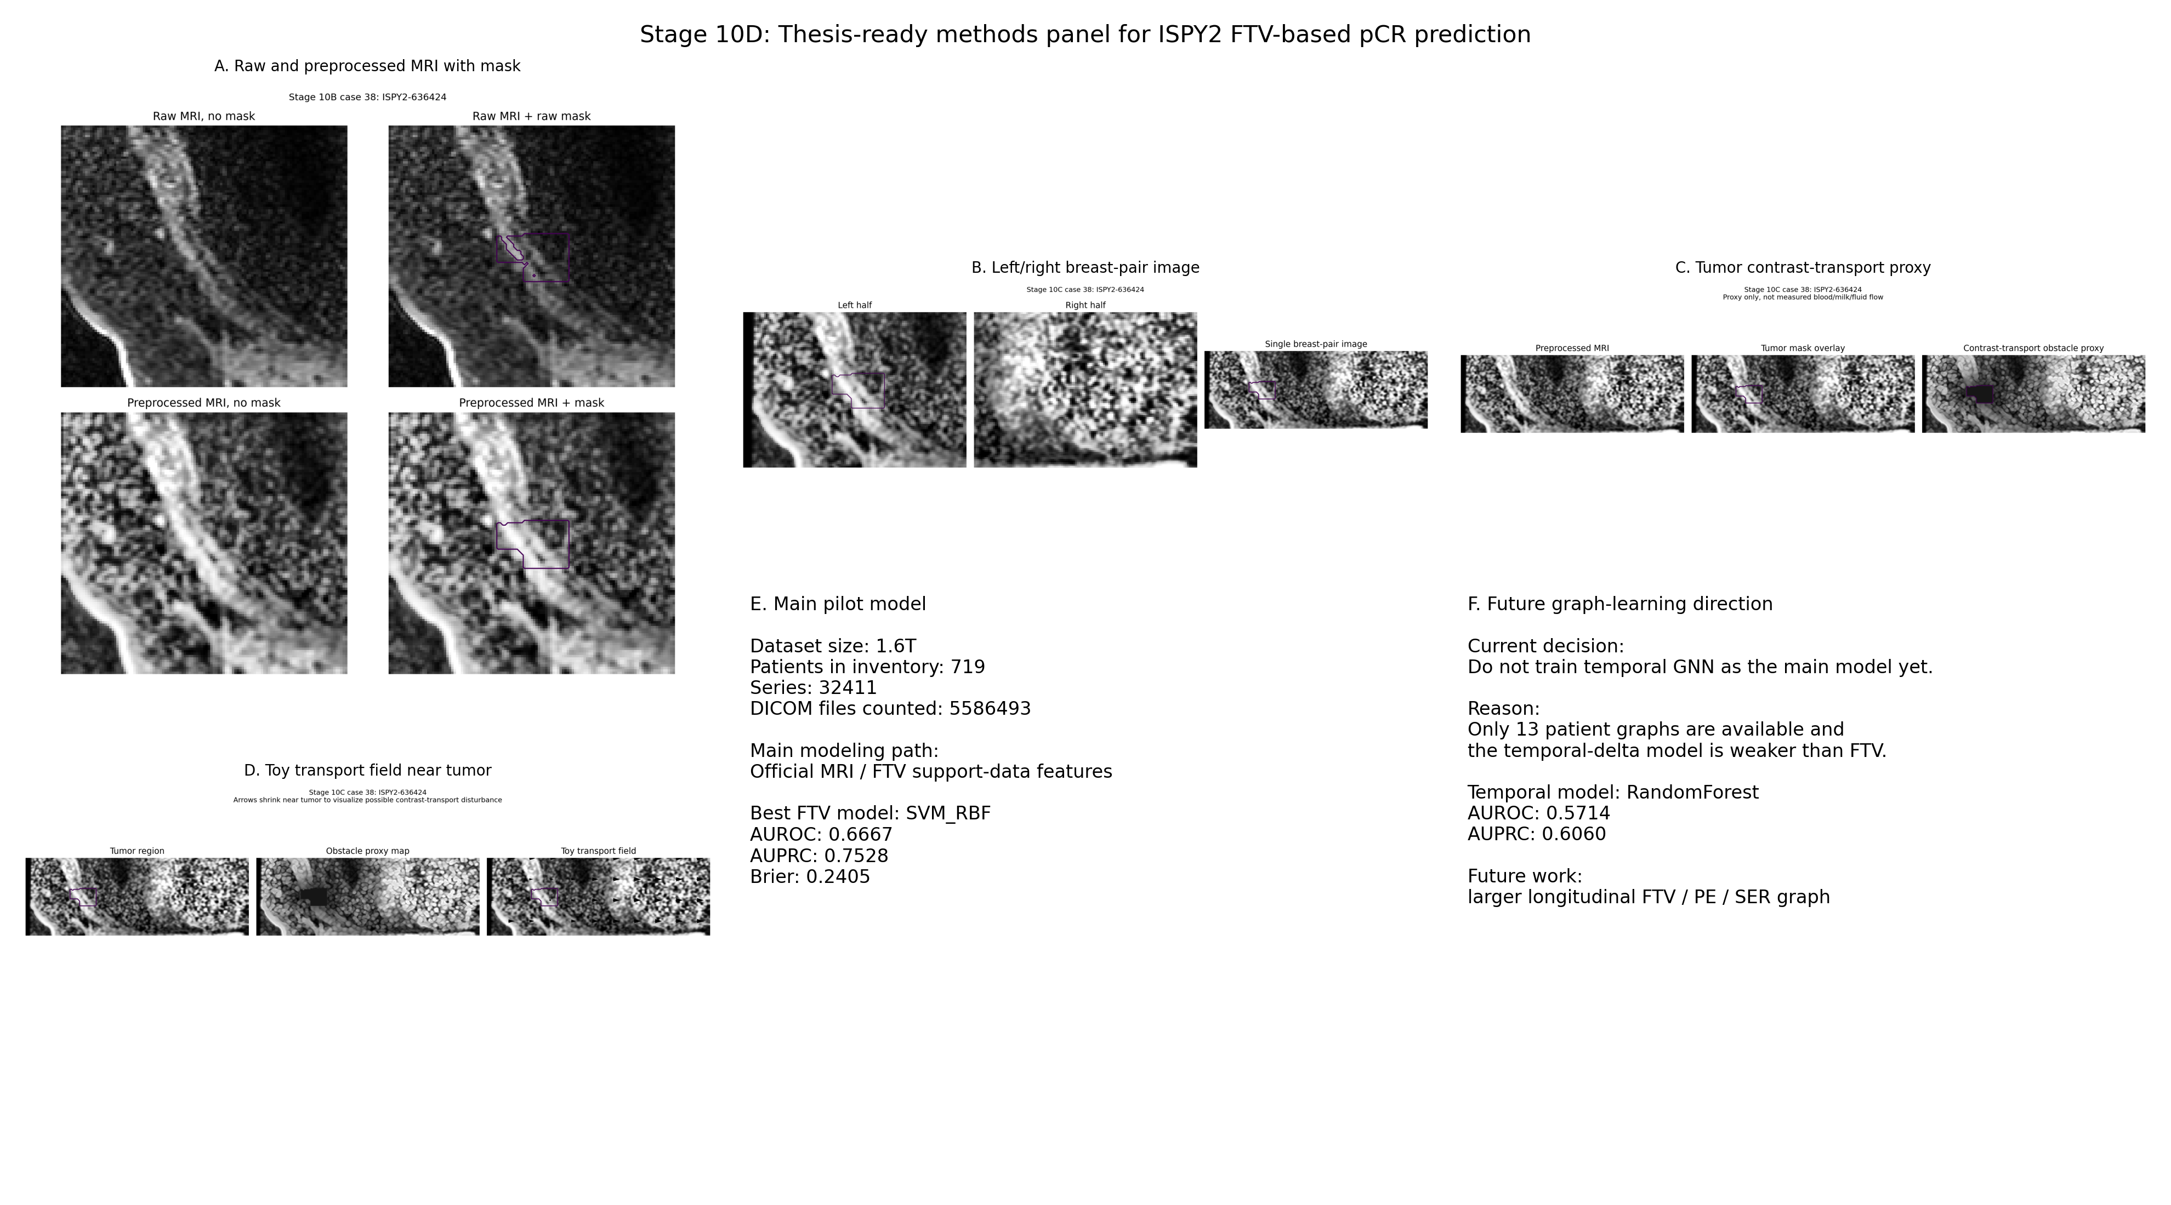
Figure 2. Master methods panel.
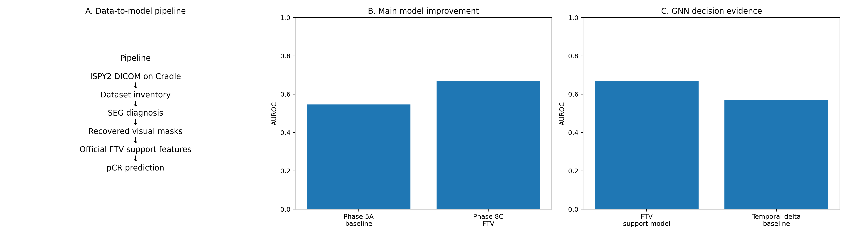
Figure 3. Final pipeline and model result figure.

7. Temporal Graph Decision
A graph-ready longitudinal FTV dataset was created. However, the temporal-delta model did not beat the FTV support-data model. Therefore, temporal GNN is future work, not the main current model.
Table 2. Phase 9C model decision summary
analysis | best_model | n_patients | AUROC | AUPRC | Brier_score | role
Phase 8C FTV support-data model | SVM_RBF | 13 | 0.6666666666666667 | 0.7527734170591311 | 0.2405088066605158 | current strongest pilot model
Phase 9B temporal-delta baseline | RandomForest | 13 | 0.5714285714285714 | 0.6059523809523809 | 0.2724052884615385 | diagnostic temporal baseline

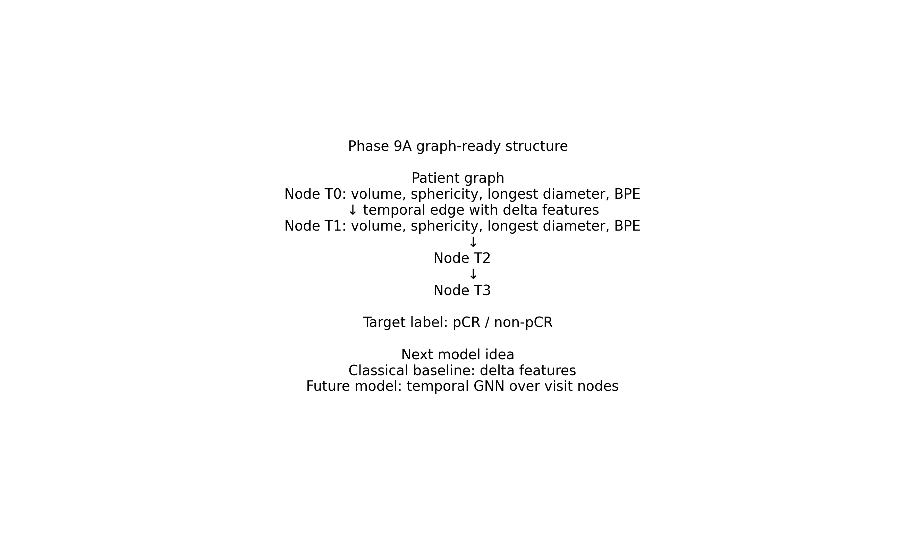
Figure 4. Future graph-ready longitudinal representation.

8. Limitations
This is pilot work. The strongest model used a small labeled cohort and should not be described as clinical validation.
The obstacle proxy is a conceptual contrast-transport visualization. It is not a direct measurement of blood flow, milk flow, or fluid flow.
The temporal GNN direction needs more patients and more stable longitudinal tumor-region features.

9. Future Work
Future work should use a larger longitudinal FTV/PE/SER cohort and build a temporal graph model with stable patient-visit or tumor-region nodes. A future GNN should be compared against the current FTV SVM baseline before making stronger claims.

10. Recommended Thesis Figures
Table 3. Figure caption map
figure_file | paper_section | caption
340_stage10d_master_methods_panel.png | Methods overview | Composite panel showing preprocessing, recovered tumor mask overlay, breast-pair formation, contrast-transport proxy visualization, and the final modeling decision.
341_stage10d_selected_case_contact_sheet.png | Preprocessing visual QC | Representative case examples showing raw and preprocessed MRI with recovered tumor-mask candidates.
342_stage10d_final_pipeline_and_model_result.png | Main results | Summary of the analysis path and model comparison showing that the official MRI/FTV support-data model is the strongest pilot result.
270_phase8e_project_pipeline.png | Study workflow | Overall project pipeline from ISPY2 data organization to FTV modeling and future temporal graph learning.
283_phase9a_graph_schema.png | Future work | Graph-ready longitudinal representation where patient visits become nodes and temporal edges encode treatment progression.

