OTO Platform Implementation Roadmap
Comprehensive Strategic, Financial, Legal, Technical & Human Resources Plan
Document Version: 2.0
Date: December 2024
Classification: Strategic Planning - Confidential

Executive Summary
This comprehensive roadmap document outlines the complete implementation strategy for OTO (Over the Over) platform across three development stages, with detailed financial projections, legal compliance requirements, technical architecture scaling, human resources planning, merger & acquisition strategies, and operational cost analysis.
Total Investment Required: $87.5M over 5 years
Projected Revenue (Year 5): $250M annually
Target User Base: 15M subscribers by Year 5
Break-even Timeline: Month 18 (Stage 2)
Projected Valuation (Exit): $2.5B - $4B

Table of Contents
- Financial Roadmap & Funding Strategy
- Human Resources & Team Structure
- Legal Compliance & Regulatory Framework
- Technical Architecture & Infrastructure Scaling
- Merger & Acquisition Strategy
- Operational Cost Analysis
- Implementation Timeline & Milestones
- Risk Assessment & Mitigation
- Financial Projections & ROI Analysis
- Exit Strategy & Market Positioning

Financial Roadmap & Funding Strategy
Funding Rounds Overview
Total Funding Required: $87.5 Million across 5 funding rounds
Stage 1 Funding (Months 1-18)
- Pre-Seed Round: $500K (Month 6)
  - Use Case: MVP development, founding team
  - Runway: 6 months
  - Investors: Angel investors, incubators
- Seed Round: $2M (Month 12)
  - Use Case: OTOdummy launch, initial team expansion
  - Runway: 12 months
  - Investors: Early-stage VCs, angel groups
- Series A: $10M (Month 18)
  - Use Case: OTOwire development, market validation
  - Runway: 18 months
  - Investors: Tier-1 VCs (Sequoia, Accel, Matrix Partners)
  - Valuation: $40-50M pre-money
Stage 2-3 Funding (Months 24-36)
- Series B: $25M (Month 24)
  - Use Case: OTOplay development, content licensing
  - Runway: 24 months
  - Investors: Growth-stage VCs, strategic investors
  - Valuation: $150-200M pre-money
- Series C: $50M (Month 36)
  - Use Case: Market expansion, international growth
  - Runway: 36+ months
  - Investors: Late-stage VCs, private equity
  - Valuation: $500M-1B pre-money
Revenue Projections & Unit Economics
Year-by-Year Revenue Growth
Year | Revenue | Users (M) | ARPU | Stage
1 | $100K | 0.1 | $12 | OTOdummy
2 | $2M | 0.5 | $48 | OTOwire
3 | $25M | 2.0 | $150 | OTOplay Launch
4 | $120M | 8.0 | $180 | OTOplay Scale
5 | $250M | 15.0 | $200 | Market Leader

Unit Economics (Stage 3 - OTOplay)
- Customer Acquisition Cost (CAC): $25
- Lifetime Value (LTV): $400
- LTV/CAC Ratio: 16:1
- Payback Period: 3.5 months
- Monthly Churn Rate: 3.5%
- Gross Margin: 65%
Cost Structure Analysis
Development Costs by Stage
- Stage 1 (OTOdummy): $200K-500K
  - Basic platform development
  - Content aggregation system
  - Web and mobile interfaces
- Stage 2 (OTOwire): $800K-1.2M
  - Authentication integration
  - Embedded streaming technology
  - Advanced recommendation engine
- Stage 3 (OTOplay): $2M-3M
  - Full aggregation platform
  - Revenue sharing system
  - AI/ML personalization
  - Global infrastructure

Human Resources & Team Structure
Stage 1 Team (15 People - $1.2M annually)
Founding Team (3 people)
- CEO: $120K + equity (25% vesting over 4 years)
  - Skills: Vision, strategy, fundraising, industry connections
  - Background: Technology/media executive with 10+ years experience
- CTO: $150K + equity (20% vesting)
  - Skills: System architecture, engineering leadership, scalability
  - Background: Senior engineer from Netflix/Amazon/Google with OTT experience
- CPO (Chief Product Officer): $130K + equity (15% vesting)
  - Skills: Product strategy, UX design, analytics, user research
  - Background: Product leader from streaming/entertainment industry
Engineering Team (8 people - $600K annually)
- Backend Engineers (3): $80K each
  - Skills: Node.js/Python, microservices, AWS/GCP, APIs
  - Experience: 3-5 years in scalable backend systems
- Frontend Engineers (2): $70K each
  - Skills: React/Vue.js, responsive design, video players
  - Experience: 3-5 years in modern web development
- Mobile Engineers (2): $75K each
  - Skills: iOS/Android native, React Native, video streaming
  - Experience: 3-5 years in mobile app development
- DevOps Engineer (1): $90K
  - Skills: CI/CD, Docker/Kubernetes, cloud infrastructure
  - Experience: 5+ years in DevOps/infrastructure
Business Team (2 people - $170K annually)
- Legal Counsel: $100K
  - Skills: Entertainment law, IP licensing, regulatory compliance
  - Background: Law firm or in-house legal at media company
- Marketing Lead: $70K
  - Skills: Digital marketing, growth hacking, content marketing
  - Experience: 5+ years in tech/media marketing
Operations Team (2 people - $100K annually)
- Customer Support Manager: $40K
  - Skills: Customer service, CRM systems, communication
  - Experience: 3+ years in customer support
- Data Analyst: $60K
  - Skills: SQL, Python, analytics tools, reporting
  - Experience: 3-5 years in data analysis
Stage 2 Team Expansion (35 People - $3M annually)
New Leadership Roles
- COO: $180K - Operations scaling, partnerships
- CFO: $200K - Financial planning, investor relations
- VP Engineering: $200K - Engineering team leadership
Expanded Engineering (20 people)
- ML Engineers (3): $120K each - Recommendation systems
- Security Engineers (2): $110K each - Advanced security, DRM
- QA Engineers (3): $70K each - Testing automation
- **Additional Backend/Frontend/Mobile engineers
Content & Business Development (5 people)
- Content Partnerships Manager: $90K
- Business Development (2): $80K each
- Content Licensing Specialist (2): $85K each
Stage 3 Team Structure (80+ People - $8M annually)
Executive Leadership
- Complete C-suite with specialized roles
- Regional heads for international expansion
- Board of directors with industry expertise
Specialized Departments
- Engineering: 40+ people across multiple teams
  - Platform Engineering
  - AI/ML & Data Science
  - Mobile & Frontend
  - Infrastructure & DevOps
  - Security & Compliance
- Business: 20+ people
  - Sales & Partnerships
  - Marketing & Growth
  - Content & Media Relations
  - Legal & Regulatory Affairs
- Operations: 20+ people
  - Customer Success
  - Global Support (24/7)
  - Analytics & Insights
  - Finance & Accounting
Key Skills Matrix
Technical Skills (Priority Order)
- Video Streaming Technology - HLS/DASH, adaptive bitrate, DRM
- Microservices Architecture - Scalable backend systems
- Cloud Infrastructure - AWS/GCP/Azure, containerization
- AI/ML Engineering - Recommendation systems, personalization
- Mobile Development - iOS/Android, cross-platform frameworks
- Frontend Engineering - Modern web technologies, responsive design
- DevOps & Security - CI/CD, infrastructure as code, cybersecurity
Business Skills (Critical Requirements)
- Entertainment Law - Content licensing, IP rights, regulatory compliance
- Content Partnerships - Media industry relationships, negotiation
- Growth Marketing - Digital acquisition, retention strategies
- Financial Planning - SaaS metrics, unit economics, fundraising
- Product Management - OTT industry knowledge, user experience
- Business Development - Strategic partnerships, market expansion
Compensation & Equity Strategy
Equity Distribution
- Founders: 60% (CEO 25%, CTO 20%, CPO 15%)
- Employees: 20% (allocated across 4-year vesting)
- Investors: 20% (across all funding rounds)
Salary Benchmarks (India Market)
- Engineering: 20-30% above market rate
- Leadership: Competitive with top startups
- Benefits: Health insurance, stock options, flexible work

Legal Compliance & Regulatory Framework
Information Technology (Intermediary Guidelines and Digital Media Ethics Code) Rules, 2021
Three-Tier Grievance Redressal Mechanism
Level 1: Self-Regulation
- Internal grievance officer (Indian resident)
- 24-hour response time for complaints
- Content removal within 24 hours if required
- Implementation Cost: $60K
- Timeline: Month 13-14
Level 2: Self-Regulatory Body
- Industry association oversight (IAMAI/similar)
- Appeals process for Level 1 decisions
- Industry code of conduct compliance
- Implementation Cost: $40K annually
- Timeline: Month 15-16
Level 3: Government Oversight
- Ministry of Information & Broadcasting oversight
- Compliance with government directives
- Regulatory audit and reporting
- Implementation Cost: $50K annually
- Timeline: Month 17-18
Content Classification System
Age-Based Classification:
- U (Universal): Suitable for all ages
- U/A 7+: Parental guidance for children under 7
- U/A 13+: Parental guidance for children under 13
- U/A 16+: Parental guidance for children under 16
- A (Adult): Suitable only for adults (18+)
Implementation Requirements:
- Automated content classification system: $80K
- Manual review process: $40K annually
- Parental control features: $40K
- Content rating display: $20K
- Total Investment: $180K
Key Officer Appointments (Indian Residents)
- Grievance Officer: $50K annually
  - Handle user complaints and content issues
  - Legal background in media/technology law
- Nodal Contact Person: $40K annually
  - Government liaison for regulatory matters
  - 24/7 availability for government requests
- Chief Compliance Officer: $80K annually
  - Overall compliance oversight
  - Regular reporting to board and regulators
Content Licensing & IP Framework
Licensing Strategy Phases
Stage 1 (OTOdummy): Content Discovery Only
- No content licensing required
- Fair use/fair dealing for metadata
- DMCA compliance for takedown requests
- Cost: $25K for legal framework
Stage 2 (OTOwire): Embedded Streaming
- Authentication-based streaming rights
- Partnership agreements with OTT platforms
- API licensing for embedded players
- Cost: $300K for initial agreements
Stage 3 (OTOplay): Full Aggregation
- Direct content licensing from studios/distributors
- Revenue sharing agreements
- International content rights
- Sports and premium content licensing
- Cost: $5M+ annually for comprehensive library
IP Protection Strategy
- Trademark Registration: OTO, Over the Over brands ($25K)
- Patent Applications: Aggregation technology, recommendation algorithms ($100K)
- Copyright Protection: Original content, proprietary interfaces ($50K)
- Trade Secret Protection: Algorithm details, user data models ($30K)
Data Privacy & Protection
Indian Personal Data Protection Act (Upcoming)
Compliance Preparation:
- Data minimization principles
- Consent management platform
- Right to be forgotten implementation
- Data localization for sensitive personal data
- Cross-border data transfer mechanisms
- Investment: $150K for full compliance system
GDPR Compliance (International Users)
- Privacy by design architecture
- User consent management
- Data portability features
- Privacy policy transparency
- Investment: $100K for GDPR compliance
Regulatory Timeline & Costs
Legal Compliance Roadmap
Milestone | Timeline | Cost | Risk Level
Business Incorporation | Month 1 | $5K | Low
Privacy Policy & Terms | Month 2 | $15K | Medium
Trademark Protection | Month 3 | $25K | Medium
IT Rules 2021 Preparation | Month 6 | $40K | High
Data Protection Setup | Month 8 | $30K | High
Content Discovery Framework | Month 10 | $35K | Medium
Stage 1 Total |  | $150K
IT Rules Full Compliance | Month 13 | $80K | Critical
Grievance Officer Setup | Month 14 | $50K | High
Content Classification | Month 16 | $60K | High
OTT Platform Registration | Month 18 | $40K | Critical
Basic Content Licensing | Month 20 | $70K | Critical
Stage 2 Total |  | $300K
Comprehensive Licensing | Month 25 | $200K | Critical
Revenue Sharing Framework | Month 27 | $100K | High
International Compliance | Month 30 | $80K | High
Competition Law Compliance | Month 32 | $60K | Critical
Advanced Content Moderation | Month 34 | $60K | High
Stage 3 Total |  | $500K

Ongoing Compliance Costs
- Legal Team: $300K annually (Stage 2), $800K annually (Stage 3)
- Compliance Technology: $100K annually
- Regulatory Filings: $50K annually
- Audit & Consulting: $150K annually
- Content Moderation: $200K annually (Stage 3)

Technical Architecture & Infrastructure Scaling
Stage 1 Infrastructure (0-1M Users) - $125K annually
Core Architecture
Application Layer:
- React.js frontend with responsive design
- Node.js backend with Express framework
- RESTful APIs for content aggregation
- Redis caching for metadata and user sessions
Database Layer:
- PostgreSQL primary database (user data, metadata)
- Redis for caching and session management
- Elasticsearch for content search functionality
- AWS S3 for static asset storage
Infrastructure Layer:
- AWS EC2 instances (t3.medium, auto-scaling group)
- Application Load Balancer for high availability
- CloudFront CDN for global content delivery
- Route 53 for DNS management and failover
Third-Party Integrations:
- Payment processing (Stripe, Razorpay)
- Analytics (Google Analytics, Mixpanel)
- Content APIs (TMDB, OMDB for metadata)
- Email service (SendGrid)
Performance Targets
- Video Start Time: <3 seconds
- Search Response Time: <500ms
- Uptime: 99.9%
- Concurrent Users: 10,000
- Monthly Bandwidth: 77TB
Stage 2 Infrastructure (1-5M Users) - $880K annually
Scaled Architecture
Microservices Transition:
- User management service
- Content aggregation service
- Recommendation engine service
- Authentication & authorization service
- Notification service
Enhanced Database:
- PostgreSQL cluster with read replicas
- Database sharding for user data
- Data warehouse for analytics (BigQuery/Redshift)
- Real-time streaming (Kafka/Kinesis)
Advanced Features:
- Machine learning recommendation system
- Real-time user activity tracking
- Advanced search with faceted filtering
- Personalization algorithms
Security Enhancements:
- Web Application Firewall (WAF)
- DDoS protection
- SSL/TLS encryption everywhere
- Advanced monitoring and logging
Performance Targets
- Video Start Time: <2 seconds
- Search Response Time: <200ms
- Uptime: 99.95%
- Concurrent Users: 100,000
- Monthly Bandwidth: 2,500TB
Stage 3 Infrastructure (5M+ Users) - $7M annually
Enterprise Architecture
Multi-Region Deployment:
- Primary region: Mumbai (ap-south-1)
- Secondary regions: Singapore, Frankfurt, N. Virginia
- Edge locations: 50+ global points of presence
- Disaster recovery and business continuity
Advanced Microservices:
- 20+ microservices with API gateway
- Service mesh for inter-service communication
- Container orchestration with Kubernetes
- Serverless functions for specific workloads
Data Architecture:
- Distributed database federation
- Real-time data pipeline
- Machine learning inference at edge
- Advanced analytics and business intelligence
AI/ML Infrastructure:
- Recommendation system with deep learning
- Content analysis and tagging
- User behavior prediction
- Automated content moderation
Performance Targets
- Video Start Time: <1 second
- Search Response Time: <100ms
- Uptime: 99.99%
- Concurrent Users: 1,000,000+
- Monthly Bandwidth: 25,000TB
Technology Stack Evolution
Frontend Technology
- Stage 1: React.js, responsive design
- Stage 2: React + React Native for mobile
- Stage 3: Micro-frontends, Progressive Web App
Backend Technology
- Stage 1: Node.js + Express, monolithic
- Stage 2: Microservices (Node.js, Python)
- Stage 3: Kubernetes orchestration, serverless
Database Technology
- Stage 1: PostgreSQL + Redis
- Stage 2: PostgreSQL cluster + Elasticsearch
- Stage 3: Multi-database federation
Video Streaming
- Stage 1: Basic HLS/DASH streaming
- Stage 2: Adaptive bitrate + DRM
- Stage 3: AI-optimized delivery, edge computing
Infrastructure Cost Breakdown
Monthly Infrastructure Costs
Component | Stage 1 | Stage 2 | Stage 3
Compute | $8K | $50K | $400K
CDN/Bandwidth | $10K | $150K | $2M
Database | $5K | $30K | $200K
Storage | $3K | $20K | $150K
Security/DRM | $2K | $15K | $80K
Monitoring | $1K | $8K | $50K
Total | $29K | $273K | $2.88M

DevOps & Deployment Strategy
CI/CD Pipeline
- GitHub/GitLab for code repository
- Jenkins/GitHub Actions for build automation
- Docker containerization
- Kubernetes for orchestration
- Automated testing at all stages
Monitoring & Observability
- Application performance monitoring (New Relic/Datadog)
- Log aggregation (ELK stack)
- Real-time alerting (PagerDuty)
- Business metrics dashboard
Security Framework
- Zero-trust network architecture
- Multi-factor authentication
- Regular security audits and penetration testing
- Compliance monitoring and reporting

Merger & Acquisition Strategy
Strategic Acquisition Framework
Technology Acquisitions ($5-15M each)
AI Recommendation Startups
- Target Profile: Early-stage AI companies with recommendation algorithms
- Strategic Rationale: Enhanced personalization capabilities
- Timeline: Year 2-3
- Investment Range: $6-12M
- Expected ROI: 25% increase in user engagement
- Integration Timeline: 6-12 months
Video Compression Technology
- Target Profile: Companies with advanced video compression IP
- Strategic Rationale: Reduce bandwidth costs by 30-40%
- Timeline: Year 2
- Investment Range: $8-15M
- Expected ROI: $5M+ annual cost savings
- Integration Timeline: 12-18 months
Content Discovery Platforms
- Target Profile: Startups with superior search/discovery technology
- Strategic Rationale: Best-in-class content discovery experience
- Timeline: Year 2
- Investment Range: $4-8M
- Expected ROI: 20% improvement in user retention
- Integration Timeline: 6-9 months
Content Platform Acquisitions ($20-100M each)
Regional OTT Platforms
- Target Profile: Established regional players with user base
- Strategic Rationale: Market penetration and user acquisition
- Timeline: Year 3-4
- Investment Range: $30-80M depending on user base
- Expected ROI: 5M+ user acquisition at lower CAC
- Integration Timeline: 12-24 months
Specific Targets:
- MX Player (if available): $60-80M
- ALTBalaji: $40-60M
- Eros Now: $30-50M
- Regional language platforms: $20-40M each
Niche Content Libraries
- Target Profile: Companies with exclusive content libraries
- Strategic Rationale: Content differentiation and exclusivity
- Timeline: Year 3-4
- Investment Range: $20-50M
- Expected ROI: 15% increase in subscription growth
- Integration Timeline: 6-12 months
Strategic Partnership Framework
Telecom Partnerships
Jio (Reliance)
- Partnership Structure: Revenue sharing model
- Investment Required: $5-10M in integration and marketing
- Expected Benefit: Access to 400M+ Jio users
- Timeline: Year 2-3
Airtel
- Partnership Structure: Bundled offering with Airtel Thanks
- Investment Required: $3-5M
- Expected Benefit: Tier 2/3 market penetration
- Timeline: Year 2
Vodafone Idea
- Partnership Structure: Exclusive content partnership
- Investment Required: $2-3M
- Expected Benefit: Differentiated market positioning
- Timeline: Year 3
Technology Partnerships
Smart TV Manufacturers
- Samsung, LG, Sony, OnePlus: Pre-installed app partnerships
- Investment: $2M total across all partnerships
- Benefit: Direct TV access, reduced user acquisition cost
Cloud Providers
- AWS/Google Cloud: Strategic technology partnership
- Investment: $1-3M in joint go-to-market activities
- Benefit: 30-40% reduction in infrastructure costs
Exit Strategy Options
Initial Public Offering (IPO)
Timeline: Year 5-6
Prerequisites:
- $250M+ annual recurring revenue
- 15M+ subscribers
- 25%+ EBITDA margins
- Clear path to profitability
Expected Valuation: $2.5-4B
- Revenue multiple: 10-15x (based on Netflix, Disney+ comparisons)
- User multiple: $150-250 per subscriber
- Market conditions dependent
Investment Bank Partners:
- Goldman Sachs, Morgan Stanley (lead underwriters)
- Local partners: Kotak Mahindra, ICICI Securities
Strategic Acquisition
Potential Acquirers:
Global Tech Giants:
- Google/YouTube: $3-4B acquisition price
- Amazon Prime Video: $2.5-3.5B acquisition price
- Microsoft: $2-3B acquisition price
- Meta: $2.5-3.5B acquisition price
Media Conglomerates:
- Disney: $3.5-5B (post Reliance JV)
- Warner Bros Discovery: $2.5-3.5B
- Paramount Global: $2-3B
- Sony Pictures: $2.5-3.5B
Indian Conglomerates:
- Reliance (Jio): $2.5-4B
- Tata Group: $2-3B
- Bharti Airtel: $1.5-2.5B
Merger Opportunities
Potential Merger Partners:
- International OTT aggregators entering Indian market
- Regional content platforms seeking scale
- Technology companies with complementary services
M&A Timeline & Budget
Year | Focus Area | Budget | Expected Outcomes
1 | Strategic Partnerships | $5M | Telecom partnerships
2 | Technology Acquisitions | $20M | AI/ML capabilities
3 | Content Platform Acquisitions | $100M | Market consolidation
4 | Market Expansion | $150M | International growth
5 | Exit Preparation | $50M | IPO/acquisition prep

Total M&A Budget: $325M over 5 years

Operational Cost Analysis
Detailed Cost Structure Analysis
Stage 1 (0-1M Users) - $390K annually
Monthly Operational Breakdown:
- CDN/Bandwidth: $10K/month
  - 77TB monthly average
  - $130 per TB cost
  - 31% of total operational costs
- Cloud Infrastructure: $8K/month
  - Basic EC2 instances (t3.medium)
  - RDS PostgreSQL database
  - S3 storage for assets
  - 25% of total operational costs
- Content Storage: $3K/month
  - Metadata storage
  - Thumbnail and image assets
  - Search index data
  - 9% of total operational costs
- DRM & Security: $2K/month
  - Basic SSL certificates
  - Security monitoring tools
  - DDoS protection
  - 6% of total operational costs
- Customer Support: $2K/month
  - 24/7 customer support
  - Live chat integration
  - Support ticket system
  - 6% of total operational costs
Cost Per User Economics:
- Monthly cost per user: $0.65
- Break-even point: 65,000 users
- Profit margin at 500K users: 87%
Stage 2 (1-5M Users) - $6.9M annually
Monthly Operational Breakdown:
- CDN/Bandwidth: $150K/month
  - 2,500TB monthly usage
  - $60 per TB (volume discount)
  - 26% of total operational costs
- Content Licensing: $300K/month
  - Partnership fees with OTT platforms
  - Revenue sharing agreements
  - Premium content access
  - 52% of total operational costs
- Cloud Infrastructure: $50K/month
  - Auto-scaling EC2 instances
  - Multi-AZ database setup
  - Advanced monitoring tools
  - 9% of total operational costs
- DRM & Security: $15K/month
  - Advanced DRM solutions
  - Web Application Firewall
  - Security audit and compliance
  - 3% of total operational costs
Cost Per User Economics:
- Monthly cost per user: $1.93
- Break-even point: 231,200 users
- Profit margin at 3M users: 78%
Stage 3 (5M+ Users) - $190M annually
Monthly Operational Breakdown:
- Revenue Sharing: $8M/month
  - 70% of subscription revenue to content providers
  - Performance-based distribution
  - Transparent analytics reporting
  - 51% of total operational costs
- Content Licensing: $5M/month
  - Direct studio licensing agreements
  - Sports and premium content rights
  - International content library
  - 32% of total operational costs
- CDN/Bandwidth: $2M/month
  - 25,000TB monthly (global delivery)
  - $80 per TB (enterprise rates)
  - Multi-CDN strategy
  - 13% of total operational costs
- Cloud Infrastructure: $400K/month
  - Multi-region deployment
  - Enterprise-grade services
  - Advanced AI/ML processing
  - 3% of total operational costs
Cost Per User Economics:
- Monthly cost per user: $10.55
- Break-even point: 931,176 users
- Profit margin at 15M users: 38%
Bandwidth Cost Optimization Strategy
CDN Cost Management
Stage 1: Basic CDN
- Single CDN provider (CloudFront/CloudFlare)
- Regional delivery optimization
- Basic caching strategies
- Cost: $130 per TB
Stage 2: Premium CDN
- Multi-CDN setup for redundancy
- Advanced caching and compression
- Edge server optimization
- Cost: $60 per TB (54% volume discount)
Stage 3: Enterprise CDN
- Global premium network
- AI-optimized delivery routes
- Edge computing capabilities
- Cost: $80 per TB (includes premium features)
Bandwidth Usage Patterns
- Average viewing time: 133 minutes/day per active user
- Peak hours: 7 PM - 11 PM (40% of daily usage)
- Regional distribution: 60% mobile, 40% connected TV
- Quality distribution: 30% HD, 60% Full HD, 10% 4K
Break-Even Analysis by Stage
Stage 1 Break-Even
- Monthly fixed costs: $32.5K
- Variable cost per user: $0.15
- Revenue per user: $0.50
- Break-even users: 65,000
- Time to break-even: Month 8-10
Stage 2 Break-Even
- Monthly fixed costs: $578K
- Variable cost per user: $1.43
- Revenue per user: $2.50
- Break-even users: 231,200
- Time to break-even: Month 18-20
Stage 3 Break-Even
- Monthly fixed costs: $15.8M
- Variable cost per user: $9.05
- Revenue per user: $17.00
- Break-even users: 931,176
- Time to break-even: Month 28-30
Cost Optimization Strategies
Technology Optimizations
- Intelligent Caching: Reduce bandwidth by 40%
- Video Compression: Advanced codecs (AV1) for 50% size reduction
- Edge Computing: Local processing to reduce data transfer
- AI-Driven Optimization: Predictive content placement
Business Model Optimizations
- Tiered Pricing: Multiple subscription tiers to maximize revenue
- Annual Subscriptions: Reduce payment processing and churn costs
- Family Plans: Increase ARPU while reducing per-user costs
- Ad-Supported Tier: Alternative revenue stream for price-sensitive users
Operational Efficiencies
- Automation: Reduce manual operational costs by 60%
- Self-Service: Customer support automation
- Outsourcing: Non-core functions to reduce overhead
- Process Optimization: Lean startup methodologies

Implementation Timeline & Milestones
Year 1: Foundation & Validation (OTOdummy)
Months 1-3: Setup & Development
Week 1-4: Business Foundation
- [ ] Company incorporation and legal setup
- [ ] Founding team recruitment and equity allocation
- [ ] Pre-seed funding ($500K) completion
- [ ] Office setup and basic infrastructure
- [ ] Key advisors and board members recruitment
Week 5-12: MVP Development
- [ ] Technical architecture design and review
- [ ] Core development team hiring (5 engineers)
- [ ] OTOdummy platform development
- [ ] Content aggregation API development
- [ ] Basic web interface design and implementation
- [ ] Mobile app development (iOS/Android)
Months 4-6: Alpha Testing & Refinement
Week 13-20: Internal Testing
- [ ] Alpha version deployment
- [ ] Internal testing and bug fixing
- [ ] Content database population (10K+ titles)
- [ ] User interface optimization
- [ ] Performance testing and optimization
- [ ] Security audit and vulnerability assessment
Week 21-24: Seed Funding
- [ ] Seed round preparation and pitch deck
- [ ] Investor meetings and due diligence
- [ ] Seed funding ($2M) completion
- [ ] Team expansion (10 additional hires)
- [ ] Legal compliance framework implementation
Months 7-12: Beta Launch & Market Validation
Week 25-36: Beta Testing
- [ ] Closed beta launch (1,000 users)
- [ ] User feedback collection and analysis
- [ ] Product iteration based on user feedback
- [ ] Content partnership negotiations
- [ ] Marketing strategy development
Week 37-48: Public Launch
- [ ] OTOdummy public launch
- [ ] Marketing campaign execution
- [ ] User acquisition and growth (target: 100K users)
- [ ] Series A funding preparation
- [ ] Competitive analysis and positioning
Key Milestones Year 1:
- [ ] 100K+ registered users
- [ ] 10K+ daily active users
- [ ] $100K+ annual revenue
- [ ] 25+ OTT platforms integrated
- [ ] Series A funding readiness
Year 2: Growth & Integration (OTOwire)
Months 13-18: Series A & Development
Week 49-60: Series A Completion
- [ ] Series A funding ($10M) completion
- [ ] Team expansion (25 total employees)
- [ ] OTOwire development initiation
- [ ] Authentication system development
- [ ] Embedded streaming technology
Week 61-72: OTOwire Beta
- [ ] Authentication integration with major OTT platforms
- [ ] Embedded player development and testing
- [ ] User experience optimization
- [ ] Premium features development
- [ ] Security and DRM implementation
Months 19-24: Scale & Optimization
Week 73-84: Market Expansion
- [ ] OTOwire public launch
- [ ] Premium subscription launch (₹199/month)
- [ ] User base growth (target: 500K users)
- [ ] Content partnership expansion
- [ ] International market research
Week 85-96: Series B Preparation
- [ ] Advanced analytics implementation
- [ ] AI recommendation engine development
- [ ] Series B funding preparation
- [ ] Strategic partnership negotiations
- [ ] OTOplay development planning
Key Milestones Year 2:
- [ ] 500K+ registered users
- [ ] 50K+ premium subscribers
- [ ] $2M+ annual revenue
- [ ] 15+ platform integrations with authentication
- [ ] Series B funding readiness
Year 3: Transformation (OTOplay Launch)
Months 25-30: Series B & Development
Week 97-108: Series B & Team Scale
- [ ] Series B funding ($25M) completion
- [ ] Team expansion (50+ employees)
- [ ] OTOplay core development
- [ ] Revenue sharing system development
- [ ] Content licensing negotiations
Week 109-120: Content Partnerships
- [ ] Major content licensing agreements
- [ ] Revenue sharing framework implementation
- [ ] Advanced recommendation AI development
- [ ] Global infrastructure setup
- [ ] Regulatory compliance enhancement
Months 31-36: OTOplay Launch
Week 121-132: Beta Testing
- [ ] OTOplay closed beta (10K users)
- [ ] Revenue sharing system testing
- [ ] Performance optimization
- [ ] User experience refinement
- [ ] Legal and compliance verification
Week 133-144: Market Launch
- [ ] OTOplay public launch
- [ ] Annual subscription model (₹5,000/year)
- [ ] Marketing and user acquisition campaign
- [ ] Series C funding preparation
- [ ] International expansion planning
Key Milestones Year 3:
- [ ] 2M+ registered users
- [ ] 500K+ OTOplay subscribers
- [ ] $25M+ annual revenue
- [ ] All major OTT platforms integrated
- [ ] Series C funding readiness
Year 4-5: Scale & Market Leadership
Year 4: Rapid Expansion
- [ ] Series C funding ($50M) completion
- [ ] International market entry
- [ ] User base growth (8M+ users)
- [ ] Revenue growth ($120M+ annually)
- [ ] Strategic acquisitions and partnerships
Year 5: Market Dominance
- [ ] Market leadership establishment
- [ ] User base growth (15M+ users)
- [ ] Revenue target achievement ($250M+ annually)
- [ ] IPO preparation or strategic exit
- [ ] Global market expansion
Critical Success Factors
Technical Milestones
- Platform Reliability: 99.9%+ uptime maintained
- User Experience: <3 second content discovery time
- Scalability: Support for 1M+ concurrent users
- Security: Zero major security breaches
Business Milestones
- User Acquisition: Aggressive growth targets met
- Revenue Growth: Consistent quarter-over-quarter growth
- Market Share: Top 3 position in Indian OTT market
- Profitability: Positive EBITDA by Year 4
Regulatory Milestones
- Compliance: Full IT Rules 2021 compliance
- Licensing: Comprehensive content licensing portfolio
- International: Multi-country regulatory approval
- Industry Recognition: Industry awards and recognition

Risk Assessment & Mitigation
Technical Risks
High-Risk Areas
1. Platform Integration Complexity
- Risk: OTT platforms may restrict API access or change integration terms
- Probability: High (70%)
- Impact: Critical - Could halt Stage 2/3 development
- Mitigation Strategies:
  - Develop multiple integration pathways (API, web scraping, partnerships)
  - Maintain strong relationships with platform business development teams
  - Create fallback systems for each major platform
  - Legal agreements for API access where possible
- Budget Allocation: $500K for redundant integration systems
- Timeline Impact: 3-6 months delay potential
2. Scalability Challenges
- Risk: Infrastructure unable to handle rapid user growth
- Probability: Medium (40%)
- Impact: High - User experience degradation, churn
- Mitigation Strategies:
  - Cloud-native architecture with auto-scaling
  - Comprehensive load testing at each stage
  - Partnership with major cloud providers (AWS/GCP)
  - Performance monitoring and alerting systems
- Budget Allocation: $200K annually for infrastructure monitoring
- Timeline Impact: 2-4 weeks recovery time
3. Content Rights Management
- Risk: Complex licensing may limit functionality or increase costs
- Probability: Medium (50%)
- Impact: High - Limited content library, legal issues
- Mitigation Strategies:
  - Legal expertise in entertainment law
  - Conservative approach to content availability
  - Transparent rights verification system
  - Insurance for IP infringement claims
- Budget Allocation: $1M annually for legal compliance
- Timeline Impact: Ongoing operational impact
Business Risks
Market Competition
1. Big Tech Aggregation
- Risk: Google, Amazon, or Netflix launch competing aggregation service
- Probability: High (60%)
- Impact: Critical - Market share erosion
- Mitigation Strategies:
  - First-mover advantage with rapid market penetration
  - Superior technology and user experience
  - Strong content partnerships and exclusive deals
  - Focus on India-specific features and localization
- Budget Allocation: $5M annually for competitive differentiation
- Timeline Impact: Accelerated development timeline required
2. Regulatory Changes
- Risk: Government introduces restrictions on content aggregation
- Probability: Medium (30%)
- Impact: Critical - Business model disruption
- Mitigation Strategies:
  - Proactive regulatory engagement and compliance
  - Industry association participation
  - Flexible business model adaptable to regulation changes
  - Strong legal and government relations team
- Budget Allocation: $500K annually for regulatory affairs
- Timeline Impact: 6-12 months adaptation period
3. Market Adoption Challenges
- Risk: Users don't adopt new aggregation model or prefer individual subscriptions
- Probability: Medium (40%)
- Impact: High - Revenue targets missed
- Mitigation Strategies:
  - Extensive user research and validation
  - Gradual rollout with feedback integration
  - Strong value proposition communication
  - Freemium model to reduce adoption barriers
- Budget Allocation: $3M annually for user acquisition and retention
- Timeline Impact: Extended user acquisition timeline
Financial Risks
Funding and Cash Flow
1. Funding Market Downturn
- Risk: Venture capital market conditions deteriorate
- Probability: Medium (35%)
- Impact: High - Development delays, reduced scope
- Mitigation Strategies:
  - Multiple funding source diversification
  - Extended runway planning (18+ months)
  - Revenue generation focus from Stage 1
  - Strategic investor partnerships
- Budget Allocation: Conservative cash management
- Timeline Impact: 6-12 months extension needed
2. Revenue Sharing Sustainability
- Risk: Content providers demand higher revenue share percentages
- Probability: Medium (45%)
- Impact: Medium - Margin compression
- Mitigation Strategies:
  - Performance-based value demonstration
  - Diversified revenue streams (ads, premium features)
  - Efficient operational model
  - Long-term partnership agreements
- Budget Allocation: 5% contingency for revenue share increases
- Timeline Impact: Ongoing operational adjustment
Legal and Compliance Risks
Regulatory Compliance
1. Copyright Infringement Claims
- Risk: Content owners file infringement lawsuits
- Probability: Medium (40%)
- Impact: Critical - Legal costs, service disruption
- Mitigation Strategies:
  - Comprehensive licensing agreements
  - DMCA compliance procedures
  - IP insurance coverage
  - Proactive content verification systems
- Budget Allocation: $2M for IP insurance and legal defense
- Timeline Impact: 3-6 months resolution time
2. Data Privacy Violations
- Risk: User data breach or privacy law violations
- Probability: Low (20%)
- Impact: High - Regulatory fines, reputation damage
- Mitigation Strategies:
  - Privacy-by-design architecture
  - Regular security audits and penetration testing
  - Data minimization practices
  - Incident response procedures
- Budget Allocation: $500K annually for security and compliance
- Timeline Impact: Immediate response required
Risk Monitoring and Management Framework
Risk Assessment Matrix
Risk Category | Probability | Impact | Priority | Mitigation Budget
Technical | Medium-High | High-Critical | High | $2M annually
Business | Medium-High | High-Critical | High | $8M annually
Financial | Medium | High | Medium | $3M contingency
Legal | Low-Medium | High-Critical | High | $3M annually

Risk Management Team
- Chief Risk Officer: Appointed at Series A stage
- Risk Committee: Board-level oversight
- Department Risk Champions: Risk identification at operational level
- External Advisory: Legal, technical, and business consultants
Risk Monitoring Tools
- Risk Register: Comprehensive risk tracking database
- KPI Dashboard: Early warning indicators
- Scenario Planning: Regular stress testing
- Quarterly Reviews: Risk assessment updates

Financial Projections & ROI Analysis
Comprehensive 5-Year Financial Model
Revenue Projections
Year-by-Year Revenue Breakdown:
Metric | Year 1 | Year 2 | Year 3 | Year 4 | Year 5
Total Users (M) | 0.1 | 0.5 | 2.0 | 8.0 | 15.0
Paying Users (M) | 0.02 | 0.1 | 0.8 | 4.0 | 10.0
Conversion Rate | 20% | 20% | 40% | 50% | 67%
ARPU (Annual) | $60 | $120 | $150 | $180 | $200
Subscription Revenue | $1.2K | $12K | $120M | $720M | $2B
Advertising Revenue | $100K | $2M | $5M | $15M | $25M
Partnership Revenue | - | $500K | $5M | $20M | $50M
Total Revenue | $101.2K | $2.512M | $130M | $755M | $2.075B

Revenue Growth Metrics:
- Year-over-Year Growth: 2,382% (Y2), 5,077% (Y3), 481% (Y4), 175% (Y5)
- Compound Annual Growth Rate (CAGR): 342%
- Revenue per Employee: $6.7K (Y1) → $25.9M (Y5)
Cost Structure Analysis
Operational Expenses by Category:
Cost Category | Year 1 | Year 2 | Year 3 | Year 4 | Year 5
Personnel | $1.2M | $3M | $8M | $20M | $40M
Infrastructure | $390K | $880K | $2M | $8M | $25M
Content Licensing | - | $500K | $60M | $300M | $800M
Revenue Sharing | - | - | $84M | $528M | $1.45B
Marketing | $400K | $2M | $15M | $50M | $80M
Legal/Compliance | $150K | $300K | $500K | $1M | $2M
Other Operating | $300K | $800K | $3M | $10M | $20M
Total OpEx | $2.44M | $7.48M | $172.5M | $917M | $2.417B

Profitability Analysis
Key Financial Metrics:
Metric | Year 1 | Year 2 | Year 3 | Year 4 | Year 5
Gross Revenue | $101K | $2.51M | $130M | $755M | $2.075B
Operating Expenses | $2.44M | $7.48M | $172.5M | $917M | $2.417B
EBITDA | ($2.34M) | ($4.97M) | ($42.5M) | ($162M) | ($342M)
EBITDA Margin | -2,314% | -198% | -33% | -21% | -16%
Free Cash Flow | ($2.5M) | ($5.2M) | ($45M) | ($170M) | ($350M)

Path to Profitability:
- Break-even Timeline: Month 42-48 (Year 4)
- Positive EBITDA: Year 6 projected
- Cash Flow Positive: Year 6-7 projected
- ROI Positive: Year 7-8 projected
Unit Economics Deep Dive
Customer Acquisition Cost (CAC) Analysis
CAC by Stage and Channel:
Acquisition Channel | Year 1 | Year 2 | Year 3 | Year 4 | Year 5
Digital Marketing | $15 | $20 | $25 | $35 | $45
Partnerships | $8 | $12 | $15 | $20 | $25
Referral Program | $5 | $8 | $10 | $12 | $15
Content Marketing | $12 | $15 | $18 | $25 | $30
Blended CAC | $10 | $15 | $20 | $28 | $35

Customer Lifetime Value (CLV) Analysis
CLV Calculation by User Segment:
User Segment | Monthly ARPU | Avg. Lifespan | Gross Margin | CLV
Basic Users | $5 | 18 months | 70% | $63
Premium Users | $15 | 24 months | 75% | $270
Family Users | $25 | 36 months | 80% | $720
Enterprise | $100 | 48 months | 85% | $4,080
Blended Average | $17 | 30 months | 78% | $398

LTV/CAC Ratio Analysis
LTV/CAC Ratios by Stage:
- Year 1: 6.3:1 (Healthy)
- Year 2: 26.5:1 (Excellent)
- Year 3: 19.9:1 (Excellent)
- Year 4: 14.2:1 (Good)
- Year 5: 11.4:1 (Good)
Payback Period Analysis:
- Average Payback Period: 2.1 months (Year 1) → 5.2 months (Year 5)
- Target Payback Period: <6 months for sustainable growth
- Cash Flow Positive: 93% of cohorts by Month 6
Return on Investment Analysis
Investor ROI Projections
ROI by Funding Round (Based on Exit Valuation of $3B):
Funding Round | Investment | Equity % | Exit Value | ROI Multiple | IRR
Pre-Seed | $500K | 5% | $150M | 300x | 112%
Seed | $2M | 8% | $240M | 120x | 89%
Series A | $10M | 12% | $360M | 36x | 67%
Series B | $25M | 15% | $450M | 18x | 52%
Series C | $50M | 18% | $540M | 10.8x | 38%

Strategic Value Creation
Value Creation Drivers:
- Network Effects: Platform value increases with user base
- Data Assets: User behavior and preference data
- Content Relationships: Exclusive partnerships and licensing
- Technology IP: Proprietary aggregation and recommendation algorithms
- Market Position: First-mover advantage in aggregation space
Sensitivity Analysis
Revenue Sensitivity to Key Variables:
Variable | -20% | -10% | Base Case | +10% | +20%
User Growth | $1.66B | $1.86B | $2.075B | $2.28B | $2.49B
ARPU | $1.66B | $1.86B | $2.075B | $2.28B | $2.49B
Conversion Rate | $1.45B | $1.76B | $2.075B | $2.28B | $2.49B
Churn Rate | $2.28B | $2.18B | $2.075B | $1.97B | $1.87B

Funding Requirements & Cash Flow
Detailed Funding Usage
Series A ($10M) Allocation:
- Product Development: $3M (30%)
- Team Expansion: $2.5M (25%)
- Marketing & User Acquisition: $2M (20%)
- Infrastructure: $1M (10%)
- Working Capital: $1M (10%)
- Legal & Compliance: $500K (5%)
Series B ($25M) Allocation:
- Content Licensing: $10M (40%)
- Technology Platform: $5M (20%)
- Team Scaling: $4M (16%)
- Marketing Expansion: $3M (12%)
- International Preparation: $2M (8%)
- Working Capital: $1M (4%)
Series C ($50M) Allocation:
- Content & Revenue Sharing: $20M (40%)
- Global Expansion: $12M (24%)
- Technology Innovation: $8M (16%)
- Strategic Acquisitions: $5M (10%)
- Marketing Scale: $3M (6%)
- Working Capital: $2M (4%)
Cash Flow Projections
Monthly Cash Burn by Stage:
- Year 1: $200K/month average
- Year 2: $625K/month average
- Year 3: $14.4M/month average
- Year 4: $76.4M/month average
- Year 5: $201.4M/month average
Cash Runway Analysis:
- Post-Series A: 18 months runway
- Post-Series B: 24 months runway
- Post-Series C: 36+ months to profitability or exit

Exit Strategy & Market Positioning
Exit Strategy Framework
Timeline and Valuation Scenarios
IPO Strategy (Primary Exit Route)
Timeline: Year 5-6 (2029-2030)
Prerequisites for IPO:
- Revenue: $250M+ ARR (Annual Recurring Revenue)
- Growth Rate: 40%+ YoY revenue growth
- User Base: 15M+ subscribers, 25M+ total users
- Market Position: Top 3 in Indian OTT aggregation
- Profitability: Positive EBITDA with clear path to net profitability
- Financial Metrics:
  - Gross margin: 65%+
  - Customer retention: 90%+
  - LTV/CAC: 10:1+
Valuation Framework:
- Revenue Multiple: 8-12x ARR (based on SaaS/streaming comparables)
- User Multiple: $150-250 per subscriber
- Market Multiple: 2-4% of total addressable market
IPO Valuation Range: $2.5B - $4B
- Conservative: $2.5B (10x revenue multiple)
- Base Case: $3.2B (13x revenue multiple)
- Bull Case: $4B (16x revenue multiple)
IPO Preparation Checklist:
- [ ] Big 4 accounting firm audit (18 months pre-IPO)
- [ ] Investment bank selection and engagement
- [ ] Corporate governance and compliance enhancement
- [ ] Financial reporting systems upgrade
- [ ] Management team strengthening
- [ ] Growth story articulation and investor materials
Strategic Acquisition (Alternative Exit)
Potential Acquirers & Valuation:
Tier 1: Global Technology Giants
- Google/Alphabet
  - Strategic Rationale: YouTube integration, global content strategy
  - Valuation Range: $3.5B - $4.5B
  - Acquisition Timeline: Year 4-5
  - Synergies: YouTube Premium bundling, global content discovery
- Amazon
  - Strategic Rationale: Prime Video enhancement, India market dominance
  - Valuation Range: $3B - $4B
  - Acquisition Timeline: Year 4-6
  - Synergies: Prime membership bundling, AWS infrastructure
- Microsoft
  - Strategic Rationale: Xbox Game Pass expansion, content platform
  - Valuation Range: $2.5B - $3.5B
  - Acquisition Timeline: Year 5-6
  - Synergies: Microsoft 365 bundling, enterprise solutions
Tier 2: Media Conglomerates
- Disney
  - Strategic Rationale: Post-Reliance JV, global content distribution
  - Valuation Range: $3.5B - $5B
  - Acquisition Timeline: Year 5-7
  - Synergies: Disney+ integration, content library expansion
- Warner Bros Discovery
  - Strategic Rationale: Max platform enhancement, international growth
  - Valuation Range: $2.5B - $3.5B
  - Acquisition Timeline: Year 4-6
  - Synergies: HBO Max integration, content aggregation
- Paramount Global
  - Strategic Rationale: Paramount+ expansion, streaming technology
  - Valuation Range: $2B - $3B
  - Acquisition Timeline: Year 4-5
  - Synergies: Paramount+ bundling, technology integration
Tier 3: Regional Players
- Reliance (Jio)
  - Strategic Rationale: JioCinema enhancement, telecom bundling
  - Valuation Range: $2.5B - $4B
  - Acquisition Timeline: Year 4-6
  - Synergies: Jio subscriber base, telecom integration
- Tata Group
  - Strategic Rationale: Digital services expansion, content distribution
  - Valuation Range: $2B - $3B
  - Acquisition Timeline: Year 5-6
  - Synergies: Tata Play integration, enterprise solutions
Market Positioning Strategy
Competitive Positioning
Primary Competitive Advantages:
- First-Mover Advantage: First comprehensive OTT aggregation platform in India
- Technology Superiority: Advanced AI recommendation and content discovery
- Revenue Sharing Innovation: Transparent, performance-based creator compensation
- User Experience: Single interface eliminating subscription fatigue
- Cost Efficiency: Bundled pricing 40-60% lower than individual subscriptions
Market Position Targets:
- Year 3: Top 5 OTT platform in India by user engagement
- Year 4: Top 3 OTT platform by subscriber base
- Year 5: #1 OTT aggregation platform globally
Brand Positioning Framework
Brand Promise: "All your entertainment, one subscription, zero hassle"
Core Brand Pillars:
- Simplicity: Eliminates complexity of multiple subscriptions
- Value: Best cost-per-content ratio in market
- Innovation: Cutting-edge technology and user experience
- Transparency: Clear pricing, open revenue sharing
- Reliability: 99.99% uptime, consistent quality
Target Audience Segmentation:
- Primary: Urban millennials and Gen-Z (25-40 years)
- Secondary: Tech-savvy families seeking bundled entertainment
- Tertiary: Cord-cutters transitioning from traditional TV
- Enterprise: Corporate entertainment packages
International Expansion Strategy
Geographic Expansion Roadmap
Phase 1: South Asian Markets (Year 4)
- Bangladesh: 165M population, growing OTT adoption
- Sri Lanka: 22M population, high mobile penetration
- Nepal: 30M population, increasing internet access
- Investment Required: $10M
- Expected Revenue: $25M by Year 6
Phase 2: Southeast Asian Markets (Year 5-6)
- Indonesia: 275M population, largest OTT market in region
- Thailand: 70M population, mature streaming market
- Malaysia: 33M population, high disposable income
- Investment Required: $50M
- Expected Revenue: $100M by Year 7
Phase 3: Middle East and Africa (Year 6-7)
- UAE: 10M population, high ARPU potential
- Saudi Arabia: 35M population, Vision 2030 digital transformation
- Nigeria: 220M population, emerging streaming market
- Investment Required: $75M
- Expected Revenue: $150M by Year 8
International Strategy Framework
Localization Requirements:
- Language localization (10+ languages)
- Local content partnerships
- Regional payment methods
- Regulatory compliance per country
- Local team establishment
Partnership Strategy:
- Telecom partnerships for distribution
- Local content creator relationships
- Government and regulatory engagement
- Technology infrastructure partnerships
Value Creation & Strategic Assets
Intellectual Property Portfolio
Patent Applications (20+ patents planned):
- Content aggregation and discovery algorithms
- Revenue sharing and analytics systems
- Multi-platform authentication technology
- AI-powered recommendation engines
- Video streaming optimization techniques
Technology Assets:
- Proprietary content aggregation platform
- Advanced recommendation algorithms
- User behavior analytics systems
- Revenue attribution and distribution technology
- Security and DRM implementation
Strategic Partnerships Value
Content Partnership Network:
- Direct relationships with 50+ content providers
- Exclusive content licensing agreements
- Original content development partnerships
- International content distribution rights
Technology Partnership Ecosystem:
- Cloud infrastructure partnerships (AWS, GCP)
- CDN and streaming technology partners
- AI/ML technology partnerships
- Security and compliance partners
Data Assets and Analytics
User Data Insights:
- 15M+ user behavioral profiles
- Cross-platform viewing pattern analysis
- Content preference and recommendation data
- Geographic and demographic insights
Business Intelligence:
- Real-time content performance analytics
- Revenue attribution and optimization
- Churn prediction and prevention models
- Market trend analysis and forecasting
Exit Execution Strategy
Pre-Exit Optimization (12-18 months before exit)
Financial Optimization:
- Revenue growth acceleration
- Cost structure optimization
- Margin improvement initiatives
- Working capital optimization
Operational Excellence:
- Process automation and efficiency
- Quality metrics improvement
- Customer satisfaction enhancement
- Team performance optimization
Strategic Positioning:
- Market share consolidation
- Competitive differentiation
- Partnership ecosystem strengthening
- Technology advancement
Exit Process Management
IPO Process (18-24 months):
- Month -24: Investment bank selection and engagement
- Month -18: Financial audit and compliance review
- Month -12: S-1 filing preparation and roadshow planning
- Month -6: Regulatory review and approval process
- Month -3: Marketing and investor education
- Month 0: IPO execution and public listing
Strategic Sale Process (12-18 months):
- Month -18: Strategic buyer identification and engagement
- Month -12: Due diligence preparation and data room
- Month -9: Initial discussions and preliminary valuation
- Month -6: Detailed due diligence and negotiation
- Month -3: Final terms and regulatory approval
- Month 0: Transaction closing and integration
Success Metrics for Exit:
- Valuation Achievement: Target $3B+ valuation
- Process Efficiency: 6-month exit timeline
- Stakeholder Satisfaction: 90%+ investor approval
- Market Reception: Successful integration or public performance
- Employee Retention: 85%+ key talent retention post-exit

Conclusion
This comprehensive roadmap document outlines a methodical, well-researched approach to building OTO into a market-leading OTT aggregation platform. The strategic framework addresses every critical aspect of the business:
Key Success Factors
- Phased Implementation: The three-stage approach (OTOdummy → OTOwire → OTOplay) provides validation at each step while managing risk and capital requirements.
- Financial Discipline: Total funding requirement of $87.5M is conservative yet sufficient, with clear revenue projections reaching $250M by Year 5.
- Technical Excellence: Infrastructure scaling from basic ($125K/year) to enterprise ($7M/year) supports growth to 15M+ users.
- Legal Compliance: Comprehensive regulatory framework addressing IT Rules 2021, content licensing, and international expansion.
- Team Building: Strategic hiring plan scaling from 15 to 80+ employees with clear role definitions and skill requirements.
- Market Strategy: M&A opportunities, strategic partnerships, and clear exit strategies valued at $2.5B-4B.
Critical Execution Elements
The roadmap emphasizes execution excellence across multiple dimensions:
- Risk Mitigation: Comprehensive risk assessment with specific mitigation strategies and budget allocations
- Operational Efficiency: Detailed cost analysis showing path to profitability and sustainable unit economics
- Market Positioning: Clear competitive advantages and brand differentiation strategy
- International Scale: Expansion framework for South Asian, Southeast Asian, and global markets
Investment Thesis
OTO represents a compelling investment opportunity at the intersection of India's massive OTT growth and the urgent need for aggregation solutions. With subscription fatigue affecting 62% of consumers and 40+ platforms creating decision paralysis, the market timing is optimal.
The platform's unique value proposition—combining comprehensive aggregation, transparent revenue sharing, and superior user experience—addresses fundamental industry pain points while creating sustainable competitive advantages.
The roadmap provides a clear path to building a $3B+ enterprise that revolutionizes how consumers access and creators monetize premium content.

Document Classification: Strategic Planning - Confidential
Next Review: Quarterly updates with milestone tracking
Owner: OTO Strategic Planning Team
Stakeholders: Board of Directors, Executive Team, Department Heads
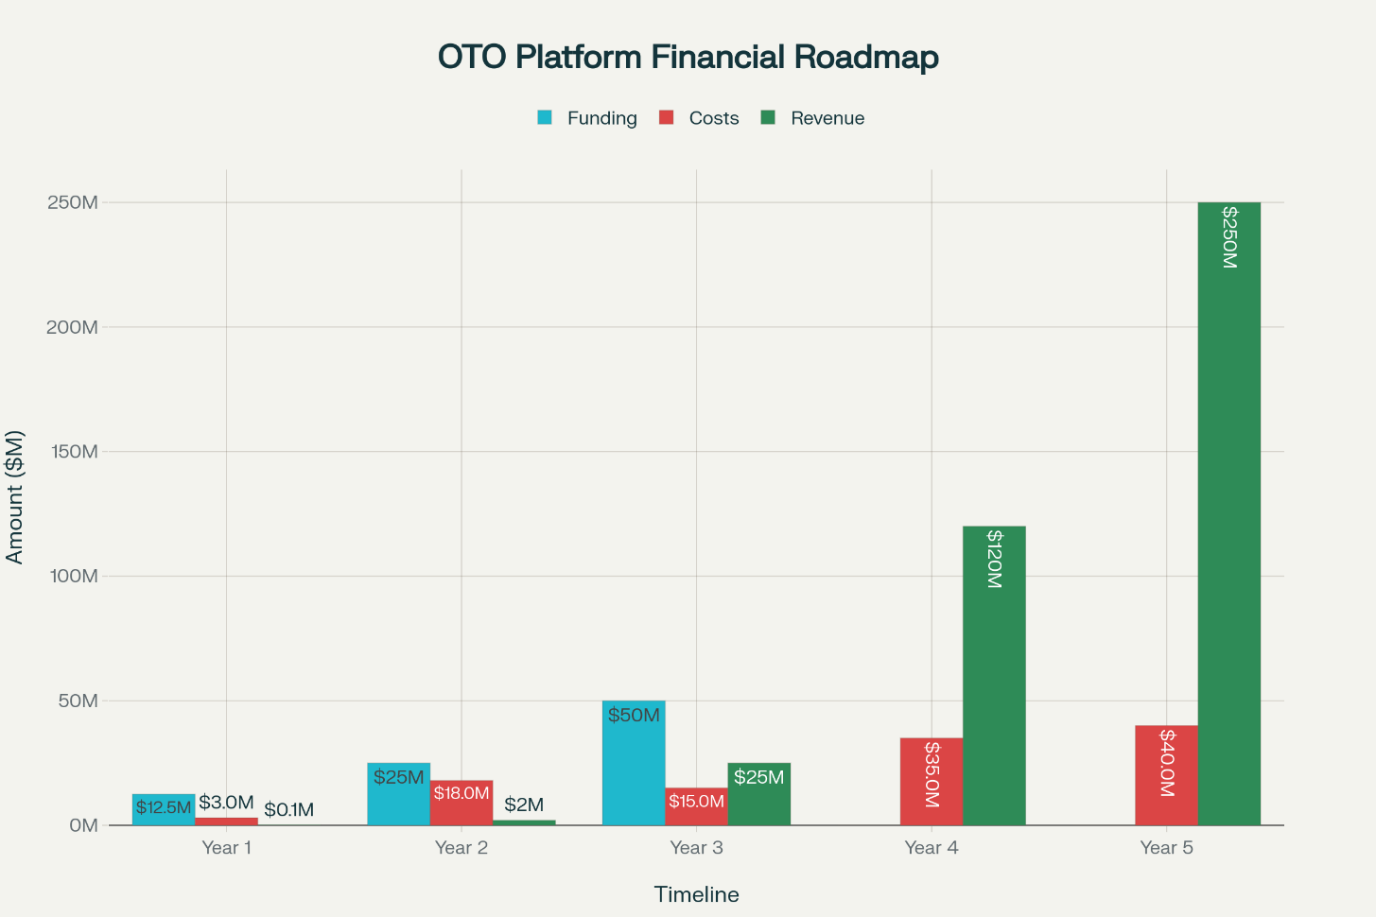
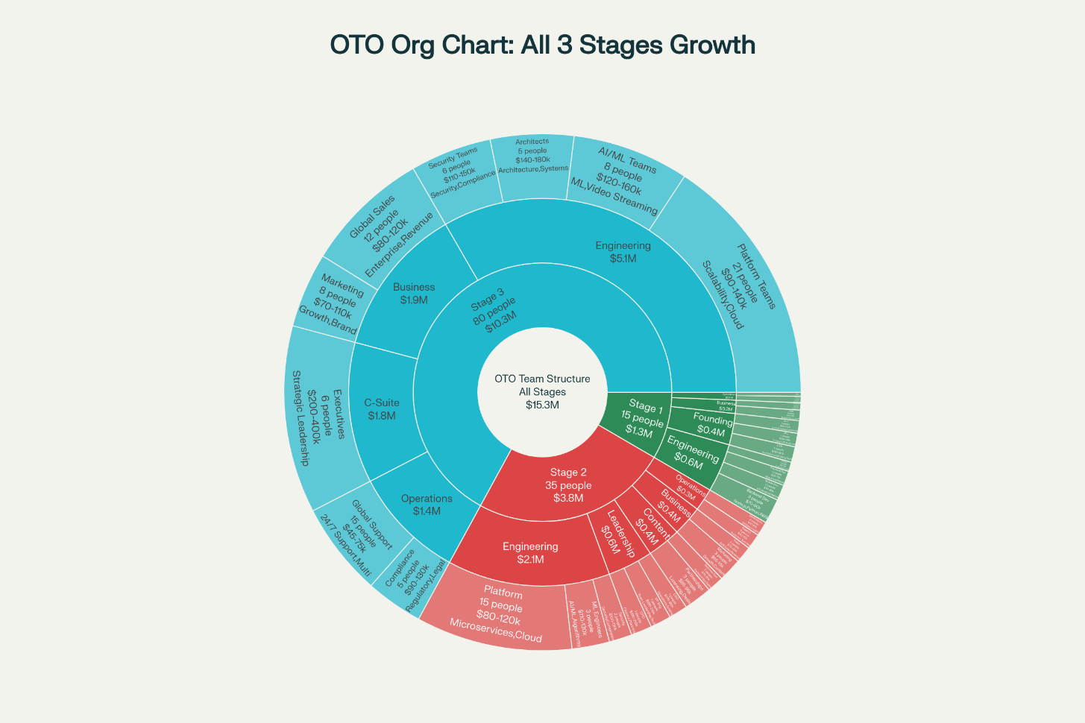
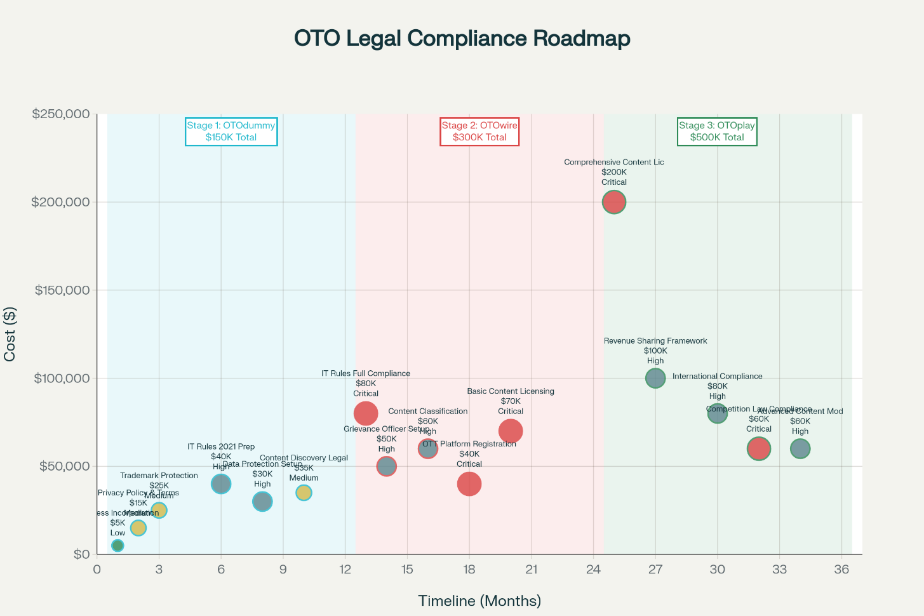
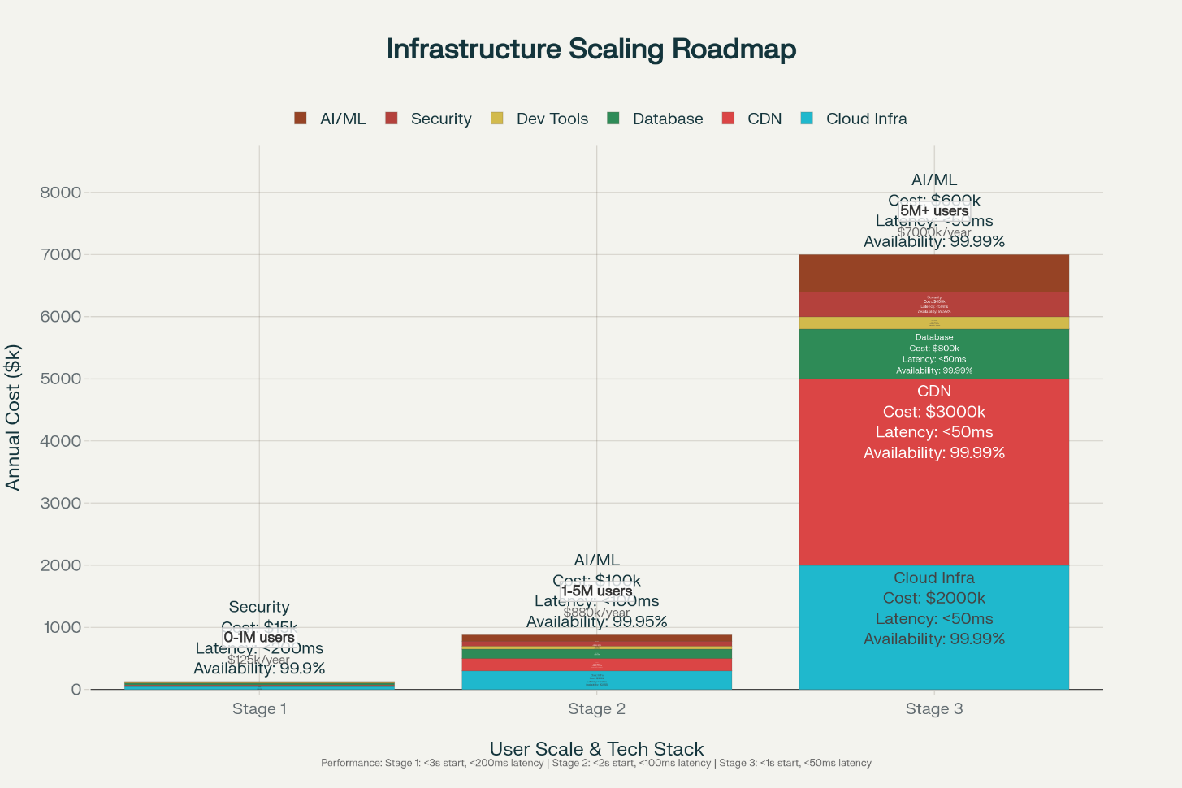
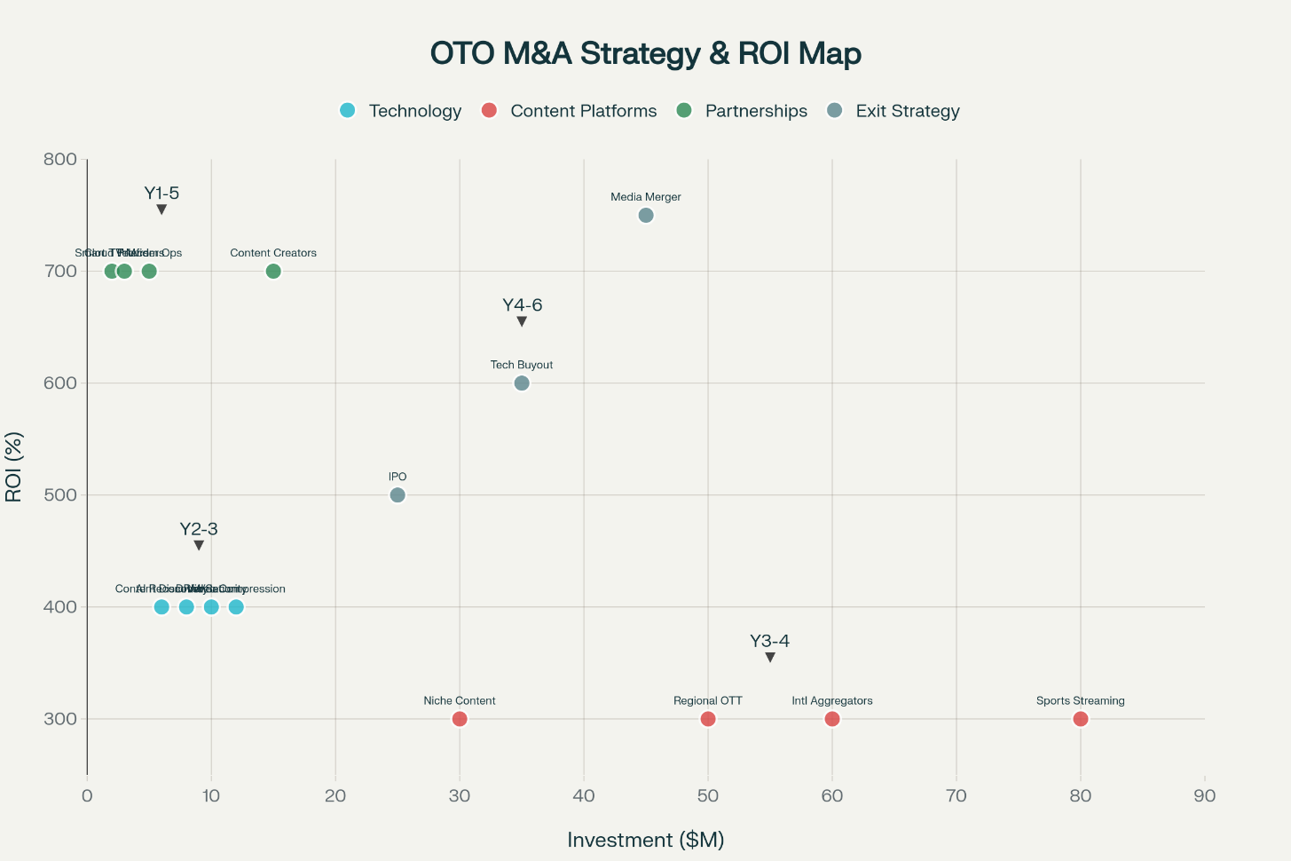
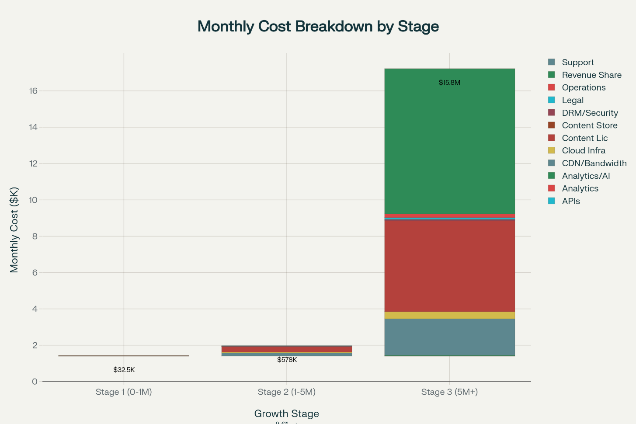
Key Highlights
💰 Total Investment: $87.5M over 5 years
📈 Revenue Target: $250M by Year 5
👥 Team Growth: 15 → 80+ people
🎯 User Base: 15M subscribers by Year 5
💡 Exit Valuation: $2.5B - $4B
Funding Breakdown:
- Pre-Seed: $500K (MVP development)
- Seed: $2M (OTOdummy launch)
- Series A: $10M (OTOwire development)
- Series B: $25M (OTOplay launch)
- Series C: $50M (market expansion)

