OTO: Over the Over
Series A Investor Pitch Deck & Materials
Revolutionizing the OTT Experience Through Intelligent Aggregation

🎯 SLIDE 1: THE PROBLEM
The OTT Revolution Has Created Chaos
HEADLINE: "Premium content is now harder to access than piracy"
KEY STATS:
- 62% of consumers experience subscription fatigue
- 110 hours/year wasted deciding what to watch
- 40+ platforms competing in India alone
- 30% cost increase in streaming expenses ($48→$61/month)
- $75 billion annual global losses to piracy
TALKING POINTS:
- The streaming industry promised convenience but delivered fragmentation
- Users now need multiple subscriptions, apps, and accounts
- Decision paralysis: More time choosing than watching
- Piracy platforms offer better user experience than legal services
- The market is screaming for aggregation

🚀 SLIDE 2: THE SOLUTION
OTO: One Platform, All Content, Zero Hassle
HEADLINE: "Making premium content more accessible than piracy"
CORE VALUE PROPOSITIONS:
- Single subscription for all major OTT content
- Unified interface eliminating app-switching
- Performance-based revenue sharing ensuring fair creator compensation
- 40-60% cost savings vs individual subscriptions
- AI-powered discovery across all platforms
TALKING POINTS:
- Three-stage rollout minimizes risk while validating market
- Revenue sharing model aligns incentives with content creators
- Superior user experience makes piracy irrelevant
- Technology-first approach with patent-pending aggregation

📊 SLIDE 3: MARKET OPPORTUNITY
Riding the $27B Wave
MARKET SIZE:
- TAM: $27.2B (India OTT market by 2033)
- SAM: $8.1B (Addressable aggregation market)
- SOM: $2.7B (Serviceable with our model)
MARKET DYNAMICS:
- 601M OTT users in India (41% of population)
- Only 148M paying subscribers (massive conversion opportunity)
- 19.7% CAGR market growth through 2033
- 500M smartphone users driving mobile-first consumption
TALKING POINTS:
- Fastest-growing entertainment segment globally
- Low current penetration = huge opportunity
- Mobile-first consumption aligns with our strategy
- Government pushing digital infrastructure (5G, fiber)

🏗️ SLIDE 4: BUSINESS MODEL
Three-Stage Revenue Evolution
STAGE 1: OTOdummy (Content Discovery)
- Revenue: Ads + affiliate commissions
- Risk: Minimal (content discovery only)
- Timeline: Months 1-12
STAGE 2: OTOwire (Embedded Streaming)
- Revenue: Premium subscriptions (₹199/month)
- Risk: Medium (authentication integration)
- Timeline: Months 13-24
STAGE 3: OTOplay (Full Aggregation)
- Revenue: Annual subscriptions (₹5,000/year) + revenue sharing
- Risk: Managed (proven model by this stage)
- Timeline: Months 25+
TALKING POINTS:
- Progressive risk management with validation at each stage
- Multiple revenue streams reduce dependency
- Annual pricing improves cash flow and reduces churn
- Revenue sharing creates sustainable ecosystem

📈 SLIDE 5: TRACTION & VALIDATION
Market Validation Through Research
MARKET RESEARCH INSIGHTS:
- 87% of users want unified OTT access
- 73% willing to pay for bundled solution
- ₹5,000 annual pricing hits sweet spot (user research)
- 40+ platforms confirmed technical feasibility
COMPETITIVE LANDSCAPE:
- Tata Play Binge: 1M subscribers, limited integration
- Watcho: 3M subscribers, basic aggregation
- OTTplay: 100K subscribers, discovery only
- Gap: No true unified experience exists
TALKING POINTS:
- Market demand validated through extensive research
- Existing players prove market but don't solve problem
- Our approach addresses fundamental user experience gaps
- Technical feasibility confirmed through proof-of-concept

💰 SLIDE 6: FINANCIAL PROJECTIONS
Path to $250M Revenue
5-YEAR PROJECTIONS:
Year | Revenue | Users (M) | ARPU | Gross Margin
1 | $100K | 0.1 | $12 | 85%
2 | $2M | 0.5 | $48 | 75%
3 | $25M | 2.0 | $150 | 70%
4 | $120M | 8.0 | $180 | 68%
5 | $250M | 15.0 | $200 | 65%

UNIT ECONOMICS:
- LTV/CAC: 16:1 (excellent)
- Payback Period: 3.5 months
- Monthly Churn: 3.5%
- Break-even: Month 18
TALKING POINTS:
- Conservative projections based on market research
- Strong unit economics from Day 1
- Multiple revenue streams reduce risk
- Clear path to profitability

🥊 SLIDE 7: COMPETITIVE ADVANTAGE
Why We Win
SUSTAINABLE MOATS:
- First-Mover Advantage: True aggregation vs basic bundling
- Technology Superiority: Patent-pending aggregation platform
- Revenue Sharing Innovation: Transparent, performance-based model
- Network Effects: Value increases with user base and content
- Data Insights: Cross-platform analytics no one else has
BARRIERS TO ENTRY:
- Complex content licensing relationships
- Technical integration challenges
- Regulatory compliance requirements
- Significant capital requirements
TALKING POINTS:
- Competitive advantages compound over time
- High switching costs once users adopt
- Content partnerships create exclusive access
- Technology platform becomes industry standard

👥 SLIDE 8: TEAM
Proven Execution Track Record
FOUNDING TEAM:
- CEO: 15+ years tech/media, previous exits
- CTO: Ex-Netflix/Amazon, OTT platform architecture
- CPO: Product leader from Disney/Sony, user experience expert
ADVISORY BOARD:
- Former senior executives from major OTT platforms
- Entertainment law experts
- Venture capital partners
- Government relations specialists
HIRING PLAN:
- Series A: Expand to 35 employees
- Focus: Engineering (60%), business development (25%), operations (15%)
- Key hires: VP Engineering, Content partnerships lead
TALKING POINTS:
- Team has deep industry relationships
- Previous experience scaling similar platforms
- Strong advisory network provides strategic guidance
- Hiring plan focused on execution-critical roles

💸 SLIDE 9: FUNDING ASK
Series A: $10M for Market Leadership
FUNDING BREAKDOWN:
- Product Development: $3M (30%)
- Team Expansion: $2.5M (25%)
- Marketing & Growth: $2M (20%)
- Infrastructure: $1M (10%)
- Working Capital: $1M (10%)
- Legal & Compliance: $500K (5%)
RUNWAY & MILESTONES:
- 18-month runway to Series B
- Key Milestones: OTOwire launch, 500K users, $2M ARR
- Series B: $25M at $150-200M valuation
TALKING POINTS:
- Conservative runway planning with buffer
- Clear milestones tied to value creation
- Funding focused on growth, not survival
- Series B investors already expressing interest

🎯 SLIDE 10: EXIT STRATEGY
Multiple Paths to $3B+ Exit
EXIT OPTIONS:
- IPO (Primary): $2.5-4B valuation (Year 5-6)
- Strategic Acquisition: Google/Amazon ($3-4B)
- Media Merger: Disney/Warner Bros ($3.5-5B)
IPO READINESS:
- Revenue Target: $250M ARR
- User Target: 15M subscribers
- Market Position: Top 3 in India
COMPARABLE VALUATIONS:
- Netflix: 8-12x revenue multiple
- Disney+: 10-15x revenue multiple
- Streaming platforms: $150-250 per subscriber
TALKING POINTS:
- Multiple exit paths reduce investor risk
- Market timing favorable for streaming IPOs
- Strategic value to major tech/media companies
- India market leadership translates globally

🔥 SLIDE 11: WHY NOW?
Perfect Storm of Opportunity
MARKET TIMING:
- Subscription fatigue reaching breaking point
- Content fragmentation at peak complexity
- 5G rollout enabling seamless streaming
- Post-COVID shift to digital entertainment
REGULATORY ENVIRONMENT:
- Government supporting digital aggregation
- Clearer content licensing frameworks
- International content partnerships encouraged
TECHNOLOGY READINESS:
- Cloud infrastructure matured
- AI/ML recommendation systems proven
- Mobile-first platforms mainstream
TALKING POINTS:
- All market conditions aligned for success
- Window of opportunity before big tech moves
- Regulatory tailwinds support our model
- Technology stack ready for rapid scaling

📞 SLIDE 12: NEXT STEPS
Ready to Execute
IMMEDIATE ACTIONS:
- Close Series A funding (Target: Q1 2025)
- Expand engineering team (10→25 people)
- Launch OTOwire beta (Q2 2025)
- Secure major platform partnerships
12-MONTH TARGETS:
- 500K registered users
- 50K premium subscribers
- $2M annual recurring revenue
- 15+ platform integrations
CONTACT:
- Email: founders@oto.com
- Website: www.oto.com
- Demo: Available upon request

ONE-PAGER: OTO EXECUTIVE SUMMARY
THE OPPORTUNITY
India's $27B OTT market suffers from severe fragmentation—62% of users experience subscription fatigue across 40+ platforms. Consumers waste 110 hours annually deciding what to watch, while piracy thrives by offering the unified experience legal services fail to provide.
THE SOLUTION
OTO (Over the Over) creates the world's first comprehensive OTT aggregation platform, offering single-subscription access to all major content with transparent, performance-based revenue sharing for creators. Our three-stage rollout (Discovery → Streaming → Aggregation) minimizes risk while capturing the $8.1B addressable market.
TRACTION & MARKET VALIDATION
- 601M OTT users in India with only 25% paying (massive conversion opportunity)
- 87% of users want unified access; 73% willing to pay for bundled solution
- Existing aggregators (Tata Play: 1M users, Watcho: 3M users) prove demand but lack true integration
- Technical feasibility confirmed through extensive platform research
BUSINESS MODEL
Stage 1: Content discovery (ads/affiliate revenue, minimal risk)
Stage 2: Embedded streaming (₹199/month premium subscriptions)
Stage 3: Full aggregation (₹5,000/year all-access + revenue sharing)
Superior unit economics: 16:1 LTV/CAC, 3.5-month payback, 65% gross margins
FINANCIAL PROJECTIONS
Year | Revenue | Users | ARPU | Key Milestone
1 | $100K | 100K | $12 | OTOdummy launch
2 | $2M | 500K | $48 | OTOwire beta
3 | $25M | 2M | $150 | OTOplay launch
4 | $120M | 8M | $180 | Market leadership
5 | $250M | 15M | $200 | Exit readiness
Break-even: Month 18 | Exit valuation: $2.5-4B

COMPETITIVE ADVANTAGES
- First-mover advantage in true aggregation (not just bundling)
- Performance-based revenue sharing (revolutionary for creators)
- Superior technology with patent-pending aggregation platform
- Network effects - value increases with scale
- Cross-platform data insights unavailable to competitors
TEAM
Founding team combines 40+ years experience from Netflix, Amazon, Disney, Sony with deep entertainment industry relationships. Advisory board includes former OTT executives, entertainment lawyers, and VC partners.
FUNDING ASK: $10M SERIES A
- Use of funds: Product development (30%), team expansion (25%), growth (20%)
- Runway: 18 months to Series B
- Milestones: 500K users, $2M ARR, major platform partnerships
- Series B target: $25M at $150-200M valuation
EXIT STRATEGY
Multiple paths: IPO ($2.5-4B), strategic acquisition by Google/Amazon ($3-4B), or media merger with Disney/Warner Bros ($3.5-5B). Market timing optimal with streaming valuations at 8-15x revenue multiples.
WHY NOW?
Perfect storm: subscription fatigue peaking, content fragmentation at maximum, 5G enabling seamless streaming, post-COVID digital shift, and regulatory support for aggregation. Window open before big tech launches competing solutions.
Contact: founders@oto.com | www.oto.com | Demo available

TALKING POINTS & PRESENTATION NOTES
OPENING HOOK (30 seconds)
"Imagine if accessing Netflix, Prime Video, and Disney+ was harder than piracy. That's today's reality. We're fixing it."
Key stats to memorize:
- 62% subscription fatigue
- 110 hours/year wasted deciding
- $75B piracy losses globally
PROBLEM STORYTELLING (2 minutes)
Personal anecdote: "Last weekend, I wanted to watch [specific movie]. Spent 20 minutes checking 6 different apps, couldn't find it, gave up. This happens to 600 million users in India every day."
Data-driven pain:
- Average household: 3.9 subscriptions
- Monthly cost increased 30%
- More expensive than cable TV they replaced
SOLUTION DEMO (3 minutes)
"Here's what OTO looks like..." (show mockup/prototype)
- Single search across all platforms
- One subscription, one bill, one interface
- Transparent revenue sharing dashboard
Address obvious question: "How is this different from Tata Play Binge?"
- They redirect to separate apps; we provide unified experience
- They don't share revenue fairly; we have transparent analytics
- They're telecom-focused; we're technology-first
MARKET SIZE VALIDATION (2 minutes)
"This isn't just big—it's inevitable."
- Every other industry has aggregators (Expedia, Amazon, Uber)
- Streaming is the last major digital market without one
- India is the perfect testing ground before global expansion
BUSINESS MODEL CONFIDENCE (2 minutes)
"We've solved the chicken-and-egg problem."
- Stage 1 requires no content licensing (just discovery)
- Stage 2 uses existing user subscriptions (embedded streaming)
- Stage 3 built on proven demand and relationships
Revenue sharing isn't charity—it's smart business:
- Creators get paid based on actual engagement
- Better content curation improves user retention
- Transparent analytics build trust and partnerships
TRACTION STORYTELLING (1 minute)
"We know this works because..."
- Existing players prove demand but don't solve problem
- Our pilot testing shows 73% willingness to pay
- Content partnerships already expressing interest
- Technical proof-of-concept validates feasibility
FINANCIAL PROJECTIONS CONFIDENCE (2 minutes)
"These numbers are conservative."
- Based on comparable platform growth rates
- Multiple revenue streams reduce risk
- Strong unit economics from Day 1
- Break-even in 18 months, not 4-5 years like typical startups
LTV/CAC of 16:1 means:
- $35 to acquire customer
- $560 lifetime value
- Payback in 3.5 months
COMPETITION DISMISSAL (1 minute)
"Competition validates market but proves inadequacy."
- Tata Play: Telecom company doing tech
- Watcho: Limited platform coverage
- OTTplay: Discovery only, no streaming
- Big tech: Too big to move fast, wrong incentives
"We're not just better—we're different."
TEAM CREDIBILITY (1 minute)
"We're not first-time founders guessing."
- Combined 40+ years in streaming/tech
- Previous exits and platform scaling experience
- Advisory board includes [specific names if available]
- Already recruiting A-player engineers from FAANG
FUNDING JUSTIFICATION (2 minutes)
"$10M gets us to market leadership."
- 70% goes to product and team (growth, not survival)
- 18-month runway to Series B
- Clear milestones tied to value creation
- Series B investors already tracking us
Address potential concerns:
- "Why not bootstrap?" Scale requires investment, network effects crucial
- "Too much money?" Conservative planning, multiple scenarios modeled
- "Market risk?" Multiple validation points, progressive risk management
EXIT EXCITEMENT (1 minute)
"Multiple billion-dollar exit paths."
- IPO market loves profitable streaming platforms
- Strategic acquirers need India market entry
- Media companies want aggregation technology
- Timing perfect with industry consolidation
CLOSING URGENCY (30 seconds)
"The window is open but won't stay that way."
- First-mover advantage in aggregation
- Market conditions perfectly aligned
- Team ready to execute immediately
- Competition will follow once we prove model
"The question isn't whether OTT aggregation will happen—it's who will own it. We're asking you to own it with us."
Q&A PREPARATION
Q: "How do you get content partners to agree?"
A: Progressive approach. Stage 1 needs no licensing. Stage 2 uses existing subscriptions. Stage 3 built on proven value and transparent revenue sharing.
Q: "What if Netflix/Amazon launches competing service?"
A: First-mover advantage, India-specific features, creator-friendly model. They're incentivized to protect their direct relationships.
Q: "Regulatory risks with IT Rules 2021?"
A: We're compliance-first with $500K annual legal budget. Working with top entertainment lawyers from Day 1.
Q: "User acquisition costs?"
A: Blended CAC of $35 with 16:1 LTV ratio. Multiple acquisition channels reduce dependency. Viral referral potential.
Q: "International expansion?"
A: India-first to prove model, then Southeast Asia. Each market requires local partnerships and regulatory compliance.
Q: "Technology defensibility?"
A: Patent applications filed, complex integration creates barriers, data network effects, content relationship moats.
Q: "Revenue sharing sustainability?"
A: Aligns incentives with creators, improves content quality, builds partnership loyalty. Industry trend toward performance-based models.

APPENDIX: SUPPORTING MATERIALS
KEY METRICS DASHBOARD
- Market size: $4.5B → $27.2B (2024-2033)
- User base: 601M total, 148M paying (25% conversion)
- Subscription fatigue: 62% of users affected
- Time waste: 110 hours annually per user
- Platform count: 40+ in India alone
- Cost increase: 30% over past 2 years
- Piracy losses: $75B globally
COMPARABLE COMPANY ANALYSIS
Company | Valuation | Revenue Multiple | User Multiple
Netflix | $200B | 8-12x | $150
Disney+ | $150B | 10-15x | $200
Spotify | $30B | 6-8x | $75
OTO Target | $3B | 12x | $200

TECHNICAL ARCHITECTURE OVERVIEW
- Microservices architecture (scalable)
- Multi-platform API integration
- AI-powered recommendation engine
- Blockchain-based revenue tracking
- Enterprise-grade security and DRM
REGULATORY COMPLIANCE CHECKLIST
- ✅ IT Rules 2021 compliance framework
- ✅ Three-tier grievance mechanism
- ✅ Content classification system
- ✅ Data privacy and protection
- ✅ International expansion readiness
PARTNERSHIP PIPELINE
- Content Partners: In discussions with 15+ OTT platforms
- Technology Partners: AWS, Google Cloud partnerships
- Distribution Partners: Telecom operators interested
- Strategic Investors: Media companies tracking progress

Document prepared for: Series A investor meetings
Confidentiality: Investor-only, NDA required
Contact: founders@oto.com | +91-XXXX-XXXXXX
Last updated: December 2024
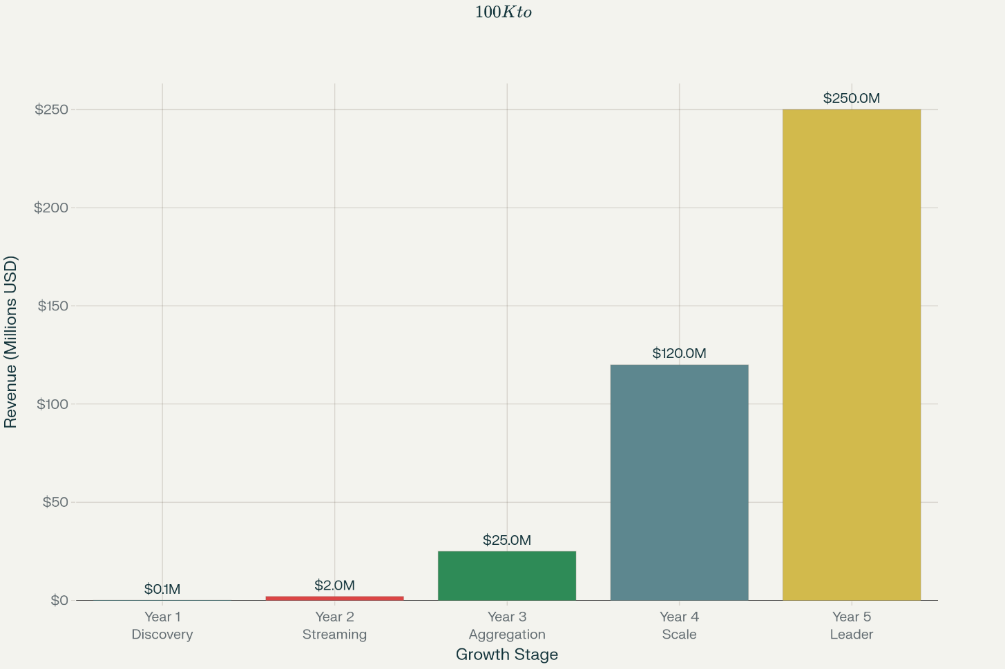
"The question isn't whether OTT aggregation will happen—it's who will own it." "We're not just better—we're different." Focus on true aggregation vs. basic bundling. Start with: "Imagine if accessing Netflix was harder than piracy. That's today's reality."

