12303277
Rai Singh
SET ‘A’
A develpoer is building a java based app and wants to contanarize using docker . the application should be accessible from the host system and most comunicate with another service container , data is generated by the application should presist even if the container is removed.
Create a dockerfile for a java app using : from, workdir,copy, run,cmd, expose
build image
create custom network bridge
run two container
implement port mapping
use named volume
demonstrate copy-on-write
list and explain image layer

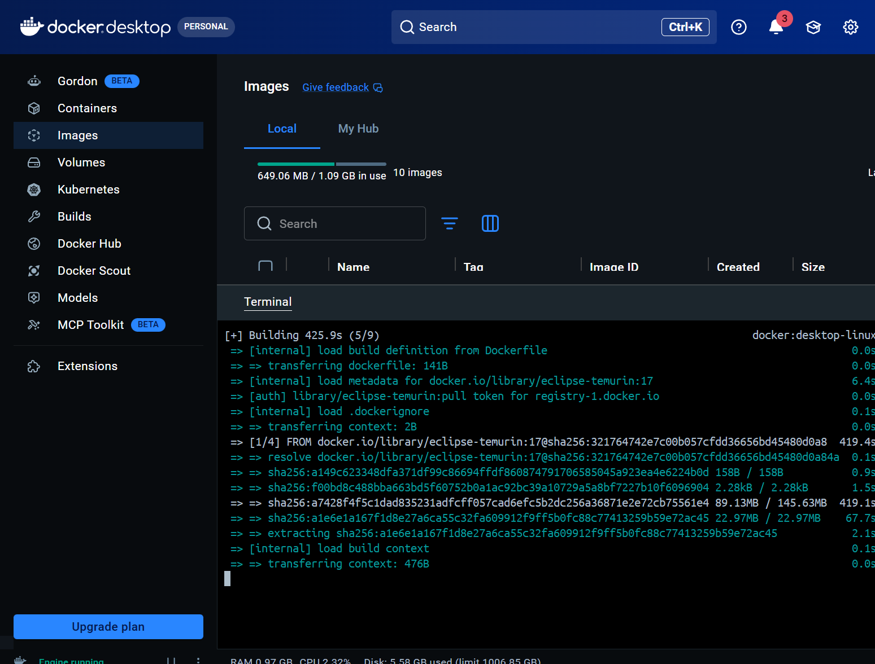

https://drive.google.com/drive/folders/1Rjjli6c04anbmhDNavnC3HHqKxWWXLYW?usp=drive_link

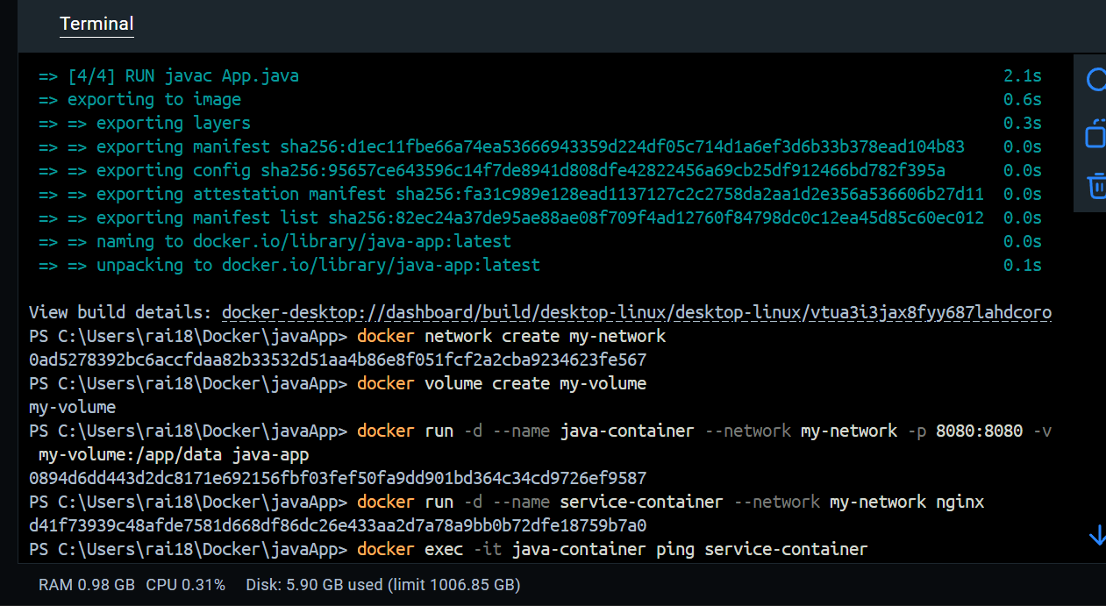

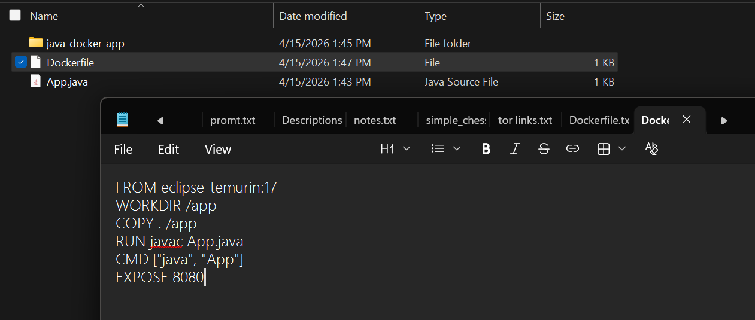
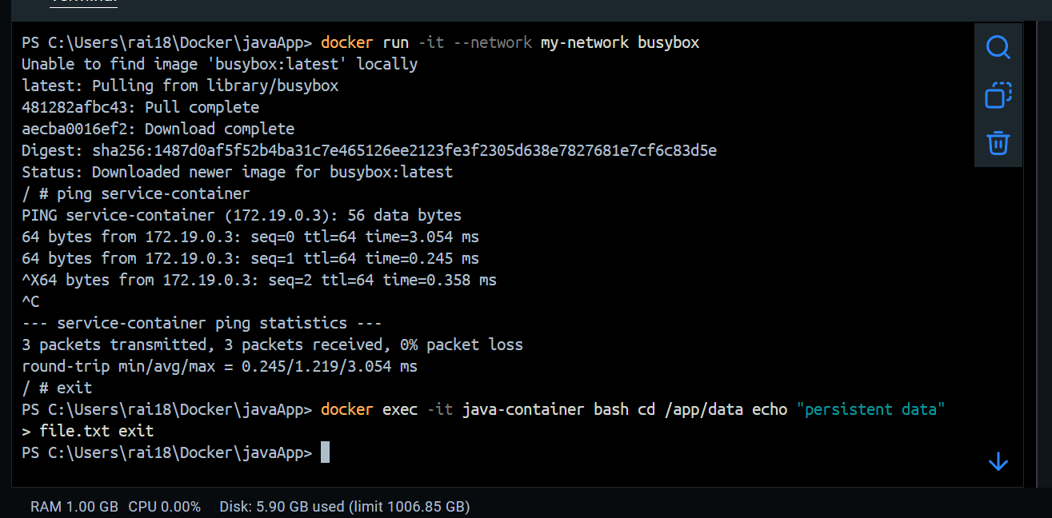

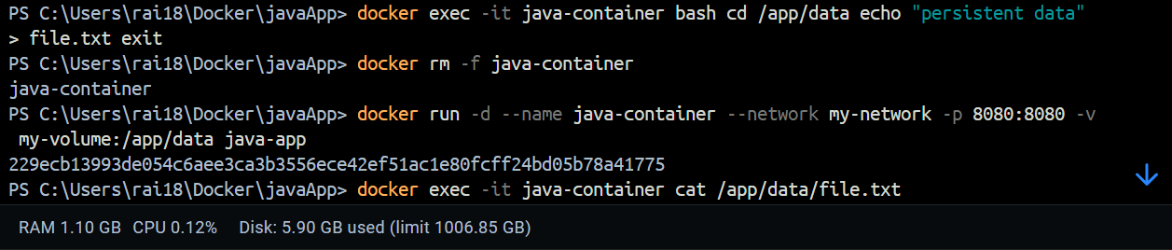

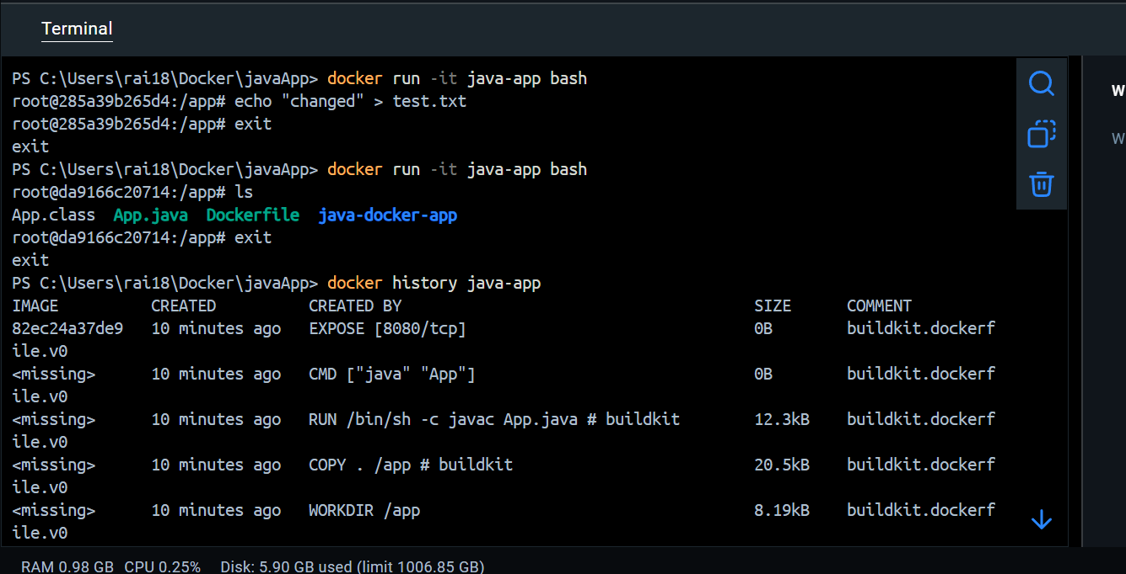

explantion of image layer
FROM openjdk:17
- FROM openjdk:17
Java instaled
WORKDIR /app
Creates working dir
COPY . /app
Copies project filos
RUN javac App.java
Compiles Java code
CMD ["java", "App"]
Default exe cmd
EXPOSE 8080
port info

