User input Prompt: Write a Python script to sort my dataset fast.
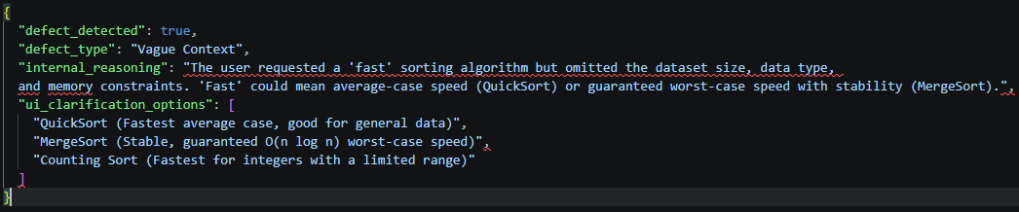
Write a Python script to sort a dataset using Merge Sort, prioritizing a stable algorithm with a guaranteed worst-case time complexity of O(n log n). Provide the complete code and complexity analysis.

