Chapter 1

INTRODUCTION

1.1 AI-based Scientific Research Assistance
Lung cancer is one of the most serious and life-threatening diseases worldwide and remains a leading cause of cancer-related deaths. The primary reason for the high mortality rate is the *late detection of the disease*, which significantly reduces treatment effectiveness and survival chances. Early identification of individuals who are at high risk of developing lung cancer is therefore crucial for improving diagnosis, enabling preventive measures, and increasing survival rates.

Recent advancements in *Artificial Intelligence (AI), Machine Learning (ML), and Deep Learning (DL)* have opened new possibilities for assisting medical diagnosis and disease prediction. These technologies can analyze large healthcare datasets and identify hidden patterns that may not be easily recognized through traditional clinical analysis. By examining patient health indicators such as smoking habits, respiratory symptoms, and lifestyle factors, predictive models can estimate the likelihood of lung cancer occurrence.

Over the past decade, machine learning techniques have evolved from basic statistical models to advanced algorithms capable of handling complex healthcare data. Classical machine learning models such as *Decision Trees, Random Forests, Support Vector Machines, and K-Nearest Neighbors* have been widely applied for medical prediction tasks. In addition, *Deep Learning models*, particularly neural networks, have demonstrated strong capabilities in capturing complex relationships among multiple medical features.

In recent years, *Quantum Machine Learning (QML)* has emerged as a promising research area that combines principles of quantum computing with machine learning algorithms. Quantum models such as *Quantum Neural Networks (QNN)* have the potential to improve computational efficiency and pattern recognition capabilities for certain complex problems. However, the practical performance and advantages of QML models compared with classical ML and DL approaches in healthcare applications are still under active investigation.

With the increasing availability of healthcare data and computational resources, there is a growing need to develop *integrated systems that can evaluate and compare different predictive techniques in a practical environment*. A full-stack implementation that connects data processing, model training, prediction, and user interaction can make such systems accessible and useful for real-world applications.

Therefore, this project focuses on developing a *full-stack lung cancer risk prediction system* that utilizes machine learning, deep learning, and quantum machine learning techniques. The system aims to analyze patient health data, compare different predictive models, and provide a web-based platform where users can input health parameters and receive lung cancer risk predictions. This approach contributes toward improving early risk assessment and demonstrating the potential of advanced AI technologies in healthcare analytics.

1.1.1 Overview
Due to the intense and rapid growth in the number of scientific publications, keeping up with new developments in one’s area of research has become increasingly difficult for researchers. Each year thousands of research papers are published, which makes the literature review and knowledge extraction processes become increasingly complex and time-consuming. As a result, researchers have many pain points when it comes to finding the right information, identifying research gaps, and creating new ideas efficiently.
Artificial intelligence technologies which include retrieval-augmented generation and large language models enable researchers to automate new parts of their research workflow. The technologies enable users to obtain pertinent research documents which they can study to create valuable summaries and insights. The proposed system will assist researchers in creating and assessing research hypotheses through the combined use of these technologies and scientific validation methods.

1.2 Real world relevance
Many healthcare systems and medical research institutions face the challenge of *early detection and risk assessment of lung cancer*, which remains one of the leading causes of cancer-related deaths worldwide. Traditional diagnostic methods such as CT scans, biopsies, and clinical evaluations require specialized medical equipment and trained professionals. These procedures are often expensive and time-consuming, making large-scale early screening difficult, especially in developing healthcare systems.
With the increasing availability of healthcare data, *Artificial Intelligence (AI) techniques such as Machine Learning (ML) and Deep Learning (DL)* are being widely explored to support medical diagnosis and disease risk prediction. These technologies can analyze complex patient data, including lifestyle factors, medical history, and symptoms, to identify patterns associated with lung cancer risk. Predictive models can assist healthcare professionals in identifying high-risk individuals earlier, enabling preventive screening and timely medical intervention.
.

1.3 Current challenges and limitations

Despite advancements in *Machine Learning (ML), Deep Learning (DL), and Quantum Machine Learning (QML)*, several challenges still exist in lung cancer risk prediction systems.

One major challenge is the *limited availability and quality of healthcare datasets*. Medical data often contains missing values, inconsistent records, and smaller sample sizes, which can affect the accuracy and reliability of predictive models.

Another limitation is the *variation in performance among different models*. Classical ML algorithms work well with structured datasets, while DL models require large amounts of data and higher computational resources for effective training.

The use of *Quantum Machine Learning (QML)* also faces challenges because quantum computing technology is still in its early stages. Current quantum hardware has limitations such as limited qubits and noise, which restrict practical large-scale implementation.

Additionally, many existing studies focus on *only one modeling approach, and there is limited work that compares **ML, DL, and QML models within a unified system*. This makes it difficult to identify the most effective technique for lung cancer risk prediction.

1.4 Organization of the report

Each chapter gives an overview concerning the purpose of this project; Chapter 1 provides background, significance, and related challenges in the area of Artificial Intelligence (AI) for Research Assistance. Chapter 2 provides literature reviews on prior published works. Chapter 3 presents details regarding the project Problems and Goals.

The project document requirements are discussed in Chapter 4. The Project Methodology and
Architecture of the Proposed System are presented in Chapter 5. System Design Diagrams are displayed in Chapter 6. Chapter 7 includes information about the Execution of the Project. The outcome of the project is reported in Chapter 8. The conclusion of the report along with recommendations for future work is presented in Chapter 9.

Chapter 2

LITERATURE REVIEW

2.1 Review of existing research work

Deep learning and machine learning models have demonstrated significant success in healthcare applications, particularly in disease prediction and medical data analysis. These models can analyze large volumes of patient data to identify complex patterns associated with diseases such as Lung Cancer. However, building accurate predictive systems requires well-structured datasets, effective feature selection, and robust model training. Researchers have therefore explored various machine learning and deep learning techniques to improve prediction accuracy and early diagnosis capabilities.
Traditional approaches in Machine Learning include algorithms such as Decision Trees, Random Forests, Support Vector Machines, and K-Nearest Neighbors, which are widely used for structured medical datasets. These models analyze clinical and lifestyle factors such as smoking habits, breathing problems, and chest pain to estimate lung cancer risk. In recent years, advancements in Deep Learning have enabled the use of neural networks that can automatically learn complex relationships among medical variables, often achieving higher predictive performance when sufficient training data is available.
.More recently, researchers have begun exploring Quantum Machine Learning, an emerging field that combines principles of Quantum Computing with machine learning techniques. Quantum models such as Quantum Neural Networks aim to leverage quantum properties like superposition and entanglement to improve computational efficiency and pattern recognition. Although still in early development, QML has shown promising potential for handling complex optimization and classification problems in healthcare analytics.

2.2 Comparative Analysis
This section compares methodologies used in prior work.
Table 2.1 Comparative analysis

Sl.  No. | Title & Author | Methodology/ Approach | Key Contribution | Research Gap  identified | Suggestive enhancements
1 | Lung Cancer Prediction using ML – Various Authors (2021) | Decision Tree and Random Forest | Demonstrated that ML models can predict lung cancer risk using patient symptoms and lifestyle data | Limited dataset size and fewer algorithms evaluated | Use larger datasets and include additional ML models
2 | Lung Cancer Detection using Deep Learning – Researchers (2022) | using Deep Learning – Researchers (2022)  Convolutional Neural Networks (CNN) | Achieved improved prediction accuracy using deep neural networks | Requires large labeled datasets and high computation | Apply optimization techniques and hybrid models
3 | Comparative Study of ML Algorithms for Disease Prediction – Authors (2020) | SVM, KNN, Random Forest | Provided comparative evaluation of different ML models | Limited focus on deep learning approaches | Integrate DL models for improved performance
4 | AI-based Lung Cancer Prediction System – Researchers (2023) | Multiple ML algorithms with healthcare data | Demonstrated early disease risk prediction using AI models | Lack of integrated full-stack implementatio | Develop web-based prediction platforms

5 | Deep Learning Applications in Healthcare – Authors (2022) | Neural Network based models | Showed DL capability to capture complex medical data patterns | Requires high-quality training data | Improve data preprocessing and feature selection
6 | Hybrid ML Models for Medical Prediction – Researchers (2021) | Combination of ML classifiers | Improved accuracy through ensemble methods | Limited evaluation on lung cancer datasets | Apply hybrid models on lung cancer prediction tasks
7 | Quantum Machine Learning for Medical Diagnosis – Authors (2024) | Quantum Neural Networks (QNN) | Introduced QML models for healthcare classification problems | Quantum hardware limitations | Develop hybrid classical–quantum models
8 | AI in Lung Cancer Risk Assessment – Researchers (2022) | ML models with risk factor analysis | Identified important lifestyle and health indicators for prediction | Limited model comparison | Evaluate multiple ML and DL techniques
9 | Machine Learning in Medical Data Analysis – Researchers (2021) | Data mining and ML techniques | Demonstrated predictive analysis in healthcare systems | Lack of real-time prediction systems | Integrate ML models with web-based applications

Research Gap
Based on the literature review, several significant research gaps have been identified in the application of artificial intelligence for predicting Lung Cancer.
Gap 1: Limited comparative analysis of ML, DL, and QML models
Most existing studies focus only on traditional Machine Learning models such as Decision Trees, Random Forests, or Support Vector Machines. Although some research explores Deep Learning approaches, very few studies compare ML, DL, and Quantum Machine Learning methods within a unified framework. This makes it difficult to determine the most effective model for lung cancer risk prediction.
Gap 2: Limited availability of high-quality healthcare datasets
Accurate prediction models require large and well-structured medical datasets. However, many studies rely on small or incomplete datasets, which may lead to reduced prediction accuracy and poor generalization. There is a need for improved data preprocessing and feature selection methods to enhance model reliability.
Gap 3: High computational requirements for advanced models
Deep learning models often require high computational power and large training datasets. Similarly, quantum machine learning models are still limited by current quantum hardware capabilities. Efficient algorithms and optimized model architectures are needed to reduce computational complexity.
Gap 4: Lack of integrated full-stack healthcare prediction systems
Many studies focus only on model development and evaluation without implementing a practical system for real-world usage. There is limited research on integrating predictive models with user-friendly web applications that allow users or healthcare professionals to input patient data and obtain prediction results.
Gap 5: Limited real-world validation of emerging technologies
Although quantum machine learning shows promising potential, practical applications in healthcare prediction are still limited. More experimental studies comparing classical AI models with quantum-based models are required to evaluate their effectiveness in real-world healthcare scenarios.

Chapter 3

PROBLEM STATEMENT

3.1 Motivation
Recent advancements in artificial intelligence have enabled researchers to develop powerful predictive systems for healthcare applications. Techniques from Machine Learning and Deep Learning have shown great potential in analyzing medical data and identifying patterns that may indicate the risk of diseases such as Lung Cancer. Early detection of lung cancer is extremely important because the chances of successful treatment increase significantly when the disease is identified at an early stage.
Despite these advancements, many existing healthcare prediction systems rely on a limited number of algorithms and often lack comprehensive comparison among different artificial intelligence approaches. Traditional machine learning models work well for structured medical datasets, while deep learning models can capture complex relationships between multiple health factors. However, these approaches often require careful model selection, sufficient training data, and efficient computational resources.
The motivation for this project is therefore to develop an intelligent system that can analyze health-related data and provide early risk prediction for lung cancer using multiple AI approaches. By integrating and comparing ML, DL, and QML models within a single framework, the proposed system aims to improve prediction accuracy while providing a practical full-stack platform where users can input health parameters and receive prediction results.
3.2 Problem Definition
Early detection of diseases plays a critical role in improving treatment outcomes and reducing mortality rates. In the case of Lung Cancer, delayed diagnosis significantly reduces the chances of effective treatment. Traditional diagnostic approaches depend heavily on clinical examinations, imaging techniques, and expert medical analysis, which can be time-consuming and expensive. Therefore, there is a growing need for intelligent systems that can assist in predicting lung cancer risk at an early stage using patient health data.
Recent developments in Machine Learning and Deep Learning have shown promising results in healthcare prediction tasks. These models can analyze multiple health indicators such as smoking habits, respiratory symptoms, and lifestyle factors to identify patterns associated with lung cancer risk. However, many existing systems rely on a limited number of algorithms and do not provide a comprehensive comparison between different artificial intelligence techniques.

Objectives
The objectives of the proposed work are:
- To develop an intelligent prediction system for early detection of Lung Cancer using patient health and lifestyle data.
- To implement and analyze different predictive models based on Machine Learning algorithms such as Decision Tree, Random Forest, and Support Vector Machine.
- To design and train advanced models using Deep Learning techniques to capture complex relationships among health parameters.
- To explore the application of Quantum Machine Learning models and evaluate their potential for healthcare prediction tasks.
- To compare the performance of ML, DL, and QML models using evaluation metrics such as accuracy, precision, recall, and F1-score.
- To develop a full-stack web-based system that allows users to input health parameters and obtain lung cancer risk prediction results.

3.4 Scope of the project
The project focuses on developing an intelligent prediction system for assessing the risk of Lung Cancer using patient health and lifestyle data. The system applies different artificial intelligence techniques to analyze factors such as smoking habits, respiratory symptoms, and other health indicators that may contribute to lung cancer risk.The scope of the project includes implementing predictive models based on Machine Learning algorithms and advanced models using Deep Learning techniques. In addition, the project explores the use of Quantum Machine Learning to understand its potential advantages in medical prediction tasks.
Another important aspect of the project is the development of a full-stack web-based system where users can enter health-related parameters and obtain lung cancer risk prediction results. The system integrates data preprocessing, model training, prediction, and result visualization in a single platform.
The project mainly focuses on model development, comparison, and system implementation using available healthcare datasets. However, the system is designed for research and educational purposes and does not replace professional medical diagnosis. Future improvements may include integration with larger clinical datasets, real-time healthcare systems, and advanced predictive models to further enhance accuracy and usability.

Chapter 4

SYSTEM REQUIREMENTS SPECIFICATION
This chapter describes the software requirements necessary for the successful design and implementation of the proposed lung cancer prediction system. The system applies techniques from Machine Learning, Deep Learning, and Quantum Machine Learning to analyze health-related data and predict the risk of Lung Cancer.
The chapter specifies both functional and non-functional requirements of the system and outlines the hardware and software environment required for development and execution. These requirements ensure that the system operates efficiently, reliably, and achieves the intended objectives.

4.1 Functional requirements
Functional requirements describe the core operations that the system must perform.

Data Input
The system should allow users to input health-related parameters such as smoking habits, breathing difficulty, chest pain, coughing, fatigue, and other relevant indicators. These inputs will be used for prediction.

Data Preprocessing
The system should preprocess the input dataset before model training. This includes handling missing values, data normalization, feature selection, and converting the data into a suitable format for model training.
Model Training
The system should train predictive models using historical healthcare datasets. Different algorithms from machine learning and deep learning should be implemented to learn patterns associated with lung cancer risk.
Model Comparison
The system should evaluate and compare multiple prediction models based on performance metrics such as accuracy, precision, recall, and F1-score.

Prediction Module
The system should allow users to input patient data and generate a prediction indicating the risk level of.

4.2 Non-functional requirements
Non-functional requirements define the quality attributes and operational constraints of the system.

Performance Requirements
The system should process input data and generate prediction results within a reasonable time. Model training and prediction processes should be efficient.

Security Constraints
The system should ensure secure handling of healthcare data and prevent unauthorized access or modification of datasets.

Scalability
The system should be capable of handling larger healthcare datasets in the future without significant reduction in performance.

Usability
The system should provide a simple and user-friendly interface so that users can easily enter data and understand prediction results.

Reliability
The system should provide consistent and accurate prediction results when used multiple times with different input values.

Maintainability
The system should be designed in a modular way so that future improvements, such as adding ne

4.3 Operating environment
The operating system for the proposed system determines the required hardware and software configuration to enable efficient development and execution of the proposed system. The system has been created for use on a single computer, with sufficient processing power and memory resources available to support machine learning models and data processing.

4.3.1 Hardware Specifications
- The following list provides minimum hardware requirements which developers need to build and run the proposed system.
- The processor needs to function with at least four cores because it requires an Intel i5 processor or any higher multi-core CPU.
- The system requires a minimum of 8 GB RAM but 16 GB RAM serves as the most suitable option.
- Storage - At least 20 GB (depending on the size of machine learning algorithms) of available disk space.
- GPU - While GPU's are not required to use the proposed System, they could provide faster processing of AI models.
- Network - You will need an internet connection to download the necessary research papers from ArXiv through its API.
- Display - A standard monitor will be required to view and interact with the proposed System using Glimmer.

4.3.2 Software Requirements
- The proposed system requires these software components for its development and execution.
- The system requires an operating system which can run on Windows Linux and macOS platforms.
- The system requires Python software which must be version 3.10 or higher.
- The system needs these packages: PyMuPDF and Sentence Transformers and FAISS and NumPy and Pandas.
- Framework: Streamlit framework used to build the user interface
- Large-Scale Language Model: Mistral model with Argonian (Local LLM)
- API: arXiv API to access scientific articles
- IDE: Visual Studio Code or any other IDE for developing python applications
- Browser: Google Chrome, Microsoft Edge, or Firefox to access Streamlit UI

Chapter 5

PROPOSED METHODOLOGY

5.1 System Architecture
The proposed system architecture describes the overall workflow of the hybrid active learning framework designed to improve data efficiency in machine learning models. The architecture consists of multiple interconnected components that manage data processing, model training, sample selection, and iterative learning.
Initially, the system receives a dataset containing both labeled and unlabeled samples. The dataset is divided into two parts: a small labeled dataset used for initial training and a large pool of unlabeled data from which informative samples will be selected. Before training begins, the data preprocessing module performs operations such as cleaning, normalization, and feature extraction to prepare the dataset for model training.
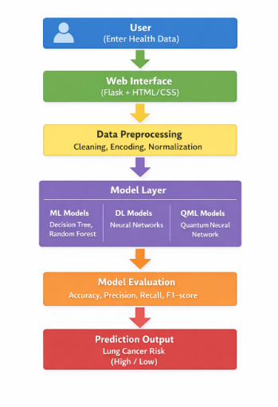
Fig 5.1 Overview of Architecture

5.2 Modules
This new system consists of several modularized components that will work in unison to automate both research analysis and hypothesis validation. The modules support individual tasks like identifying appropriate research papers, processing documents, generating research information, and providing evaluation for their hypotheses. Because the system's architecture has been broken into modules, the overall system will be more efficient, maintainable, and scalable.

5.2.1 Dataset Management Modul
This module is responsible for managing and organizing the datasets used in the active learning process. It maintains two separate datasets that are used during the training and sample selection stages.
- Labeled Dataset (L): This dataset contains samples that already have known labels and is used for training the machine learning or deep learning model. Initially, the labeled dataset is small and gradually increases as new samples are annotated during the active learning process.
- Unlabeled Dataset (U): This dataset contains samples without labels. The system analyzes these samples using query strategies to identify the most informative data points that should be selected for labeling and added to the labeled dataset.
Initially, a small subset of labeled data is used to train the model, while the remaining data forms the unlabeled pool.

5.3 Algorithms

The proposed system uses a Hybrid Active Learning Algorithm that combines uncertainty-based sampling and diversity-based selection to identify the most informative training samples. This approach helps the model focus on difficult and representative data points while avoiding redundant selections. The algorithm works in an iterative manner where the model is repeatedly trained, evaluated, and improved by selecting new samples from the unlabeled dataset. By selecting only the most valuable samples for labeling, the system reduces the dependency on large labeled datasets while maintaining high model performance..

Algorithm Name: Hybrid Active Learning Framework
Algorithm Type: Iterative supervised learning with intelligent sample selection

Algorithm Steps

- Initialize the labeled dataset L and unlabeled pool U from the available dataset.
- Train the machine learning or deep learning model using the labeled dataset L.
- Use the trained model to predict probabilities for all samples in the unlabeled pool U.
- Compute uncertainty scores for each sample in U to measure the model’s prediction confidence.
- Select the most uncertain samples using the primary query strategy ϕₚ(x) based on uncertainty sampling.
- Apply diversity-based selection using the secondary query strategy ϕᵩ(I) to ensure that the selected samples represent different regions of the dataset and avoid redundancy.
- Select the final batch S of samples according to the predefined batch size B.
- Label the selected samples through the annotation process.
- Update the datasets as follows:
  - L = L ∪ S (Add the selected samples to the labeled dataset)
  - U = U − S (Remove the selected samples from the unlabeled pool)
- Retrain the model using the updated labeled dataset L.
- Repeat the process until the stopping criteria such as maximum iterations or desired model accuracy are reached.
This hybrid algorithm improves data efficiency by selecting informative and diverse samples, which leads to better model learning while reducing labeling costs and computational effort.
16: Assign classification Λ ← "High Contradiction"
17: else if μ_ndi < (1 - t_ndi) then
18: Assign classification Λ ← "Low Novelty"
19: else
20: Assign classification Λ ← "Valid and Novel"
21: end if

Chapter 6

System Design

6.1 Use Case Diagram
The use case diagram illustrates the interaction between the user and the Lung Cancer Risk Prediction System. It represents how the user interacts with the system to obtain lung cancer risk predictions based on the provided health-related information.
The process begins when the user enters required medical or lifestyle data through the system interface. These inputs may include parameters such as age, smoking habits, alcohol consumption, air pollution exposure, and other relevant health indicators. Once the data is submitted, the system processes the input using the data preprocessing module, which performs operations such as data cleaning, normalization, and feature preparation.
After preprocessing, the processed data is passed to the prediction module where different models such as Machine Learning (ML), Deep Learning (DL), and Quantum Machine Learning (QML) algorithms are used to analyze the input data. These models evaluate the patterns and relationships within the dataset to determine the likelihood of lung cancer risk.

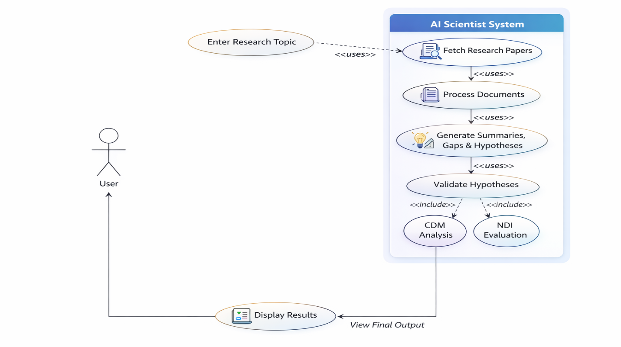
Figure 6.1: Sample use case diagram

6.1.1 Research Interaction Method

The research interaction method describes how the user interacts with the Lung Cancer Risk Prediction system to obtain risk analysis results. The process begins when the user accesses the system through the web interface and enters the required health-related information. These inputs may include parameters such as age, smoking habits, alcohol consumption, air pollution exposure, and other relevant medical or lifestyle factors associated with lung cancer risk.

Once the data is submitted, the system processes the input using the data preprocessing module. This module performs operations such as data cleaning, normalization, and feature preparation to ensure that the information is suitable for model analysis. The processed data is then forwarded to the prediction module.

The prediction module uses multiple models, including Machine Learning (ML), Deep Learning (DL), and Quantum Machine Learning (QML) algorithms, to analyze the input data and estimate the probability of lung cancer risk. These models evaluate patterns in the dataset and generate predictions based on the trained models.

After the analysis is completed, the system evaluates the results using performance metrics such as accuracy, precision, recall, and F1-score to ensure reliable predictions. Finally, the predicted lung cancer risk level is displayed to the user through the system interface, allowing users to understand their potential health risk and supporting early awareness for preventive healthcare.

6.2 Class Diagram
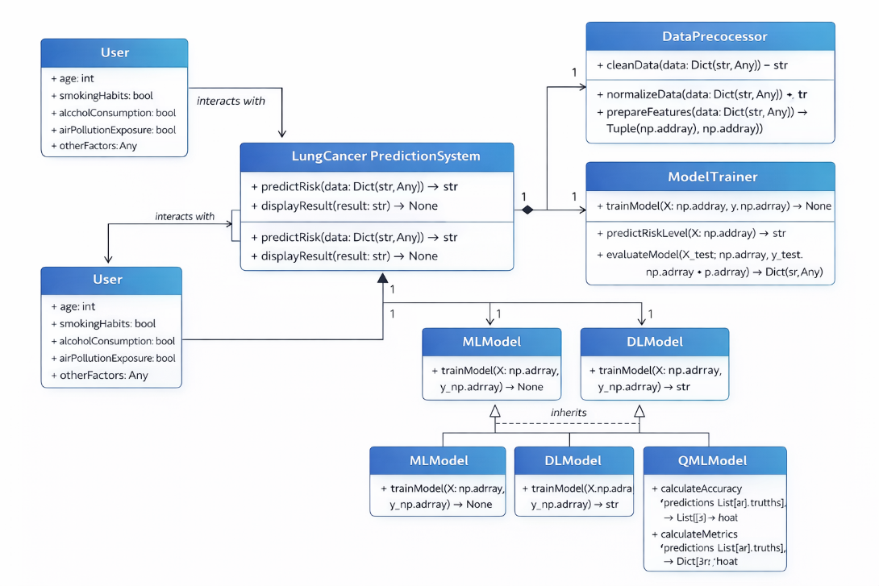
Fig 6.2: sample class diagram

6.3 Sequence Diagram
The sequence diagram represents the interaction between the user and the Lung Cancer Risk Prediction System during the prediction process. The user first enters personal and medical information such as age, smoking habits, alcohol consumption, air pollution exposure, and other health-related factors through the system interface.
After receiving the input, the system sends the data to the Data Preprocessing Module, where the dataset is cleaned, normalized, and converted into a suitable format for machine learning models. This step ensures that the data is consistent and ready for analysis.
Once preprocessing is completed, the processed data is forwarded to the Model Prediction Module, where trained Machine Learning, Deep Learning, or Quantum Machine Learning models analyze the input features. The model evaluates the risk factors and generates a prediction indicating the probability or risk level of lung cancer.
The predicted result is then passed to the Evaluation Module, which validates the prediction using performance metrics such as accuracy, precision, recall, and F1-score to ensure the reliability of the model.
Finally, the system displays the lung cancer risk prediction result to the user through the interface. This process allows the user to quickly understand their potential risk level based on the provided health information.
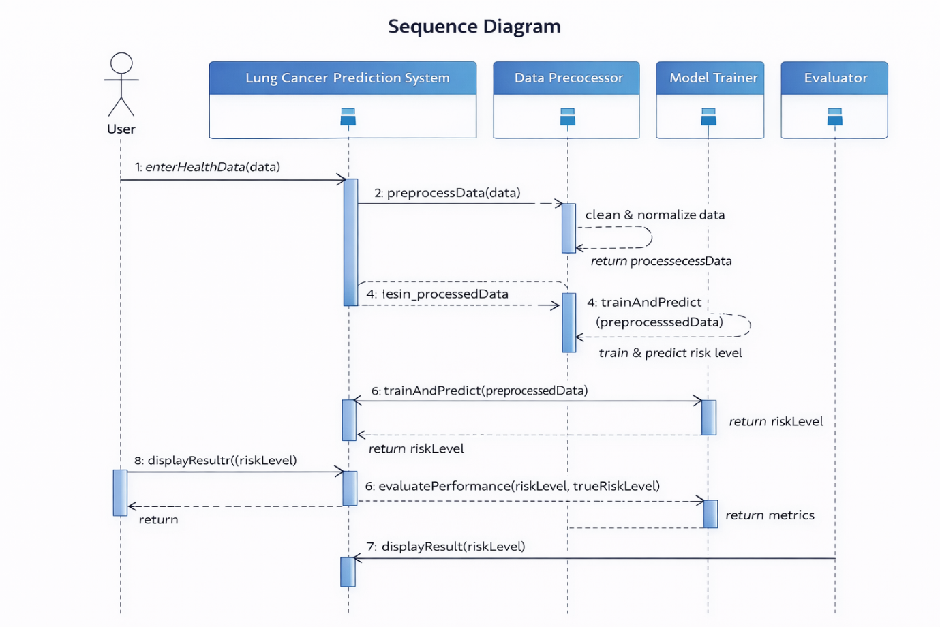
Fig 6.3: sample sequence diagram

