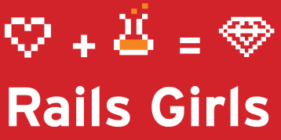

Date Day-Month-Year

To whom it may concern:

This is to certify that **Name Surname** volunteered as coach at the RAILS GIRLS event held in Galway, Ireland during the weekend dates-month-year.

Rails Girls is a workshop for girls who want to learn to build the web. During one weekend they learn to concept, code and ship a web application. Workshops happen worldwide. The coaches’ tasks consist of providing introductory lectures on software development with Ruby and Rails and helping the girls building their first web application.

<http://railsgirls.com/galway> Name Surname

Rails Girls Galway Co-Organizer

Signature