Semantic Priming and Stroop Effect: Data Analysis
Raima
2025-12-30

1. Setup and Data Loading

1.1 Load Raw Data
cat("=== Data Overview ===\n")
## === Data Overview ===
cat("Total participants:", n_distinct(data_raw$participant_id), "\n")
## Total participants: 39
cat("Total trials:", nrow(data_raw), "\n")
## Total trials: 18550
cat("Trials per participant:", nrow(data_raw) / n_distinct(data_raw$participant_id), "\n")
## Trials per participant: 475.641

1.2 Demographics
participant_demographics <- data_raw %>%
select(participant_id, age, gender) %>%
distinct()
demo_summary <- participant_demographics %>%
summarise(
N_participants = n(),
N_female = sum(gender == "Female", na.rm = TRUE),
N_male = sum(gender == "Male", na.rm = TRUE),
N_other_or_missing = sum(!gender %in% c("Female", "Male")),
Percent_female = round(sum(gender == "Female", na.rm = TRUE) / n() * 100, 1),
Mean_age = round(mean(age, na.rm = TRUE), 1),
Min_age = min(age, na.rm = TRUE),
Max_age = max(age, na.rm = TRUE),
Age_range = paste0(min(age, na.rm = TRUE), "-", max(age, na.rm = TRUE))
)
cat("=== Participant Demographics ===\n\n")
## === Participant Demographics ===
cat("Total Participants:", demo_summary$N_participants, "\n")
## Total Participants: 39
cat("Female:", demo_summary$N_female, "(", demo_summary$Percent_female, "%)\n")
## Female: 24 ( 61.5 %)
cat("Male:", demo_summary$N_male, "\n")
## Male: 15
if (demo_summary$N_other_or_missing > 0) {
cat("Other/Missing:", demo_summary$N_other_or_missing, "\n")
}
cat("\nAge Statistics:\n")
##
## Age Statistics:
cat("Mean age:", demo_summary$Mean_age, "years\n")
## Mean age: 20.9 years
cat("Age range:", demo_summary$Age_range, "years\n")
## Age range: 17-33 years

2. Data Preprocessing

2.1 Exclusion Criteria
data_filtered <- data_raw %>%
filter(
rt >= 0.2, # anticipatory responses (< 200ms)
rt <= 3.0 # very slow responses (> 3000ms)
)
data_clean_all <- data_filtered %>%
group_by(participant_id) %>%
mutate(
rt_z = scale(rt)[, 1],
outlier = abs(rt_z) > 3
) %>%
ungroup() %>%
filter(!outlier) %>%
mutate(
prime_type = factor(prime_type, levels = c("neutral", "congruent", "incongruent")),
participant_id = factor(participant_id),
trial_type = factor(trial_type, levels = c("stroop", "color_block"))
) %>%
select(-rt_z, -outlier)
data_stroop <- data_clean_all %>%
filter(trial_type == "stroop", correct == TRUE) %>%
mutate(stroop_type = factor(stroop_type, levels = c("congruent", "incongruent")))
data_colorblock <- data_clean_all %>%
filter(trial_type == "color_block")
data_colorblock_RT <- data_colorblock %>%
filter(correct == TRUE)

2.2 Exclusion Summary
exclusion_summary <- tibble(
Stage = c(
"Original trials",
"Incorrect responses",
"Too fast (< 200ms)",
"Too slow (> 3000ms)",
"Outliers (> 3 SD)",
"Final clean dataset"
),
N = c(
nrow(data_raw),
sum(data_raw$correct == FALSE),
sum(data_raw$rt < 0.2 & data_raw$correct == TRUE),
sum(data_raw$rt > 3.0 & data_raw$correct == TRUE),
nrow(data_filtered) - sum(data_filtered$correct == FALSE) - nrow(data_clean_all),
nrow(data_clean_all)
)
)
exclusion_summary <- exclusion_summary %>%
mutate(
Percentage = round(N / nrow(data_raw) * 100, 2)
)
kable(exclusion_summary, caption = "Data Exclusion Summary")
Data Exclusion Summary
Stage | N | Percentage
Original trials | 18550 | 100.00
Incorrect responses | 1221 | 6.58
Too fast (< 200ms) | 29 | 0.16
Too slow (> 3000ms) | 6 | 0.03
Outliers (> 3 SD) | -854 | -4.60
Final clean dataset | 18148 | 97.83

3. Descriptive Statistics

3.1 Overall Summary
desc_overall <- data_clean_all %>%
summarise(
N_trials = n(),
N_participants = n_distinct(participant_id),
Mean_RT_ms = round(mean(rt) * 1000, 1),
SD_RT_ms = round(sd(rt) * 1000, 1),
Median_RT_ms = round(median(rt) * 1000, 1),
Min_RT_ms = round(min(rt) * 1000, 1),
Max_RT_ms = round(max(rt) * 1000, 1),
Overall_Accuracy = round(mean(correct) * 100, 2),
SD_Accuracy = round(sd(correct) * 100, 2)
)
kable(desc_overall, caption = "Overall Descriptive Statistics")
Overall Descriptive Statistics
N_trials | N_participants | Mean_RT_ms | SD_RT_ms | Median_RT_ms | Min_RT_ms | Max_RT_ms | Overall_Accuracy | SD_Accuracy
18148 | 39 | 414.3 | 116.5 | 389 | 201.9 | 1320.5 | 93.6 | 24.48

3.2 RT by Condition (Stroop Trials Only)
rt_by_condition <- data_stroop %>%
group_by(stroop_type, prime_type) %>%
summarise(
n = n(),
Mean_RT_ms = round(mean(rt) * 1000, 1),
SD_RT_ms = round(sd(rt) * 1000, 1),
SE_RT_ms = round(sd(rt) * 1000 / sqrt(n()), 1),
.groups = "drop"
) %>%
arrange(stroop_type, prime_type)
kable(rt_by_condition, caption = "RT by Stroop Type and Prime Type (Correct Trials)")
RT by Stroop Type and Prime Type (Correct Trials)
stroop_type | prime_type | n | Mean_RT_ms | SD_RT_ms | SE_RT_ms
congruent | neutral | 1424 | 427.8 | 109.5 | 2.9
congruent | congruent | 1424 | 412.4 | 106.8 | 2.8
congruent | incongruent | 1402 | 423.8 | 118.8 | 3.2
incongruent | neutral | 1420 | 429.5 | 127.1 | 3.4
incongruent | congruent | 1401 | 422.5 | 126.4 | 3.4
incongruent | incongruent | 1393 | 422.8 | 122.3 | 3.3

3.3 Accuracy by Condition
acc_by_condition <- data_clean_all %>%
filter(trial_type == "stroop") %>%
group_by(stroop_type, prime_type) %>%
summarise(
n = n(),
Accuracy_pct = round(mean(correct) * 100, 2),
.groups = "drop"
) %>%
arrange(stroop_type, prime_type)
kable(acc_by_condition, caption = "Accuracy by Stroop Type and Prime Type")
Accuracy by Stroop Type and Prime Type
stroop_type | prime_type | n | Accuracy_pct
congruent | neutral | 1505 | 94.62
congruent | congruent | 1521 | 93.62
congruent | incongruent | 1512 | 92.72
incongruent | neutral | 1503 | 94.48
incongruent | congruent | 1506 | 93.03
incongruent | incongruent | 1513 | 92.07

4. Baseline Stroop Effect Validation

4.1 Stroop Effect Test
stroop_neutral_means <- data_stroop %>%
filter(prime_type == "neutral") %>%
group_by(participant_id, stroop_type) %>%
summarise(mean_rt = mean(rt), .groups = "drop") %>%
pivot_wider(names_from = stroop_type, values_from = mean_rt) %>%
mutate(stroop_effect_ms = (incongruent - congruent) * 1000)
# Paired t-test
stroop_ttest <- t.test(
stroop_neutral_means$incongruent,
stroop_neutral_means$congruent,
paired = TRUE
)
print(stroop_ttest)
##
## Paired t-test
##
## data: stroop_neutral_means$incongruent and stroop_neutral_means$congruent
## t = 0.91577, df = 38, p-value = 0.3656
## alternative hypothesis: true mean difference is not equal to 0
## 95 percent confidence interval:
## -0.004650287 0.012332889
## sample estimates:
## mean difference
## 0.003841301

4.2 Stroop Effect Size
stroop_effect_stats <- stroop_neutral_means %>%
summarise(
Mean_effect_ms = round(mean(stroop_effect_ms), 2),
SD_effect_ms = round(sd(stroop_effect_ms), 2),
N = n()
)
# Cohen's d for paired samples
cohens_d_stroop <- stroop_effect_stats$Mean_effect_ms / stroop_effect_stats$SD_effect_ms
cat("=== Baseline Stroop Effect (Neutral Primes) ===\n")
## === Baseline Stroop Effect (Neutral Primes) ===
cat("Mean Stroop Effect:", stroop_effect_stats$Mean_effect_ms, "ms\n")
## Mean Stroop Effect: 3.84 ms
cat("SD:", stroop_effect_stats$SD_effect_ms, "ms\n")
## SD: 26.2 ms
cat("Cohen's d:", round(cohens_d_stroop, 3), "\n")
## Cohen's d: 0.147
cat("95% CI:", round(stroop_ttest$conf.int[1] * 1000, 2), "to",
round(stroop_ttest$conf.int[2] * 1000, 2), "ms\n")
## 95% CI: -4.65 to 12.33 ms

4.3 Visualization: Baseline Stroop Effect
stroop_neutral <- data_stroop %>%
filter(prime_type == "neutral")
ggplot(stroop_neutral, aes(x = stroop_type, y = rt * 1000, fill = stroop_type)) +
geom_boxplot(width = 0.6, outlier.shape = NA, alpha = 0.7) +
geom_jitter(width = 0.3, alpha = 0.2, size = 0.7) +
stat_summary(fun = mean, geom = "point", size = 4, color = "white", shape = 18) +
scale_fill_manual(values = c("congruent" = "#2ecc71", "incongruent" = "#e74c3c")) +
labs(
title = "Baseline Stroop Effect (Neutral Primes)",
subtitle = paste0("Effect = ", round(stroop_effect_stats$Mean_effect_ms, 1),
" ms, d = ", round(cohens_d_stroop, 2)),
x = "Stroop Type",
y = "Reaction Time (ms)"
) +
theme_minimal(base_size = 17) +
theme(legend.position = "none")
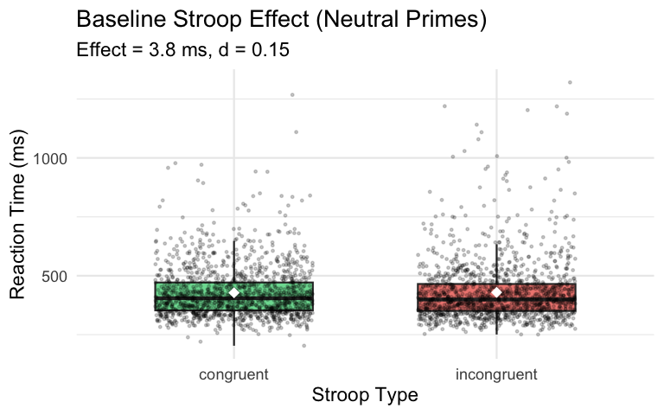 # 5. Speed-Accuracy Trade-off Check ## 5.1 Speed Accuracy Stroop
speed_acc_by_subj <- data_clean_all %>%
filter(prime_type == "neutral", trial_type == "stroop") %>%
group_by(participant_id, stroop_type) %>%
summarise(
mean_rt_ms = mean(rt) * 1000,
accuracy = mean(correct) * 100,
.groups = "drop"
)
acc_wide <- speed_acc_by_subj %>%
select(participant_id, stroop_type, accuracy) %>%
pivot_wider(names_from = stroop_type, values_from = accuracy)
acc_ttest <- t.test(acc_wide$congruent, acc_wide$incongruent, paired = TRUE)
cat("=== Speed-Accuracy Trade-off Analysis ===\n")
## === Speed-Accuracy Trade-off Analysis ===
cat("Accuracy difference (Congruent - Incongruent):\n")
## Accuracy difference (Congruent - Incongruent):
print(acc_ttest)
##
## Paired t-test
##
## data: acc_wide$congruent and acc_wide$incongruent
## t = 0.17396, df = 38, p-value = 0.8628
## alternative hypothesis: true mean difference is not equal to 0
## 95 percent confidence interval:
## -1.496848 1.778287
## sample estimates:
## mean difference
## 0.1407199
sat_summary <- data_clean_all %>%
filter(prime_type == "neutral", trial_type == "stroop") %>%
group_by(stroop_type) %>%
summarise(
Mean_RT_ms = round(mean(rt) * 1000, 1),
Accuracy_pct = round(mean(correct) * 100, 2),
.groups = "drop"
)
kable(sat_summary, caption = "Speed-Accuracy Summary (Neutral Primes)")
Speed-Accuracy Summary (Neutral Primes)
stroop_type | Mean_RT_ms | Accuracy_pct
congruent | 426.3 | 94.62
incongruent | 432.0 | 94.48
sat_corr <- speed_acc_by_subj %>%
group_by(stroop_type) %>%
summarise(
r = cor(mean_rt_ms, accuracy),
p = cor.test(mean_rt_ms, accuracy)$p.value,
.groups = "drop"
)
kable(sat_corr, digits = 3,
caption = "RT–Accuracy Correlations by Stroop Condition (Neutral Primes)")
RT–Accuracy Correlations by Stroop Condition (Neutral Primes)
stroop_type | r | p
congruent | 0.101 | 0.542
incongruent | -0.168 | 0.306

5.2 Speed-Accuracy Tradeoff Color-Blocks
speed_acc_colorblock <- data_colorblock %>%
group_by(participant_id, prime_type) %>%
summarise(
mean_rt_ms = mean(rt) * 1000,
accuracy = mean(correct) * 100,
.groups = "drop"
)
acc_colorblock_wide <- speed_acc_colorblock %>%
select(participant_id, prime_type, accuracy) %>%
pivot_wider(names_from = prime_type, values_from = accuracy)
acc_neut_cong <- t.test(acc_colorblock_wide$neutral,
acc_colorblock_wide$congruent,
paired = TRUE)
acc_neut_incong <- t.test(acc_colorblock_wide$neutral,
acc_colorblock_wide$incongruent,
paired = TRUE)
acc_cong_incong <- t.test(acc_colorblock_wide$congruent,
acc_colorblock_wide$incongruent,
paired = TRUE)
cat("=== Speed-Accuracy Trade-off Analysis: Color Blocks ===\n\n")
## === Speed-Accuracy Trade-off Analysis: Color Blocks ===
cat("Neutral vs Congruent:\n")
## Neutral vs Congruent:
print(acc_neut_cong)
##
## Paired t-test
##
## data: acc_colorblock_wide$neutral and acc_colorblock_wide$congruent
## t = 1.2497, df = 38, p-value = 0.219
## alternative hypothesis: true mean difference is not equal to 0
## 95 percent confidence interval:
## -0.5154368 2.1785412
## sample estimates:
## mean difference
## 0.8315522
cat("\nNeutral vs Incongruent:\n")
##
## Neutral vs Incongruent:
print(acc_neut_incong)
##
## Paired t-test
##
## data: acc_colorblock_wide$neutral and acc_colorblock_wide$incongruent
## t = 4.0669, df = 38, p-value = 0.0002314
## alternative hypothesis: true mean difference is not equal to 0
## 95 percent confidence interval:
## 1.184750 3.533247
## sample estimates:
## mean difference
## 2.358999
cat("\nCongruent vs Incongruent:\n")
##
## Congruent vs Incongruent:
print(acc_cong_incong)
##
## Paired t-test
##
## data: acc_colorblock_wide$congruent and acc_colorblock_wide$incongruent
## t = 2.307, df = 38, p-value = 0.0266
## alternative hypothesis: true mean difference is not equal to 0
## 95 percent confidence interval:
## 0.1871026 2.8677906
## sample estimates:
## mean difference
## 1.527447
sat_colorblock_summary <- data_colorblock %>%
group_by(prime_type) %>%
summarise(
Mean_RT_ms = round(mean(rt) * 1000, 1),
Accuracy_pct = round(mean(correct) * 100, 2),
.groups = "drop"
)
kable(sat_colorblock_summary, caption = "Speed-Accuracy Summary: Color Blocks")
Speed-Accuracy Summary: Color Blocks
prime_type | Mean_RT_ms | Accuracy_pct
neutral | 414.5 | 94.85
congruent | 399.0 | 93.93
incongruent | 405.2 | 92.53
sat_correlations <- speed_acc_colorblock %>%
group_by(prime_type) %>%
summarise(
r = cor(mean_rt_ms, accuracy),
p = cor.test(mean_rt_ms, accuracy)$p.value,
.groups = "drop"
)
kable(sat_correlations,
digits = 3,
caption = "RT–Accuracy Correlations by Prime Type (Color Blocks)")
RT–Accuracy Correlations by Prime Type (Color Blocks)
prime_type | r | p
neutral | 0.343 | 0.033
congruent | -0.033 | 0.844
incongruent | 0.335 | 0.037

6. Priming Effect on Stroop

6.1 Linear Mixed-Effects Model (RT)
m_rt <- lmer(
rt ~ prime_type * stroop_type + (1 | participant_id),
data = data_stroop
)
cat("=== ANOVA Table ===\n")
## === ANOVA Table ===
anova(m_rt)
## Type III Analysis of Variance Table with Satterthwaite's method
## Sum Sq Mean Sq NumDF DenDF F value Pr(>F)
## prime_type 0.202989 0.101495 2 8420.2 10.4694 2.876e-05 ***
## stroop_type 0.038505 0.038505 1 8420.2 3.9718 0.0463 *
## prime_type:stroop_type 0.035543 0.017772 2 8420.1 1.8332 0.1600
## ---
## Signif. codes: 0 '***' 0.001 '**' 0.01 '*' 0.05 '.' 0.1 ' ' 1
cat("\n=== Model Summary ===\n")
##
## === Model Summary ===
summary(m_rt)
## Linear mixed model fit by REML. t-tests use Satterthwaite's method [
## lmerModLmerTest]
## Formula: rt ~ prime_type * stroop_type + (1 | participant_id)
## Data: data_stroop
##
## REML criterion at convergence: -14991.3
##
## Scaled residuals:
## Min 1Q Median 3Q Max
## -3.4772 -0.5937 -0.1709 0.3627 7.4989
##
## Random effects:
## Groups Name Variance Std.Dev.
## participant_id (Intercept) 0.004493 0.06703
## Residual 0.009694 0.09846
## Number of obs: 8464, groups: participant_id, 39
##
## Fixed effects:
## Estimate Std. Error df
## (Intercept) 4.265e-01 1.105e-02 4.179e+01
## prime_typecongruent -1.463e-02 3.692e-03 8.420e+03
## prime_typeincongruent -3.801e-03 3.706e-03 8.420e+03
## stroop_typeincongruent 4.080e-03 3.695e-03 8.420e+03
## prime_typecongruent:stroop_typeincongruent 5.311e-03 5.233e-03 8.420e+03
## prime_typeincongruent:stroop_typeincongruent -4.746e-03 5.247e-03 8.420e+03
## t value Pr(>|t|)
## (Intercept) 38.610 < 2e-16 ***
## prime_typecongruent -3.962 7.48e-05 ***
## prime_typeincongruent -1.026 0.305
## stroop_typeincongruent 1.104 0.270
## prime_typecongruent:stroop_typeincongruent 1.015 0.310
## prime_typeincongruent:stroop_typeincongruent -0.904 0.366
## ---
## Signif. codes: 0 '***' 0.001 '**' 0.01 '*' 0.05 '.' 0.1 ' ' 1
##
## Correlation of Fixed Effects:
## (Intr) prm_typc prm_typn strp_t prm_typc:_
## prm_typcngr -0.167
## prm_typncng -0.166 0.498
## strp_typncn -0.167 0.500 0.498
## prm_typcn:_ 0.118 -0.705 -0.351 -0.706
## prm_typnc:_ 0.118 -0.352 -0.706 -0.704 0.497

6.2 Effect Sizes for Fixed Effects
eta_sq <- eta_squared(m_rt, partial = TRUE, ci = 0.95)
print(eta_sq)
## # Effect Size for ANOVA (Type III)
##
## Parameter | Eta2 (partial) | 95% CI
## ------------------------------------------------------
## prime_type | 2.48e-03 | [0.00, 1.00]
## stroop_type | 4.71e-04 | [0.00, 1.00]
## prime_type:stroop_type | 4.35e-04 | [0.00, 1.00]
##
## - One-sided CIs: upper bound fixed at [1.00].

6.4 Visualization: Stroop × Prime Interaction
plot_data <- data_stroop %>%
group_by(participant_id, stroop_type, prime_type) %>%
summarise(mean_rt = mean(rt), .groups = "drop") %>%
group_by(stroop_type, prime_type) %>%
summarise(
rt_mean = mean(mean_rt) * 1000,
rt_se = sd(mean_rt) * 1000 / sqrt(n()),
.groups = "drop"
)
ggplot(plot_data, aes(x = prime_type, y = rt_mean,
color = stroop_type, group = stroop_type)) +
geom_line(linewidth = 1.2) +
geom_point(size = 4) +
geom_errorbar(aes(ymin = rt_mean - rt_se, ymax = rt_mean + rt_se),
width = 0.1, linewidth = 0.8) +
scale_color_manual(
values = c("congruent" = "#2ecc71", "incongruent" = "#e74c3c"),
labels = c("Congruent", "Incongruent")
) +
labs(
title = "Stroop × Prime Interaction across Conditions",
x = "Prime Type",
y = "Mean RT (ms)",
color = "Stroop Type"
) +
theme_minimal(base_size = 17) +
theme(
plot.title = element_text(face = "bold", hjust = 0.5),
legend.position = "right"
)
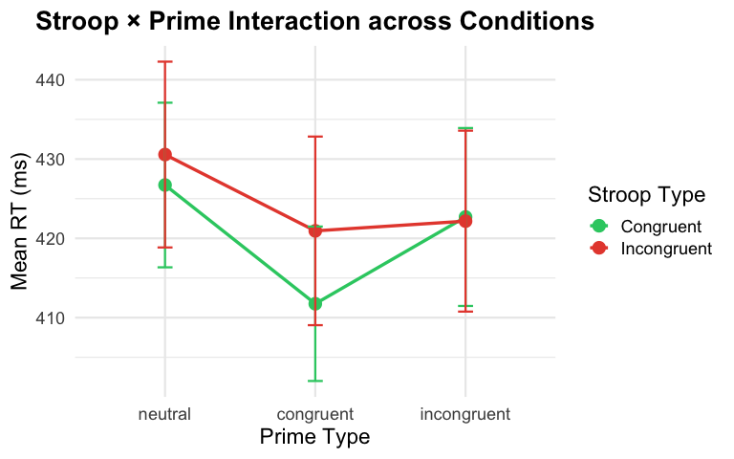 # 7. Accuracy Analysis
m_acc <- glmer(
correct ~ prime_type * stroop_type + (1 | participant_id),
data = data_clean_all %>% filter(trial_type == "stroop"),
family = binomial
)
cat("=== ANOVA Table (Accuracy) ===\n")
## === ANOVA Table (Accuracy) ===
anova(m_acc)
## Analysis of Variance Table
## npar Sum Sq Mean Sq F value
## prime_type 2 11.7769 5.8884 5.8884
## stroop_type 1 0.8260 0.8260 0.8260
## prime_type:stroop_type 2 0.1635 0.0817 0.0817
cat("\n=== Model Summary ===\n")
##
## === Model Summary ===
summary(m_acc)
## Generalized linear mixed model fit by maximum likelihood (Laplace
## Approximation) [glmerMod]
## Family: binomial ( logit )
## Formula: correct ~ prime_type * stroop_type + (1 | participant_id)
## Data: data_clean_all %>% filter(trial_type == "stroop")
##
## AIC BIC logLik deviance df.resid
## 4314.1 4363.9 -2150.1 4300.1 9053
##
## Scaled residuals:
## Min 1Q Median 3Q Max
## -6.9448 0.1905 0.2521 0.2976 0.4474
##
## Random effects:
## Groups Name Variance Std.Dev.
## participant_id (Intercept) 0.3341 0.578
## Number of obs: 9060, groups: participant_id, 39
##
## Fixed effects:
## Estimate Std. Error z value
## (Intercept) 2.99987 0.14903 20.130
## prime_typecongruent -0.18495 0.15497 -1.193
## prime_typeincongruent -0.32339 0.15109 -2.140
## stroop_typeincongruent -0.02243 0.16039 -0.140
## prime_typecongruent:stroop_typeincongruent -0.07331 0.21675 -0.338
## prime_typeincongruent:stroop_typeincongruent -0.08004 0.21125 -0.379
## Pr(>|z|)
## (Intercept) <2e-16 ***
## prime_typecongruent 0.2327
## prime_typeincongruent 0.0323 *
## stroop_typeincongruent 0.8888
## prime_typecongruent:stroop_typeincongruent 0.7352
## prime_typeincongruent:stroop_typeincongruent 0.7048
## ---
## Signif. codes: 0 '***' 0.001 '**' 0.01 '*' 0.05 '.' 0.1 ' ' 1
##
## Correlation of Fixed Effects:
## (Intr) prm_typc prm_typn strp_t prm_typc:_
## prm_typcngr -0.564
## prm_typncng -0.578 0.556
## strp_typncn -0.544 0.523 0.537
## prm_typcn:_ 0.402 -0.715 -0.397 -0.740
## prm_typnc:_ 0.412 -0.397 -0.715 -0.759 0.562

8. Color Block Analysis (Priming Without Stroop Conflict)

8.1 RT Analysis
m_color_rt <- lmer(
rt ~ prime_type + (1 | participant_id),
data = data_colorblock_RT
)
cat("=== Color Block RT Analysis ===\n")
## === Color Block RT Analysis ===
anova(m_color_rt)
## Type III Analysis of Variance Table with Satterthwaite's method
## Sum Sq Mean Sq NumDF DenDF F value Pr(>F)
## prime_type 0.29036 0.14518 2 8481.1 16.687 5.848e-08 ***
## ---
## Signif. codes: 0 '***' 0.001 '**' 0.01 '*' 0.05 '.' 0.1 ' ' 1
summary(m_color_rt)
## Linear mixed model fit by REML. t-tests use Satterthwaite's method [
## lmerModLmerTest]
## Formula: rt ~ prime_type + (1 | participant_id)
## Data: data_colorblock_RT
##
## REML criterion at convergence: -16046.1
##
## Scaled residuals:
## Min 1Q Median 3Q Max
## -3.1803 -0.6036 -0.1715 0.3847 8.1258
##
## Random effects:
## Groups Name Variance Std.Dev.
## participant_id (Intercept) 0.003637 0.06031
## Residual 0.008700 0.09327
## Number of obs: 8522, groups: participant_id, 39
##
## Fixed effects:
## Estimate Std. Error df t value Pr(>|t|)
## (Intercept) 4.137e-01 9.813e-03 3.965e+01 42.161 < 2e-16 ***
## prime_typecongruent -1.411e-02 2.467e-03 8.481e+03 -5.719 1.11e-08 ***
## prime_typeincongruent -5.259e-03 2.477e-03 8.481e+03 -2.123 0.0338 *
## ---
## Signif. codes: 0 '***' 0.001 '**' 0.01 '*' 0.05 '.' 0.1 ' ' 1
##
## Correlation of Fixed Effects:
## (Intr) prm_typc
## prm_typcngr -0.125
## prm_typncng -0.125 0.496

8.3 Accuracy Analysis
m_color_acc <- glmer(
correct ~ prime_type + (1 | participant_id),
data = data_colorblock,
family = binomial
)
cat("=== Color Block Accuracy Analysis ===\n")
## === Color Block Accuracy Analysis ===
anova(m_color_acc)
## Analysis of Variance Table
## npar Sum Sq Mean Sq F value
## prime_type 2 14.182 7.0909 7.0909
summary(m_color_acc)
## Generalized linear mixed model fit by maximum likelihood (Laplace
## Approximation) [glmerMod]
## Family: binomial ( logit )
## Formula: correct ~ prime_type + (1 | participant_id)
## Data: data_colorblock
##
## AIC BIC logLik deviance df.resid
## 4185.0 4213.4 -2088.5 4177.0 9084
##
## Scaled residuals:
## Min 1Q Median 3Q Max
## -6.8072 0.2057 0.2467 0.2885 0.3879
##
## Random effects:
## Groups Name Variance Std.Dev.
## participant_id (Intercept) 0.2396 0.4895
## Number of obs: 9088, groups: participant_id, 39
##
## Fixed effects:
## Estimate Std. Error z value Pr(>|z|)
## (Intercept) 3.0064 0.1156 26.016 < 2e-16 ***
## prime_typecongruent -0.1754 0.1117 -1.570 0.116314
## prime_typeincongruent -0.4013 0.1072 -3.745 0.000181 ***
## ---
## Signif. codes: 0 '***' 0.001 '**' 0.01 '*' 0.05 '.' 0.1 ' ' 1
##
## Correlation of Fixed Effects:
## (Intr) prm_typc
## prm_typcngr -0.521
## prm_typncng -0.544 0.561

8.4 Visualization: Color Block Priming
rt_summary <- data_colorblock_RT %>%
group_by(prime_type) %>%
summarise(
mean_rt_ms = mean(rt) * 1000,
se_rt_ms = sd(rt) / sqrt(n()) * 1000,
.groups = "drop"
)
ggplot(rt_summary, aes(x = prime_type, y = mean_rt_ms, color = prime_type)) +
geom_line(aes(group = 1), colour = "grey50", linewidth = 0.6) +
geom_point(size = 4) +
geom_errorbar(
aes(ymin = mean_rt_ms - se_rt_ms,
ymax = mean_rt_ms + se_rt_ms),
width = 0.10, linewidth = 0.8
) +
scale_color_brewer(palette = "Set2", guide = "none") +
labs(
title = "Color block reaction time by prime type",
x = "Prime type",
y = "Reaction time (ms)"
) +
theme_minimal(base_size = 14) +
theme(
plot.title = element_text(face = "bold"),
panel.grid.minor = element_blank()
)
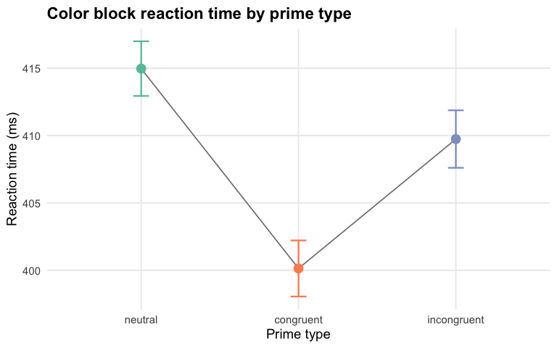 # 9. Task Comparison: Stroop vs Color Block
data_combined <- bind_rows(
data_stroop %>% mutate(task = "stroop"),
data_colorblock_RT %>% mutate(task = "colorblock", stroop_type = NA)
)
m_combined <- lmer(
rt ~ task * prime_type + (1 | participant_id),
data = data_combined
)
cat("=== Task × Prime Interaction ===\n")
## === Task × Prime Interaction ===
anova(m_combined)
## Type III Analysis of Variance Table with Satterthwaite's method
## Sum Sq Mean Sq NumDF DenDF F value Pr(>F)
## task 1.01883 1.0188 1 16942 110.4483 < 2.2e-16 ***
## prime_type 0.48580 0.2429 2 16942 26.3320 3.819e-12 ***
## task:prime_type 0.00641 0.0032 2 16942 0.3473 0.7066
## ---
## Signif. codes: 0 '***' 0.001 '**' 0.01 '*' 0.05 '.' 0.1 ' ' 1

10. Individual Differences Analysis

10.1 Distribution of Individual Stroop Effects
ggplot(stroop_neutral_means, aes(x = stroop_effect_ms)) +
geom_histogram(bins = 20, fill = "#3498db", color = "white", alpha = 0.8) +
geom_vline(xintercept = 0, linetype = "dotted", color = "gray40", linewidth = 1) +
geom_vline(
xintercept = mean(stroop_neutral_means$stroop_effect_ms),
linetype = "dashed", color = "#e74c3c", linewidth = 1
) +
labs(
title = "Distribution of Individual Stroop Effects",
subtitle = paste0("Mean = ", round(mean(stroop_neutral_means$stroop_effect_ms), 1),
" ms (red); Zero reference (gray)"),
x = "Stroop Effect (Incongruent − Congruent, ms)",
y = "Number of Participants"
) +
theme_minimal(base_size = 17) +
theme(
plot.title = element_text(face = "bold"),
panel.grid.minor = element_blank()
)
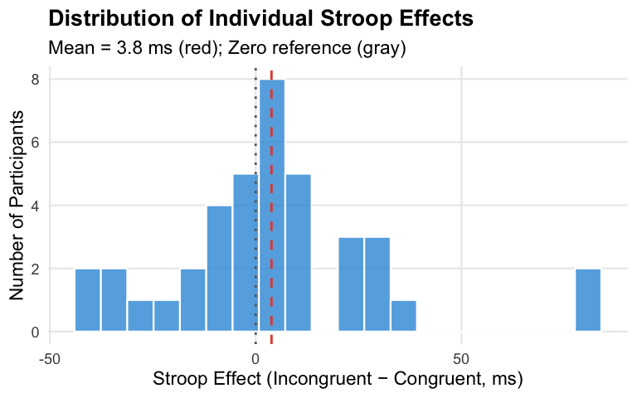 ## 10.2 Individual Stroop Effects by Prime Condition
stroop_by_prime_individual <- data_stroop %>%
group_by(participant_id, prime_type, stroop_type) %>%
summarise(mean_rt = mean(rt), .groups = "drop") %>%
pivot_wider(names_from = stroop_type, values_from = mean_rt) %>%
mutate(stroop_effect_ms = (incongruent - congruent) * 1000)
stroop_by_prime_summary <- stroop_by_prime_individual %>%
group_by(prime_type) %>%
summarise(
Mean_effect_ms = round(mean(stroop_effect_ms), 2),
SD_effect_ms = round(sd(stroop_effect_ms), 2),
SE_effect_ms = round(sd(stroop_effect_ms) / sqrt(n()), 2),
N = n(),
.groups = "drop"
)
kable(stroop_by_prime_summary, caption = "Stroop Effect by Prime Condition")
Stroop Effect by Prime Condition
prime_type | Mean_effect_ms | SD_effect_ms | SE_effect_ms | N
neutral | 3.84 | 26.20 | 4.19 | 39
congruent | 9.19 | 32.91 | 5.27 | 39
incongruent | -0.52 | 15.71 | 2.51 | 39

10.3 Consistency of Individual Effects Across Prime Conditions
stroop_wide <- stroop_by_prime_individual %>%
select(participant_id, prime_type, stroop_effect_ms) %>%
pivot_wider(names_from = prime_type, values_from = stroop_effect_ms)
cor_matrix <- cor(stroop_wide[, -1], use = "complete.obs")
cat("=== Correlation of Stroop Effects Across Prime Conditions ===\n")
## === Correlation of Stroop Effects Across Prime Conditions ===
print(round(cor_matrix, 3))
## neutral congruent incongruent
## neutral 1.000 0.349 -0.262
## congruent 0.349 1.000 -0.223
## incongruent -0.262 -0.223 1.000
stroop_by_prime_individual %>%
ggplot(aes(x = prime_type, y = stroop_effect_ms, group = participant_id)) +
geom_line(alpha = 0.3, color = "gray50") +
geom_point(alpha = 0.4, color = "gray50") +
stat_summary(
aes(group = 1),
fun = mean, geom = "line",
color = "#e74c3c", linewidth = 2
) +
stat_summary(
aes(group = 1),
fun = mean, geom = "point",
color = "#e74c3c", size = 4
) +
geom_hline(yintercept = 0, linetype = "dashed", color = "gray70") +
labs(
title = "Individual Stroop Effects Across Prime Conditions",
subtitle = "Gray lines = individuals; Red line = group mean",
x = "Prime Type",
y = "Stroop Effect (ms)"
) +
theme_minimal(base_size = 14)
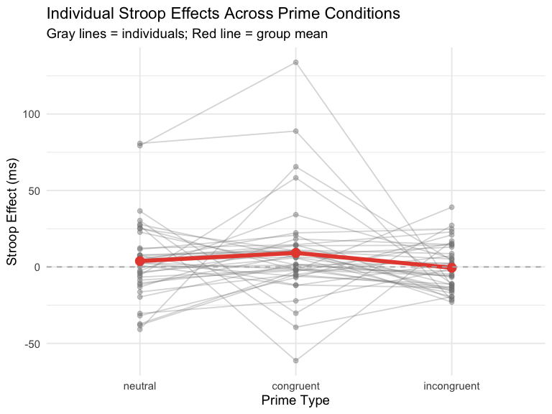

10.4 Participant-Level Summary
participant_summary <- data_clean_all %>%
group_by(participant_id) %>%
summarise(
N_trials = n(),
Mean_RT_ms = round(mean(rt) * 1000, 1),
SD_RT_ms = round(sd(rt) * 1000, 1),
Accuracy_pct = round(mean(correct) * 100, 2),
.groups = "drop"
) %>%
left_join(
stroop_neutral_means %>%
select(participant_id, stroop_effect_ms) %>%
rename(Stroop_Effect_ms = stroop_effect_ms),
by = "participant_id"
)
cat("=== Participant Variability Summary ===\n")
## === Participant Variability Summary ===
cat("Mean RT range:", round(range(participant_summary$Mean_RT_ms), 1), "ms\n")
## Mean RT range: 342 588.8 ms
cat("Accuracy range:", round(range(participant_summary$Accuracy_pct), 1), "%\n")
## Accuracy range: 88.2 99.8 %
cat("Stroop effect range:", round(range(participant_summary$Stroop_Effect_ms, na.rm = TRUE), 1), "ms\n")
## Stroop effect range: -40.8 80.8 ms

11. Bayesian Analysis

11.1 Model Comparison for Interaction
data_bf <- data_stroop %>%
mutate(
participant_id = factor(participant_id),
prime_type = factor(prime_type),
stroop_type = factor(stroop_type)
)
bf_full <- lmBF(
rt ~ prime_type * stroop_type + participant_id,
data = data_bf,
whichRandom = "participant_id",
progress = FALSE
)
# Model without interaction (main effects only)
bf_main <- lmBF(
rt ~ prime_type + stroop_type + participant_id,
data = data_bf,
whichRandom = "participant_id",
progress = FALSE
)
bf_interaction <- bf_full / bf_main
cat("=== Bayes Factor: Interaction Effect ===\n")
## === Bayes Factor: Interaction Effect ===
cat("BF₁₀ (interaction model vs main effects only):\n")
## BF₁₀ (interaction model vs main effects only):
print(bf_interaction)
## Bayes factor analysis
## --------------
## [1] prime_type * stroop_type + participant_id : 0.01733731 ±1.92%
##
## Against denominator:
## rt ~ prime_type + stroop_type + participant_id
## ---
## Bayes factor type: BFlinearModel, JZS

11.2 Full Model Comparison
bf_all <- anovaBF(
rt ~ prime_type * stroop_type + participant_id,
data = data_bf,
whichRandom = "participant_id",
progress = FALSE
)
print(bf_all)
## Bayes factor analysis
## --------------
## [1] prime_type + participant_id : 49.30355 ±0.73%
## [2] stroop_type + participant_id : 0.1822129 ±1.75%
## [3] prime_type + stroop_type + participant_id : 8.905589 ±1.49%
## [4] prime_type + stroop_type + prime_type:stroop_type + participant_id : 0.1504996 ±1.69%
##
## Against denominator:
## rt ~ participant_id
## ---
## Bayes factor type: BFlinearModel, JZS

11.3 Stroop Effect by Prime Type
ggplot(stroop_by_prime_summary, aes(x = prime_type, y = Mean_effect_ms)) +
geom_col(fill = "palegreen3", alpha = 0.7, width = 0.6) +
geom_errorbar(
aes(ymin = pmax(0, Mean_effect_ms - SE_effect_ms), ymax = Mean_effect_ms + SE_effect_ms),
width = 0.2, linewidth = 1
) +
geom_hline(
yintercept = mean(stroop_by_prime_summary$Mean_effect_ms),
linetype = "dashed", color = "violetred4", linewidth = 1
) +
labs(
title = "Constant Stroop Effect Across Prime Types",
subtitle = bquote("Consistent effect supports independent processing " ~ (BF[10] == .(round(extractBF(bf_interaction)$bf, 3)))),
x = "Prime Type",
y = "Stroop Effect (ms)",
caption = "Error bars = ±1 SE. Dashed line = overall mean."
) +
theme_minimal(base_size = 14) +
theme(
plot.title = element_text(face = "bold", hjust = 0.5),
plot.subtitle = element_text(color = "grey40", hjust = 0.5)
)
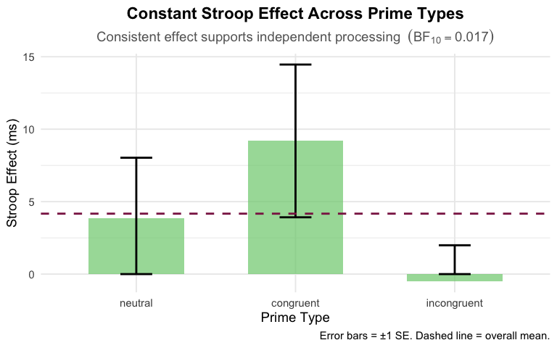 # 12. Power Analysis ## 12.1 Observed Effect Size for Interaction
interaction_effects <- stroop_by_prime_individual %>%
select(participant_id, prime_type, stroop_effect_ms) %>%
pivot_wider(names_from = prime_type, values_from = stroop_effect_ms) %>%
mutate(
# Interaction contrast: (Inc - Neut) vs (Cong - Neut)
priming_modulation = incongruent - congruent
)
observed_sigma <- sigma(m_rt)
cat("=== Observed Parameters ===\n")
## === Observed Parameters ===
cat("Residual SD:", round(observed_sigma * 1000, 2), "ms\n")
## Residual SD: 98.46 ms
cat("N participants:", n_distinct(data_stroop$participant_id), "\n")
## N participants: 39
cat("N trials per condition (approx):", round(nrow(data_stroop) /
(n_distinct(data_stroop$participant_id) * 6)), "\n")
## N trials per condition (approx): 36

12.2 Sensitivity Power Analysis
n_participants <- n_distinct(data_stroop$participant_id)
power_result <- pwr.f2.test(
u = 2, # numerator df for interaction
v = (n_participants - 1) * 2, # denominator df approximation
f2 = NULL,
sig.level = 0.05,
power = 0.80
)
detectable_f2 <- power_result$f2
detectable_eta_sq <- detectable_f2 / (1 + detectable_f2)
cat("=== Sensitivity Analysis (80% power, α = .05) ===\n")
## === Sensitivity Analysis (80% power, α = .05) ===
cat("Minimum detectable f²:", round(detectable_f2, 4), "\n")
## Minimum detectable f²: 0.1269
cat("Minimum detectable partial η²:", round(detectable_eta_sq, 4), "\n")
## Minimum detectable partial η²: 0.1126
cat("Interpretation: Small effect = 0.01, Medium = 0.06, Large = 0.14\n")
## Interpretation: Small effect = 0.01, Medium = 0.06, Large = 0.14

12.3 Post-hoc Power for Observed Effect
observed_eta <- eta_squared(m_rt, partial = TRUE)
interaction_eta <- observed_eta$Eta2_partial[3] # Interaction term
if (!is.na(interaction_eta) && interaction_eta > 0) {
observed_f2 <- interaction_eta / (1 - interaction_eta)
power_observed <- pwr.f2.test(
u = 2,
v = (n_participants - 1) * 2,
f2 = observed_f2,
sig.level = 0.05,
power = NULL
)
cat("=== Post-hoc Power Analysis ===\n")
cat("Observed partial η² for interaction:", round(interaction_eta, 4), "\n")
cat("Observed f²:", round(observed_f2, 4), "\n")
cat("Achieved power:", round(power_observed$power * 100, 1), "%\n")
} else {
cat("Interaction effect size too small to calculate meaningful power.\n")
}
## === Post-hoc Power Analysis ===
## Observed partial η² for interaction: 4e-04
## Observed f²: 4e-04
## Achieved power: 5.2 %

12.4 Power Curve
#power curve for different effect sizes
effect_sizes <- seq(0.001, 0.15, by = 0.005)
powers <- sapply(effect_sizes, function(eta) {
f2 <- eta / (1 - eta)
result <- pwr.f2.test(
u = 2,
v = (n_participants - 1) * 2,
f2 = f2,
sig.level = 0.05,
power = NULL
)
result$power
})
power_df <- data.frame(
partial_eta_sq = effect_sizes,
power = powers
)
ggplot(power_df, aes(x = partial_eta_sq, y = power * 100)) +
geom_line(linewidth = 1.2, color = "#3498db") +
geom_hline(yintercept = 80, linetype = "dashed", color = "#e74c3c") +
geom_vline(xintercept = 0.01, linetype = "dotted", color = "gray50") +
geom_vline(xintercept = 0.06, linetype = "dotted", color = "gray50") +
annotate("text", x = 0.01, y = 5, label = "Small", size = 3, hjust = -0.1) +
annotate("text", x = 0.06, y = 5, label = "Medium", size = 3, hjust = -0.1) +
labs(
title = "Power Curve for Priming × Stroop Interaction",
subtitle = paste("N =", n_participants, "participants"),
x = "Partial η² (Effect Size)",
y = "Power (%)"
) +
scale_y_continuous(limits = c(0, 100), breaks = seq(0, 100, 20)) +
scale_x_continuous(limits = c(0, 0.15)) +
theme_minimal(base_size = 14)
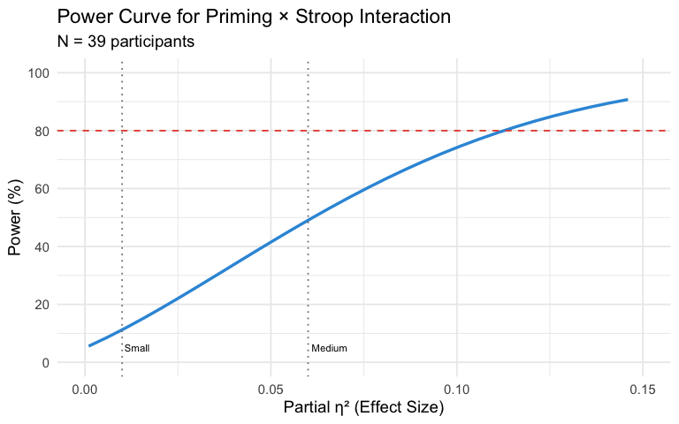

13. Time Effects: Learning and Fatigue Across Blocks

13.1 Overall RT and Accuracy Trends
block_trends <- data_clean_all %>%
filter(trial_type == "stroop") %>%
group_by(block, prime_type, stroop_type) %>%
summarise(
mean_rt = mean(rt) * 1000,
accuracy = mean(correct) * 100,
n = n(),
.groups = "drop"
)
# trends collapsed across conditions
block_trends_overall <- data_clean_all %>%
filter(trial_type == "stroop") %>%
group_by(block) %>%
summarise(
mean_rt = mean(rt) * 1000,
se_rt = sd(rt) * 1000 / sqrt(n()),
accuracy = mean(correct) * 100,
n = n(),
.groups = "drop"
)
kable(block_trends_overall,
caption = "Overall Performance Trends Across Blocks",
digits = 2)
Overall Performance Trends Across Blocks
block | mean_rt | se_rt | accuracy | n
1 | 432.01 | 3.86 | 92.53 | 1152
2 | 423.80 | 3.55 | 93.45 | 1145
3 | 417.72 | 3.76 | 93.40 | 1137
4 | 421.31 | 3.58 | 94.08 | 1148
5 | 419.78 | 3.48 | 93.18 | 1129
6 | 420.27 | 3.40 | 92.10 | 1127
7 | 418.55 | 3.59 | 93.90 | 1114
8 | 424.98 | 3.37 | 94.77 | 1108

13.2 Visualization: RT Across Blocks
ggplot(block_trends_overall, aes(x = block, y = mean_rt)) +
geom_line(linewidth = 1.2, color = "#3498db") +
geom_point(size = 3, color = "#3498db") +
geom_errorbar(aes(ymin = mean_rt - se_rt, ymax = mean_rt + se_rt),
width = 0.2, linewidth = 0.8) +
geom_smooth(method = "lm", se = TRUE, color = "#e74c3c",
linetype = "dashed", linewidth = 0.8) +
labs(
title = "Reaction Time Across Experimental Blocks",
subtitle = "Linear trend line shows practice effects",
x = "Block Number",
y = "Mean Reaction Time (ms)"
) +
scale_x_continuous(breaks = 1:8) +
theme_minimal(base_size = 14) +
theme(
plot.title = element_text(face = "bold"),
panel.grid.minor = element_blank()
)
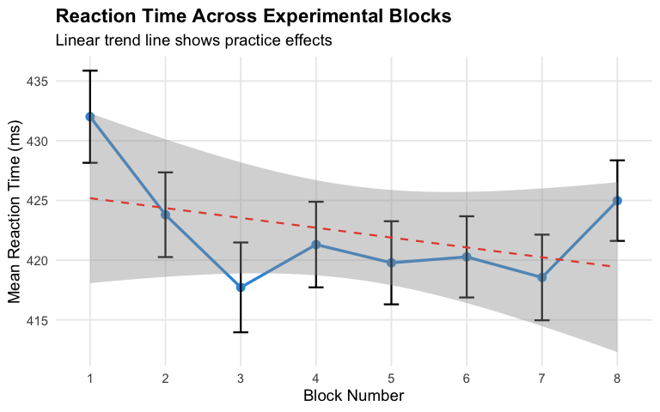 ## 13.3 Test for Linear Time Trend
m_time_trend <- lmer(
rt ~ block + (1 | participant_id),
data = data_clean_all %>% filter(trial_type == "stroop")
)
cat("=== Linear Time Trend Analysis ===\n")
## === Linear Time Trend Analysis ===
summary(m_time_trend)
## Linear mixed model fit by REML. t-tests use Satterthwaite's method [
## lmerModLmerTest]
## Formula: rt ~ block + (1 | participant_id)
## Data: data_clean_all %>% filter(trial_type == "stroop")
##
## REML criterion at convergence: -15820.1
##
## Scaled residuals:
## Min 1Q Median 3Q Max
## -3.6061 -0.5919 -0.1637 0.3694 7.4480
##
## Random effects:
## Groups Name Variance Std.Dev.
## participant_id (Intercept) 0.004676 0.06838
## Residual 0.009989 0.09994
## Number of obs: 9060, groups: participant_id, 39
##
## Fixed effects:
## Estimate Std. Error df t value Pr(>|t|)
## (Intercept) 4.276e-01 1.119e-02 4.069e+01 38.210 < 2e-16 ***
## block -1.282e-03 4.600e-04 9.021e+03 -2.786 0.00534 **
## ---
## Signif. codes: 0 '***' 0.001 '**' 0.01 '*' 0.05 '.' 0.1 ' ' 1
##
## Correlation of Fixed Effects:
## (Intr)
## block -0.183
#slope
block_effect <- fixef(m_time_trend)["block"]
cat("\nBlock effect:", round(block_effect * 1000, 3), "ms per block\n")
##
## Block effect: -1.282 ms per block
time_anova <- anova(m_time_trend)
cat("F-test for block effect:\n")
## F-test for block effect:
print(time_anova)
## Type III Analysis of Variance Table with Satterthwaite's method
## Sum Sq Mean Sq NumDF DenDF F value Pr(>F)
## block 0.077543 0.077543 1 9021.3 7.7631 0.005343 **
## ---
## Signif. codes: 0 '***' 0.001 '**' 0.01 '*' 0.05 '.' 0.1 ' ' 1
sessionInfo()
## R version 4.4.2 (2024-10-31)
## Platform: aarch64-apple-darwin20
## Running under: macOS Sonoma 14.5
##
## Matrix products: default
## BLAS: /Library/Frameworks/R.framework/Versions/4.4-arm64/Resources/lib/libRblas.0.dylib
## LAPACK: /Library/Frameworks/R.framework/Versions/4.4-arm64/Resources/lib/libRlapack.dylib; LAPACK version 3.12.0
##
## locale:
## [1] en_US.UTF-8/en_US.UTF-8/en_US.UTF-8/C/en_US.UTF-8/en_US.UTF-8
##
## time zone: Europe/Copenhagen
## tzcode source: internal
##
## attached base packages:
## [1] stats graphics grDevices utils datasets methods base
##
## other attached packages:
## [1] knitr_1.49 simr_1.0.8 pwr_1.3-0
## [4] effectsize_1.0.1 BayesFactor_0.9.12-4.7 coda_0.19-4.1
## [7] emmeans_1.11.2-8 lmerTest_3.1-3 lme4_1.1-36
## [10] Matrix_1.7-1 lubridate_1.9.4 forcats_1.0.0
## [13] stringr_1.5.1 dplyr_1.1.4 purrr_1.0.4
## [16] readr_2.1.5 tidyr_1.3.1 tibble_3.2.1
## [19] ggplot2_4.0.0 tidyverse_2.0.0
##
## loaded via a namespace (and not attached):
## [1] tidyselect_1.2.1 RLRsim_3.1-9 farver_2.1.2
## [4] S7_0.2.0 fastmap_1.2.0 bayestestR_0.17.0
## [7] digest_0.6.37 estimability_1.5.1 timechange_0.3.0
## [10] lifecycle_1.0.4 magrittr_2.0.3 compiler_4.4.2
## [13] rlang_1.1.5 tools_4.4.2 plotrix_3.8-13
## [16] yaml_2.3.10 labeling_0.4.3 bit_4.5.0.1
## [19] plyr_1.8.9 RColorBrewer_1.1-3 abind_1.4-8
## [22] withr_3.0.2 numDeriv_2016.8-1.1 grid_4.4.2
## [25] datawizard_1.3.0 scales_1.4.0 iterators_1.0.14
## [28] MASS_7.3-61 insight_1.4.2 cli_3.6.3
## [31] mvtnorm_1.3-3 crayon_1.5.3 rmarkdown_2.29
## [34] reformulas_0.4.0 generics_0.1.3 rstudioapi_0.17.1
## [37] binom_1.1-1.1 tzdb_0.4.0 parameters_0.28.2
## [40] minqa_1.2.8 pbapply_1.7-4 splines_4.4.2
## [43] parallel_4.4.2 vctrs_0.6.5 boot_1.3-31
## [46] carData_3.0-5 car_3.1-3 hms_1.1.3
## [49] bit64_4.6.0-1 pbkrtest_0.5.3 Formula_1.2-5
## [52] glue_1.8.0 nloptr_2.1.1 stringi_1.8.4
## [55] gtable_0.3.6 pillar_1.10.1 htmltools_0.5.8.1
## [58] R6_2.5.1 Rdpack_2.6.2 vroom_1.6.5
## [61] evaluate_1.0.3 lattice_0.22-6 rbibutils_2.3
## [64] backports_1.5.0 broom_1.0.7 MatrixModels_0.5-3
## [67] Rcpp_1.0.14 nlme_3.1-166 mgcv_1.9-1
## [70] xfun_0.50 pkgconfig_2.0.3

