Corporate Network

Environment Setup up (Ubuntu host machine, GNS3, Appliances (OVS, Cisco, Linux) App Development (Python Based)

6th Semester Project
RAIMAL RAJA 2K23/BLCS/49
HAROON 2K23/BLCS/38

Contents
Ubuntu; Set up host machine on hardware 3
Install GNS and GNS VM on host operating system 10
GNS3 installations 10
Install VMware workstation Pro: 13
GNS3 VM 14
Appliances; Installing appliances on GNS3 (OVS, Cisco Routers) 18
1 - Open vSwitch 18
2 – Cisco Router 21

Ubuntu; Set up host machine on hardware
We used Ubuntu Linux for best practice, because it is more familiar with GN3 appliance like open v switch (OVS), Routers,
STEP – 1: Download Image
Download Ubuntu distro iSO image from its official website, using link given below
https://ubuntu.com/download/desktop
STEP - 2: make pen drive bootable
Take a 16GB portal pen drive and make it bootable
STEP – 3: Turn off secure boot
search your device model on google check BOIS function key, then restart your machine and then press function key to get into bios and then turn off secure boot mode, and then start your machine again press boot, select bootable pen drive.

Further Steps for installation
Step – 4: Boot from USB flash drive
Select system language e.g. English
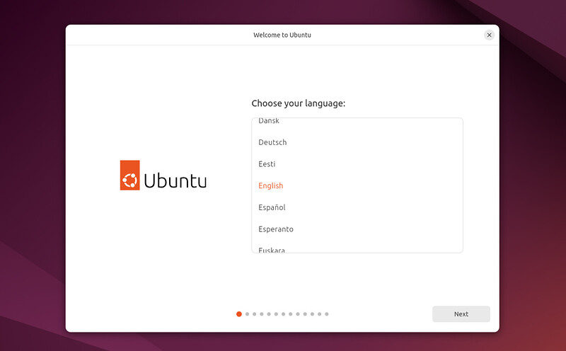

Step – 5: Installation setup
Chose Interactive installation
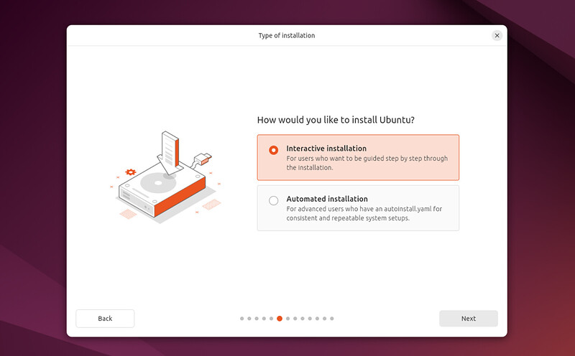
Go with default selection
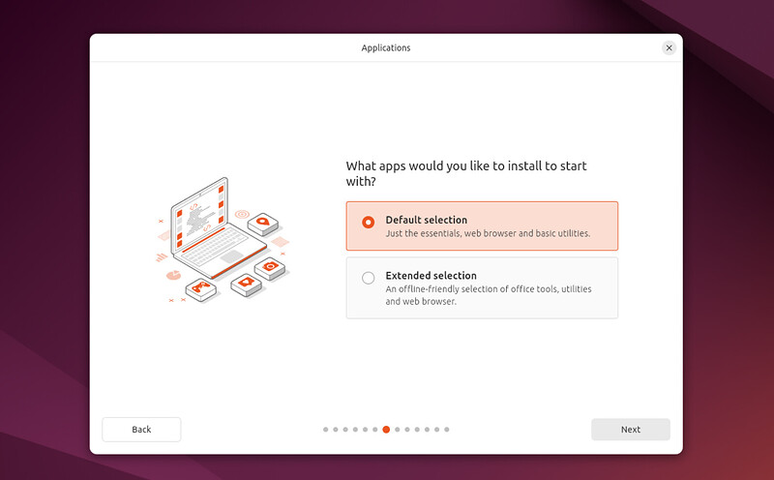

Step – 6: Select disk partition
This screen allows you to configure your installation. If you would like Ubuntu to be the only operating system on your hard drive, select Erase disk and install Ubuntu.
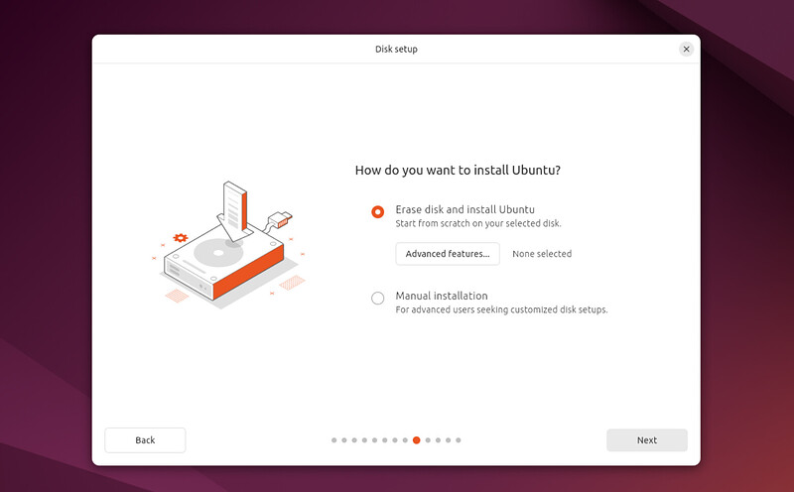

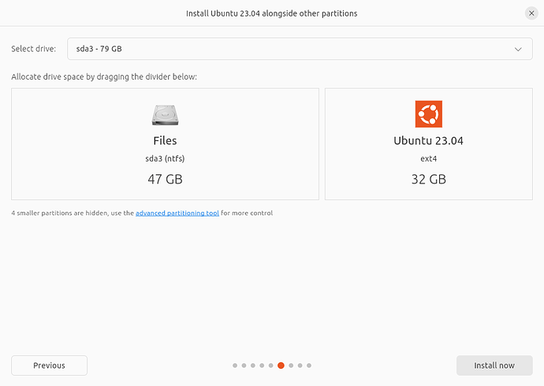
Erase disk and install Ubuntu
If you select this option Ubuntu will take up the entire disk space on the selected drive.
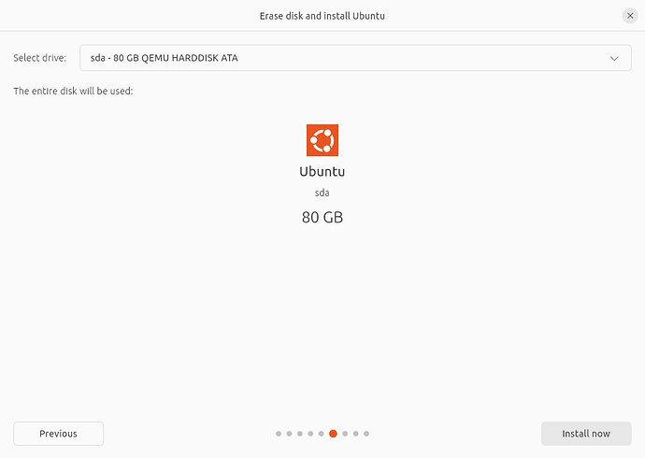
If your PC has multiple hard drives then this option allows you to install Ubuntu alongside an existing OS as long as they each have their own drive. Take care to ensure that you are selecting the right drive in this instance!
Step – 7: Create Your Login Details
On this screen, you will be prompted to enter your name and the name of your computer as it will appear on the network. Finally, you will create a username and a strong password.
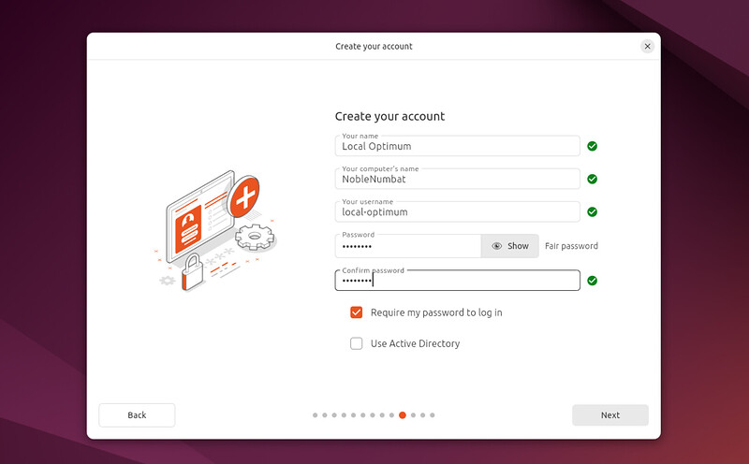

Step – 8: Choose your Location
Select your location and time zone from the map screen and click Continue. This information will be detected automatically if you are connected to the internet
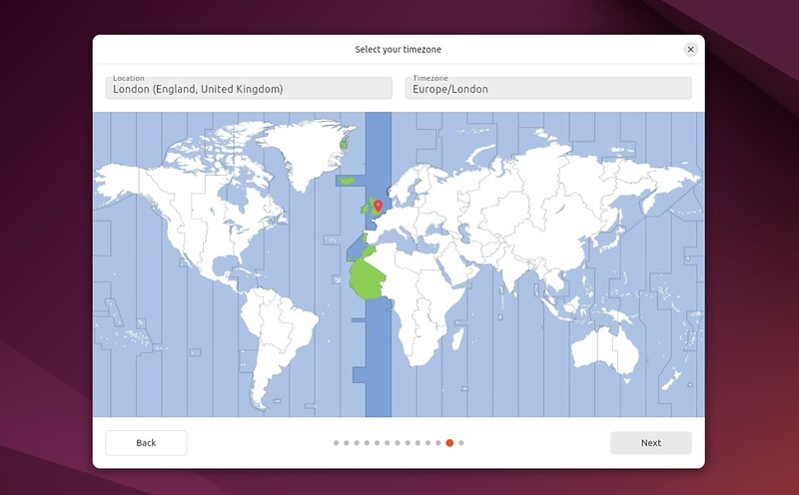

Step – 9: Ready to install
Clicking Next will take you to a summary of your installation configuration to give you a chance to confirm your setup before clicking Install.
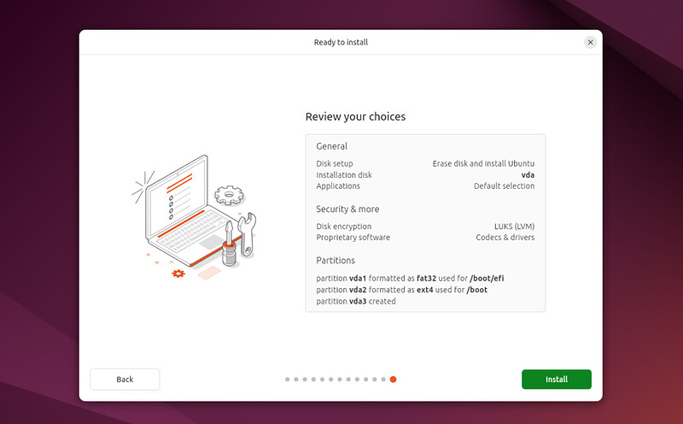
Step – 10: Complete the Installation
Sit back and enjoy the slideshow as Ubuntu installs in the background.
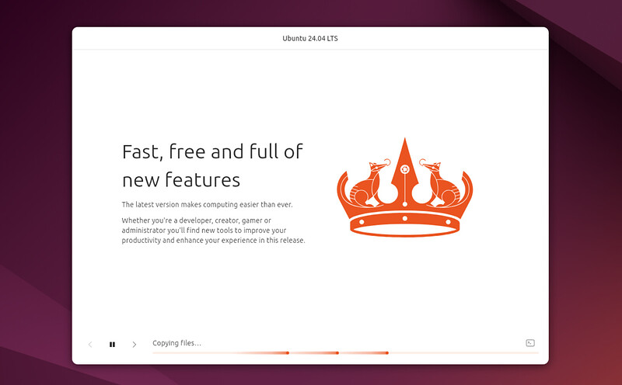

Once the installation has completed, you will be prompted to restart your machine.
Click Restart Now.
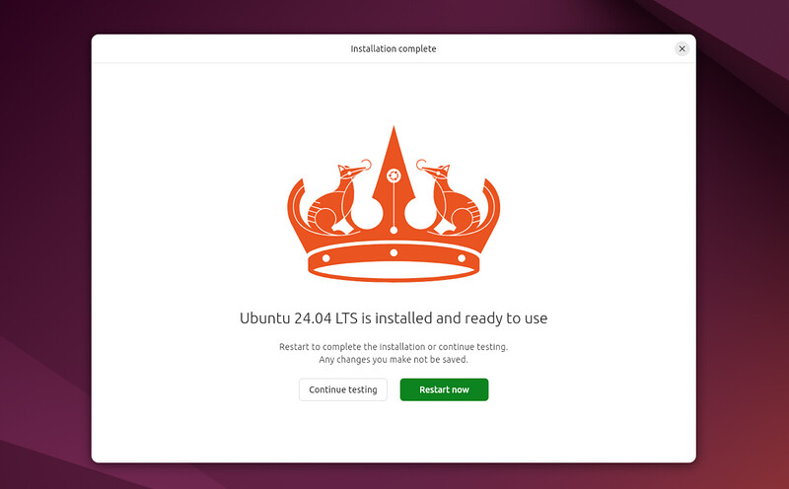

Step – 11: Don’t forget to Update
Open terminal and then run these two commands one by one to update and upgrade ubuntu
1 - sudo apt update
2 - sudo apt upgrade

Here you have completed your setting up your host machine for GNS3 and GN3 VM

Install GNS and GNS VM on host operating system
What is GNS3?
A free, open-source software tool that allows users to design, emulate, and simulate computer networks in a virtual environment The software that empowers network professionals.

GNS3 installations
Step – 1 Download it from its official website, download Ubuntu Linux. latest version at this time Version 2.2.54, you must install same version to avoid unexpected issues and problems,
Link: https://docs.gns3.com/docs/getting-started/installation/linux/
This link will redirect you to gns3 installation commands, copy all commands one by one and paste it in terminal. Run only Ubuntu-based distributions (64-bit only) commands, do not run Debian based distros or other
Copy the command below, and hit ENTER, it will ask you to enter root password, enter it, and then hit ENTER
Command – 1: sudo add-apt-repository ppa:gns3/ppa
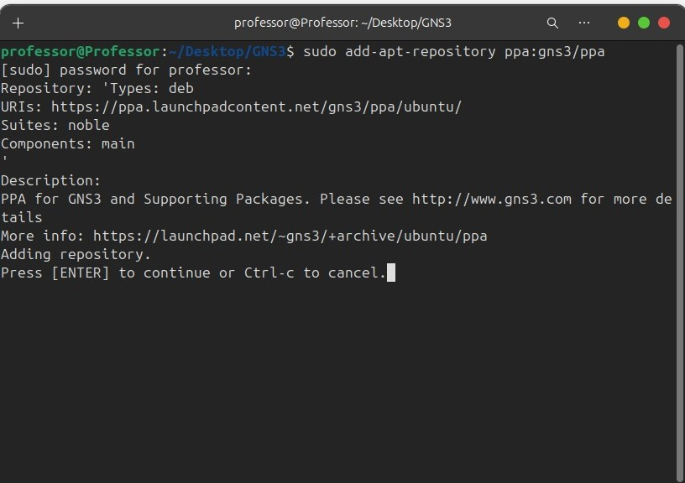

After running this command, this will ask you again to continue this process. Say yes, hit ENTER (for yes)
Then run second command, to make sure everything is listed and working correctly.
Command – 2: sudo apt update
Then run third command to install GNS3 GUI, it’s about 166MB, make sure you have additional 683MB, it will ask to prerequisites, enter ‘Y’ and hit ENTER.
Command – 3: sudo apt install gns3-gui gns3-server
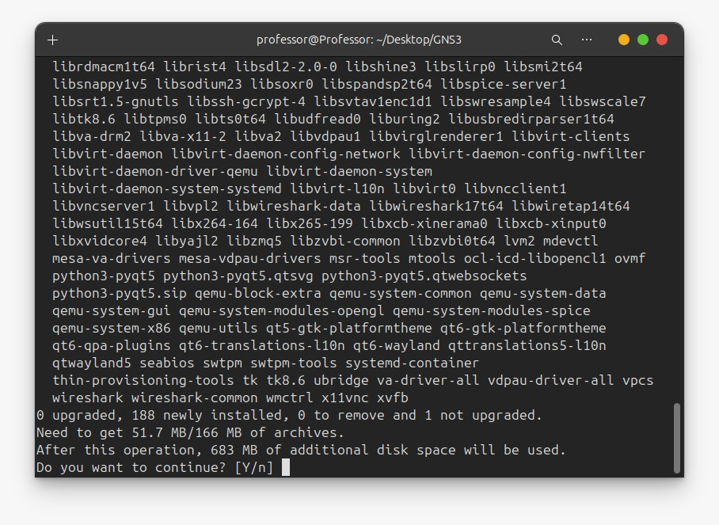
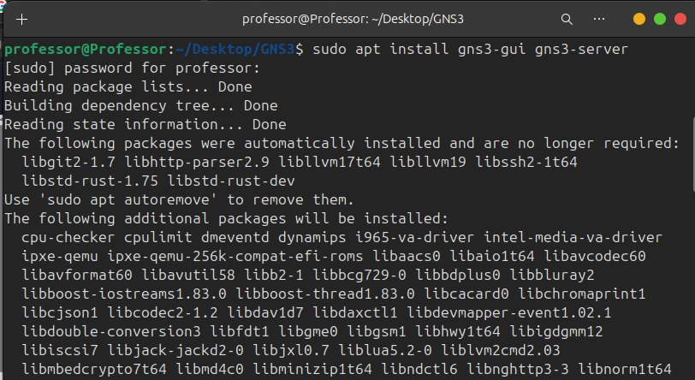

After installing GNS3 from internet then a pop up will appear on your terminal window, it asks if non-superusers (like users in sudo or admin groups) should be able to run GNS3 and capture packets. Choosing Yes is the security-recommended option because it prevents GNS3 from running with full root privileges.
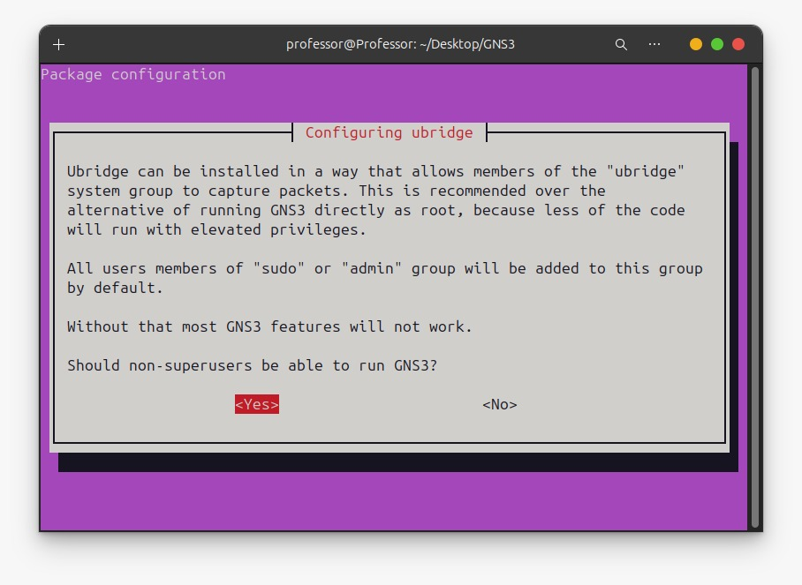

Then another pop up will appear, keep default (no) but I will recommend you choose yes and hit ENTER. This asks if non-superusers should be able to run Wireshark/Tshark to capture network packets by adding them to the wireshark group.
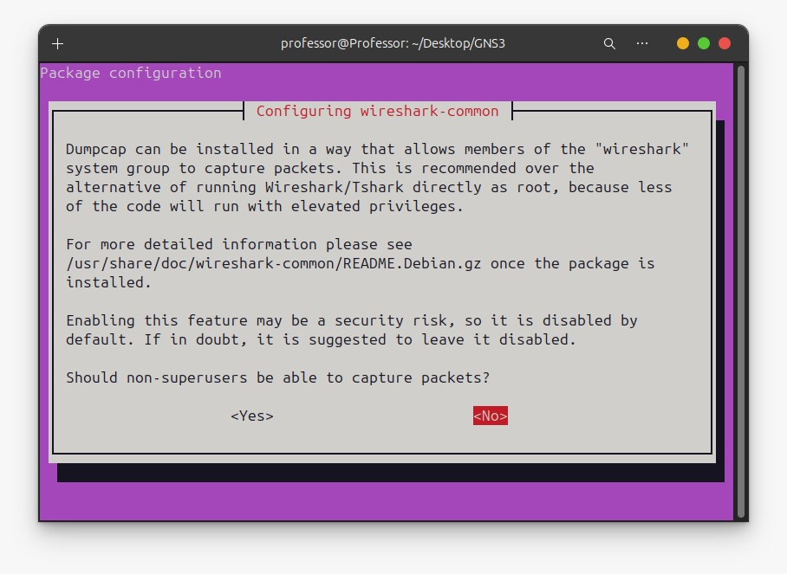
You have installed GNS3 GUI successfully
Note: do no open GN3 GUI, install GNS3 VM first.

Install VMware workstation Pro:
Why VMware Workstation Pro?
The GNS3 GUI is a lightweight tool for design. The GNS3 VM is a powerful server needed to run complex, resource-intensive virtual devices (like modern Cisco images) efficiently and stably using technologies like KVM. And for installation and to setup up GNS3 VM, we need virtual environments /hypervisor. In this case I am using VMware Workstation Pro 25H2.
Download it from its official website
Link: https://www.vmware.com/products/desktop-hypervisor/workstation-and-fusion
Rename this file as VMwarePro.double.
Here are steps to install Ubuntu after downloading successfully,
Step – 1: open terminal in the root directory where VMware Workstation Pro .double file exists. Run these two commands
Run this command to make script executable binary
Command – 1: chmod +x VmwarePro.double
Then command below to install
Command – 2: sudo ./VmwarePro.double
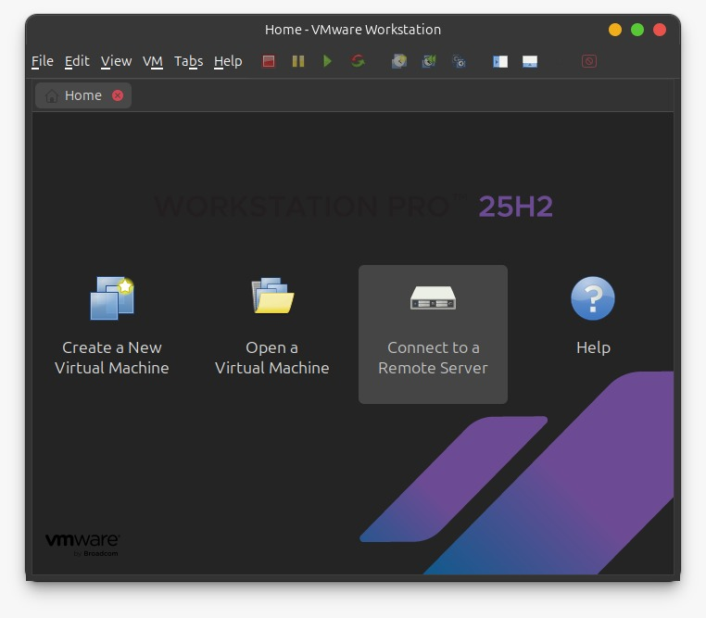
VMware Workstation Pro installed successfully. Restart your machine and continuously press F1, then find VTx or Virtualizations, press ENTER and enable it. And then start machine normally.
Now open VMware Workstation Pro.

GNS3 VM
Step – 2: Download GNS3 VM from its official website
Link: https://gns3.com/software/download-vm
When you download GNS3 VM successfully, open VMware Workstation Pro 25H2, if you haven’t opened.
Click on File tab on left top corner, File>Open, Then Select GNS VM, and import it
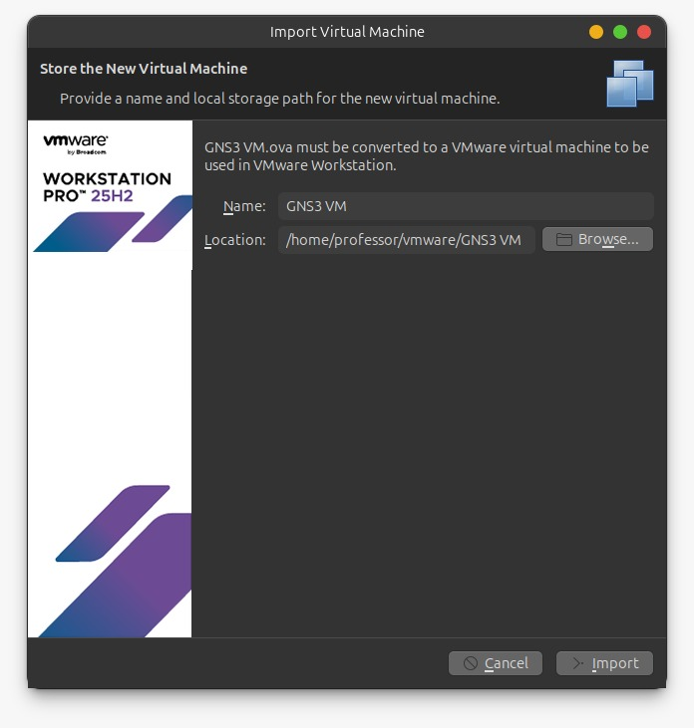

After importing, VMware will look like this on click ‘Start up the guest operating system’ and run the virtual machine
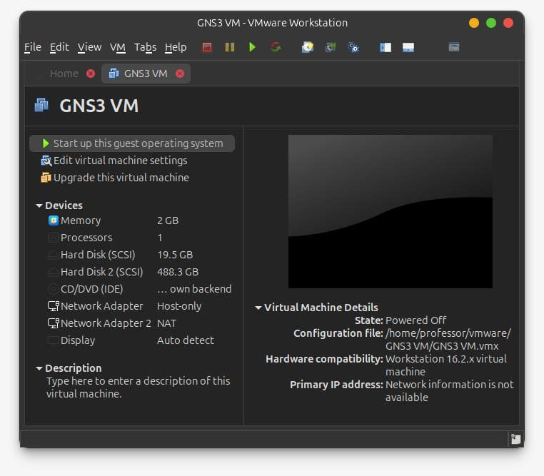
GN3 VM is successfully configured
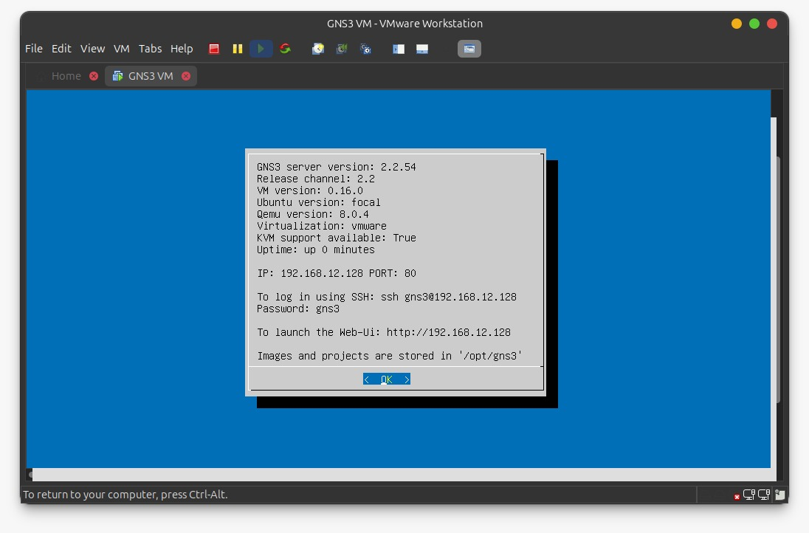
Step – 3: connect both GNS3 GUI and GNS3 VM
Now open GNS3 GUI, select first option ‘Run appliances in a virtual machine’ 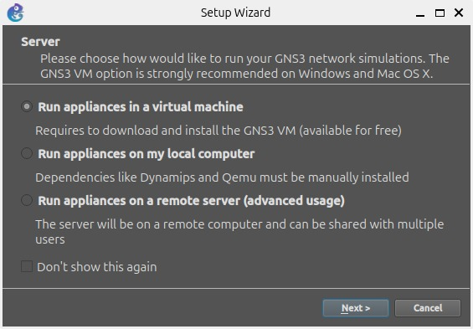

Keep it as default, press Next
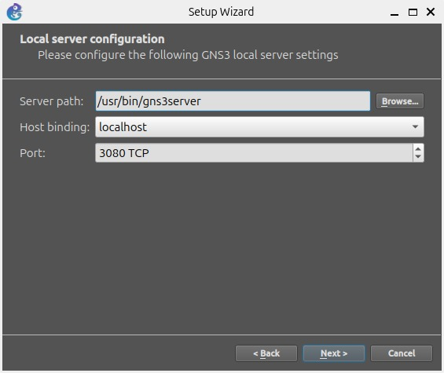

It shows successful message.
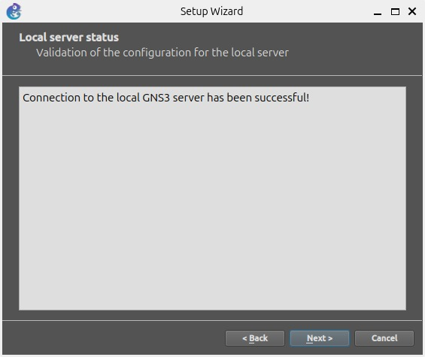

If you are having few further steps on your machine, then keep them default press ‘Next’ and finish it.
Final Step (Optional Step. it wouldn’t affect your project if you skip this)
Now final step to finish environments setup. Multi-session manager like Solor-PuTTY, Solar-PuTTY is basically a multi-session SSH/Telnet manager, a popular terminal emulator (like PuTTY) that GNS3 uses by default on Windows, not Ubuntu. It helps you console into virtual network devices, but you can install alternative like terminator or remmina. Installing terminator is much easier than remmina
Open terminal and run these two commands
Command – 1: sudo apt update && sudo apt upgrade -y
Command – 2: sudo apt install terminator -y
Now do some changes in GNS3 Gui, open GN3 Gui and make sure GN3 VM must be running.
GNS3 → Preferences → General → Console > click on edit > choose Terminator. Save the changes, you are done!

Appliances; Installing appliances on GNS3 (OVS, Cisco Routers)

1 - Open vSwitch
Open vSwitch (OVS) is a specialized switch, you can configure it as a Router. It is an open-source, multilayer virtual switch that enables network automation, monitoring, and management across virtualized environments and physical networks.
How to install GN3VM?
Open your GNS3 GUI the VM will automatically started if you have configured it correctly as guided
Open GN3 GUI > inside on the left side icons column click on Browse Switches > New Template select first option “Install an appliance from the GNS3 server (recommended)” > switches > Open vSwitch > Select first option “install the appliance on the GNS3 VM (recommended)” > FINISHED
Step – 1: Open GNS3 GUI
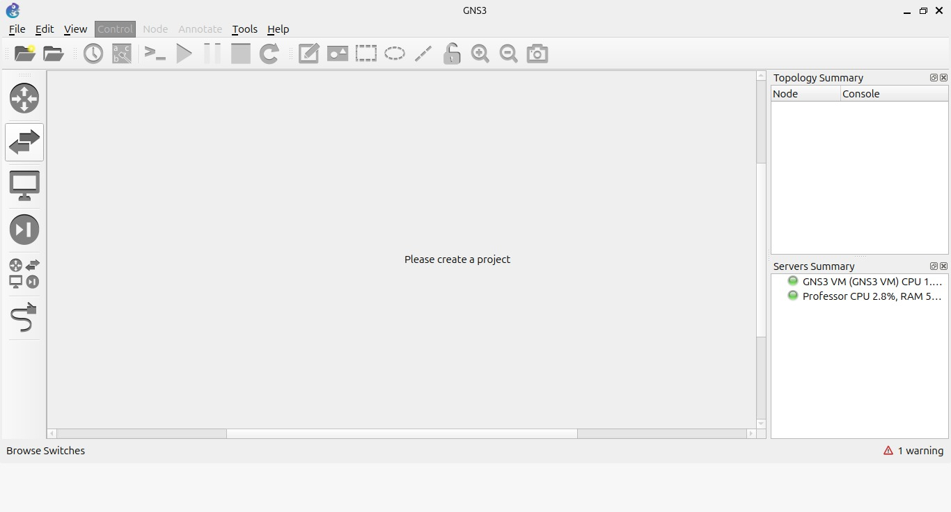
Step – 2: Browse Switches

Step – 3: New Templates
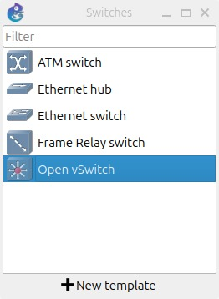

Step – 4: Install an appliance from the GNS3 server (recommended)
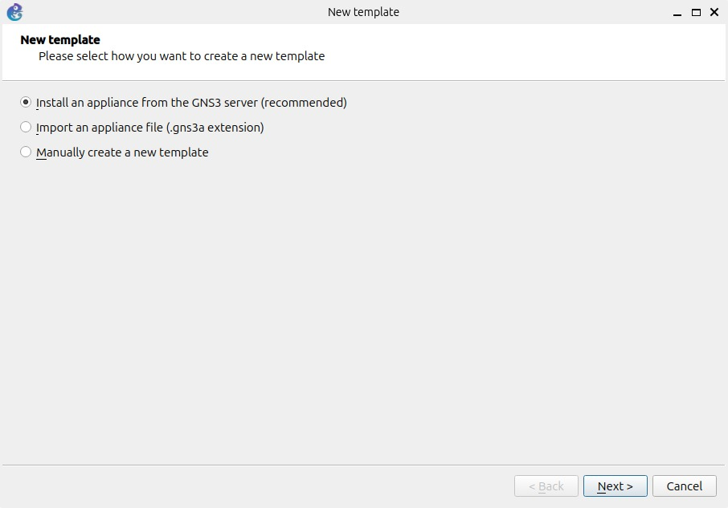
Step – 5: Switches > Open vSwitch
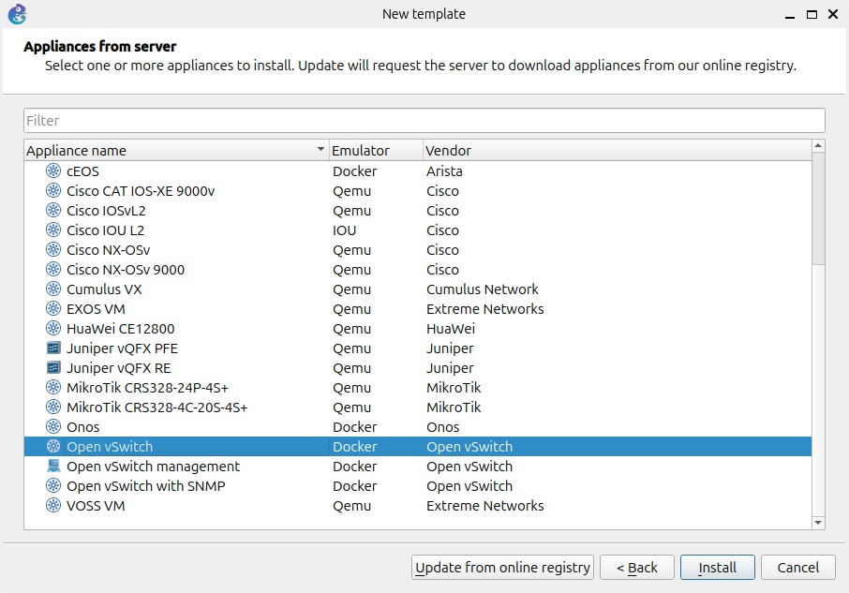
Step 6: Final step, installing it in VM
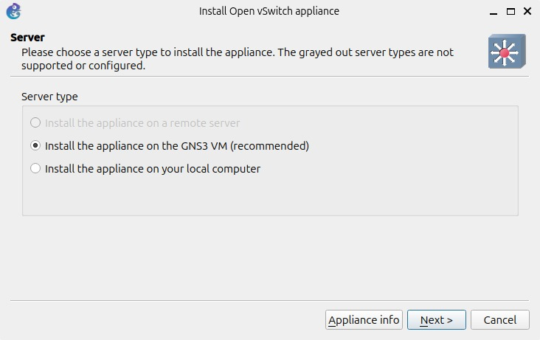

2 – Cisco Router
Cisco Routers have variety of models; we are not going to use cisco router in project but will now how to install. Installing router is little bit different from Open vSwitch
In GN3, when you must work with Cisco Routers, you need to buy virtual routers from Cisco Appliance Official website and download it’s iso image and then need to import in GNS3 and select model of image and Router in GNS3.
You can download Cisco free appliances from my GitHub repository
Link: https://github.com/Raimal-Raja/Cisco_Appliances_Router_ISO_Images
