HTML/CSS course

Assignment 9

Overview

How to format form elements?

Output

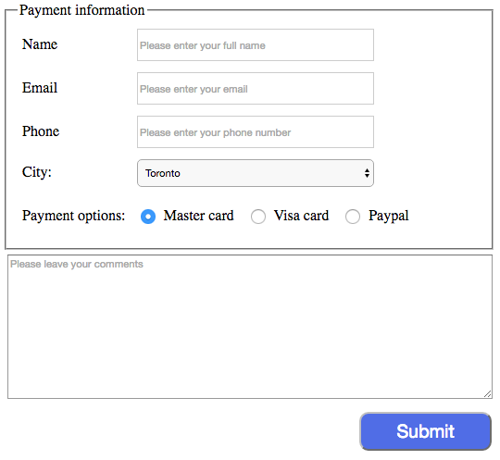

Materials and tools

1. Format ‘select’ tag, you use ‘-webkit-appearance: menulist-button’ to reset styles which are set by Chrome, otherwise, you can’t change even height property for this element.
2. To align radio buttons and their labels, you may use ‘vertical-align: middle’ to align them properly.