所有样本，4个特征：
训练集：
Accuracy: 0.9231 recall: 0.9700 f1: 0.9368
confusion metrix:
[[220 37]
[ 11 356]]
Classification Report:
precision recall f1-score support

0 0.95 0.86 0.90 257
1 0.91 0.97 0.94 367

accuracy 0.92 624
macro avg 0.93 0.91 0.92 624
weighted avg 0.93 0.92 0.92 624

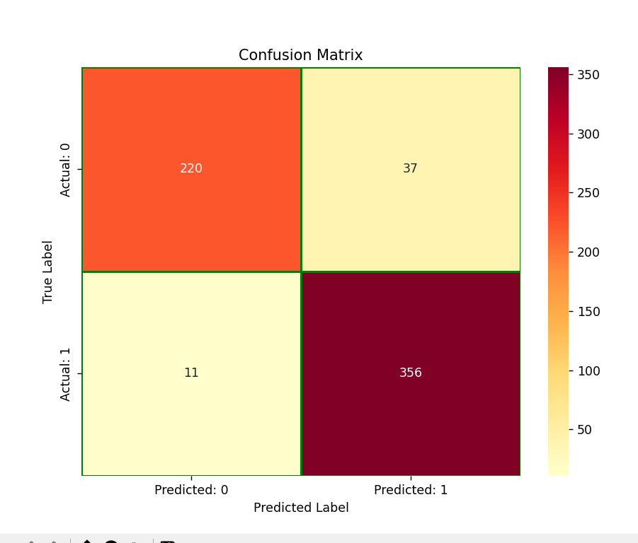

测试集：
Accuracy: 0.5410 recall: 0.7006 f1: 0.6414
confusion metrix:
[[ 35 76]
[ 47 110]]
Classification Report:
precision recall f1-score support

0 0.43 0.32 0.36 111
1 0.59 0.70 0.64 157

accuracy 0.54 268
macro avg 0.51 0.51 0.50 268
weighted avg 0.52 0.54 0.53 268

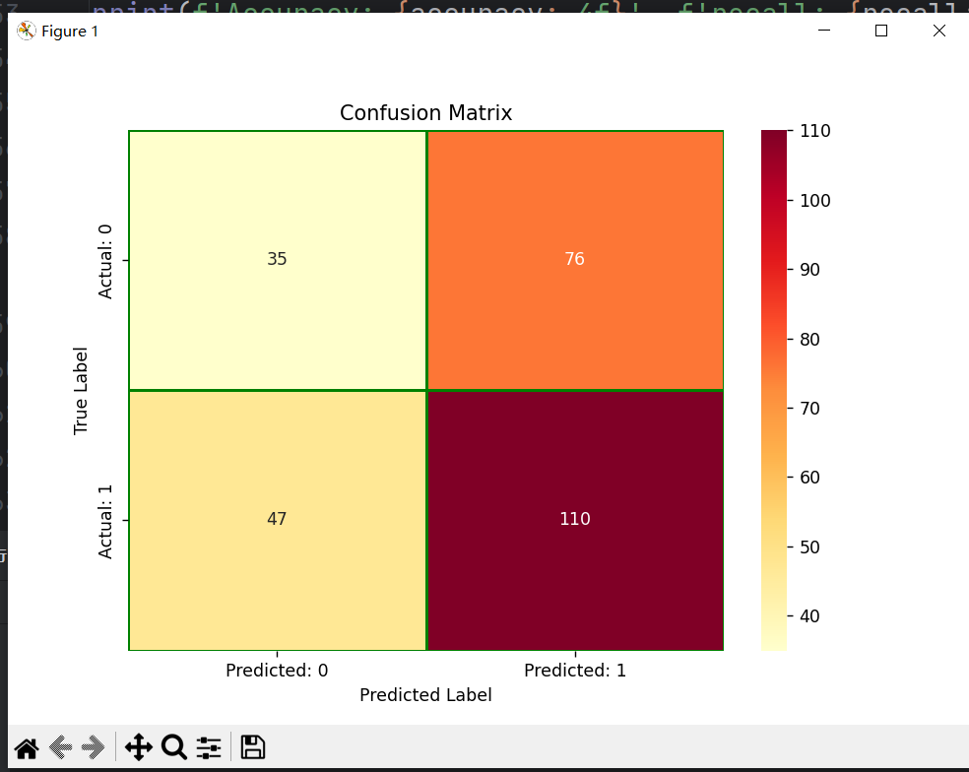

测试集网格搜索：f1值

Best parameters found: {'C': np.float64(8.9), 'gamma': np.float64(9.599999999999998), 'kernel': 'rbf'}
Best cross-validation score: 0.6399293689231242
best svm is SVC(C=np.float64(8.9), decision_function_shape='ovo',
gamma=np.float64(9.599999999999998))
test集交叉验证结果真阴率: [0.64788732 0.61538462 0.73239437 0.57142857 0.6969697 ]
accuracy= 0.5373134328358209 ; recall= 0.7197452229299363 ; f1= 0.6457142857142857
混淆矩阵
[[ 31 80]
[ 44 113]]
tesy集真阴率 0.27927927927927926
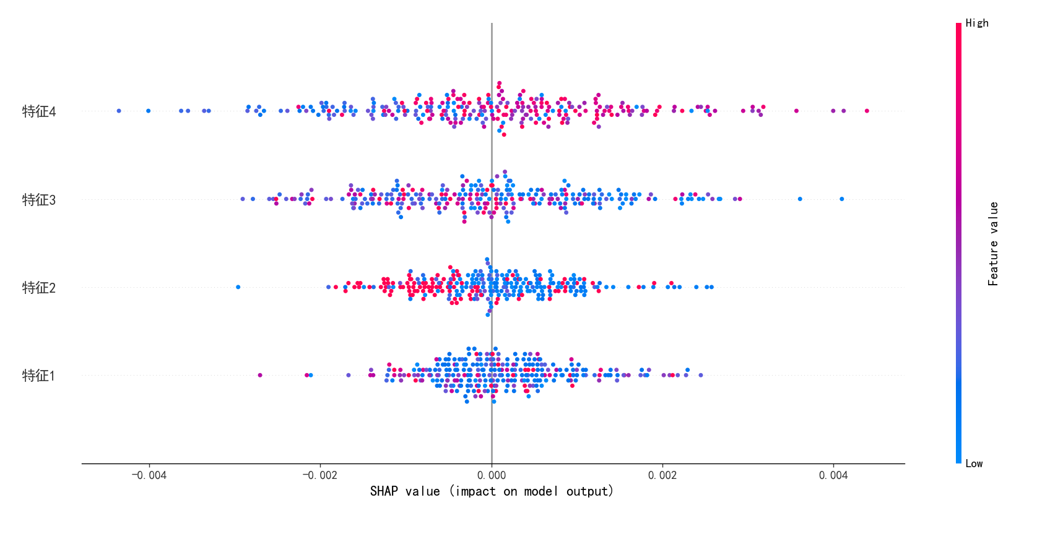

若使用前879数据：
训练集
Accuracy: 0.9976 recall: 0.9960 f1: 0.9980
confusion metrix:
[[167 0]
[ 1 247]]
Classification Report:
precision recall f1-score support

0 0.99 1.00 1.00 167
1 1.00 1.00 1.00 248

accuracy 1.00 415
macro avg 1.00 1.00 1.00 415
weighted avg 1.00 1.00 1.00 415

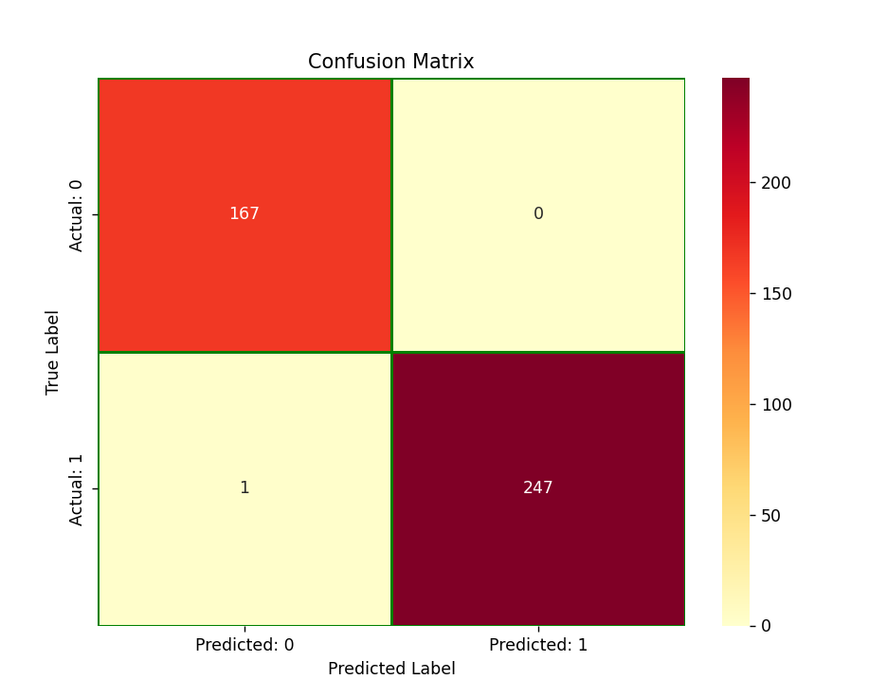

测试集
Accuracy: 0.5899 recall: 0.8037 f1: 0.7020
confusion metrix:
[[19 52]
[21 86]]
Classification Report:
precision recall f1-score support

0 0.47 0.27 0.34 71
1 0.62 0.80 0.70 107

accuracy 0.59 178
macro avg 0.55 0.54 0.52 178
weighted avg 0.56 0.59 0.56 178

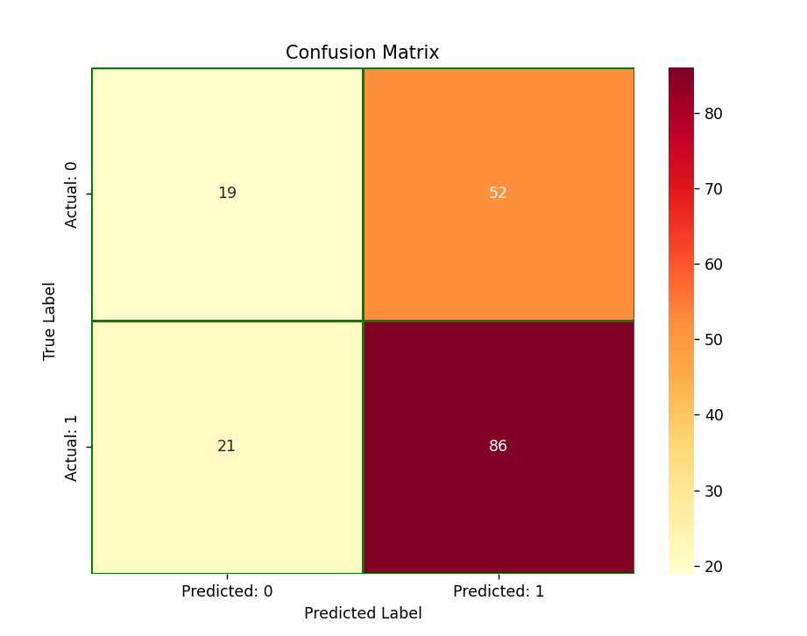
网格搜索：

best parameters found: {'C': np.float64(8.9), 'gamma': np.float64(9.899999999999997), 'kernel': 'rbf'}
Best cross-validation score: 0.7222490875036841
best svm is SVC(C=np.float64(8.9), decision_function_shape='ovo',
gamma=np.float64(9.899999999999997))
test集交叉验证结果真阴率: [0.72727273 0.77777778 0.74509804 0.66666667 0.75 ]
accuracy= 0.5842696629213483 ; recall= 0.794392523364486 ; f1= 0.6967213114754098
混淆矩阵
[[19 52]
[22 85]]
tesy集真阴率 0.2676056338028169
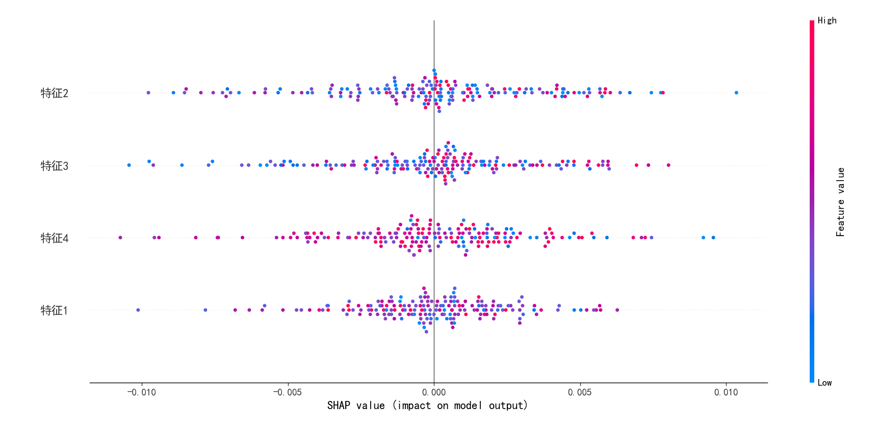

若只保留特征2、4：
训练集：
Accuracy: 0.7880 recall: 0.8387 f1: 0.8254
confusion metrix:
[[119 48]
[ 40 208]]
Classification Report:
precision recall f1-score support

0 0.75 0.71 0.73 167
1 0.81 0.84 0.83 248

accuracy 0.79 415
macro avg 0.78 0.78 0.78 415
weighted avg 0.79 0.79 0.79 415

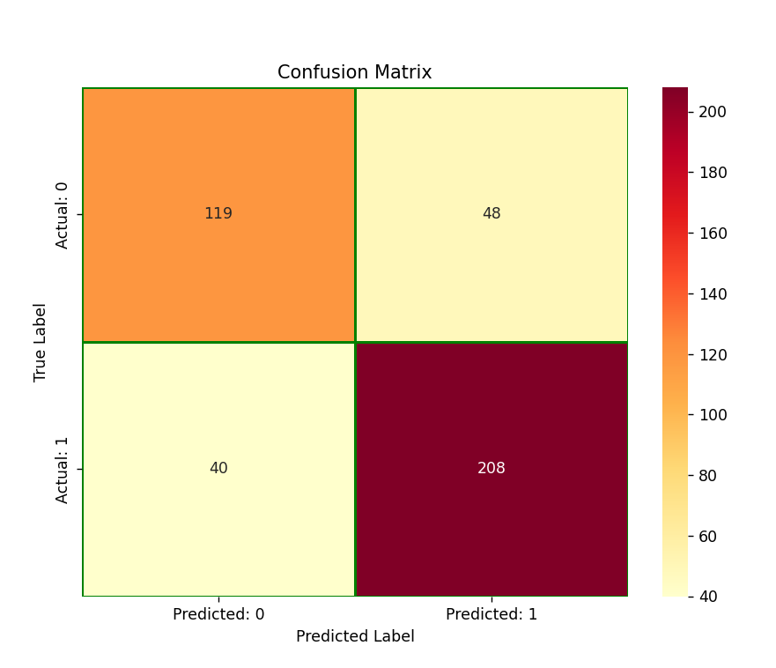

测试集：

Accuracy: 0.4944 recall: 0.5888 f1: 0.5833
confusion metrix:
[[25 46]
[44 63]]
Classification Report:
precision recall f1-score support

0 0.36 0.35 0.36 71
1 0.58 0.59 0.58 107

accuracy 0.49 178
macro avg 0.47 0.47 0.47 178
weighted avg 0.49 0.49 0.49 178

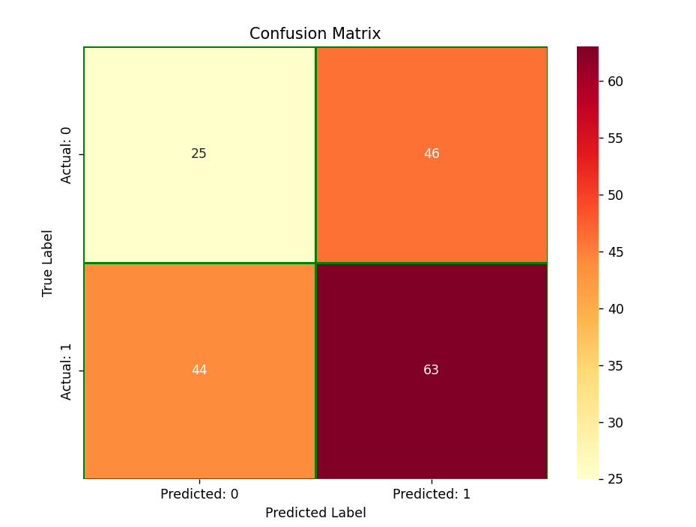

总结：前879组，特征1~4较为管用

