黄昌斌SVM程序+新的GSR3特征：
训练集：
Accuracy: 0.7740 recall: 0.8556 f1: 0.8166
confusion metrix:
[[169 88]
[ 53 314]]
Classification Report:
precision recall f1-score support

0 0.76 0.66 0.71 257
1 0.78 0.86 0.82 367

accuracy 0.77 624
macro avg 0.77 0.76 0.76 624
weighted avg 0.77 0.77 0.77 624

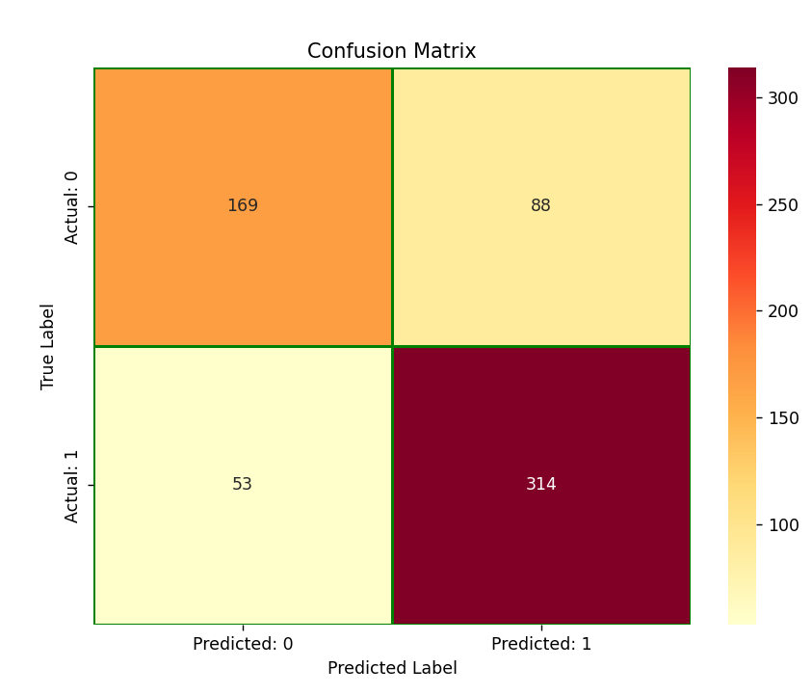

测试集：
Accuracy: 0.5485 recall: 0.6815 f1: 0.6388
confusion metrix:
[[ 40 71]
[ 50 107]]
Classification Report:
precision recall f1-score support

0 0.44 0.36 0.40 111
1 0.60 0.68 0.64 157

accuracy 0.55 268
macro avg 0.52 0.52 0.52 268
weighted avg 0.54 0.55 0.54 268

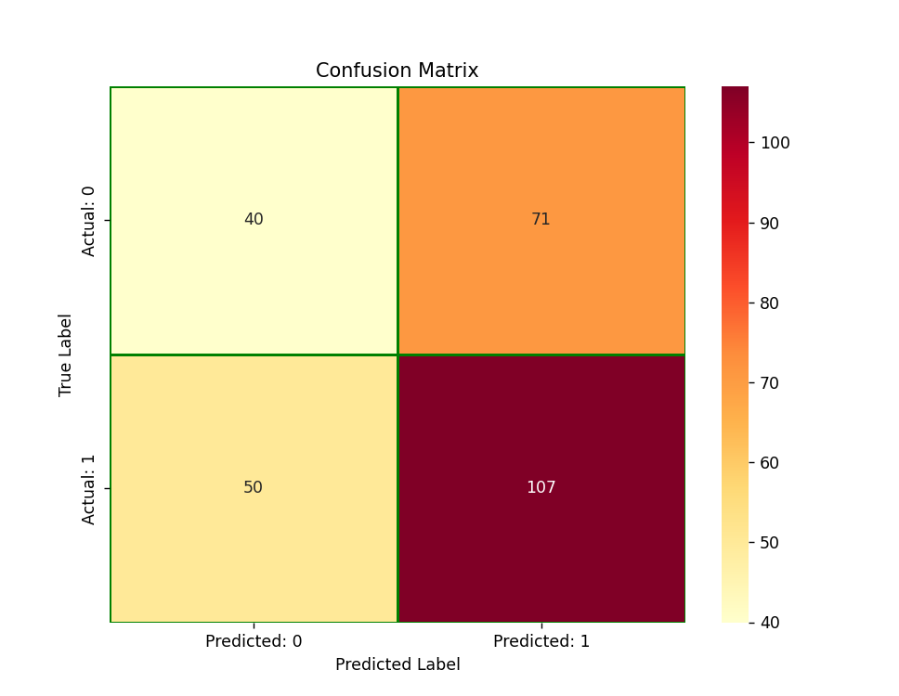

在10附近网格搜索:
训练集：
Best parameters found: {'C': np.float64(9.0), 'gamma': np.float64(9.1), 'kernel': 'rbf'}
Best cross-validation score: 0.6885120431517288
best svm is SVC(C=np.float64(9.0), decision_function_shape='ovo', gamma=np.float64(9.1))
训练集交叉验证结果真阴率: [0.70454545 0.69318182 0.69767442 0.71186441 0.63529412]
accuracy= 0.8974358974358975 ; recall= 0.9455040871934605 ; f1= 0.9155672823218998
混淆矩阵
[[213 44]
[ 20 347]]
训练集真阴率 0.8287937743190662

测试集
Best cross-validation score: 0.6885120431517288
best svm is SVC(C=np.float64(8.9), decision_function_shape='ovo', gamma=np.float64(9.1))
test集交叉验证结果真阴率: [0.69230769 0.7012987 0.69333333 0.68421053 0.71232877]
accuracy= 0.5597014925373134 ; recall= 0.8280254777070064 ; f1= 0.6878306878306878
混淆矩阵
[[ 20 91]
[ 27 130]]
tesy集真阴率 0.18018018018018017

