YogaFlow
Sprint 1 · Project Report 1.0

Requirements workflow / OpenUP
Project | Details
Team | RAS
Team members | Raina Qiu · Andrew Deuley · Shaurya Manhas
Product / client | YogaFlow / Yoga H’om
Document status | Working draft for stakeholder review

Contents
Section | Page
1. Vision | 3
2. Use Case Model | 4
3. Use Case Specifications | 4
4. Supporting Requirements (FURPS+) | 7
5. Glossary | 8
6. Mockups and Validation Questions | 9
7. AI Usage and Critical Review | 10

Figures: 2.1 Use Case Diagram; 3.1 Attendance Activity Diagram; 6.1–6.3 Interactive Prototype Screenshots.

1. Vision

1.1 Background and problem
Yoga H’om runs regular yoga classes, workshops, and special programs. It sells four-class, ten-class, three-month unlimited, and drop-in options for regular classes; workshops and programs are priced separately. The studio currently records purchases on customer cards and attendance on separate paper sheets. Staff must compare those records to check pass usage or look back at attendance.
YogaFlow is intended to replace this split paper process with a shared record of passes, class sessions, and check-ins. The team still needs to confirm how often record mismatches occur and which tasks take the most time.
Table 1.1 — Problem and proposed response
Current issue | Proposed response
Separate paper records for purchases and attendance | Link purchases, passes, and attendance in one system.
Pass balance is not visible in one place | Show pass status and remaining uses to authorized users.
Hard to review activity across classes | Provide a basic sales and attendance summary.

1.2 Vision statement
YogaFlow will help Yoga H’om manage class schedules, pass purchases, and attendance in one place. Staff will be able to record a purchase or check-in without updating separate paper records, and managers will have a clearer view of studio activity.

1.3 Stakeholders and scope
Table 1.2 — Proposed users and needs
User | Main need
Customer | See the schedule and, if self-service is approved, their pass status.
Instructor | See class details and attendance; check-in responsibility is unconfirmed.
Studio Manager | Manage schedules and review pass usage, corrections, and summaries.
Studio Staff (proposed) | Record purchases and check-ins if the studio has this role.

Proposed core features: published schedules, pass purchase records, pass status, check-ins, corrections, and basic reporting. Not included in this first model: advance booking, class capacity limits, online payments, automated notifications, or age verification. Those features may be reconsidered after stakeholder feedback. We still need to confirm pass validity, discount rules, staff permissions, and whether regular passes cover workshops.

1.4 What success looks like
The proposed design should let staff follow a purchase or check-in from start to finish, find a customer’s current pass status, and trace a deduction back to its class. Measurable targets for speed or error reduction can be set after stakeholder review.

2. Use Case Model
The system boundary is YogaFlow. The actors are Customer, Instructor, Studio Manager, and proposed Studio Staff; their needs are listed in Table 1.2. A customer looks up classes or passes; instructors may review attendance; managers oversee schedules and records; staff may handle sales and check-ins. The studio must confirm staff responsibilities. A payment processor is not shown because payment integration has not been agreed.
Table 2.1 — Core use cases
ID | Use case | Main actor(s) | Purpose
UC-01 | View Class Schedule | Customer, Instructor, Manager | Find class times and details
UC-02 | Record Pass Purchase | Staff / Manager | Create a purchase and pass
UC-03 | View Pass Status | Customer / Staff | Check validity and remaining uses
UC-04 | Record Class Attendance | Staff / Instructor | Record check-in and pass use
UC-05 | Manage Class Schedule | Manager | Add, edit, or cancel sessions
UC-06 | Correct Purchase or Attendance Record | Manager | Fix mistakes and preserve history
UC-07 | Review Sales and Attendance Summary | Manager | See basic studio activity

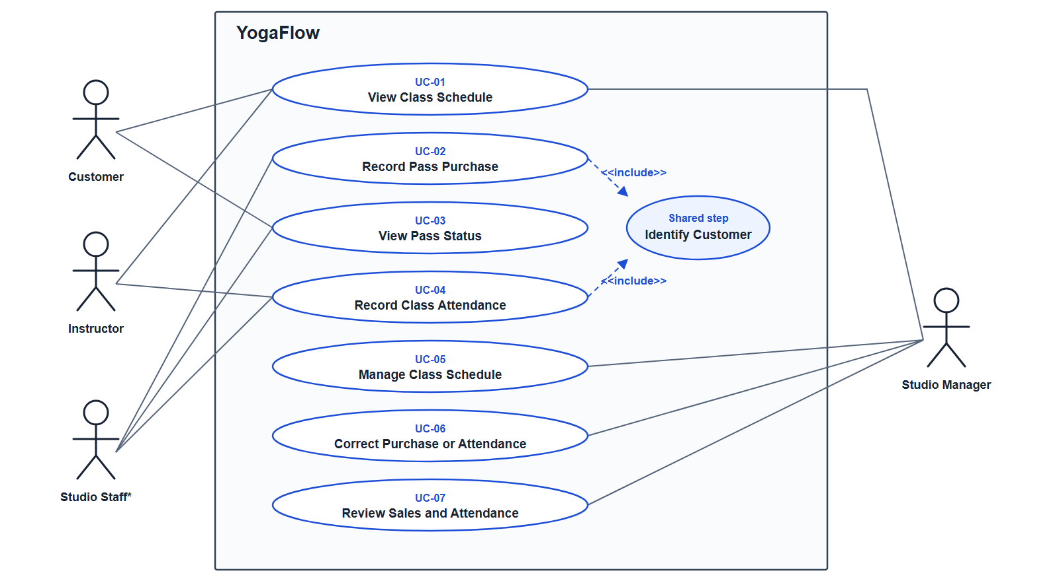
Figure 2.1 — YogaFlow use case diagram. Studio Staff is a proposed role; actor responsibilities require confirmation.
UC-02 and UC-04 address the main paper workflows and are the strongest candidates for deeper design in Sprint 2. The other five use cases support those workflows or provide oversight. The studio will help confirm priorities.

3. Use Case Specifications
These first-iteration specifications focus on user goals, basic flows, and key exceptions. We will expand them after the studio confirms outstanding business rules.

3.1 UC-01 View Class Schedule
Actor(s): Customer, Instructor, Studio Manager
Trigger: The user wants to find a class.
Precondition: A published class session exists.
Main flow
1. The user opens the schedule and selects a date or week.
2. YogaFlow shows session times, class types, and instructors.
3. The user selects a session to view details.
Alternative / exception: If there are no sessions, show an empty schedule. Cancellation display needs confirmation.
Outcome: The selected class details are displayed; no records change.

3.2 UC-02 Record Pass Purchase
Actor(s): Studio Staff or Studio Manager (to confirm)
Trigger: A customer purchases a pass.
Precondition: The customer is identified; pass offerings are available.
Main flow
1. Staff selects or creates the customer record.
2. Staff chooses a pass and enters any applicable discount and payment details.
3. YogaFlow shows the price, validity, and uses for review.
4. Staff confirms; YogaFlow saves the purchase and creates the pass.
Alternative / exception: Unverified discounts require staff review. Payment may be recorded from an external terminal rather than processed in YogaFlow.
Outcome: A purchase and its pass are recorded.

3.3 UC-03 View Pass Status
Actor(s): Customer or Studio Staff (access to confirm)
Trigger: The user needs to check a pass.
Precondition: The user has permission to view the customer record.
Main flow
1. The user opens the customer’s pass list.
2. YogaFlow shows each pass, its validity, and remaining uses where relevant.
3. The user can open a pass to review its history.
Alternative / exception: Show expired and depleted passes clearly. If more than one pass is active, display each; selection rules remain open.
Outcome: Current pass information is displayed; no records change.

3.4 UC-04 Record Class Attendance
Actor(s): Studio Staff or Instructor (to confirm)
Trigger: A customer arrives for a class, or attendance is entered later.
Precondition: The class session exists; the customer can be found.
Main flow
1. Staff opens a session and selects the customer.
2. YogaFlow shows the customer’s eligible passes and drop-in option.
3. Staff selects how attendance will be covered and reviews any deduction.
4. YogaFlow checks for an existing check-in; staff confirms.
5. YogaFlow saves attendance, adjusts the pass if needed, and updates the roster.
Alternative / exception: If no valid pass is found, staff follows the studio’s drop-in or exception policy. A duplicate check-in must not deduct twice.
Outcome: Attendance is linked to the session, customer, and pass or drop-in.

3.5 UC-05 Manage Class Schedule
Actor(s): Studio Manager (to confirm)
Trigger: A class is added, changed, or canceled.
Precondition: The user has schedule-editing permission.
Main flow
1. The manager chooses a session or creates a new one.
2. The manager enters the class type, time, and instructor.
3. YogaFlow saves and publishes the update.
Alternative / exception: Missing details block saving. Rules for cancellation and edits after attendance need confirmation.
Outcome: The schedule reflects the change.

3.6 UC-06 Correct Purchase or Attendance Record
Actor(s): Studio Manager (to confirm)
Trigger: An incorrect purchase or check-in is reported.
Precondition: An incorrect record exists; the user has correction permission.
Main flow
1. The manager opens the record and reviews the related pass balance.
2. The manager enters a correction and reason; YogaFlow previews the effect.
3. The manager confirms; YogaFlow updates the record and keeps the correction history.
Alternative / exception: Reject corrections that create conflicting check-ins or invalid balances until resolved.
Outcome: The corrected state and original action remain traceable.

3.7 UC-07 Review Sales and Attendance Summary
Actor(s): Studio Manager
Trigger: The manager wants to review studio activity.
Precondition: The manager can view reports.
Main flow
1. The manager chooses a date range.
2. YogaFlow shows recorded purchases and class attendance.
3. The manager can open supporting records for a total.
Alternative / exception: Show an empty state when no data exists. Filters and exports need confirmation.
Outcome: A summary of recorded activity is displayed; no records change.

3.8 Activity Diagram for UC-04
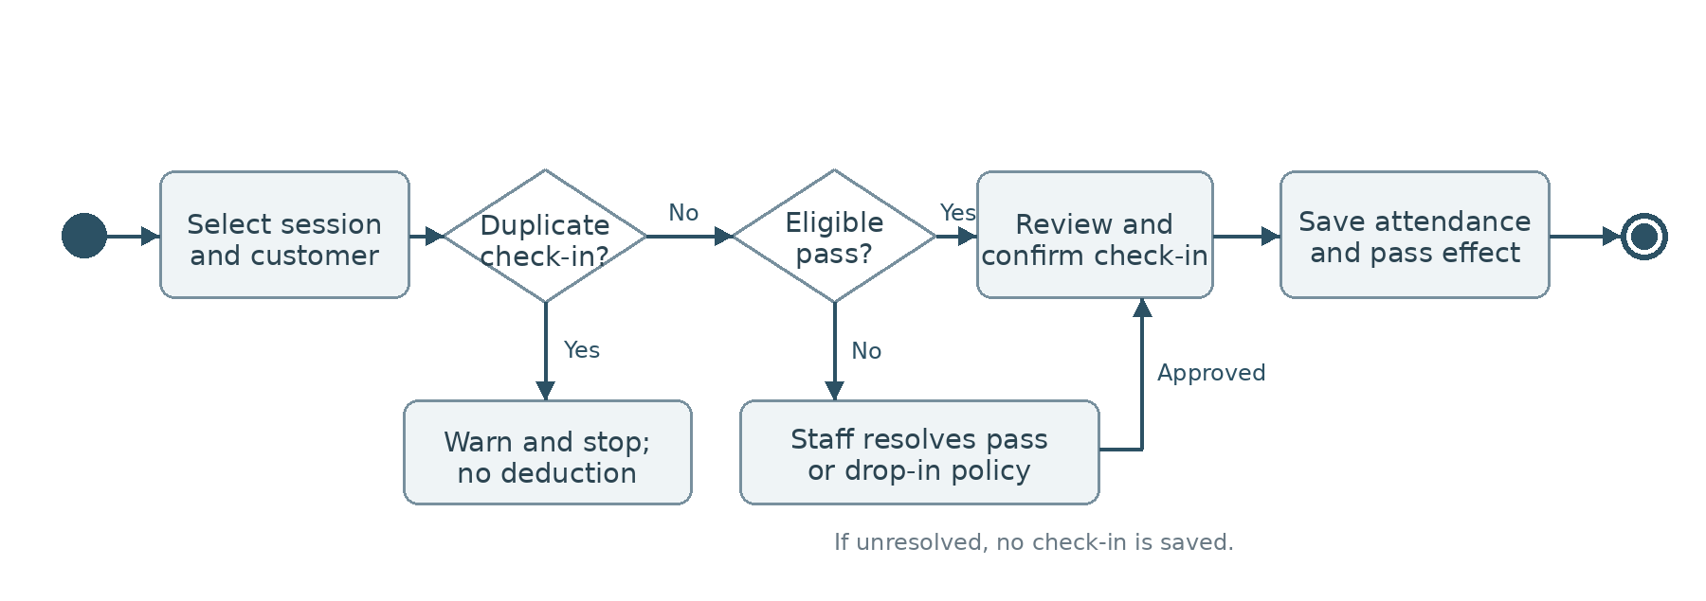
Figure 3.1 — Proposed check-in activity diagram (pending policy and role confirmation).

4. Supporting Requirements
These requirements cover cross-cutting rules and qualities not fully specified by individual use cases. They follow FURPS+ and remain subject to stakeholder review.

4.1 Functionality (F)
Table 4.1 — Functionality requirements
ID | Requirement | Reason / follow-up
SR-F-01 | Distinguish regular classes, workshops, and program series. | Different prices and possible rules.
SR-F-02 | Support 4-class, 10-class, 3-month unlimited, and drop-in options. | Confirm validity and use rules.
SR-F-03 | Apply the studio’s confirmed senior discount policy. | Eligibility checks are open.
SR-F-04 | Link each check-in to a session, customer, and pass or drop-in. | Makes deductions traceable.
SR-F-05 | Use the same confirmed pass-validity rules across purchase, pass status, and check-in. | Avoid inconsistent pass results.

4.2 Usability (U)
Table 4.2 — Usability requirements
ID | Requirement | Reason / follow-up
SR-U-01 | Before check-in, show the session, customer, pass status, and deduction. | Staff can catch mistakes.
SR-U-02 | Label passes as active, expired, or depleted; show dates and uses. | Pass status should be clear.
SR-U-03 | Explain errors and what the user can do next. | Validate in mockups.

4.3 Reliability (R)
Table 4.3 — Reliability requirements
ID | Requirement | Reason / follow-up
SR-R-01 | Save attendance and any related deduction as one operation. | Avoid mismatched records.
SR-R-02 | Repeated check-in requests must not create extra deductions. | Handle retry or double-click.
SR-R-03 | Keep the previous value, new value, user, time, and reason for corrections. | Support review and reconciliation.

4.4 Performance (P)
Table 4.4 — Performance requirements
ID | Requirement | Reason / follow-up
SR-P-01 | Schedule lookup and check-in should meet an agreed response-time target during class arrival. | Target and expected volume to confirm with studio.

4.5 Supportability (S)
Table 4.5 — Supportability requirements
ID | Requirement | Reason / follow-up
SR-S-01 | Authorized managers should be able to edit schedules and applicable prices or pass settings. | Confirm which settings staff controls.
SR-S-02 | Summary totals should be traceable to purchase and attendance records. | Help explain discrepancies.

4.6 Plus: Constraints and Interfaces
Table 4.6 — Plus requirements
ID | Requirement | Reason / follow-up
SR-+-01 | Restrict customer data, transactions, and corrections by user role. | Confirm permissions.
SR-+-02 | Collect only customer information needed for approved workflows. | Confirm required fields.

Open decisions (not confirmed requirements): whether YogaFlow processes payments or only records them; target platform and integrations; backup approach; and accessibility expectations. These will be defined after stakeholder review.

5. Glossary
Table 5.1 — Domain terms used in this report
Term | Meaning
Class session | One scheduled occurrence of a class at a specific date and time.
Regular class | A weekly class eligible for standard passes, subject to studio rules.
Workshop | A separately priced class or event; pass eligibility is unconfirmed.
Special program series | A multi-session offering with its own price and rules.
Class pass | A purchase that allows entry to eligible classes for a period.
4-class / 10-class pass | A pass with four or ten available visits, respectively.
Unlimited pass | A three-month pass without a per-class visit balance.
Drop-in | One class attended without using a multi-class or unlimited pass.
Validity period | Dates when a pass can be used; exact boundaries are unconfirmed.
Remaining uses | Eligible visits left on a limited pass.
Check-in | Recording a customer’s attendance and how it is covered.
Attendance record | A link between a customer, class session, and pass or drop-in.
Senior discount | A reduced pass price for eligible seniors; rules need confirmation.
Studio Staff | Proposed role for purchase and check-in tasks, if applicable.

6. Mockups and Validation Questions
We built an interactive front-end prototype to show how YogaFlow might support the studio’s daily tasks. The screens use sample records and let us try the proposed workflows before deciding on the final design. The prototype runs in a browser and stores demo changes locally; it does not have a backend or payment processing. The screenshots below will be added from the running prototype.
Prototype: https://github.com/RainaQiu/YogaFlow-OOD

6.1 Class schedule
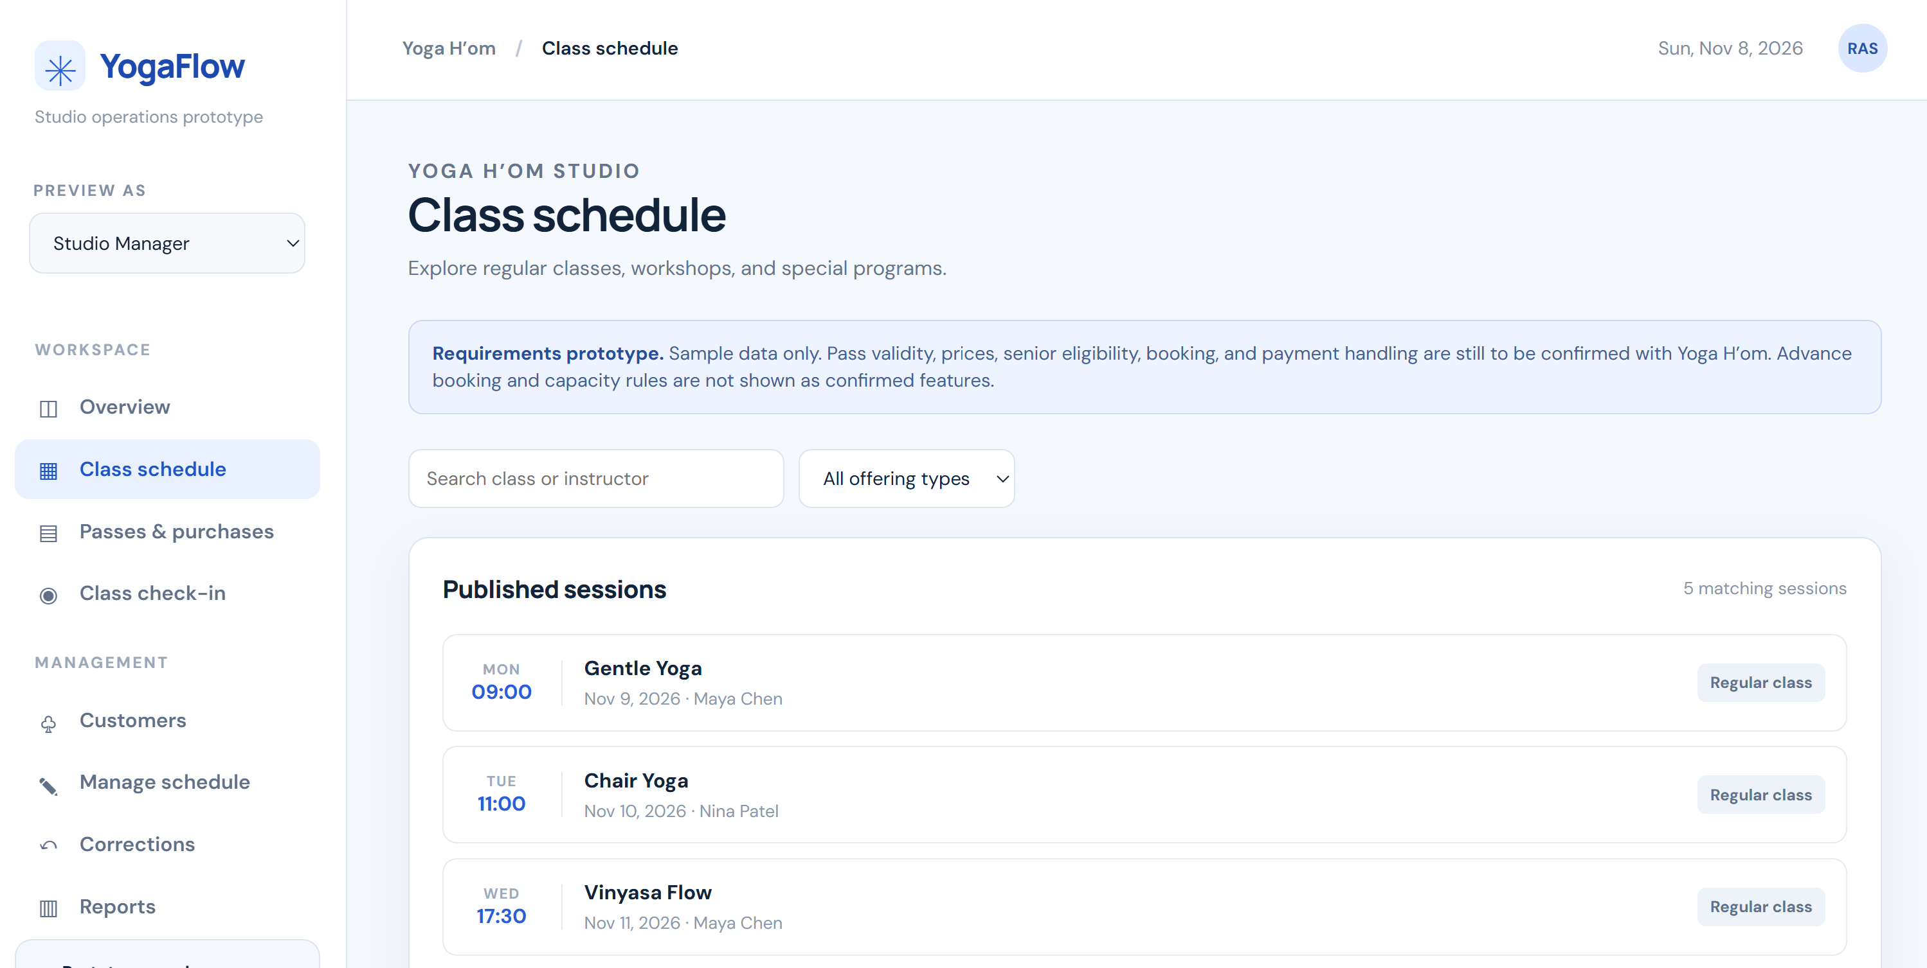
Figure 6.1 — Class Schedule screen (UC-01).
Validation question: Are the class type, instructor, date, and time enough for customers? Should the schedule also show prices, cancellations, or booking options?

6.2 Pass purchase and status
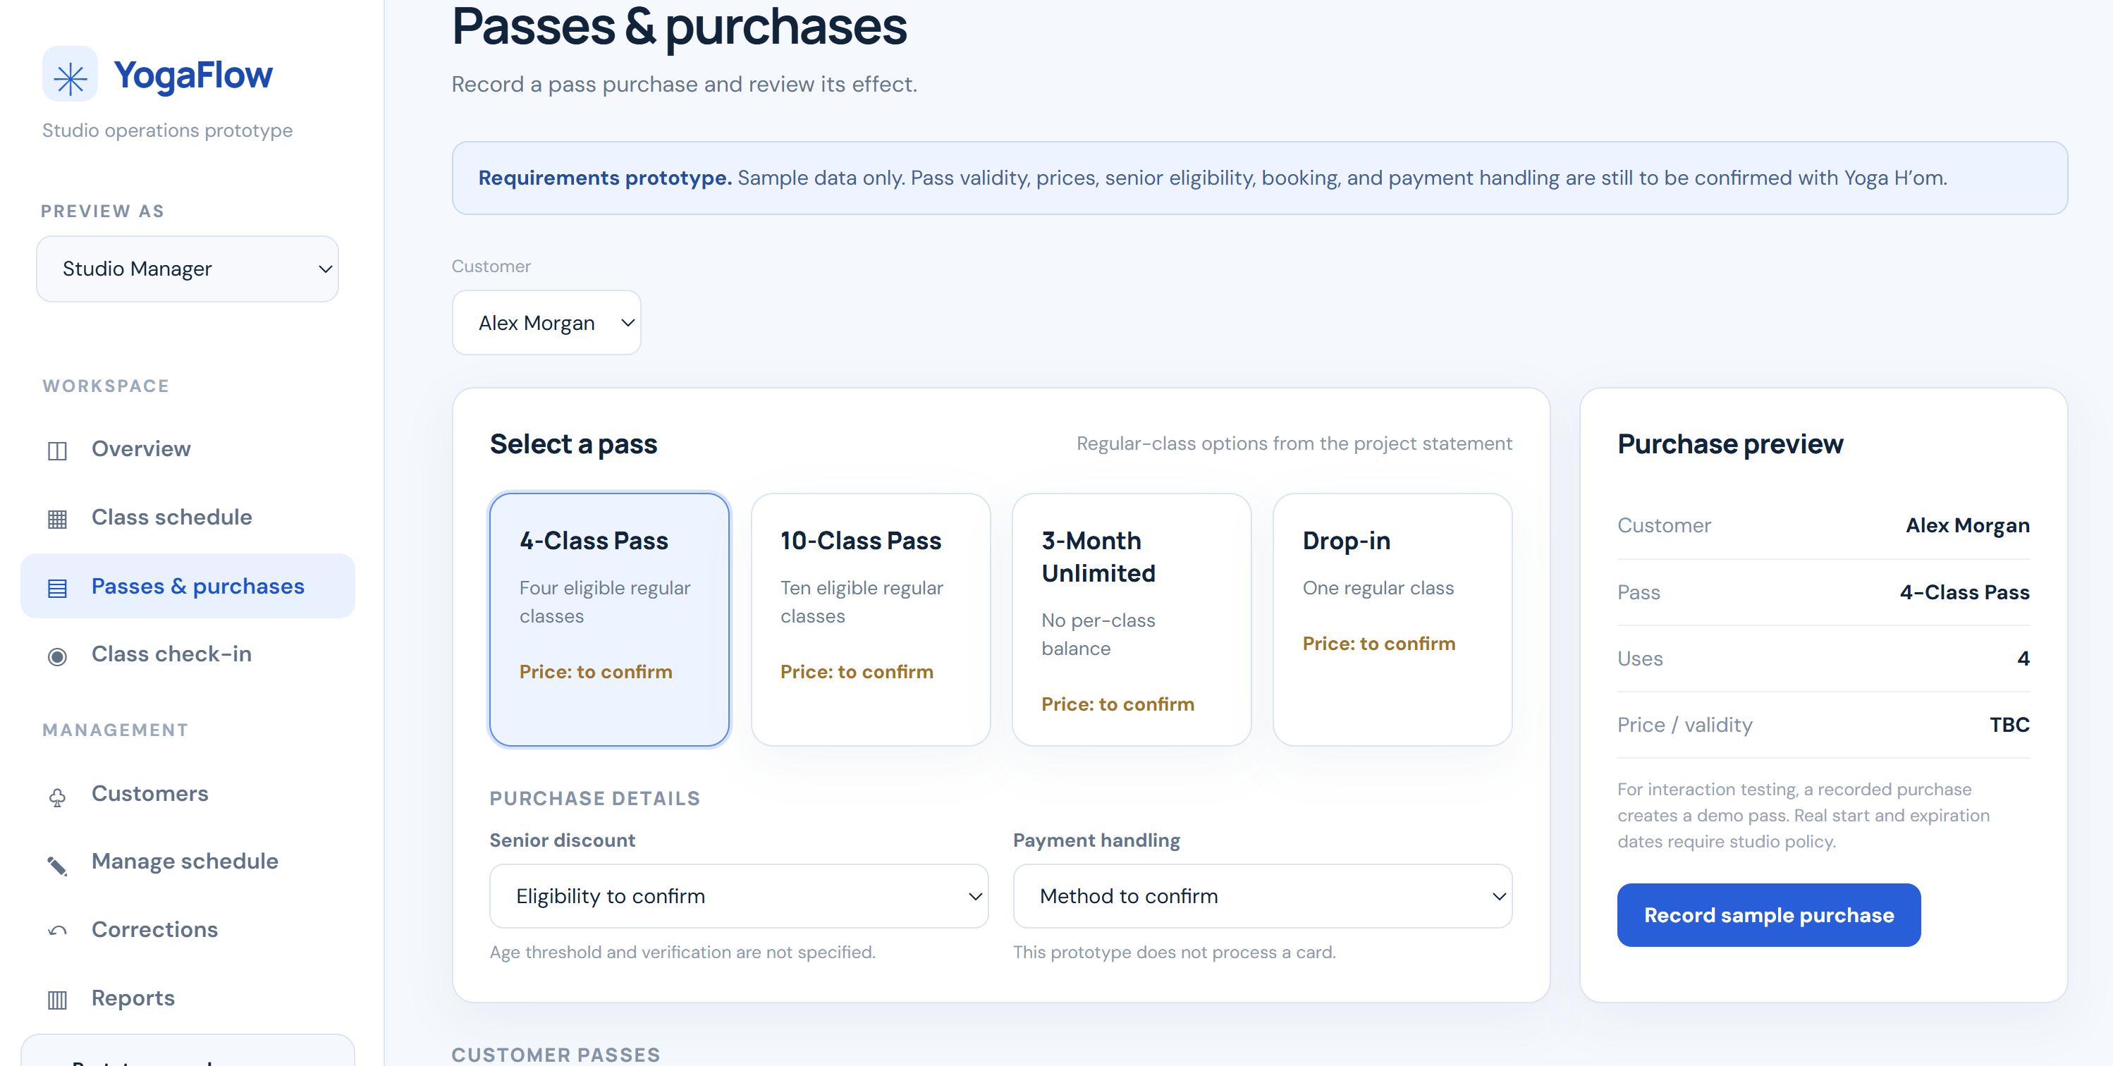
Figure 6.2 — Pass purchase and status screen (UC-02, UC-03).
Validation question: When does a pass become valid? How should staff handle senior discounts and record payments?

6.3 Class check-in
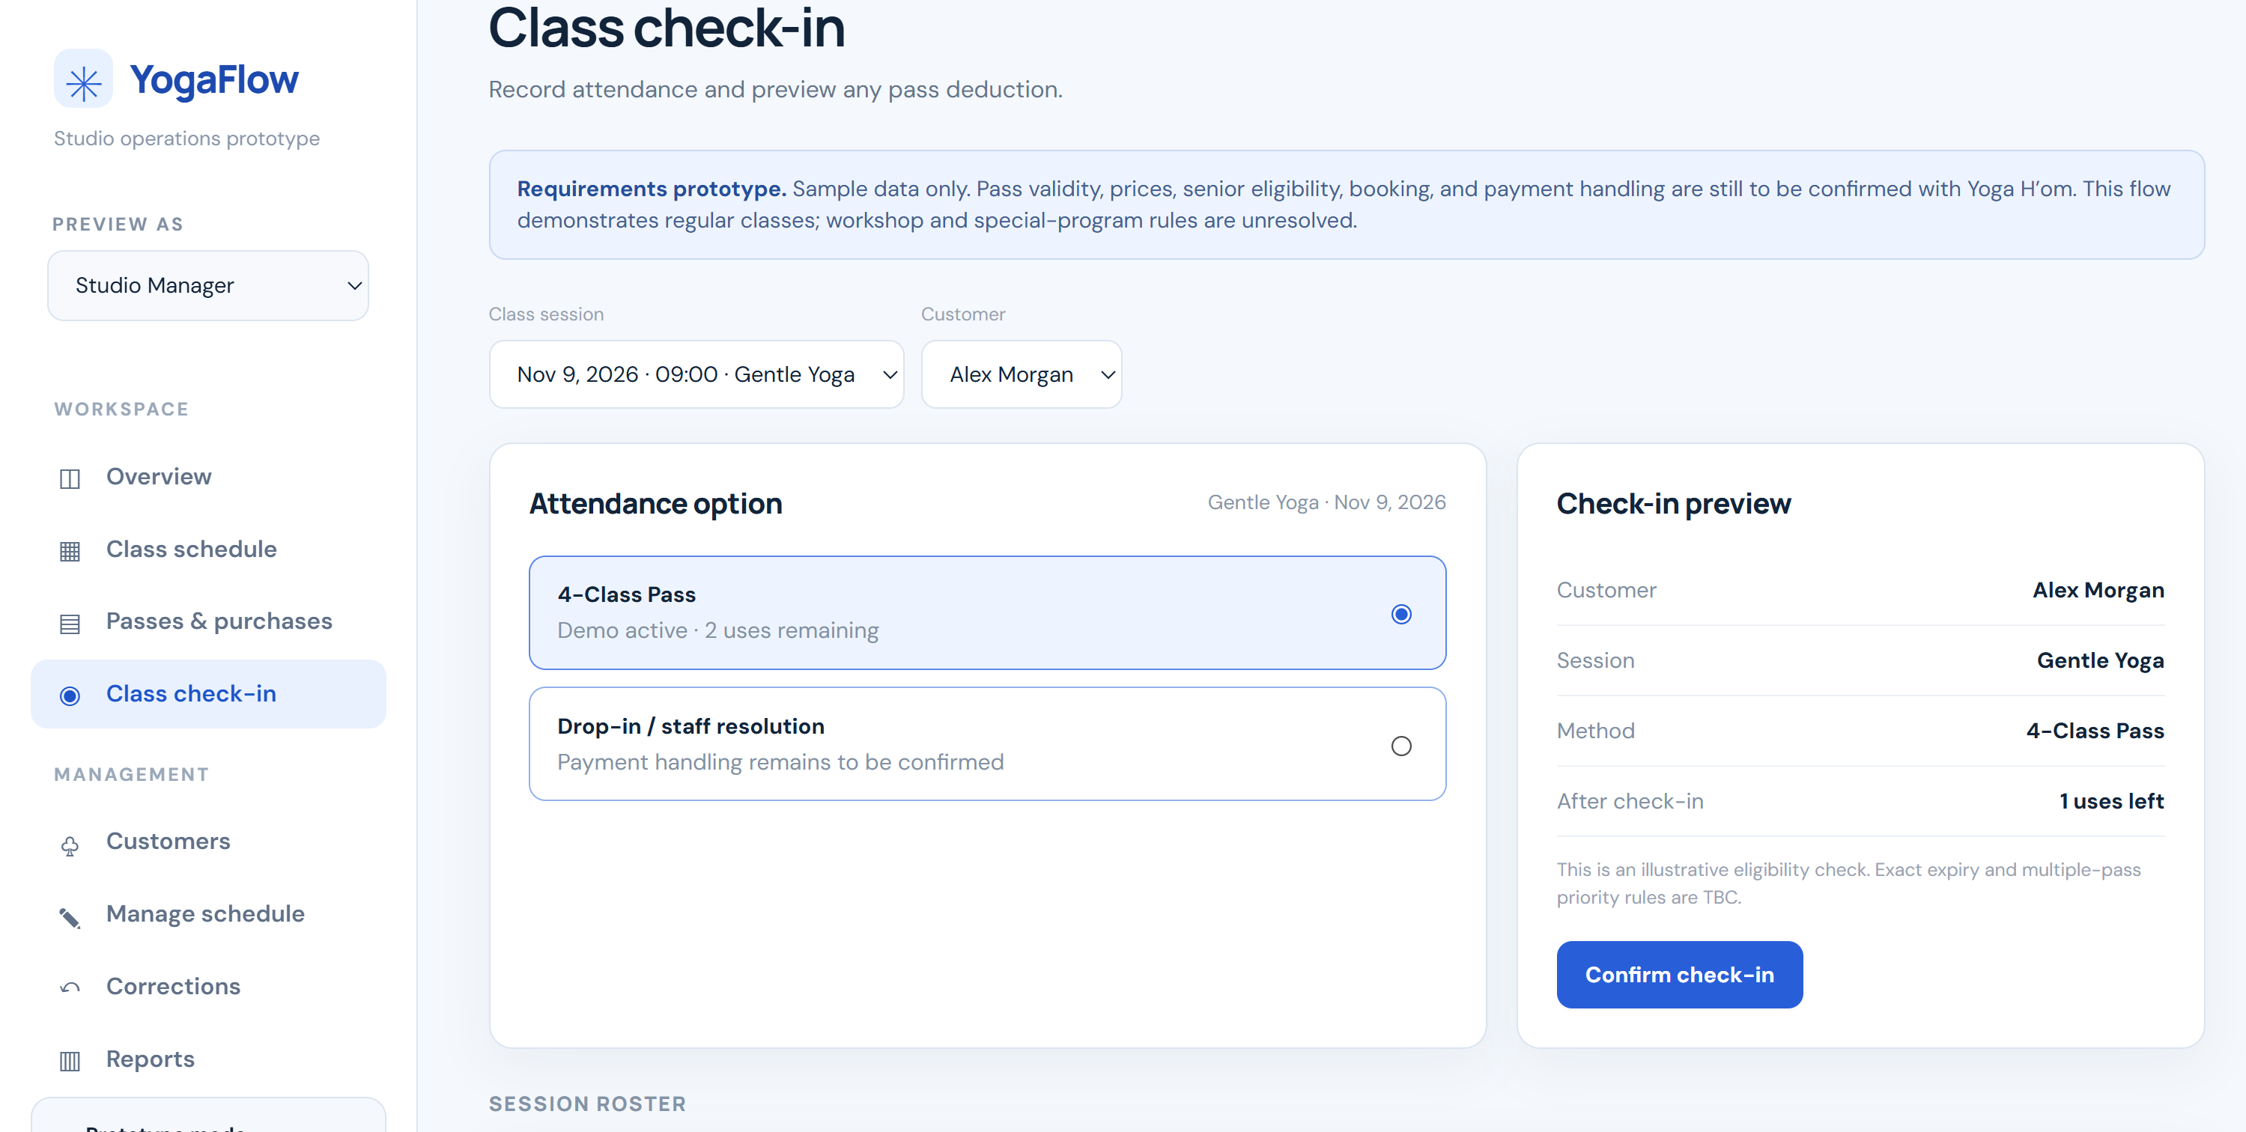
Figure 6.3 — Class check-in screen (UC-04).
Validation question: Who performs check-in? What should happen if a customer has no eligible pass or has already checked in?

6.4 Prototype scope and feedback
The prototype also includes schedule management, corrections, and basic reports, which we can demonstrate during the presentation. Prices, validity rules, roles, and payment handling are still examples or open decisions. We have not recorded stakeholder feedback yet; after the review, we will note any changes needed and update the related use cases.

7. AI Usage and Critical Review

7.1 How AI was used
We used ChatGPT to review our report structure, improve wording, and check consistency between the use cases, diagrams, and supporting requirements. We compared the suggestions with the project statement and Sprint 0 questions. The team will also document any AI assistance used to build or test the front-end prototype before final submission.

7.2 What we checked
AI suggestions sometimes treated open policy questions as settled facts. We kept payment processing, pass validity, discount rules, bookings, and staff responsibilities open and checked that use-case names match across the report. The interactive prototype is for stakeholder review; it has not been validated by the studio.

7.3 Implications for later sprints
For later sprints, AI may be useful for checking changes across requirements, diagrams, and test scenarios. We will use stakeholder decisions, not AI-generated assumptions, to decide what goes into the final design.

