Project: Excel PM Dashboard

Dataset: Personal

Tools: Excel

# Steps

1. Make a copy of the data file and save it as an Excel Workbook (.xlsx)



1. The workbook has worksheets for Teams, Activities and Issues
2. 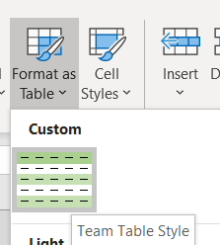Format Team Details as Table

|  |  |
| --- | --- |
| Member | Team |
| Jukka P | Team A |
| Jarmo H | Team B |
| Anant S | Team C |
| John W | Team C |
| Selena G | Team B |
| Ryan H | Team B |
| Tanya K | Team A |
| Lin H | Team B |
| Yani T | Team A |
| Jose D | Team C |
| Lucy C | Team C |
| wayne B | Team B |

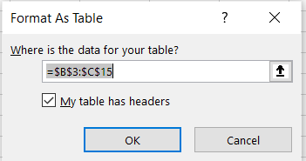

1. Format Project Activities as Table

|  |  |  |  |  |  |  |
| --- | --- | --- | --- | --- | --- | --- |
| Activity | Feature | Category | Owner | Start Date | End Date | % Done |
| A-001 | Feature-1 | Specifications | Jukka P | 22-Oct-21 | 26-Oct-21 | 100% |
| A-002 | Feature-1 | Design | Jarmo H | 26-Oct-21 | 31-Oct-21 | 100% |
| A-003 | Feature-1 | Development | Selena G | 2-Nov-21 | 7-Nov-21 | 65% |
| A-004 | Feature-1 | Testing | Anant S | 7-Nov-21 | 11-Nov-21 | 0% |
| A-005 | Feature-1 | Deployment | John W | 11-Nov-21 | 14-Nov-21 | 0% |
| A-006 | Feature-2 | Specifications | Tanya K | 22-Oct-21 | 27-Oct-21 | 100% |
| A-007 | Feature-2 | Design | Ryan H | 25-Oct-21 | 28-Oct-21 | 100% |
| A-008 | Feature-2 | Development | Lin H | 29-Oct-21 | 2-Nov-21 | 95% |
| A-009 | Feature-2 | Testing | Jose D | 4-Nov-21 | 6-Nov-21 | 55% |
| A-010 | Feature-2 | Deployment | Lucy C | 6-Nov-21 | 7-Nov-21 | 0% |

1. Create Relationships between Team and Activities tables

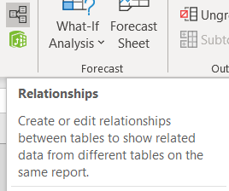

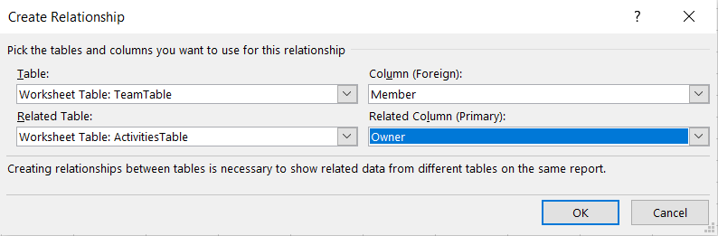

The relationship is created on column ‘Member’ in TeamTable and the column ‘Owner’ in ActivitiesTable

1. Create a new worksheet ‘Calculations’



1. Insert ‘Pivot Table’ into Calculations worksheet. Option -> ‘Use this workbook’s Data Model’

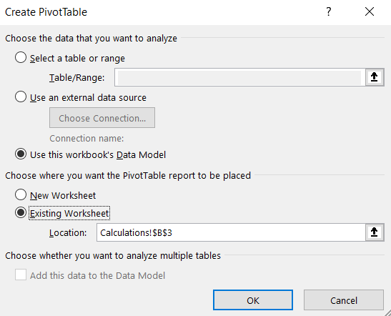

1. Choose:

**Activities Tables**

Rows -> Feature, Category, activity

Values -> Start Date, End Date

1. In the Main Worksheet Window:

Design > Report Layout > Show in outline form

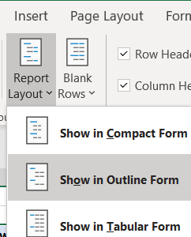

This will ensure that the Feature, Category and Activity have their own separate columns

1. Summarise ‘Start Date’ as Min, and ‘End Date’ as Max

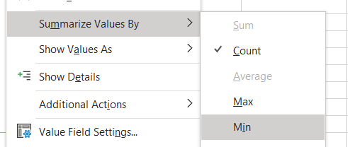

1. Show ‘Subtotals at the top’

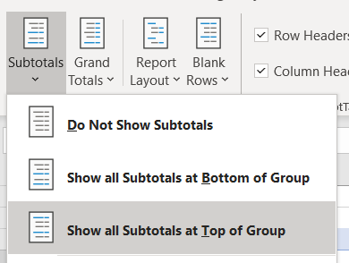

1. In the Project Activities sheet, Set the dates from where to start the Gantt Chart (Today + Start Date) and name it as ‘start.date’

  

1. Create a new worksheet ‘Gantt Chart’, and name the data that would be used:

Feature, Category, Activity, Member, Start, End, %

1. At cell K4 insert the start.date, and mark the next cell as K4 + 1. Extend the two cells to 75 more cells



Copy this row twice under the above row



Format the middle row as custom ‘d’ to display only the day portion of the Date e.g 22

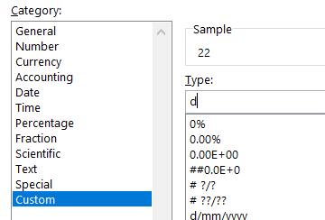

Format the lower row as custom ‘mmmmm’ to display the month as three letters e.g. O for October

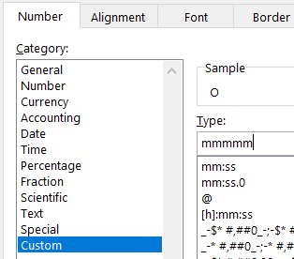

1. Copy all the data from the ‘Calculations’ worksheet, and paste it under the headings we had marked earlier in ‘Gantt Chart’ worksheet as ‘link’

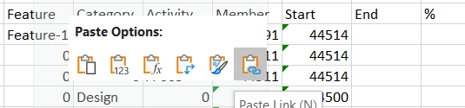

1. Move the data currently under ‘Member’ and ‘Start’ columns to ‘Start’ and ‘End’ columns

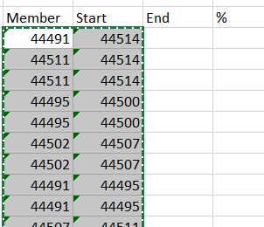 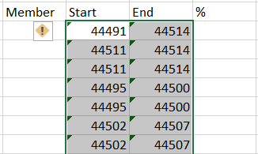

1. If the cell is empty it’s displayed as ‘0’. This can be fixed by using as IF condition:

=IF(Calculations!B5=0,"", Calculations!B5)

And extend this to all the data under columns ‘Feature, Category, Activity’

1. We also need to change the format for ‘Start’ and ‘End’ columns to date.

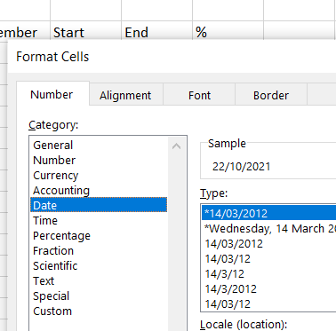 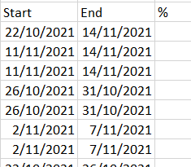

1. We now move on to create logic for displaying Gantt Chart. We use the following formula to see if the date at the top of the column is outside the ‘Start’ and ‘End’ dates

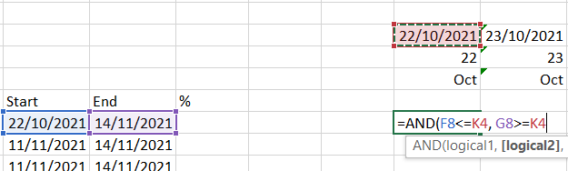

Edit the formula to refer to absolute column and row numbers

=AND($F8<=K$4, $G8>=K$4)

Extend this formula to the whole of Gantt Chart area.

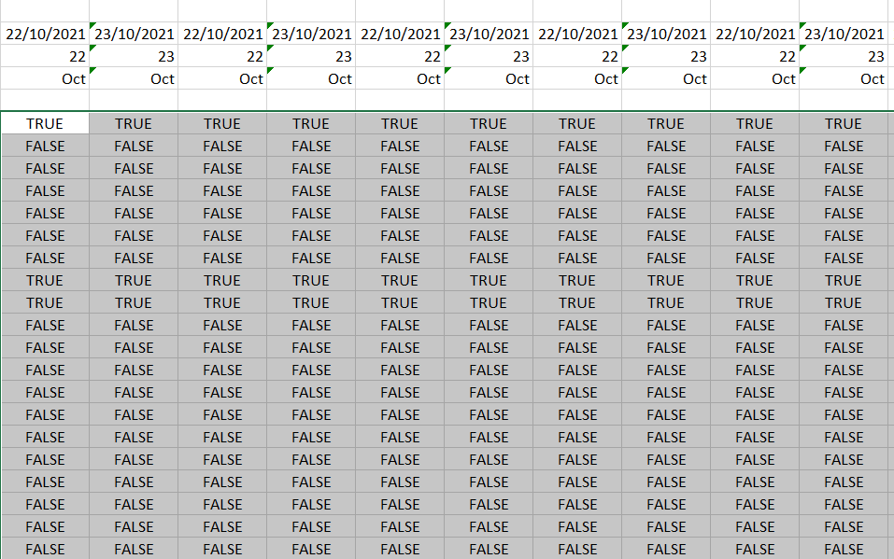

1. Create conditional formatting rule for TRUE values

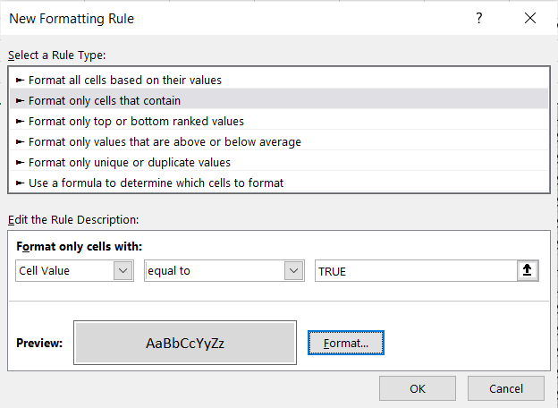

This will display the TRUE values as follows:

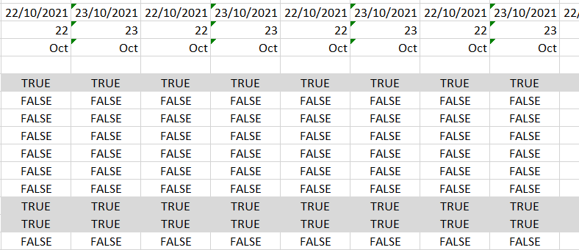

1. To get rid of TRUE and FALSE displayed within the cells, we format the cells to display nothing

by using ‘;;;’ in the custom formatting.

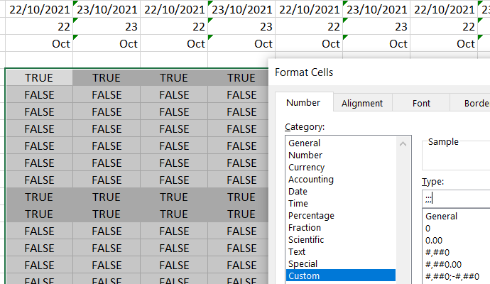

1. Narrow down the columns in the Gantt Chart display area

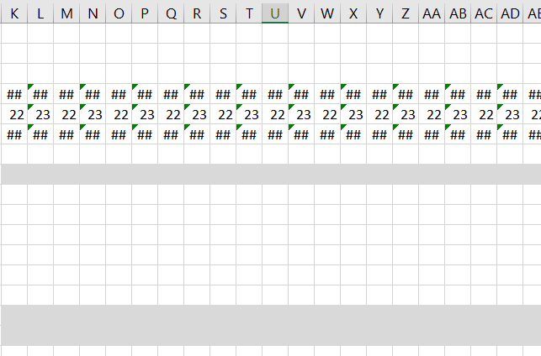

1. To insert the ‘Resource’ details, we lookup in the ‘Activities’ sheet for the ‘Activity ID’ and the ‘Owner’ of that activity.

=XLOOKUP(D10, ActivitiesTable[Activity],ActivitiesTable[Owner],"")

Extend it to the whole column.

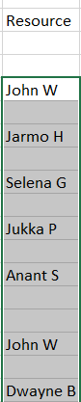

1. To insert the ‘%’ data, we lookup in the ‘Activities’ sheet for the ‘Activity ID’ and the ‘% Done’ value of that activity.

=XLOOKUP(Activities!B4, ActivitiesTable[Activity],ActivitiesTable[% Done], "")

Format the cell as %, if it doesn’t come up as a % value automatically.

Extend it to the whole column.

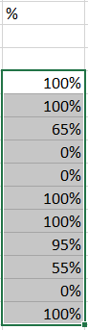

1. Add the visualisation as ‘colour’ for % column by using

Conditional Formatting > Data Bars > Solid Fill > Green Data Bar

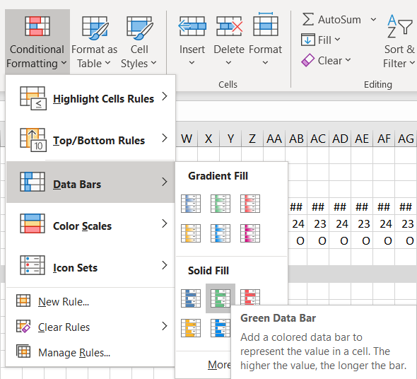 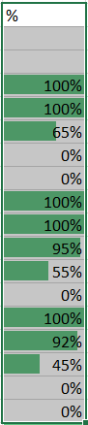

To display only the green bar

Conditional Formatting > Manage Rules

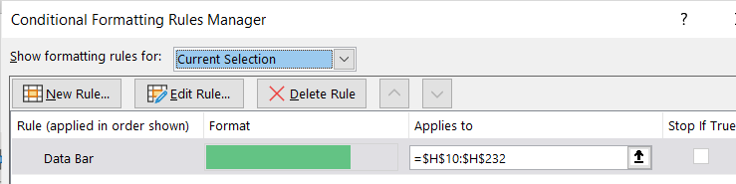

Edit Rule > Select ‘Show Bar Only’, and in the next column get the previous value (=H8). Extend rules to the whole columns

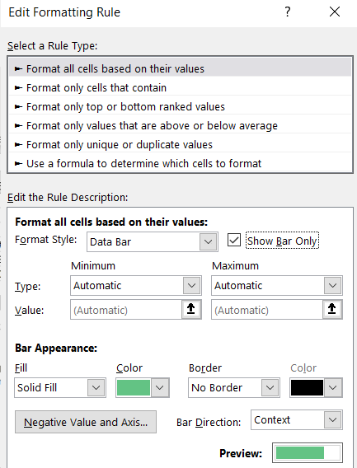 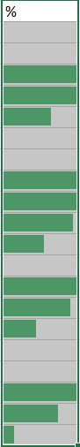 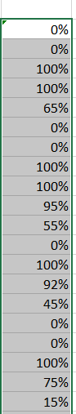

1. To add Icons for Completion of the activity in % values column

Conditional Formatting > Icon Sets > 3 Symbols (Uncircled)

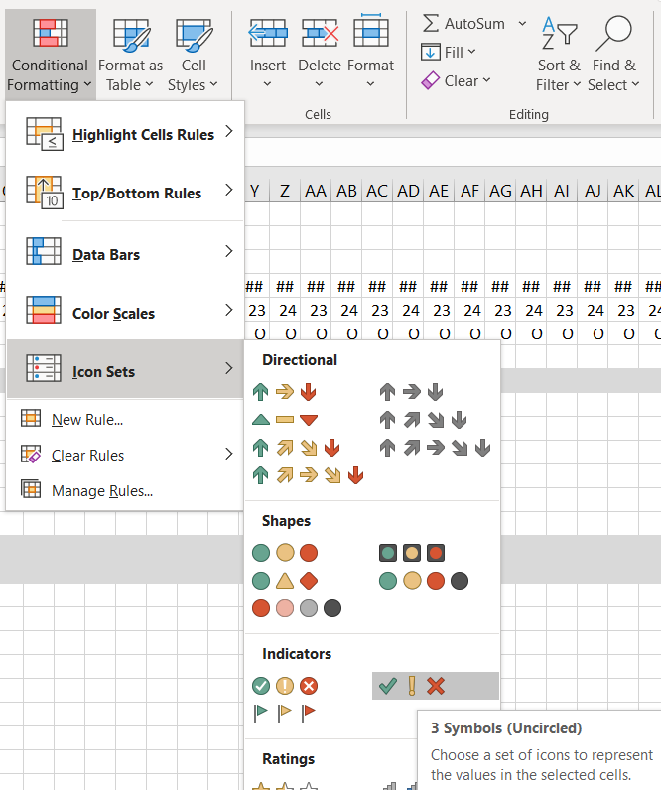 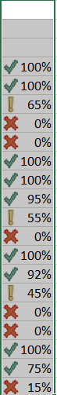

Edit the rule to display Tick Mark only when the activity is completed (>=1), else No Icon. Also change the ‘Type’ to Number. And make the % values disappear with ‘;;;’ custom format.

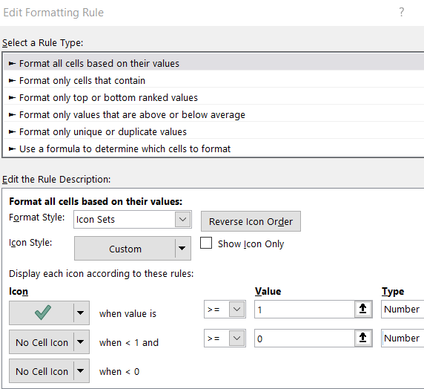 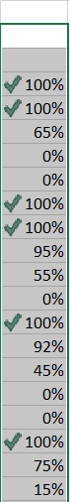 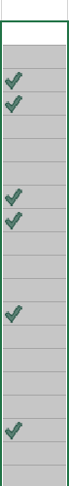 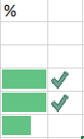

Narrow down the column to tidy it up.

1. To highlight the current day.

Select all the Gantt Chart area, also including the two bottom rows (day & month) out of the 3 date rows at the top.

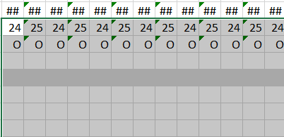

Create a new ‘Conditional Formatting’ rule: K$5=TODAY()

where, K5 is the first cell holding the date value. Lock the formula to that row number ($5). And choose a colour (e.g. Blue) to highlight today’s date as a vertical bar.

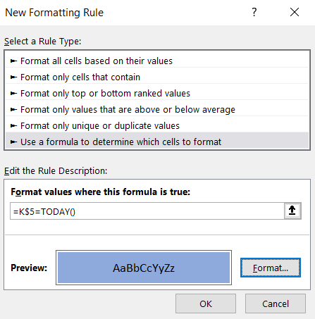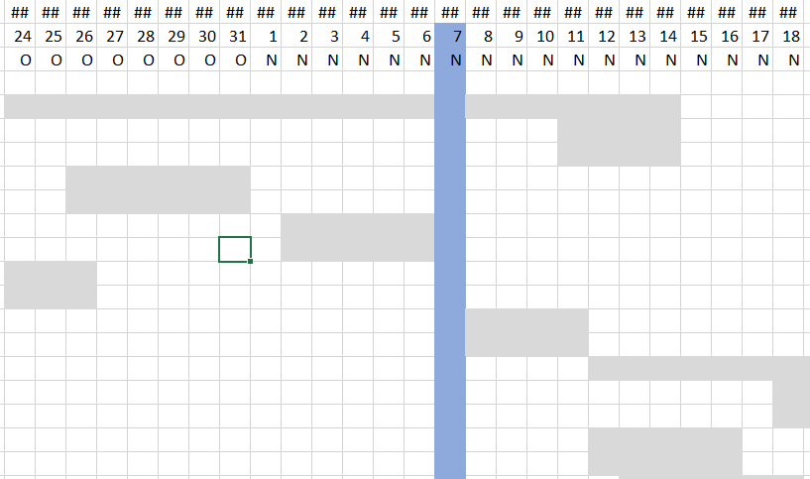

For aesthetics, we could also push the ‘today date bar’ to the background, if the activity is still active today.

Conditional Formatting > Manage Rules.

Push the above rule down, so that the ‘cell value = TRUE’ rule is applied first

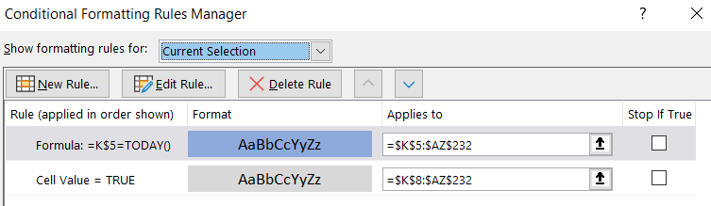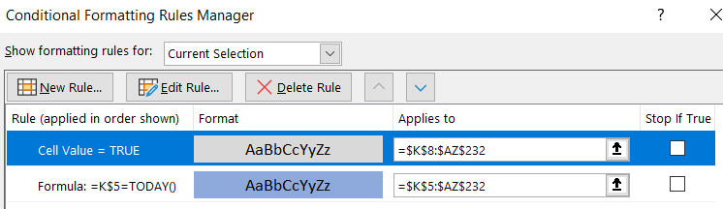

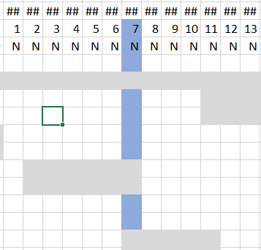

1. To highlight the header of the Gantt Chart, we could use a colour format to fill that area

Cell Styles > Data and Model > Neutral

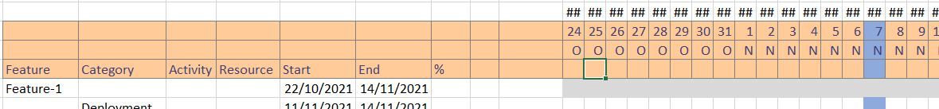

1. To add some interaction to the Gantt Chart we will add a ‘slicer’ to have an option to filter activities relate to a ‘team’.

All the input for ‘Gantt Chart’ Worksheet comes from the Pivot Table on the ‘Calculations’ worksheet. Add a ‘Slicer’ on that sheet for the ‘Team’

Select the TeamTable and right click on the ‘Team’ to ‘Add as Slicer’

Similarly select the ActivitiesTable and right click on the ‘Feature’ to ‘Add as Slicer’

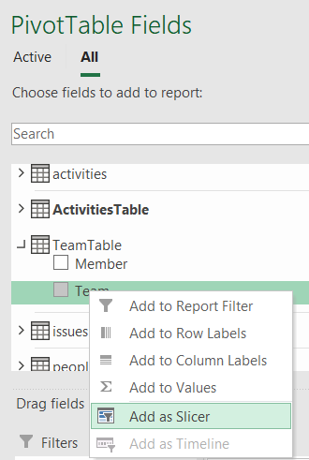 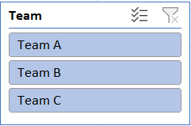 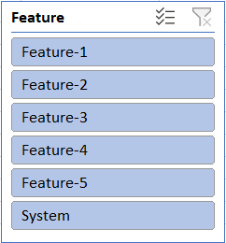

Move these Slicers to the ‘Gantt Chart’ worksheet. As the data for that comes from the Pivot Table, this slicer would apply to it too. These can be placed at the top left of the Worksheet.

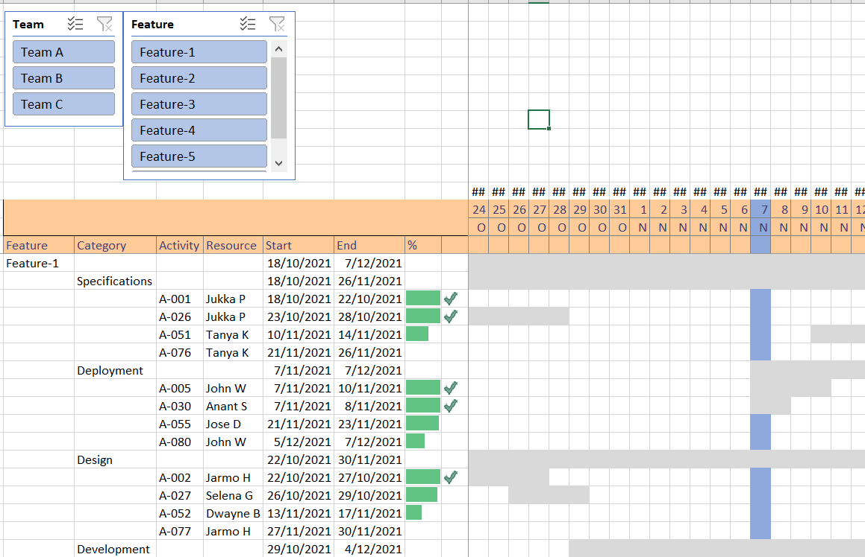

Now if we select one of the teams from here, it will filter out the activities only related to that team, e.g. Team B, grouped by ‘Feature’ and ‘Category’.

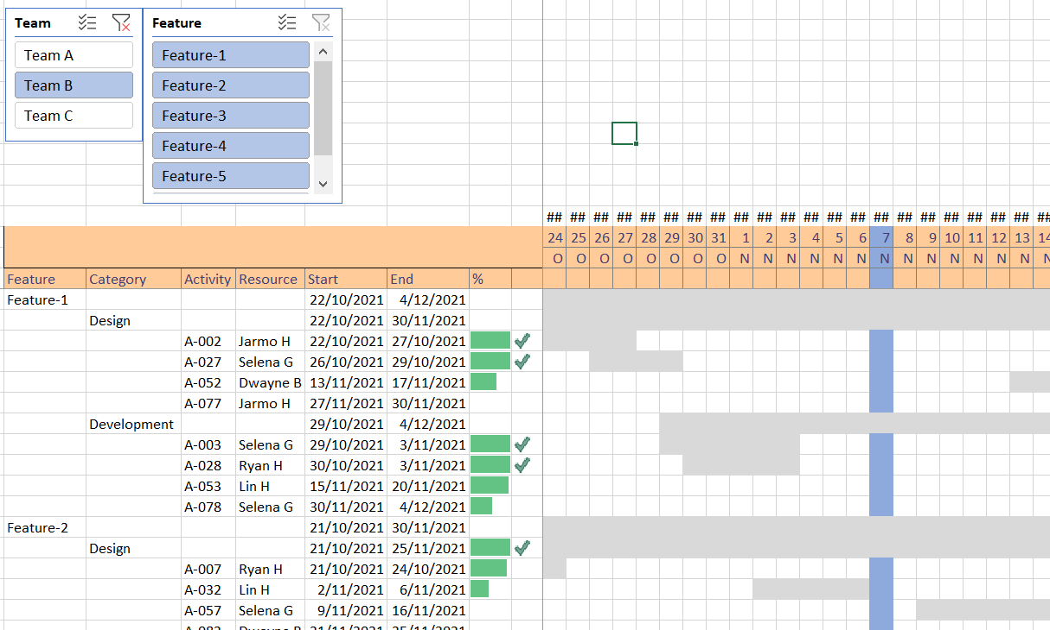

We can similarly filter data based on both ‘Team’ and ‘Feature’, e.g. Team A and Feature 2

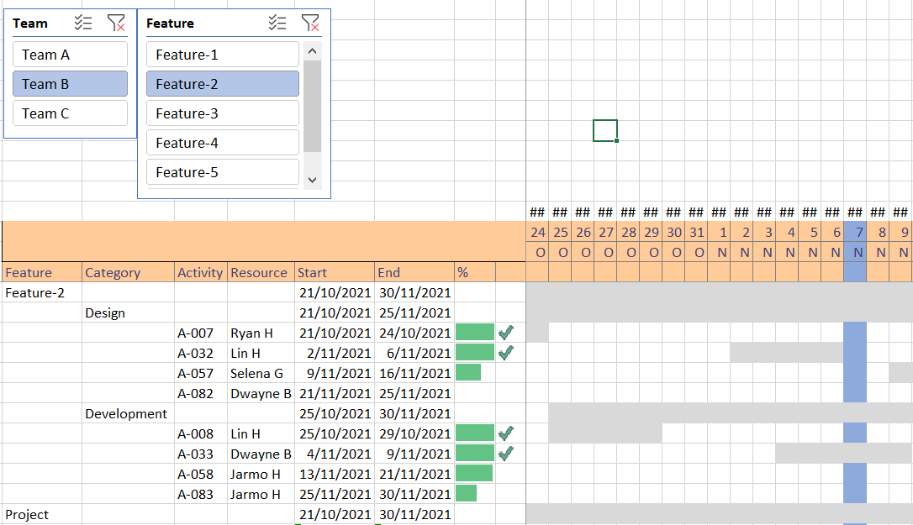

1. To get rid of the top ‘date row’ that is showing as ##

Select the row and use a darker shade to fill the row.

Cell Styles > Themed cell styles

To get rid of the ##, use the ‘;;;’ custom format for the row.

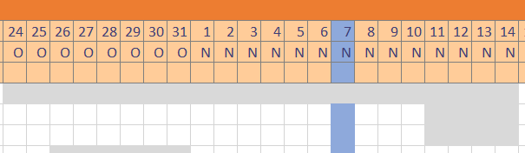

1. Now we have the Gantt Chart showing 51 days of activity, with Today as the 21st day from the Project Start date.

There are three Teams > Team A, Team B, Team C

And five Features, plus a System phase.

The Team Members and their grouping is detailed in the ‘Team’ sheet.

All the Project Activities are listed in the ‘Activities’ sheet.

1. The ‘Features’ are already sorted in ascending order.

The ‘Category’ can be sorted to show the phases as they occur e.g.

Specifications, Design, Development, Testing, Deployment

In the ‘Calculations’ sheet select the ‘Category’ heading and click on the down arrow next to it

Select ‘More sort options’ from the drop down menu, and then select ‘Manual’ for ‘Sort Options’

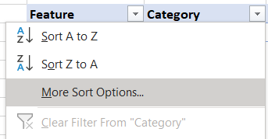 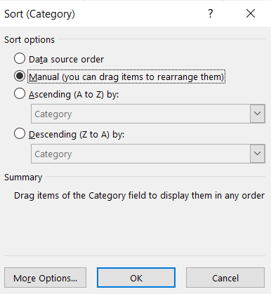

After that the ‘Category’ items can be moved around and sorted as needed.

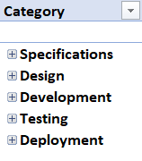

This will sort the ‘Category’ in the ‘Gantt Chart’ sheet automatically

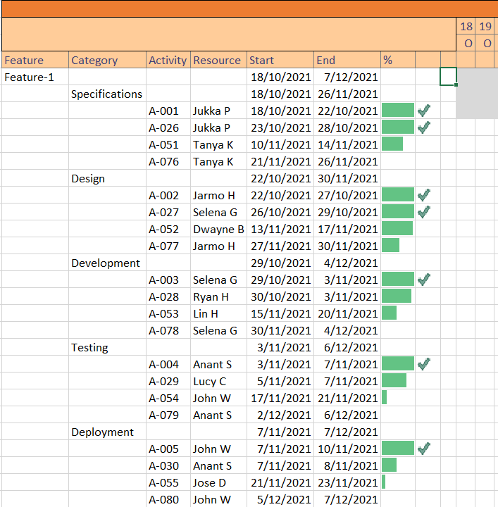

1. Clean out all the un-necessary data below the ‘Grand Total’ row in the Gantt Chart sheet by applying the IF formula logic as done before.

=IF(Calculations!E4=0, "", Calculations!E4)

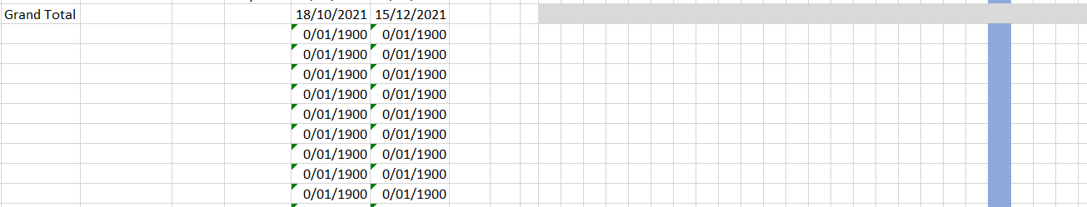

Extend it to the whole column, and repeat for other columns, if needed.

1. The ‘Grand Total’ field can be renamed to something meaningful e.g., ‘Project’ or ‘Project Timeline’. This can be done at the bottom of the ‘Pivot Table’ on the ‘Calculations’ sheet.

 

This will update the Corresponding field in the Gantt Chart too, displaying the timeline for the whole project.

1. Freeze Panes option can be used to keep the data and the headings visible as we navigate through the Gantt Chart. This can be done by clicking on the cell just before the start of the Gantt Chart area and after the last column of the data table area(J15)

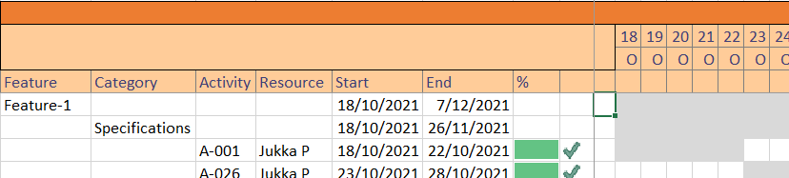

1. Now our Gantt Chart has been finalised.

