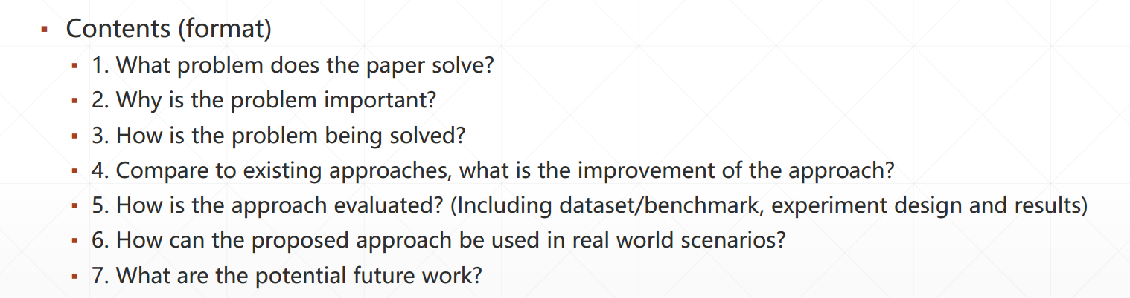

# What problem does the paper solve?

1. The  **difference of performanc**e including running time、 loss of fault detection between the two method——**test-suite reduction and regression test selection.**
2. How well if the two method combined together
3. They present **a new criterion** to measure **the quality of tests** with respect to **software changes.**