*Name: Alexander Balandin*

*ID: 132145194*

*DATA: 12/11/2020*

*Heroku url: https://glacial-eyrie-05995.herokuapp.com/*

--First task in the third assignment was to connect a database to the site. I chose mongoDB to satisfy the requirements. All user’s and room’s information are stored in the mongoDB database, and link might be found in the .env file.

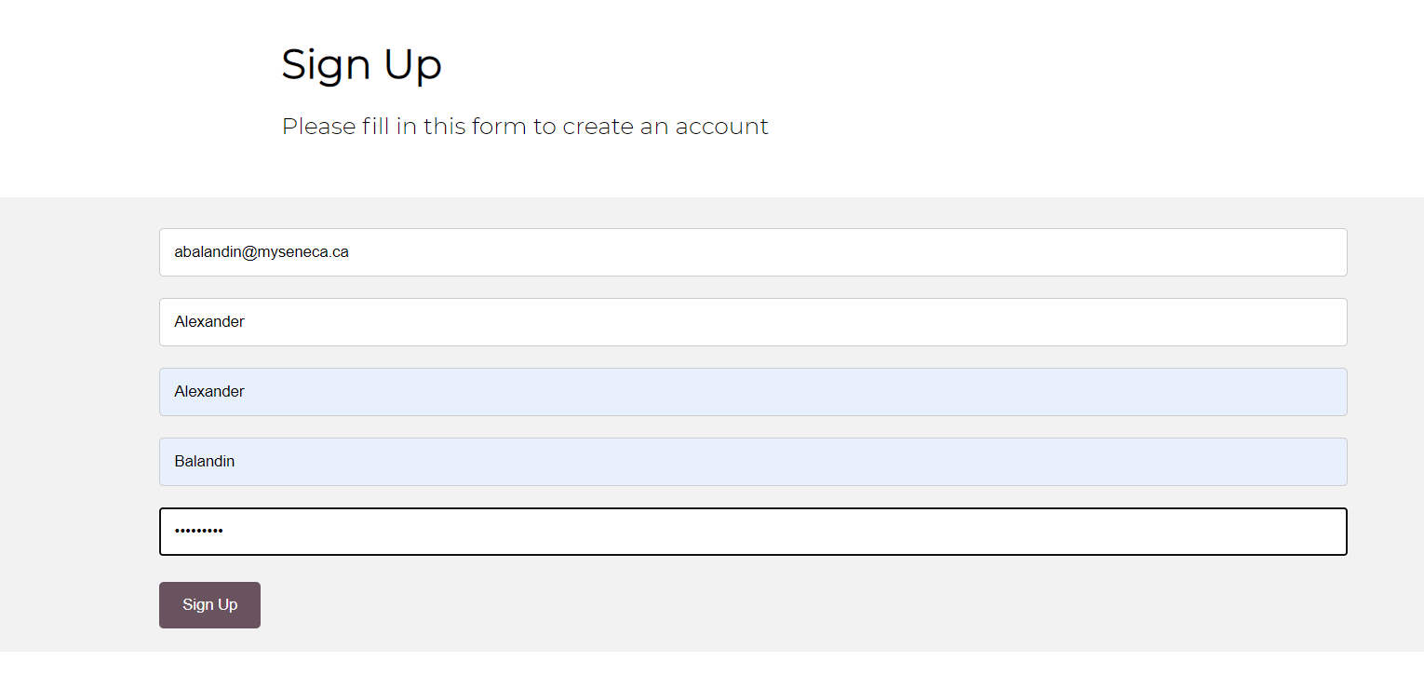

--After successful registration, use your email and password will be stored in the database.

**--To register as an administrator, use @airbnb.ca email format.**

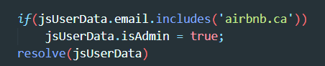

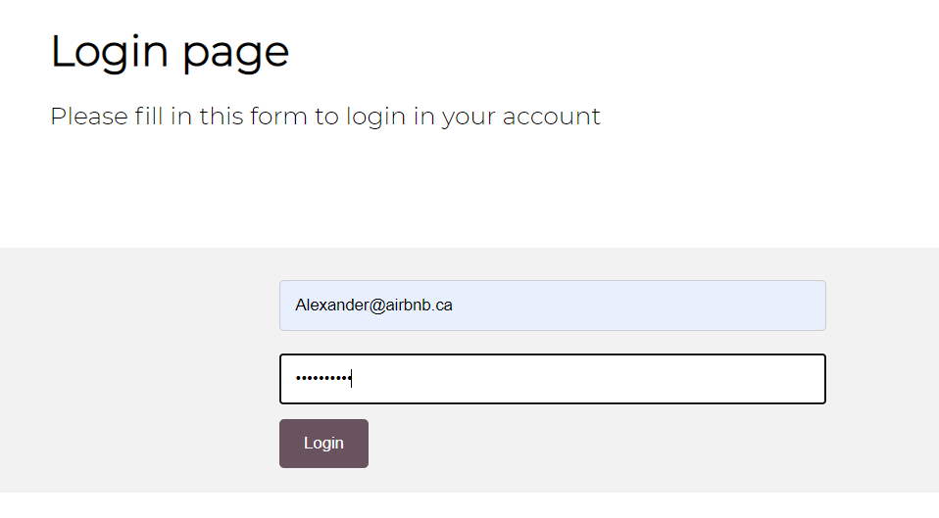

--If you logged in as an administrator, you will get an access to add/delete, and edit rooms.

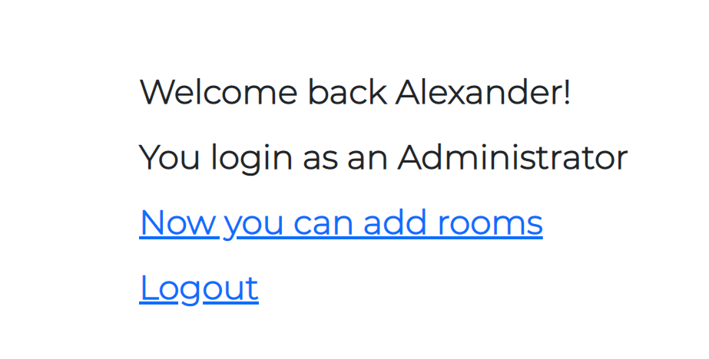

--Logout destroys current session and redirect the user to login page.

--Add rooms redirect the user to addRoom page where he/she might add a new room to the listing page.

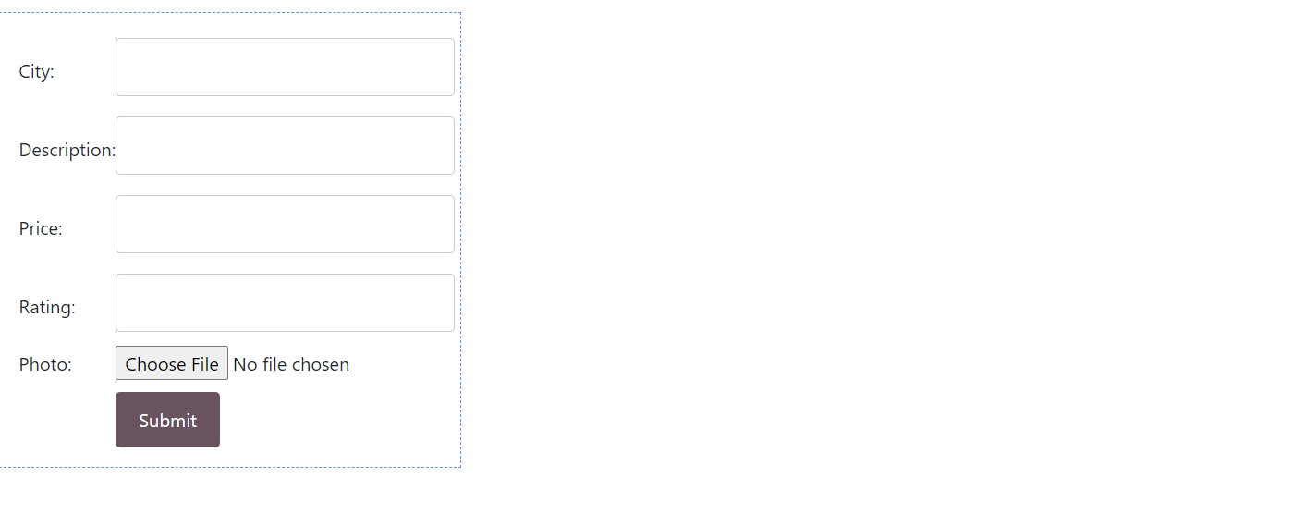

--On the listing page, an administrator has two control buttons which are delete and edit.

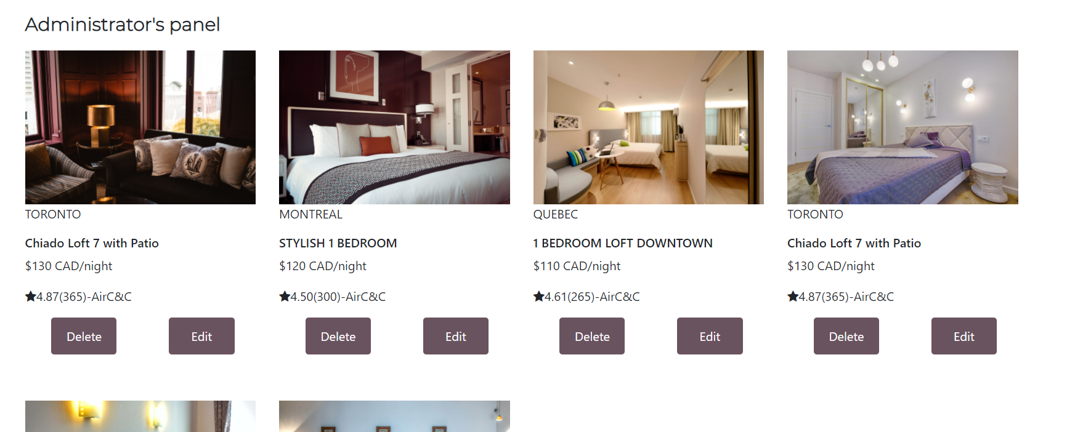

--delete deletes selected room and edit redirect the administrator to the edit page.

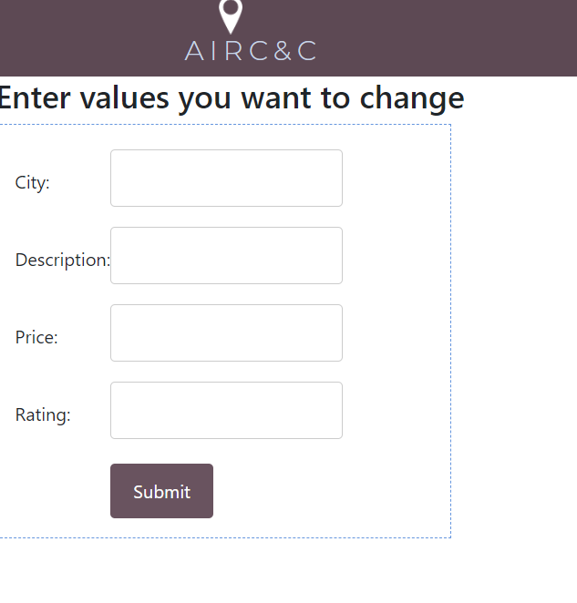

--Logged in user can book a specified room which redirects him to a booking page

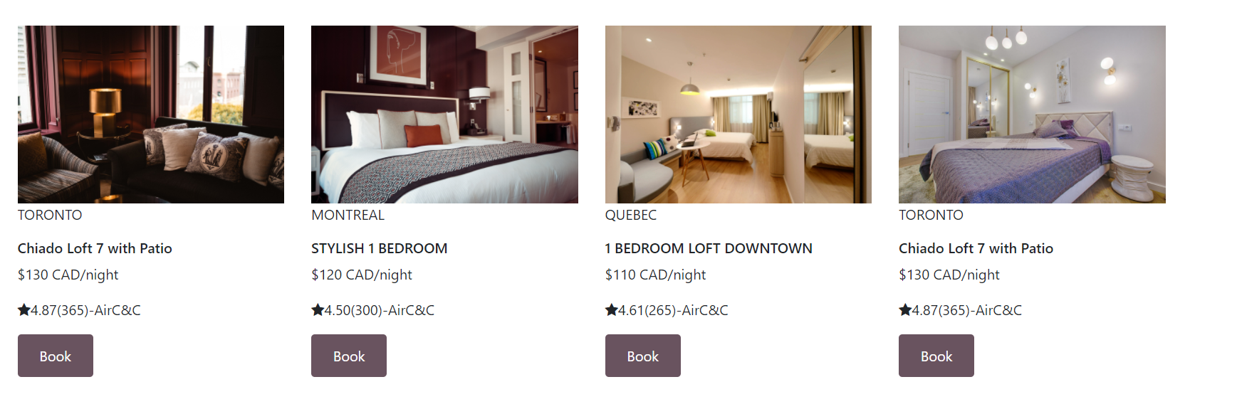

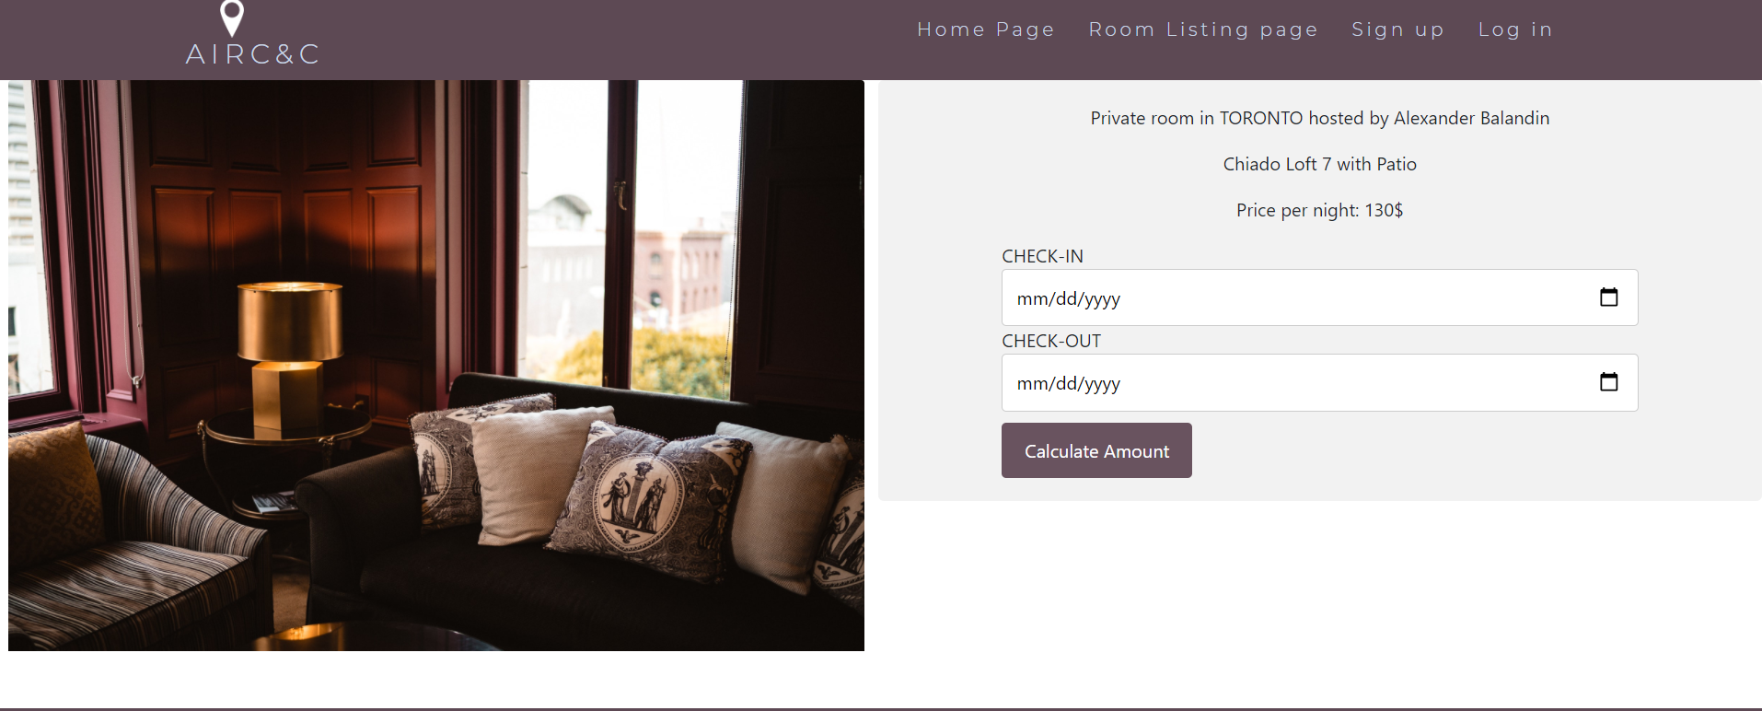

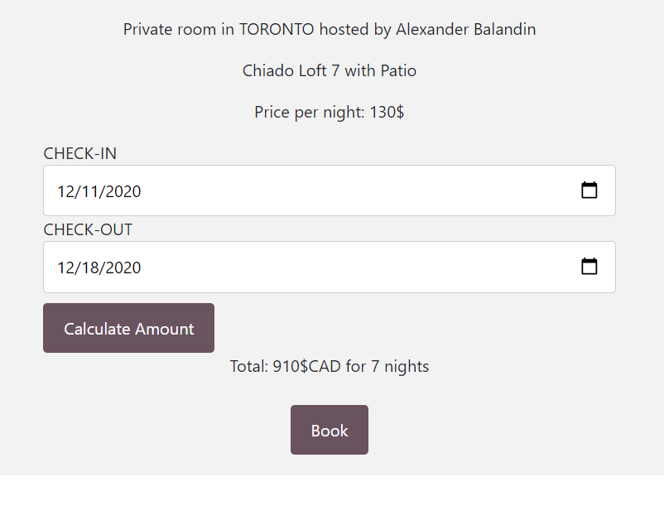

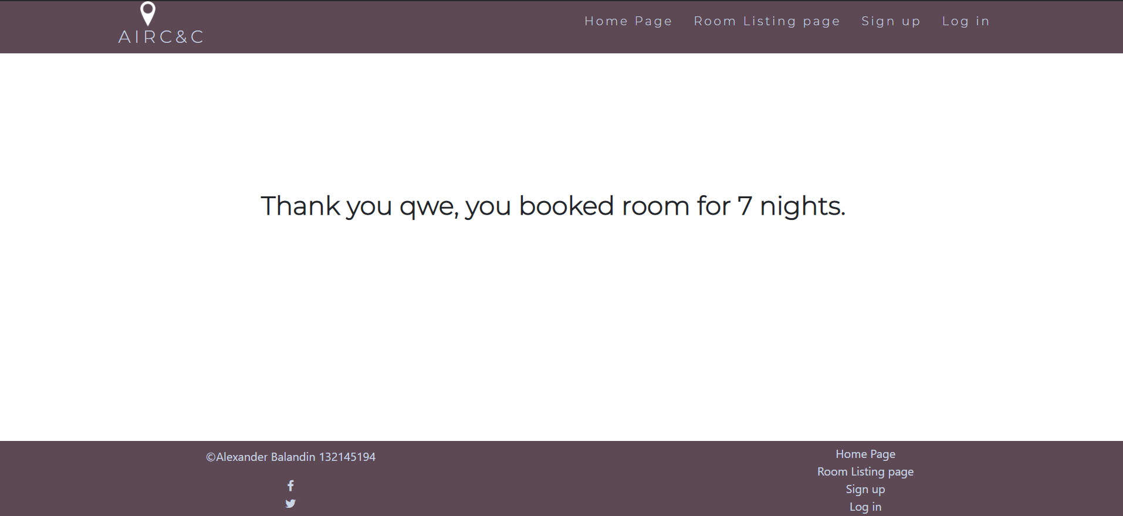

--On the home page, visitors might search for rooms in specified city:

